/

Foundations of Programming

Lab Assignment No.: 03

PROBLEM STATEMENT:
Write a program in C to generate multiplication tables for a given number.

OBJECTIVES:
- To understand the use of looping statements in C.
- To generate multiplication tables using loops.
- To improve program logic and execution flow understanding.

THEORY:
- Syntax for for loop example program
- Syntax for while loop example program
- Syntax for do while loop example program

ALGORITHM:
Step 1: Start
Step 2: Declare the variables and get an input of number (a)
Step 3: Set a loop counter (i=1)
Step 4: Repeat steps 5 and 6 while i<= 10
Step 5: Compute prod = a * i
Step 6: Display a * i = prod
Step 7: Increment i by 1
Step 8: End

FLOWCHART:
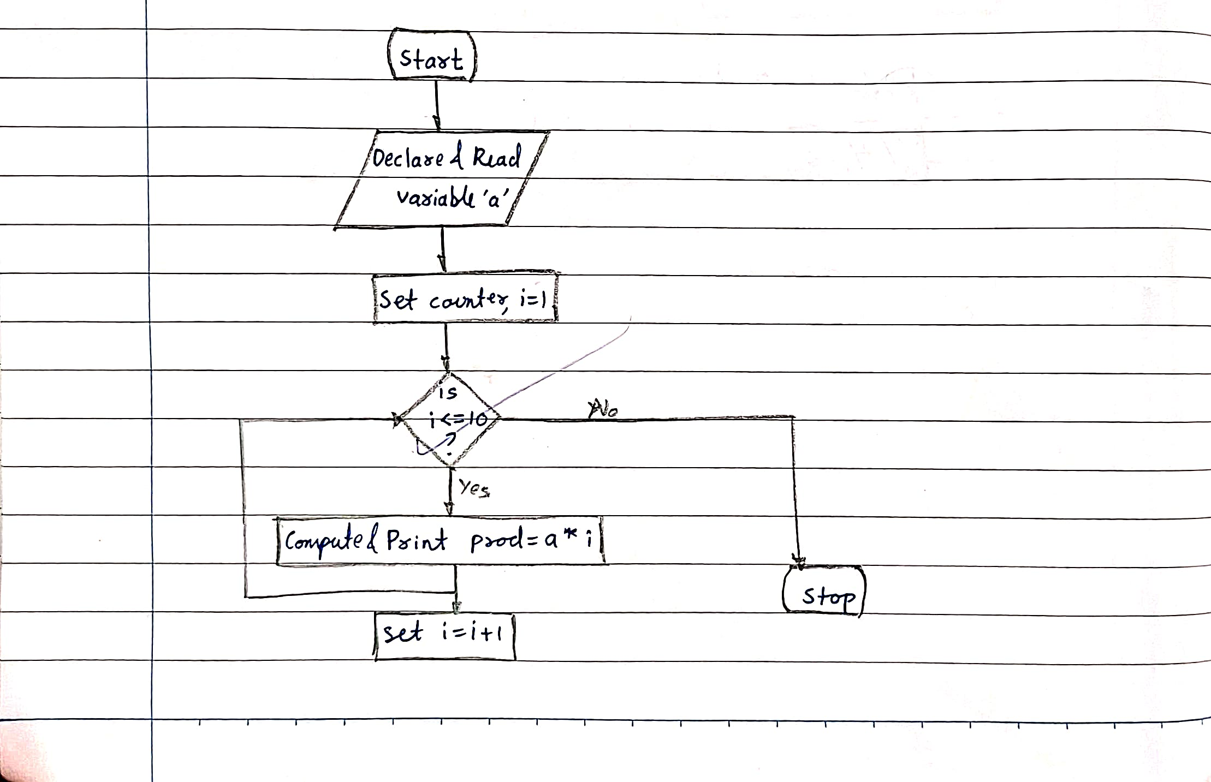

PROGRAM:
#include <stdio.h>

int main() {

int a, i, prod;
printf("Enter a number: ");
scanf("%d", &a);
i = 1;
while(i <= 10) {
prod = a * i;
printf("%d * %d = %d\n", a, i, prod);
i = i + 1;
}
return 0;
}

PLATFORM:
Linux

INPUT:
Takes a number as an input

OUTPUT:
Displays the result of the multiplication table of the number input
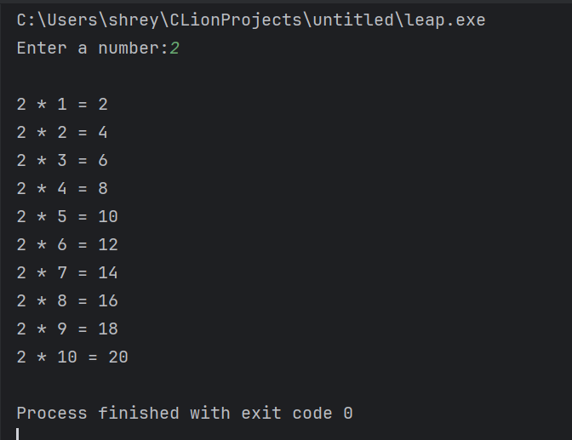

SAMPLE INPUT:
2

SAMPLE OUTPUT:
2 * 1 = 2
2 * 2 = 4
2 * 3 = 6
2 * 4 = 8
2 * 5 = 10
2 * 6 = 12
2 * 7 = 14
2 * 8 = 16
2 * 9 = 18
2 * 10 = 20

CONCLUSION:
Thus, the C program successfully generates the multiplication table of a given number using a loop structure by repeatedly computing and displaying the product from 1 to 10.

FAQs:
- Which loop is best suited for generating multiplication tables?
- What is the role of loop initialization?
- Difference between for loop, while loop and do while loop?
- Can a do–while loop be used to generate multiplication tables? Explain.
- Why is the do–while loop called an exit-controlled loop?

