Game Design Document

Fill up the following document

1. Write the title of your project.

Get ready for shhoting

1. What is the goal of the game?

Kill all the villains

1. Write a brief story of your game.

When the hero pass through a risky road the villains surround him

And and try attack him

1. Which are the playing characters of this game?

* Playing characters are the ones who respond to the user based on the input from the user.
* Cars, monkeys, dinos, wizards, etc., are the playing characters in the game.

|  |  |  |
| --- | --- | --- |
| Number | Character Name | What can this character do? |
| 1 | hero | Controlled by user |
| 2 | gun | shoots |
| 3 | road | Makes the pc and npc to walk |
| 4 | water | When the pc falls in water the game is over |
| 5 |  |  |
| 6 |  |  |
| 7 |  |  |
| 8 |  |  |

1. Which are the Non-Playing Characters of this game?

* Non-Playing characters are the ones that don't have an action or behavior when the user interacts with the game.
* Hurdles, stones, bananas, coins, etc., are non-playing characters in the game.

|  |  |  |
| --- | --- | --- |
| Number | Character Name | What can this character do? |
| 1 | villain | Attacks the hero |
| 2 | knife | Kills the pc |
| 3 |  |  |
| 4 |  |  |
| 5 |  |  |
| 6 |  |  |
| 7 |  |  |
| 8 |  |  |

Draw your imagination of this game. What does this game look like?

* Draw the game either on your computer or on paper.
* Add images of the game scenes to show each of the playing and non-playing characters at least once.

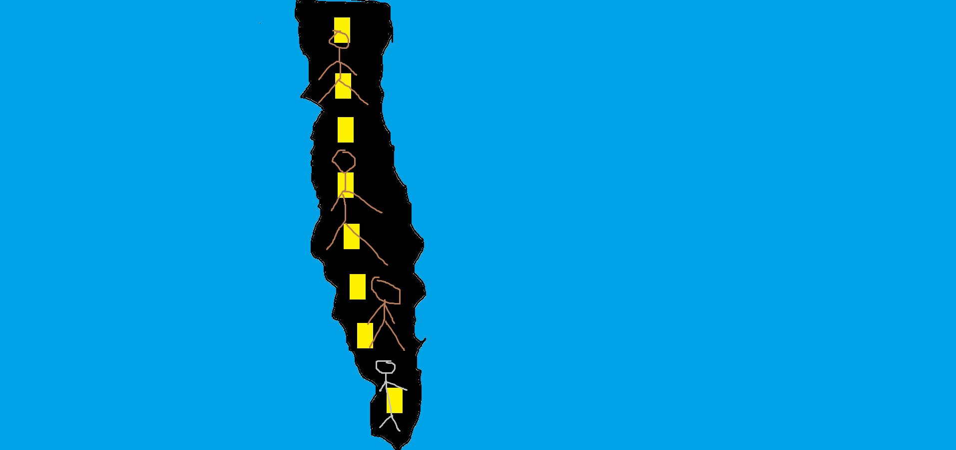

How do you plan to make your game engaging?