/*

Name: Yashwant Bist

Id:T100169692

Date:2025-02-10

Purpose: Multi-row functions

*/

/*-- Q1: Create a query to determine the average and the total sales in the database. Named the

columns “Total” and “Total average per sale” */

// Q1 SOLUTION

SELECT

SUM(lab2_sale_price) AS "Total",

AVG(lab2_sale_price) AS "Total average per sale"

FROM

lab2_sale;

*Q2: Repeat the same as the previous questions but add another column named “Email

domain” that represents the domain of the email of the user (google.com, icloud.com,

outlook.com, etc). Calculate the total sales and the average value per sale per each email

domain*/

//Q2 Solution

SELECT

SUBSTR(email, INSTR(email, '@') + 1) AS "Email domain",

SUM(lab2_sale_price) AS "Total",

AVG(lab2_sale_price) AS "Total average per sale"

FROM

lab2_sale

JOIN

lab2_customer ON lab2_sale.lab2_customer_id = lab2_customer.id

GROUP BY

SUBSTR(email, INSTR(email, '@') + 1);

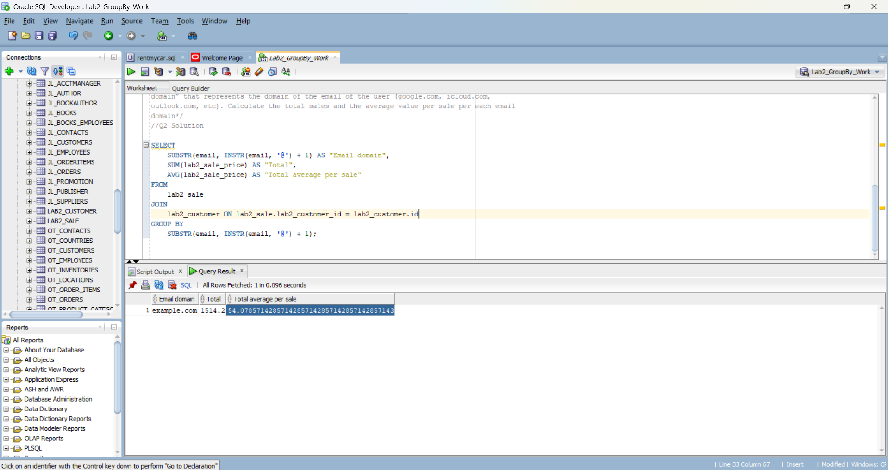

/*- Q3: Create a query that returns the name of the month a sale took place, the number of

sales for each of those months, plus the average sale amount per month*/

SELECT

TO_CHAR(lab2_sale_date, 'Month') AS "Month",

COUNT(*) AS "Number of sales",

AVG(lab2_sale_price) AS "Average sale amount"

FROM

lab2_sale

GROUP BY

TO_CHAR(lab2_sale_date, 'Month');

/* - Q4: Create a query to calculate the minimum, maximum and total sales per user. Display the

user name in one column and named it “fullname”, the user_id, the minimum, maximum and

total sales per user*/

//Q2 Solution

SELECT

(name || ' ' || last_name) AS "fullname",

lab2_customer.id AS "user_id",

MIN(lab2_sale_price) AS "Minimum Sale",

MAX(lab2_sale_price) AS "Maximum Sale",

SUM(lab2_sale_price) AS "Total Sales"

FROM

lab2_customer

JOIN

lab2_sale ON lab2_customer.id = lab2_sale.lab2_customer_id

GROUP BY

lab2_customer.id, name, last_name;

/* - Q5: Create a query that lists every sale ID, sale date and total price plus tax. Assume a ta rate

of 13 percent.*/

//Q2 Solution

SELECT

id ,

lab2_sale_date ,

lab2_sale_price * 1.13 AS "Total price plus tax"

FROM

lab2_sale;

