Don’t use any files from old code and copy ‘kafka’ folder from this code folder and then copy to your system E directory.
Start both zookeeper and kafka from E directory as per old instructions and then start JUPYTER notebook and train AI algorithm like below output
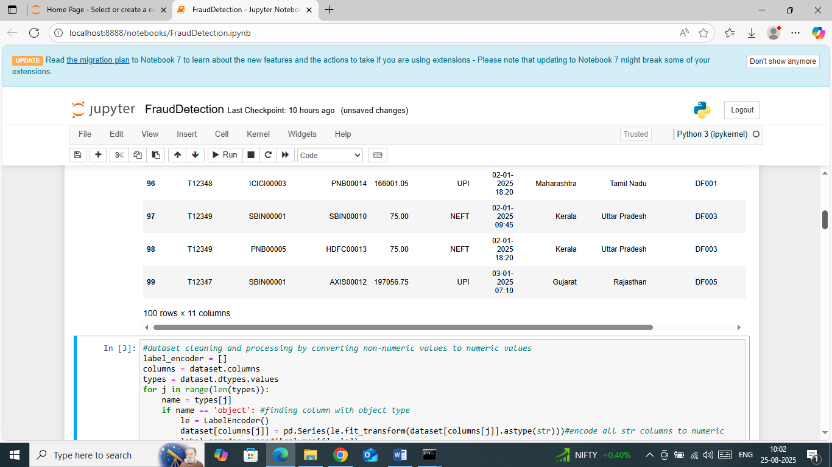
In above screen from your given dataset 100 records are loaded and run remaining blocks to train algorithm and then will get below output
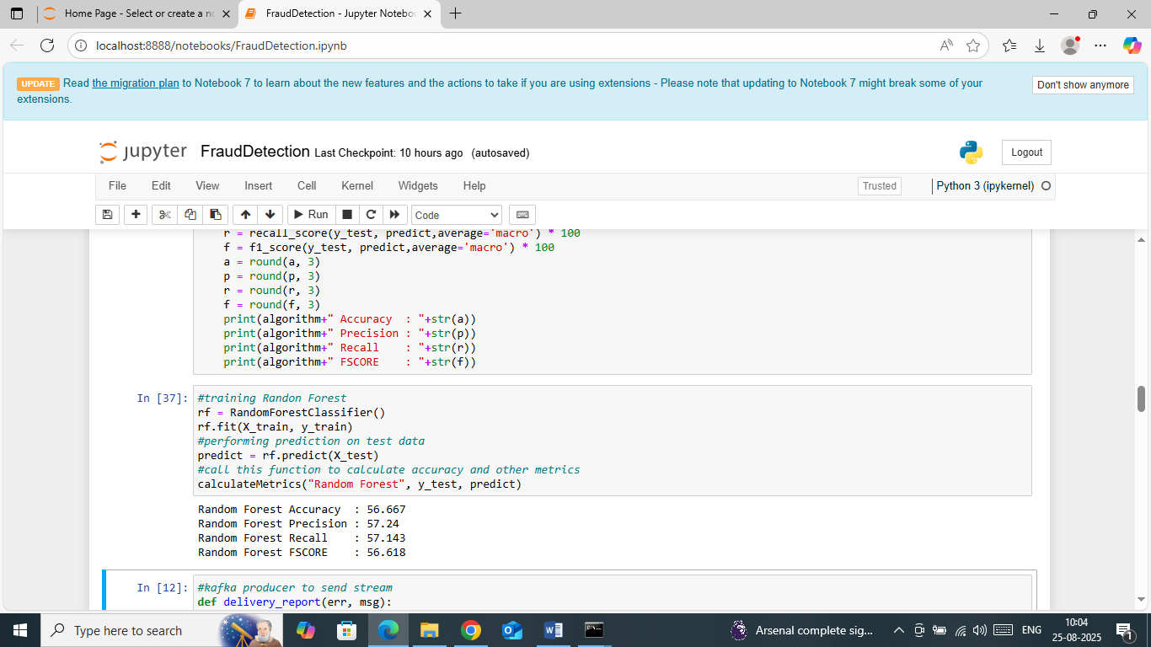
In above screen Random Forest got 56% accuracy and run web application code to publish and consume records.
Note: don’t publish from JUPYTER as it’s not good in handling threads so run from WEB like below page. Just double click on ‘runweb.bat’ file to start server and then will get below page
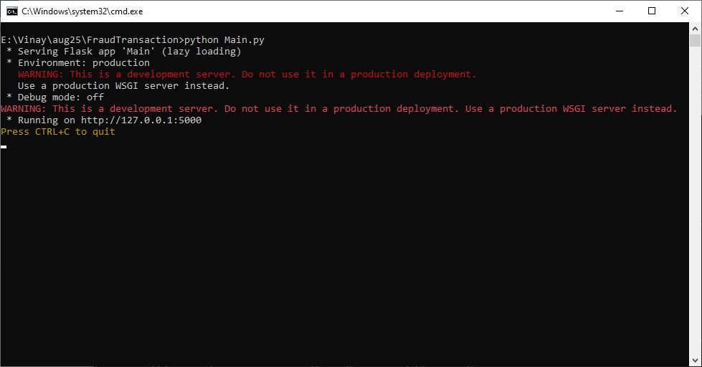
In above screen server started and now open browser and enter URL as http://127.0.0.1:5000/index and then press enter key to get below page
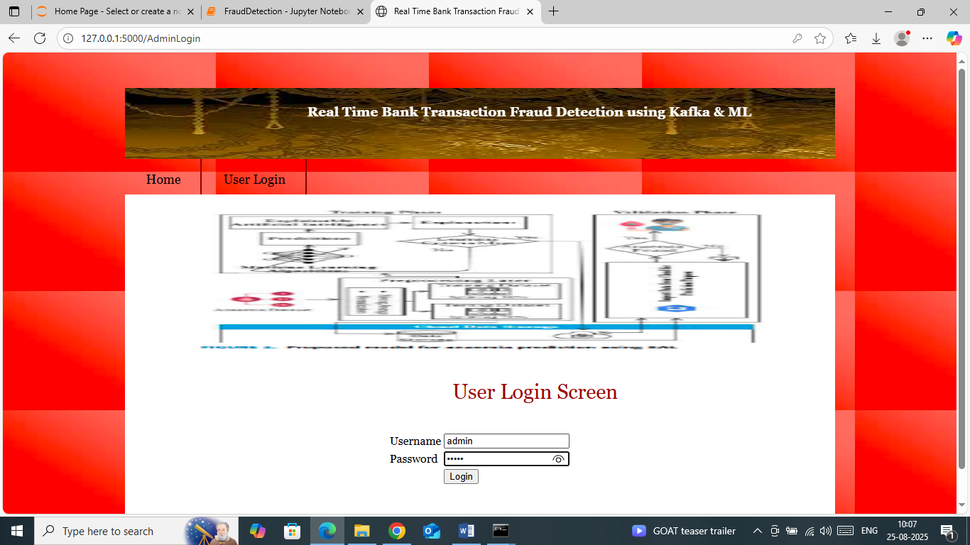
In above screen login to system to get below page
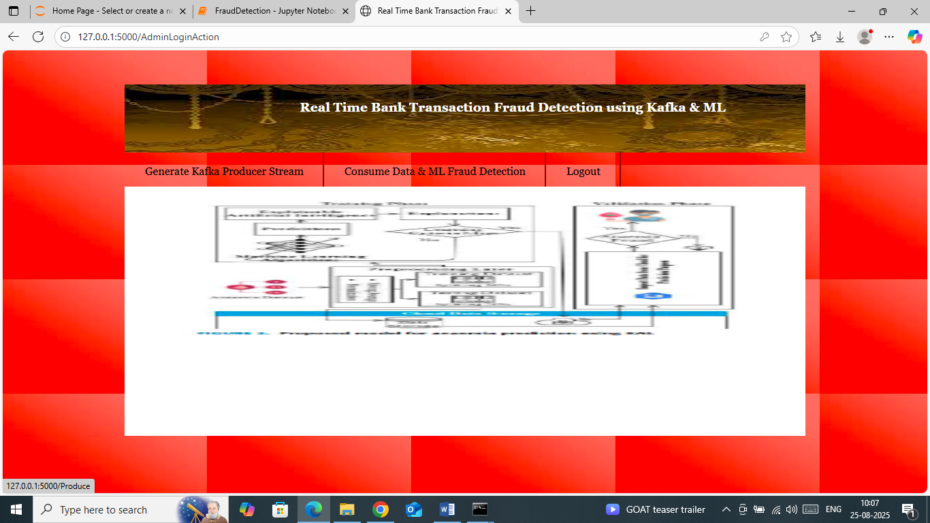
In above screen click on ‘Generate Kafka Product Stream’ to publish records and then will get below page
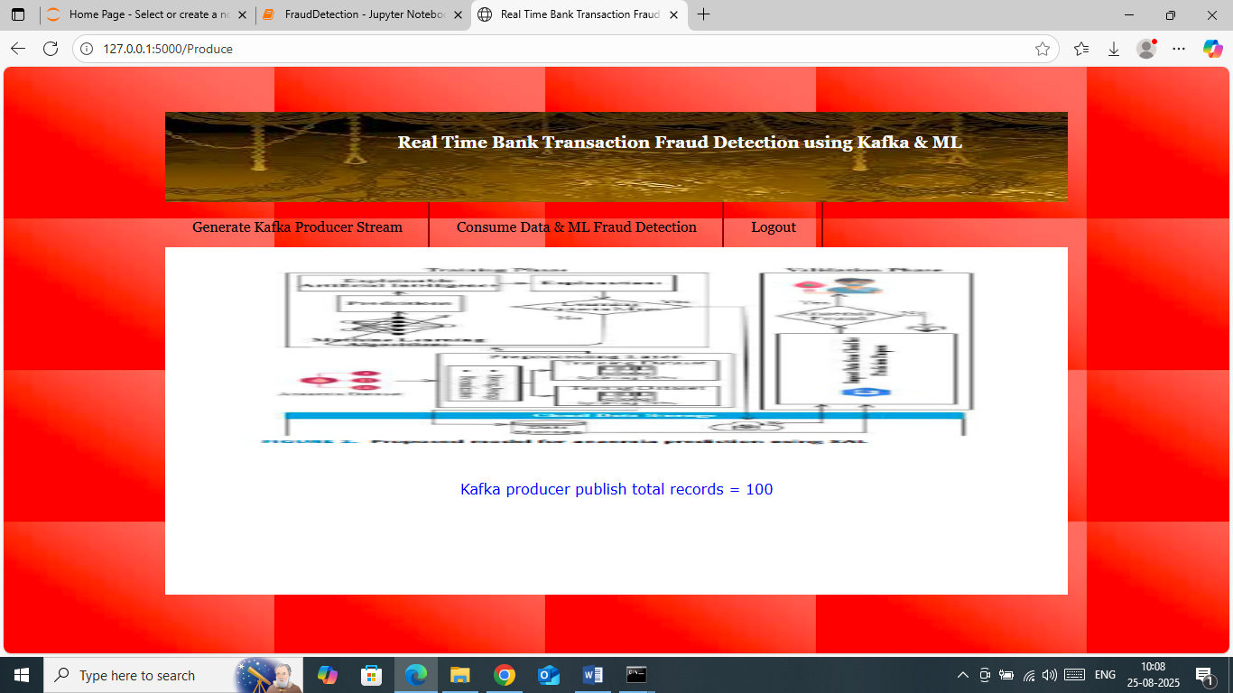
In above screen 100 records are publish and now click on ‘Consume Data & ML Fraud Detection’ link to get below consumes records
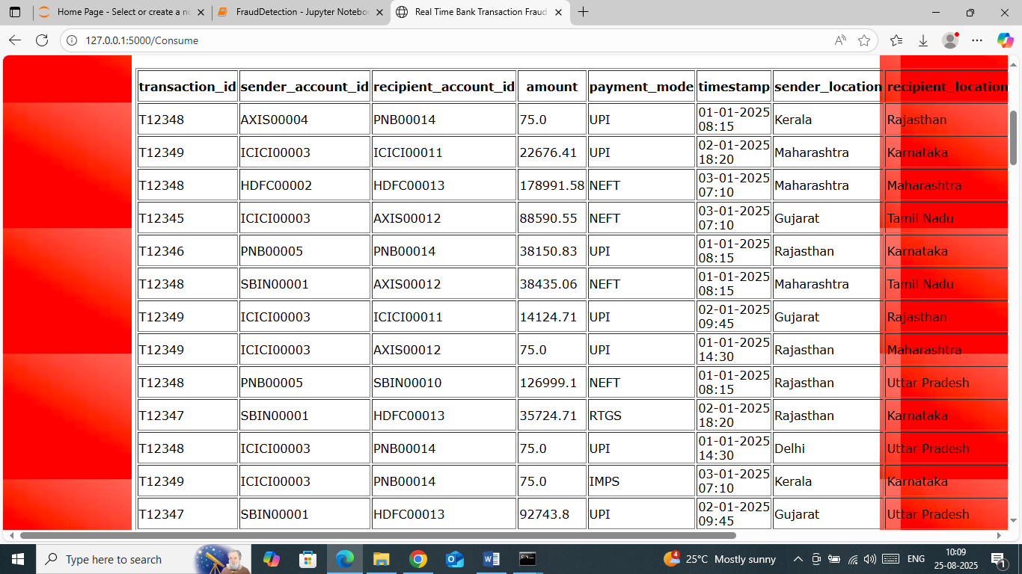
In above screen can see rows of all consume records from publishers.
Similarly you can publish and consume any number of time.
If you find any difficulty then stop Zookeeper and KAFKA and then delete ‘E’ folder created in your E directory and then restart Zookeeper and kafka and then run web part again by starting web flaks server.

