Real Time Bank Transaction Fraud Detection using Kafka & ML
In propose work we are utilizing Apache Kafka streaming technology to stream bank data and then ML algorithm will receive bank stream data and then predict weather bank data is normal or contains fraud transaction.
Kafka streaming consists of Producer and Consumer where producer will produce data on particular topic and then consumer will continuously tries to look for incoming stream data and then consume data and then pass to ML algorithm for prediction.
To setup Kafka you need to install java 1.8 and then set java home and path in environment variables. Now copy and paste ‘kafka’ folder in your system E directory and then double click on ‘runZookeper.bat’ file from ‘kafka’ folder to get below page
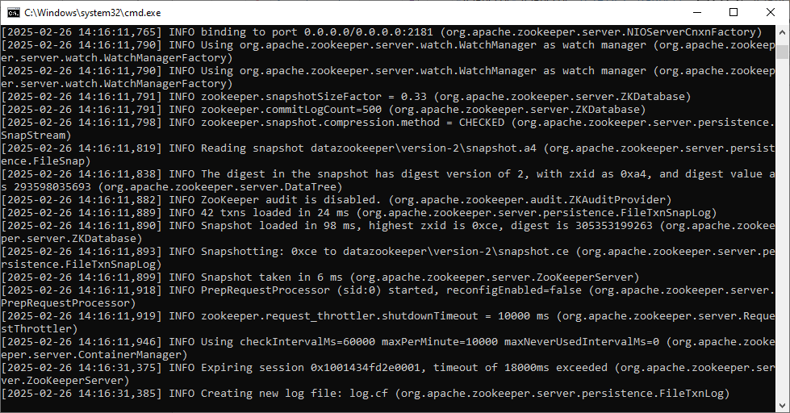
In above screen Zookeeper server started and now double click on ‘runKafka.bat’ file to start Kafka server and then will get below page
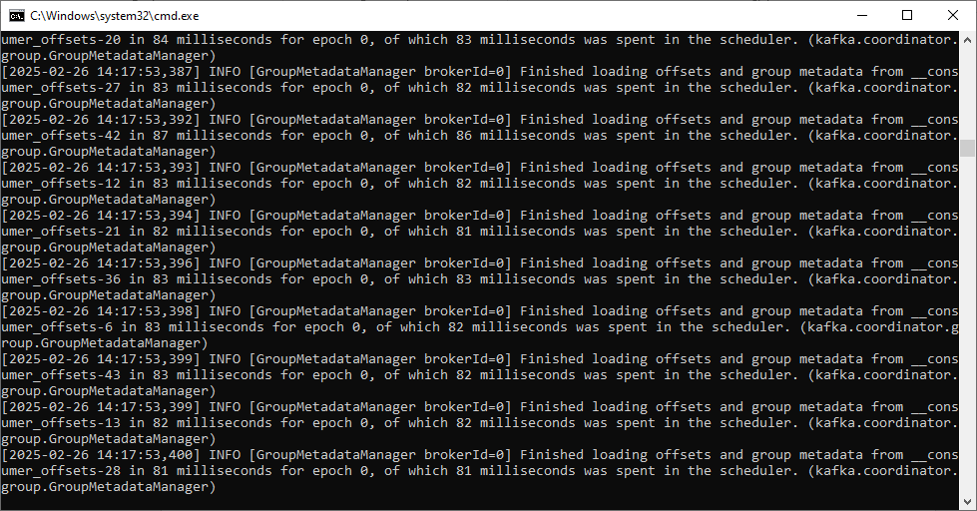
In above screen Kafka server started and now double click on ‘runJupyter.bat’ file to start JUPYTER notebook for ML training and then will get below page
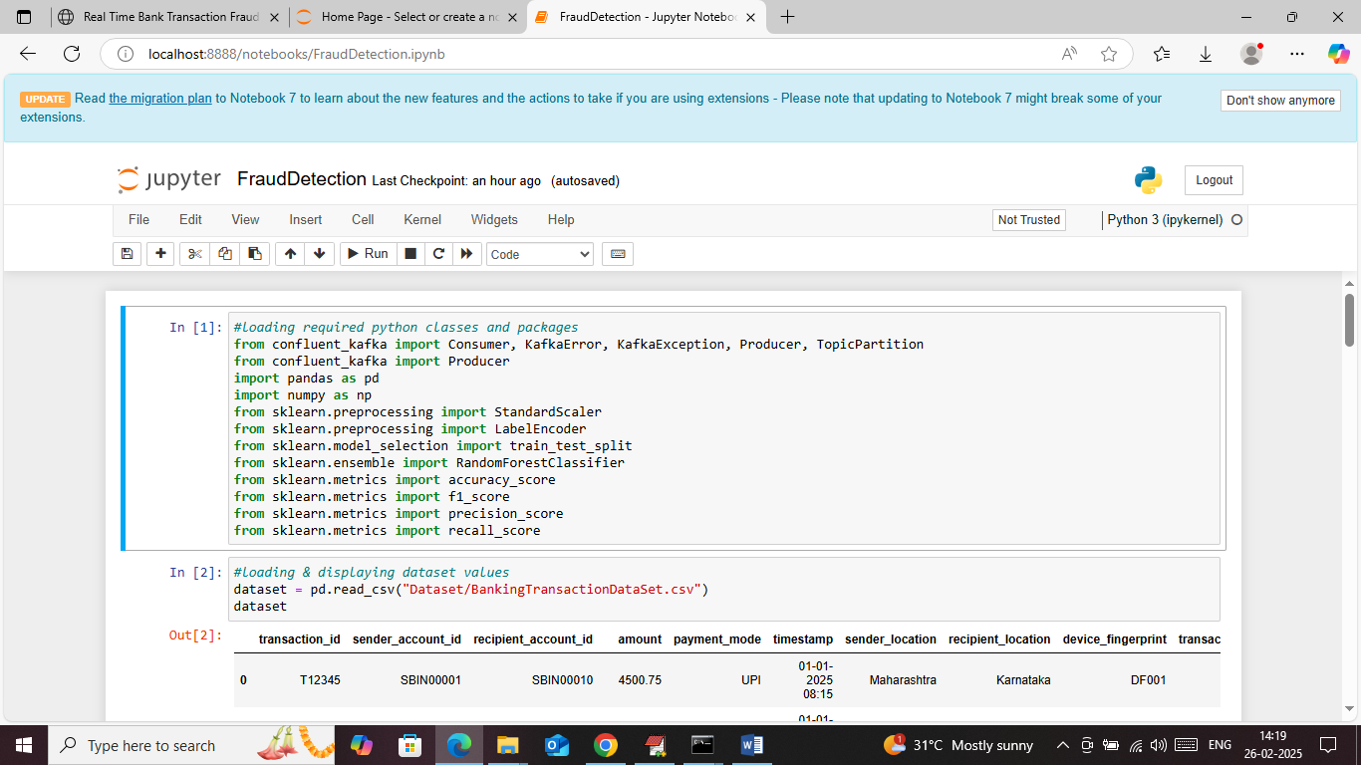
In above screen loading required package and classes
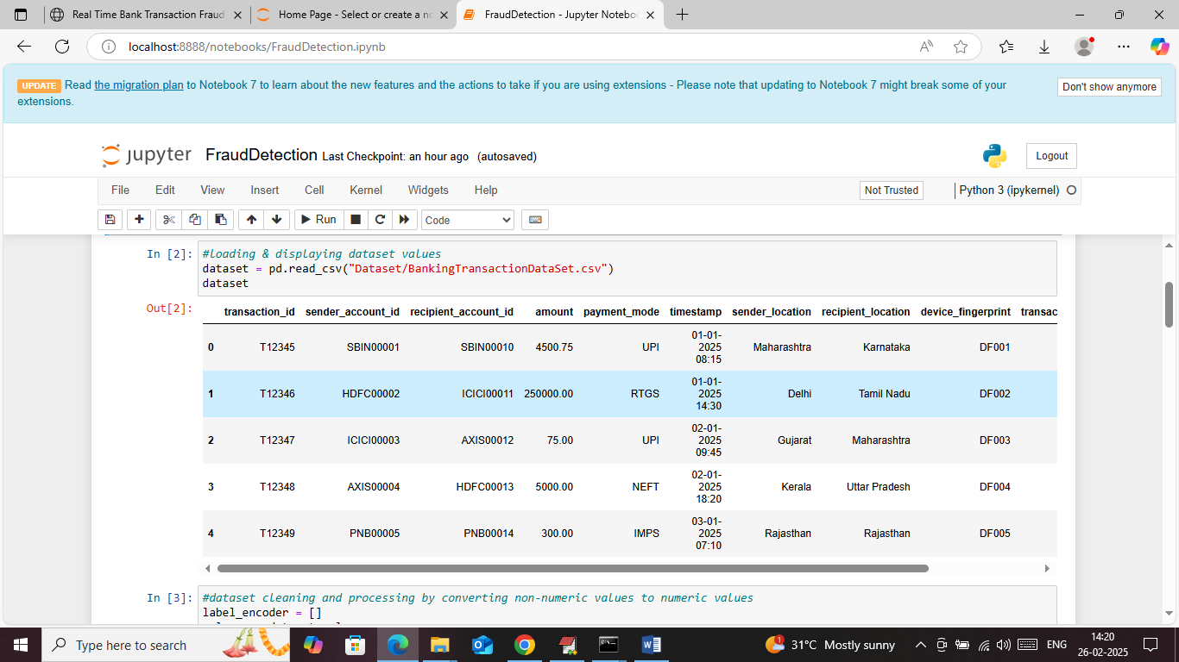
In above screen loading and displaying your transaction dataset and this dataset contains both numeric and non-numeric data but ML algorithm accept only numeric data so by employing dataset processing technique can convert non-numeric data to numeric data and then will get below page
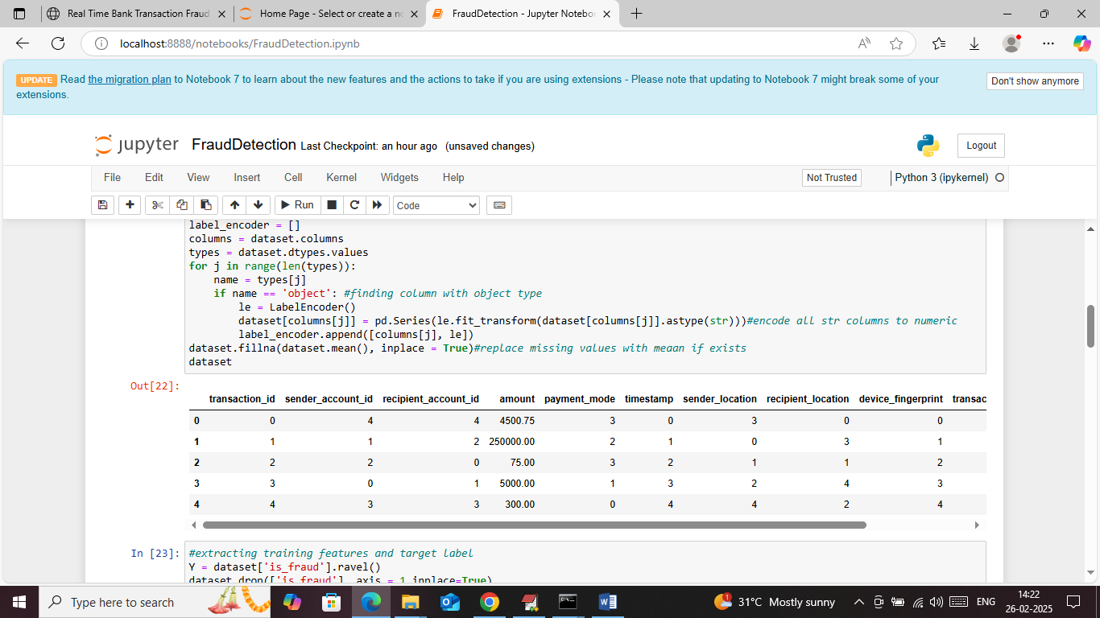
In above screen entire data converted to numeric format
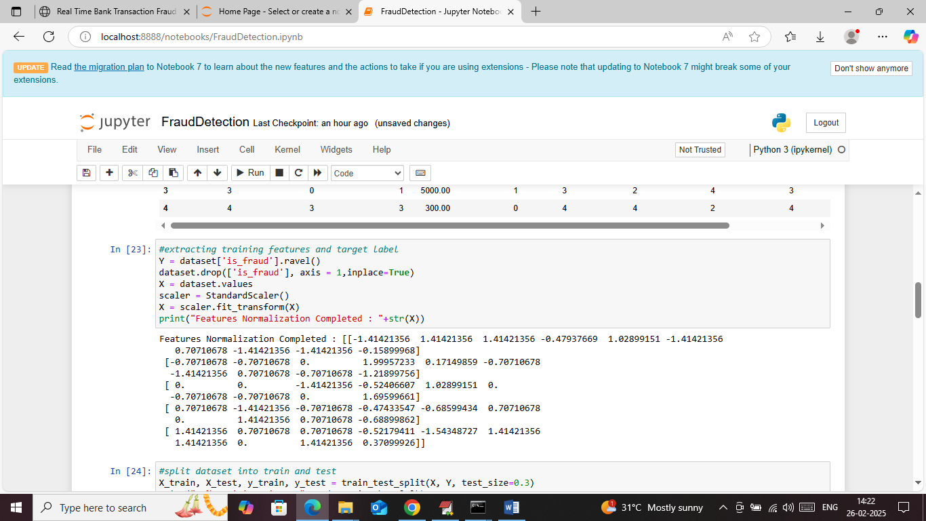
In above screen extracting dataset features and target values and then normalizing and displaying dataset features
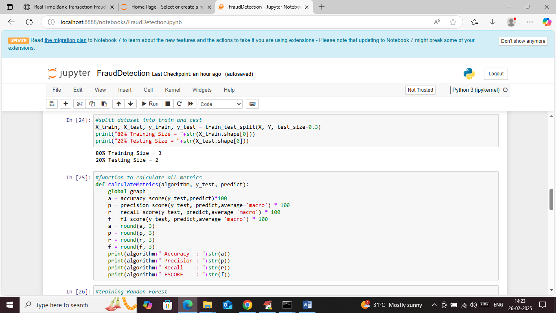
In above screen splitting dataset into train and test and then defining function to calculate accuracy and other metrics. In your dataset having only 5 records so application using 70% records for training and 30% for testing
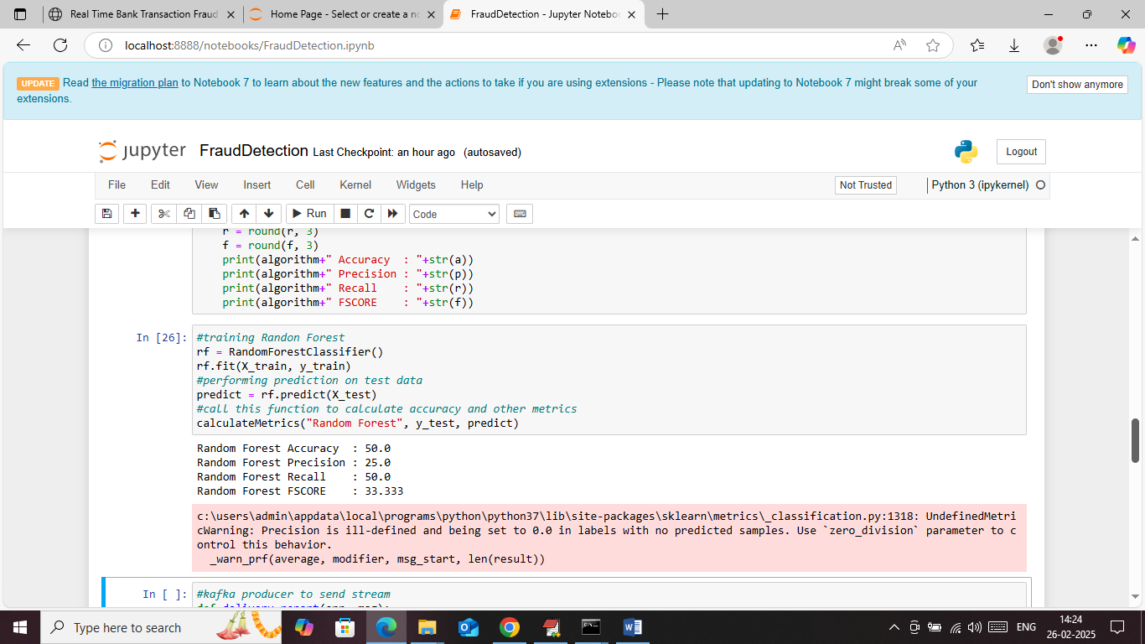
In above screen training Random Forest algorithm on training features and then performing prediction on test data and then Random Forest got 50% accuracy on get 5 transaction. If we have large dataset then will get high accuracy
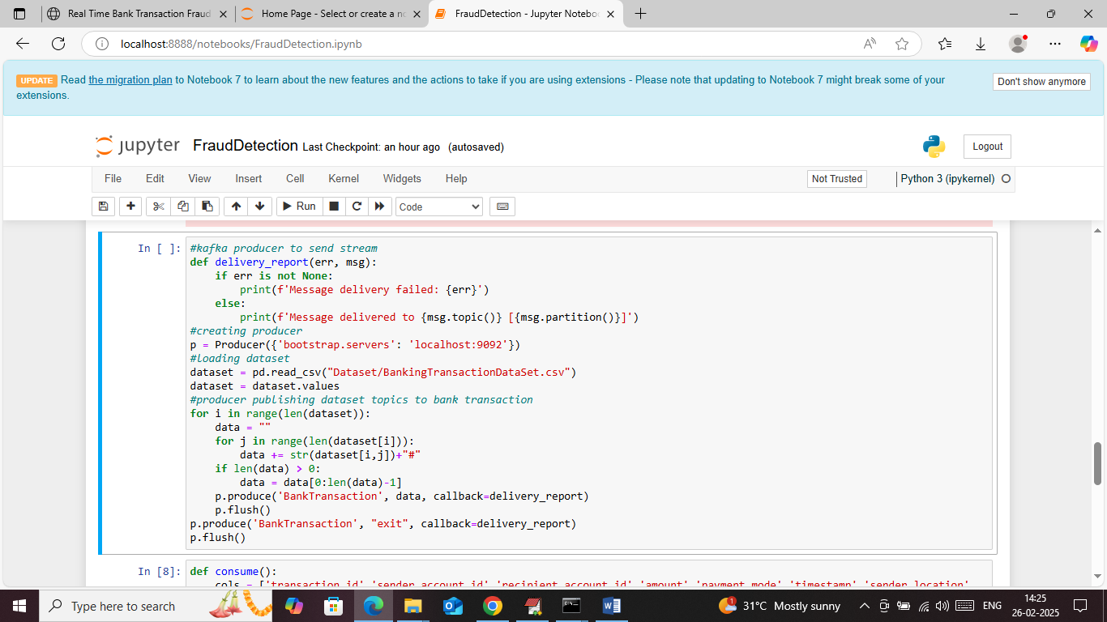
In above screen defining Kafka function to produce or publish dataset values to Kafka
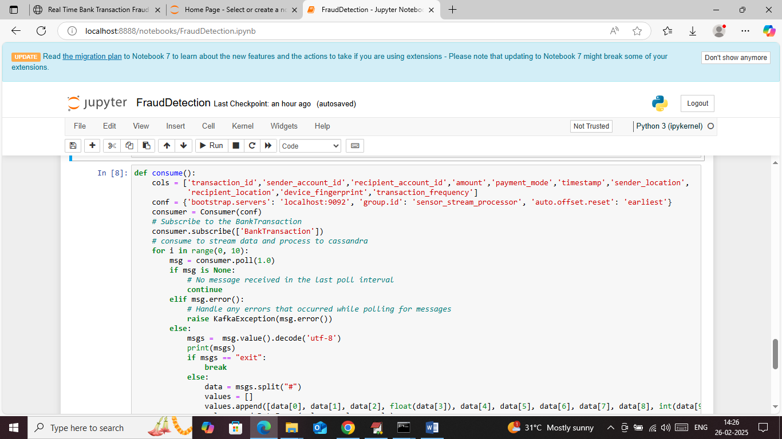
In above screen consume function will read data and then input to ML algorithm for fraud transaction prediction. In above screen we have trained and make Kafka producer and consumer.
Now double click on ‘runWeb.bat’ file to start web server and then will get below page
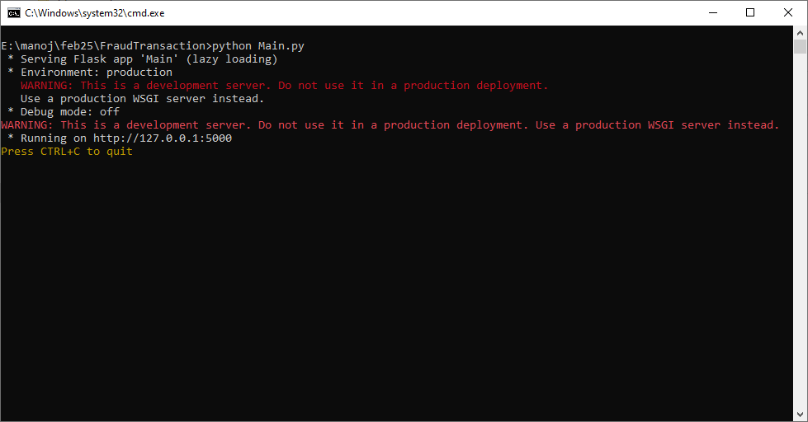
In above screen python flask webserver started and now open browser and enter URL as http://127.0.0.1:5000/index and then press enter key to get below page
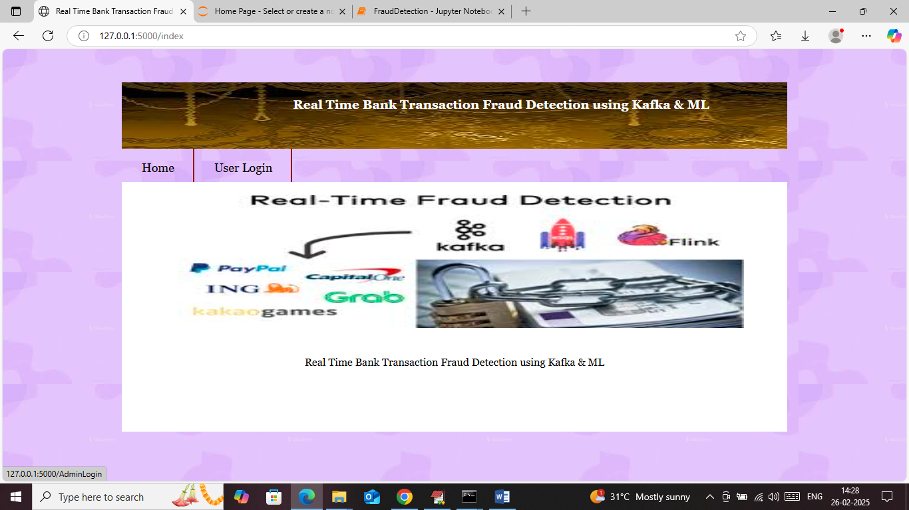
In above screen click on ‘User Login’ link to get below page
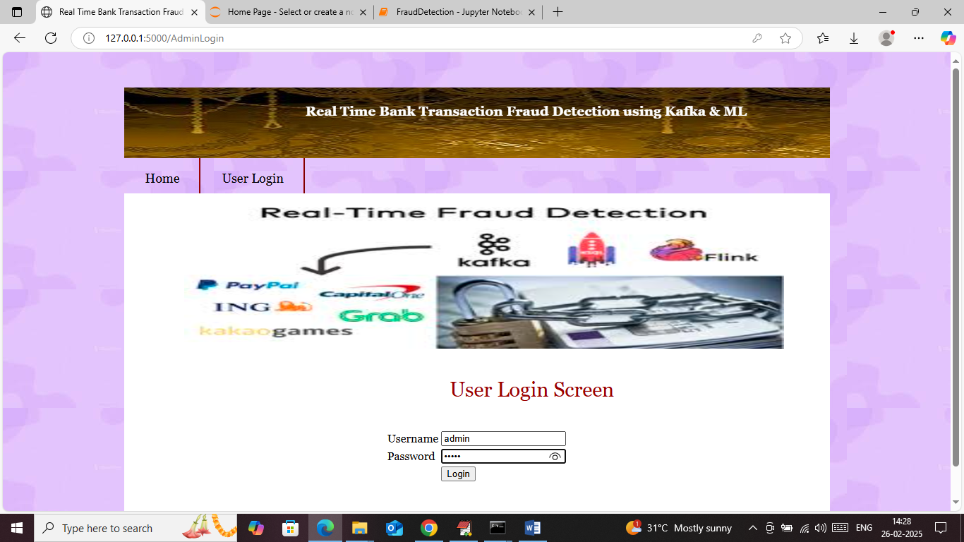
In above screen user login by giving username and password as ‘admin and admin’ and then press enter key to get below page
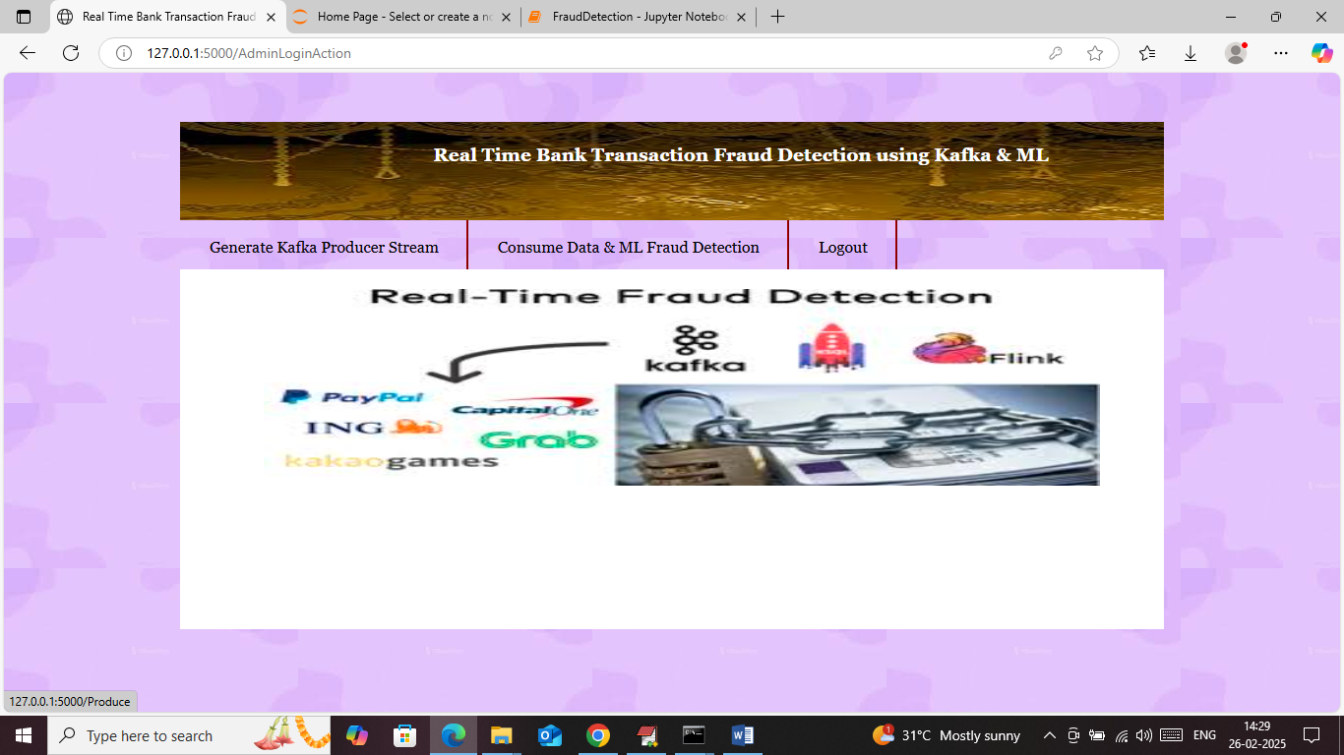
In above screen user can click on ‘Generate Kafka Producer Stream’ link to publish data to Kafka and then will get below page
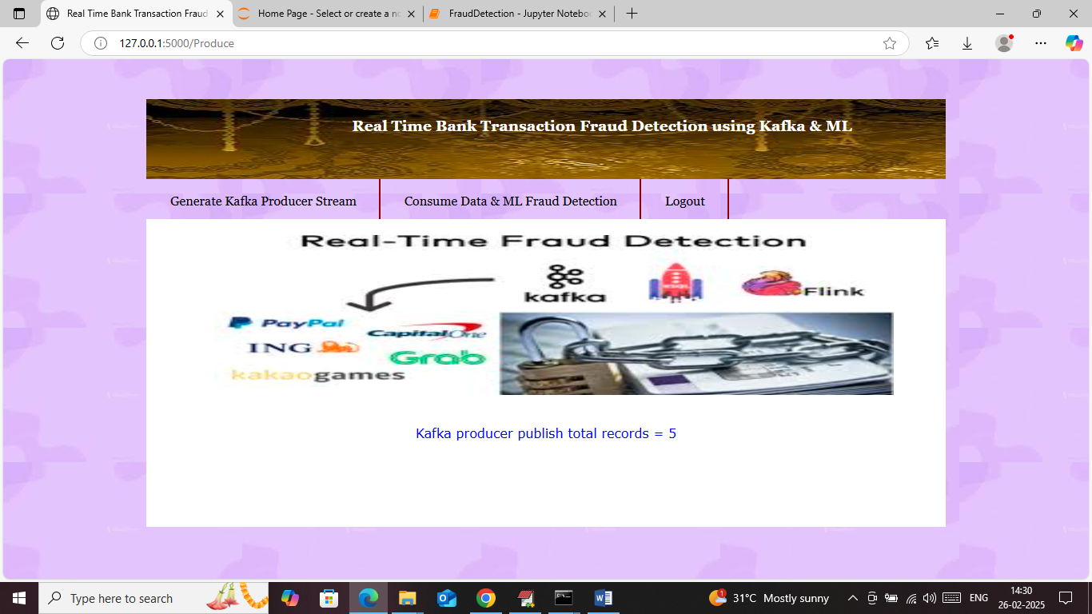
In above screen can see Kafka publish total 5 streams as transactions records and now click on ‘Consume Data & Fraud Detection’ link to consume publish data and then input to ML algorithm to predict transaction type
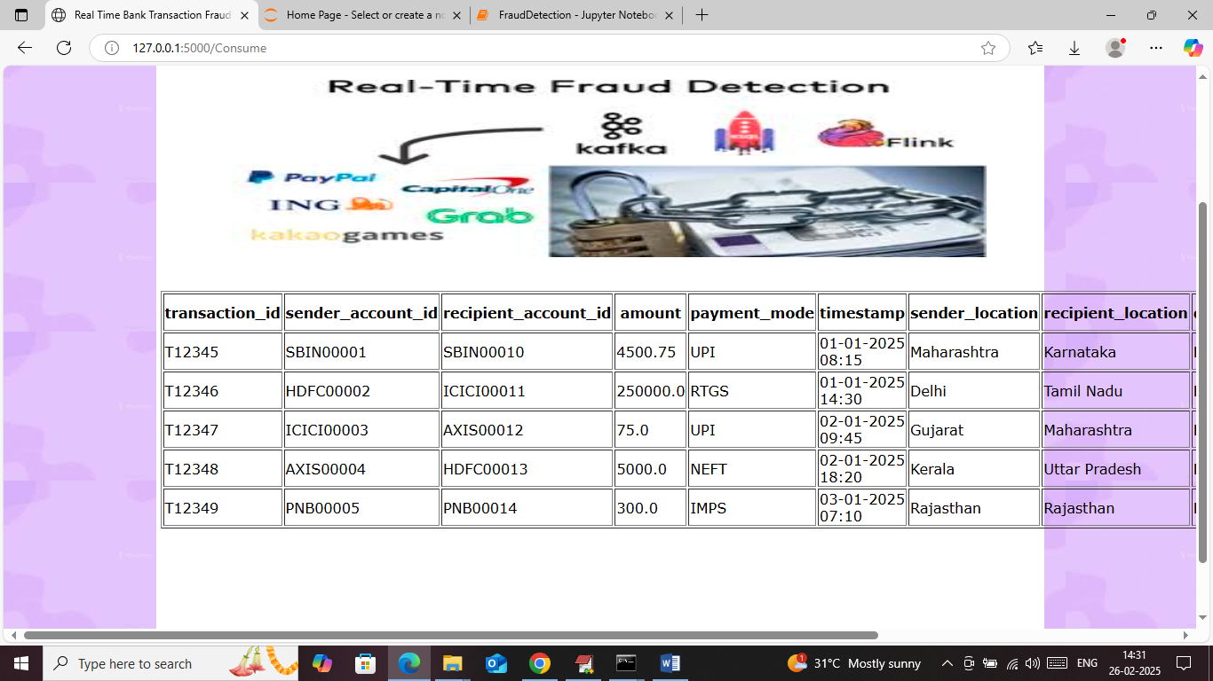
In above screen Kafka consumer receive all records and just scroll to right to view ML predicted output
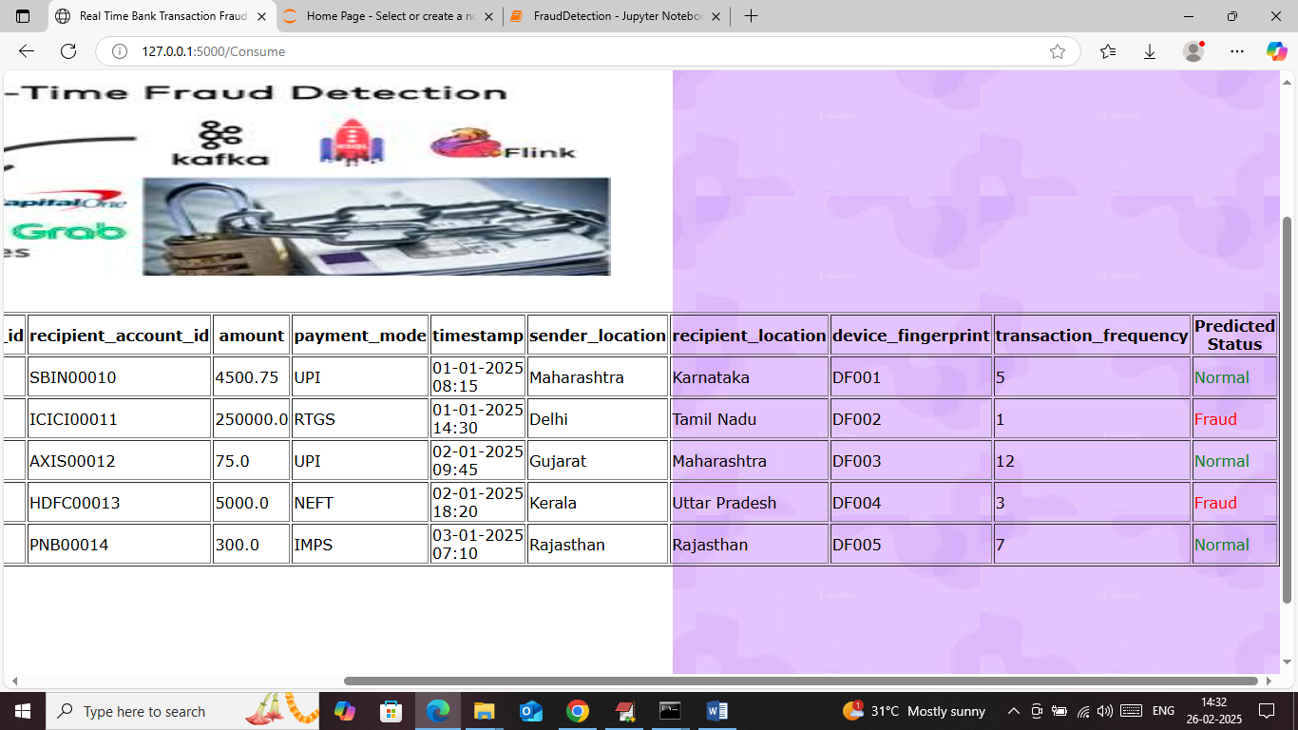
In above screen in last column ML predicted some records as ‘Normal’ and some as ‘Fraud’.
So in above project we used JUPYTER to load and train dataset and then setup Kafka modules and then using WEB we can produce, consume and then perform prediction.

