**TITLE**

**Weather Prediction App Using Django and AI for Real-Time Forecasting**

**ABSTRACT**

This project presents a weather prediction application built using Django and artificial intelligence (AI) to provide real-time weather forecasts. The app leverages weather data from external APIs like OpenWeatherMap, and integrates AI to predict weather patterns based on historical data. By combining web development with machine learning, the application offers users not only current weather information but also intelligent predictions for upcoming weather events, enhancing the user experience with more precise forecasting.

Datasets:

For your weather prediction app, you can obtain weather datasets from various sources. Here are a few that could be useful:

**1. OpenWeatherMap API:**

* Provides real-time and historical weather data. You can sign up for a free API key and access a wide range of weather data.
* **Link**: OpenWeatherMap API

**2. Kaggle Datasets:**

Kaggle hosts various weather-related datasets that you can use for machine learning and prediction tasks.

* **Weather Data from Kaggle**: Kaggle Weather Datasets
* Example: Global Historical Weather Data

**3. NOAA (National Oceanic and Atmospheric Administration):**

The NOAA offers free access to a large number of weather-related datasets that include historical weather data and climate data.

* **Link**: NOAA Climate Data Online

**4. Weather Underground:**

They provide both historical and real-time weather data through their API.

* **Link**: Weather Underground API

**5. World Bank Climate Data:**

World Bank offers datasets related to climate and weather metrics across the globe.

* **Link**: [World Bank Climate Data](https://data.worldbank.org/topic/environment)

AlGORITHM:

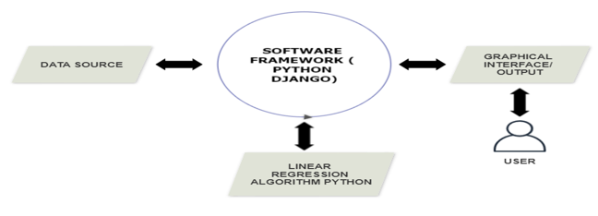

Poster:

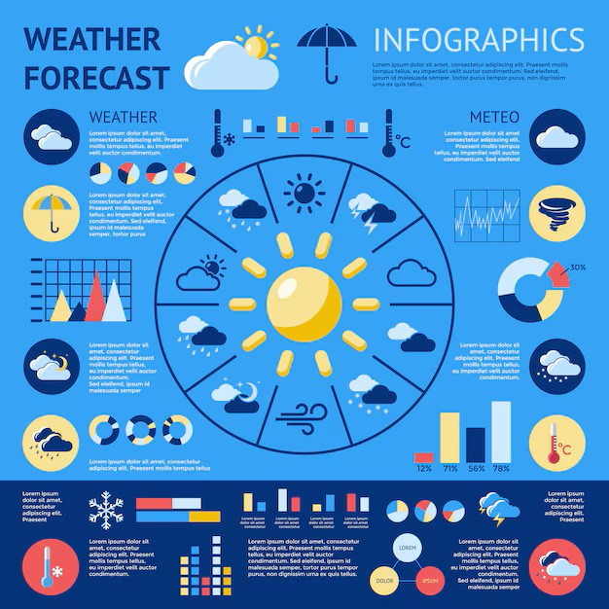

Members:

1.u.Chandrahas-2320030041

2.yashwant-2320030388

3.Chaitanya-2320030396