EMPLOYEE MANAGEMENT SYSTEM
Process Documentation
Program: DAY6.practice16 (Java, console-based)
Purpose: A menu-driven console app that stores employees in memory (ArrayList) and lets the user create records, display them, raise a chosen employee's salary, and exit.
Data model: Employee { name, age, designation, salary } — held in a static ArrayList<Employee> called 'employees', shared by all menu options for the life of the program run.

MAIN MENU LOOP

# | Prompt / Action | Validation Rule | Result
1 | 1. Create | Calls create() — adds one or more new employee records.
2 | 2. Display | Calls display() — lists every employee currently stored.
3 | 3. Raise Salary | Calls raiseSalary() — increases salary for ONE named employee.
4 | 4. Exit | Calls exit() — asks for yes/no confirmation before quitting. | Loop repeats via do-while until exitProgram = true

Each of the next 4 sections walks through one menu option step-by-step, in the exact order the code executes: the prompts shown to the user, the validation rules enforced, and what happens on success or failure.

Section 1 — Create Employee
Adds one or more new Employee records to the in-memory list. Runs inside a do-while loop so multiple employees can be added in one visit to this menu option.
STEP-BY-STEP FLOW

# | Prompt / Action | Validation Rule | Result
1 | User selects Menu Option 1 (Create) | Input must parse as an integer | create() method is called
2 | Prompt: "Enter name:" | Name may contain at most 2 spaces (checked by countSpaces()) | Re-prompts until a valid name is entered
3 | Prompt: "Enter age (18-60):" | Value must parse as an integer and fall between 18 and 60 inclusive | Re-prompts until a valid age is entered
4 | Prompt: "Enter designation (p/t/m):" | Input is lower-cased and must be exactly 'p', 't', or 'm' | Re-prompts on any other input
5 | Designation & base salary are assigned | m -> Manager $50,000 | p -> Programmer $35,000 | t -> Tester $25,000 | Salary is fixed by role, not user-entered
6 | New Employee(name, age, designation, salary) is built | — | Record appended to the shared 'employees' ArrayList
7 | Confirmation printed | — | "<name> added with base salary <salary>"
8 | Prompt: "Add another person? (yes/no)" | Loop continues only while reply equals 'yes' (case-insensitive) | do-while repeats entry flow, or returns to main menu

VALIDATION & LOGIC NOTES

- Every input field re-prompts on invalid data instead of crashing — each has its own inner while(true) loop that breaks only on success.
- Salary is never typed by the user for Create — it is derived entirely from the designation letter, so all Programmers start at the same base pay, etc.
- The name check only limits spaces (max 2), it does not block numbers or symbols in the name.

Section 2 — Display Employees
Read-only operation. Prints every employee currently held in the 'employees' ArrayList, in the order they were created.
STEP-BY-STEP FLOW

# | Prompt / Action | Validation Rule | Result
1 | User selects Menu Option 2 (Display) | Input must parse as an integer | display() method is called
2 | Check if the employees list is empty | employees.isEmpty() | If true, prints "No employees created yet." and returns immediately
3 | Print header "----- EMPLOYEE LIST -----" | — | Only reached if at least one employee exists
4 | Loop through employees with an index i | for (i = 0; i < employees.size(); i++) | Each record is read but not modified
5 | Print one line per employee | Format: <#>. Name: .. | Age: .. | Designation: .. | Salary: .. | List position (i+1) is shown as a 1-based number

VALIDATION & LOGIC NOTES

- No user input is requested in this option beyond the initial menu choice — it is purely a report of existing data.
- Records are shown in insertion order (list index), not sorted by name, age, or salary.
- Salary is printed with Java's default double formatting, which is why it appears as e.g. 35000.0 rather than 35,000.00.

Section 3 — Raise Salary
Finds one existing employee by name and increases their salary by a user-chosen percentage (1%-10%). Only ever affects a single, named record.
STEP-BY-STEP FLOW

# | Prompt / Action | Validation Rule | Result
1 | User selects Menu Option 3 (Raise Salary) | Input must parse as an integer | raiseSalary() method is called
2 | Check if the employees list is empty | employees.isEmpty() | If true, prints "No employees created yet." and returns immediately
3 | Prompt: "Enter name of employee to raise salary:" | Compared case-insensitively (equalsIgnoreCase) against stored names | First matching Employee object stored in 'found'
4 | If no match is found | found == null | Prints "Employee not found." and returns — no further prompt
5 | Prompt: "Enter raise percentage (1-10):" | Value must parse as a double and fall between 1 and 10 inclusive | Re-prompts until a valid percentage is entered
6 | New salary is calculated | salary = salary + (salary * percent / 100) | Applied directly to the matched Employee object (updates the list in place)
7 | Confirmation printed | — | "New salary of <name> is <new salary>"

VALIDATION & LOGIC NOTES

- The name lookup stops at the first match (break on match), so if two employees share a name, only the first one added is raised.
- The percentage validation loop is separate from the name lookup — a wrong name exits the method entirely before percentage is ever asked.
- Because 'found' is a reference to the live object in the ArrayList, updating found.salary changes the record permanently for the rest of the run.

Section 4 — Exit
Confirms before quitting so the user cannot leave the program by accident. Controls the boolean flag that governs the main menu's do-while loop.
STEP-BY-STEP FLOW

# | Prompt / Action | Validation Rule | Result
1 | User selects Menu Option 4 (Exit) | Input must parse as an integer | exit() method is called
2 | Prompt: "Are you sure you want to exit? (yes/no):" | Compared case-insensitively against 'yes' | Branches on the reply
3 | If reply is 'yes' | confirm.equalsIgnoreCase("yes") | Prints "Exiting program. Goodbye!" and sets exitProgram = true
4 | If reply is anything else | — | Prints "Okay, returning to menu." and exitProgram stays false
5 | Main menu do-while re-checks its condition | while (!exitProgram) | Loop ends only after a confirmed 'yes'; otherwise the menu reprints

VALIDATION & LOGIC NOTES

- exitProgram is a static boolean checked by the outer do-while in main() — this method only ever sets it, it never loops itself.
- Any answer other than exactly 'yes' (any case) is treated as 'no' — there is no re-prompt or invalid-input handling here.
- All data in 'employees' is lost on exit since it is only ever held in memory (no file or database persistence).

Sample Console Runs
Capture 1: Option 1 (Create) adds Yashwanth as a Programmer, then option 2 (Display) lists the employee.

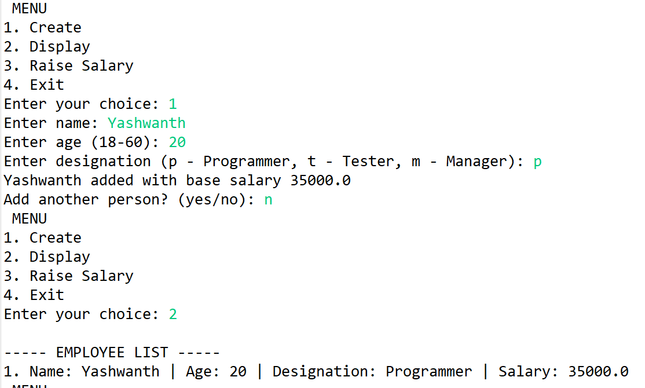
Capture 2 : Option 3 (Raise Salary) raises Yashwanth's salary by 10%, then option 4 (Exit) is confirmed with 'y'.

