
Department of AI&ML II YEAR-II SEMESTER
Subject: Operating Systems Using C++ Subject code: MR23-1CS0224

Holidays Assignment (2311cs020259)
- Conditional statements (Hacker rank) Task
Read numbers from stdin and print their sum to stdout.

Input Format

One line that contains space 3-separated integers :a ,b , and c .

Constraints


1<=a,b,c<=1000

Output Format

Print the sum of the three numbers on a single line.

Sample Input

1 2 7

Sample Output

10
Ans.
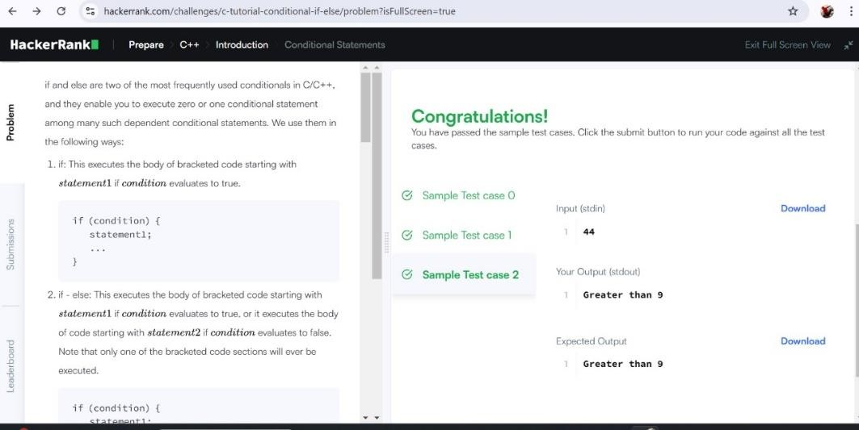

Functions (Hacker rank) Input Format
Input will contain four integers – a, b ,c, d.one per line.

Output Format
Return the greatest of the four integers. PS: I/O will be automatically handled. Sample Input
3
4
6
5

Sample Output
6

Ans.

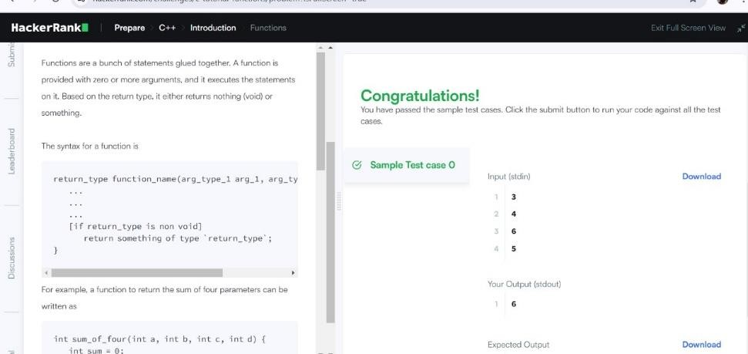

Pointer (Hacker rank) Input Format
Input will contain two integers a and b. separated by a newline.

Sample Input
4
5

Sample Output
9
1

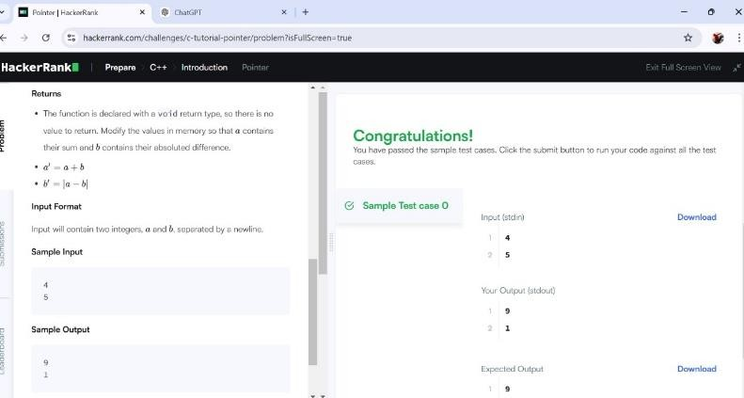
Ans.

- Structures (Hacker rank)
You have to create a struct, named Student, representing the student's details, as mentioned above, and store the data of a student.

Input Format
Input will consist of four lines.
The first line will contain an integer, representing age.

The second line will contain a string, consisting of lower-case Latin characters ('a'-'z'), representing the first_name of a student.
The third line will contain another string, consisting of lower-case Latin characters ('a'-'z'), representing the last_name of a student.
The fourth line will contain an integer, representing the standard of student. Note: The number of characters in first_name and last_name will not exceed 50. Output Format
Output will be of a single line, consisting of age, first_name, last_name and
standard, each separated by one white space. P.S.: I/O will be handled by HackerRank.

Sample Input
15 john carmac k
10

Sample Output
15 john carmack 10 Ans.

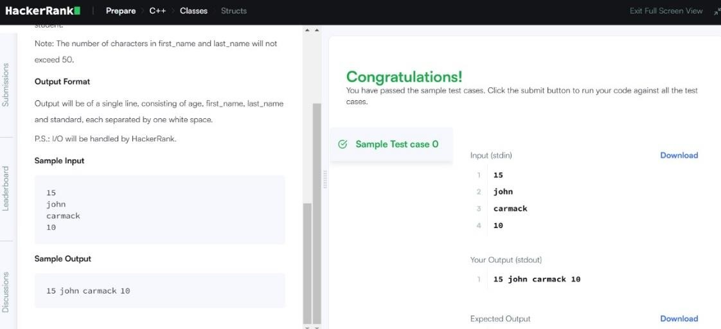

Strings (Hacker rank) Input Format
You are given two strings a and b separated by a new line. Each string will consist of lower case Latin characters ('a'-'z').

Output Format
In the first line print two space-separated integers, representing the length of a and b respectively.
In the second line print the string produced by concatenating a and b (a+b). In the third line print two strings separated by a space a’ and b’ and a’ and b’ are the same as a and b , respectively, except that their first characters are swapped. Sample Input
abcd ef

Sample Output
4 2 abcdef ebcd af Ans.

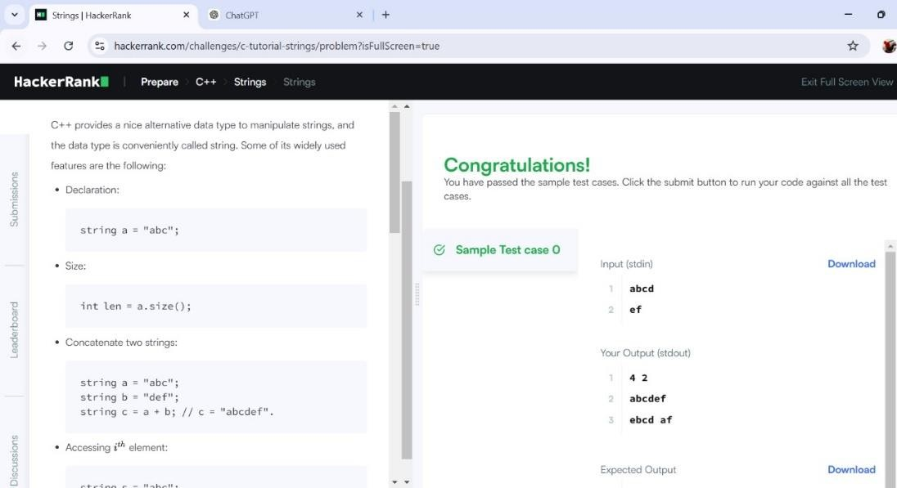

Recursion Problem (Hacker rank) Task
Write a recursive function to calculate a^b (a raised to the power of b).
Input Format
  - Two integers a and b (0 ≤ a ≤ 100, 0 ≤ b ≤ 10). Constraints
    - 0 ≤ a ≤ 100
    - 0 ≤ b ≤ 10 Output Format
Print the result of a^b. Sample Input
2 3

Sample Output 8
Ans.

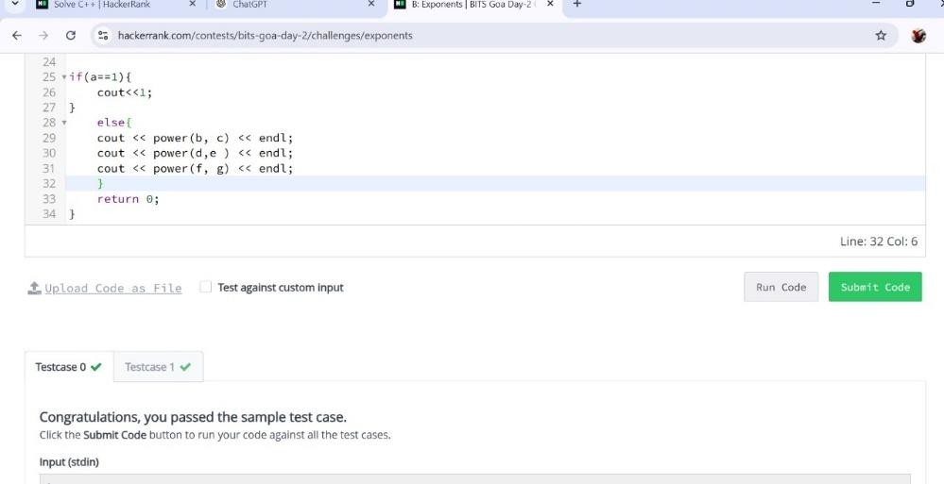

Exception Handling (Hacker rank)
Problem Statement
Write a program that takes two integers a and b and calculates their division (a / b). If the divisor b is zero, the program should throw and handle an exception to avoid crashing.
Input Format
  - Two space-separated integers a and b. Constraints
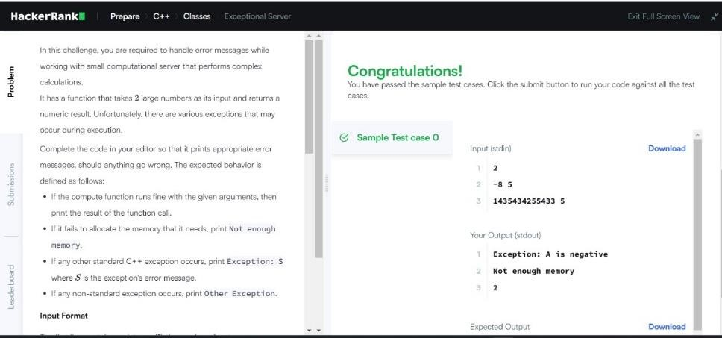
 -10^9 ≤ a, b ≤ 10^9 Ans.

For loop

Input Format

You will be given two positive integers, a and b (a<=b), separated by a newline.

Output Format

For each integer in the inclusive interval[a ,b] :
- If 1<=n<=9 , then print the English representation of it in lowercase. That is "one" for 1 , "two" for 2, and so on.
- Else if n>9 and it is an even number, then print "even".
- Else if n>9 and it is an odd number, then print "odd".

Sample Input

8
11

Sample Output

eight nine even odd
Ans.
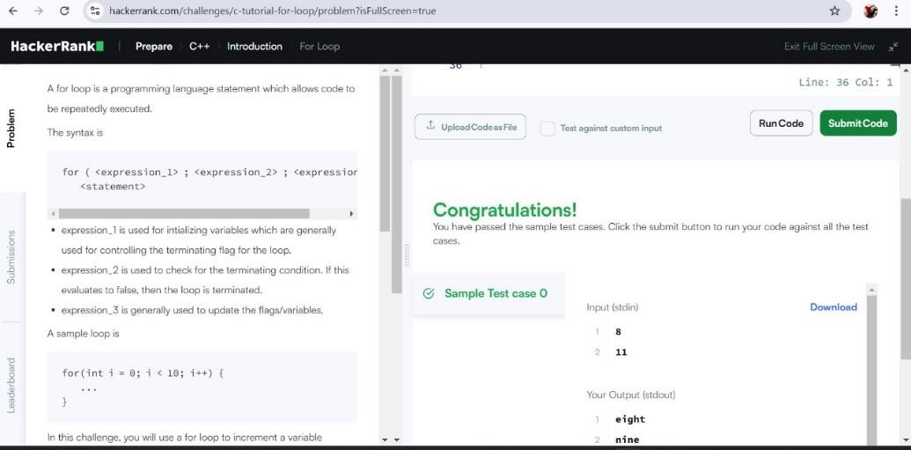

Arrays (Leetcode)

There are a total of numCourses courses you have to take, labeled from 0 to numCourses - 1. You are given an array prerequisites where prerequisites[i] = [ai, bi] indicates that you must take course bi first if you want to take course ai.

Input format:
For example, the pair [0, 1], indicates that to take course 0 you have to first take course 1.
Return true if you can finish all courses. Otherwise, return false.

Output Format
There are a total of 2 courses to take.
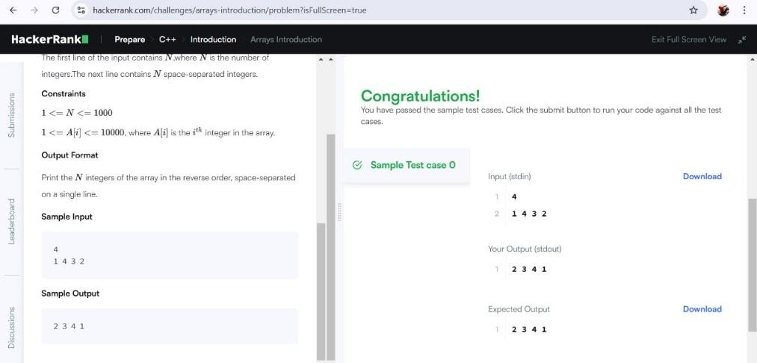
To take course 1 you should have finished course 0. So it is possible. Ans.

- Case study: Implement First come first serve and Shortest job first CPU scheduling algorithms using c++.
Ans.
- First Come First Serve (FCFS) Scheduling
FCFS is the simplest CPU scheduling algorithm where the process that arrives first gets executed first.

#include <iostream> #include <vector> #include <algorithm>

using namespace std;

struct Process { int id;
int arrivalTime; int burstTime;
int completionTime; int waitingTime;
int turnaroundTime;
};

void findWaitingTime(vector<Process>& processes) { processes[0].waitingTime = 0;
for (int i = 1; i < processes.size(); i++) {
processes[i].waitingTime = processes[i - 1].completionTime - processes[i].arrivalTime;
}
}

void findTurnaroundTime(vector<Process>& processes) { for (int i = 0; i < processes.size(); i++) {
processes[i].turnaroundTime = processes[i].burstTime + processes[i].waitingTime;
}

}

void findCompletionTime(vector<Process>& processes) { processes[0].completionTime = processes[0].arrivalTime +
processes[0].burstTime;
for (int i = 1; i < processes.size(); i++) { processes[i].completionTime = max(processes[i].arrivalTime,
processes[i - 1].completionTime) + processes[i].burstTime;
}
}

void FCFS(vector<Process>& processes) { findCompletionTime(processes); findWaitingTime(processes); findTurnaroundTime(processes);

cout << "Process ID\tArrival Time\tBurst Time\tCompletion Time\tWaiting Time\tTurnaround Time" << endl;
for (auto& process : processes) {
cout << process.id << "\t\t" << process.arrivalTime << "\t\t" << process.burstTime << "\t\t"
<< process.completionTime << "\t\t" << process.waitingTime << "\t\t" << process.turnaroundTime << endl;
}
}

int main() {
vector<Process> processes = {{1, 0, 5}, {2, 1, 3}, {3, 2, 8}, {4, 3, 6}}; FCFS(processes);
return 0;
}

Explanation:
- Process Structure: Contains the process ID, arrival time, burst time, completion time, waiting time, and turnaround time.
- findWaitingTime(): Calculates the waiting time for each process.
- findTurnaroundTime(): Calculates the turnaround time for each process.
- findCompletionTime(): Calculates the completion time for each process based on FCFS logic.
- FCFS(): Main function that calls other functions and prints the results.

Shortest Job First (SJF) Scheduling
SJF is a non-preemptive CPU scheduling algorithm that selects the process with the shortest burst time for execution next.
#include <iostream> #include <vector> #include <algorithm>

using namespace std;

struct Process { int id;
int arrivalTime;

int burstTime;
int completionTime; int waitingTime;
int turnaroundTime;
};

bool compare(Process p1, Process p2) { return p1.burstTime < p2.burstTime;
}

void findWaitingTime(vector<Process>& processes) { processes[0].waitingTime = 0;
for (int i = 1; i < processes.size(); i++) {
processes[i].waitingTime = processes[i - 1].completionTime - processes[i].arrivalTime;
}
}

void findTurnaroundTime(vector<Process>& processes) { for (int i = 0; i < processes.size(); i++) {
processes[i].turnaroundTime = processes[i].burstTime + processes[i].waitingTime;
}
}

void findCompletionTime(vector<Process>& processes) {
processes[0].completionTime = processes[0].arrivalTime + processes[0].burstTime;
for (int i = 1; i < processes.size(); i++) { processes[i].completionTime = max(processes[i].arrivalTime,
processes[i - 1].completionTime) + processes[i].burstTime;
}
}

void SJF(vector<Process>& processes) {
sort(processes.begin(), processes.end(), compare); // Sort processes by burst time (Shortest Job First)

findCompletionTime(processes); findWaitingTime(processes); findTurnaroundTime(processes);

cout << "Process ID\tArrival Time\tBurst Time\tCompletion Time\tWaiting Time\tTurnaround Time" << endl;
for (auto& process : processes) {
cout << process.id << "\t\t" << process.arrivalTime << "\t\t" << process.burstTime << "\t\t"
<< process.completionTime << "\t\t" << process.waitingTime << "\t\t" << process.turnaroundTime << endl;
}
}

int main() {
vector<Process> processes = {{1, 0, 6}, {2, 1, 8}, {3, 2, 7}, {4, 3, 3}}; SJF(processes);
return 0;
}

Explanation:
- compare(): Function to sort processes by burst time (for SJF).

findWaitingTime(), findTurnaroundTime(), findCompletionTime():
Functions similar to FCFS, calculating the corresponding times.
- SJF(): Main function for SJF scheduling that sorts processes and then calculates the times.
Output Example:
For FCFS:
Process ID Arrival Time Burst Time Completion Time Waiting Time Turnaround Time

1 | 0 | 5 | 5 | 0 | 5
2 | 1 | 3 | 8 | 4 | 7
3 | 2 | 8 | 16 | 6 | 14
4 | 3 | 6 | 22 | 13 | 19
For SJF:
Process ID Arrival Time Burst Time Completion Time Waiting Time Turnaround Time

4 | 3 | 3 | 6 | 0 | 3
1 | 0 | 6 | 12 | 3 | 9
3 | 2 | 7 | 19 | 10 | 17
2 | 1 | 8 | 27 | 18 | 2

