Guidelines for CCL Timed Labs
Cognizant Cloud Lab (CCL) — Usage Policy & Access Instructions

Overview
The Cognizant Cloud Lab (CCL) is an in-house platform that provides learners with temporary, controlled access to cloud environments on AWS, Azure, and GCP for hands-on training and practice. Each lab session is time-bound to 2.5 hours and governed by strict security policies to ensure responsible and compliant usage.

Quick Reference
Lab Duration | 2.5 hours per session
AWS Region | Ohio (us-east-2)
Azure Region | US Central
Credential Delivery | Within 5–10 minutes via academy CCL mailbox
CCL Catalogue | cognizantonline.sharepoint.com (see link in Step 1)

Step-by-Step: Accessing Your CCL Lab

Step 1 — Find Your Lab Code
Access the CCL Catalogue using the link below to find the Lab Code for your course:
CCL Catalogue: https://cognizantonline.sharepoint.com/sites/Academy-cms/LS/MLCV-2026-6630/MLCV-2026-6630-CCL.xlsx
📌 Note: Copy and paste the link into your browser to open the catalogue. The catalogue lists all use cases and their corresponding Lab Codes (e.g., CTHCC350413).

Step 2 — Register on Learn & Receive Credentials
- Search for your Lab Code on Learn and register for the activity.
- You will receive an email from the academy CCL mailbox with your login credentials within 5 to 10 minutes.
- If you have previously registered for the same activity, click 'Cancel Registration' first, then re-register to generate new credentials.

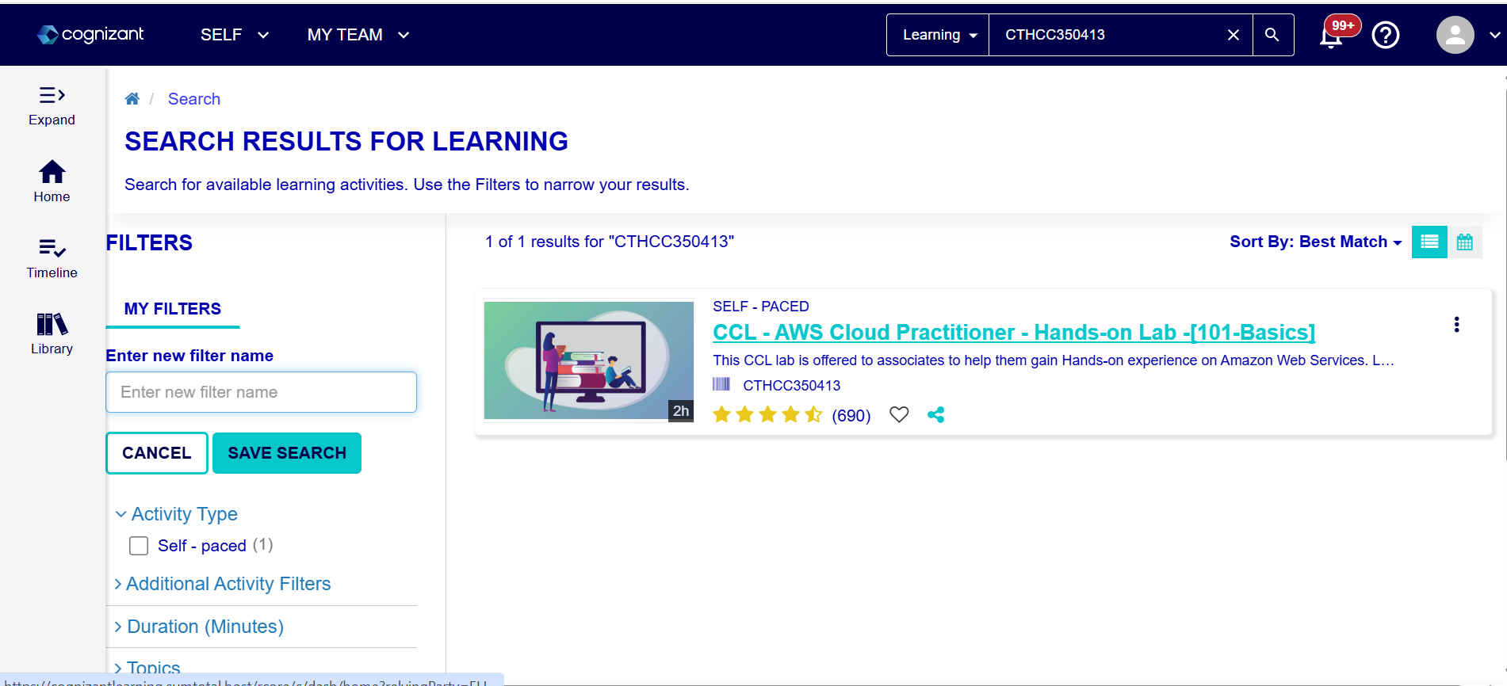
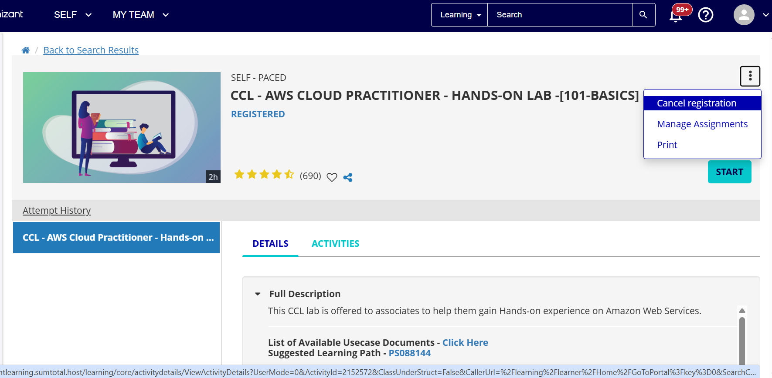
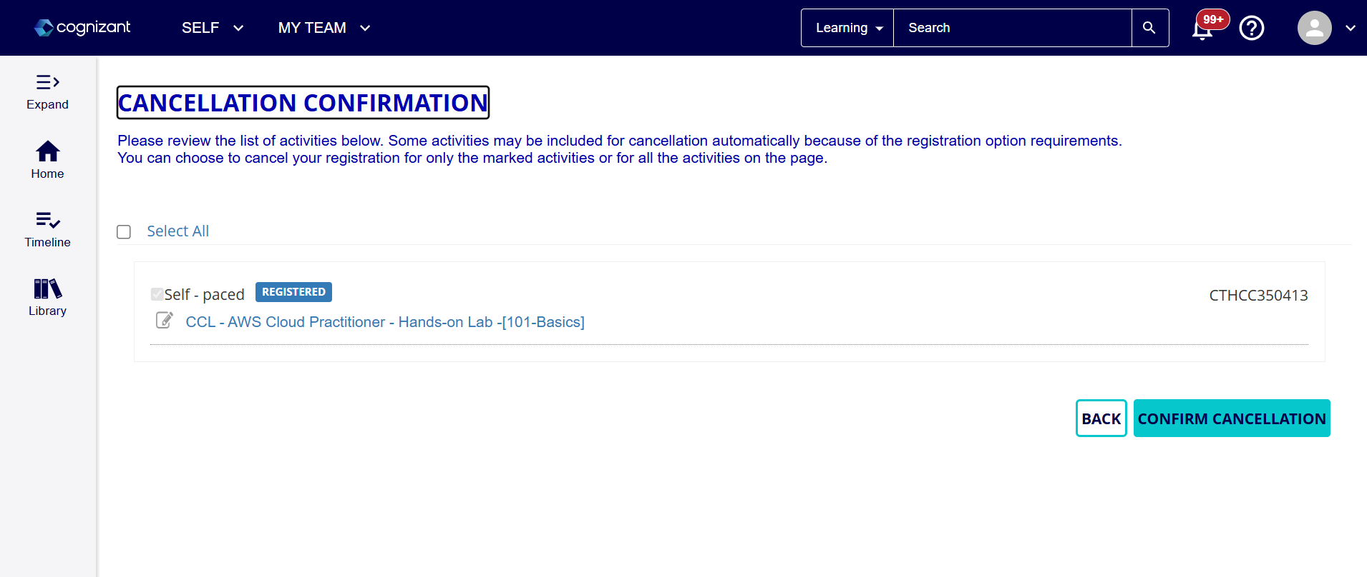
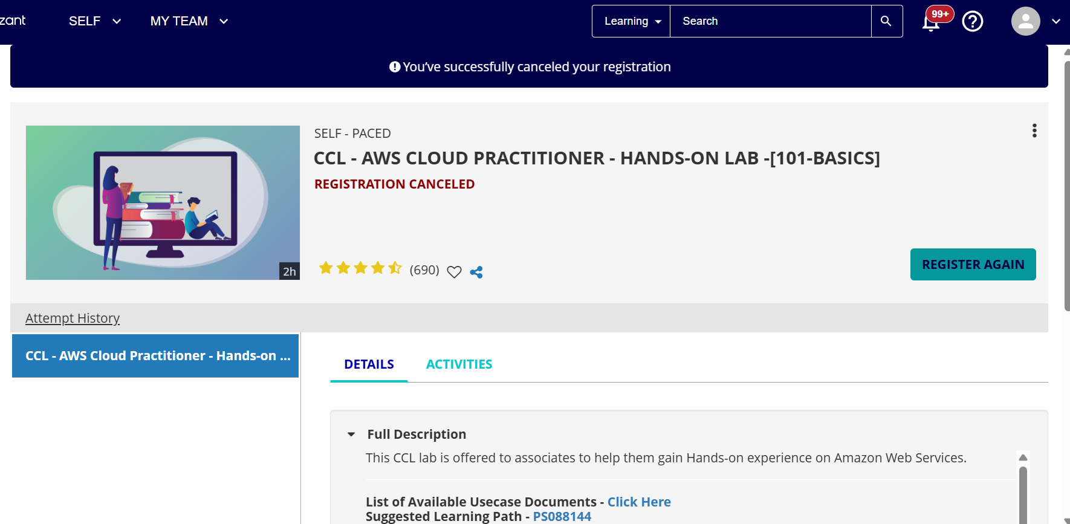
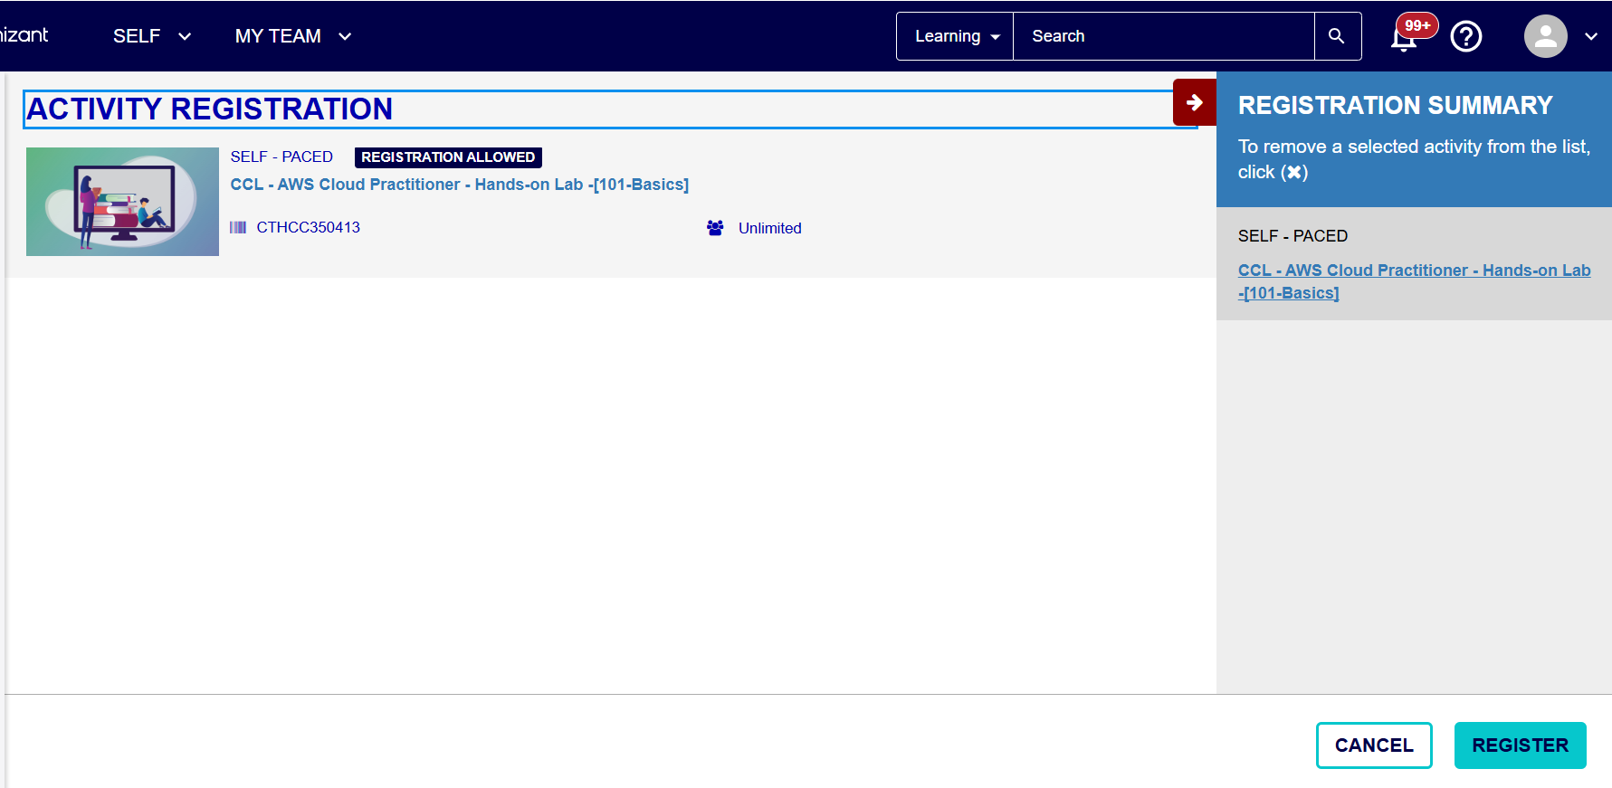

Once registration is complete, click Register. Your credentials will be emailed within 5–10 minutes.

Step 3 — Download Use Case Files
Click the Start button on Learn to download the use case document for your respective course code. Follow the steps below to access pinned attachments within the PDF:
- Open a new tab in the Microsoft Edge browser.
- Click the three-dot menu (⋯) on the top right and select Extensions.
- Click Manage Extensions and search for 'PDF reader'.
- Select 'PDF Reader and Editor' from the results and click Get to install it.
- Once installed, open the use case document in the PDF reader extension and double-click the pinned attachment to download it.
📌 Note: It is strongly recommended to use Microsoft Edge or Internet Explorer on your organization-issued laptop to open lab files. Google Chrome is not supported. This also applies to Kpoint videos.

Usage Rules & Restrictions

Device & File Access
- You cannot access or download lab files from a personal laptop. Only organization-issued devices are permitted.
- Always use Microsoft Edge or Internet Explorer on your organization-issued laptop; do not use Google Chrome.

IAM & Roles
- IAM role and policy creation is restricted. You are not permitted to create new roles or policies.
- When attaching roles to resources, select an existing role with the prefix "CCL" (e.g., CCL-EC2-Role for EC2 instances).

Region Restrictions
- For AWS, all resources must be created in the Ohio (us-east-2) region only.
- For Azure, all resources must be created in the US Central region only.
- Attempting to create resources in other regions will result in an error — this is enforced at the CCL Admin level.
- You will be logged in using your Employee ID.

Network / Security Group Rules
- When configuring inbound and outbound security group rules, always select 'My IP' as the source.
- Do not open ports to 0.0.0.0/0 (all traffic) — this is a security violation.

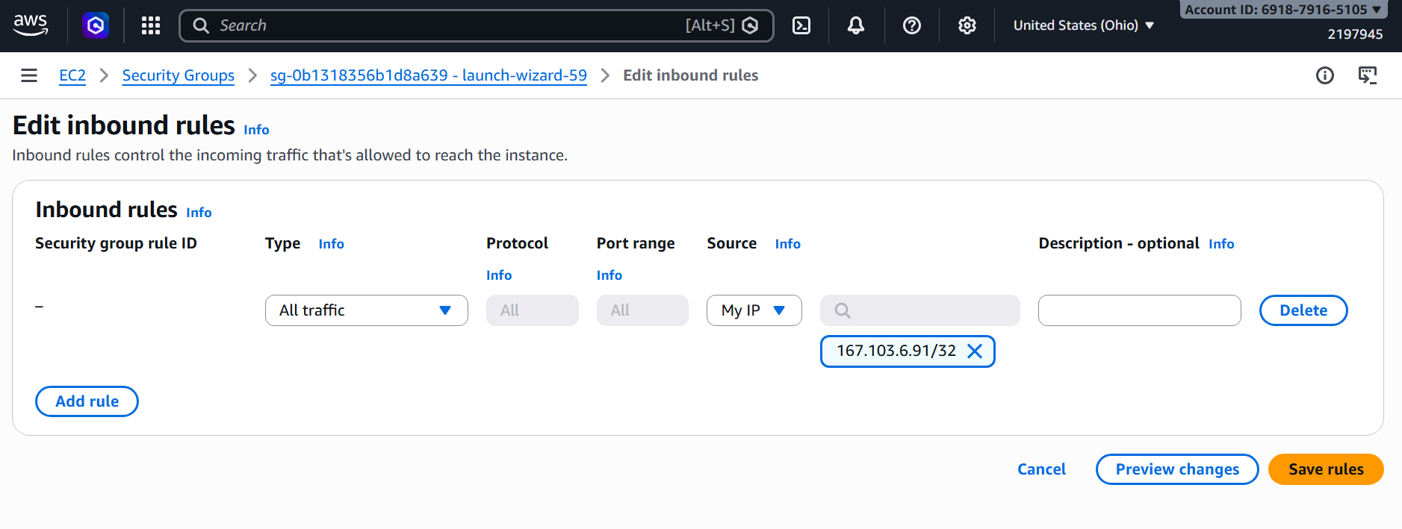

Instance & Resource Types
- Use only the instance/resource types recommended in the SOP for your use case.
- Recommended types include t2 for EC2 instances and db.t2.micro for RDS instances.
- Deviating from recommended types may cause your use case to fail or result in additional costs.

CloudFormation Tagging Requirements
All CloudFormation stacks must have the following two tags. Stack creation will fail if these tags are missing:
- CreatedBy: {your-aws-userid}
- GroupName: CCL-CF

⚠️ Important Reminders
The following behaviours have been flagged by Corporate Security and must be strictly avoided:
- Do not attempt to access cloud services or resources outside the scope of your assigned use case.
- Do not store personal data, proprietary code, or any non-lab content on cloud resources.
- Do not attempt to escalate privileges or bypass IAM restrictions.
- Do not share credentials received from the academy CCL mailbox with others.
- The lab session is automatically terminated after 2.5 hours. Save your work regularly.

Non-compliance may result in restricted access to CCL labs and escalation to the Corporate Security team.

