Activity: Create and Open a Windows EC2 Instance in AWS

Step 1: Login to AWS & Open EC2
- Login to the AWS Management Console
- Select the required region
- Open EC2 from the Services menu
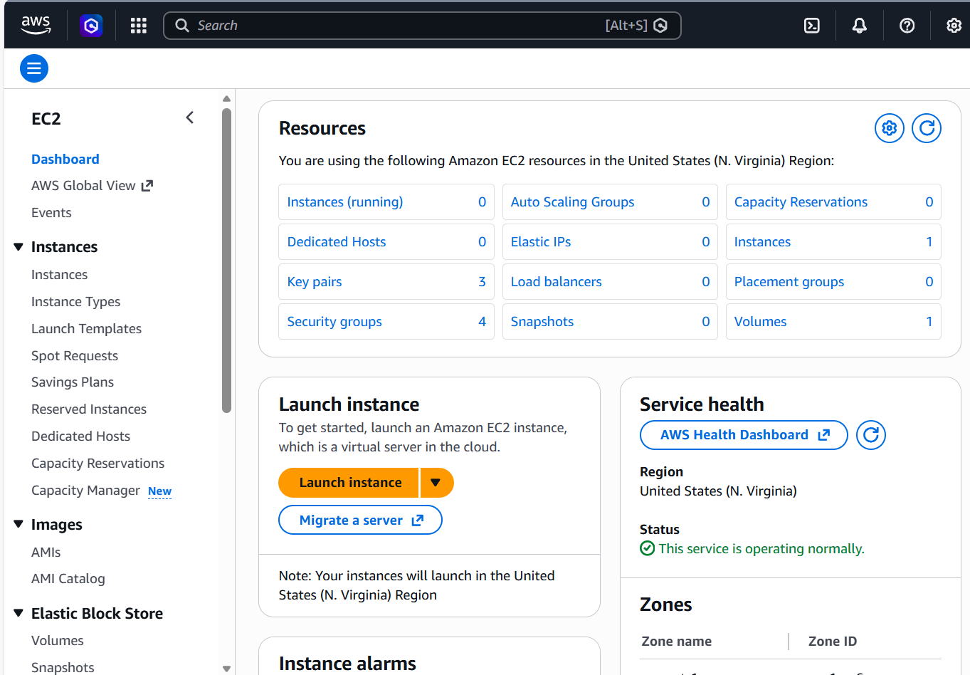
Step 2: Launch Instance & Select Windows AMI
- Click Launch Instance
- Select Windows Server (2019 / 2022 Base) AMI
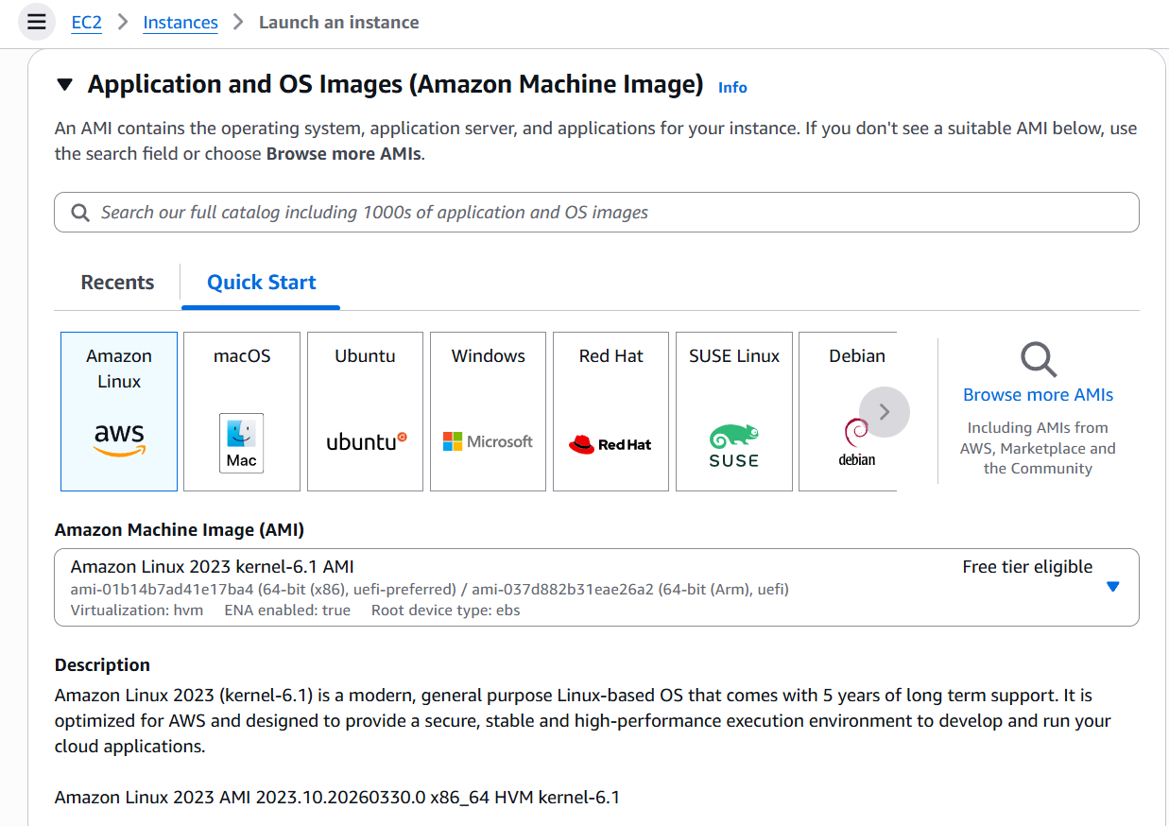
Step 3: Choose Instance Type
- Select t2.micro (Free Tier eligible)
- Keep remaining settings as default
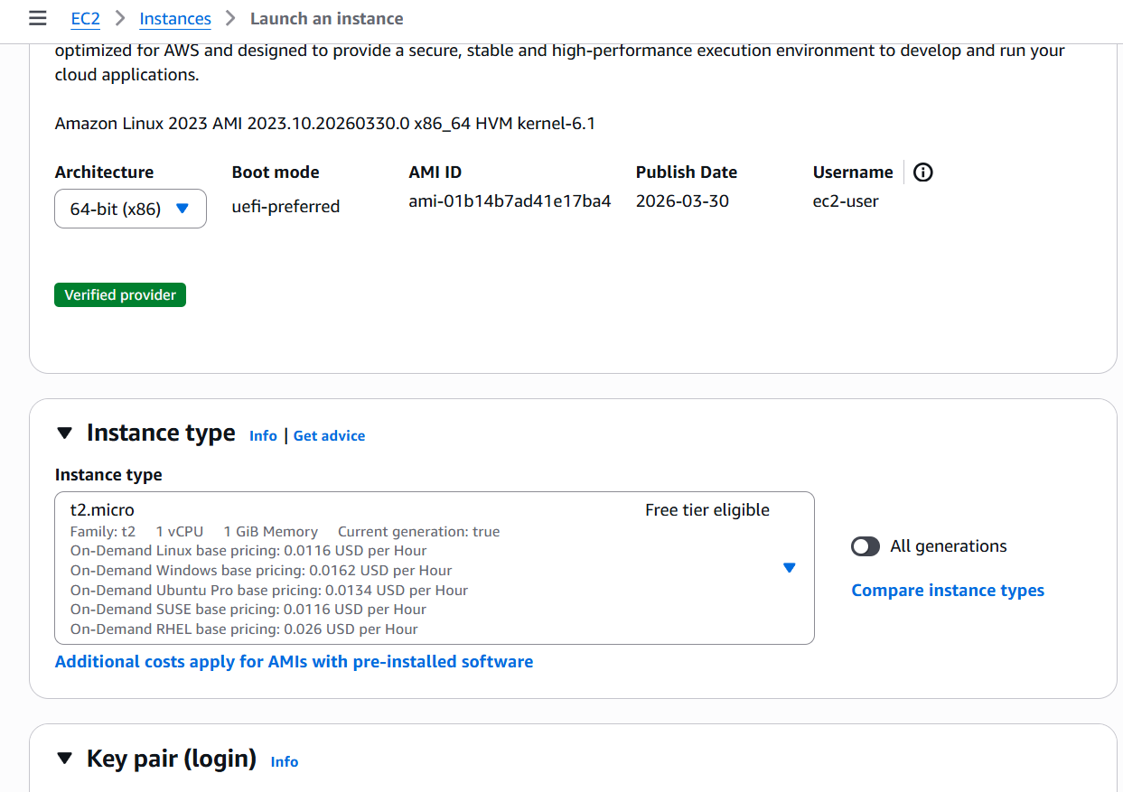
Step 4: Configure Security Group
- Create a new security group
- Allow RDP – Port 3389 – Source: My IP
📸 Screenshot 4: Security Group Rules

Step 5: Create/Select Key Pair & Launch
- Create or select a key pair
- Download the key file
- Click Launch Instance
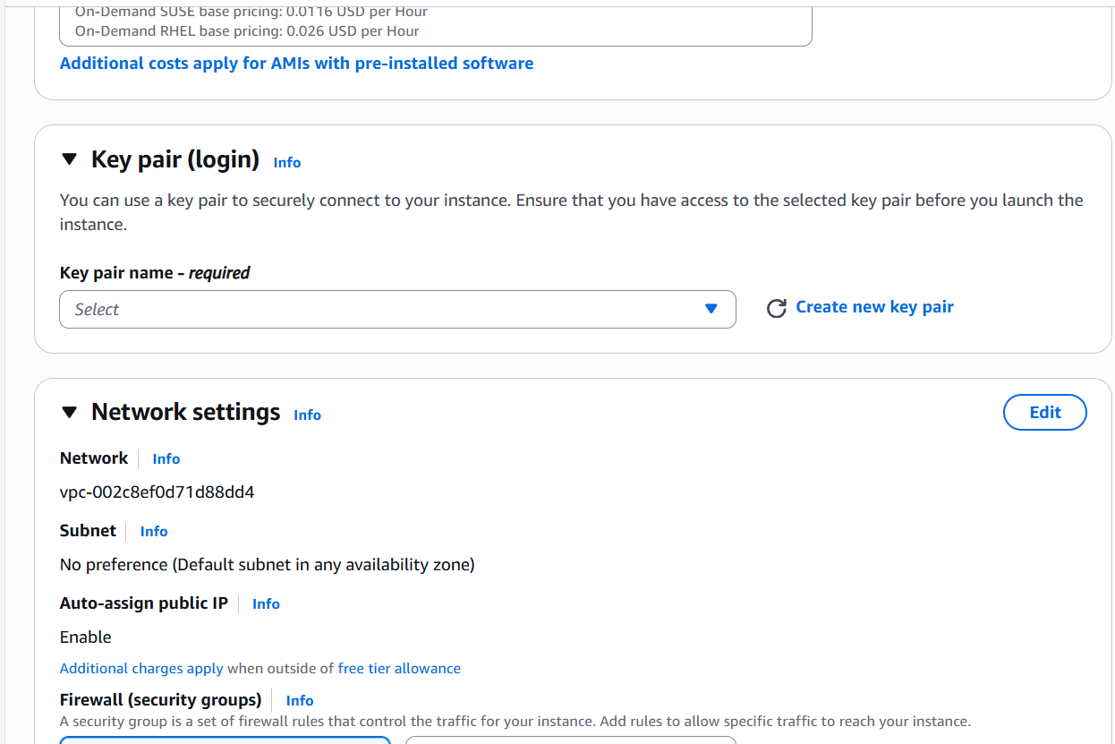
Step 6: Verify Instance Status
- Go to Instances
- Ensure instance state is Running
- Copy Public IPv4 address
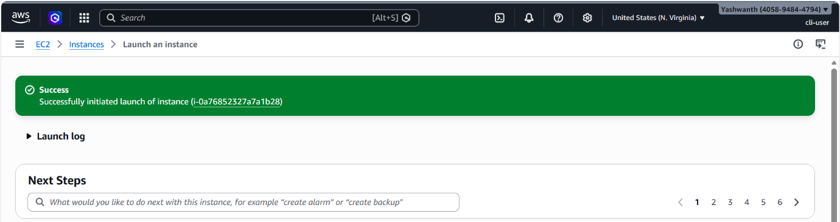

Step 7: Get Windows Password
- Select the instance → Connect
- Choose RDP Client
- Upload the key file and Decrypt password
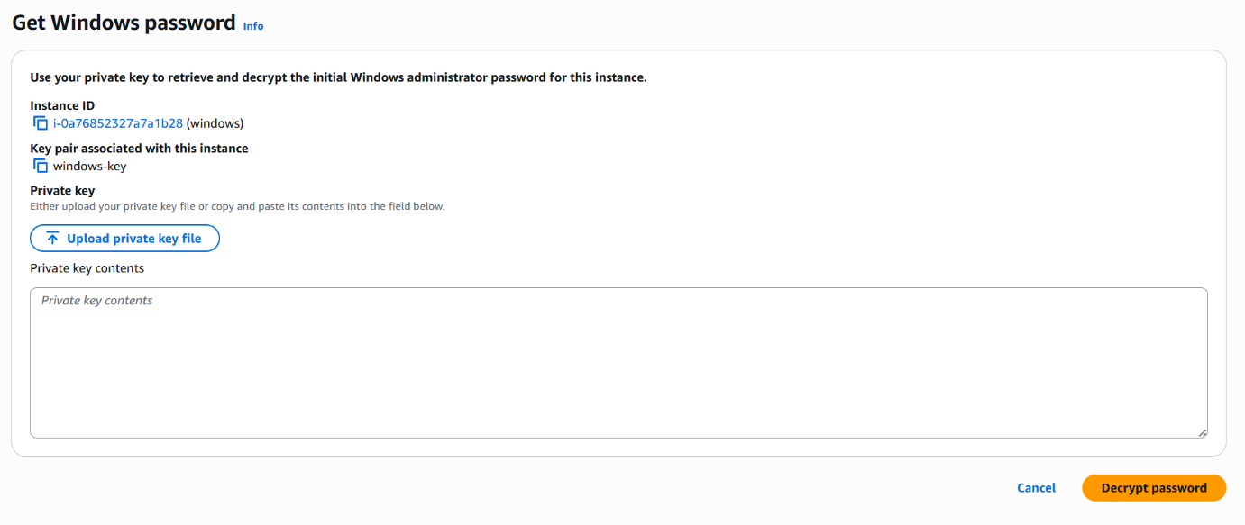
Step 8: Open Windows Using RDP
- Open Remote Desktop Connection
- Enter Public IP address
- Login using:
  - Username: Administrator
  - Password: Decrypted password
- Windows desktop will open
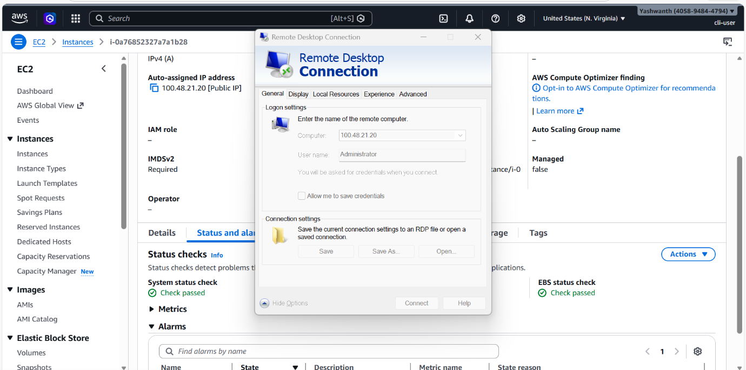
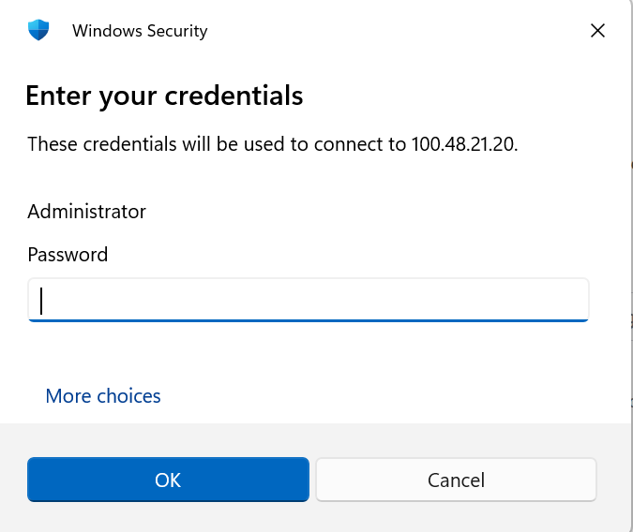
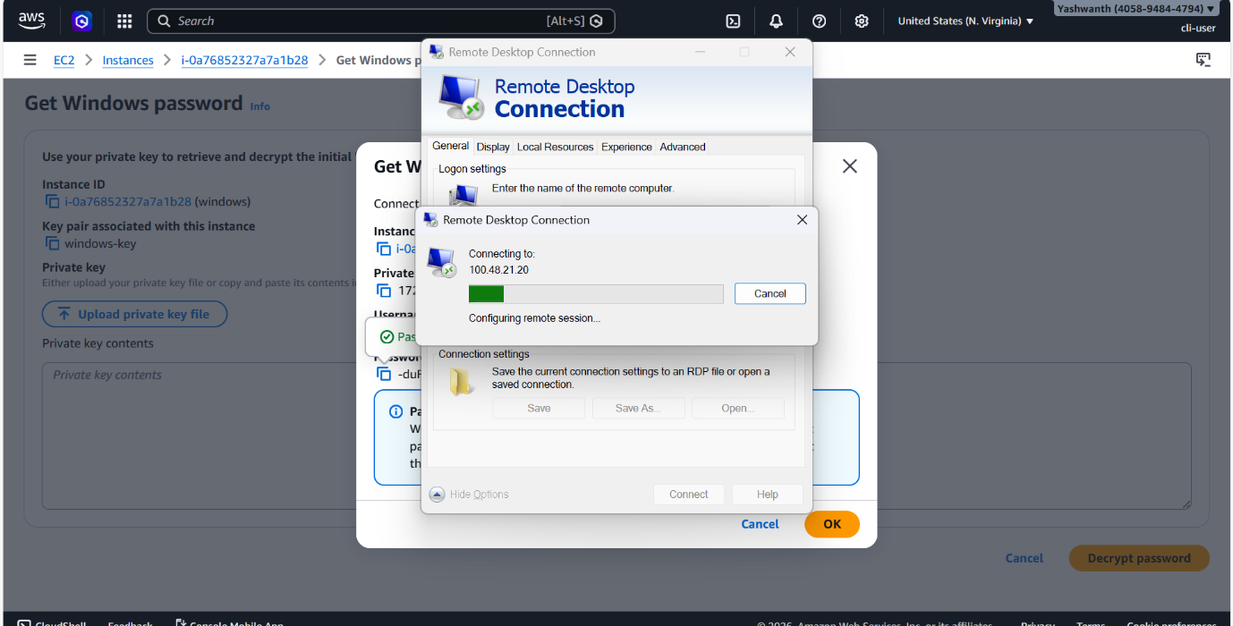
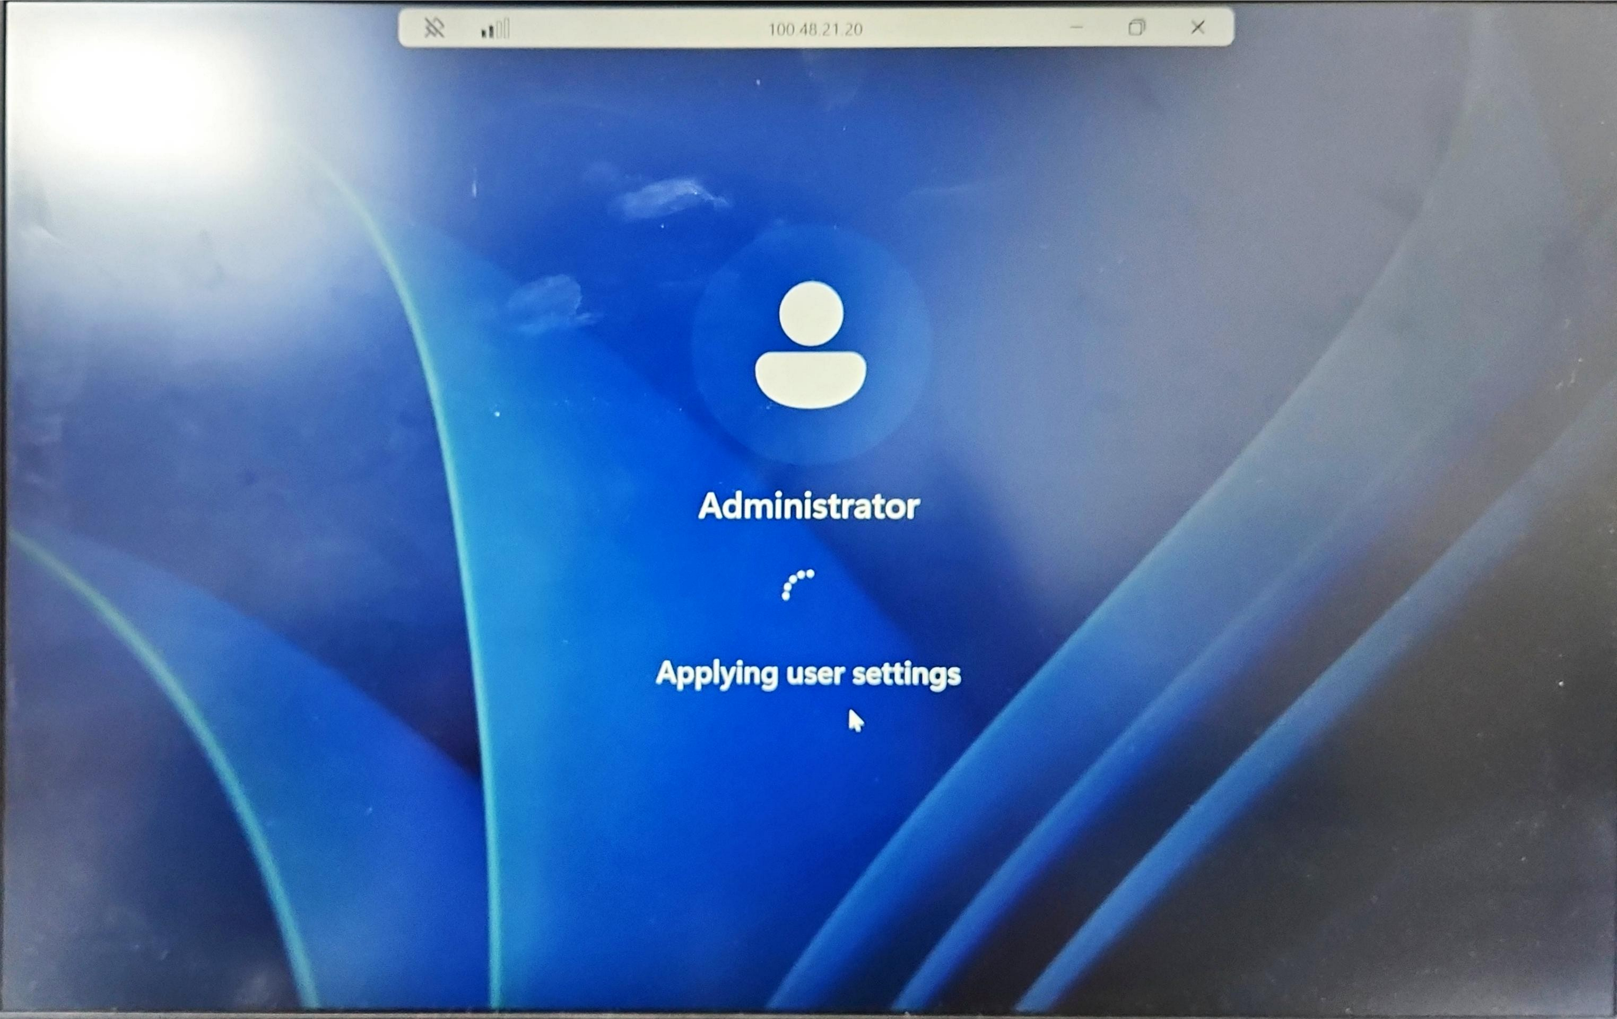
✅ Result: Windows EC2 instance successfully created and accessed.

