Step 1: Create and Attach EBS Volume
- Go to EC2 → Volumes → Create Volume
- Choose size and availability zone (same as EC2).
- Attach the volume to the EC2 instance.
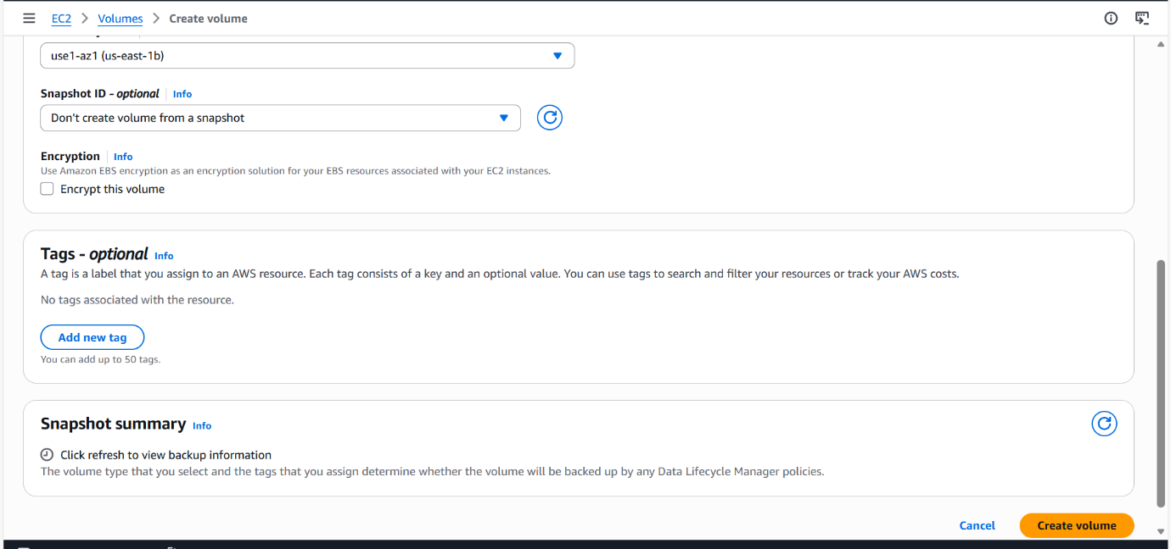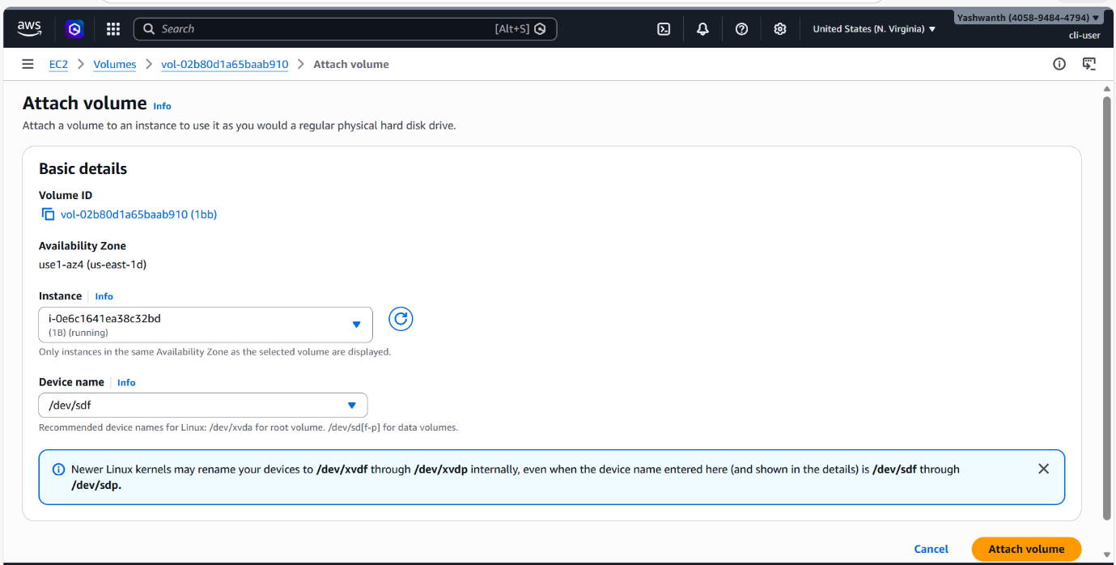

Step 2: Mount EBS Volume
Shell
lsblk
sudo mkfs -t ext4 /dev/xvdf
sudo mkdir /data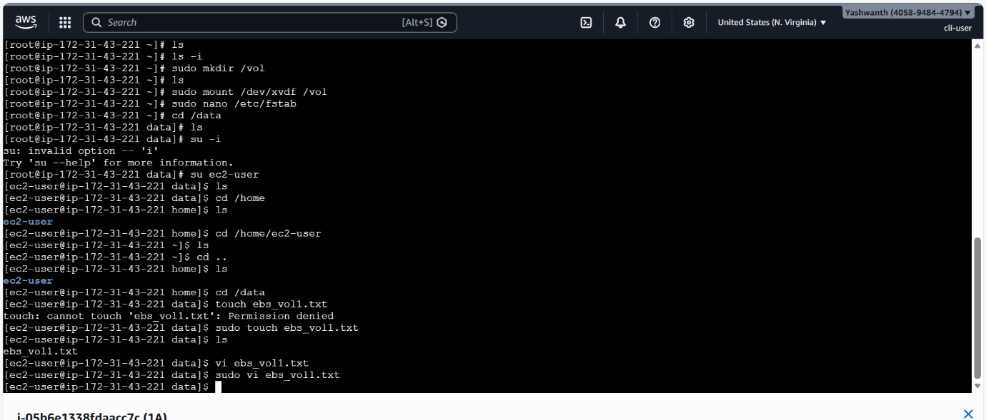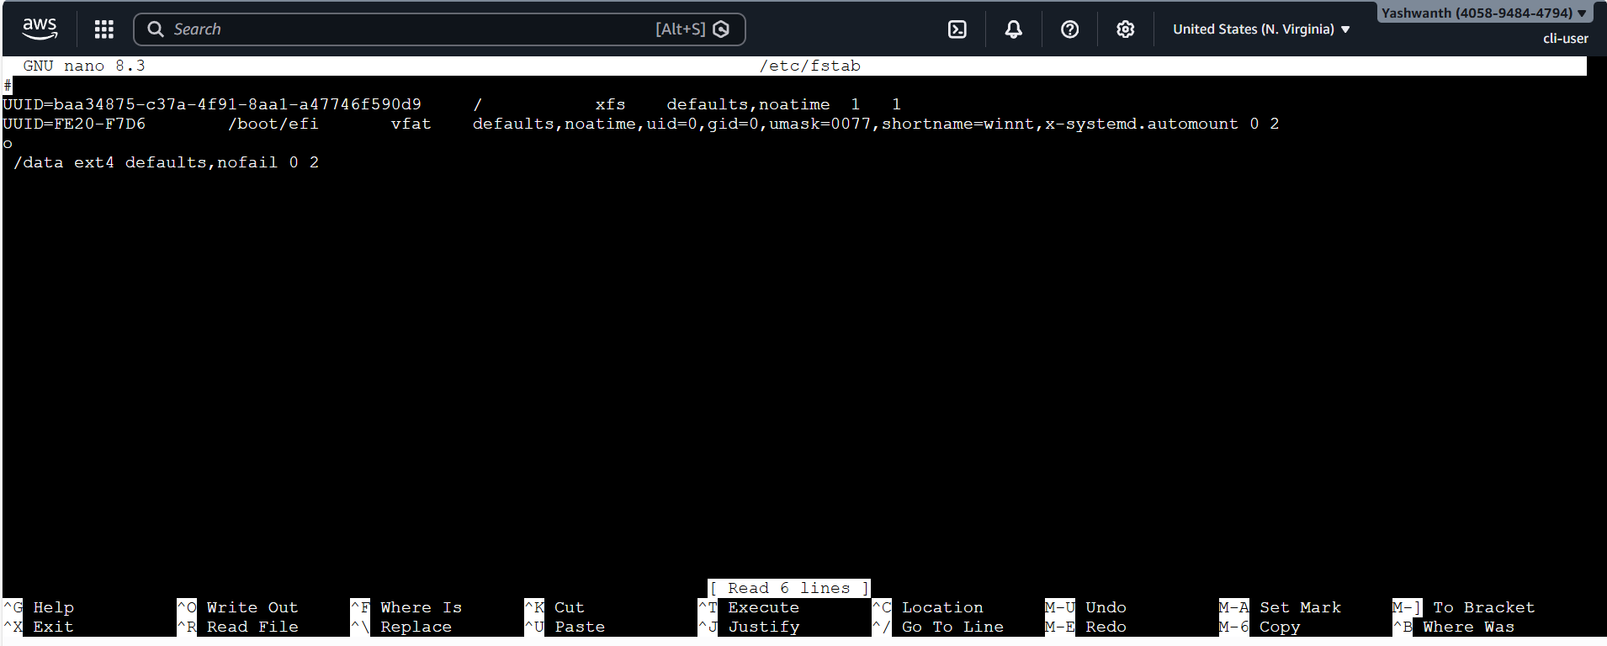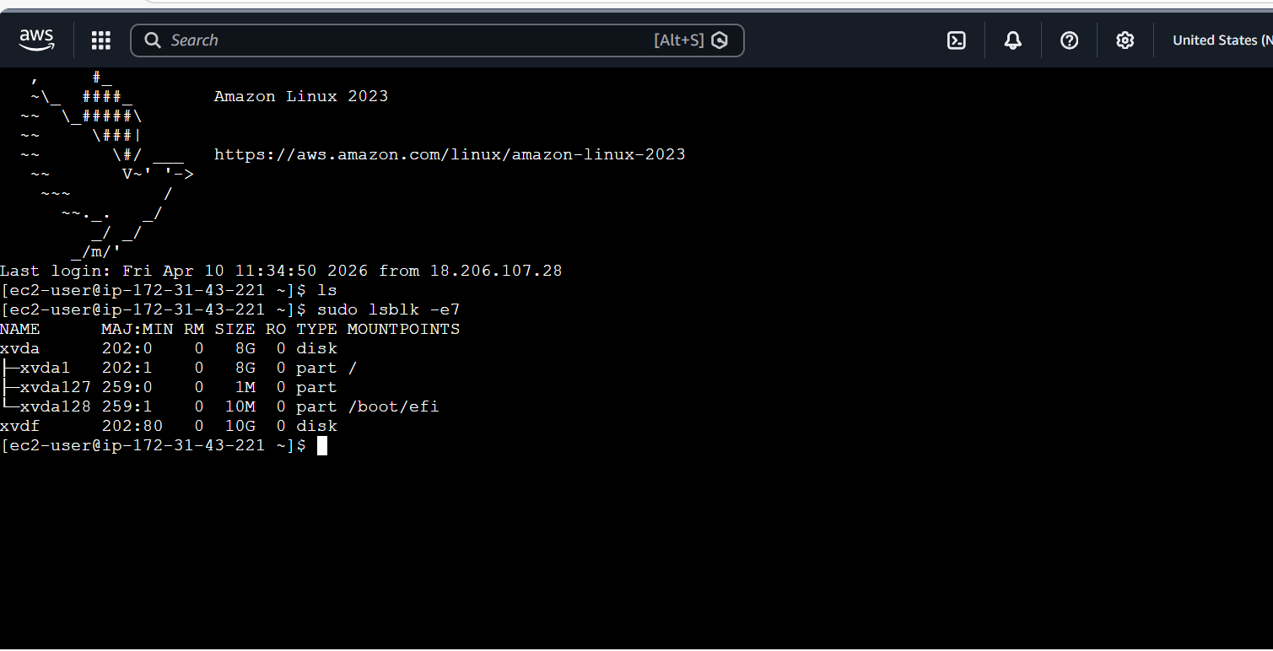
sudo mount /dev/xvdf /data
``

