📄 S3 Gateway Endpoint Setup – Short Flow
✅ Objective
Enable secure access from Private Subnet → S3 without using Internet/NAT.

🔷 Step-by-Step Process
Step 1: Create / Verify VPC Setup
- Create VPC
- Create Private Subnet
- Create Route Table and associate with private subnet
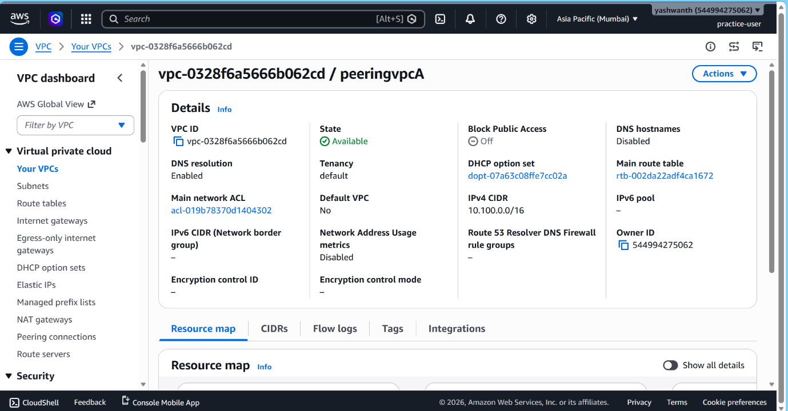
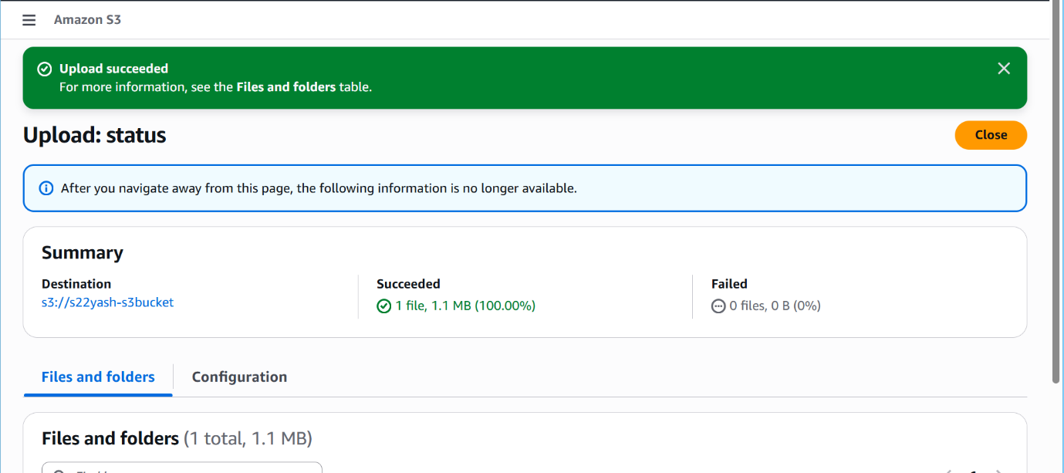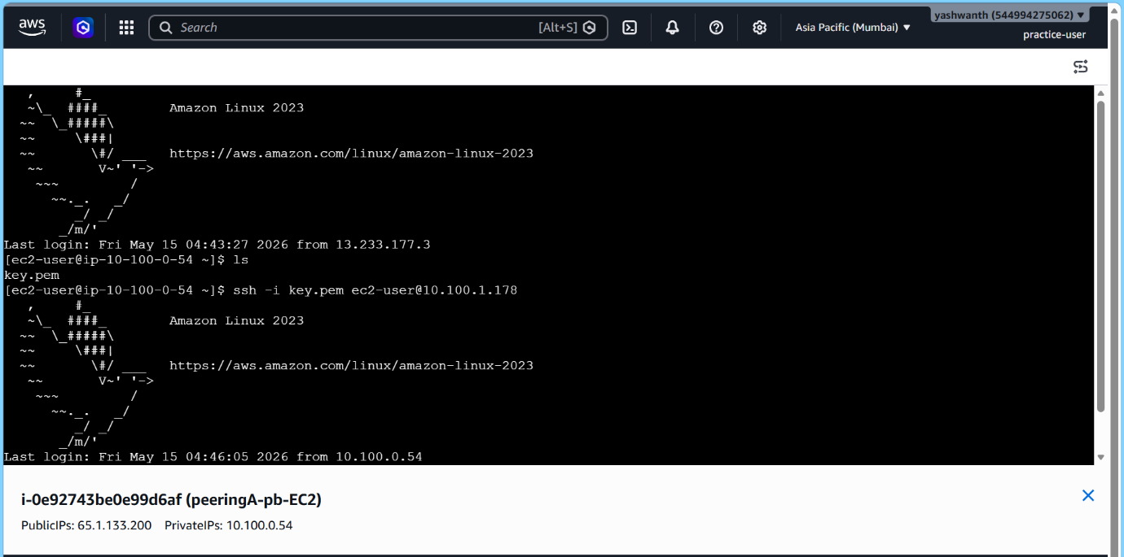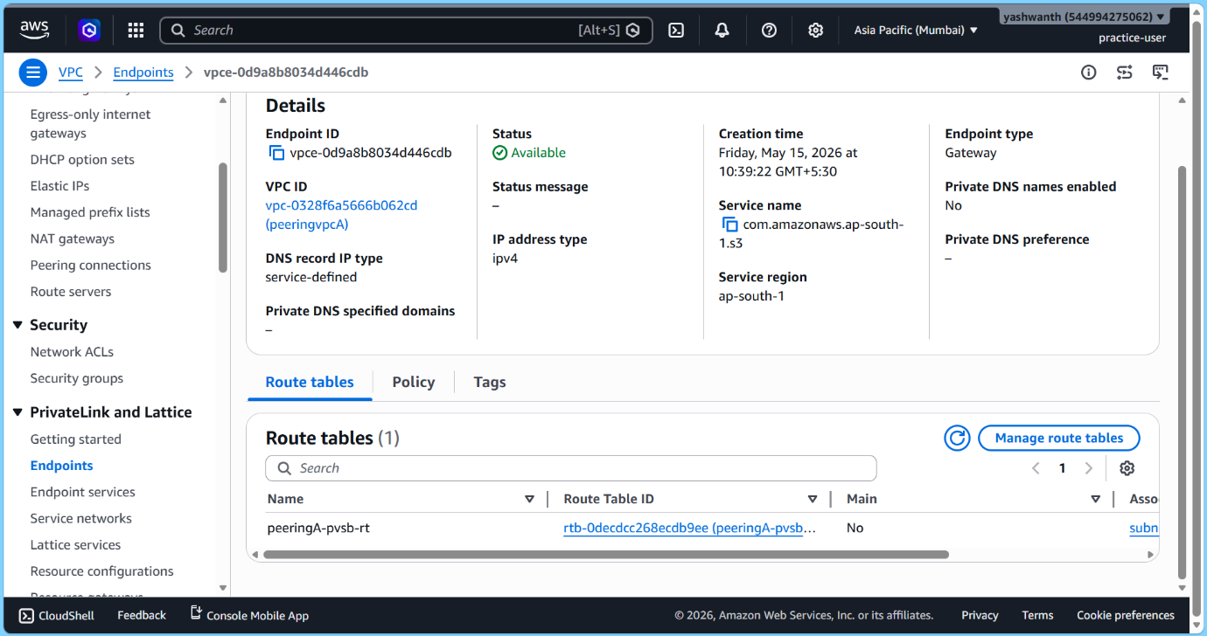

Step 1.1: Launch EC2 in Private Subnet ✅
- Launch an EC2 instance
- Select the Private Subnet
- Ensure:
  - No public IP is assigned
  - Security group allows outbound access
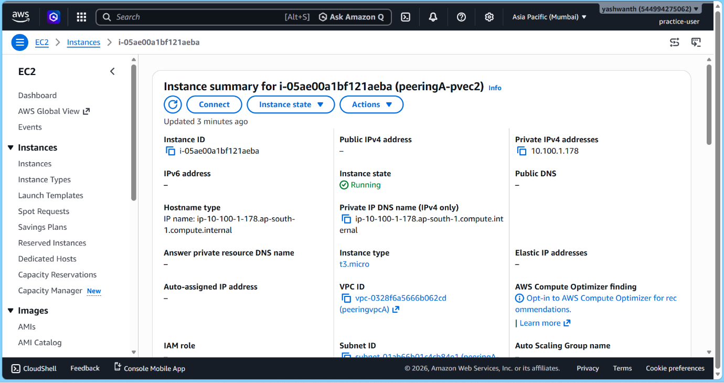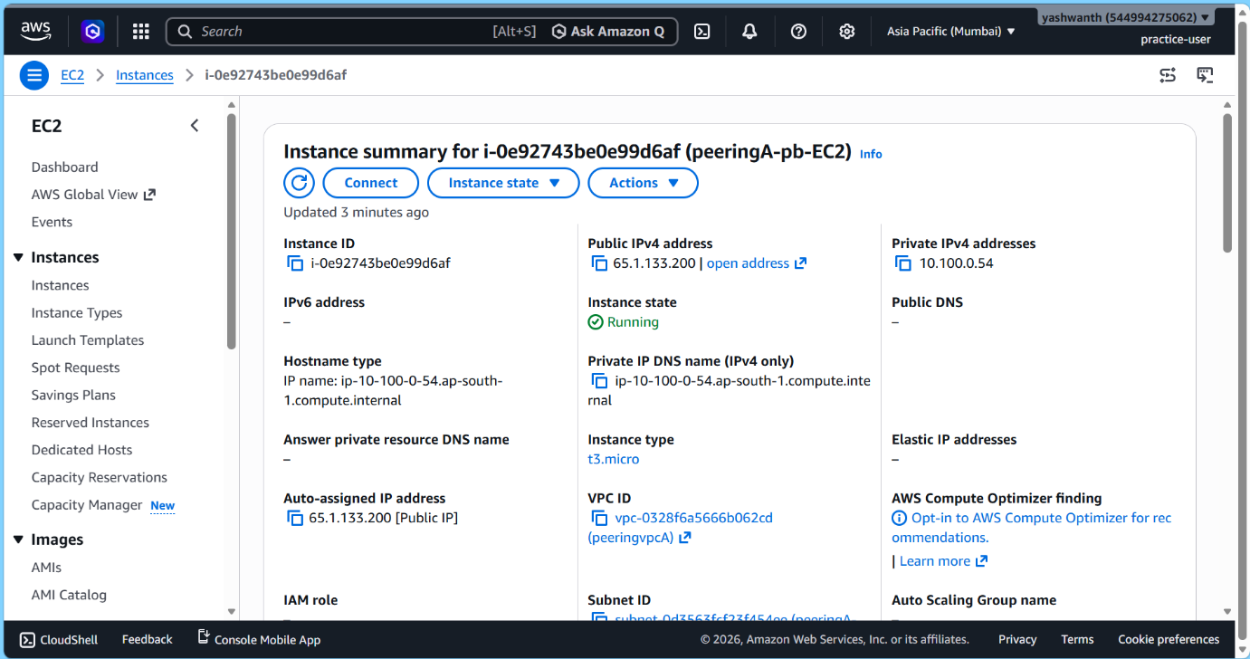

Step 1.2: Configure EC2 IAM Role ✅
- Attach IAM Role with S3 access (e.g., AmazonS3ReadOnlyAccess)
- Assign role to EC2 instance
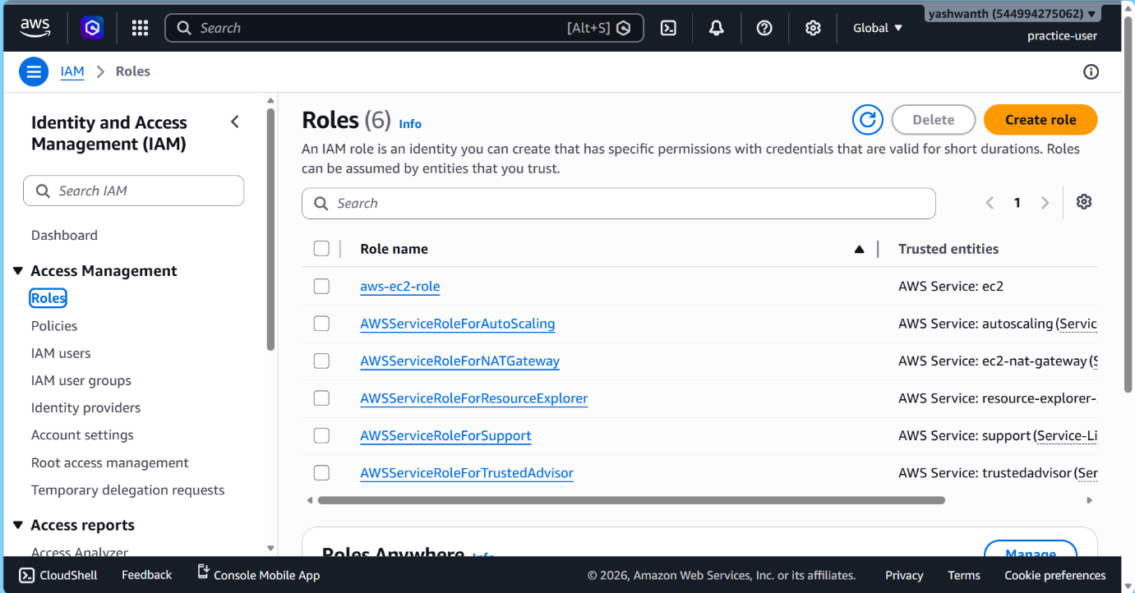

Step 2: Create Gateway Endpoint
- Go to VPC Console → Endpoints
- Click Create Endpoint
- Select:
  - Service: com.amazonaws.<region>.s3
  - Endpoint type: ✅ Gateway
  - Select your VPC
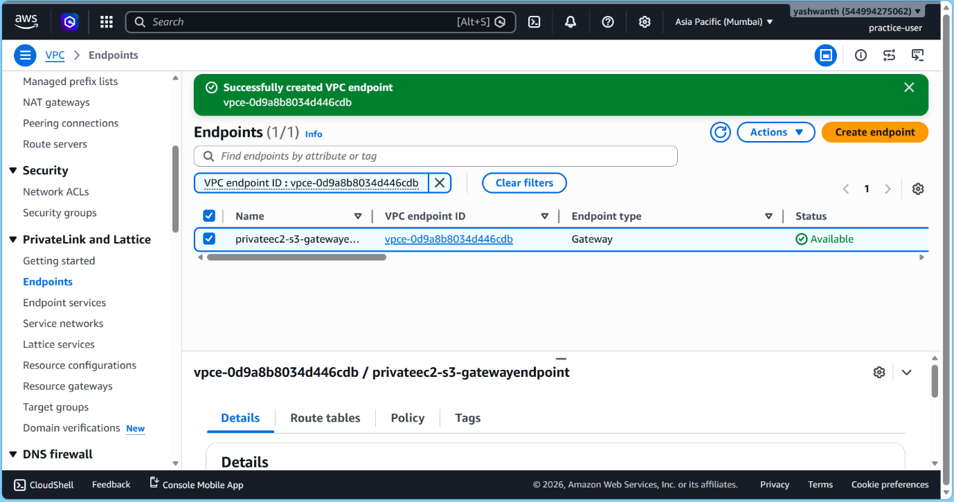

Step 3: Attach Route Table
- Select the Route Table attached to the Private Subnet
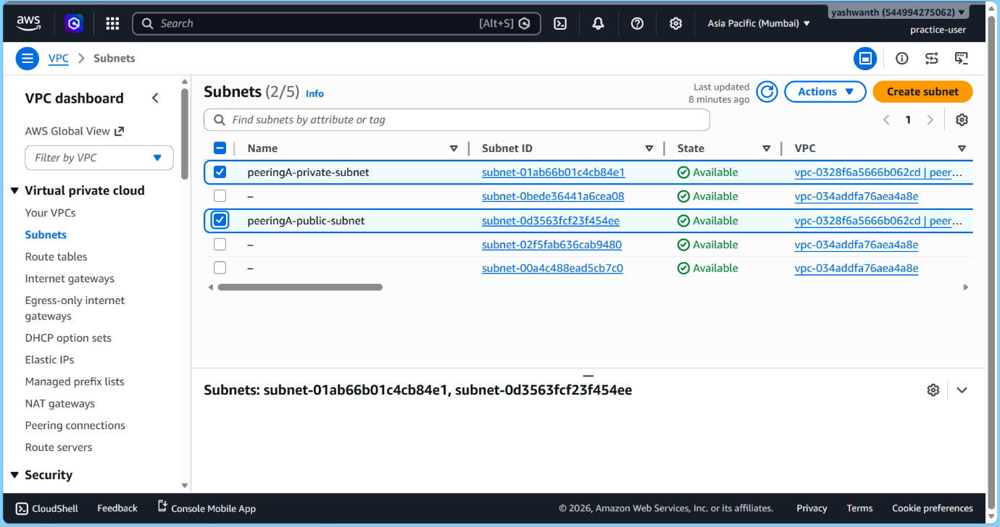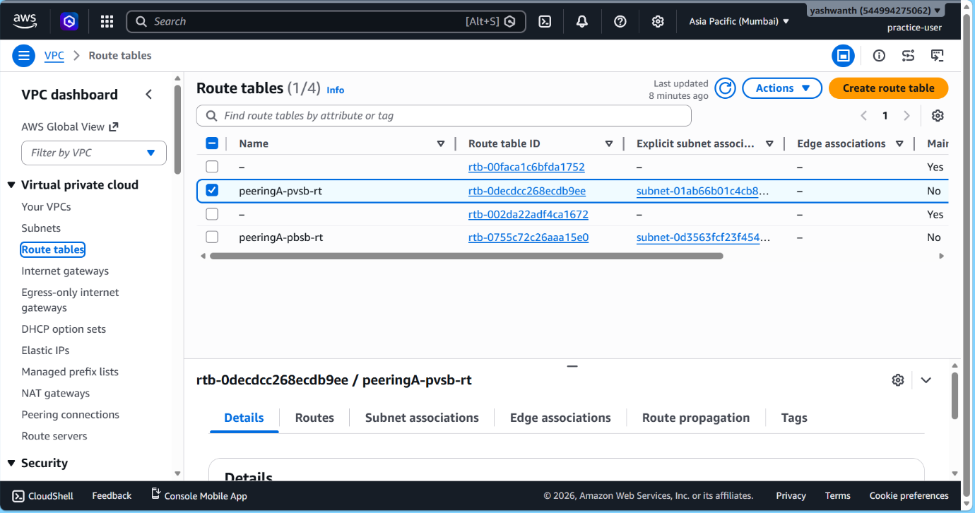

Step 4: Configure Policy
- Use default Full Access OR define custom policy for S3 bucket access
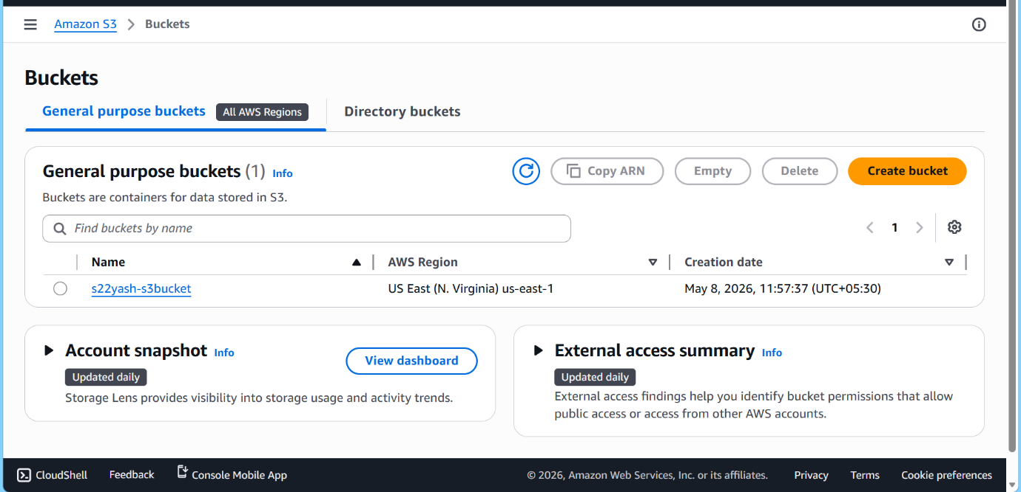

Step 5: Create Endpoint
- Click Create Endpoint
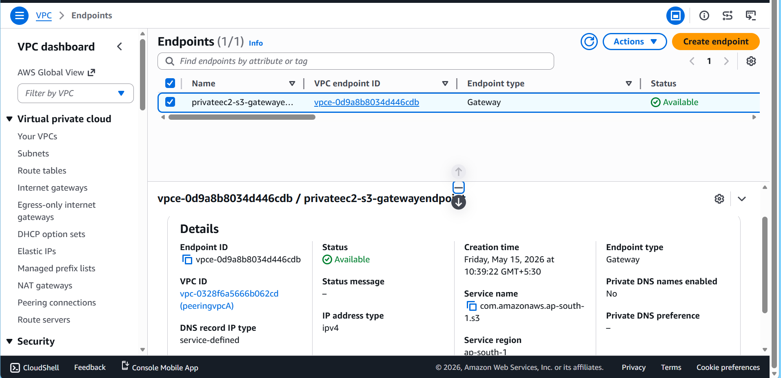

Step 6: Verify Route Entry
Check Route Table:
Destination: S3 Prefix List (pl-xxxx)
Target: Gateway Endpoint (vpce-xxxx)
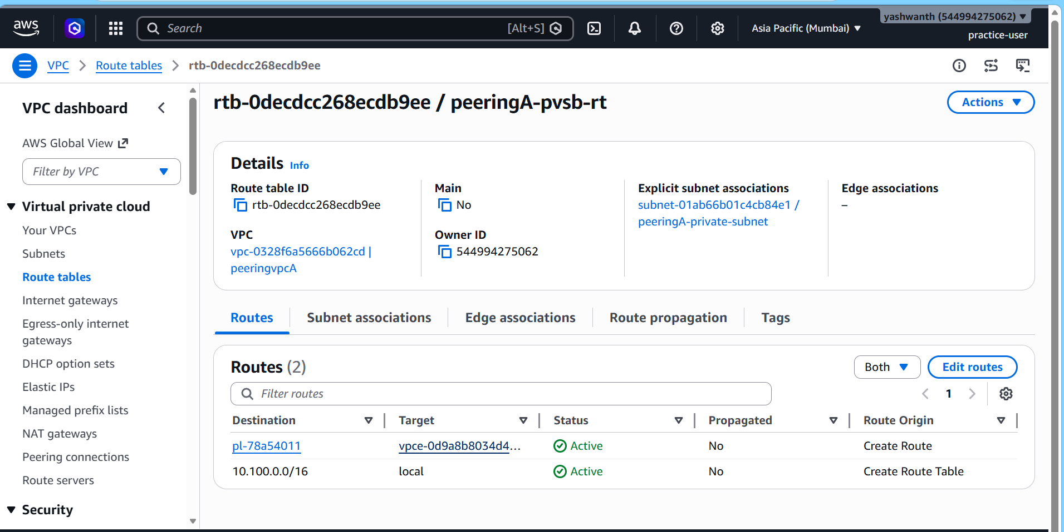

🔄 Traffic Flow (Diagram Mapping)
Private EC2 Instance
↓
Route Table (S3 Prefix)
↓
Gateway Endpoint
↓
Amazon S3
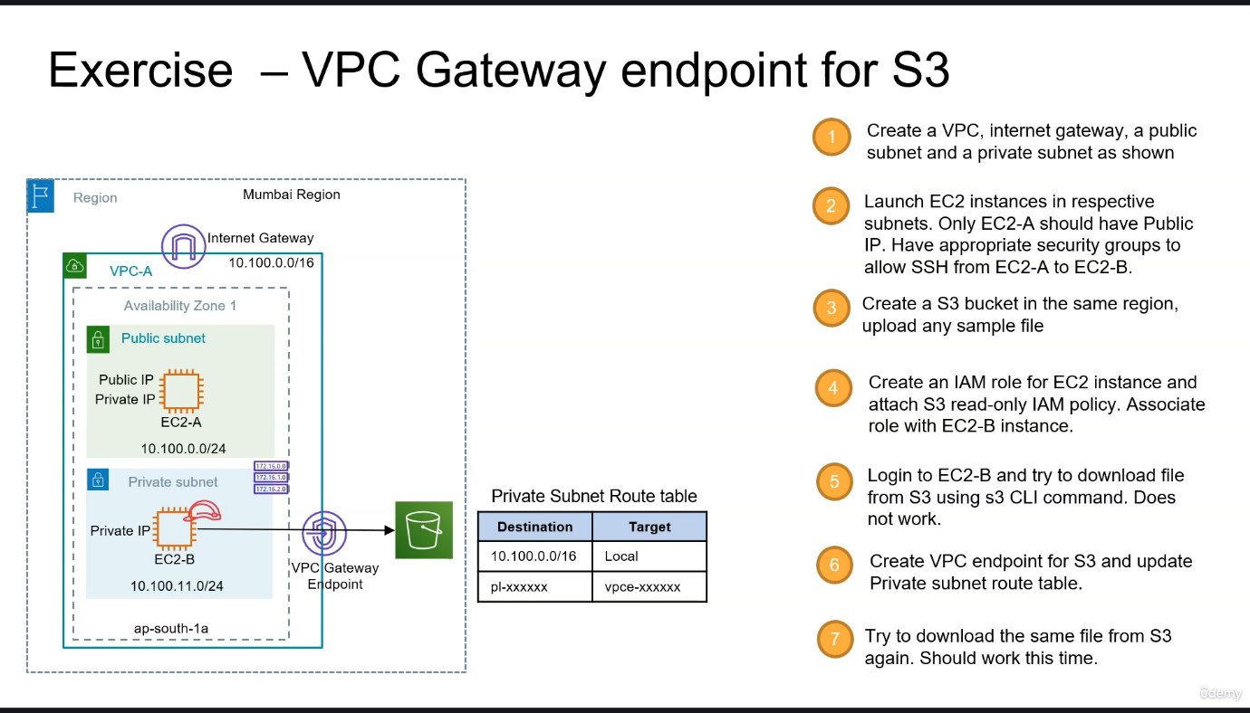
✅ No Internet Gateway
✅ No NAT Gateway
✅ Traffic stays inside AWS network

✅ Validation
From EC2 in private subnet:
Shell
aws s3 ls
``
Show more lines

🔐 Best Practice (Optional)
Restrict S3 bucket to VPC Endpoint:
JSON
"Condition": {
"StringEquals": {
"aws:SourceVpce": "vpce-xxxx"
}
}
Show more lines

✅ Final Summary (1 Line)
Private Subnet traffic to S3 is routed through a Gateway Endpoint using Route Tables, eliminating the need for Internet or NAT.
