Lab 1: Launch Your First AWS Instance
Aim
To create an Amazon EC2 instance, connect to it using SSH, and attach an EBS volume.

AWS Services Used
- Amazon EC2
- Amazon EBS
- Security Group
- Key Pair

Procedure / Flow
Step 1: Login to AWS Console
- Open the AWS Management Console.
- Login using AWS credentials.
- Select a region (example: Mumbai).
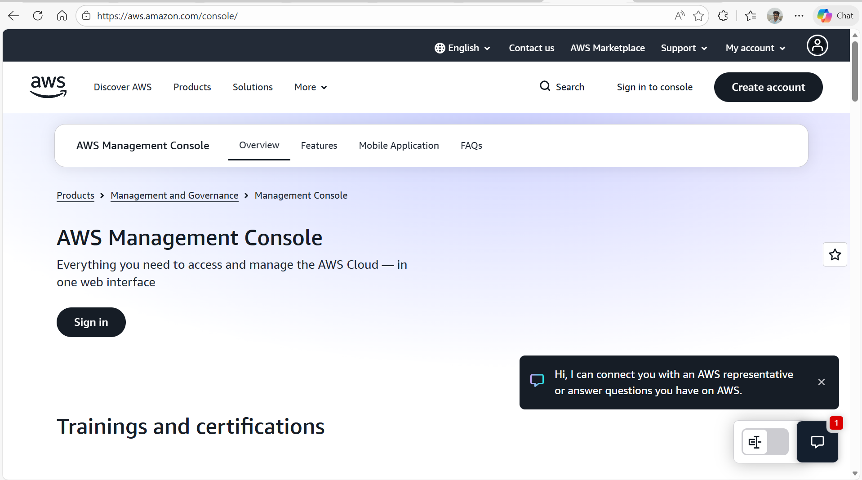
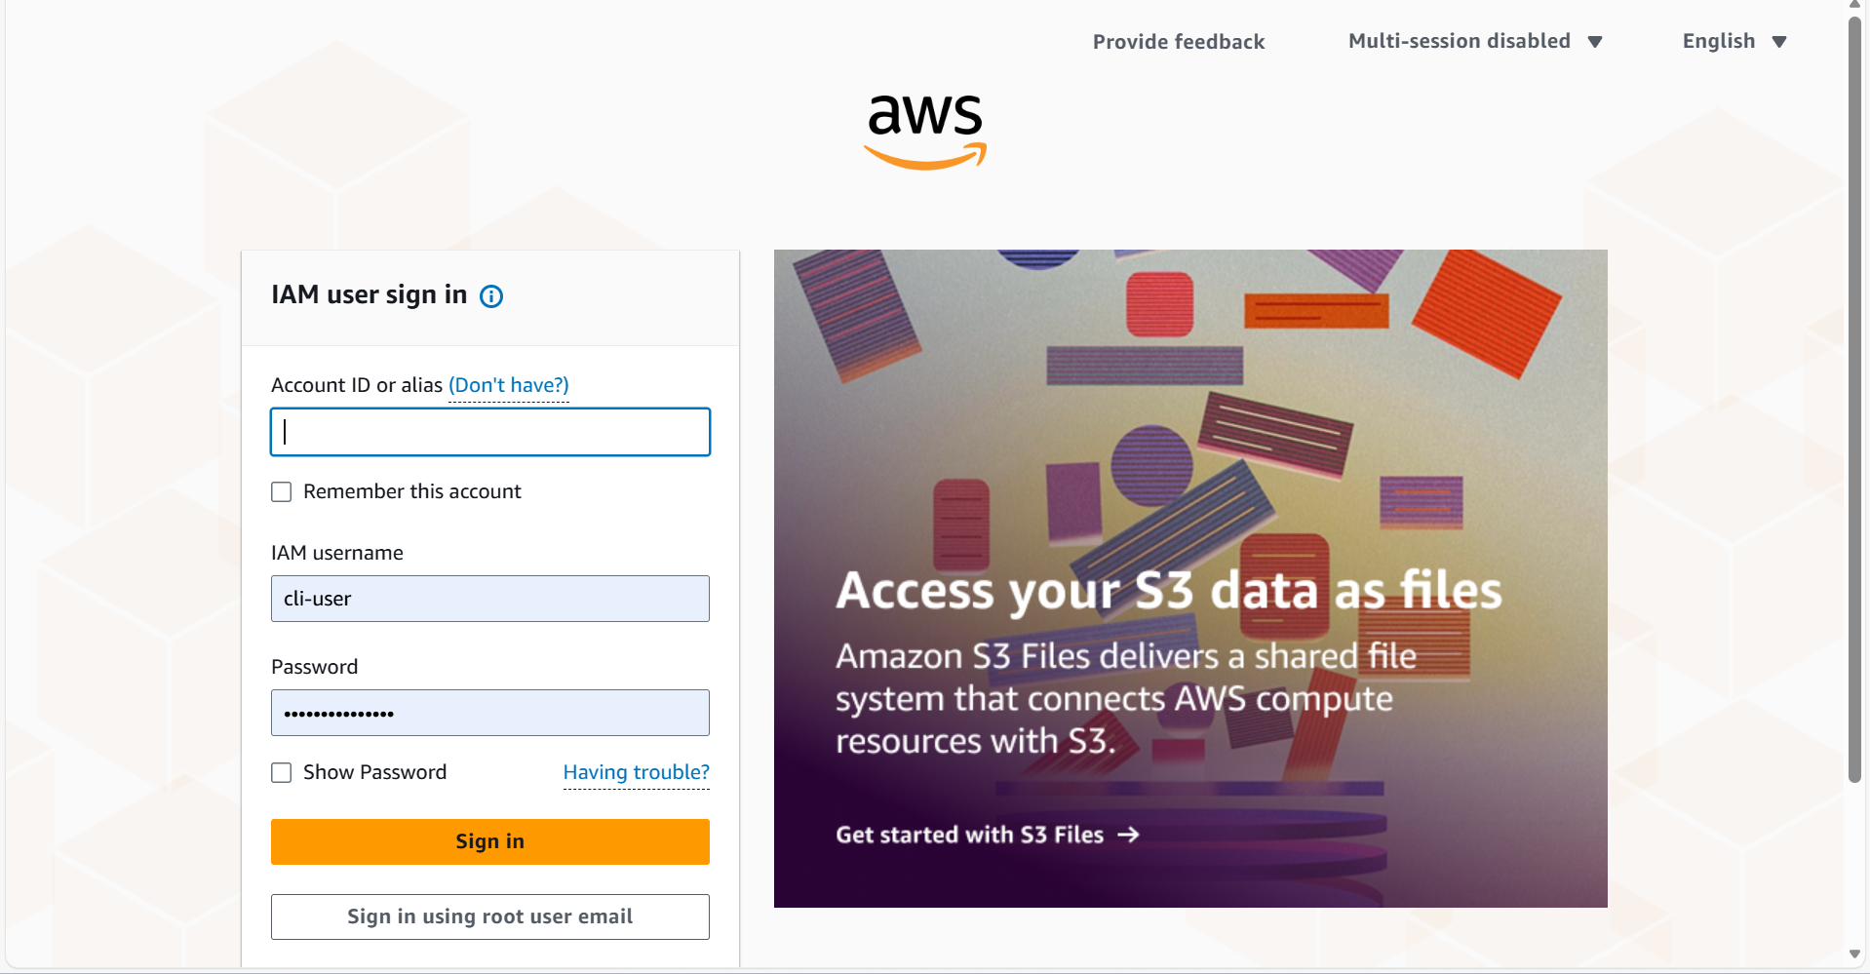
Step 2: Create EC2 Instance
- Go to Services → EC2 → Launch Instance
- Choose Amazon Linux 2 AMI
- Select instance type t2.micro
- Configure instance with default settings.
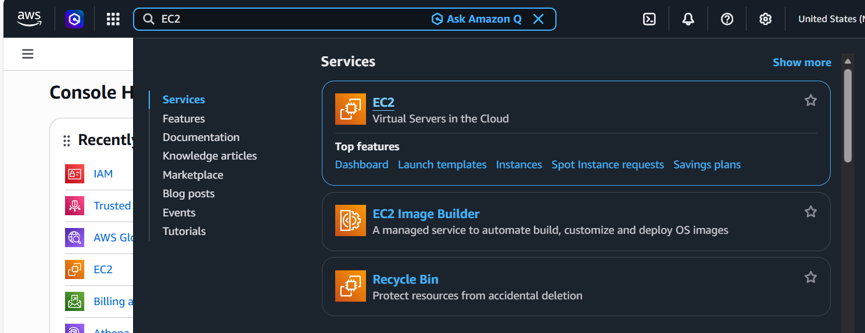

Step 3: Configure Security Group
- Create a new security group.
- Allow SSH (Port 22) from My IP.
- This allows secure access to the instance.
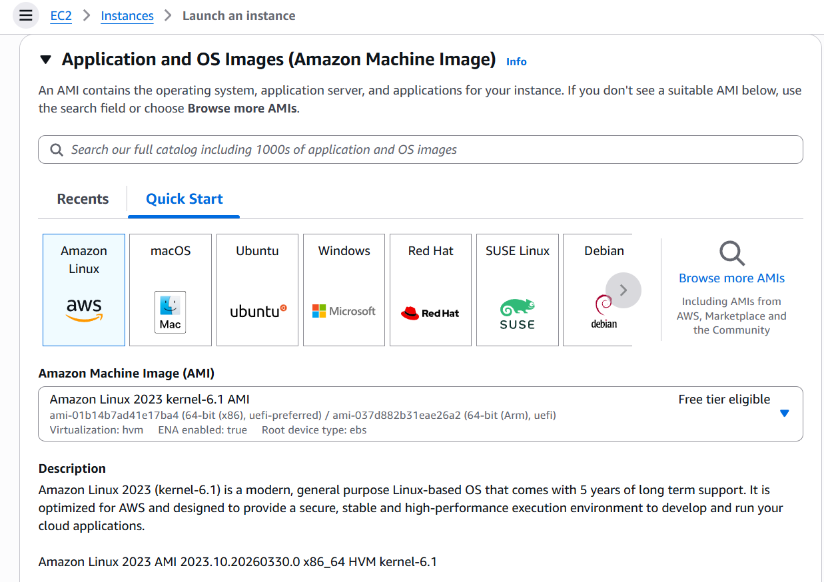

Step 4: Create Key Pair
- Create a new key pair.
- Download and save the .pem file.
- This key is used to connect to the instance.
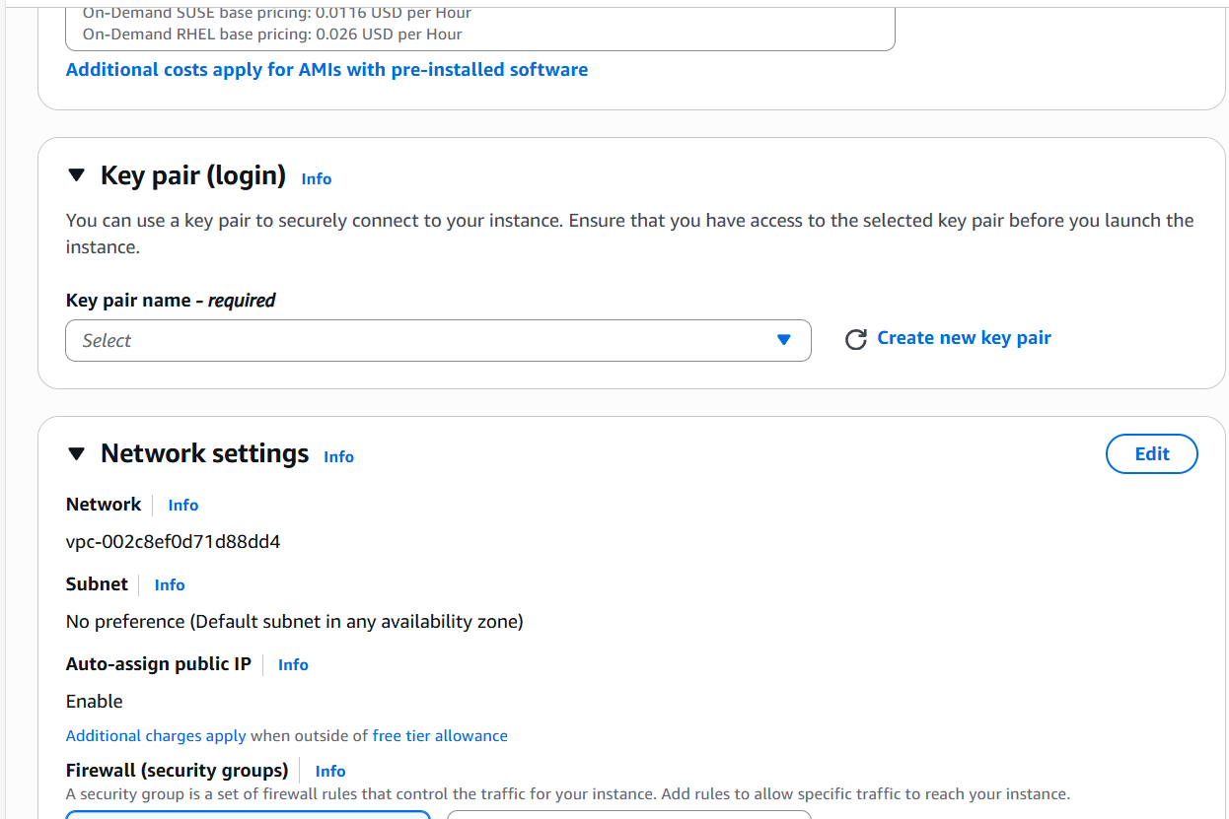
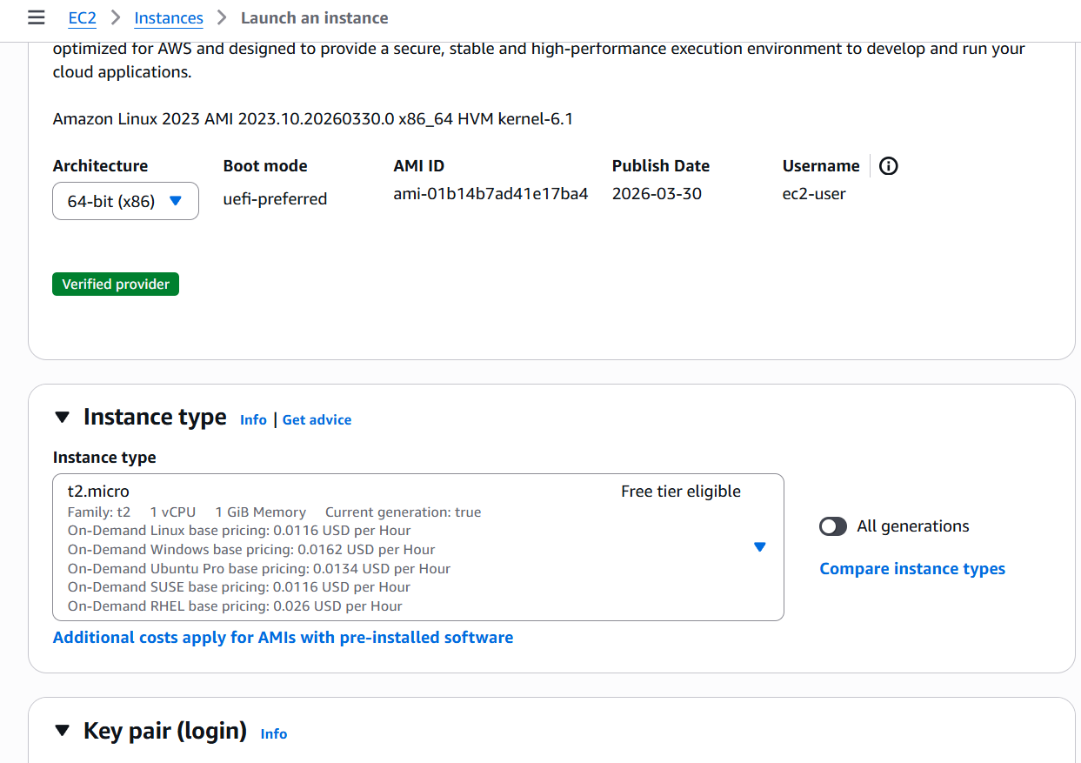

Step 5: Launch the Instance
- Review the settings.
- Click Launch
- Instance status changes to Running.
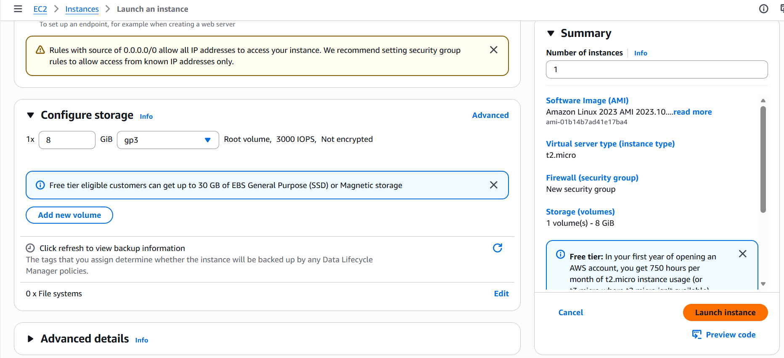

Step 6: Connect to EC2 Using SSH
- Copy the Public IP address of the instance.
- Use the command below:
Shell
ssh -i keypair.pem ec2-user@<Public-IP>

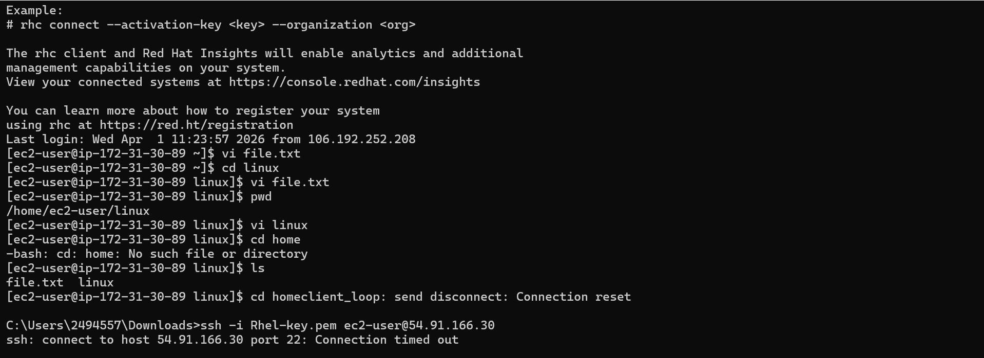

C:\Users\2494557\Downloads>ssh -i Rhel-key.pem ec2-user@54.234.114.160
kex_exchange_identification: read: Connection aborted
banner exchange: Connection to 54.234.114.160 port 22: Connection aborted

C:\Users\2494557\Downloads>ssh -i Rhel-key.pem ec2-user@54.234.114.160
Register this system with Red Hat Insights: rhc connect

Example:
# rhc connect --activation-key <key> --organization <org>

The rhc client and Red Hat Insights will enable analytics and additional
management capabilities on your system.
View your connected systems at https://console.redhat.com/insights

You can learn more about how to register your system
using rhc at https://red.ht/registration
Last login: Wed Apr 1 10:30:24 2026 from 106.192.252.208
[ec2-user@ip-172-31-30-89 ~]$ vi file.txt
"file.txt" 0L, 0B written ~]$
[ec2-user@ip-172-31-30-89 ~]$ cd linux
[ec2-user@ip-172-31-30-89 linux]$ vi file.txt
"file.txt" 5L, 151B writteninux]$
[ec2-user@ip-172-31-30-89 linux]$ cat file.txt

Step 7: Create and Attach EBS Volume
- Go to EC2 → Volumes → Create Volume
- Choose size and availability zone (same as EC2).
- Attach the volume to the EC2 instance.
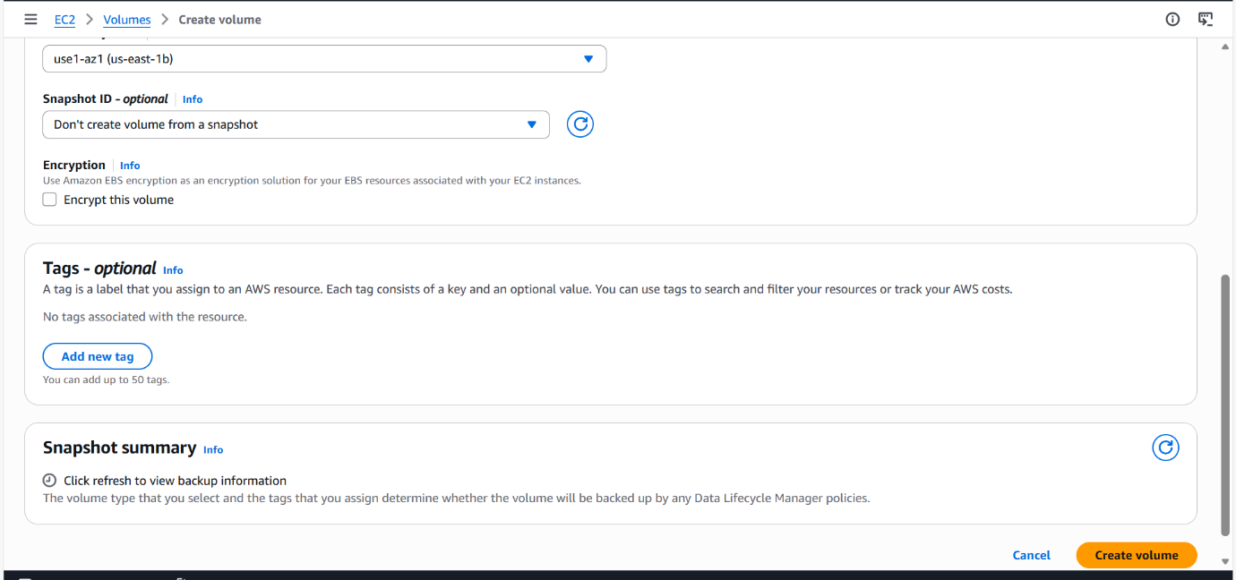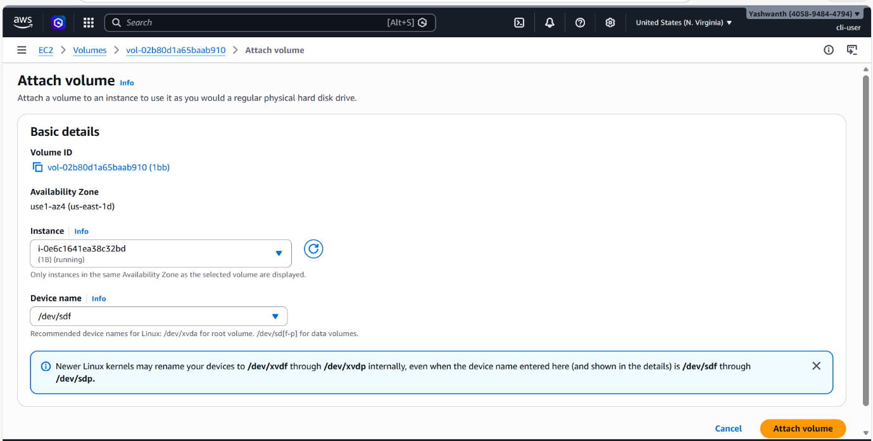

Step 8: Mount EBS Volume
Shell
lsblk
sudo mkfs -t ext4 /dev/xvdf
sudo mkdir /data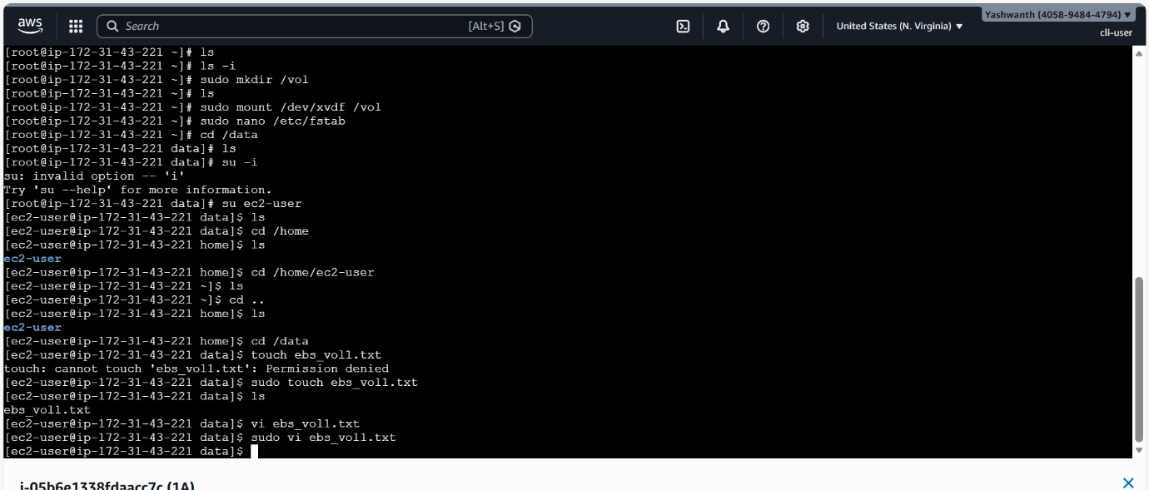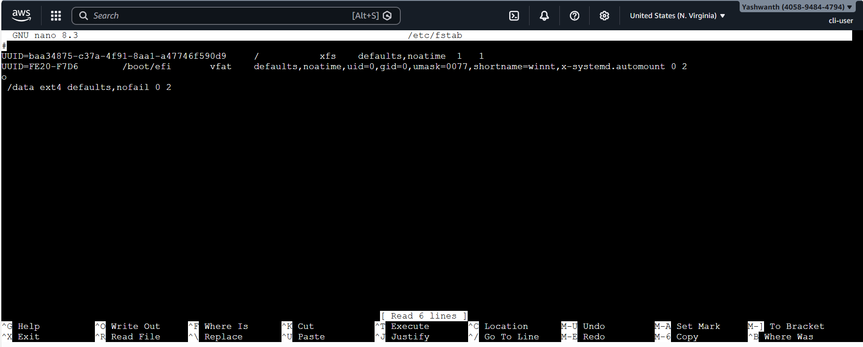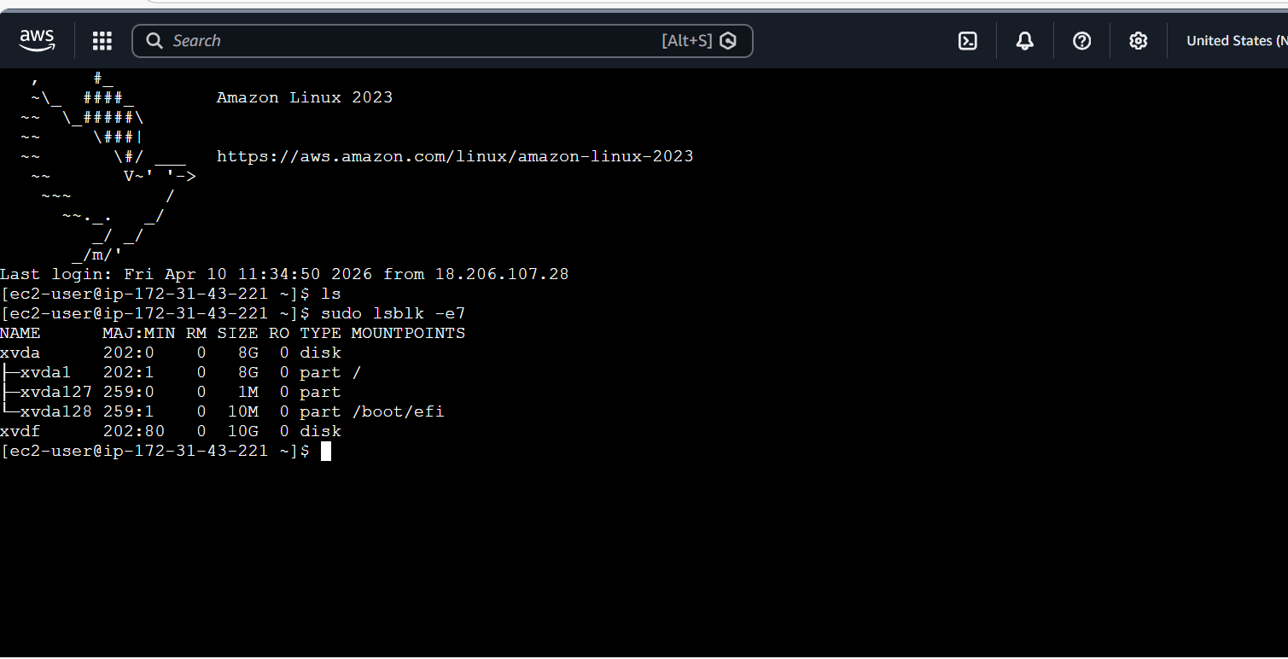
sudo mount /dev/xvdf /data
``

Result
- EC2 instance created successfully.
- Connected to EC2 using SSH.
- EBS volume attached and mounted.

Conclusion
In this lab, an EC2 instance was launched successfully in AWS. Secure access to the instance was achieved using SSH, and additional storage was added using an EBS volume.

