EXP NO 6:Demonstrate virtualization by Installing Type-2 Hypervisor in your device, create and configure VM image with a Host Operating system (Either Windows/Linux) using virtual box.

AIM
To demonstrate virtualization by installing a Type-2 Hypervisor (Oracle VirtualBox) on the host system and to create, configure, and run a Virtual Machine (VM) with a host operating system (Windows/Linux).

Requirements
Hardware Requirements
  - Computer/Laptop with virtualization support (Intel VT-x / AMD-V enabled)
  - Minimum 4 GB RAM
  - At least 20 GB free disk space

Software Requirements
  - Host Operating System: Windows / Linux
  - Oracle VirtualBox (Type-2 Hypervisor)
  - ISO image of Guest Operating System (Windows/Linux)

Procedure
Step 1: Install Oracle VirtualBox
- Download Oracle VirtualBox from the official website.
- Run the installer and follow the installation wizard.
- Accept default settings and complete the installation.
- Restart the system if required.

Step 2: Download Guest OS ISO
- Download the ISO file of the required Guest OS (Windows/Linux).
- Save the ISO file to a known location on the system.

Step 3: Create a New Virtual Machine
- Open Oracle VirtualBox.
- Click on New.
- Enter the VM name.
- Select the OS type and version (e.g., Linux → Ubuntu / Windows → Windows 10).
- Click Next.
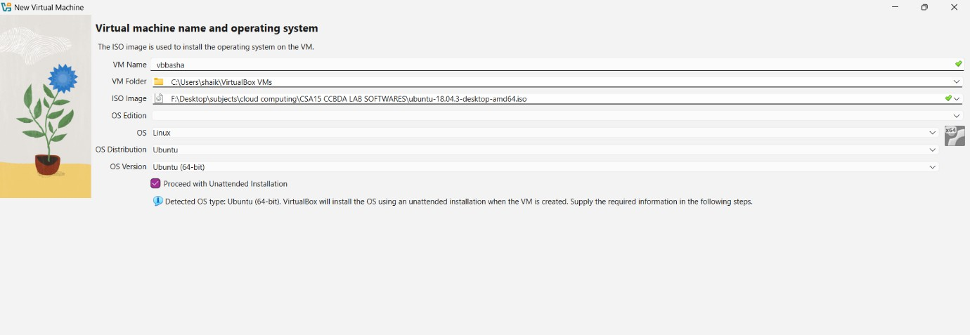
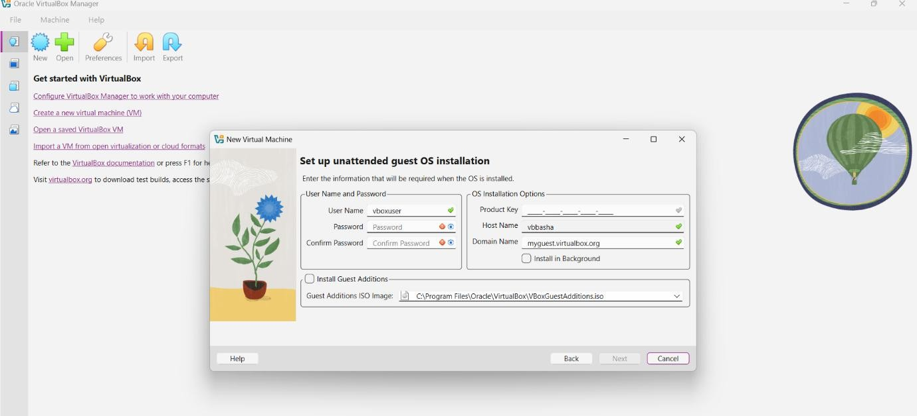

Step 4: Configure VM Hardware
  - Allocate RAM (minimum 2 GB recommended).
  - Create a virtual hard disk.
  - Select VDI (VirtualBox Disk Image).

  - Choose Dynamically Allocated.
  - Allocate disk size (minimum 20 GB).
  - Click Create.

Step 5: Attach Guest OS ISO
- Select the created VM.
- Click Settings → Storage.
- Under Controller IDE, click Empty.
- Attach the downloaded ISO file.
- Click OK.

Step 6: Install Guest Operating System
- Click Start to boot the VM.
- The system will boot from the ISO file.
- Follow the OS installation steps (language, region, user account).
- Complete the installation and reboot the VM.
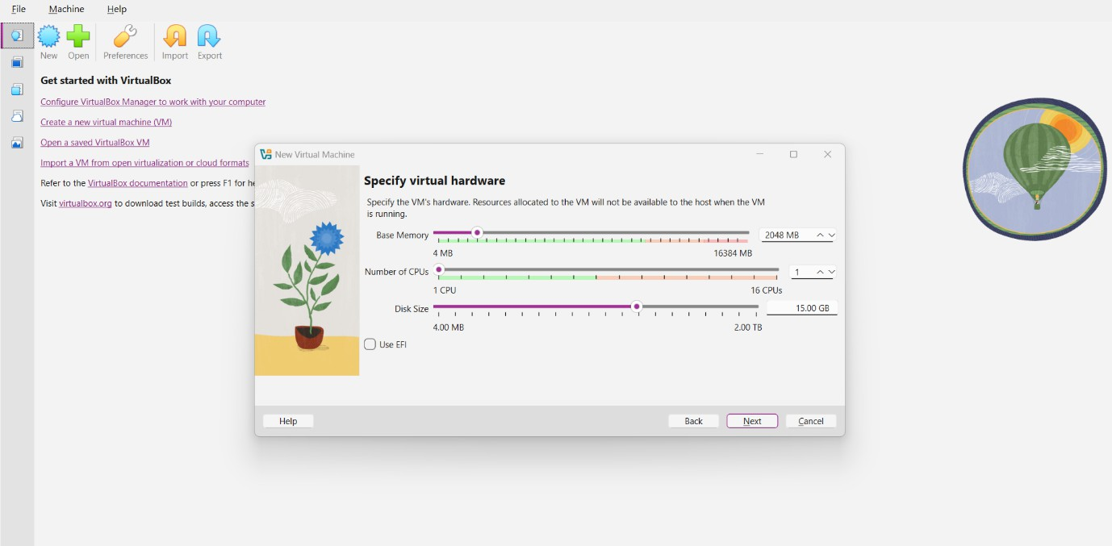

Step 7: Verify Virtual Machine
- After reboot, log in to the guest OS.
- Check system information to confirm successful installation.
- The VM now runs independently inside the host OS.

Result
Thus, virtualization was successfully demonstrated by installing a Type-2 Hypervisor (Oracle VirtualBox) and creating, configuring, and running a Virtual Machine with a guest operating system.
Output: -
