EXP NO 7:Create a Virtual Machine with 1 CPU, 2GB RAM and 15GB storage disk using a Type 2 Virtualization Software, using VirtualBox.

AIM
To create and configure a Virtual Machine (VM) with 1 CPU, 2 GB RAM, and 15 GB storage disk using Type-2 Virtualization Software (Oracle VirtualBox).

REQUIREMENTS
Hardware Requirements
  - Computer/Laptop with virtualization support (Intel VT-x / AMD-V enabled)
  - Minimum 4 GB RAM
  - At least 15 GB free disk space

Software Requirements
  - Host Operating System: Windows / Linux
  - Oracle VirtualBox (Type-2 Hypervisor)
  - ISO image of Guest Operating System (Windows/Linux)

PROCEDURE
Step 1: Install Oracle VirtualBox
- Download Oracle VirtualBox from the official website.
- Run the installer and follow the installation wizard.
- Accept default settings and complete the installation.
- Restart the system if required.

Step 2: Download Guest OS ISO
- Download the ISO file of the required Guest OS (Windows/Linux).
- Save the ISO file to a known location on the system.

Step 3: Create a New Virtual Machine
- Open Oracle VirtualBox.
- Click on New.
- Enter the VM name.
- Select the OS type and version (e.g., Linux → Ubuntu / Windows → Windows 10).
- Click Next.
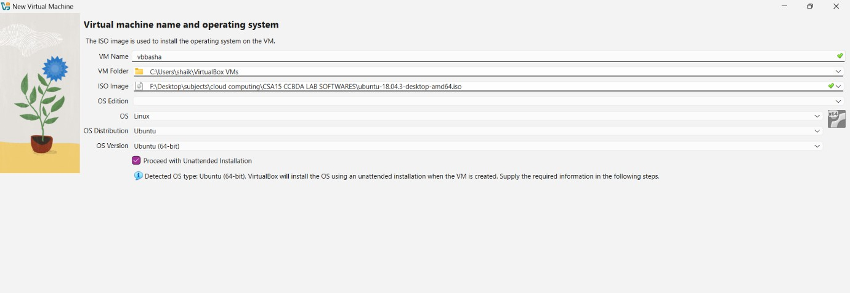

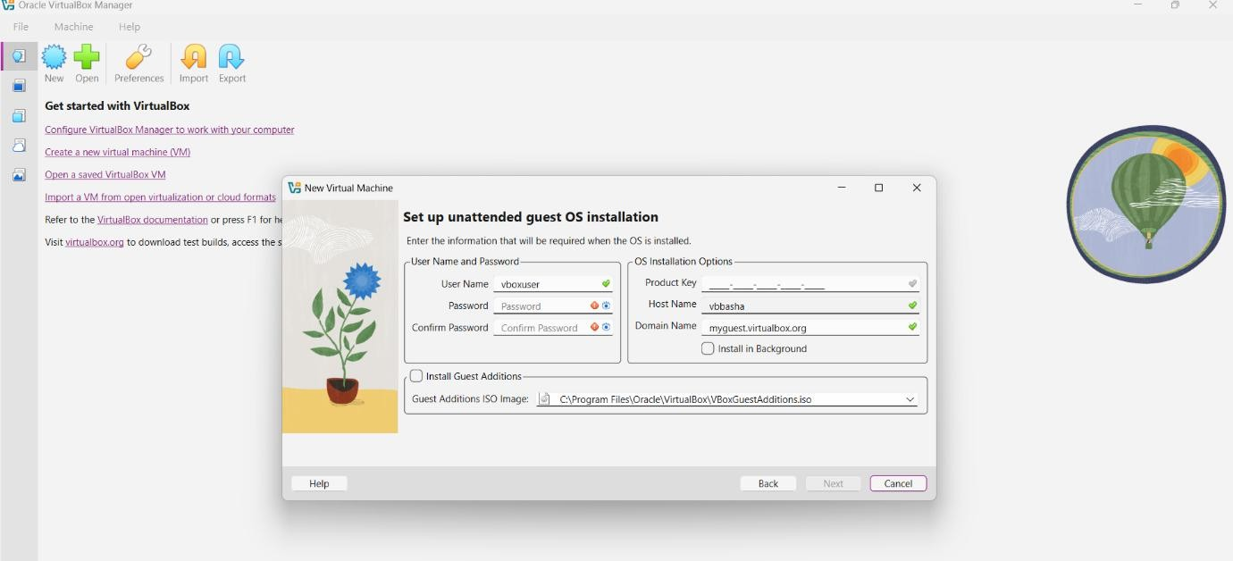

Step 4: Configure VM Hardware
  - Allocate RAM (minimum 2 GB recommended).
  - Create a virtual hard disk.
  - Select VDI (VirtualBox Disk Image).
  - Choose Dynamically Allocated.
  - Allocate disk size (minimum 20 GB).
  - Click Create.

Step 5: Attach Guest OS ISO
- Select the created VM.
- Click Settings → Storage.
- Under Controller IDE, click Empty.
- Attach the downloaded ISO file.
- Click OK.

Step 6: Install Guest Operating System
- Click Start to boot the VM.
- The system will boot from the ISO file.
- Follow the OS installation steps (language, region, user account).
- Complete the installation and reboot the VM.

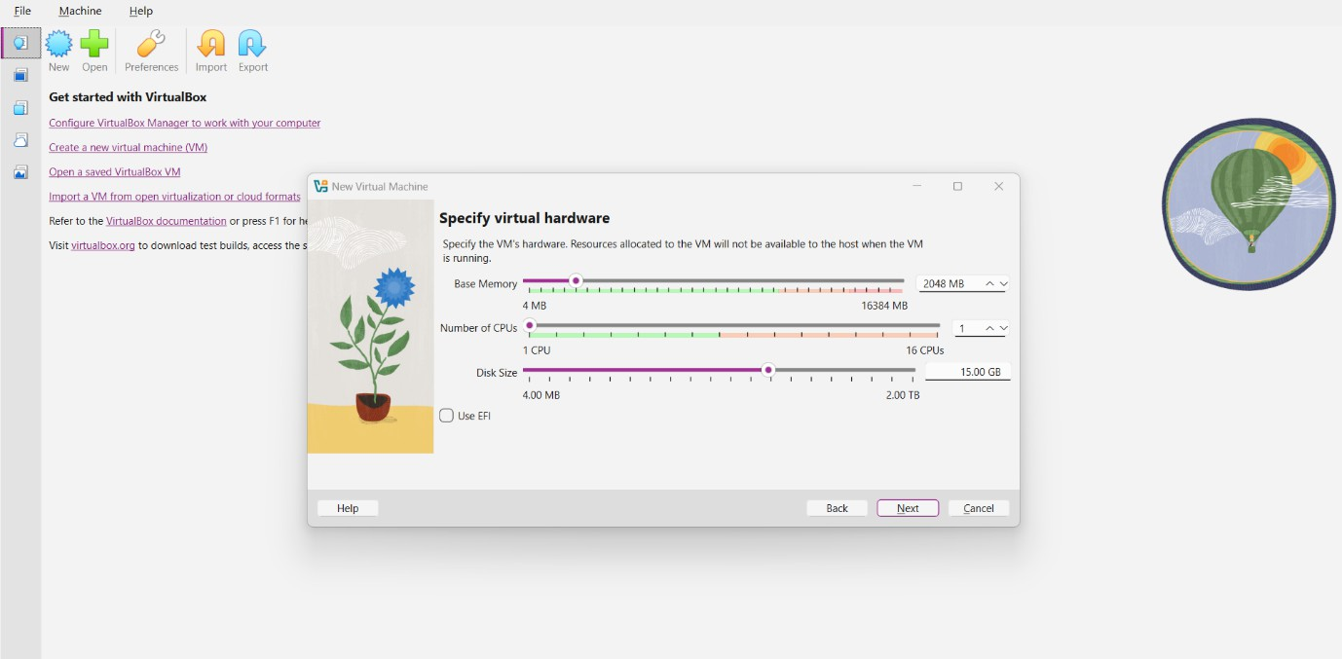

Step 7: Verify Virtual Machine
- After reboot, log in to the guest OS.
- Check system information to confirm successful installation.
- The VM now runs independently inside the host OS.

RESULT
A Virtual Machine with 1 CPU, 2 GB RAM, and 15 GB storage disk was successfully created and configured using Oracle VirtualBox, a Type-2 Hypervisor.

Output: -
