EXP NO 8:CREATE A VIRTUAL HARD DISK AND ALLOCATE THE STORAGE USING VIRTUAL

AIM
To create a Virtual Hard Disk and allocate storage using Oracle VirtualBox.

REQUIREMENTS
  - Host Operating System (Windows/Linux)
  - Oracle VirtualBox installed
  - Minimum 10–20 GB free disk space

PROCEDURE
Step 1: Open VirtualBox
- Launch Oracle VirtualBox on the host system.

Step 2: Create a New Virtual Machine
- Click New.
- Enter the Name of the virtual machine.
- Select Type and Version of the operating system.
- Click Next.
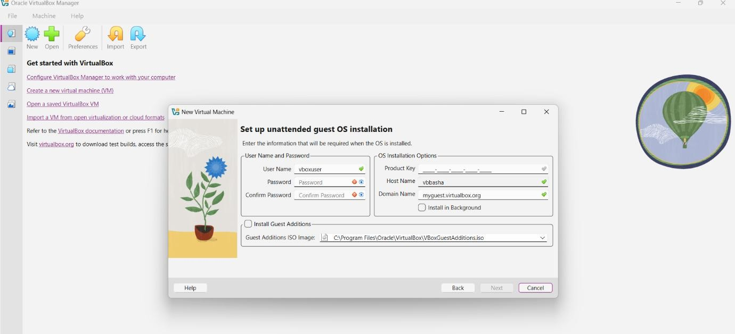

Step 3: Memory Allocation

- Allocate required RAM (e.g., 2 GB).
- Click Next.

Step 4: Create Virtual Hard Disk
- Select Create a virtual hard disk now.
- Click Create.
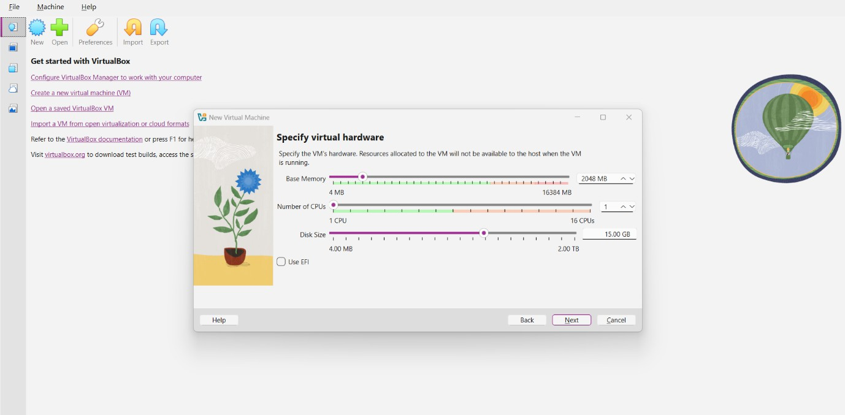

Step 5: Choose Hard Disk File Type
  - Select VDI (VirtualBox Disk Image).
  - Click Next.

Step 6: Storage Allocation Type
- Choose Dynamically allocated (uses disk space as needed)
or
Fixed size (reserves full space immediately).
- Click Next.

Step 7: Allocate Disk Size
- Set the Virtual Hard Disk size (e.g., 15 GB or 20 GB).
- Choose the location to save the disk file.
- Click Create.

Step 8: Verify Virtual Hard Disk
- Select the created VM.
- Go to Settings → Storage.
- Verify the attached virtual hard disk and allocated size.

RESULT
A Virtual Hard Disk was successfully created and storage was allocated using Oracle VirtualBox.
OUTPUT:
