**Documentation**

Before you are going to create a Twitter bot Go to the given link

https://developer.twitter.com/en/apply-for-access

STEP 1:

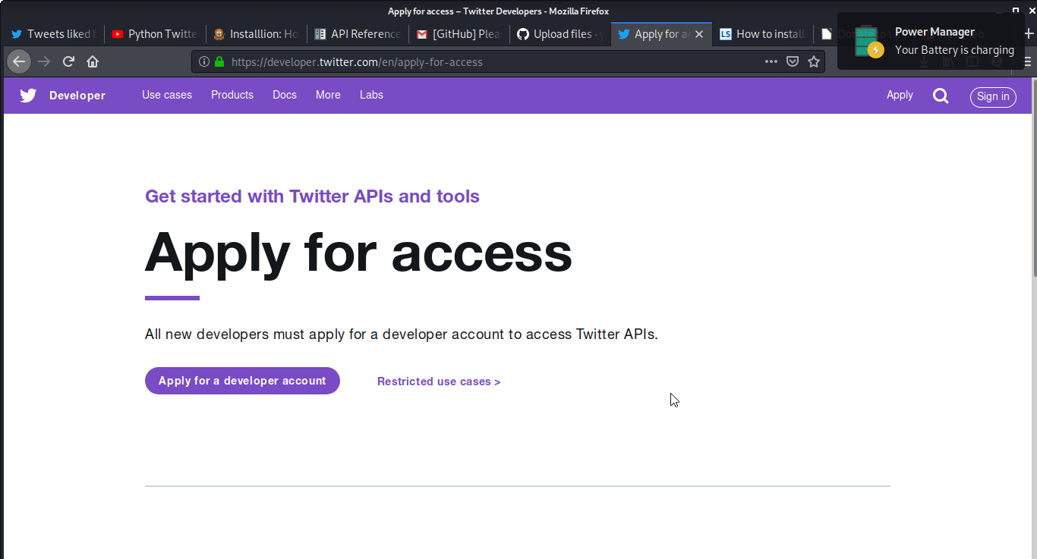

STEP 2:

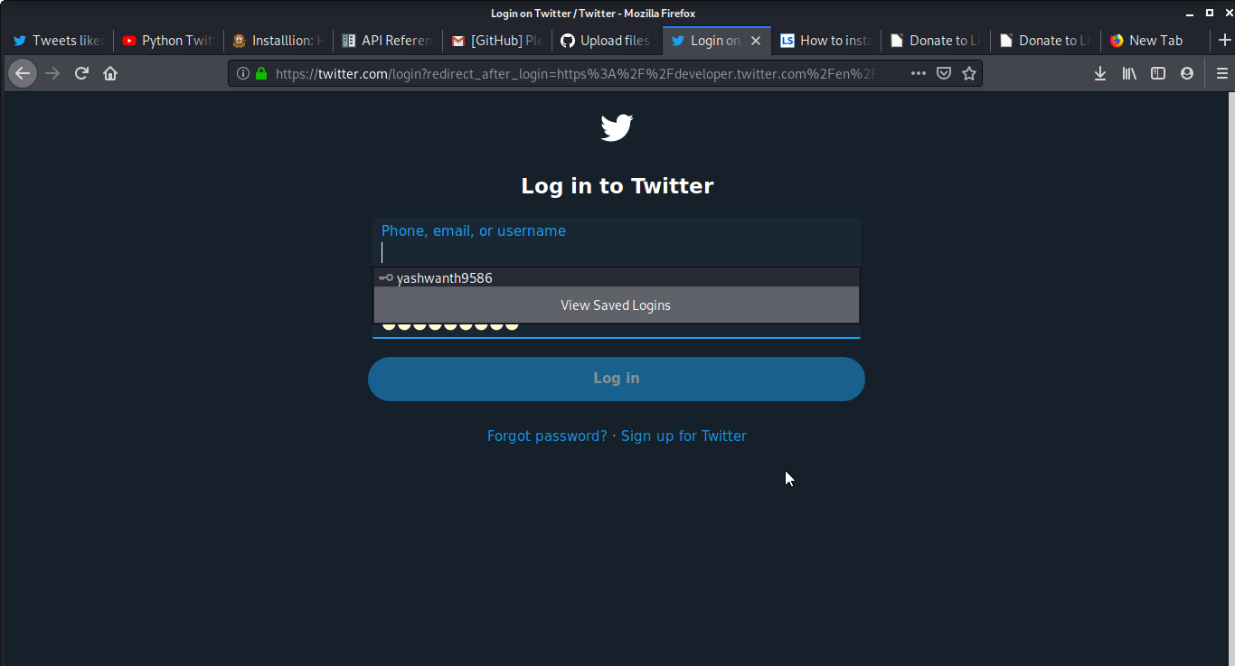

STEP 3:

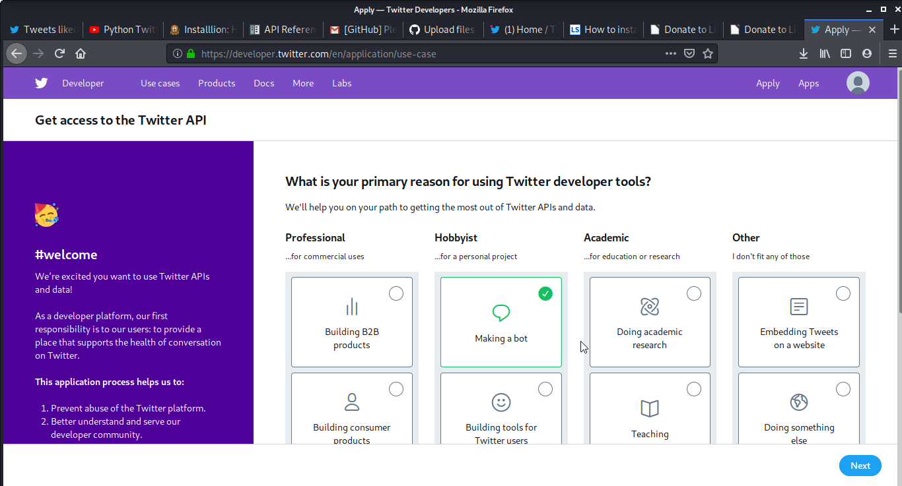

STEP 4:

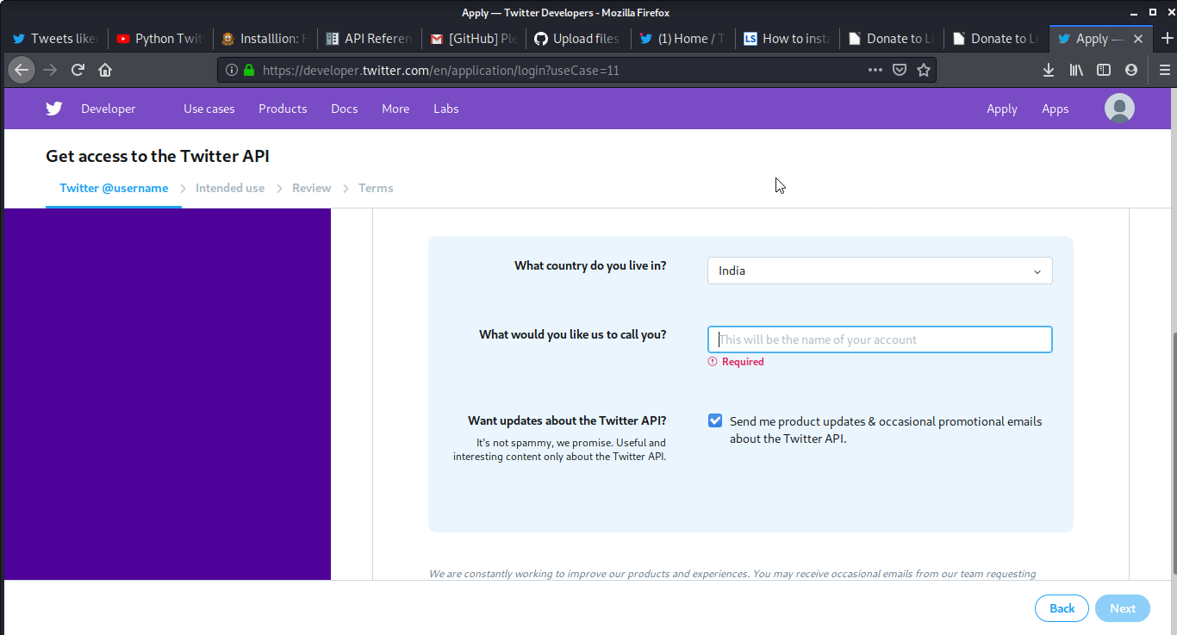

STEP 5:

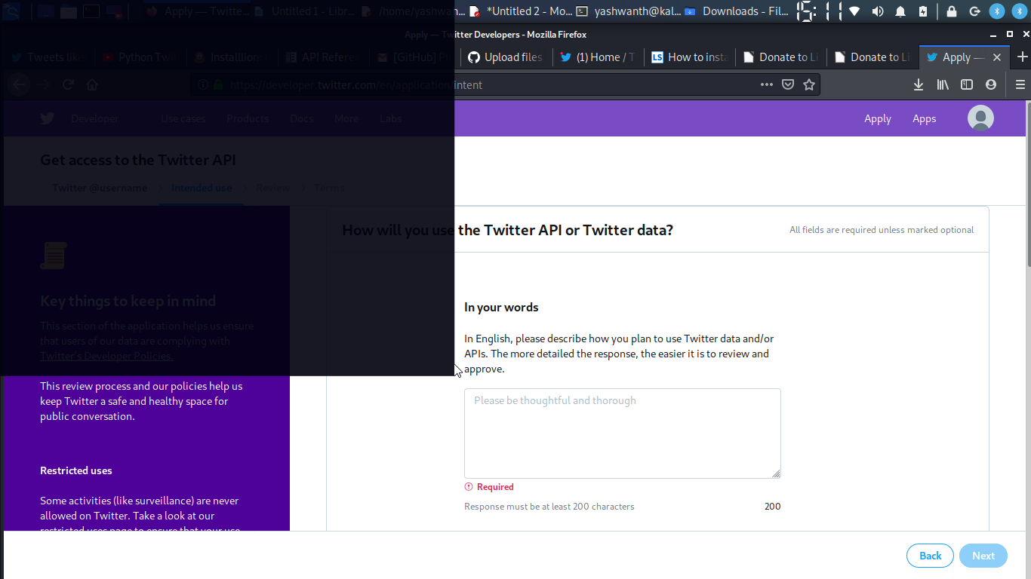

STEP 6:

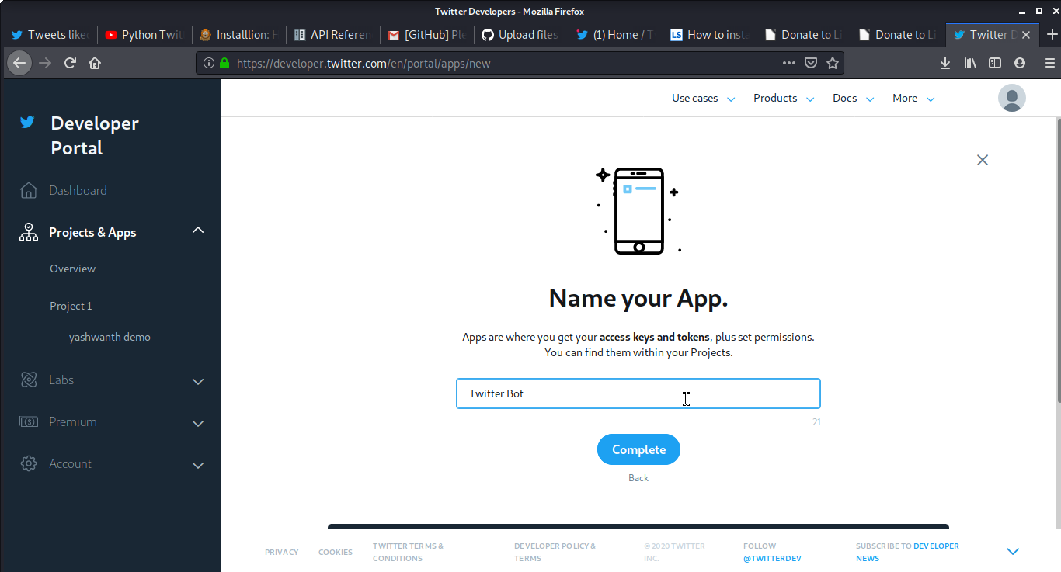

STEP 7:

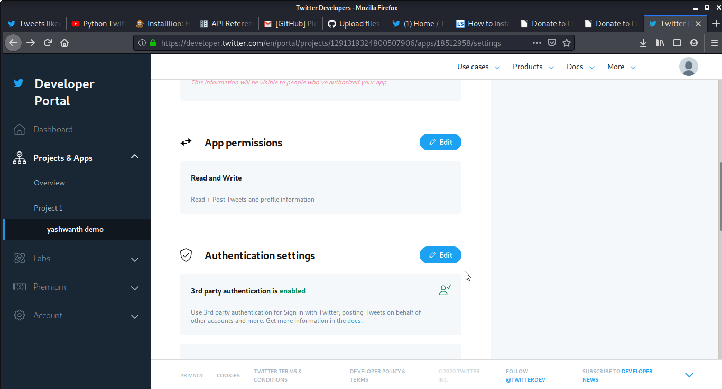

Before you are going to write a code, check the version of a python on your system by the following code:

**python3 –version**

Then install package tweepy on your system by using the following:

If you are using a Linux/ubuntu then use the following code on Terminal

**sudo apt-get install python3-tweepy**

Else use the following

**pip install tweepy**

Then proceed with the code which was given on twitterbot.py .

NOTE: API keys & Secret and Access Token and Secret can be find as shown in the following.

