USE-CASE 03
Deployment of Frontend and Backend Application to Azure App Service
Frontend → Backend → Azure Blob Storage
End-to-end CI/CD pipeline deploying a Node.js backend and static HTML frontend
to Azure App Services, connected to Azure Blob Storage
Platform: Linux App Service | Backend: Node.js 18 | Storage: Azure Blob

Environment Used in This Implementation
Resource | Value
Azure Subscription | Azure for Students
Storage Account | yashstorage405
Blob Container | uploads (Blob anonymous access)
Backend App Service | yash-backend (Node 18 LTS, Linux, Central India)
Frontend App Service | yash-frontend (Node 18 LTS, Linux, Central India)
Azure DevOps Project | project3
Backend Repo | backend-repo (server.js, package.json, .gitignore)
Frontend Repo | frontend-repo (index.html)
Service Connection | newserviceconnectionproject3 (scoped to yash-backend_group)

Architecture Overview
The following diagram shows the end-to-end CI/CD pipeline. Code pushed from VS Code triggers automated build pipelines in Azure DevOps, which package the applications and deploy them to Azure App Services. The backend connects to Azure Blob Storage to store and retrieve uploaded files.

Developer (VS Code) | Push code to Azure Repos  backend-repo (server.js) + frontend-repo (index.html)
Azure Repos (Git) | Stores source code, triggers CI pipeline on commit to main
Build Pipeline (CI) | Backend: npm install → zip → publish backend.zip  Frontend: zip → publish frontend.zip
Release Pipeline (CD) | Azure App Service Deploy task  Deploys backend.zip → yash-backend, frontend.zip → yash-frontend
Azure App Services | yash-backend (Node 18, Linux) → reads AZURE_STORAGE_CONNECTION_STRING  yash-frontend (Node 18, Linux) → serves index.html
Azure Blob Storage | Storage account: yashstorage405  Container: uploads (Blob access)  Stores uploaded files

Runtime flow: User opens frontend URL → index.html loaded from yash-frontend App Service → JavaScript calls yash-backend API → backend reads AZURE_STORAGE_CONNECTION_STRING env variable → uploads/lists files in Azure Blob Storage container.

Task 1: Create Azure Resources

Step 1: Create Storage Account
Go to Azure Portal → search "Storage accounts" → Create. Configure the following settings:
- Subscription: Azure for Students
- Resource Group: DefaultResourceGroup-CID (or create new)
- Storage account name: yashstorage405 (must be globally unique, lowercase only)
- Region: Central India
- Click Review + Create → Create

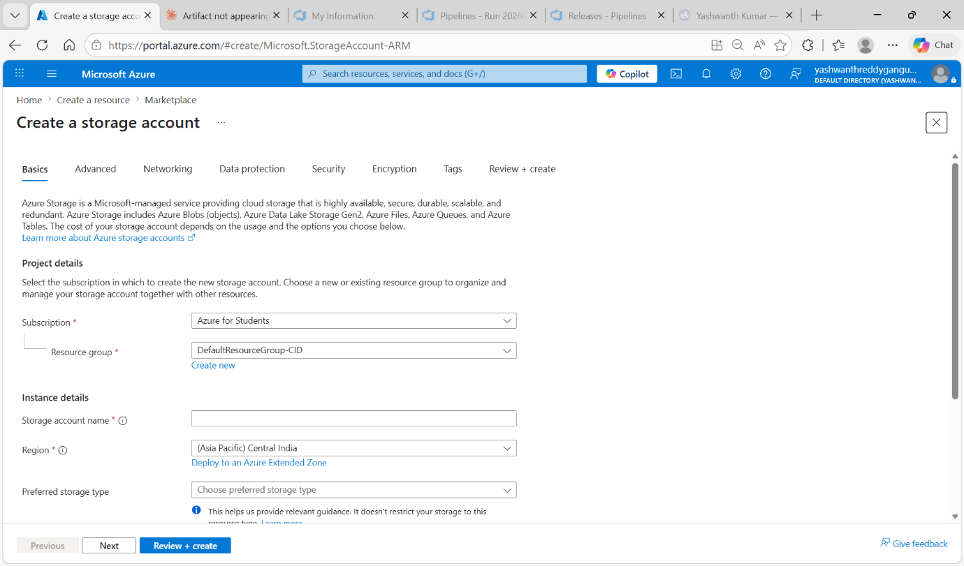
Figure 1.1: Create a storage account — Basics tab showing subscription, resource group, and storage account name yashstorage405

Deployment Complete
After the storage account deploys, click "Go to resource" to access it.

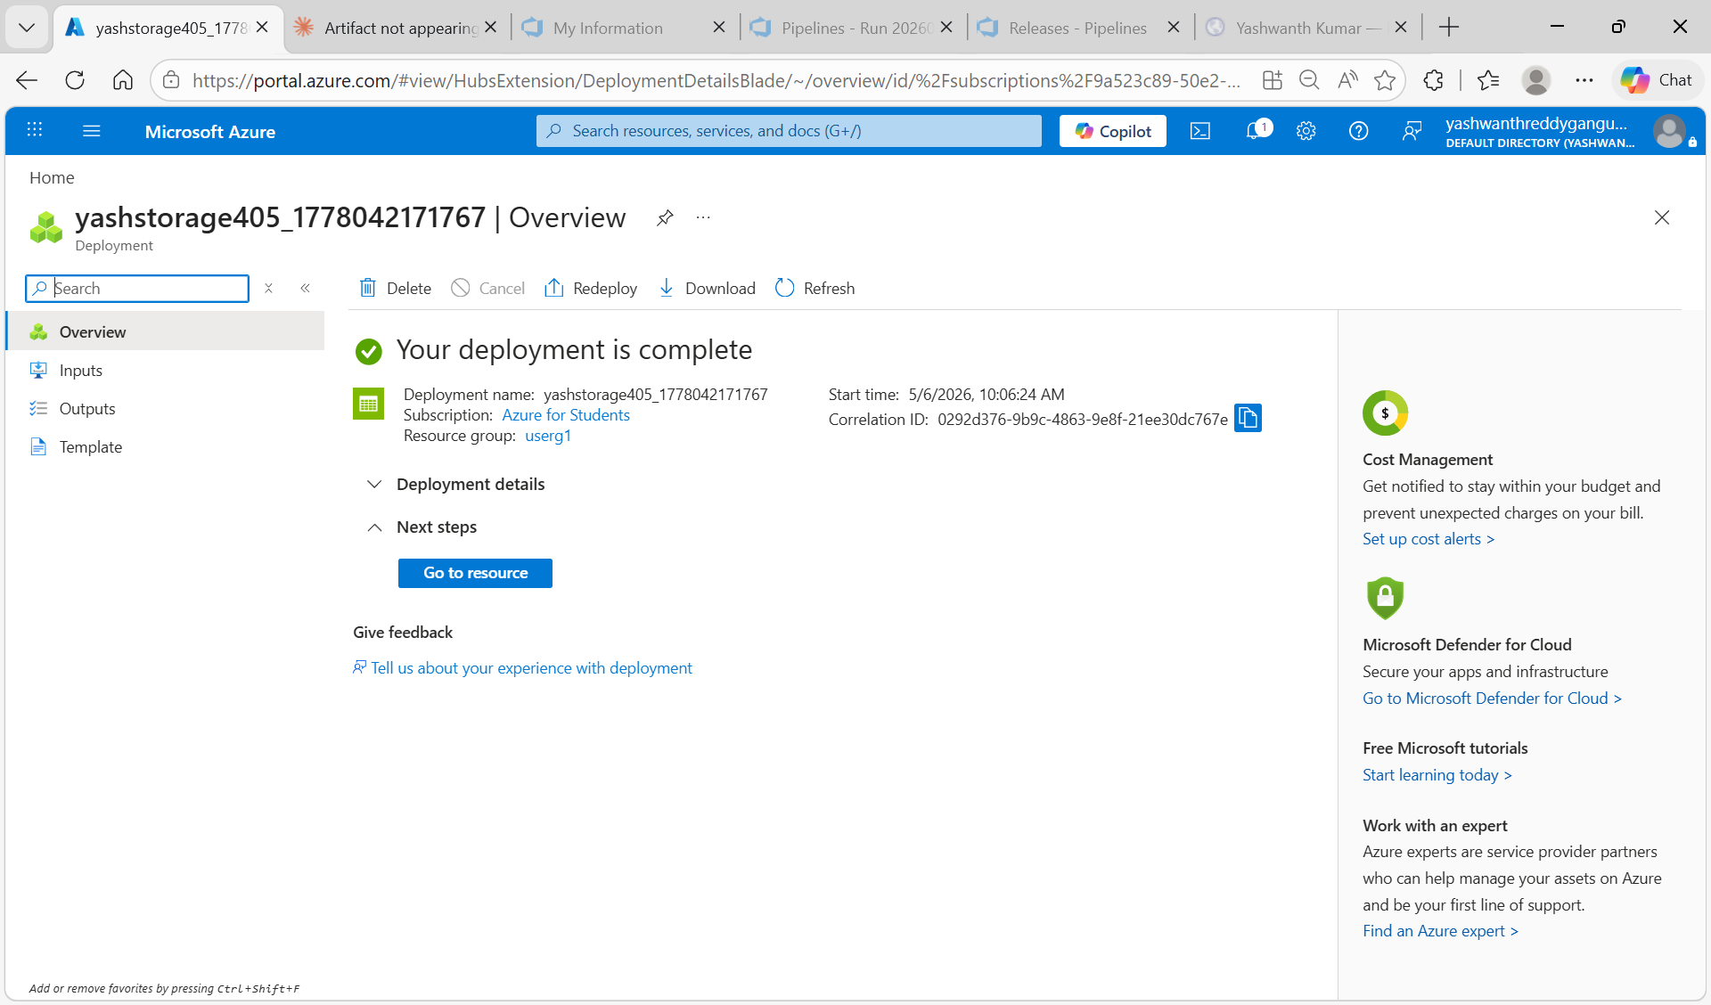
Figure 1.2: Storage account yashstorage405 deployment complete — "Your deployment is complete"

Copy Connection String
The connection string is needed later for the backend App Service environment variable. To copy it:
1. Left menu → Security + networking → Access keys
2. Click Show next to Connection string under key1
3. Copy the full connection string — save it in Notepad temporarily

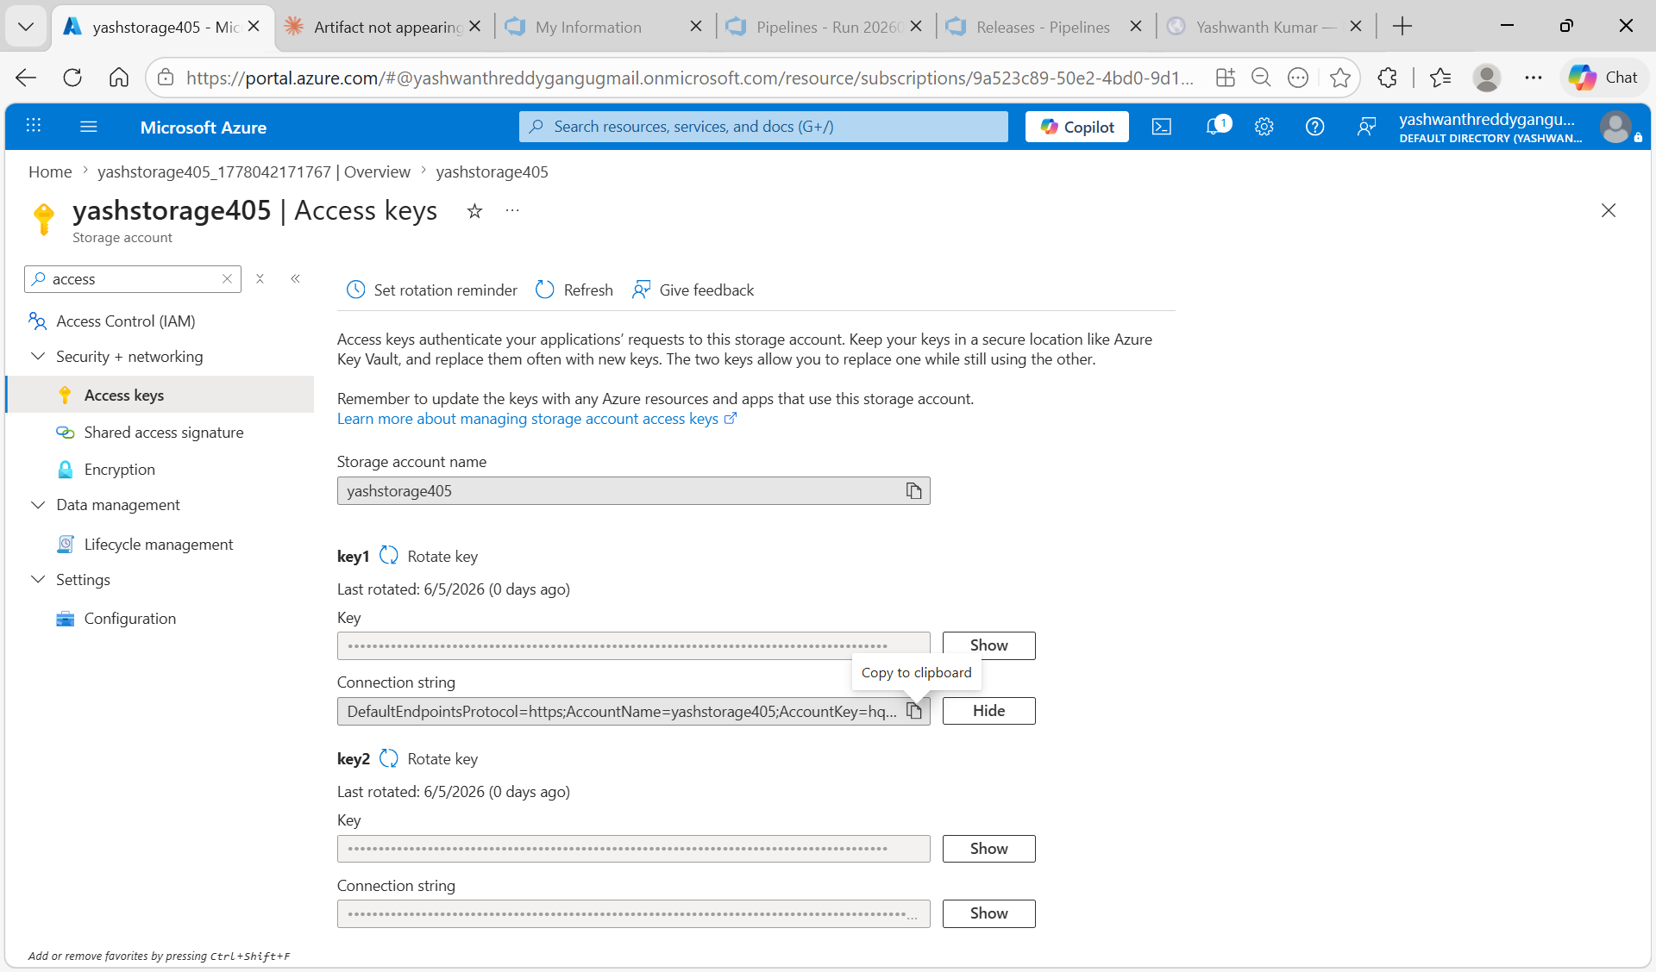
Figure 1.3: yashstorage405 Access keys — Connection string visible under key1 (click Show to reveal)

Step 2: Create Backend App Service
Azure Portal → App Services → Create. Configure:
- Name: yash-backend
- Publish: Code
- Runtime stack: Node 18 LTS
- Operating System: Linux
- Region: Central India
- Click Review + Create → Create

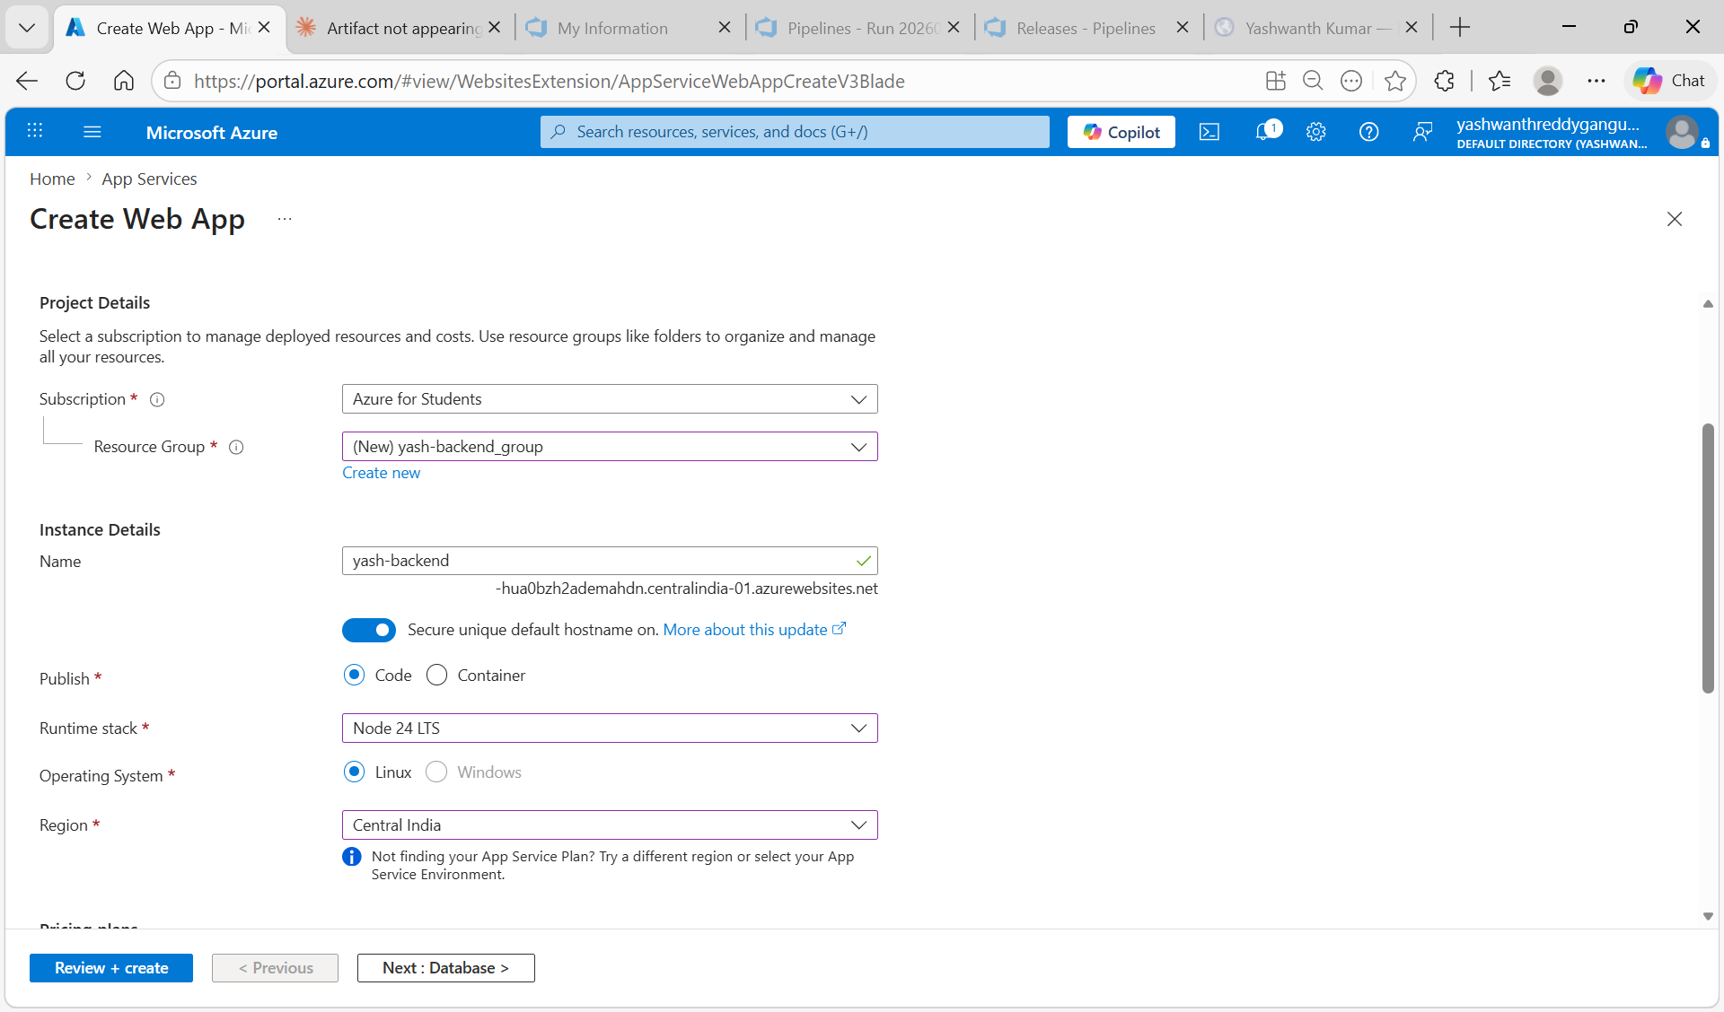
Figure 1.4: Create Web App — yash-backend, Node 24 LTS, Linux, Central India, resource group yash-backend_group

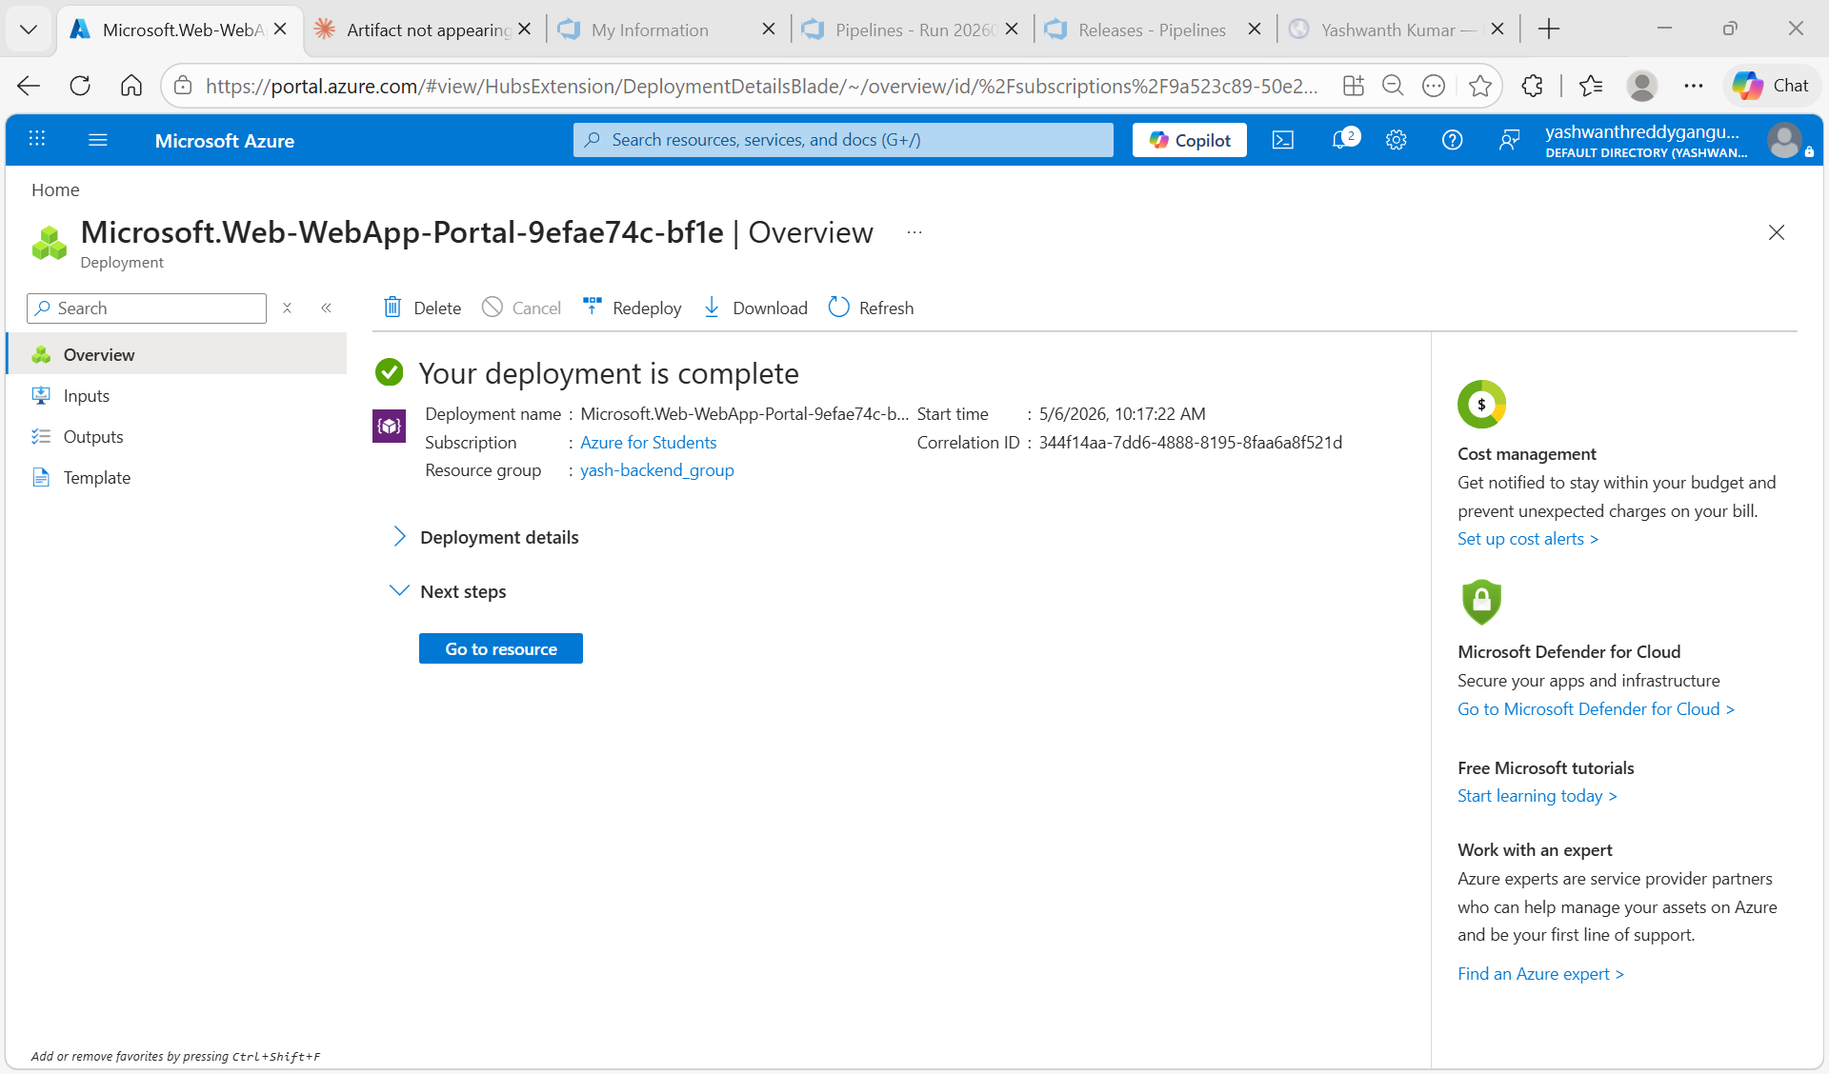
Figure 1.5: Backend App Service deployment complete — "Your deployment is complete"

Step 3: Create Frontend App Service
Same steps as backend. Configure:
- Name: yash-frontend
- Resource Group: userg1
- Runtime stack: Node 24 LTS
- Operating System: Linux
- Region: Central India

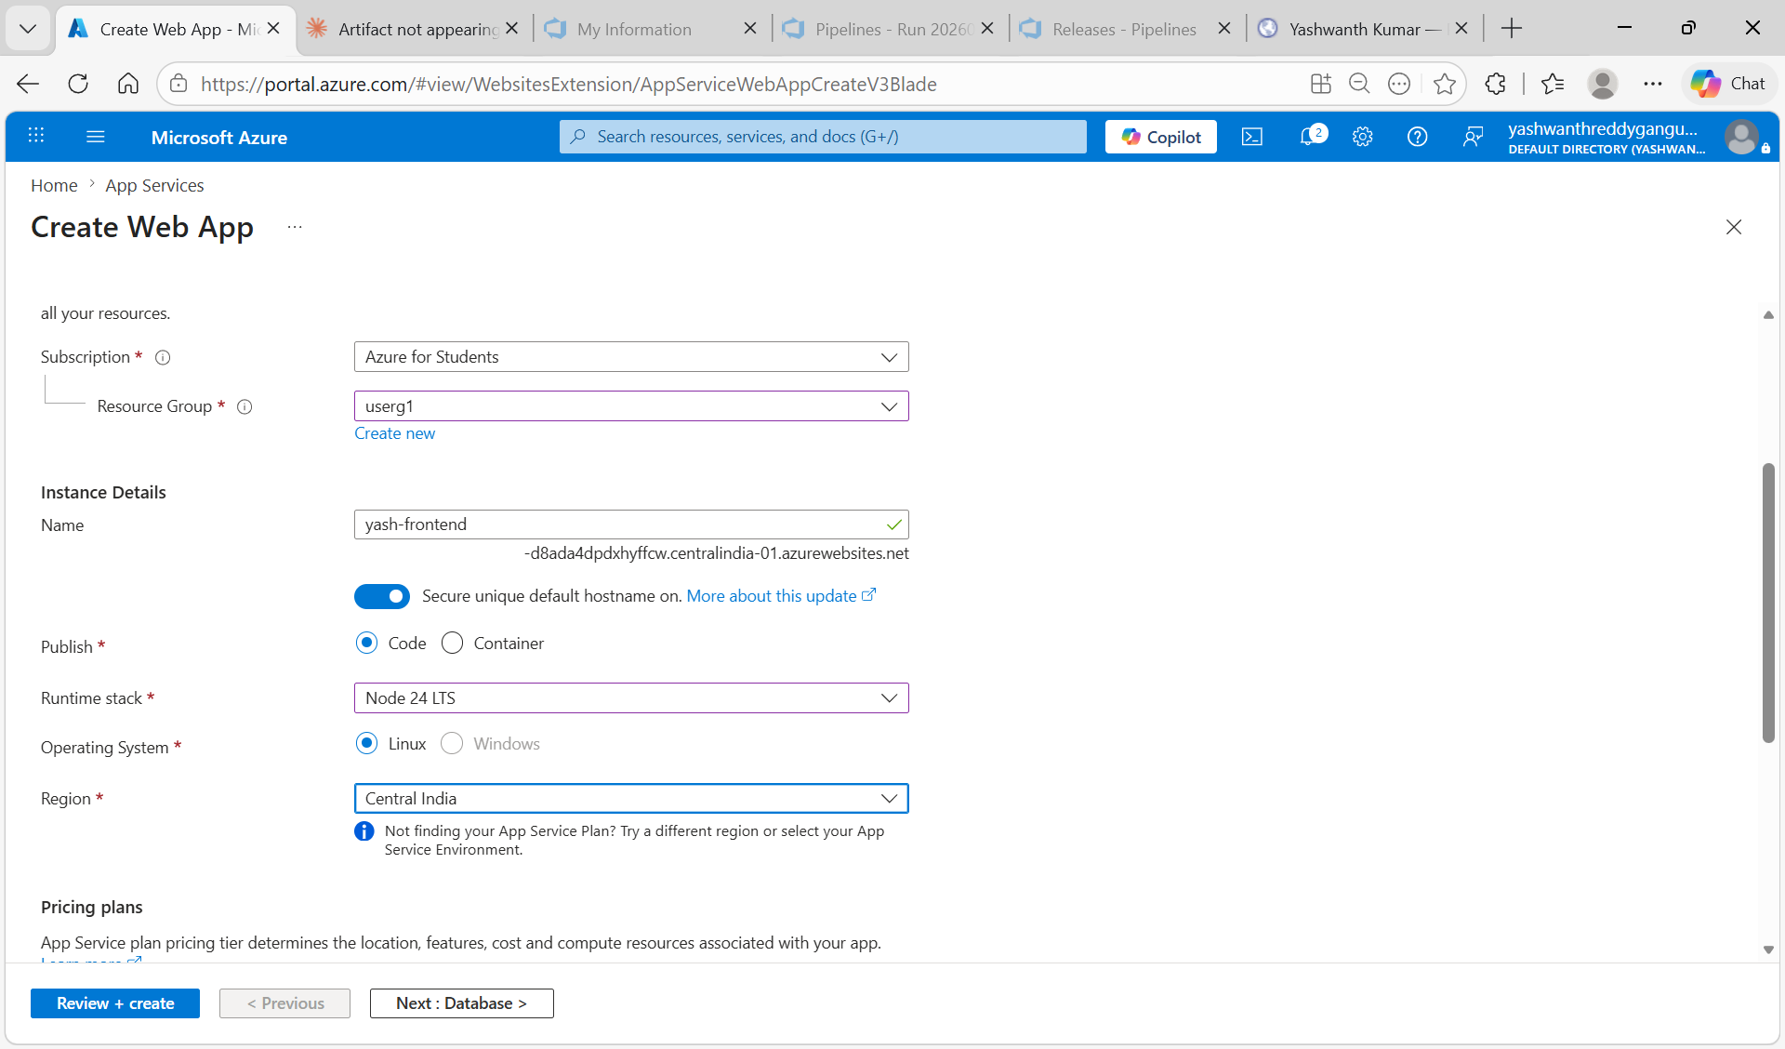
Figure 1.6: Create Web App — yash-frontend, Node 24 LTS, Linux, Central India, resource group userg1

Task 2: Push Code to Azure Repos

Step 1: Create Repositories in Azure DevOps
Go to dev.azure.com → project3 → Repos → click the repo dropdown → New repository.
- Create repo named: backend-repo
- Create repo named: frontend-repo

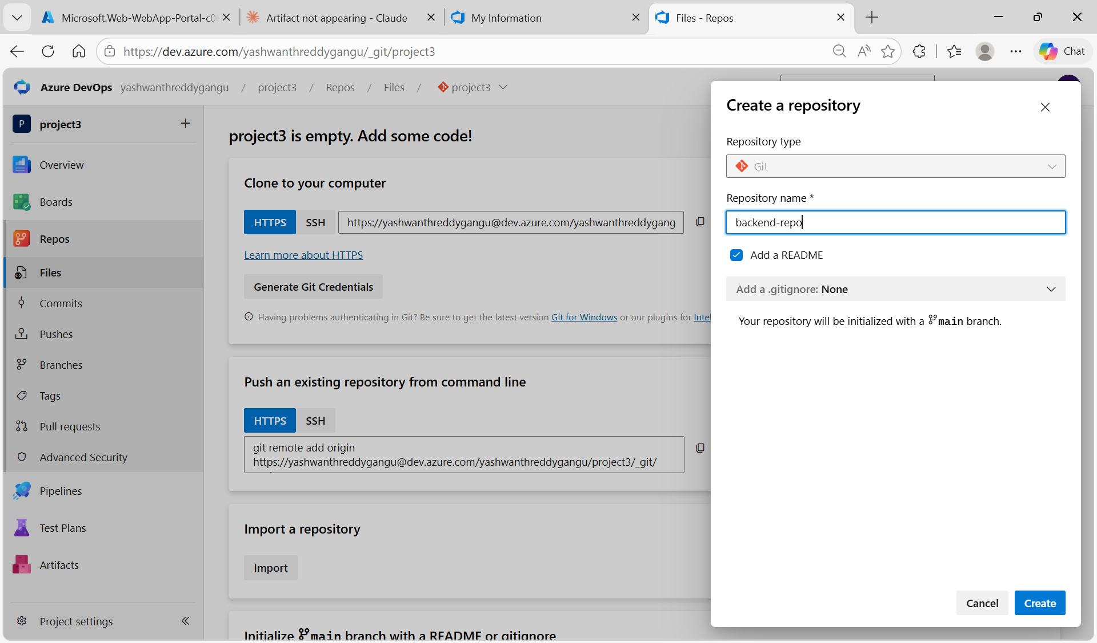
Figure 2.1: Azure DevOps — creating backend-repo in project3

Step 2: Push Backend Code
In VS Code, open the backend folder containing server.js, package.json, and .gitignore. Open terminal and run:

git init
git checkout -b main
git remote add origin https://yashwanthreddygangu@dev.azure.com/yashwanthreddygangu/project3/_git/backend-repo
git add .
git commit -m "Initial backend code"
git push -u origin main

DO NOT push .env file — connection string goes in Azure App Service Configuration only.

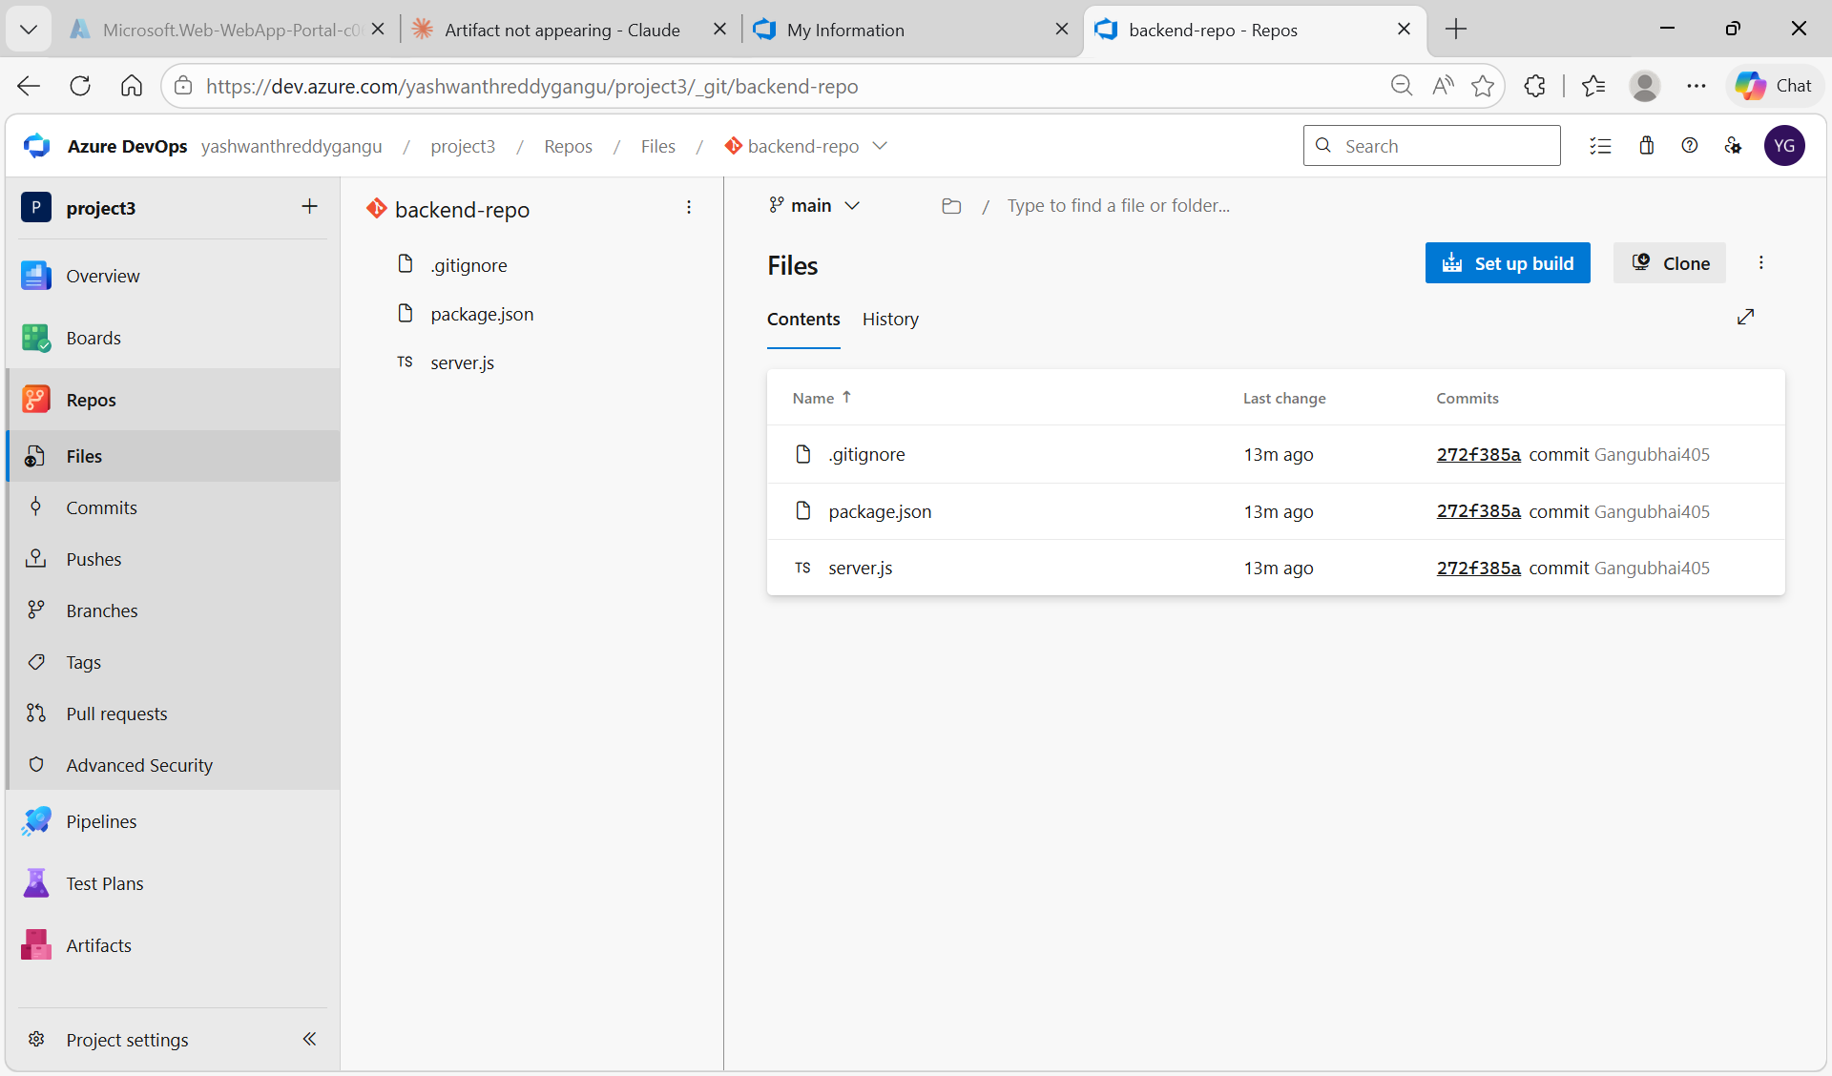
Figure 2.2: Azure Repos backend-repo — showing server.js, package.json, .gitignore pushed successfully

Step 3: Push Frontend Code
In VS Code, open the frontend folder containing only index.html. Run:

git init
git checkout -b main
git remote add origin https://yashwanthreddygangu@dev.azure.com/yashwanthreddygangu/project3/_git/frontend-repo
git add .
git commit -m "Initial frontend code"
git push -u origin main

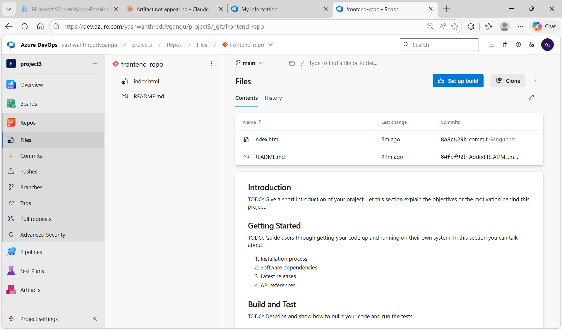
Figure 2.3: Azure Repos frontend-repo — showing index.html pushed successfully

Task 3: Add Environment Variables to Backend App Service

Step 1: Open Backend App Service Configuration
Azure Portal → App Services → yash-backend → left menu → Environment variables → App settings tab.

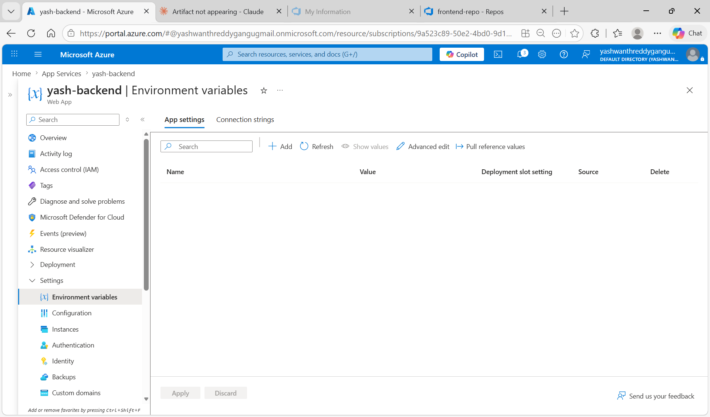
Figure 3.1: yash-backend Environment variables page — empty App settings tab, ready to add connection string

Step 2: Add AZURE_STORAGE_CONNECTION_STRING
Click + Add and fill in:
- Name: AZURE_STORAGE_CONNECTION_STRING
- Value: paste the full connection string copied from Step 1.3
- Click Apply

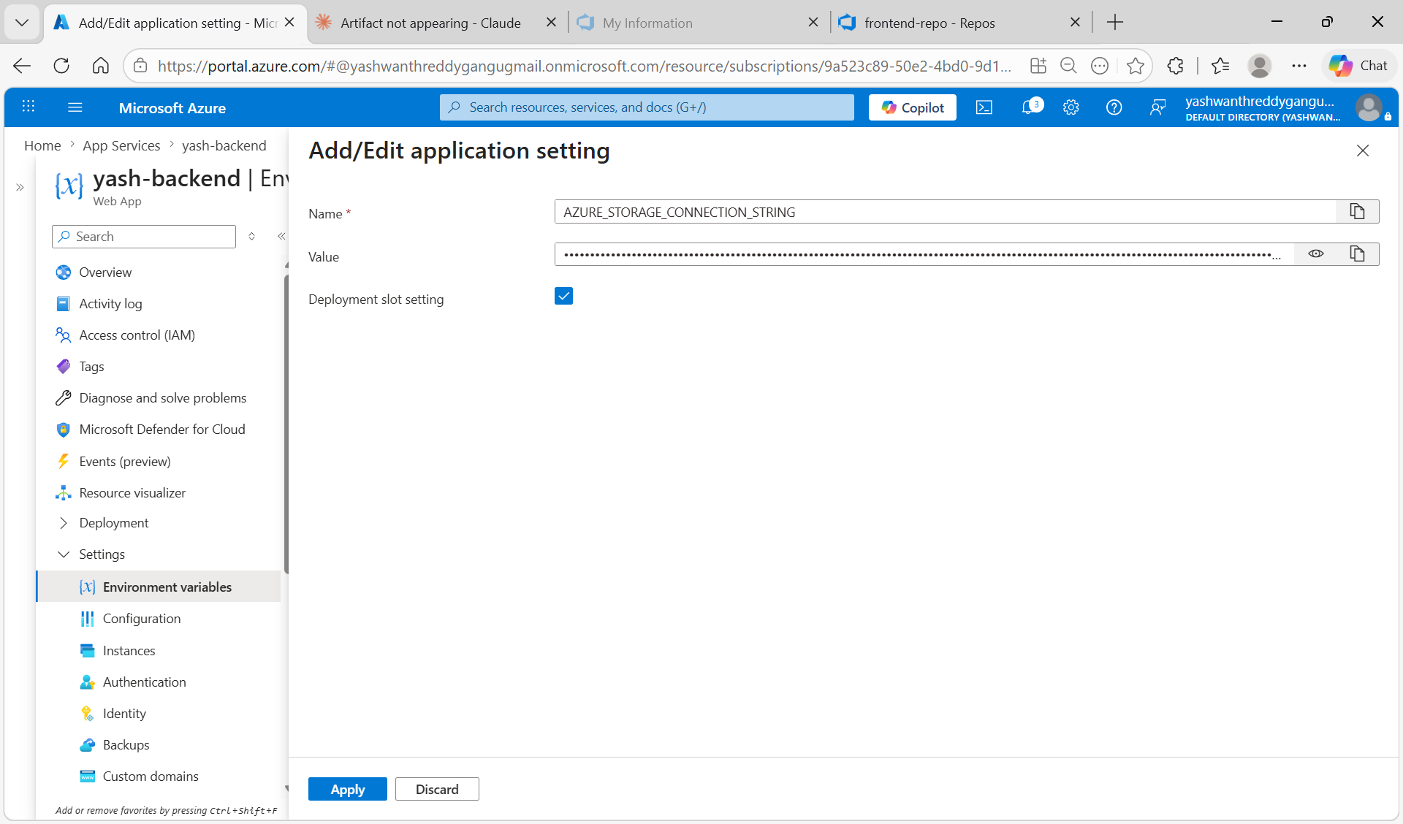
Figure 3.2: Add/Edit application setting — Name: AZURE_STORAGE_CONNECTION_STRING, value pasted (hidden)

Step 3: Add CONTAINER_NAME
Click + Add again:
- Name: CONTAINER_NAME
- Value: uploads
- Click Apply

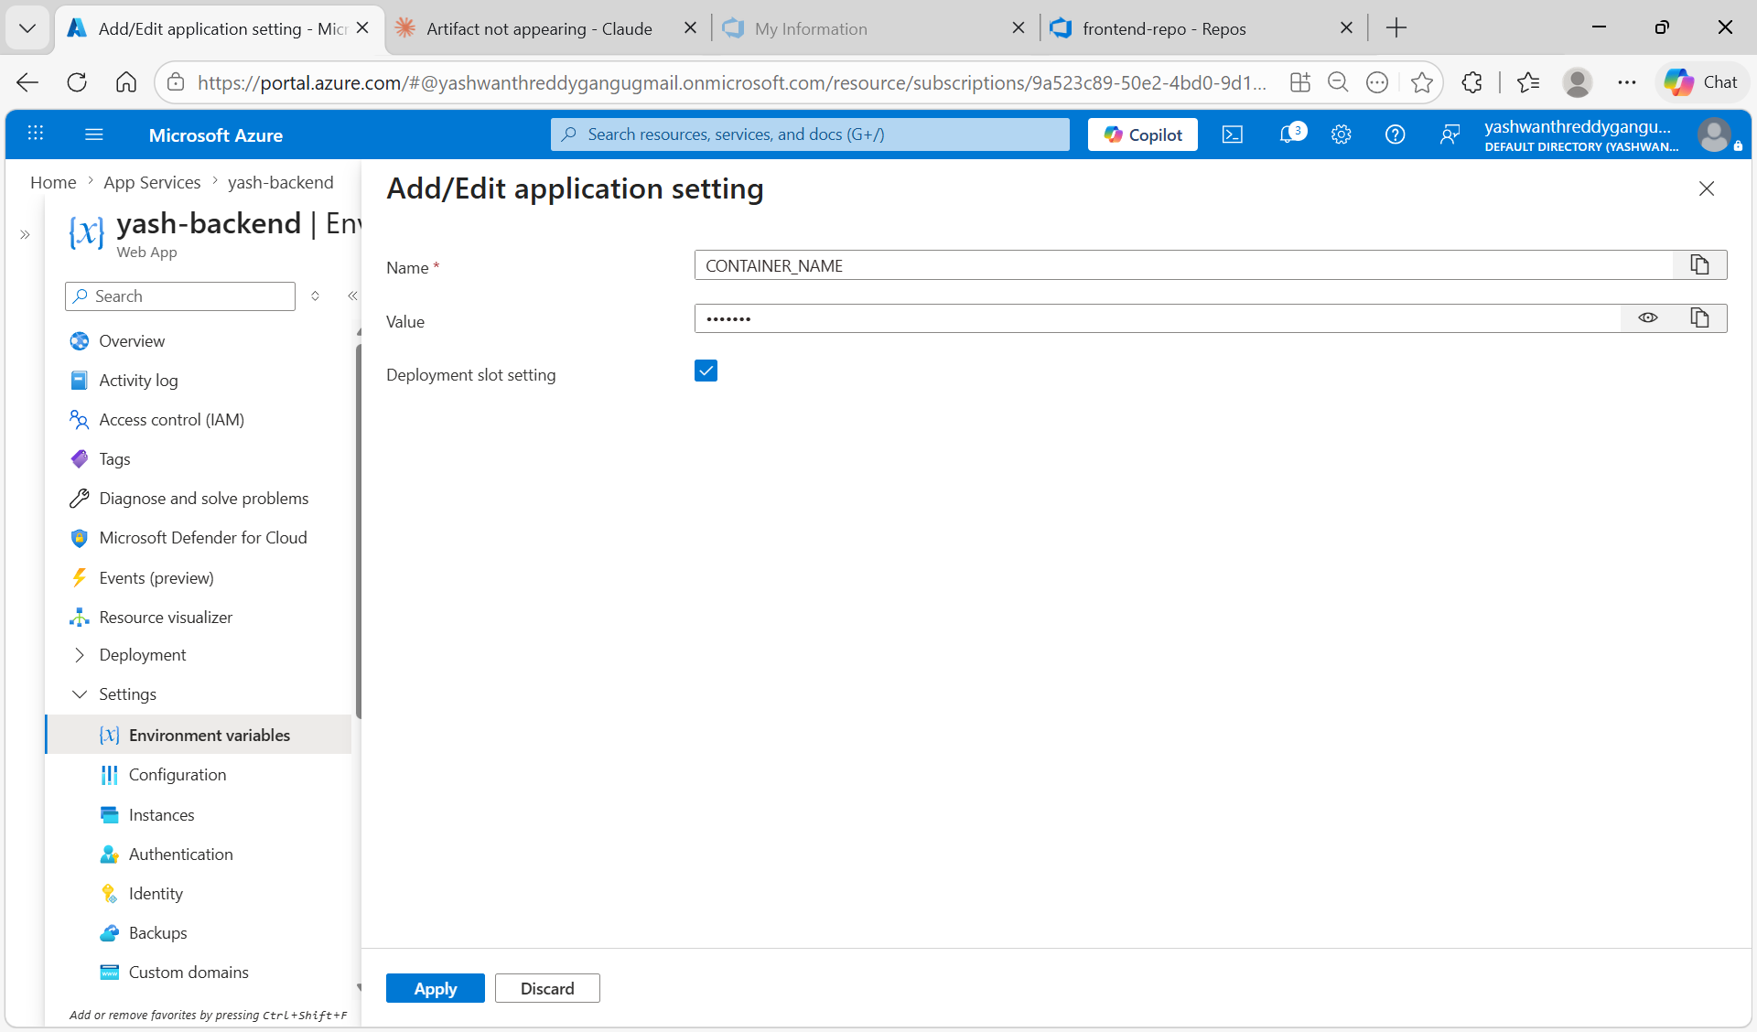
Figure 3.3: Add/Edit application setting — Name: CONTAINER_NAME, Value: uploads

Step 4: Save and Verify
Click Save at the top → Continue. Both environment variables should now appear in the list.

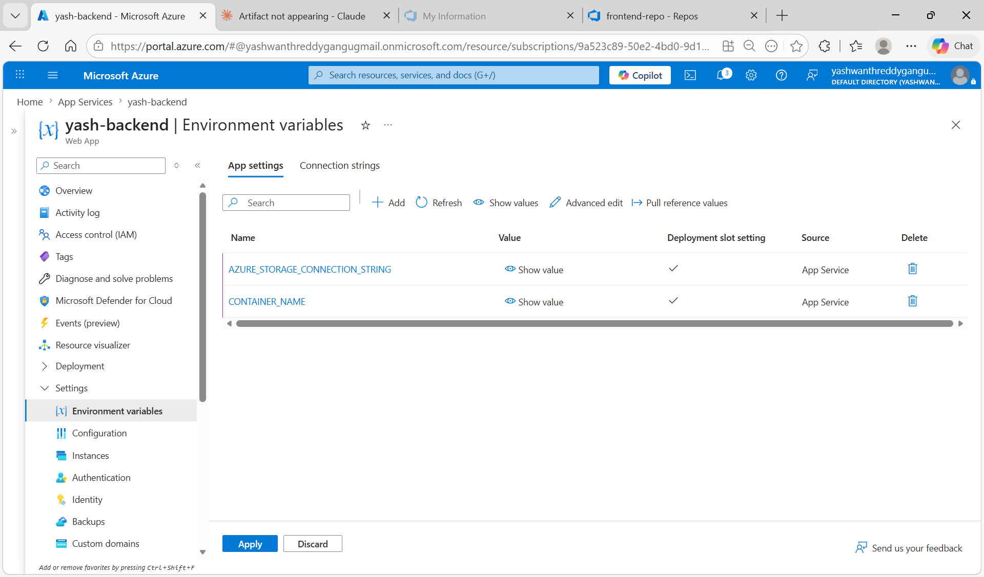
Figure 3.4: yash-backend Environment variables — AZURE_STORAGE_CONNECTION_STRING and CONTAINER_NAME both saved

Step 5: Set Startup Command
Left menu → Configuration → General settings tab → Startup command field → type:
node server.js
Click Apply → Save. This tells Azure App Service how to start the Node.js backend.

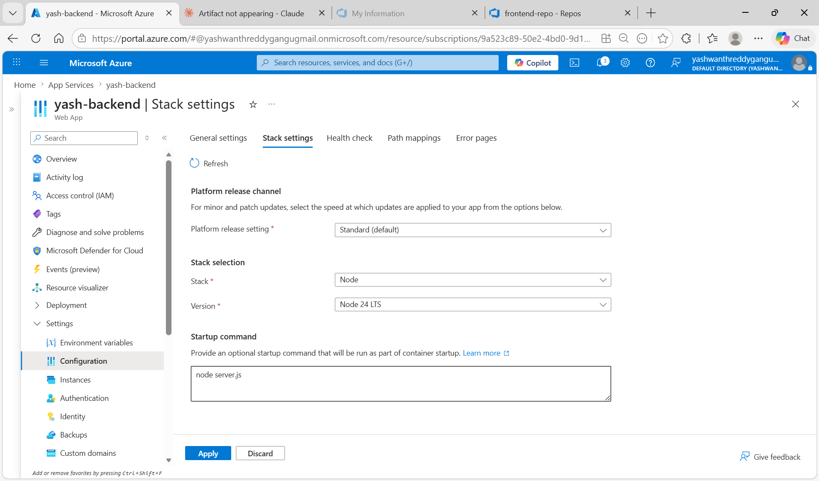
Figure 3.5: yash-backend Stack settings — Node stack, Node 24 LTS version, startup command: node server.js

Task 4: Enable Classic Pipelines and Create CI Pipelines

Step 1: Enable Classic Release Pipelines
Azure DevOps → Organization Settings → Pipelines → Settings. Turn OFF both "Disable creation of classic build pipelines" and "Disable creation of classic release pipelines".

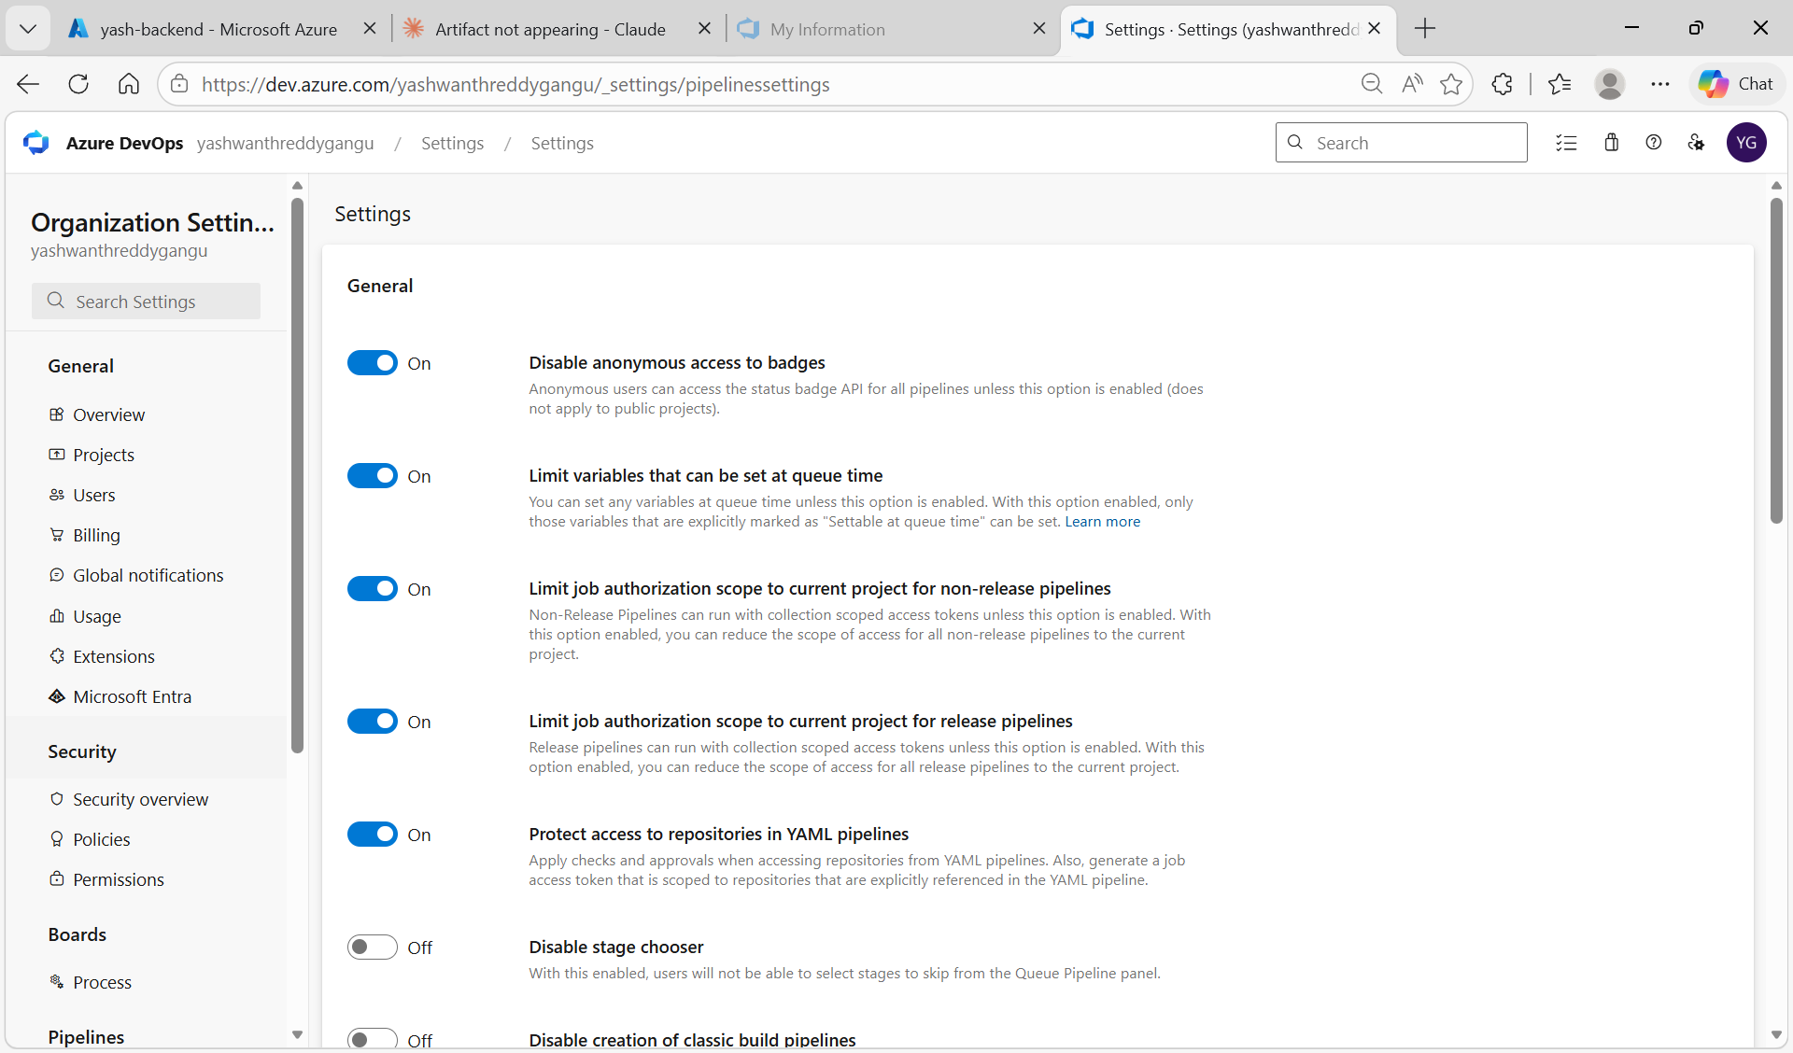
Figure 4.1: Organization Settings → Pipelines → Settings page showing pipeline settings

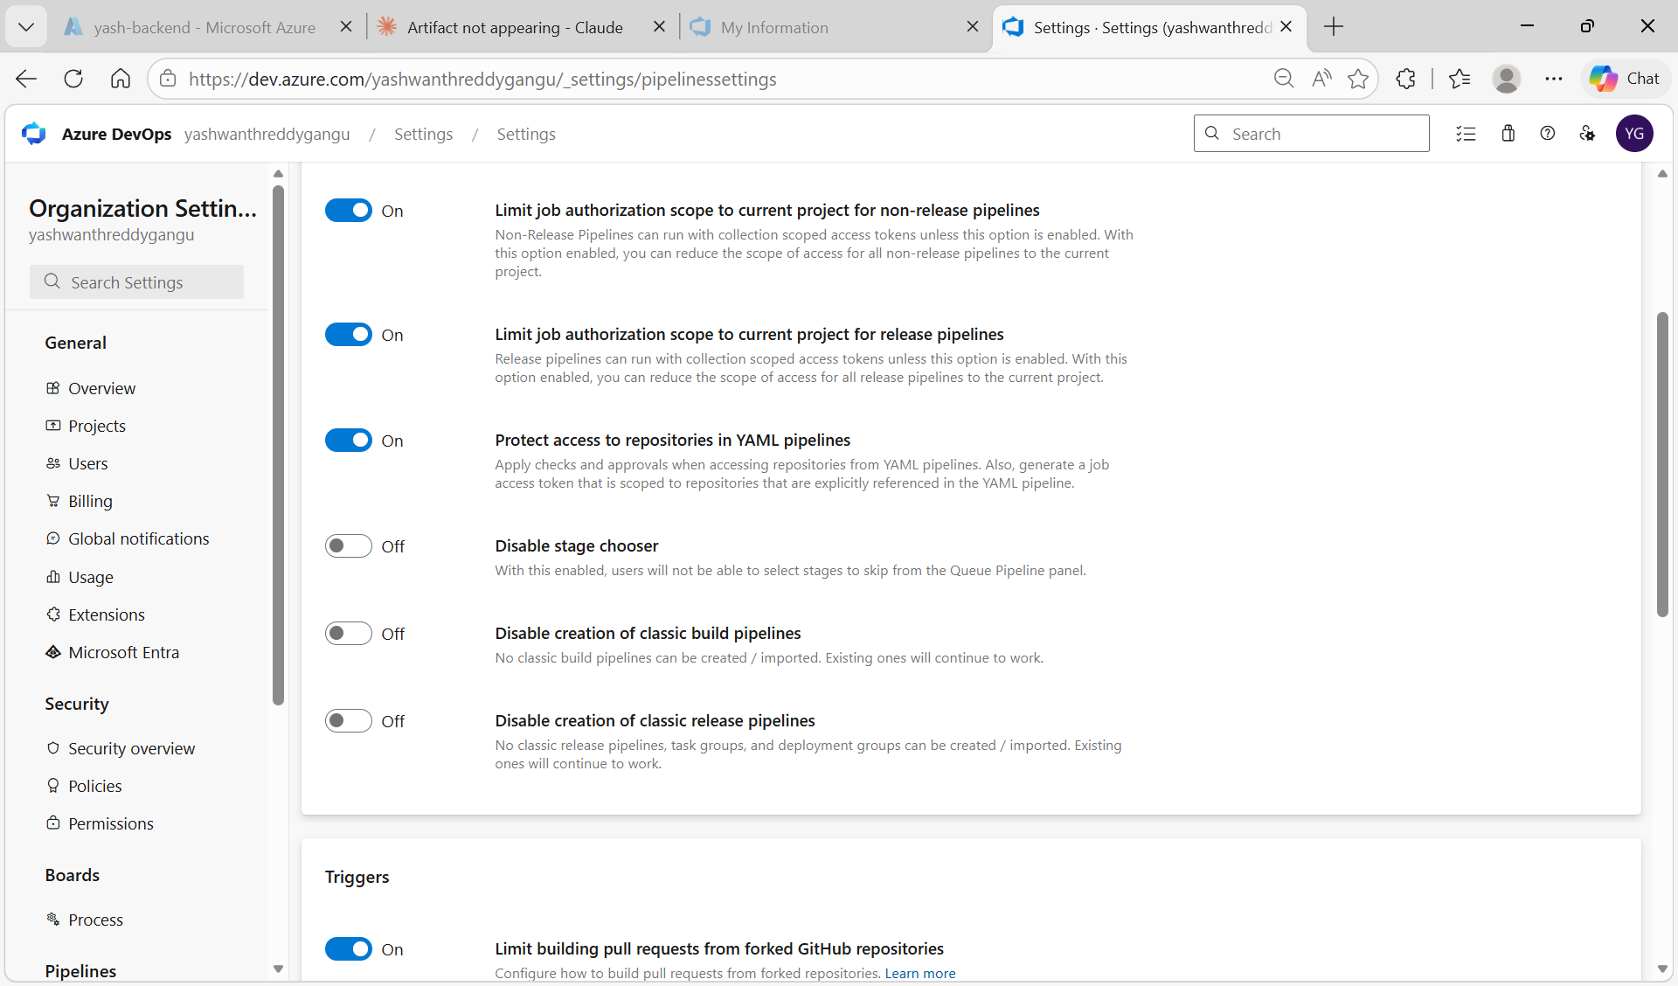
Figure 4.2: Scrolled down — "Disable creation of classic build pipelines" and "Disable creation of classic release pipelines" both turned OFF

Step 2: Create Backend CI Pipeline
Pipelines → New pipeline → Azure Repos Git → select backend-repo → Review your pipeline YAML. Use the following YAML:

trigger:
- main

pool:
vmImage: 'ubuntu-latest'

steps:
- task: NodeTool@0
displayName: 'Install Node.js 18'
inputs:
versionSpec: '18.x'
- script: npm install
displayName: 'npm install'
- task: ArchiveFiles@2
displayName: 'Zip backend files'
inputs:
rootFolderOrFile: '$(Build.SourcesDirectory)'
includeRootFolder: false
archiveType: 'zip'
archiveFile: '$(Build.ArtifactStagingDirectory)/backend.zip'
replaceExistingArchive: true
- task: PublishBuildArtifacts@1
displayName: 'Publish artifact'
inputs:
pathToPublish: '$(Build.ArtifactStagingDirectory)/backend.zip'
artifactName: 'backend'

Step 3: Create Frontend CI Pipeline
Same steps, select frontend-repo. Use this YAML:

trigger:
- main

pool:
vmImage: 'ubuntu-latest'

steps:
- task: ArchiveFiles@2
displayName: 'Zip frontend files'
inputs:
rootFolderOrFile: '$(Build.SourcesDirectory)'
includeRootFolder: false
archiveType: 'zip'
archiveFile: '$(Build.ArtifactStagingDirectory)/frontend.zip'
replaceExistingArchive: true
- task: PublishBuildArtifacts@1
displayName: 'Publish artifact'
inputs:
pathToPublish: '$(Build.ArtifactStagingDirectory)/frontend.zip'
artifactName: 'frontend'

Step 4: Select Repositories
When creating pipelines, the Select a repository screen shows both repos in project3.

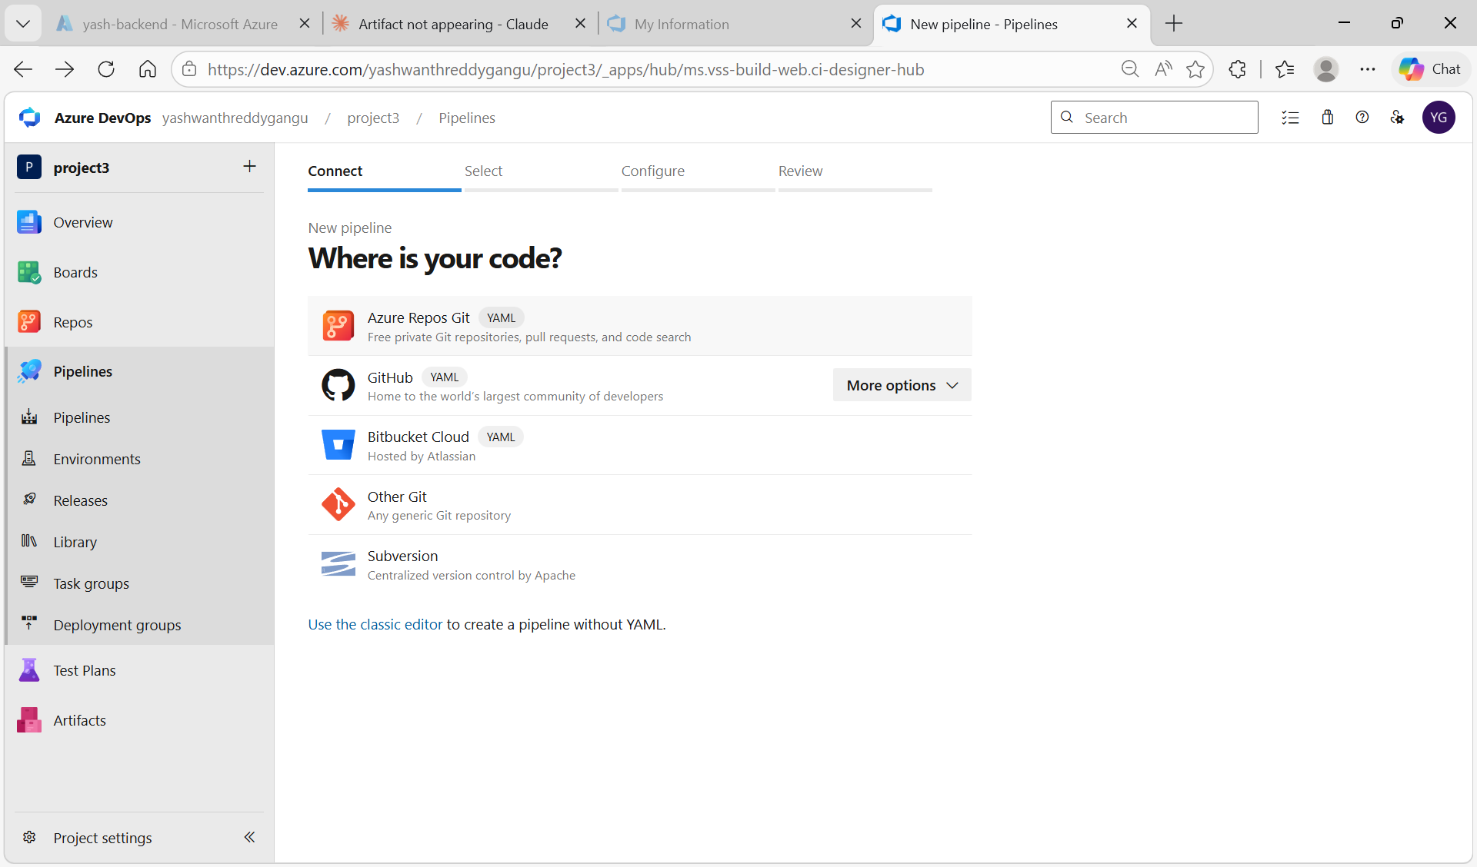
Figure 4.3: New pipeline — Where is your code? Select Azure Repos Git YAML

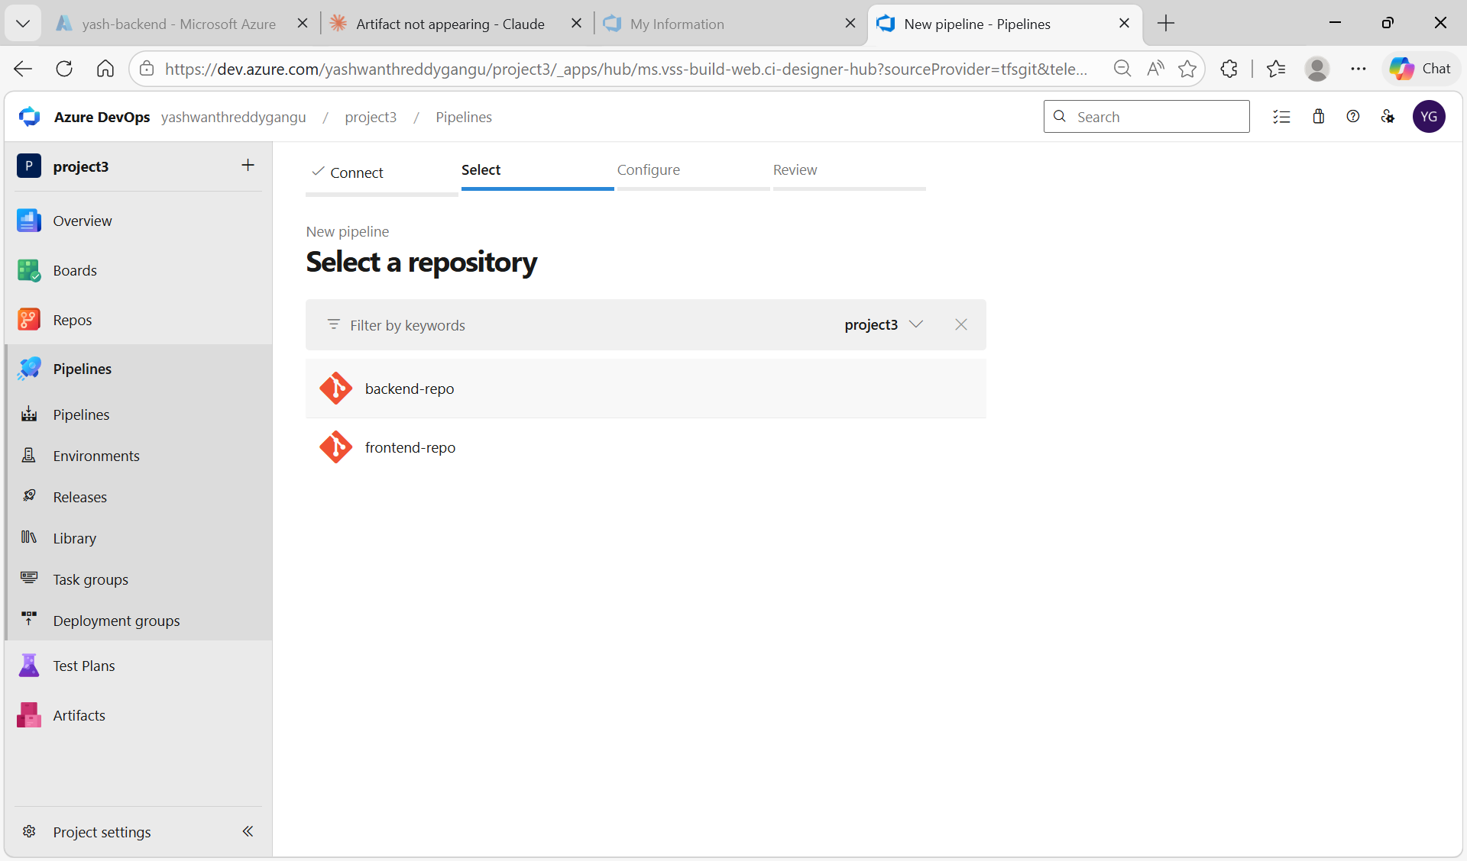
Figure 4.4: Select a repository — both backend-repo and frontend-repo visible in project3

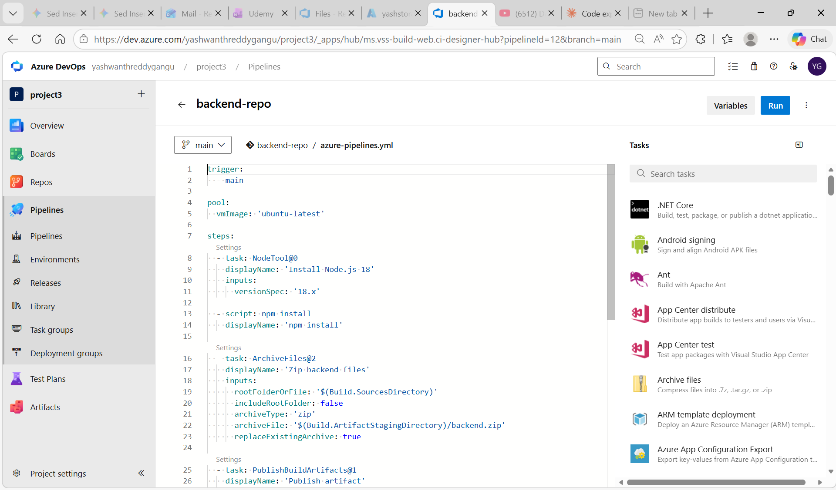

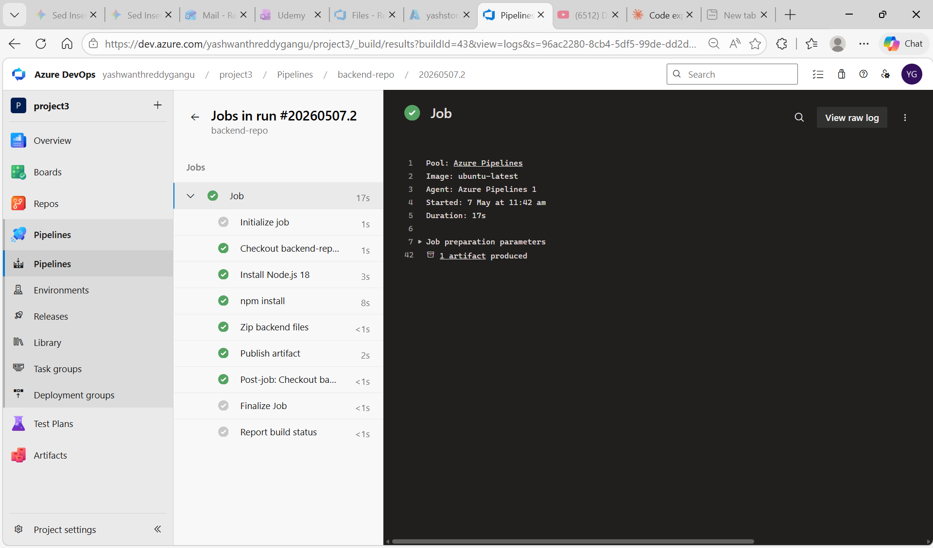

Task 5: Create Release Pipelines (CD)

Step 1: Create Backend Release Pipeline
Pipelines → Releases → New pipeline → Empty job. Add artifact from backend-repo CI pipeline.

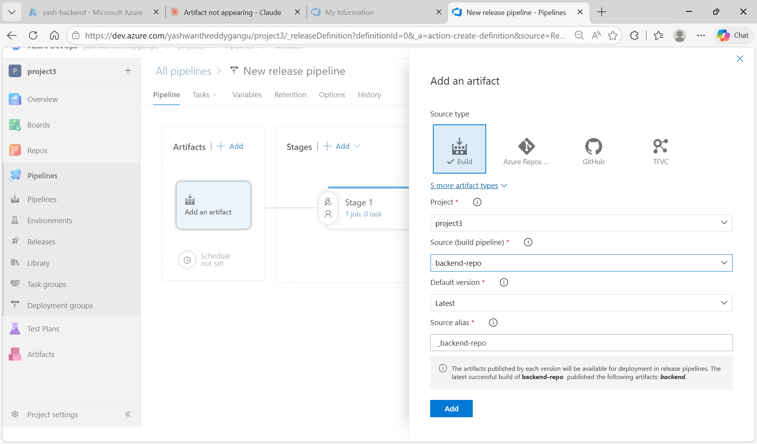
Figure 5.1: Release pipeline — Add an artifact. Source type: Build, Source pipeline: backend-repo, Source alias: _backend-repo

Step 2: Add Azure App Service Deploy Task
Tasks tab → Agent job → + → search "Azure App Service deploy" → Add.

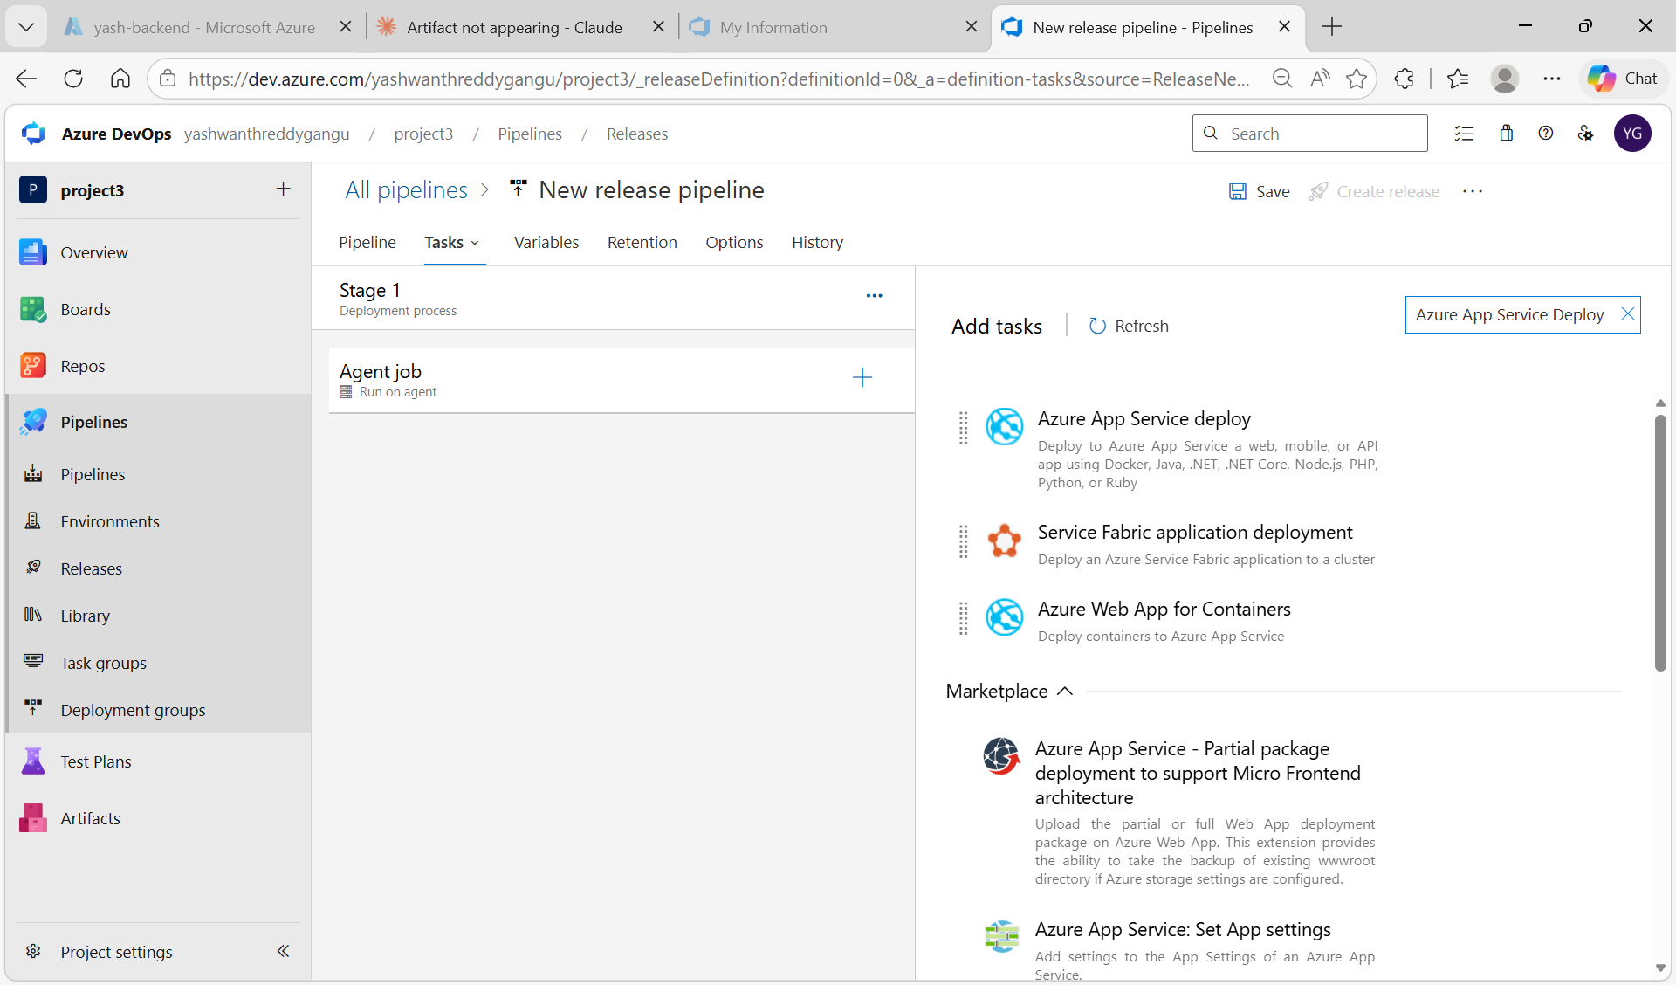
Figure 5.2: Release pipeline Tasks — searching for "Azure App Service Deploy" task

Step 3: Create New Service Connection
The initial service connection was scoped to DefaultResourceGroup-CID which did not contain the App Services. A new service connection scoped to yash-backend_group was needed.
Project Settings → Service connections → New service connection → Azure Resource Manager → Service principal (automatic).

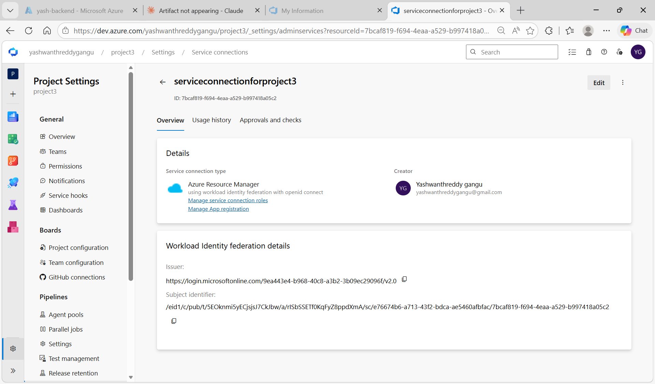
Figure 5.3: serviceconnectionforproject3 — Azure Resource Manager with workload identity federation

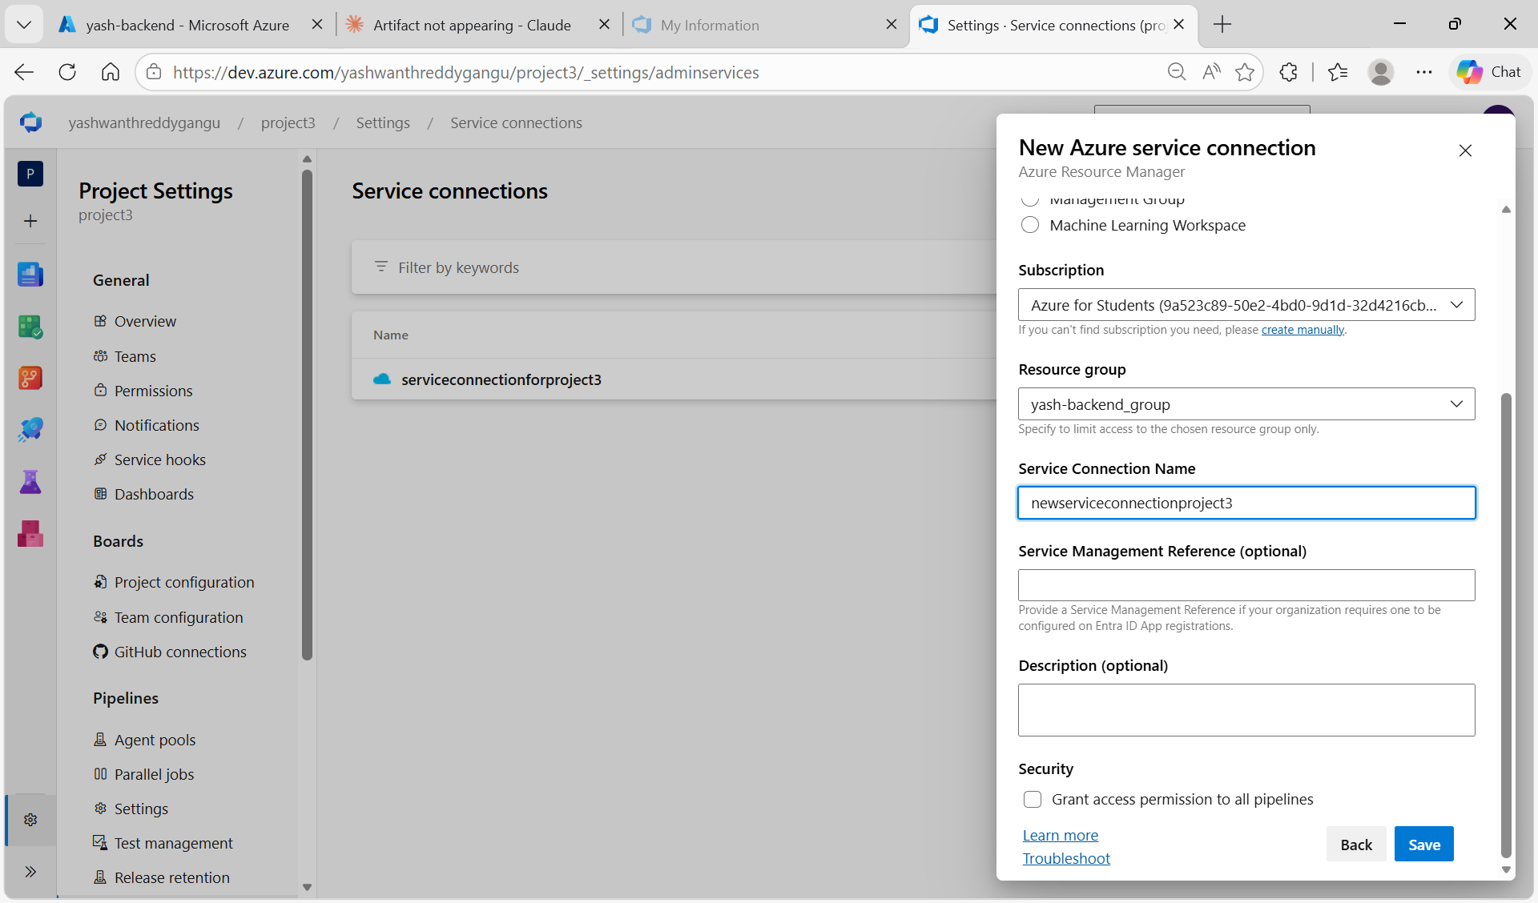
Figure 5.4: New Azure service connection — scoped to subscription Azure for Students, resource group yash-backend_group, name newserviceconnectionproject3

Step 4: Configure Backend Deploy Task
Select the new service connection and configure the deploy task:
- Azure subscription: newserviceconnectionproject3
- App Service type: Web App on Linux
- App Service name: yash-backend (select from dropdown)
- Package or folder: $(System.DefaultWorkingDirectory)/_backend-repo/backend/backend.zip

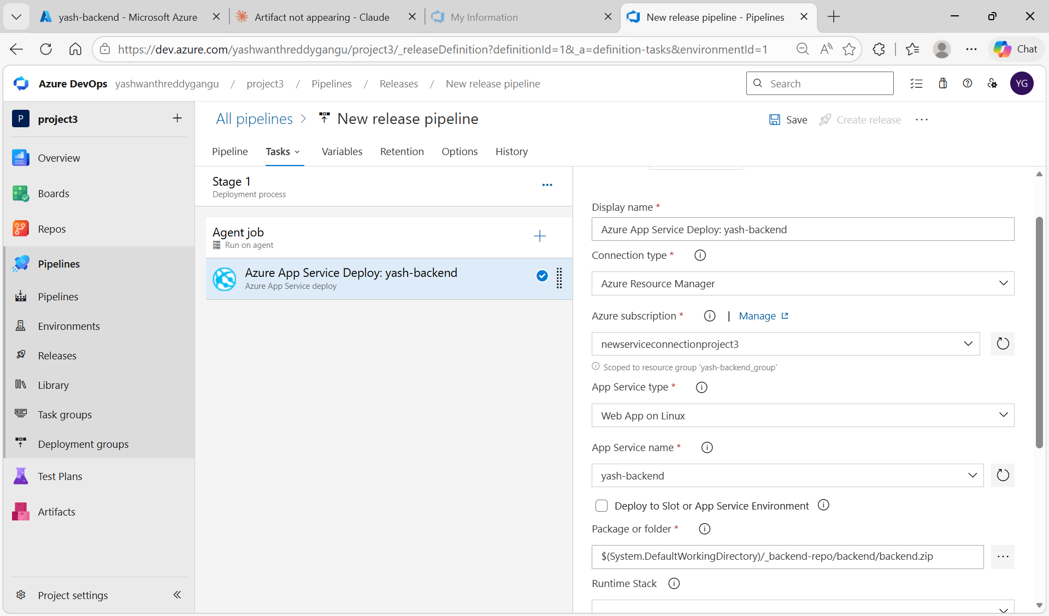
Figure 5.5: Deploy IIS Website/App task configured — newserviceconnectionproject3, Web App on Linux, yash-backend, package path set

Step 5: Deploy Backend — Release Succeeded
Save → Create release → Deploy Stage 1. The release deploys the backend.zip to yash-backend App Service.

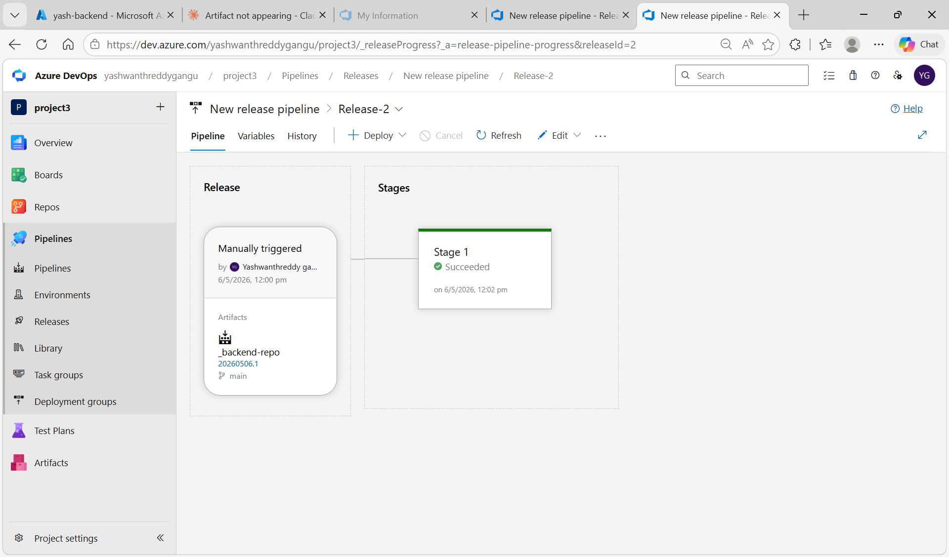
Figure 5.6: Backend Release-2 — Stage 1 Succeeded on 6/5/2026 12:00 pm

Step 6: Create Frontend Release Pipeline
New release pipeline → add artifact from frontend-repo CI pipeline → add Azure App Service Deploy task.

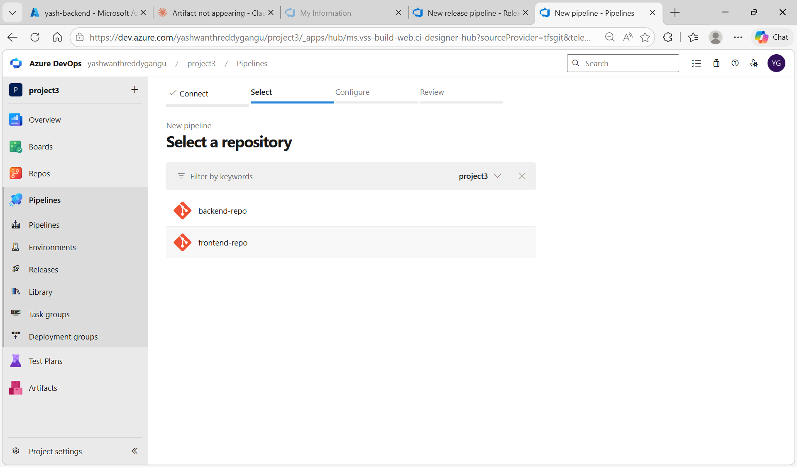
Figure 5.7: Select repository for frontend CI pipeline — frontend-repo visible

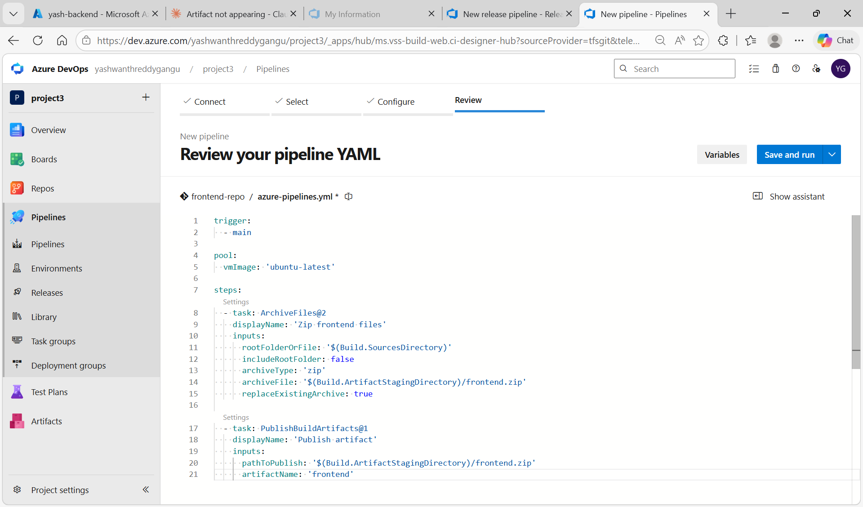
Figure 5.8: Frontend CI pipeline YAML — ArchiveFiles and PublishBuildArtifacts tasks

Step 7: Frontend CI Build Succeeds
Frontend pipeline runs. All steps green — Zip frontend files, Publish artifact. 1 artifact published.

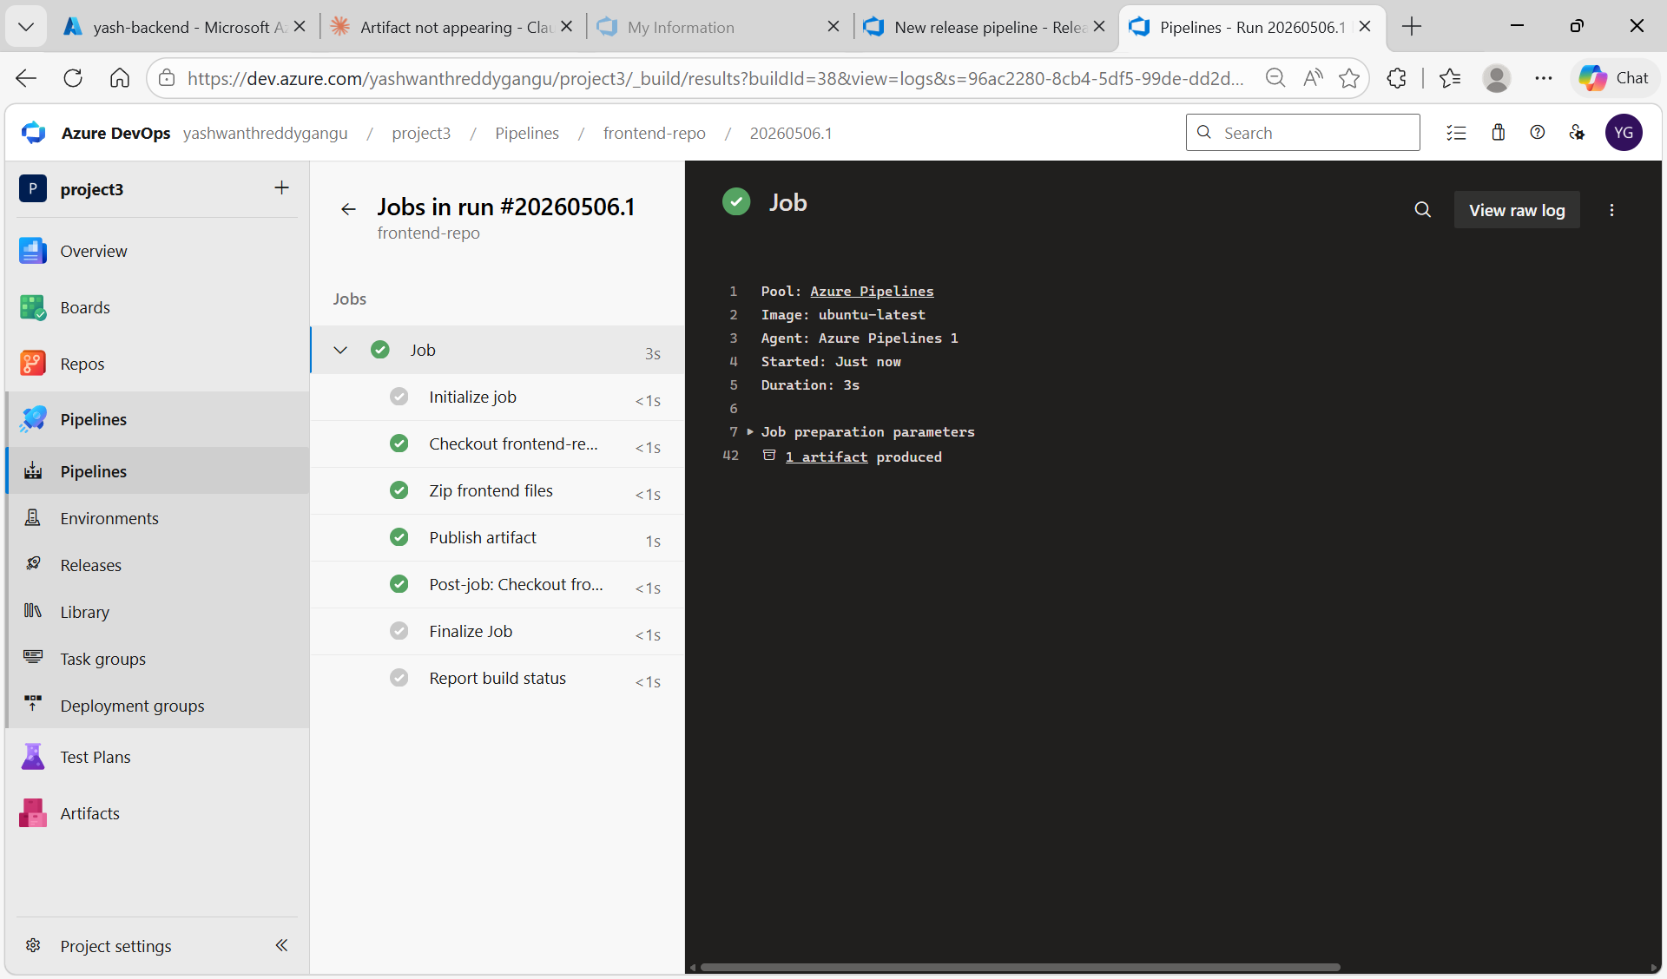
Figure 5.9: Frontend CI run #20260506.1 succeeded — Zip frontend files, Publish artifact all green, 1 artifact produced

Step 8: Frontend Release Pipeline Tasks
Stage 2 → Agent job → + → Azure App Service deploy task added.

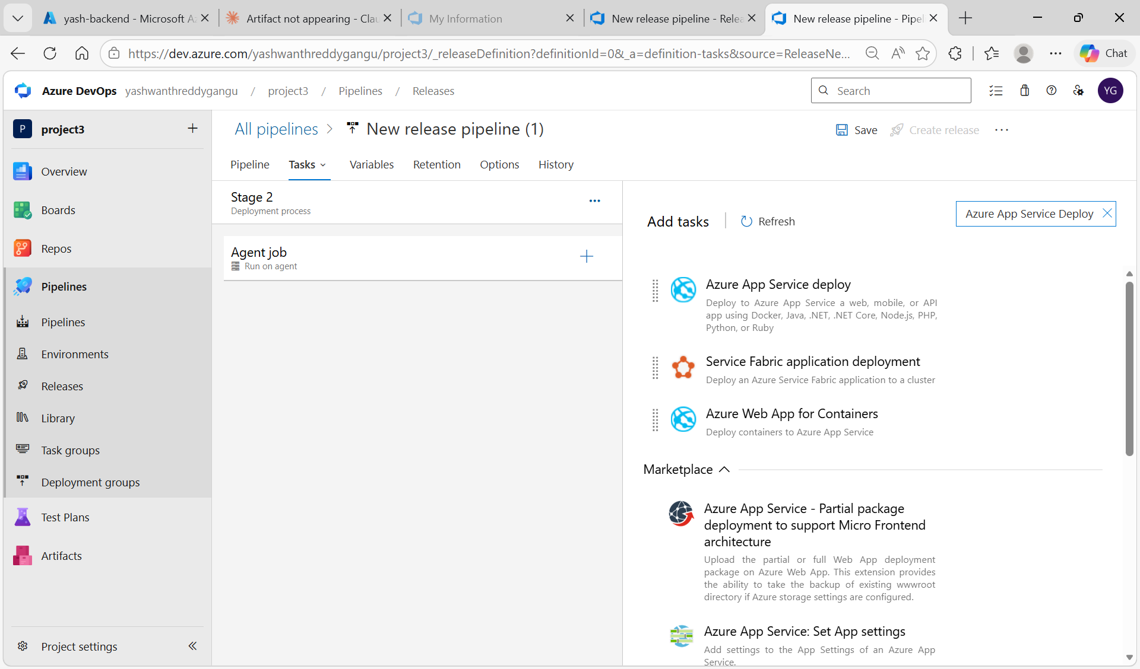
Figure 5.10: Frontend release pipeline Stage 2 — searching for Azure App Service Deploy task

Step 9: Configure Frontend Deploy Task
Configure the frontend deploy task:
- Azure subscription: serviceconnectionforproject3 (scoped to userg1)
- App Service type: Web App on Linux
- App Service name: yash-frontend
- Package: $(System.DefaultWorkingDirectory)/_frontend-repo/frontend/frontend.zip

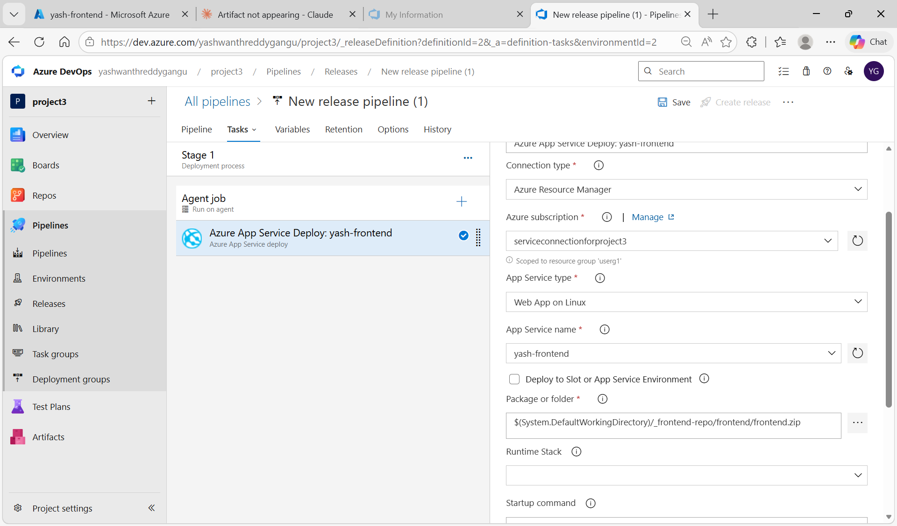
Figure 5.11: Frontend Azure App Service Deploy task — serviceconnectionforproject3, Web App on Linux, yash-frontend, package path

Step 10: Frontend Release Succeeded
Create release → Deploy. Stage 1 shows Succeeded.

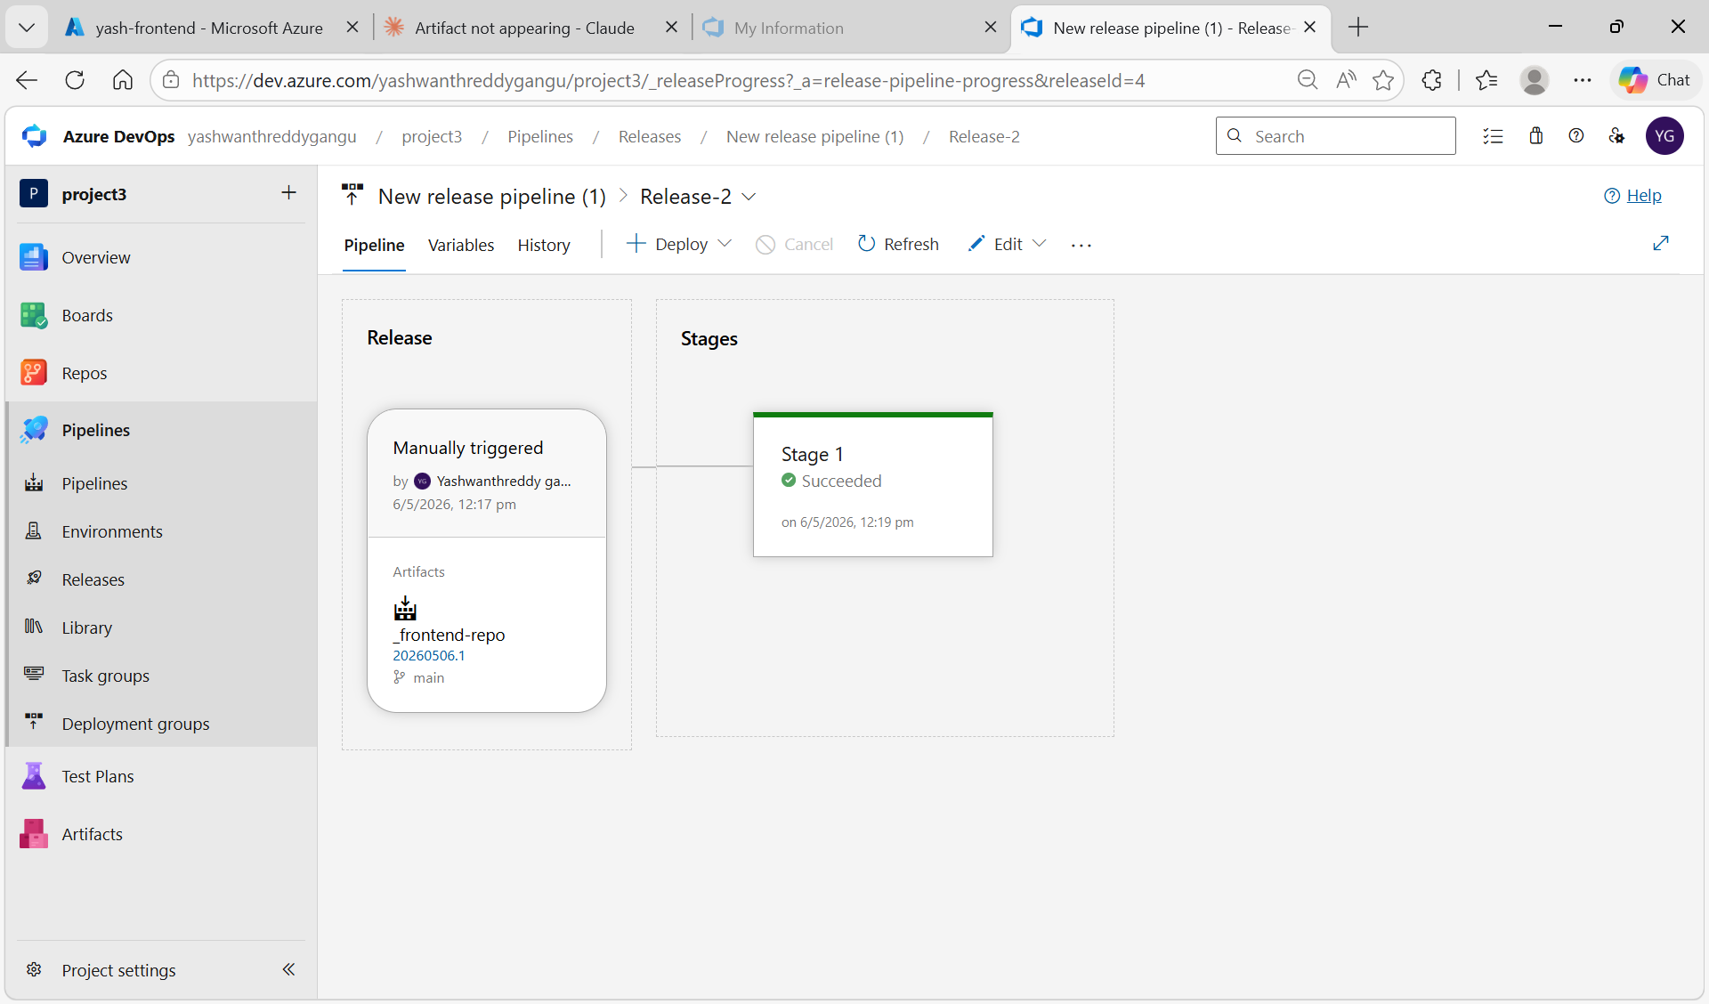
Figure 5.12: Frontend Release-2 — Stage 1 Succeeded on 6/5/2026 12:19 pm

Task 6: Configure Storage and Test Application

Step 1: Verify Backend Environment Variables
After both releases succeed, verify the backend environment variables are correctly set in Azure Portal.

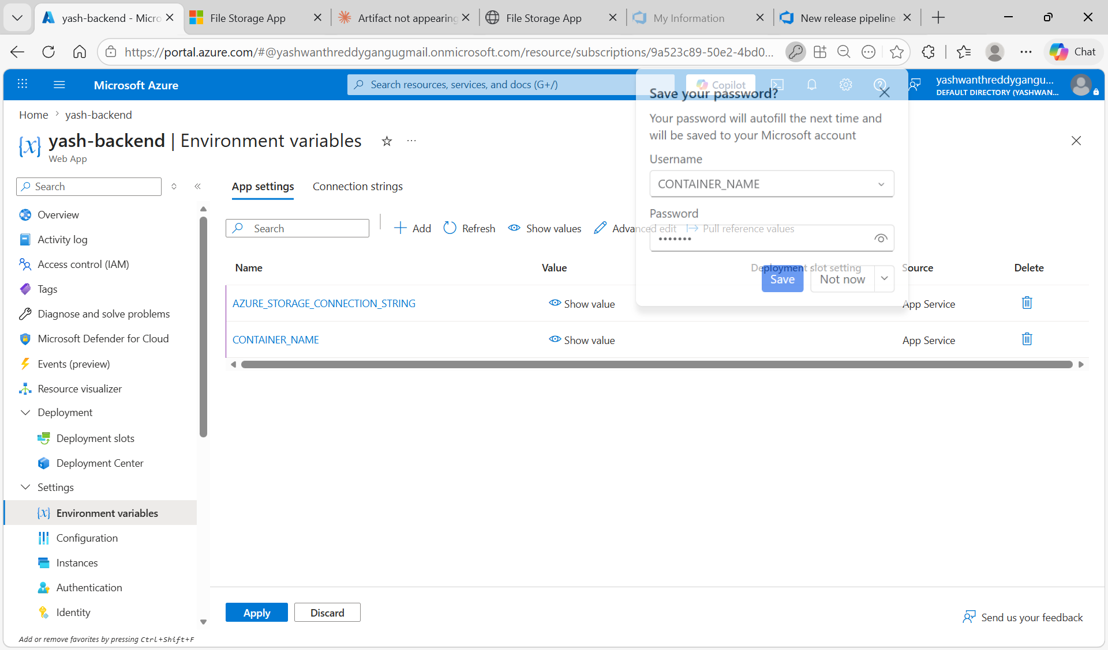
Figure 6.1: yash-backend Environment variables — AZURE_STORAGE_CONNECTION_STRING and CONTAINER_NAME both saved as App Service settings

Step 2: Create Uploads Container in Blob Storage
Azure Portal → Storage accounts → yashstorage405 → Containers → + Add container.
- Name: uploads
- Public access level: Blob (anonymous read access for blobs only)
- Click Create

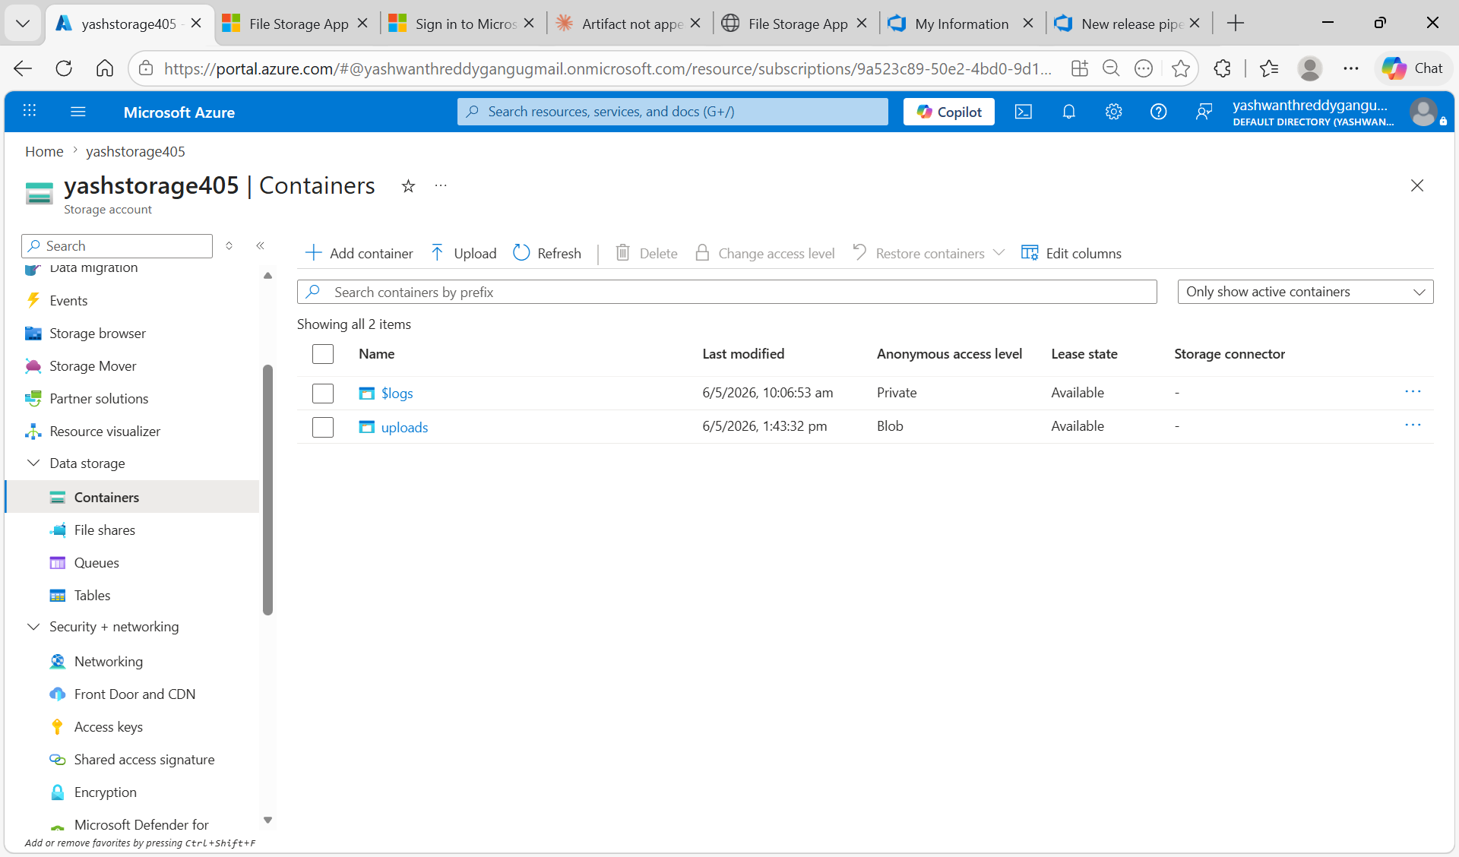
Figure 6.2: yashstorage405 Containers — uploads container created with Blob anonymous access, alongside $logs container

Step 3: Open Frontend Application
Open browser and navigate to the frontend URL: https://yash-frontend-d8ada4dpdxhyffcw.centralindia-01.azurewebsites.net
The Azure File Storage application loads with Upload File and Stored Files sections.

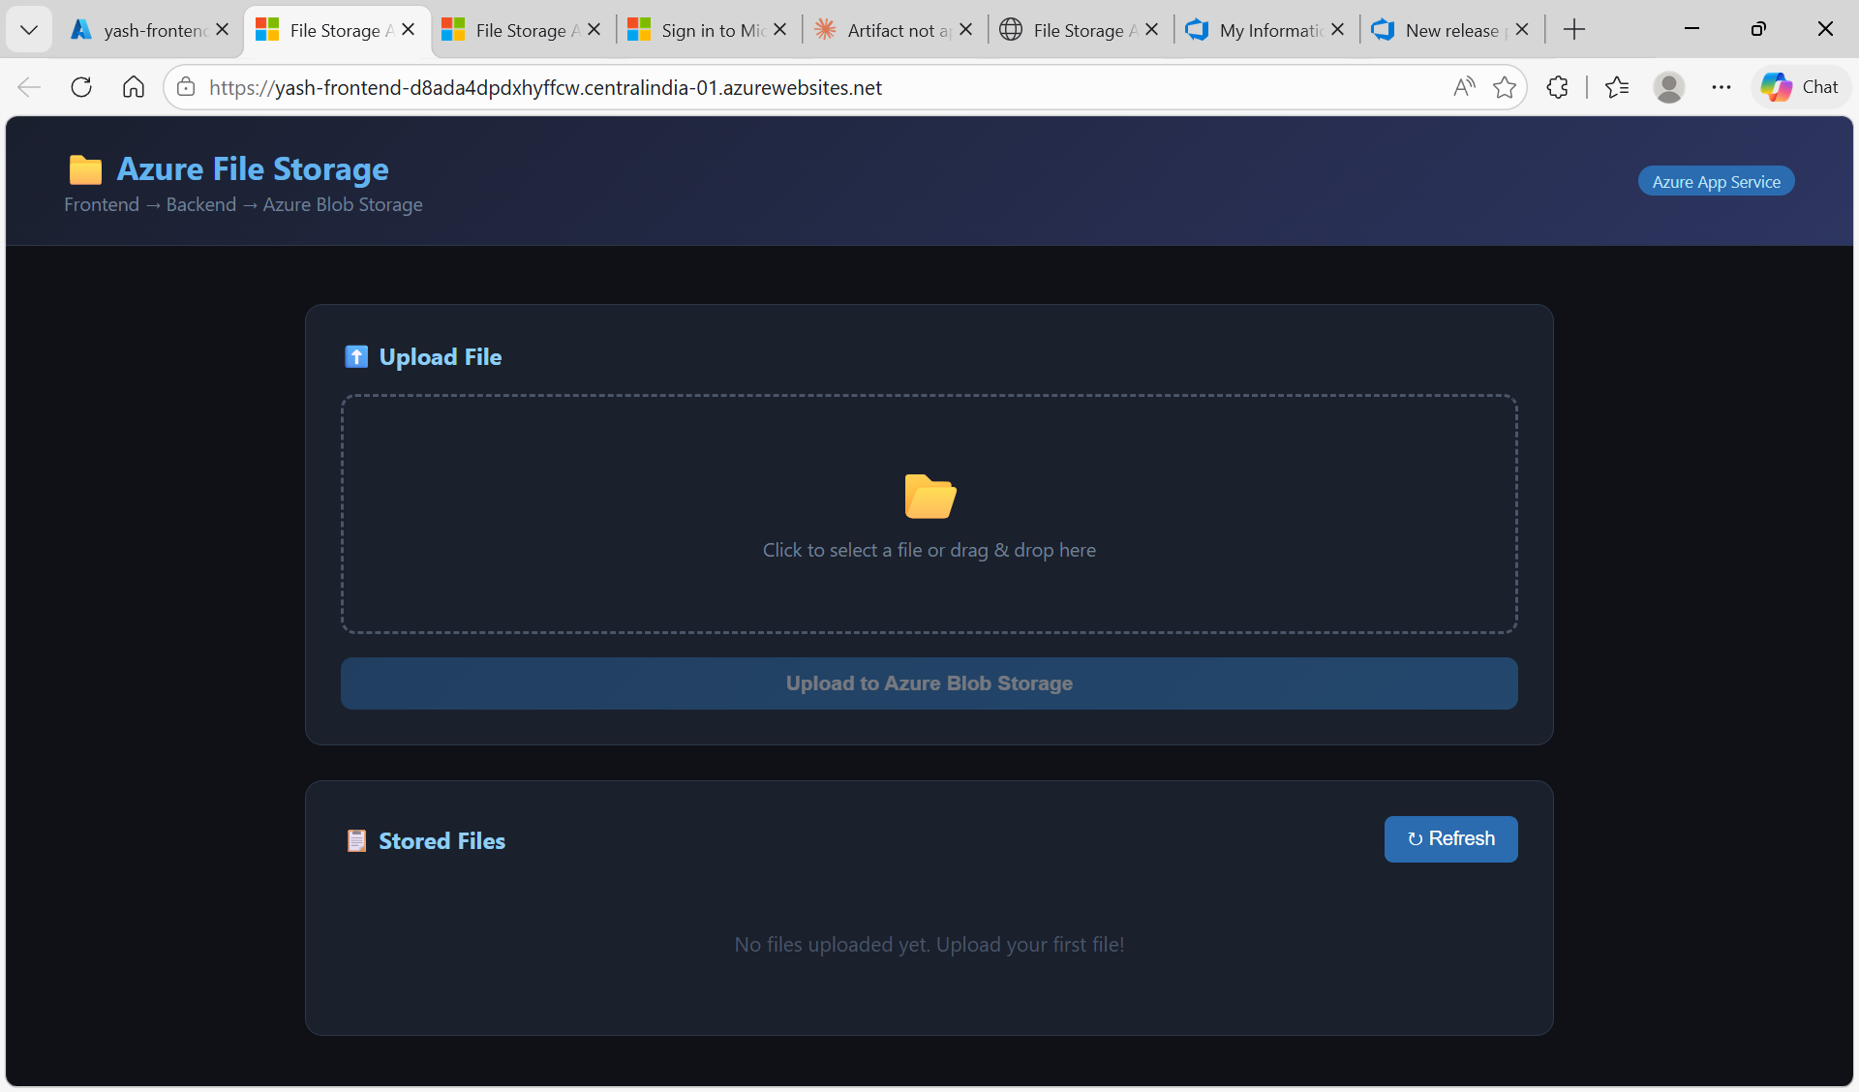
Figure 6.3: Azure File Storage application live at frontend URL — Upload File and Stored Files sections visible

Step 4: Upload a File and Verify
Select a file from your local machine and click Upload to Azure Blob Storage. The file uploads via the backend API to Azure Blob Storage and appears in the Stored Files list.

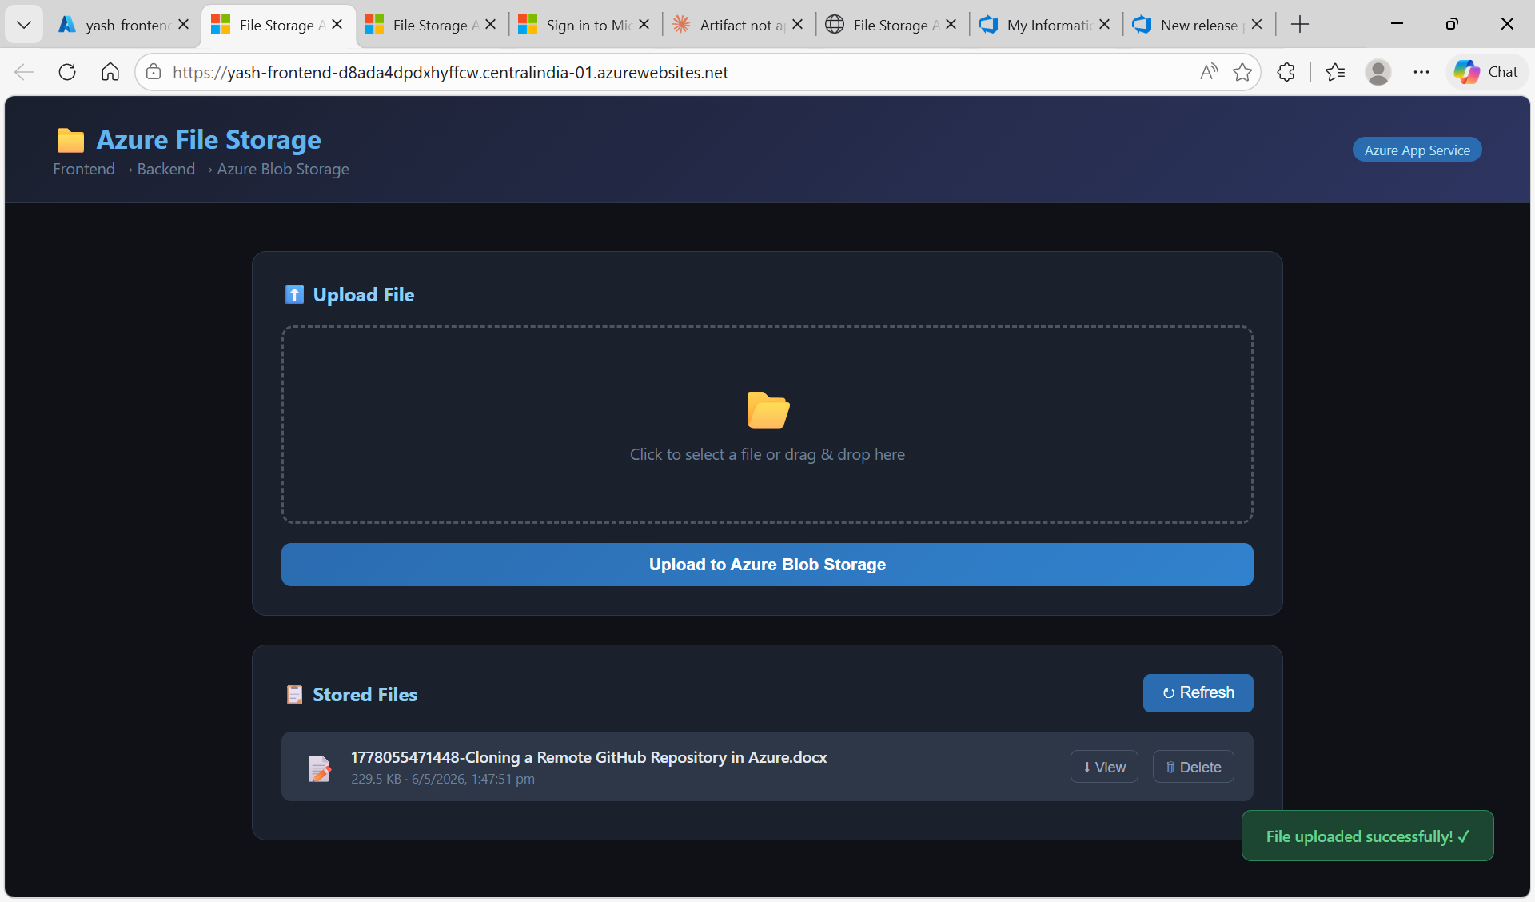
Figure 6.4: File uploaded successfully — file appears in Stored Files list with name, size, and timestamp

Step 5: Verify in Azure Blob Storage
Azure Portal → Storage accounts → yashstorage405 → Containers → uploads. The uploaded file appears in the container confirming the full flow is working.

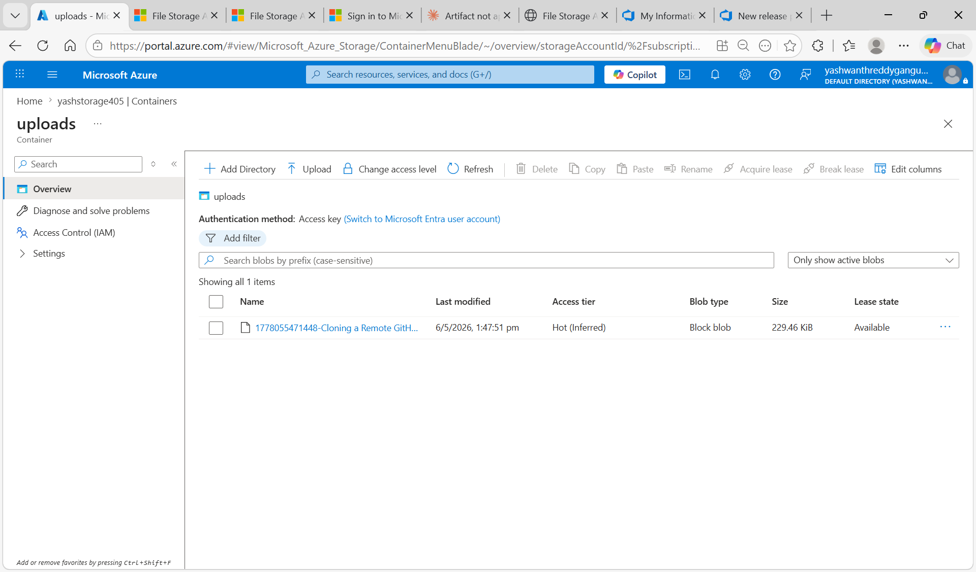
Figure 6.5: Azure Blob Storage uploads container — uploaded file visible with size 229.46 KiB, blob type Block blob

Errors Encountered and Resolutions
The following errors were encountered during implementation. Each is documented with the actual error screenshot, root cause, and fix applied.

Error 1: Wrong Task Added in Release Pipeline
Searched "Node Tool" in release pipeline instead of "Azure App Service Deploy"

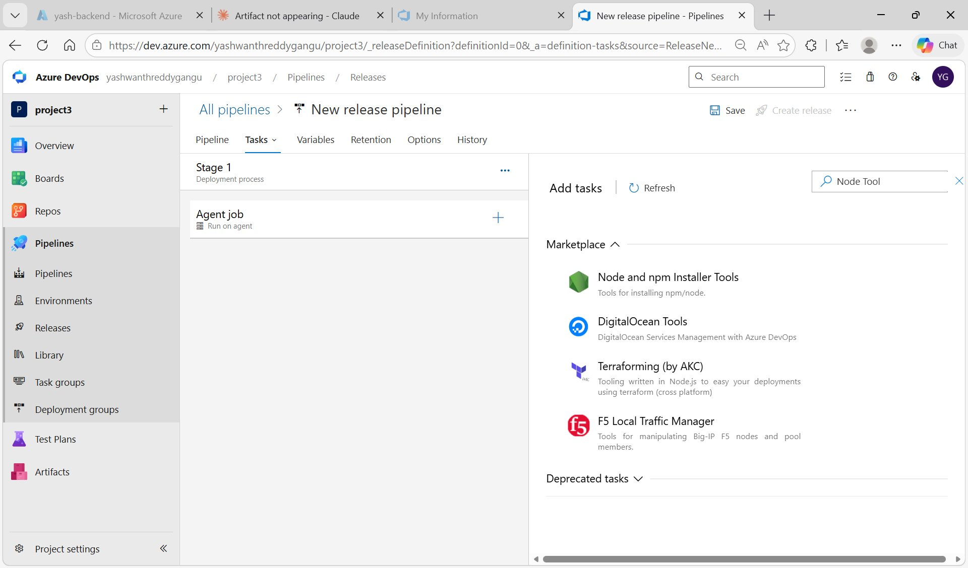
Figure E1: Release pipeline Tasks — wrong search "Node Tool" used. Release pipeline needs "Azure App Service Deploy" not Node Tool

✓ Fix: Closed the task search and searched for "Azure App Service Deploy" instead. Node Tool Installer is only needed in Build (CI) pipelines, not Release (CD) pipelines.

Error 2: Resource Does Not Exist
Error: Resource 'yash-backend' doesn't exist. Resource should exist before deployment.

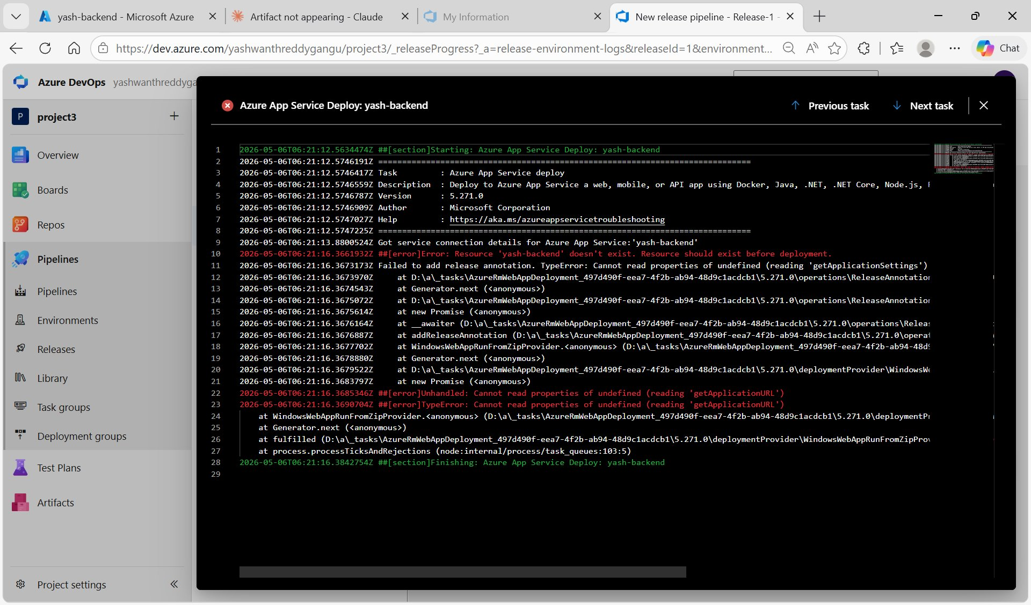
Figure E2: Release pipeline log — "Resource yash-backend doesn't exist" and WindowsWebAppRunFromZipProvider error

Root Cause: The service connection was scoped to DefaultResourceGroup-CID which did not contain yash-backend. Also App type was set to Windows instead of Linux.
✓ Fix: Created new service connection "newserviceconnectionproject3" scoped to yash-backend_group. Changed App Service type to Web App on Linux.

Fix: Created new service connection at Subscription scope level (not resource group level) so all App Services across resource groups become visible in the dropdown.

Error 3: Only yash-backend Shows in Frontend Release Dropdown
Frontend release pipeline App Service dropdown only shows yash-backend — yash-frontend in different resource group

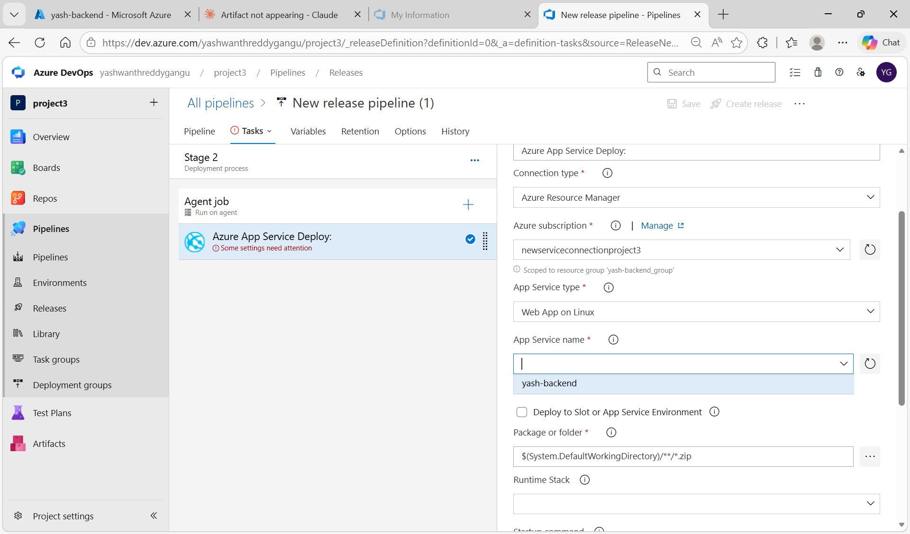
Figure E4: Frontend release pipeline — App Service name dropdown only shows yash-backend, yash-frontend missing

✓ Fix: Used serviceconnectionforproject3 (scoped to userg1 where yash-frontend was created) for the frontend release pipeline. yash-frontend then appeared in the dropdown.

Error 4: App Service Settings Task Error
Error: App Service Settings is not enabled. Please provide one of the following: App Settings or General Settings or Connection Strings

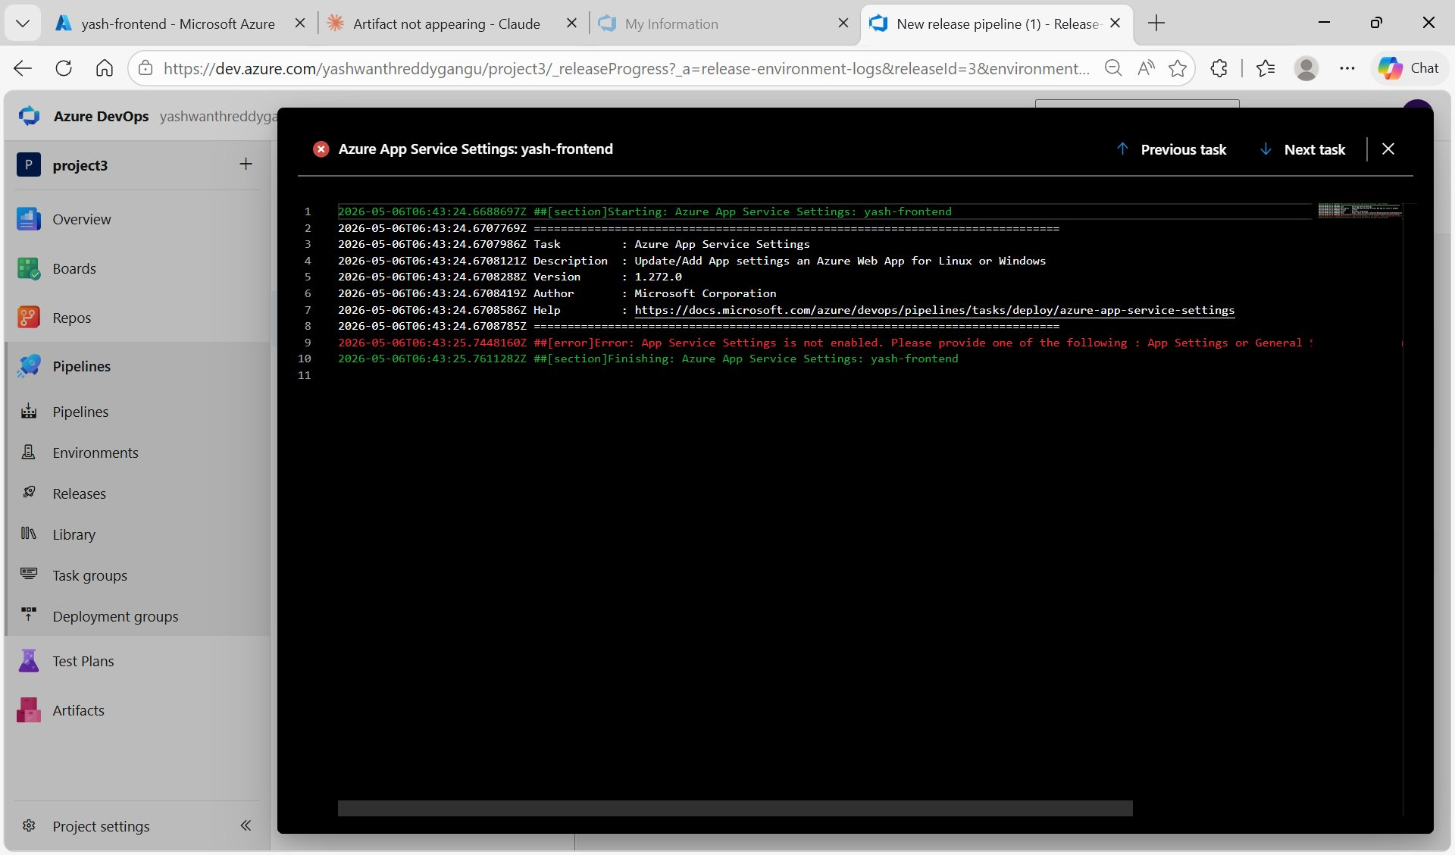
Figure E5: Frontend release log — "App Service Settings is not enabled" error from Azure App Service Settings task

✓ Fix: Removed the "Azure App Service Settings" task from the frontend release pipeline. Frontend is a static HTML file — it does not need app settings configured via pipeline. Only the deploy task is needed.

Error 5: Default Azure Page Instead of Frontend App
"Your web app is running and waiting for your content" — index.html not deployed correctly

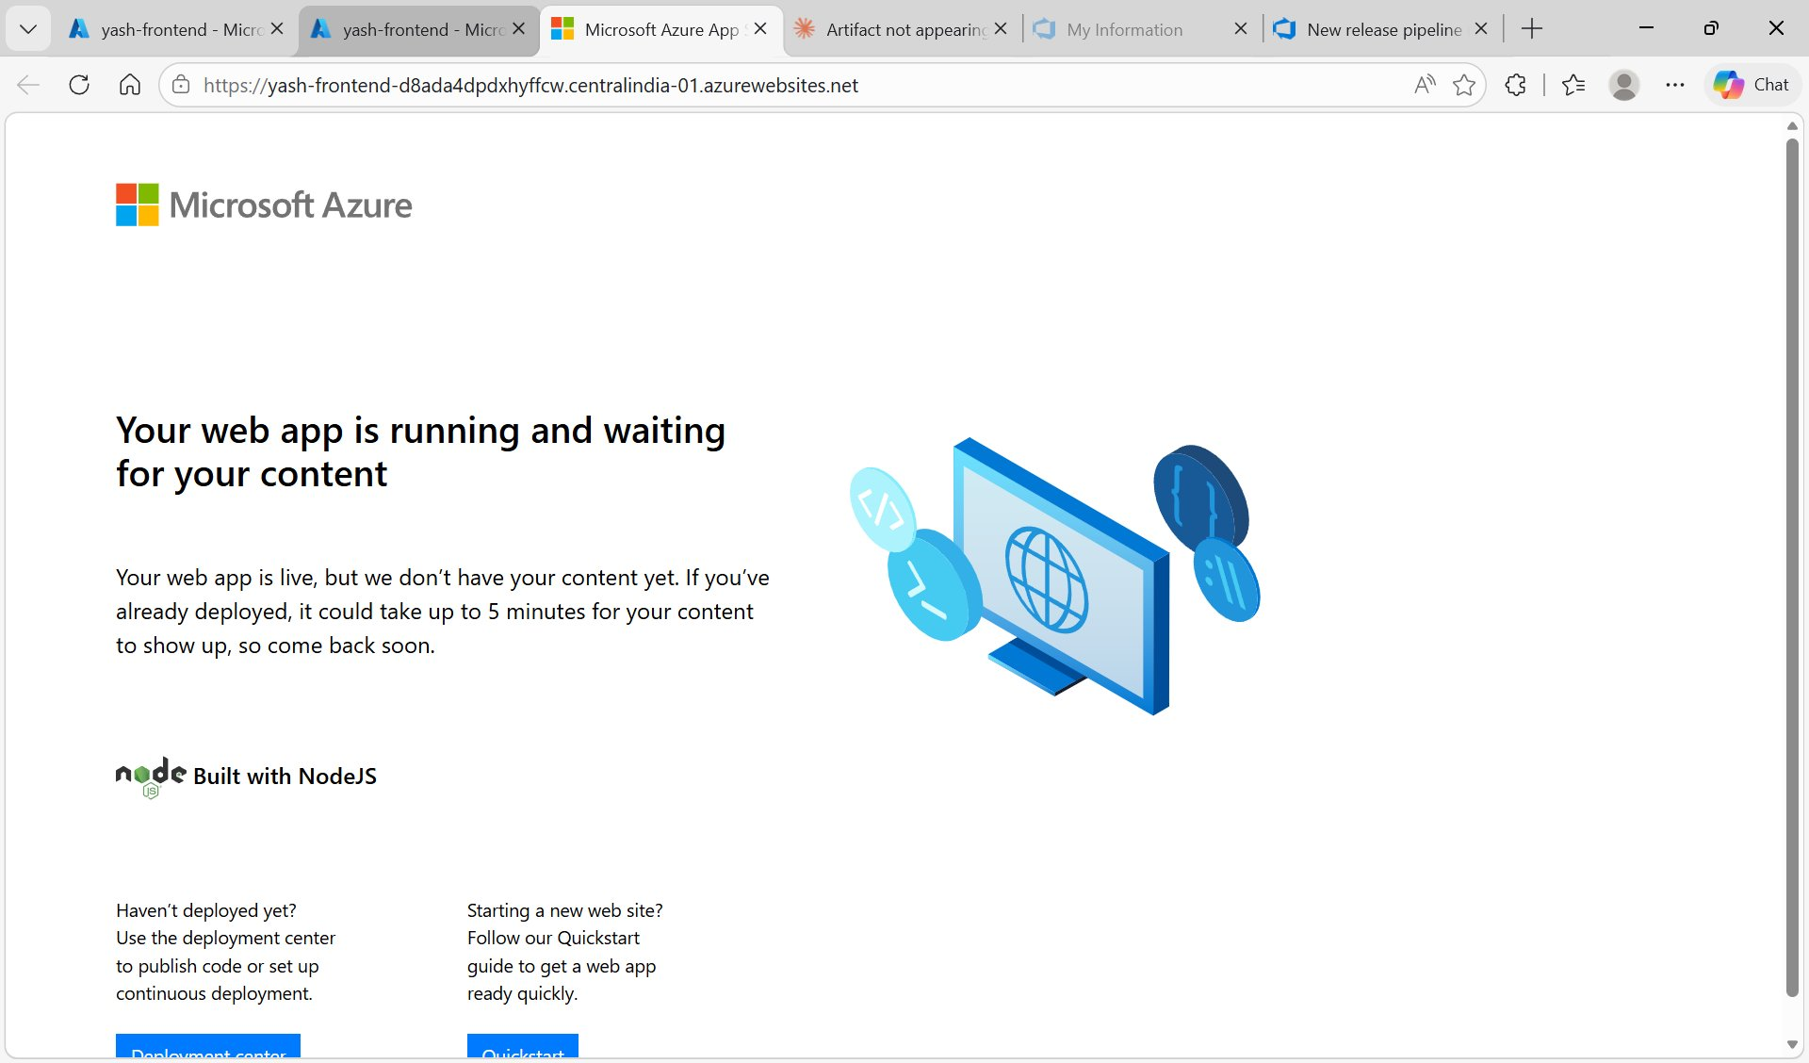
Figure E6: Browser showing default Azure "Your web app is running" page instead of the File Storage App
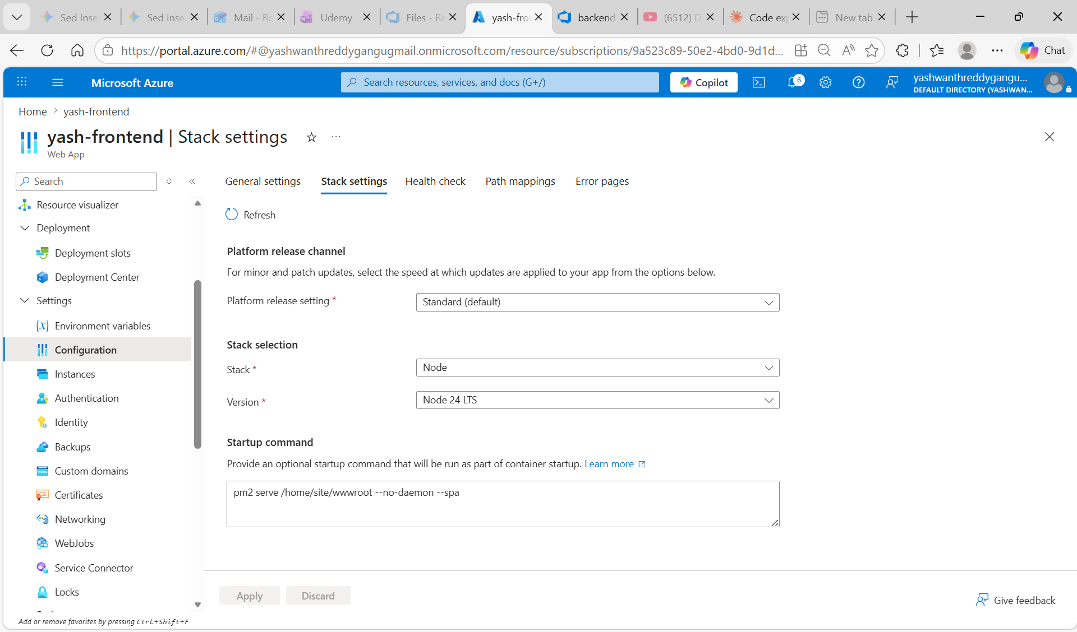

✓ Fix: Fixed the Package path in the frontend release deploy task to correctly point to frontend.zip artifact. Also set Startup command to pm2 serve /home/site/wwwroot --no-daemon --spa.

Error 6: 500 Internal Server Error — Connection String Not Set
500 Internal Server Error — AZURE_STORAGE_CONNECTION_STRING is not set

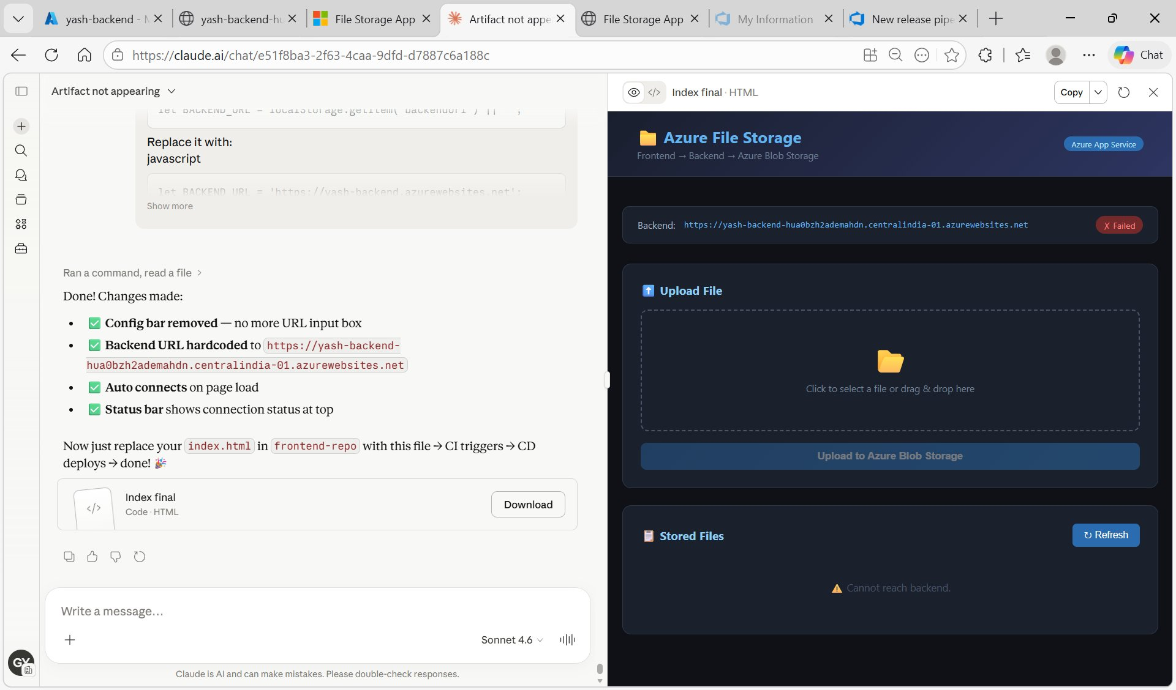
Figure E9: Upload failed error on clean UI — 500 error from backend because connection string was missing

Log stream confirmed:
List error: AZURE_STORAGE_CONNECTION_STRING is not set
Upload error: AZURE_STORAGE_CONNECTION_STRING is not set

✓ Fix: Added AZURE_STORAGE_CONNECTION_STRING and CONTAINER_NAME to yash-backend Environment variables in Azure Portal → App Services → yash-backend → Configuration → Application settings.

Error 7: Public Access Not Permitted on Storage Account
Upload failed: Public access is not permitted on this storage account.

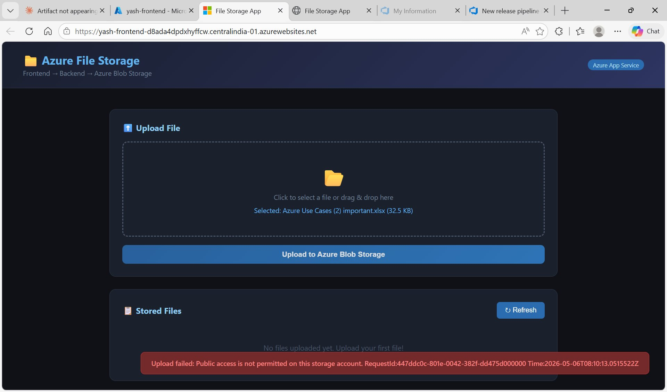
Figure E10: Upload failed — "Public access is not permitted on this storage account"
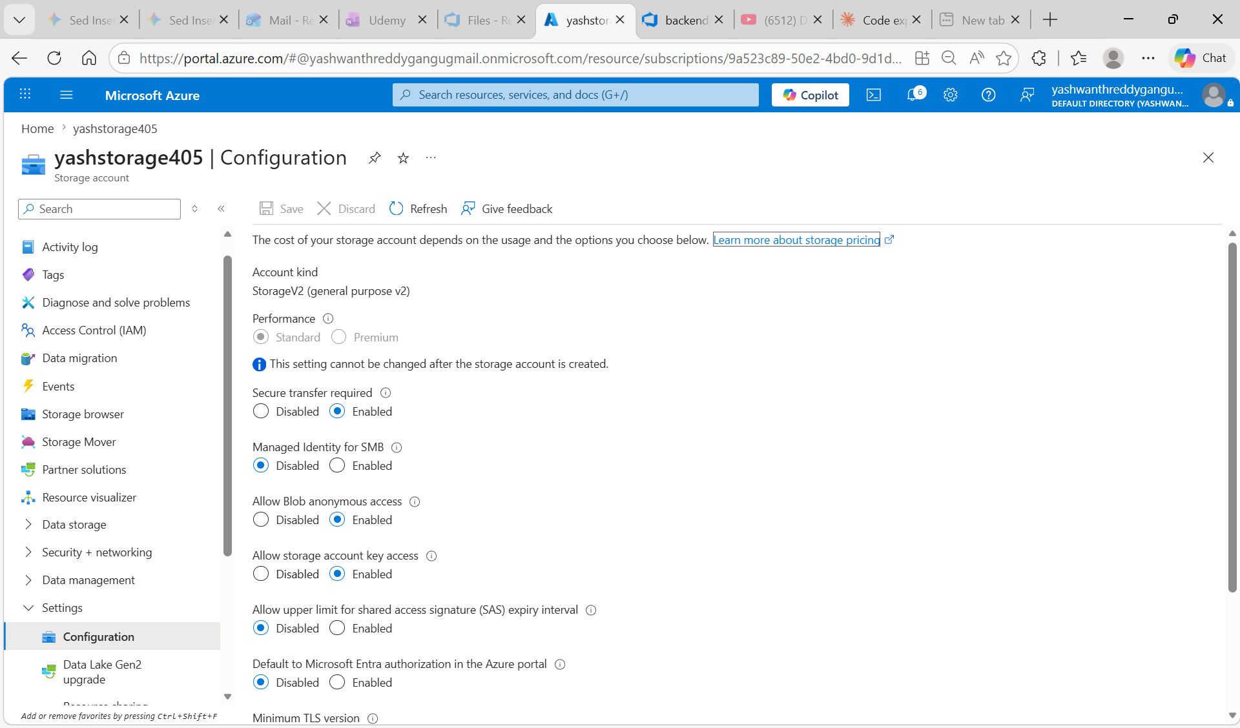

✓ Fix: Azure Portal → Storage accounts → yashstorage405 → Settings → Configuration → set "Allow Blob anonymous access" to Enabled → Save.

Error 8: uploads Container Not Created
Only $logs container exists — uploads container was never created

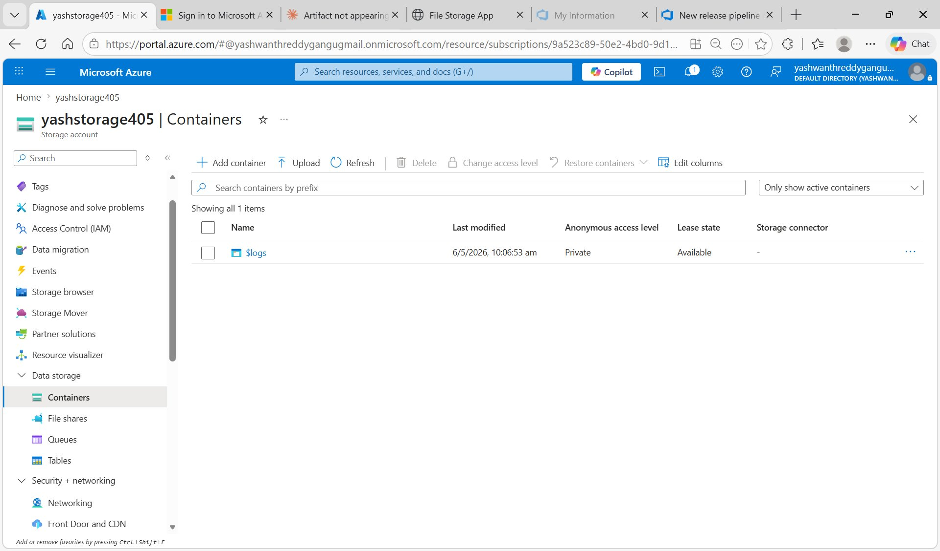
Figure E11: yashstorage405 Containers — only $logs container present, uploads container missing

✓ Fix: Created uploads container: Azure Portal → yashstorage405 → Containers → + Add container → Name: uploads → Public access level: Blob → Create.

Summary

Task | Status | Key Action | Notes
Create Storage Account | ✓ Done | yashstorage405 created | Connection string copied for env var
Create Backend App Service | ✓ Done | yash-backend (Node 18, Linux) | Central India
Create Frontend App Service | ✓ Done | yash-frontend (Node 18, Linux) | Central India
Push Backend Code | ✓ Done | backend-repo: server.js, package.json | No .env pushed
Push Frontend Code | ✓ Done | frontend-repo: index.html | Backend URL hardcoded
Add Env Variables | ✓ Done | AZURE_STORAGE_CONNECTION_STRING, CONTAINER_NAME | yash-backend App Settings
Backend CI Pipeline | ✓ Done | npm install → zip → publish backend.zip | 1 artifact published
Frontend CI Pipeline | ✓ Done | zip → publish frontend.zip | 1 artifact published
Backend Release (CD) | ✓ Done | Deploy to yash-backend App Service | Release-2 Succeeded
Frontend Release (CD) | ✓ Done | Deploy to yash-frontend App Service | Release-2 Succeeded
Create uploads Container | ✓ Done | Blob anonymous access enabled | yashstorage405
End-to-End Test | ✓ Done | File uploaded via frontend → stored in Blob | Full flow working

End of USE-CASE 06 — Deployment of Backend Application to Azure App Service: Frontend → Backend → Azure Blob Storage

