USE-CASE 05
Deployment of Web Applications to an Azure VM
using Azure CI/CD Pipelines
Deployment of a Portfolio Website to an Azure Windows VM
using Azure DevOps CI/CD Pipelines with IIS Web Server
Platform: Windows Server VM | Web Server: IIS | Deployment: Azure DevOps Release Pipeline

Architecture Overview
The following diagram shows the end-to-end CI/CD pipeline implemented in this use case. Code pushed from VS Code triggers an automated build in Azure Pipelines, which packages the portfolio site and deploys it to an Azure Windows VM running IIS.

Developer (VS Code) | Push code to Azure Repos (Git)  index.html + style.css
Azure Repos | Stores portfolio source code  Triggers Build Pipeline on commit
Build Pipeline (CI) | CopyFiles → ArchiveFiles → PublishArtifacts  Outputs: portfolio-site.zip
Release Pipeline (CD) | Deployment Group Job  Deploys via MSDeploy to IIS
Azure Windows VM (yashvm) | IIS → Default Web Site  Serves portfolio at http://4.188.81.252

Flow: Developer pushes code → Azure Repos triggers Build Pipeline → CI packages files into zip artifact → Release Pipeline deploys via Deployment Group → IIS serves website on Windows VM at public IP.

Task 1: Create an Azure Windows Virtual Machine

Step 1: Configure Basic VM Settings
Log in to portal.azure.com. Navigate to Virtual Machines → Create. Configure the following basic settings:
- Subscription: Azure for Students
- Resource Group: usrg1
- Virtual machine name: yashvm
- Region: Asia Pacific (Central India)
- Image: Windows Server (selected in next step)

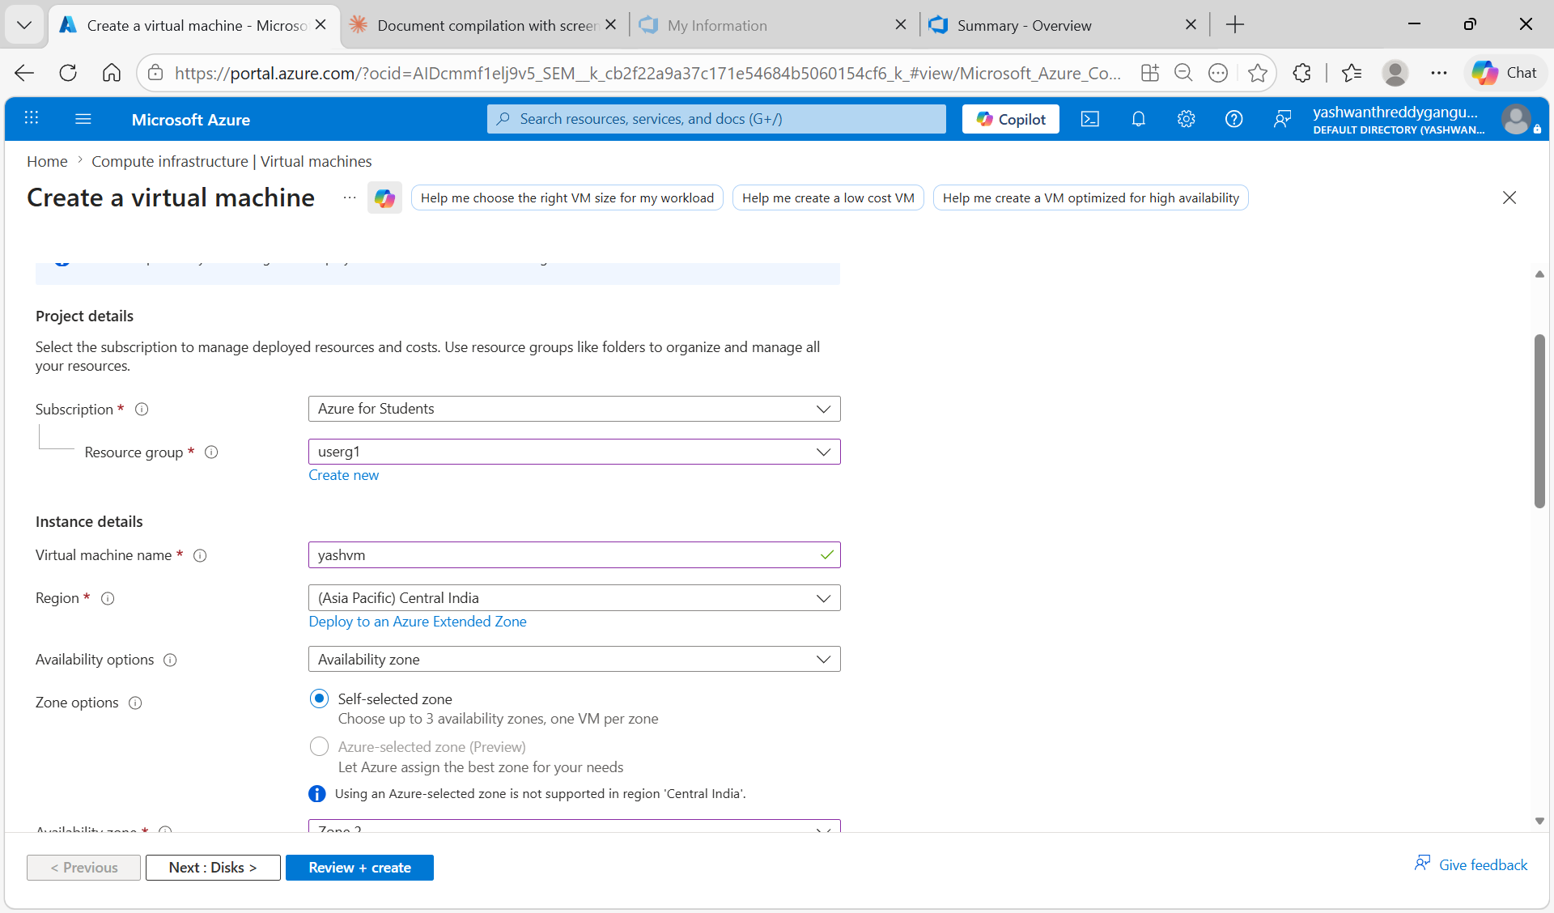
Figure 1.1: Azure Portal — Create Virtual Machine basic settings (name: yashvm, resource group: usrg1)

Step 2: Set Admin Credentials and Inbound Port Rules
Scroll down to the Administrator account section and configure:
- Username: yashvm
- Password: (set a strong password)
- Public inbound ports: Allow selected ports
- Inbound ports: HTTP (80), RDP (3389)
HTTP port 80 allows web traffic to reach IIS. RDP port 3389 allows remote desktop access to configure the VM.

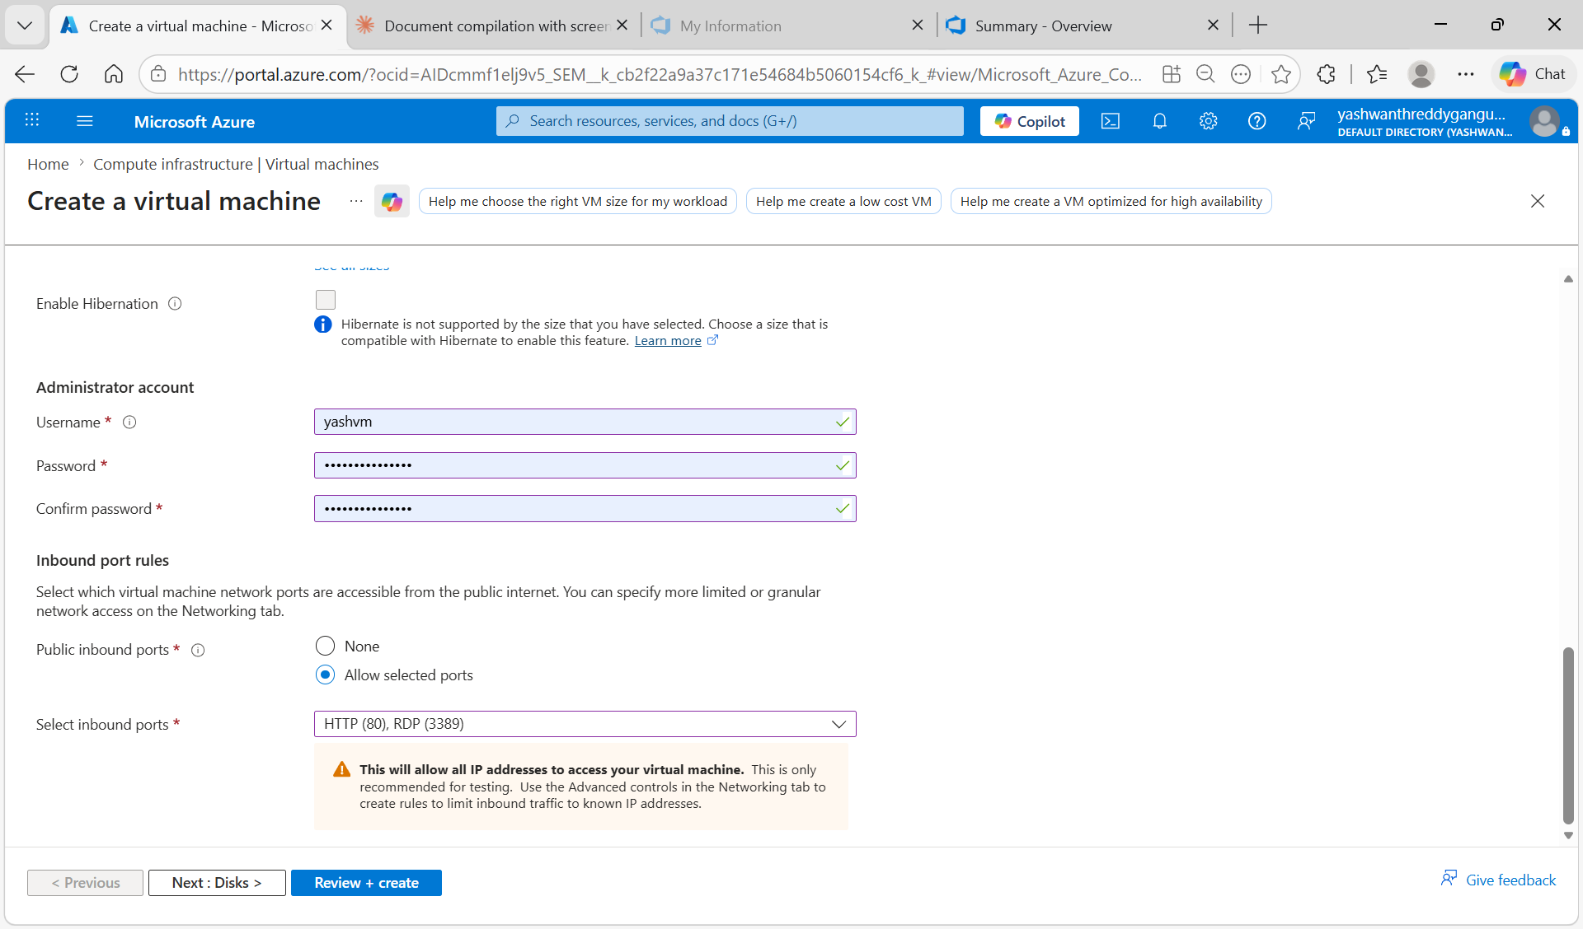
Figure 1.2: VM admin credentials and inbound ports configured — HTTP (80) and RDP (3389) allowed

Step 3: Review and Create VM
Click "Review + create", validate the configuration, then click "Create". Wait for deployment to complete (typically 2-3 minutes).

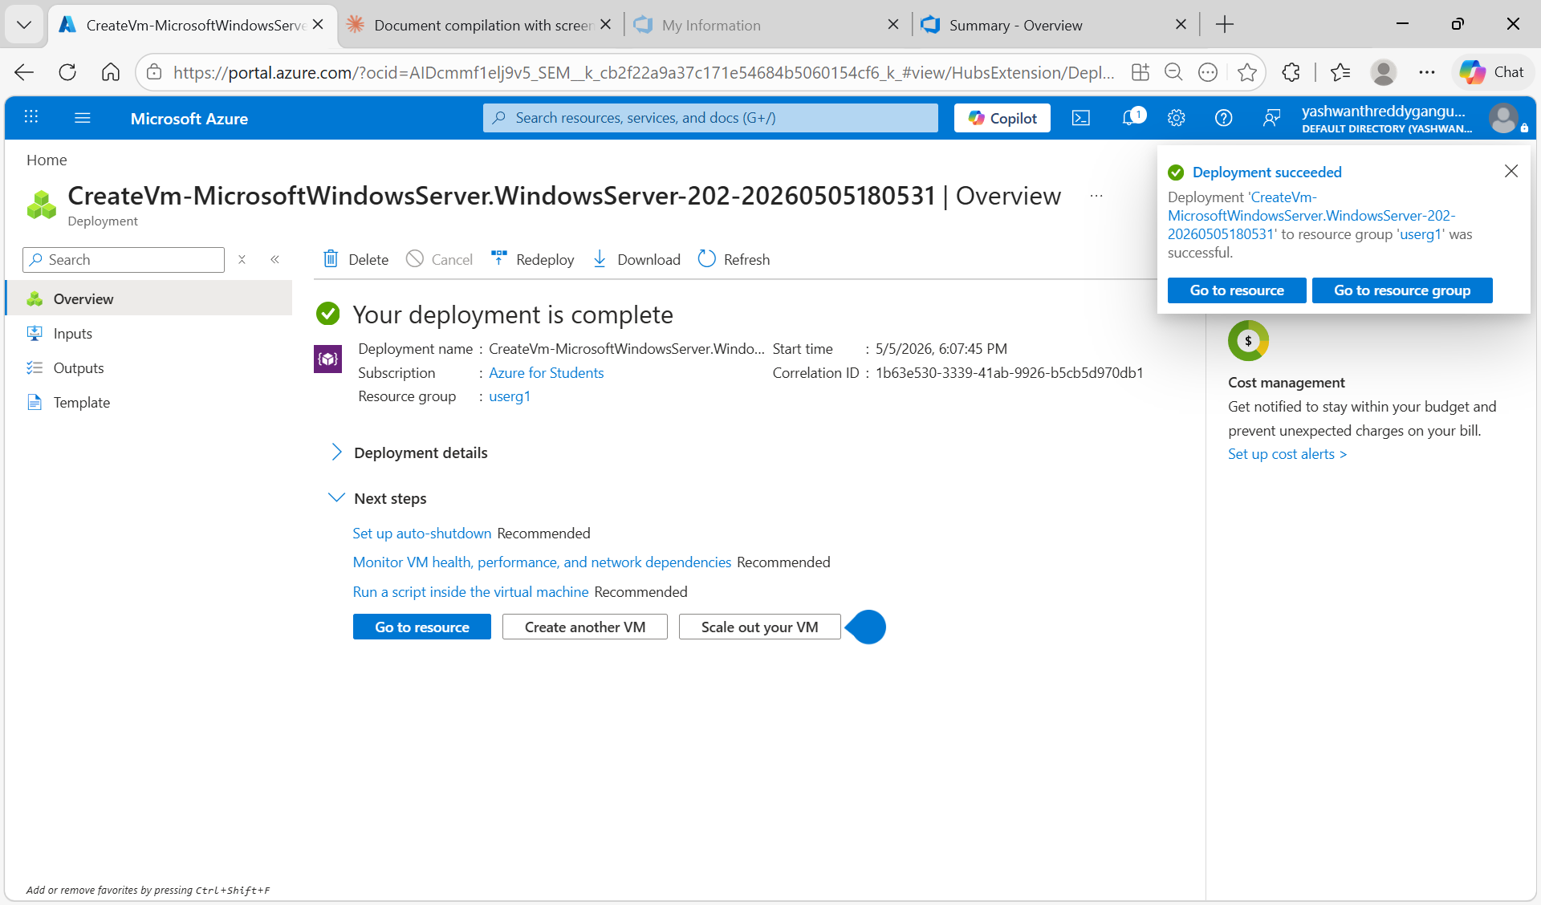
Figure 1.3: VM deployment succeeded — "Your deployment is complete" with yashvm Windows Server created

Task 2: Connect to VM and Install IIS Web Server

Step 1: RDP into the Windows VM
From Azure Portal, go to your VM → Connect → RDP. Download the RDP file and open it. Login with the username and password set during VM creation. The Server Manager Dashboard opens automatically.

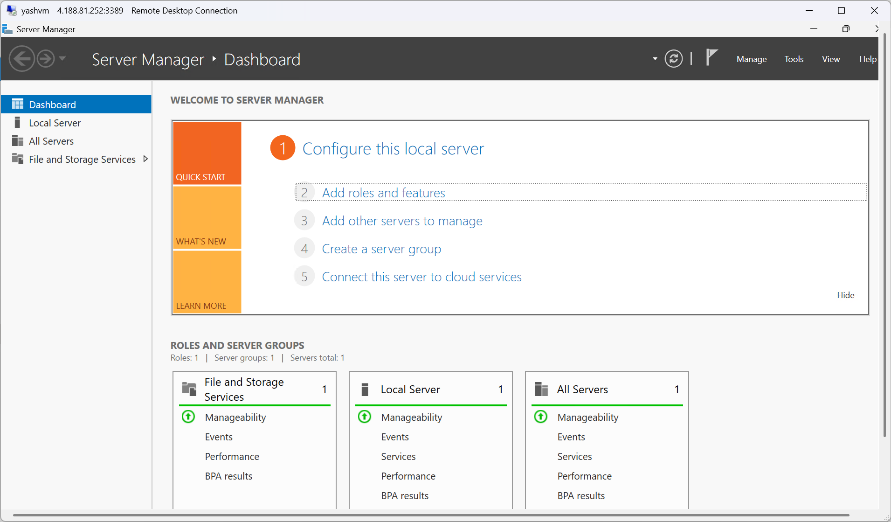
Figure 2.1: RDP connected to yashvm — Windows Server Manager Dashboard showing local server

Step 2: Install IIS Web Server via Server Manager
In Server Manager, click "Add roles and features". Follow the wizard:
1. Installation Type: Role-based or feature-based installation
2. Server Selection: Select yashvm (local server)
3. Server Roles: Check "Web Server (IIS)" — this installs IIS with all default features
4. Click Install and wait for completion

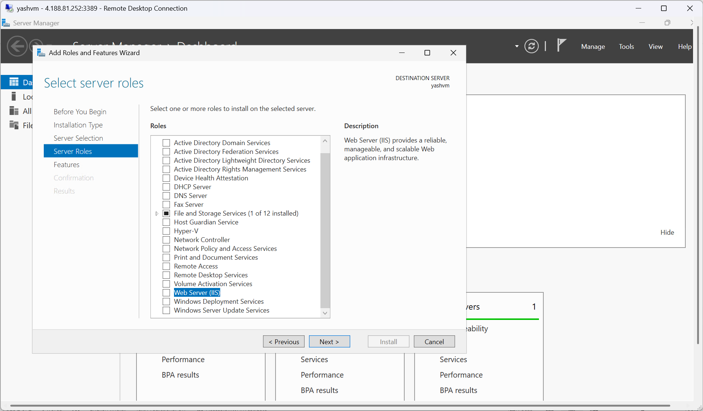
Figure 2.2: Add Roles and Features Wizard — Web Server (IIS) role selected for installation

Step 3: Wait for IIS Installation to Complete
The wizard installs IIS components including Static Content, Default Document, HTTP Errors, Request Filtering, and HTTP Logging. This takes about 1-2 minutes.

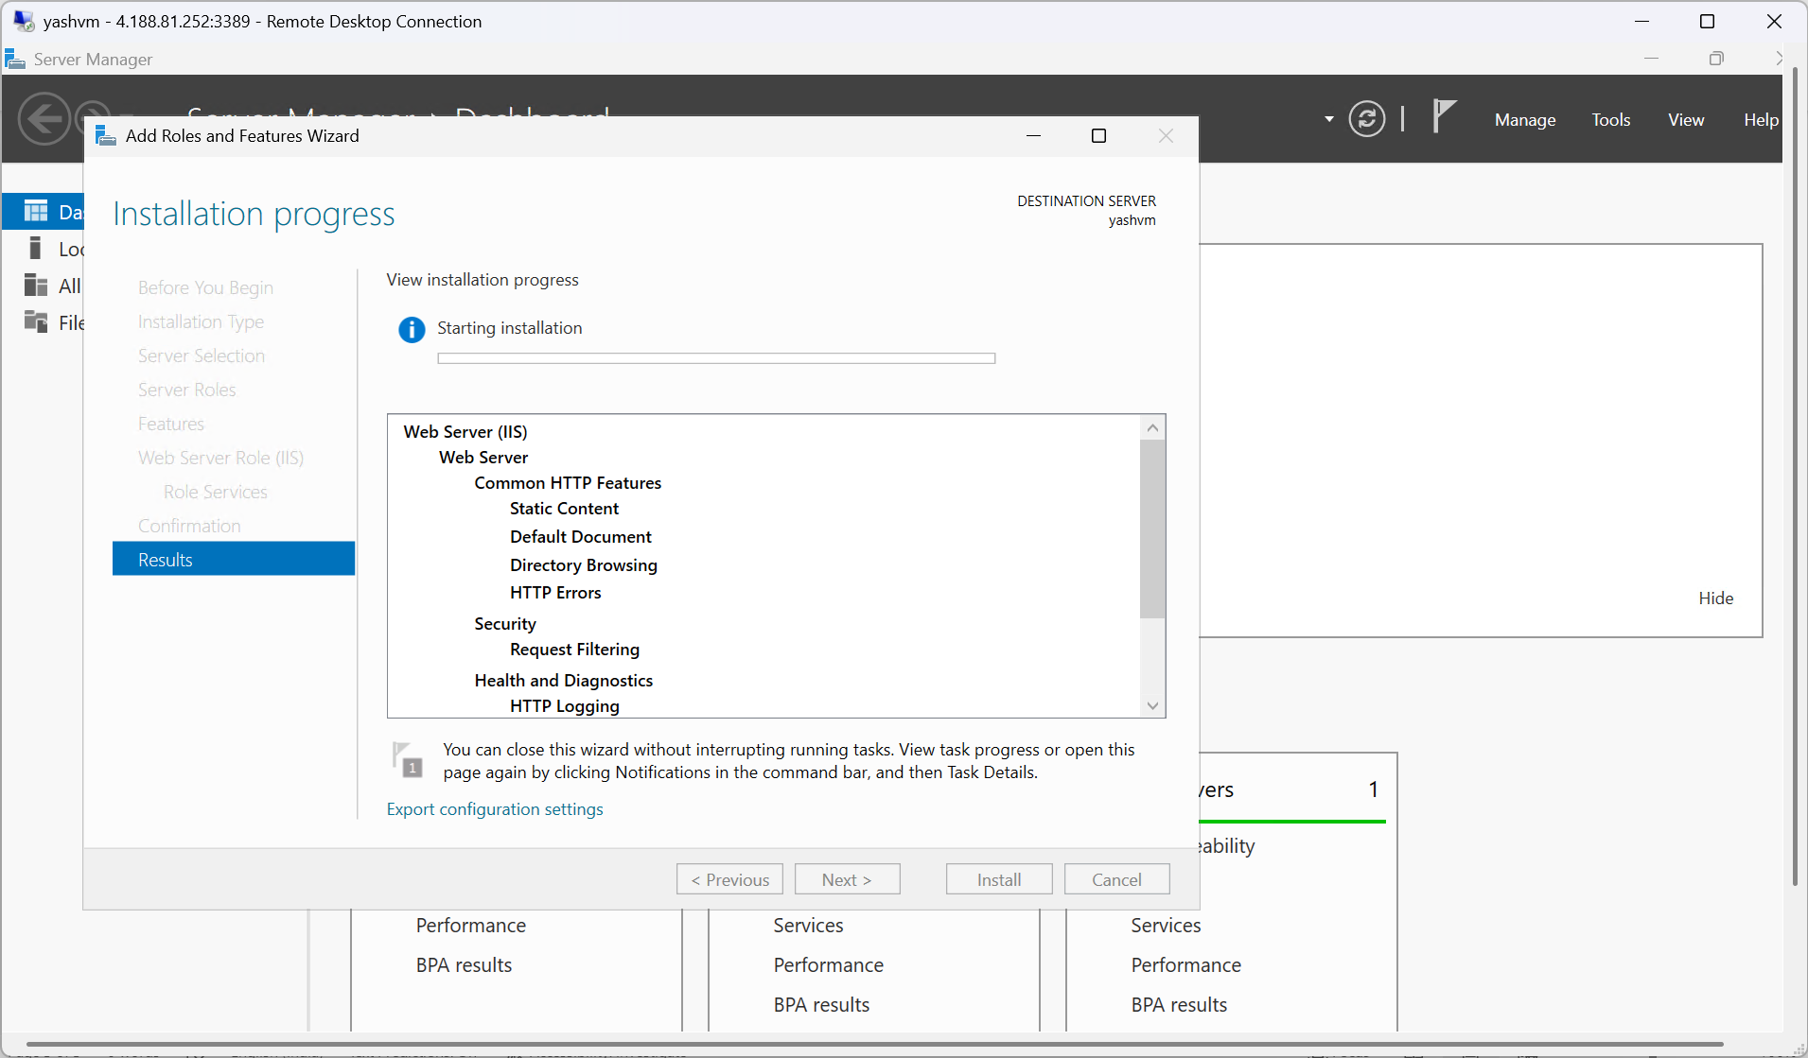
Figure 2.3: IIS installation progress — Web Server (IIS) with Static Content, Default Document components installing

Step 4: Verify IIS and inetpub Directory
After installation, IIS creates the C:\inetpub\wwwroot directory which is the default web root. Verify this through File Explorer.

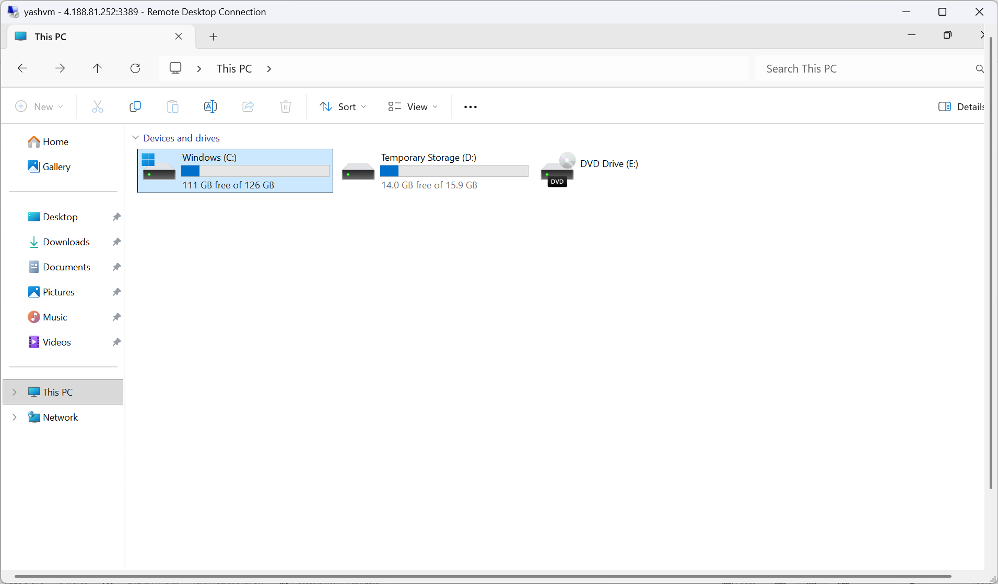
Figure 2.4: File Explorer — This PC showing Windows (C:) drive on yashvm

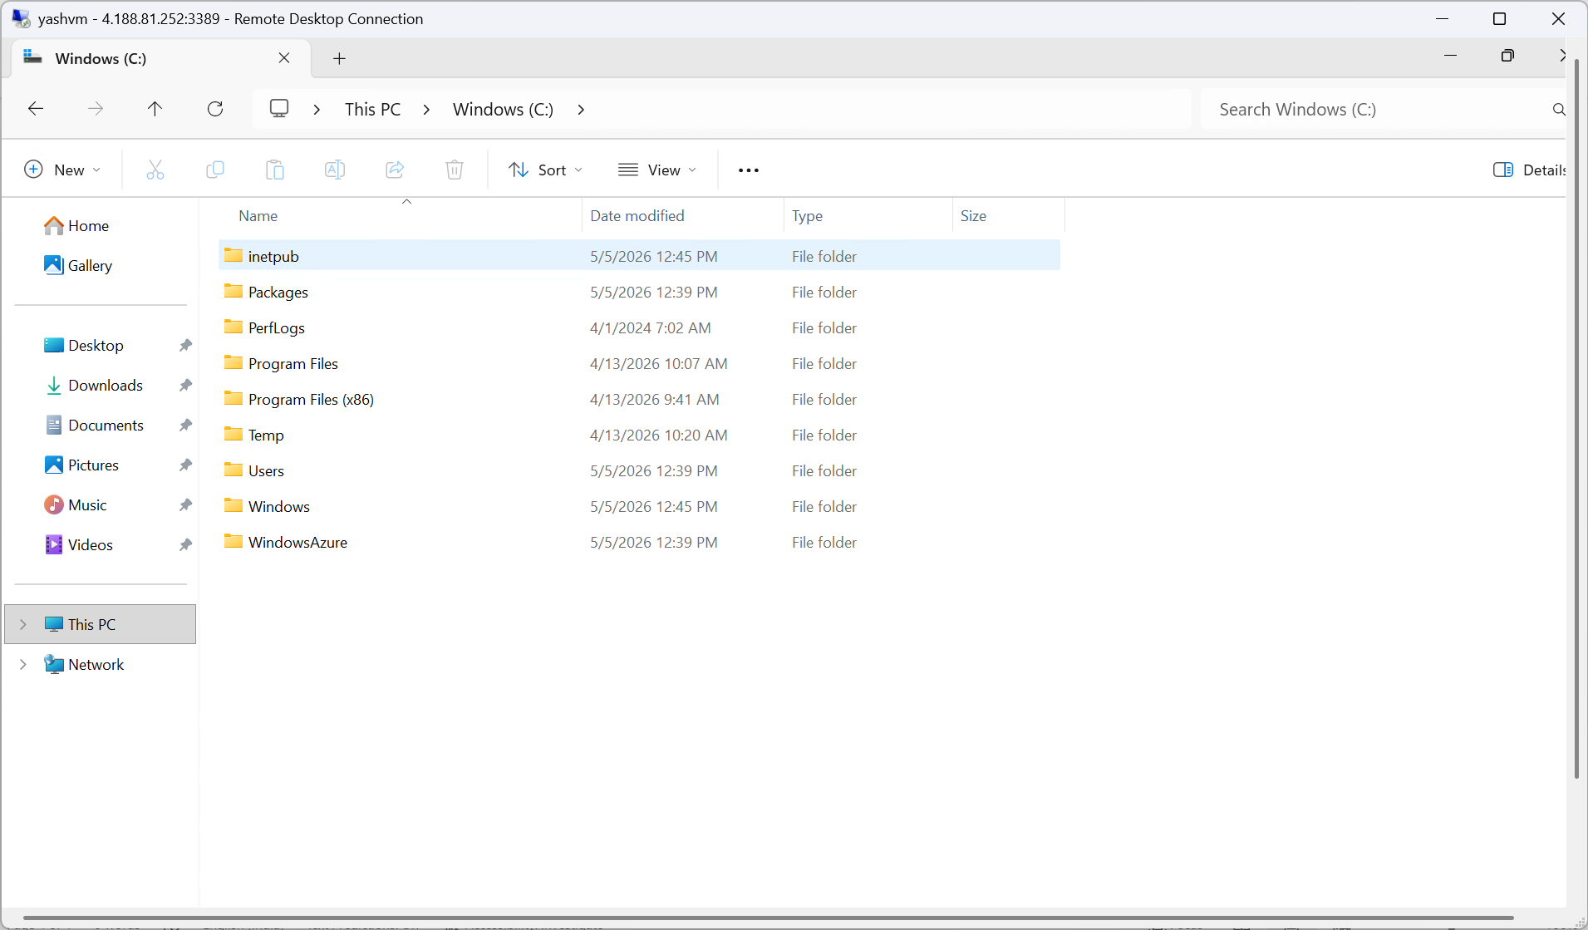
Figure 2.5: C:\ drive contents — inetpub folder created by IIS installation

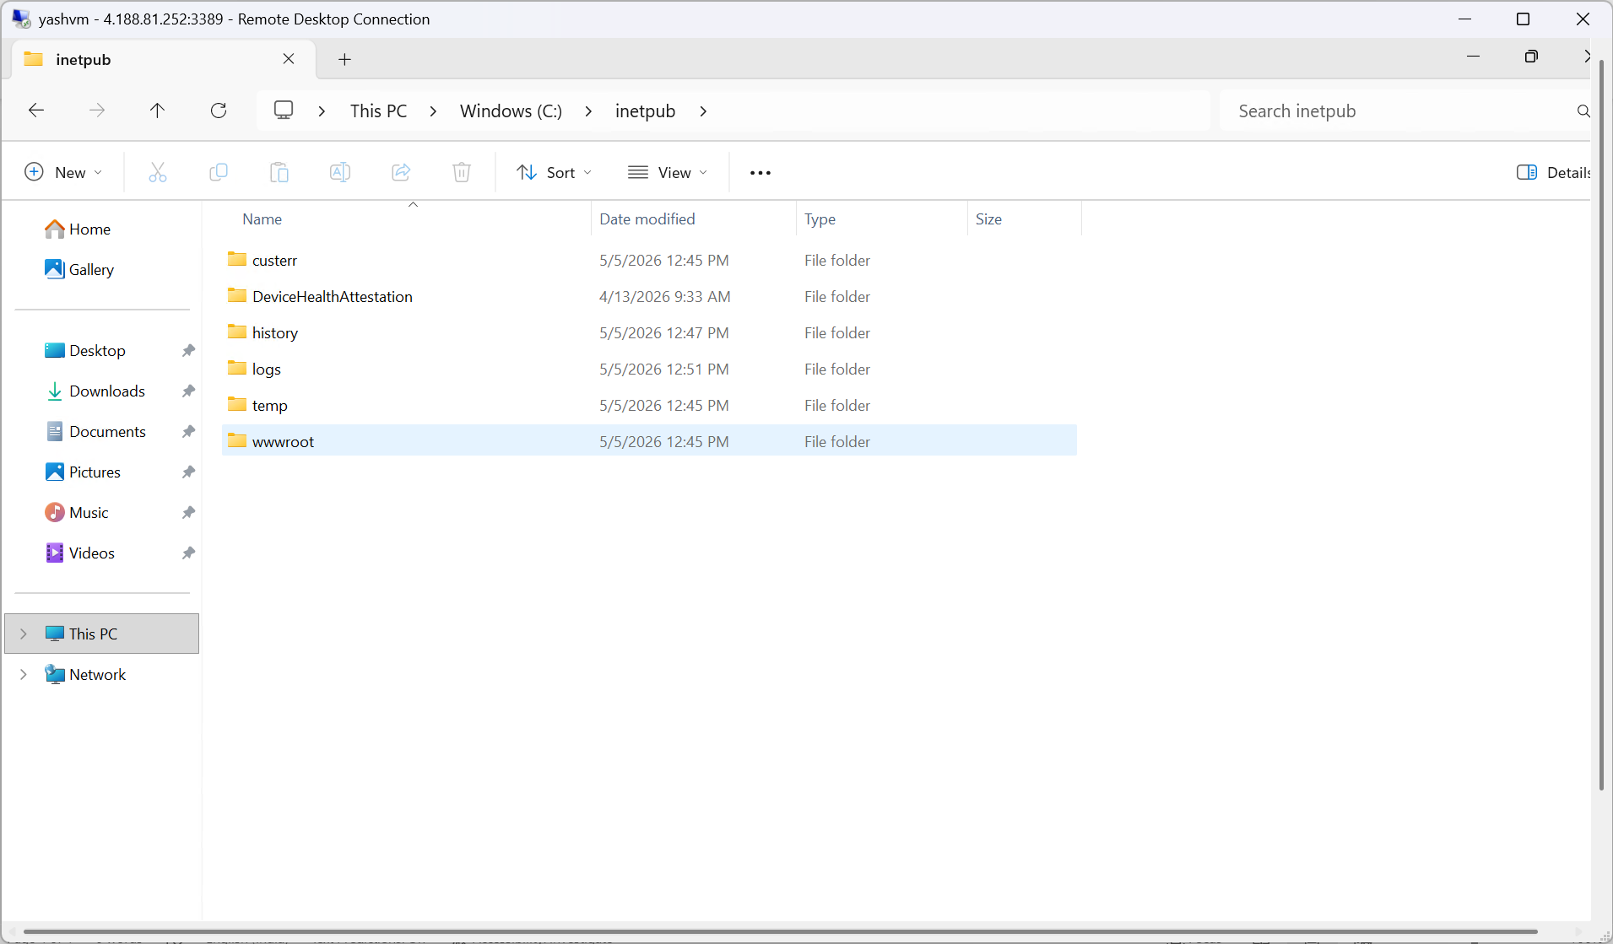
Figure 2.6: C:\inetpub folder — wwwroot directory present (default IIS web root where files will be deployed)

Task 3: Create Portfolio Website and Push to Azure Repos

Step 1: Create Portfolio Files in VS Code
Open VS Code locally. Create a project folder my-Portfolio with the following files:
- index.html — Single-page portfolio (Hero, About, Skills, Experience, Projects, Contact sections)
- style.css — Dark theme with purple-blue gradient, sticky navbar, responsive grid
- web.config — IIS configuration file
- azure-pipelines.yml — Build pipeline definition
Initialize a local Git repository and connect to Azure Repos.

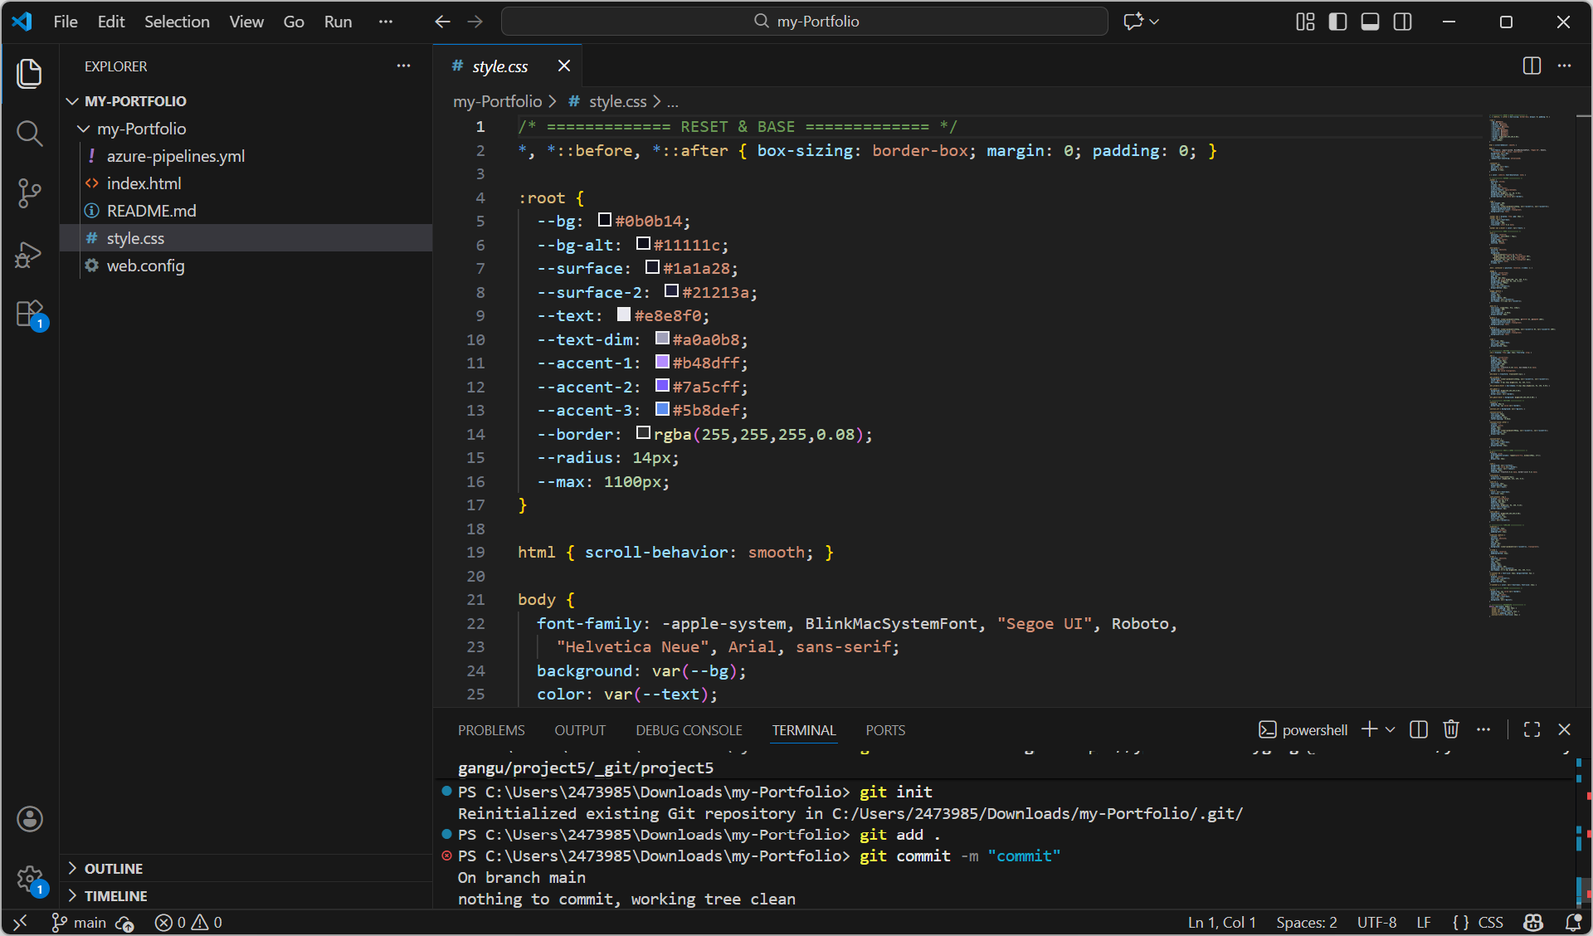
Figure 3.1: VS Code — my-Portfolio project with all files. Terminal shows: git init, git add, git commit

Step 2: Push Code to Azure Repos
Add the Azure Repos remote URL and push the code to the main branch:

git remote add origin https://yashwanthreddygangu@dev.azure.com/...
git push -u origin main

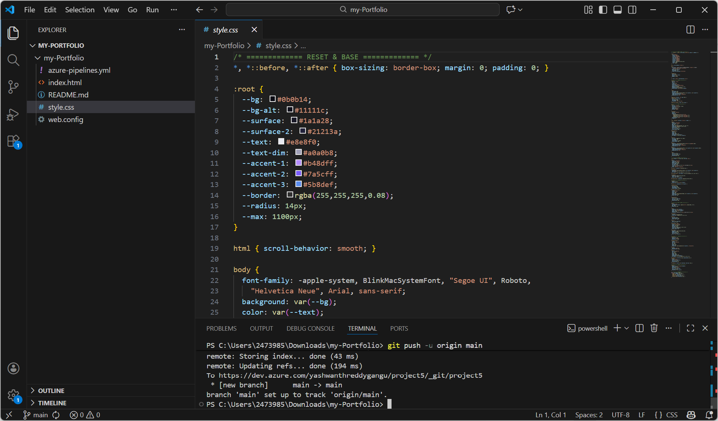
Figure 3.2: VS Code terminal — git push to Azure Repos successful. Branch main tracked to origin/main

Step 3: Verify Files in Azure Repos
Navigate to Azure DevOps → project5 → Repos → Files. Confirm all portfolio files appear in the my-Portfolio repository.

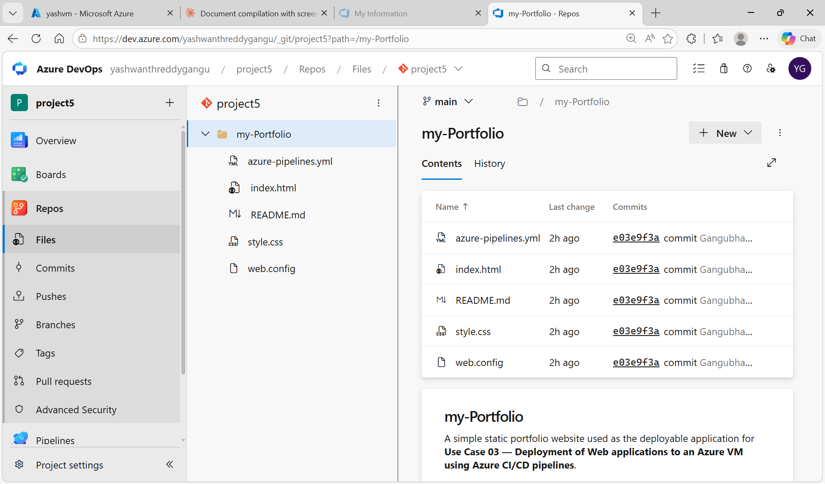
Figure 3.3: Azure Repos — my-Portfolio repository with azure-pipelines.yml, index.html, README.md, style.css, web.config

Task 4: Create Deployment Group and Register Windows VM

Step 1: Create Deployment Group in Azure DevOps
A Deployment Group registers the Azure VM as a deployment target so the release pipeline can automatically push files to it without manually RDP-ing each time.
Go to Azure DevOps → project5 → Pipelines → Deployment groups → Add a deployment group.

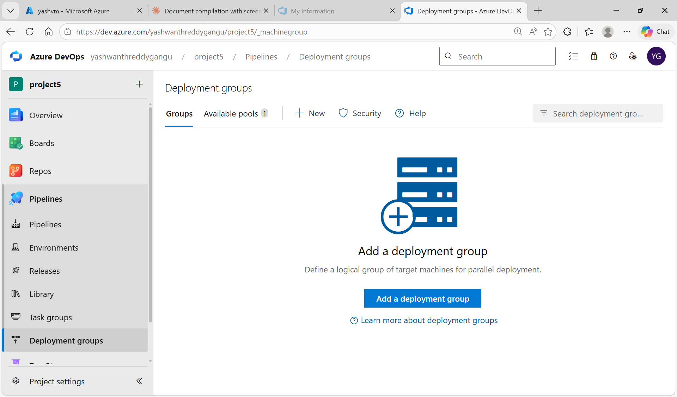
Figure 4.1: Azure DevOps Deployment groups page — empty, ready to add new group

Step 2: Configure Deployment Group
Name the group "deployment". Set the type to "Windows". The registration script is automatically generated — this PowerShell script installs the Azure Pipelines agent on the VM.

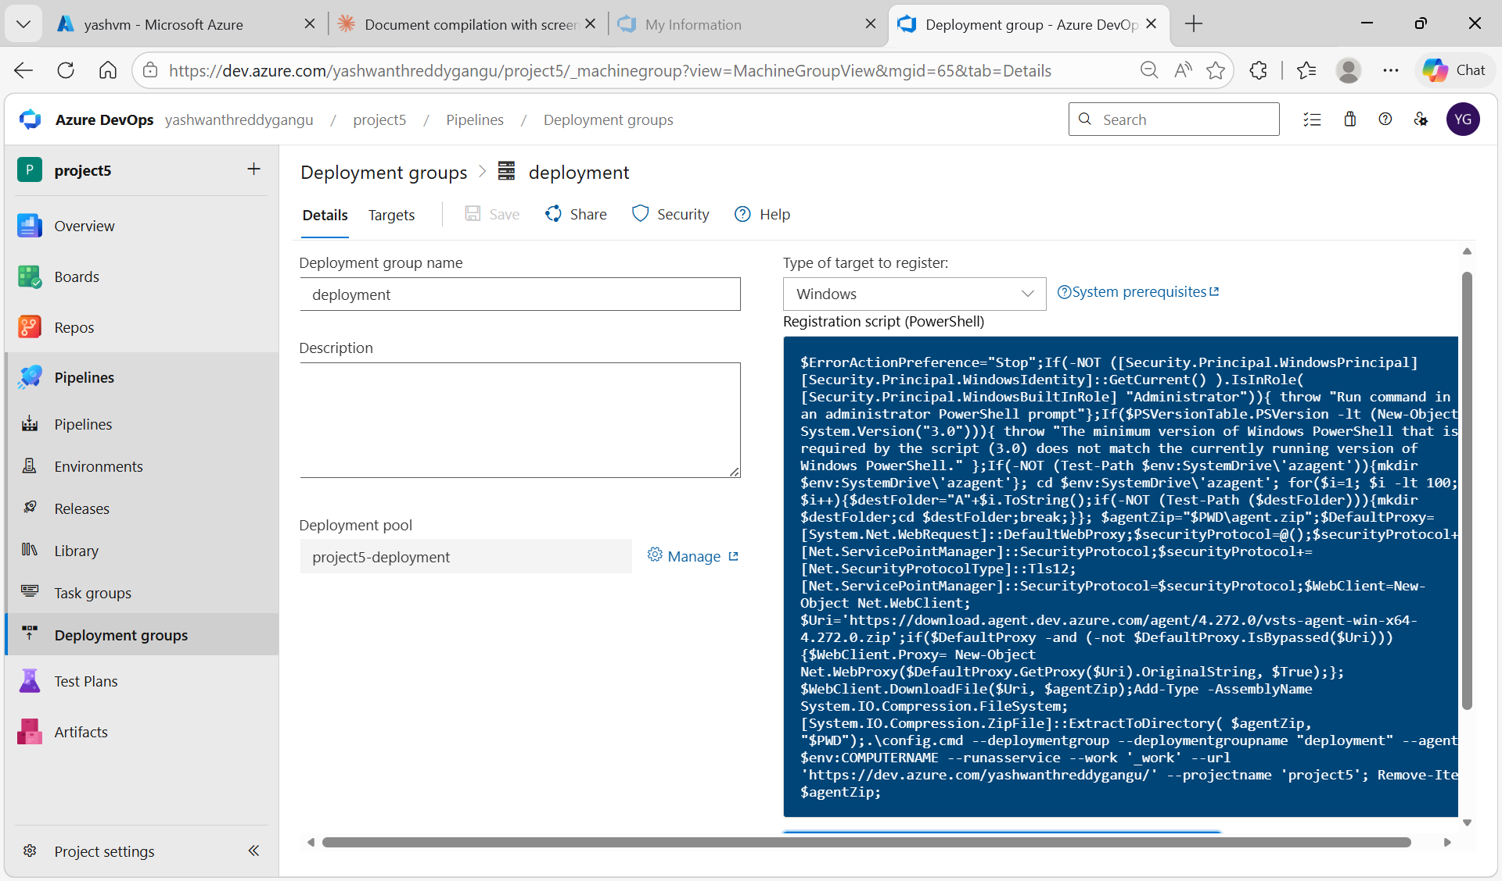
Figure 4.2: Deployment group "deployment" created — Windows registration script shown, ready to copy and run on VM

Step 3: Run Registration Script on Windows VM
RDP into yashvm. Open PowerShell as Administrator. Copy the registration script from Azure DevOps and paste it into PowerShell. When prompted, enter "Y" to add tags and type "web" as the tag.

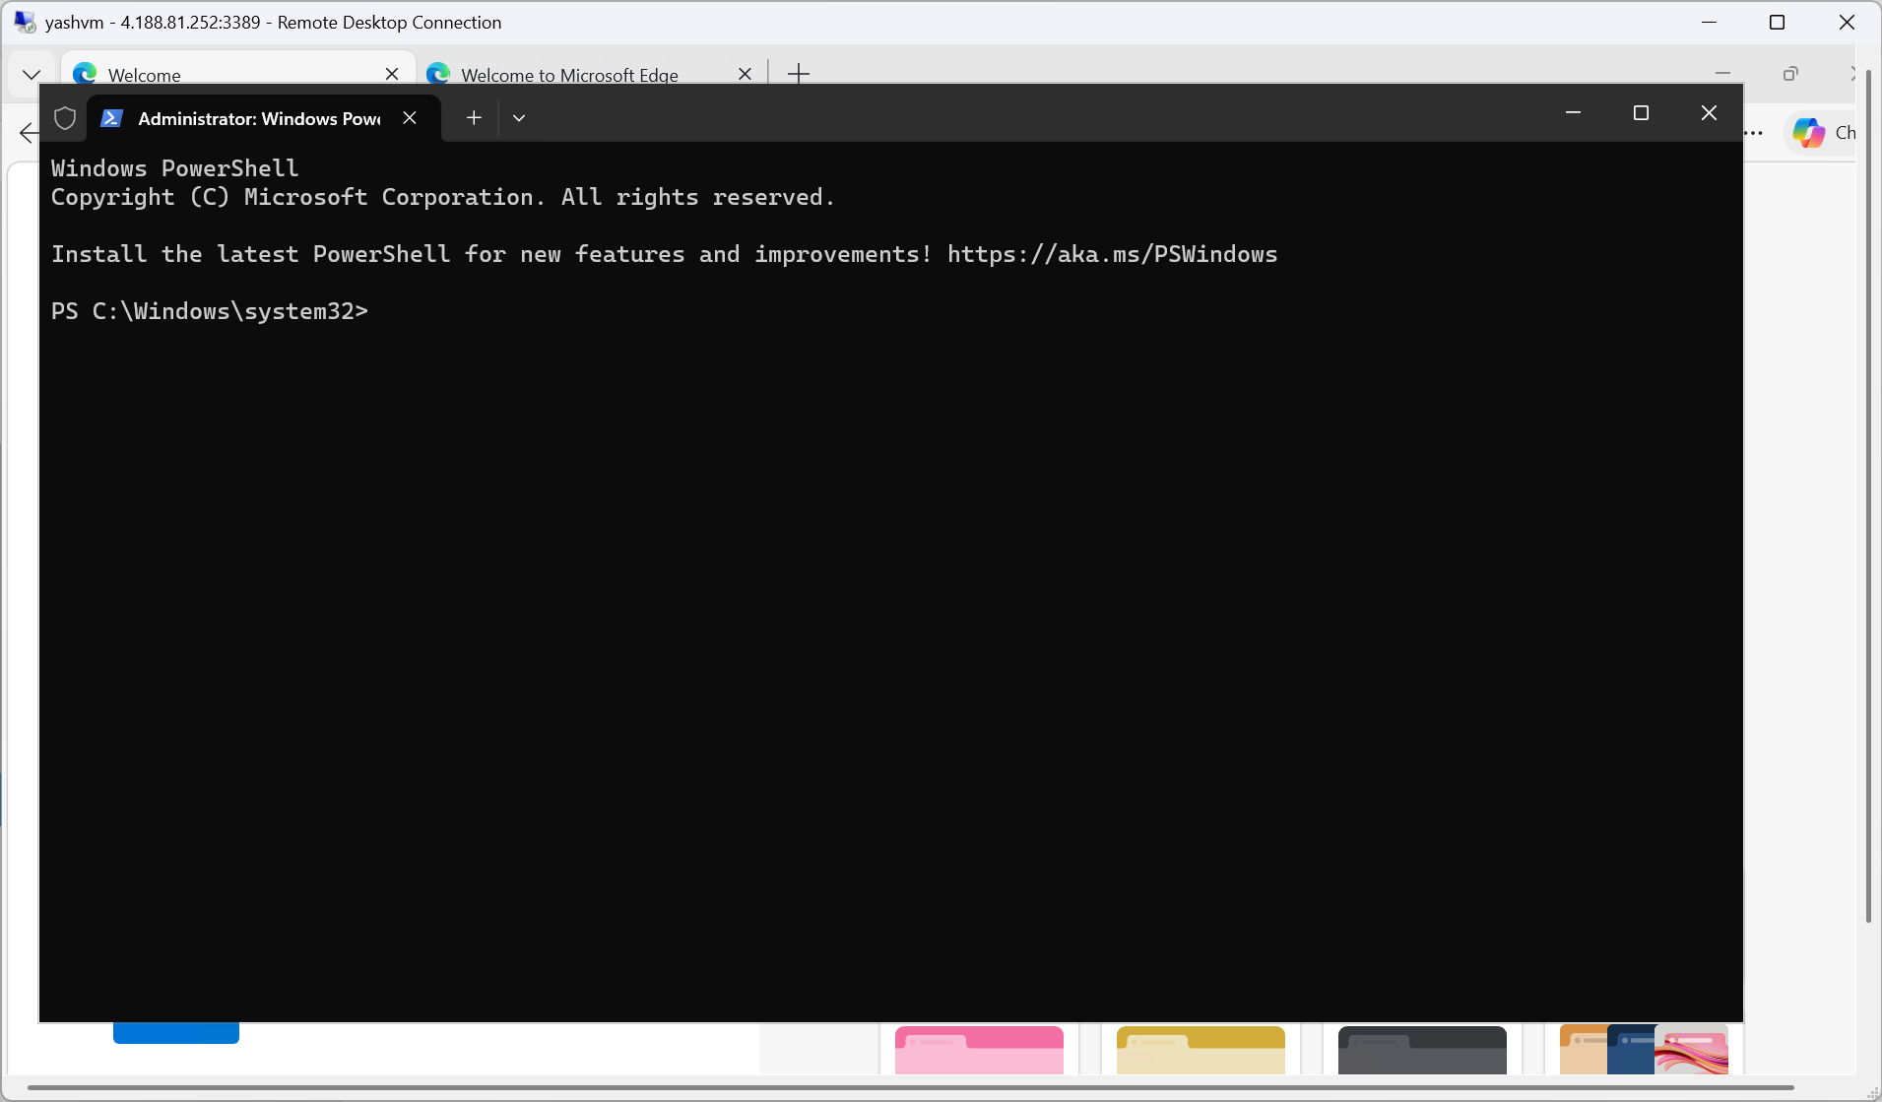
Figure 4.3: PowerShell (Admin) opened on yashvm — ready to run agent registration script

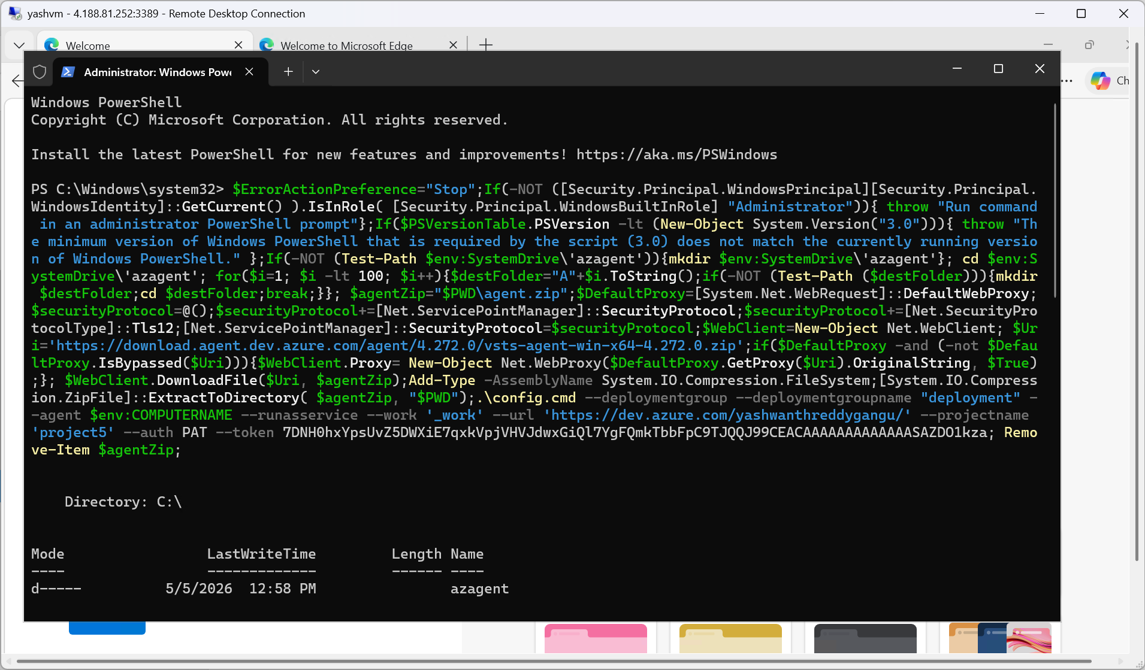
Figure 4.4: PowerShell — agent registration script executing, downloading and installing Azure Pipelines agent

Step 4: Agent Registered Successfully
After the script completes, the agent is installed as a Windows service and starts automatically. The agent registers with the deployment group with tag "web".

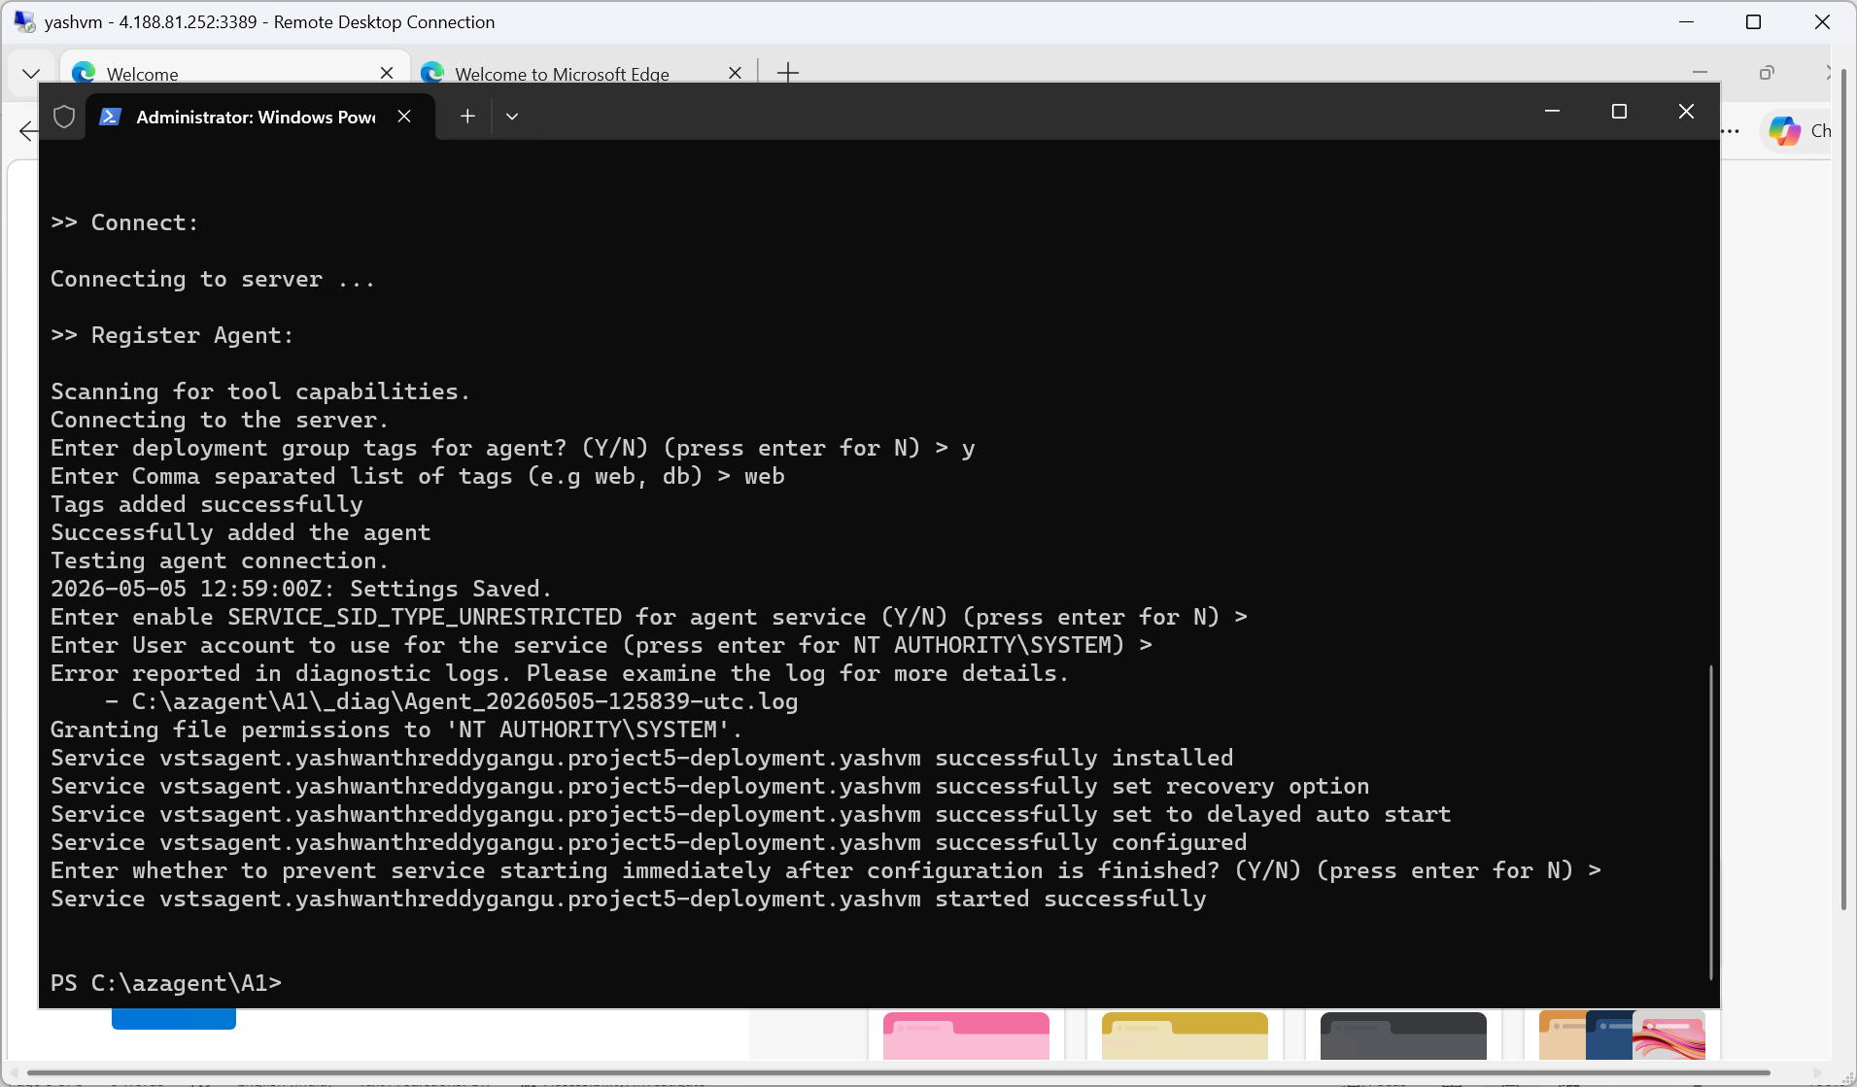
Figure 4.5: Agent registration complete — tag "web" added, service installed and started successfully

Step 5: Confirm VM is Online
Back in Azure DevOps, the deployment group now shows yashvm as Online with 1 machine ready.

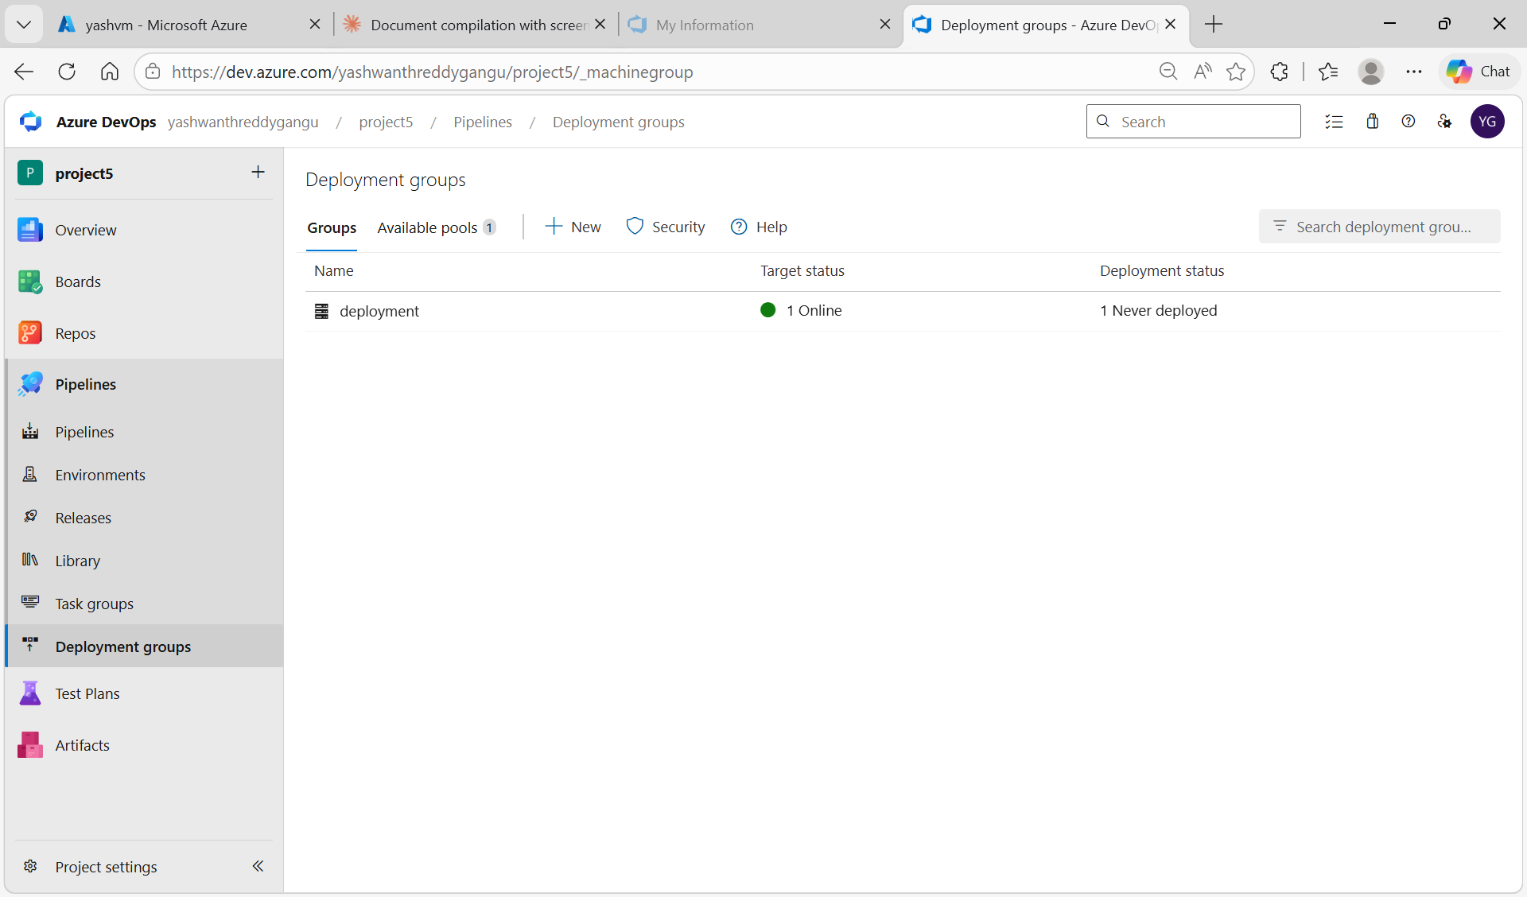
Figure 4.6: Deployment groups — "deployment" group showing 1 Online target, ready for deployments

Task 5: Create the Build Pipeline (CI)

Step 1: Configure azure-pipelines.yml
In Azure Repos, update the azure-pipelines.yml with the correct build pipeline configuration. The key requirements are:
- SourceFolder must point to the my-Portfolio subfolder (not the repo root)
- ArchiveFiles task zips the files (required by IIS Deploy task in release pipeline)
- PublishBuildArtifacts publishes the zip as "portfolio-site" artifact

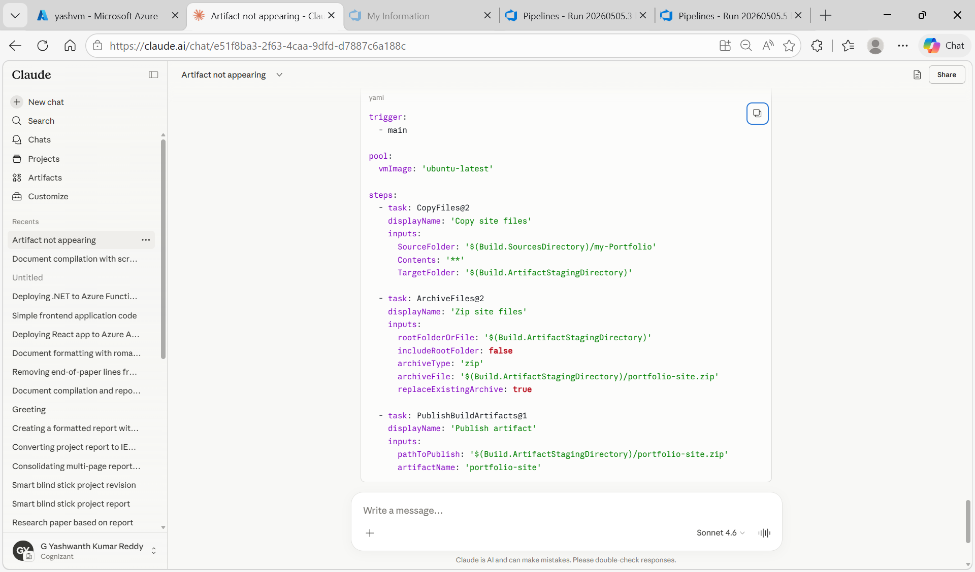
Figure 5.1: Final correct azure-pipelines.yml — CopyFiles from my-Portfolio subfolder, ArchiveFiles to zip, PublishBuildArtifacts

trigger:
- main

pool:
vmImage: 'ubuntu-latest'

steps:
- task: CopyFiles@2
displayName: 'Copy site files'
inputs:
SourceFolder: '$(Build.SourcesDirectory)/my-Portfolio'
Contents: |
index.html
style.css
TargetFolder: '$(Build.ArtifactStagingDirectory)'

- task: ArchiveFiles@2
displayName: 'Zip site files'
inputs:
rootFolderOrFile: '$(Build.ArtifactStagingDirectory)'
includeRootFolder: false
archiveType: 'zip'
archiveFile: '$(Build.ArtifactStagingDirectory)/portfolio-site.zip'
replaceExistingArchive: true

- task: PublishBuildArtifacts@1
displayName: 'Publish artifact'
inputs:
pathToPublish: '$(Build.ArtifactStagingDirectory)/portfolio-site.zip'
artifactName: 'portfolio-site'

Step 2: Build Pipeline Runs Successfully
Commit the yaml file. The pipeline triggers automatically on the main branch. All steps complete successfully and 1 artifact (portfolio-site.zip) is published.

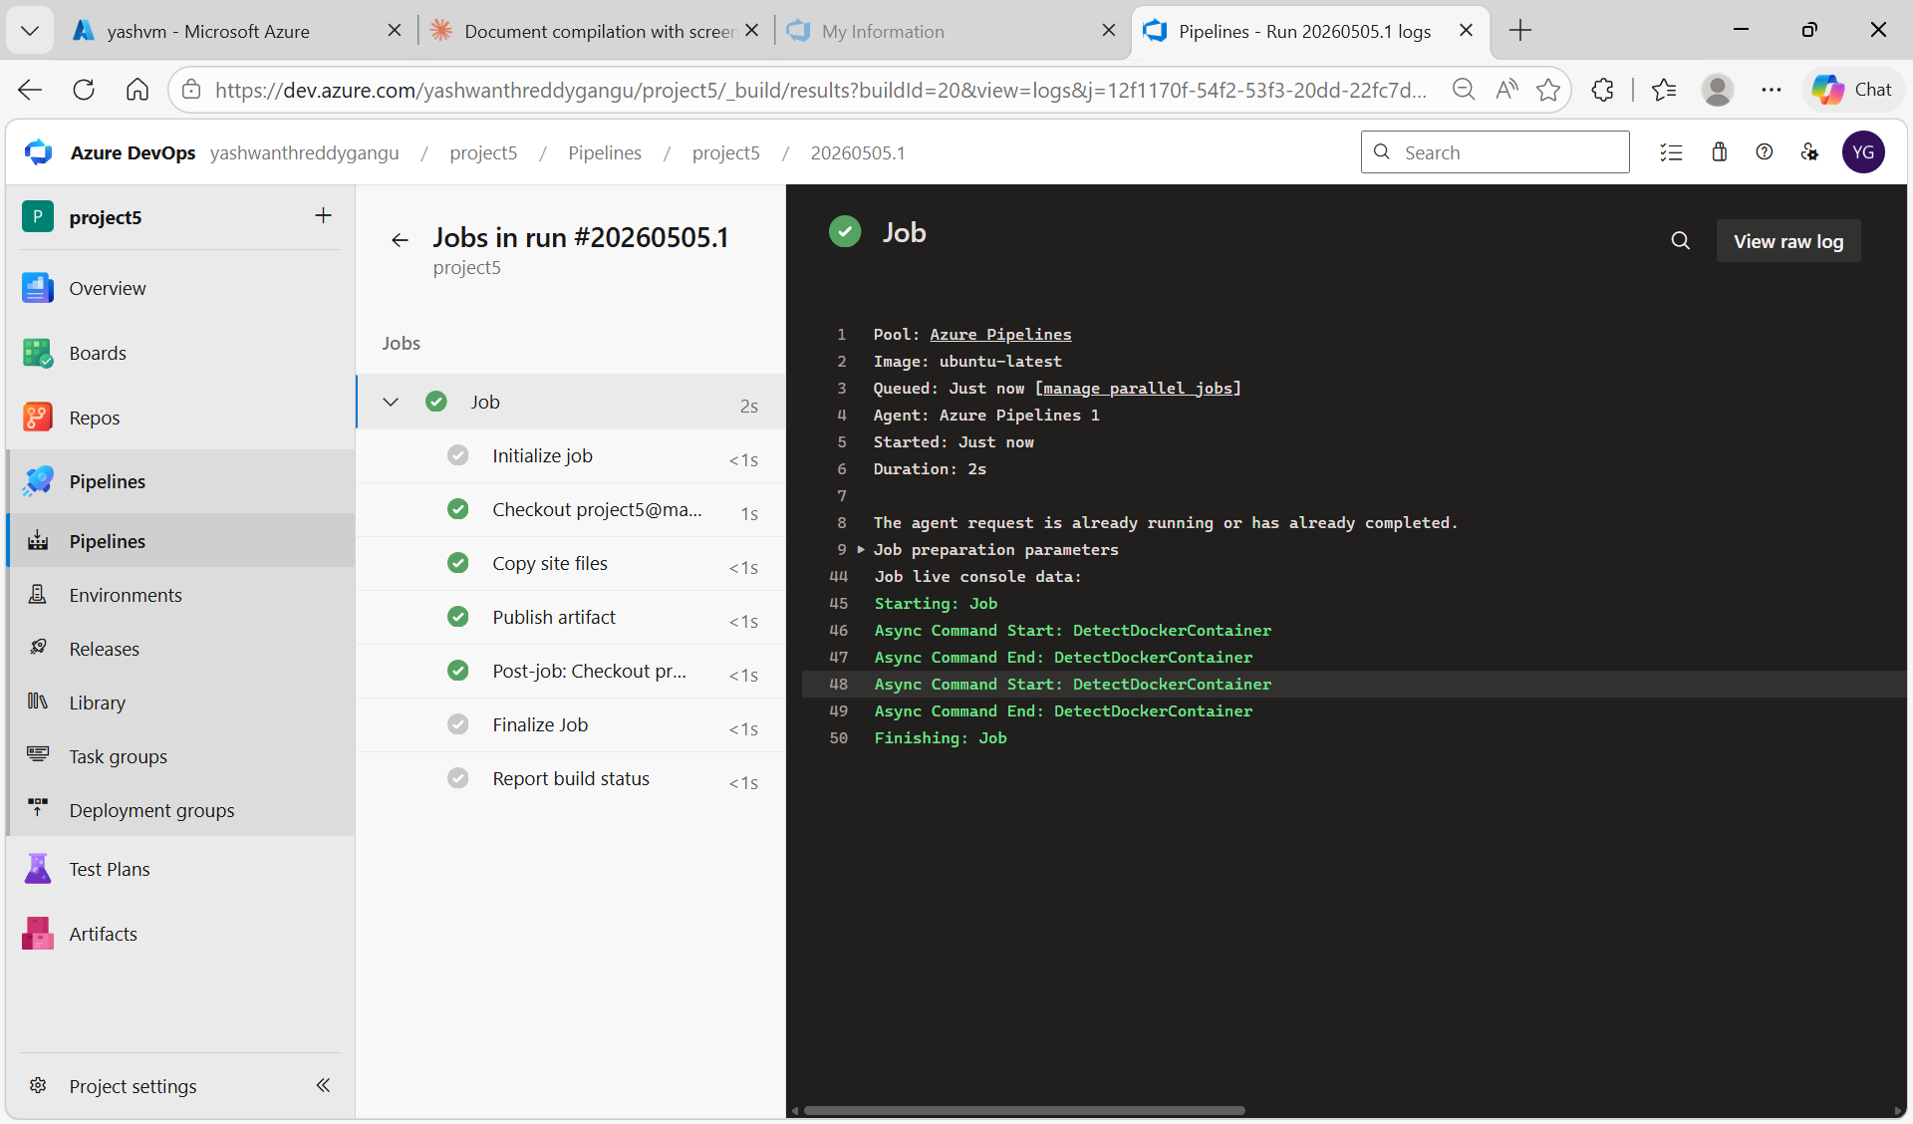
Figure 5.2: Build pipeline run #20260505.1 — all steps green: Copy site files, Publish artifact. 1 artifact published

Task 6: Create the Release Pipeline (CD)

Step 1: Add IIS Web App Deploy Task
Go to Pipelines → Releases → New pipeline. In the Tasks tab, click "+" on Deployment group job to add a task. Search for "IIS" and select "IIS web app deploy".

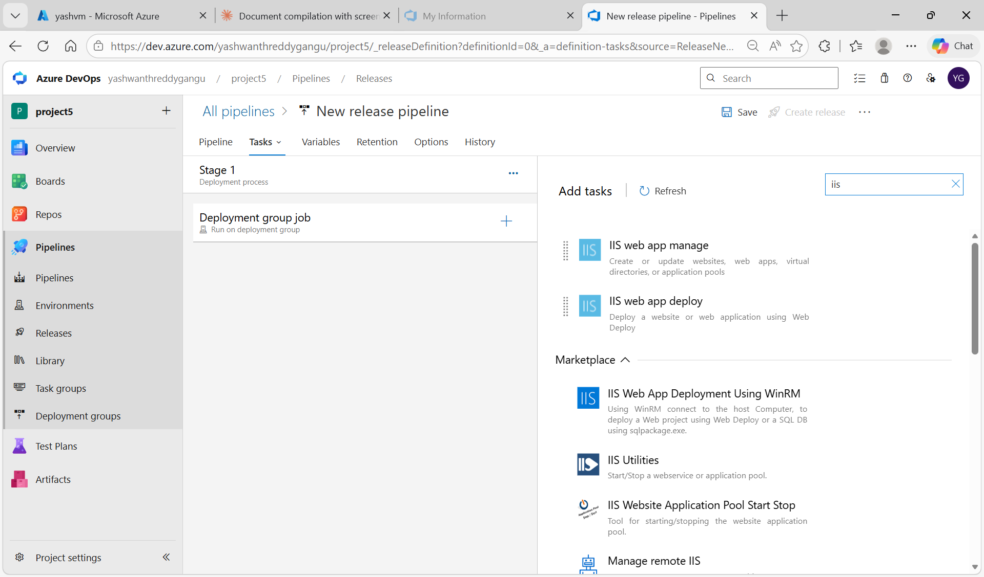
Figure 6.1: Release pipeline Tasks — searching for IIS task. "IIS web app deploy" option visible

Step 2: Configure Deploy IIS Website/App Task
Click on the added "Deploy IIS Website/App" task. Configure:
- Website Name: Default Web Site (the pre-existing IIS site on the VM)
- Package or Folder: $(System.DefaultWorkingDirectory)/_project5/portfolio-site/portfolio-site.zip

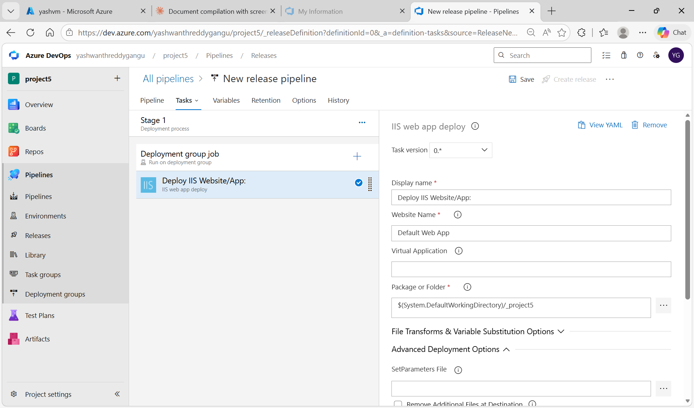
Figure 6.2: IIS web app deploy task configured — Website Name: Default Web App, package path set to project5 artifact

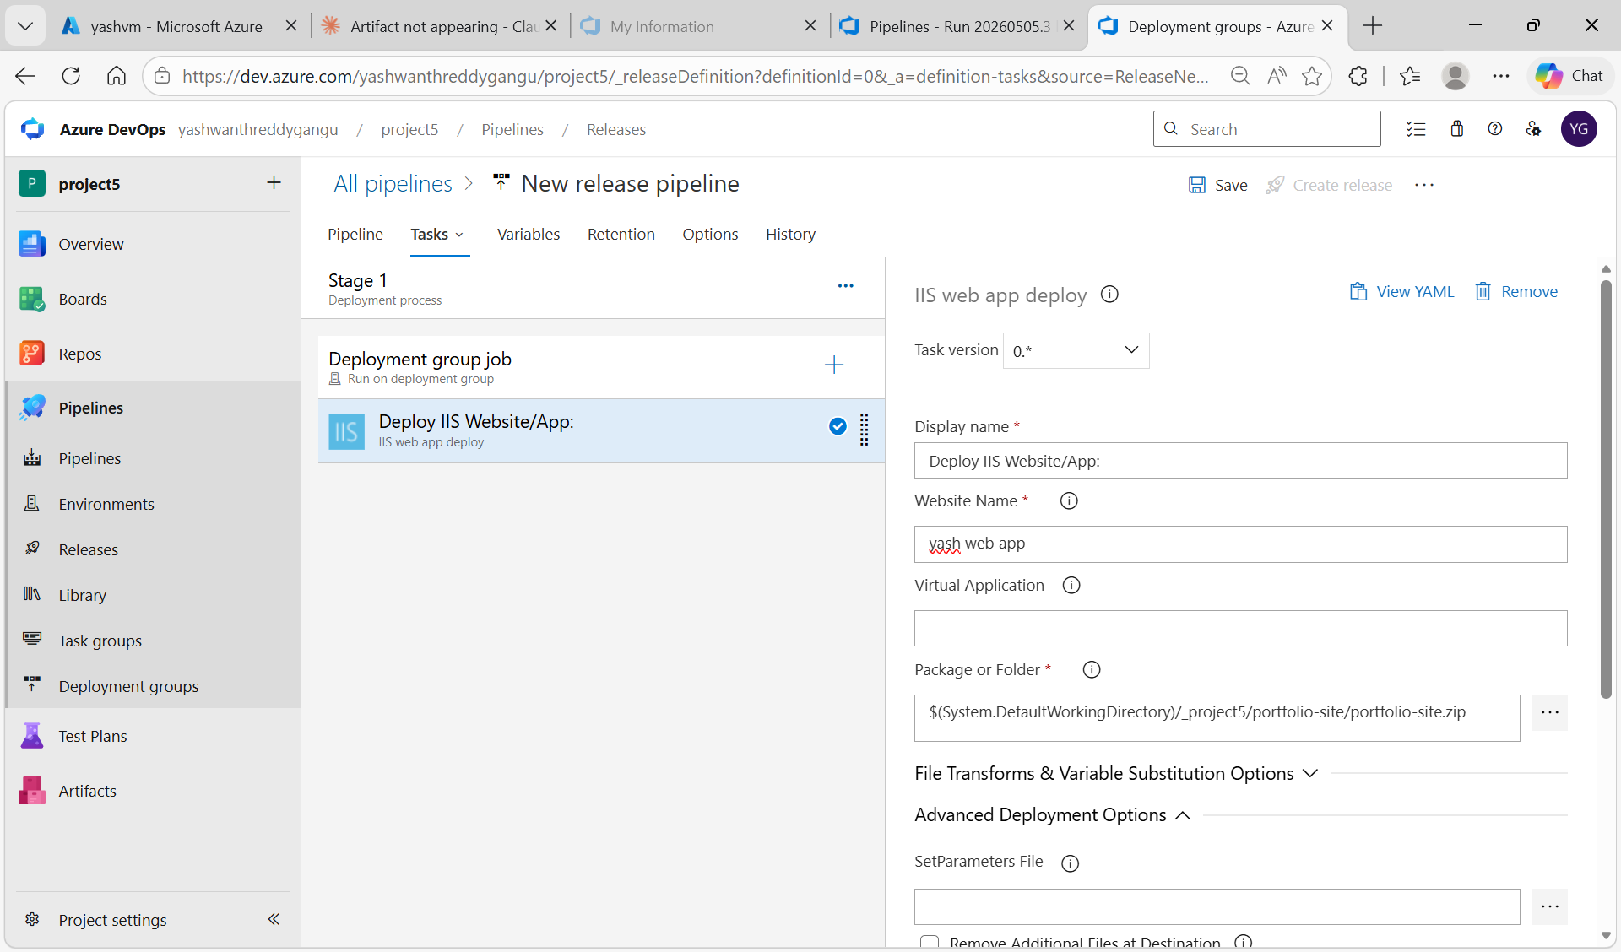
Figure 6.3: Final release pipeline configuration — Website Name: yash web app, full zip path: $(System.DefaultWorkingDirectory)/_project5/portfolio-site/portfolio-site.zip

Task 7: Deploy and Verify Portfolio Website

Step 1: Create Release and Deploy
Save the release pipeline. Click "Create release" → select the latest build artifact → click "Create". Navigate to the release and click "Deploy" for Stage 1. The deployment agent on yashvm picks up the job, downloads the artifact, and deploys via MSDeploy to IIS.

Step 2: Verify Portfolio Website is Live
Open a browser and navigate to http://4.188.81.252 (the public IP of yashvm). The Yashwanth Kumar portfolio website loads successfully, served by IIS from C:\inetpub\wwwroot.

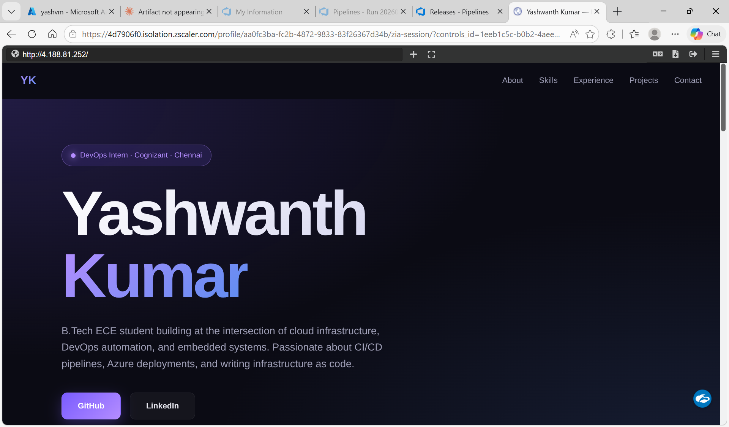
Figure 7.1: Portfolio website live at http://4.188.81.252 — Yashwanth Kumar portfolio deployed via Azure CI/CD to Windows VM with IIS

Errors Encountered and Resolutions
The following errors were encountered during the implementation process. Each is documented with its root cause and the fix applied.

Error 1: Empty Artifact Directory
Error: ##[warning] Directory /home/vsts/work/1/a is empty. Nothing will be added to build artifact

Root Cause: The CopyFiles task SourceFolder was pointing to $(Build.SourcesDirectory) (repo root), but the portfolio files were inside the my-Portfolio subfolder. No files matched so the staging directory stayed empty.

Fix Applied:
Changed SourceFolder to $(Build.SourcesDirectory)/my-Portfolio. Added ArchiveFiles@2 task to zip the copied files before publishing. The IIS deploy task requires a zip package — without the ArchiveFiles step, the release would fail even if files were copied correctly.

Error 2: No Package Found With Specified Pattern
Error: No package found with specified pattern. Check if the package exists or adjust the pattern.

Root Cause: The release pipeline Deploy IIS task had the default pattern $(System.DefaultWorkingDirectory)\**\*.zip but the build pipeline was publishing loose files (not a zip). The artifact folder was empty.

Fix Applied:
Added ArchiveFiles@2 to build pipeline to create portfolio-site.zip. Updated release package path to: $(System.DefaultWorkingDirectory)/_project5/portfolio-site/portfolio-site.zip

Error 3: IIS Site Does Not Exist (ERROR_SITE_DOES_NOT_EXIST)
Error Code: ERROR_SITE_DOES_NOT_EXIST — Site 'yash web app' does not exist.

Root Cause: The release pipeline had Website Name set to 'yash web app' but this site was never created on the Windows VM. IIS only has 'Default Web Site' installed by default.

Fix Applied:
Changed Website Name to 'Default Web Site' which is pre-existing and already running on port 80. Alternatively, created the 'yash web app' site via PowerShell on the VM using New-WebSite, but it failed due to port 80 conflict with Default Web Site. Final solution: use Default Web Site.

Error 4: 500 Internal Server Error — Duplicate web.config Entry
500 - Internal Server Error. Error 19 — Duplicate collection entry for index.html in defaultDocument

Root Cause: The web.config had two issues — (1) a duplicate <?xml version="1.0"?> declaration from a copy-paste error, and (2) it was adding index.html as a default document, but IIS already has this configured globally. Adding it again caused a duplicate entry conflict (error 500.19).

Fix Applied:
Removed web.config from the pipeline entirely. A simple static HTML/CSS site does not need web.config — IIS automatically serves index.html from Default Web Site without any extra configuration. Also manually deleted the old broken web.config from C:\inetpub\wwwroot on the VM using PowerShell: Remove-Item C:\inetpub\wwwroot\web.config -Force

Summary

Task | Status | Key Action | Notes
Create Windows VM | ✓ Done | Azure Portal — yashvm (Windows Server) | HTTP 80 + RDP 3389 open
Install IIS | ✓ Done | Server Manager — Add Web Server role | Creates C:\inetpub\wwwroot
Push code to Repos | ✓ Done | VS Code git push to Azure Repos | my-Portfolio subfolder
Deployment Group | ✓ Done | Windows agent registered on yashvm | Tag: web, Status: Online
Build Pipeline (CI) | ✓ Done | Copy → Zip → Publish artifact | portfolio-site.zip created
Release Pipeline (CD) | ✓ Done | IIS Web App Deploy task | Deploys to Default Web Site
Website Live | ✓ Done | http://4.188.81.252 | Portfolio accessible on public IP

End of USE-CASE 05 — Portfolio Website Deployed to Azure Windows VM via Azure DevOps CI/CD Pipelines with IIS

