USE-CASE-02
Planning and Implementation of
Azure SQL Database
with CI/CD and Azure Key Vault Integration

Submitted by:
Yashwanth Kumar Reddy Gangu
DevOps Intern, Cognizant

Date: May 2026

Workflow
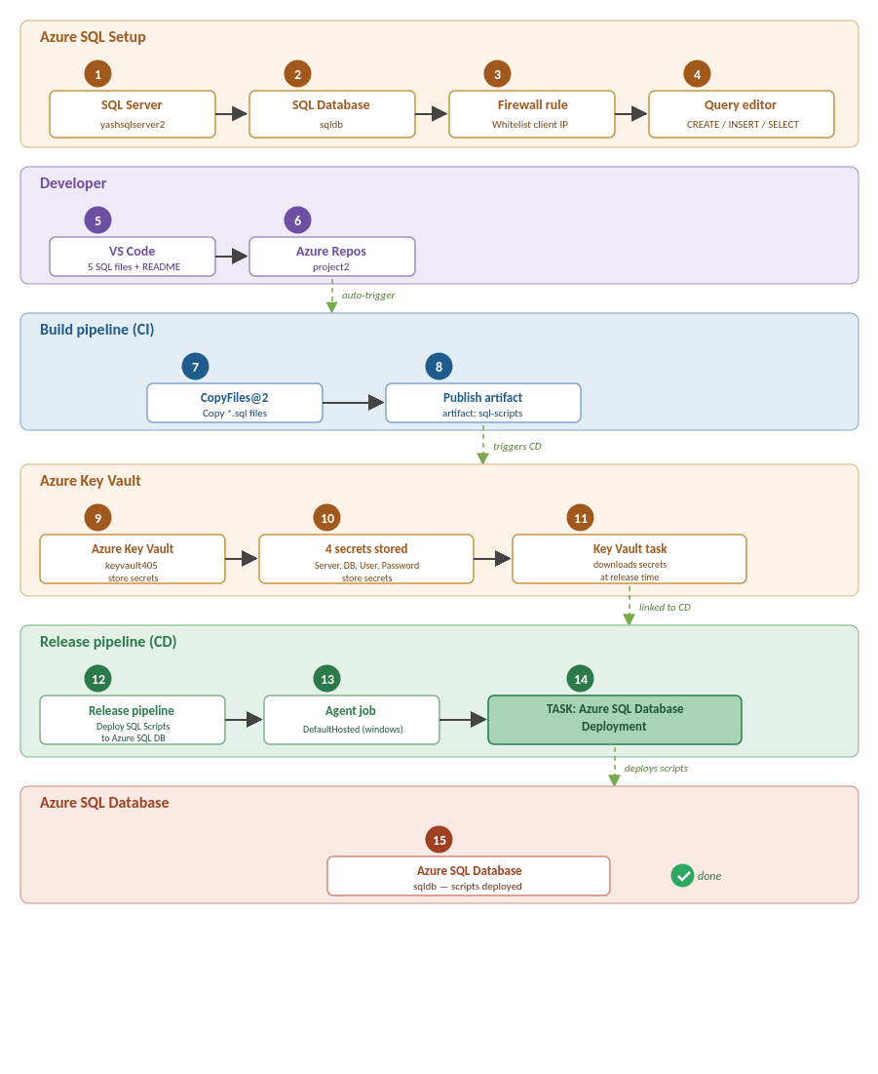
End-to-end architecture: Azure SQL Setup -> Developer (VS Code -> Azure Repos) -> CI Build -> Azure Key Vault -> CD Release -> Azure SQL Database.

Environment Used in This Implementation
- Azure subscription: Azure for Students; Resource Group: userg1; Region: Central India.
- SQL Server: yashsqlserver2.database.windows.net; SQL Database: sqldb (Development workload, Serverless GP_S_Gen5_1).
- SQL admin login: serveradmin.
- Azure Key Vault: keyvault405 (vault access policy model).
- Azure DevOps Organization: yashwanthreddygangu; Project: project2 (Git).
- Service connection: serviceconnectionproject2 (Azure Resource Manager via Workload Identity Federation, scoped to userg1).
- SQL scripts: 01-create-tables.sql, 02-seed-data.sql, 03-stored-procedures.sql, 04-views.sql, 05-test-queries.sql, plus README.md.

Task 1: Creation of SQL Server and SQL Database

Step 1: Create SQL Database Server (Basics)
In the Azure Portal, search for 'SQL servers' and click + Create. On the Basics tab choose the Azure for Students subscription and the userg1 resource group. Set the Server name to yashsqlserver2 and the Location to (Asia Pacific) Central India. The server name must be globally unique across Azure.
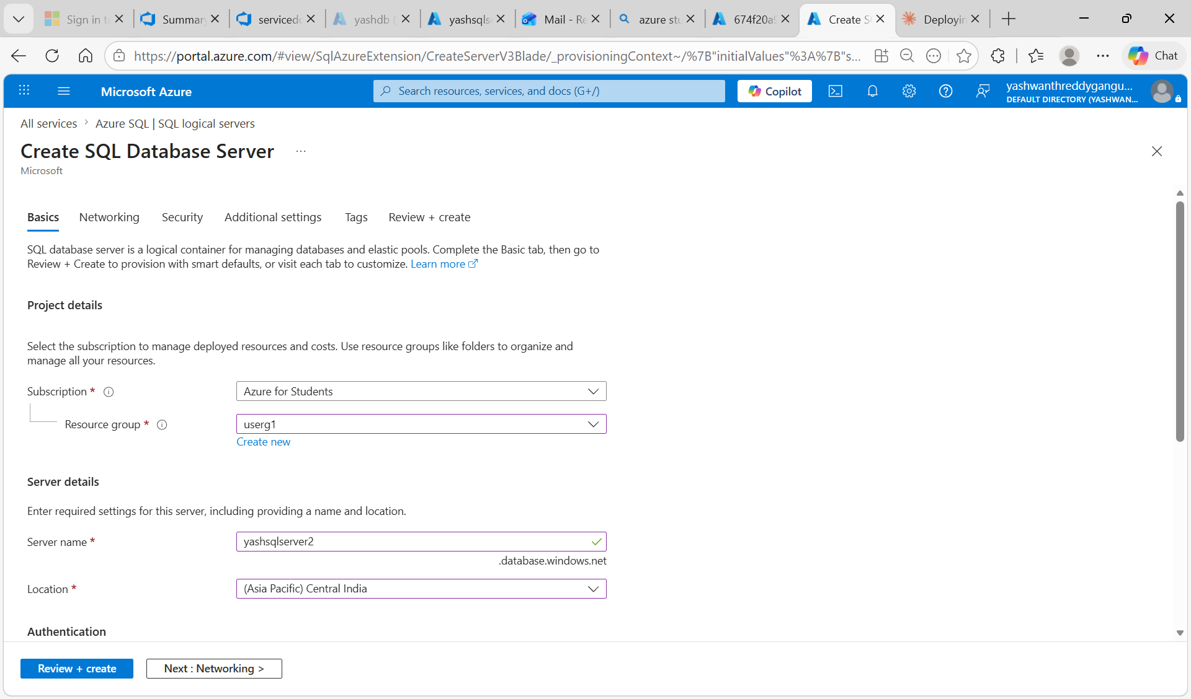
Figure 1.1 - Create SQL Database Server (Basics): subscription, resource group userg1, server name yashsqlserver2, location Central India.

Step 2: Configure SQL Authentication
Scroll down to the Authentication section. Select 'Use SQL authentication' and provide the server admin login (serveradmin) along with a strong password (Yash@123). SQL authentication is required so that the release pipeline can later sign in with credentials retrieved from Key Vault. Click Review + create, then Create.
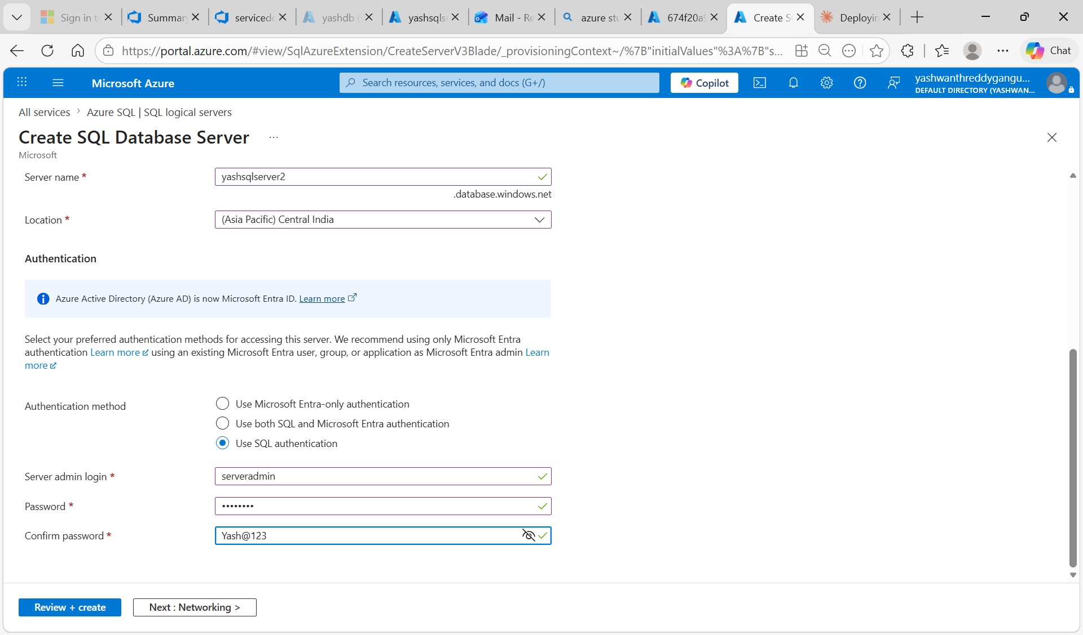
Figure 1.2 - Authentication tab: SQL authentication selected with server admin login serveradmin.

Step 3: Verify SQL Server Deployment Complete
Once validation passes, the deployment runs and the portal shows a 'Your deployment is complete' message. The SQL logical server (yashsqlserver2) is now provisioned under the userg1 resource group and ready to host one or more databases.
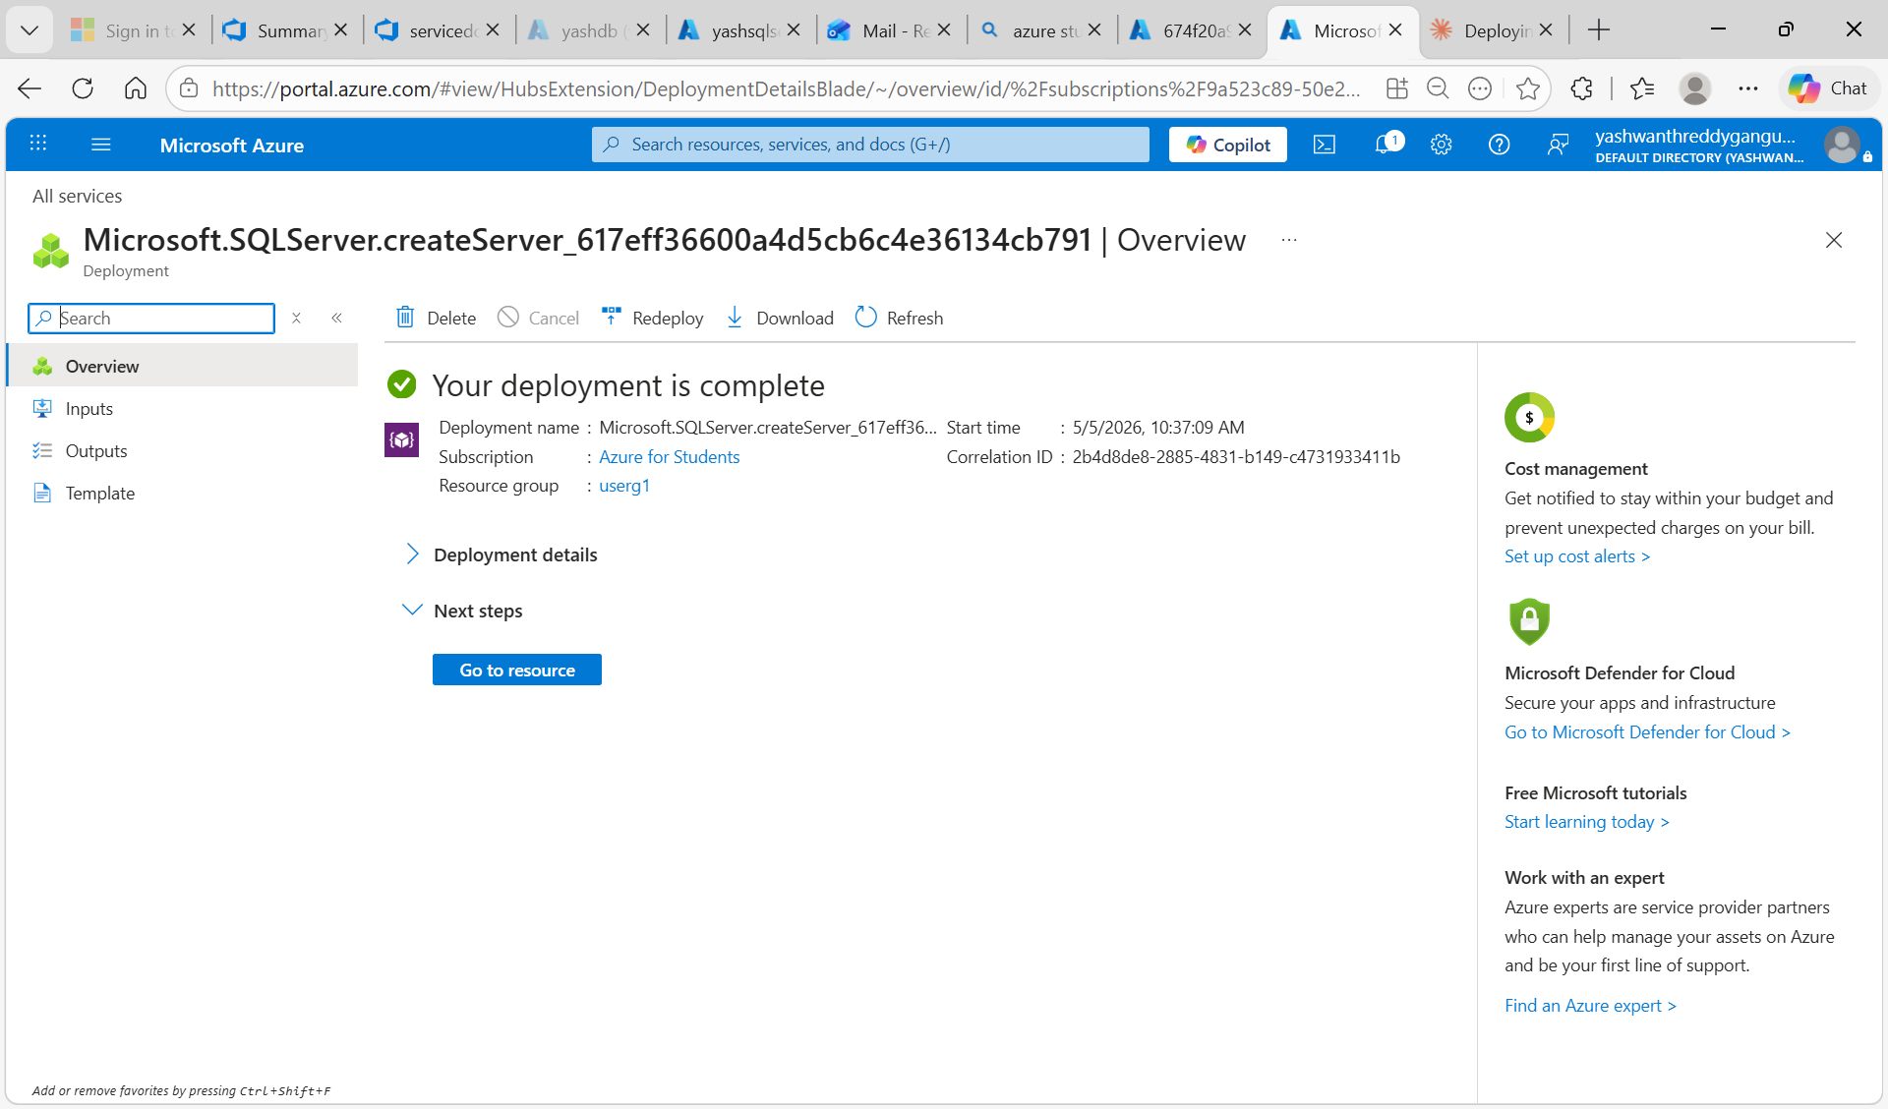
Figure 1.3 - SQL Server deployment complete (Microsoft.SQLServer.createServer).

Step 4: Create SQL Database (Basics)
From All services -> SQL databases click + Create. The Basics tab opens. The page shows a serverless free-offer banner (100,000 vCore seconds, 32GB data, 32GB backup storage free per month) and a cost summary panel on the right. This is excellent for development workloads.
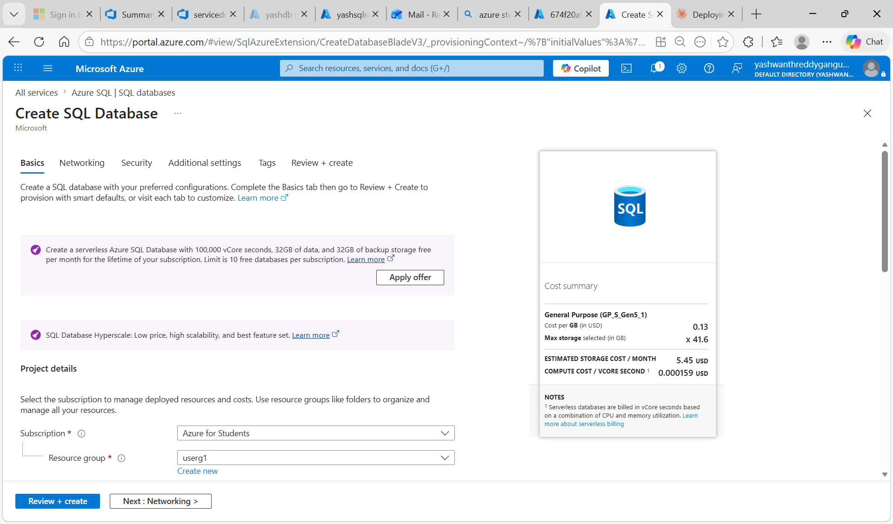
Figure 1.4 - Create SQL Database: Basics tab with the serverless free-offer banner and cost summary panel.

Step 5: Configure Database Details
Under Database details set the Database name to sqldb and pick yashsqlserver2 (Central India) as the server (the one created in Step 3). Choose No for elastic pool, and select Development as the workload environment so Azure applies cost-friendly defaults. Click Review + create, then Create.
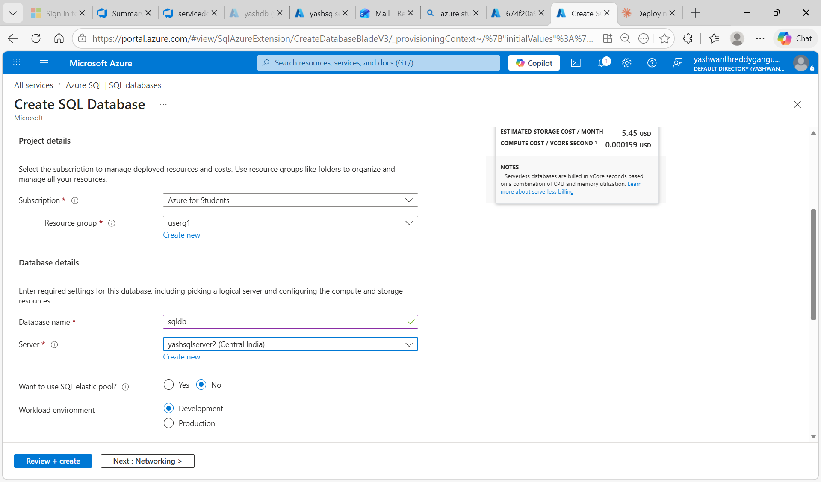
Figure 1.5 - Database details: name sqldb, server yashsqlserver2, no elastic pool, Development workload.

Step 6: Verify SQL Database Deployment Complete
Once provisioning finishes, the deployment status page confirms the database is ready. Both the server (yashsqlserver2) and the database (sqldb) now exist under the userg1 resource group, ready to receive schema deployments via the CI/CD pipeline.
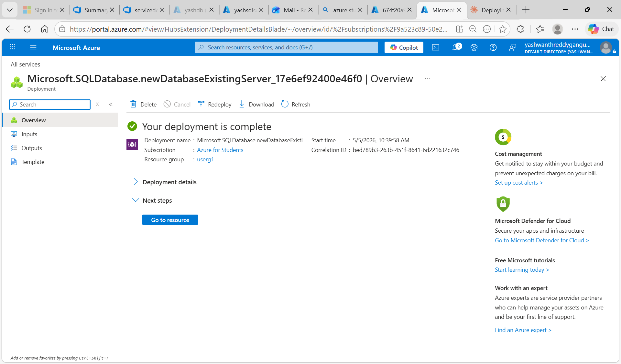
Figure 1.6 - SQL Database deployment complete.

Task 2: Implement Azure Key Vault to Store Database Secret Variables

Step 1: Open the Create Key Vault Wizard
Azure Portal -> Create a resource -> search 'Key Vault' -> click Create. The Create a key vault wizard opens on the Basics tab. Read the description: Azure Key Vault is a cloud service for managing keys, secrets, and certificates. It is FIPS 140-2 Level 2 validated and provides full audit logs of all access attempts. This is exactly what we need to store SQL credentials securely outside of source code.
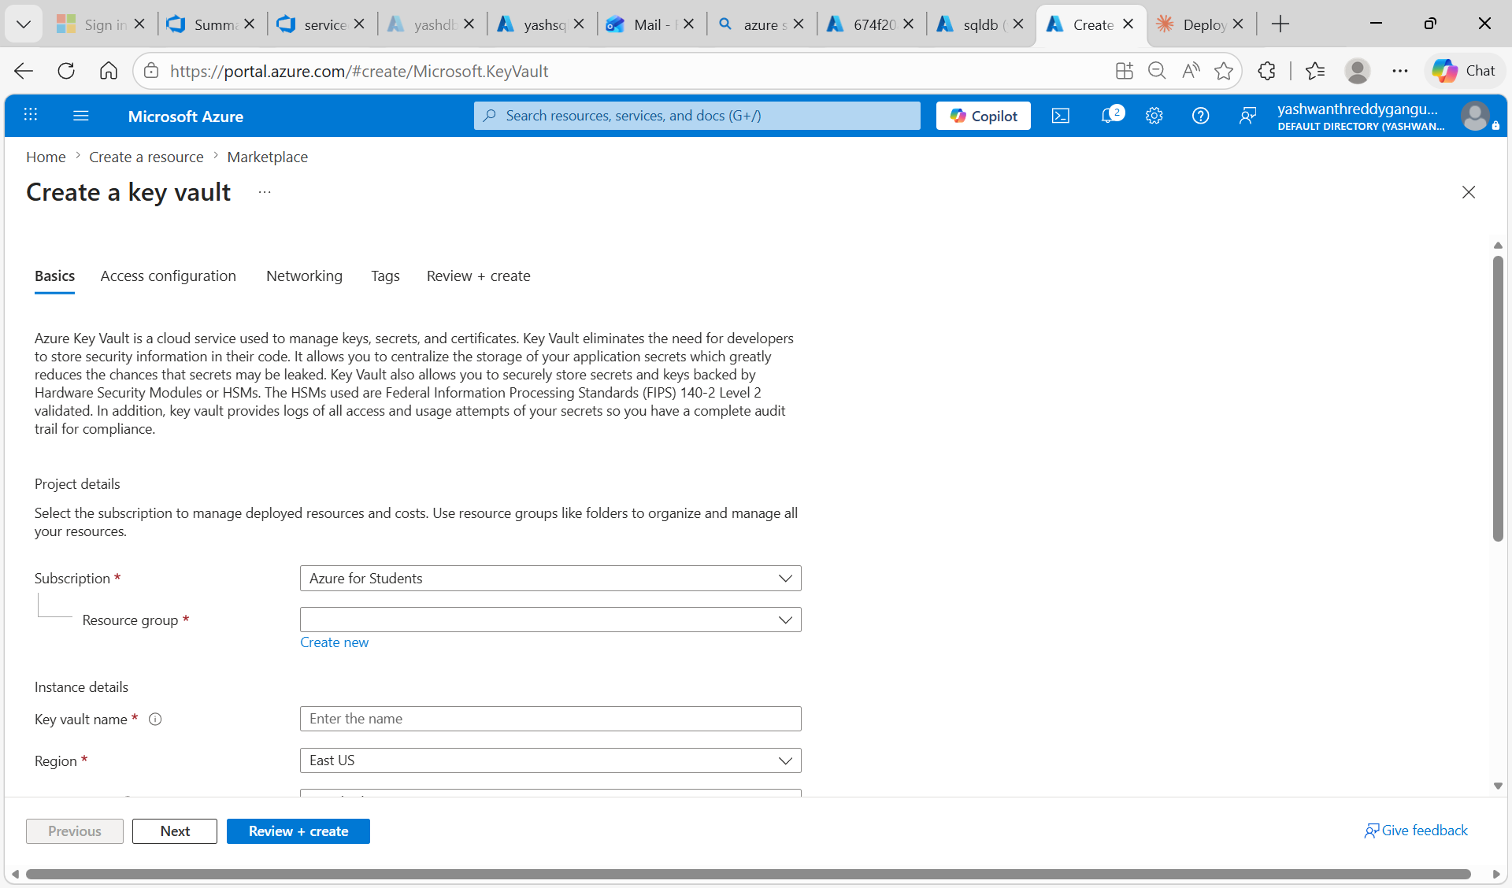
Figure 2.1 - Create a Key Vault: Basics tab introduction page (empty form).

Step 2: Fill Basics Tab - Project and Instance Details
Fill in the Basics tab fields:
- Subscription: Azure for Students
- Resource group: userg1 (the same resource group as the SQL server)
- Key vault name: keyvault405 (must be globally unique across Azure)
- Region: Central India
- Pricing tier: Standard (Standard tier is sufficient for storing secrets; Premium adds HSM-backed keys which we do not need)

Soft-delete protection is enabled by default and lets you recover accidentally deleted secrets within the retention period. Click Next to continue to the Access configuration tab.
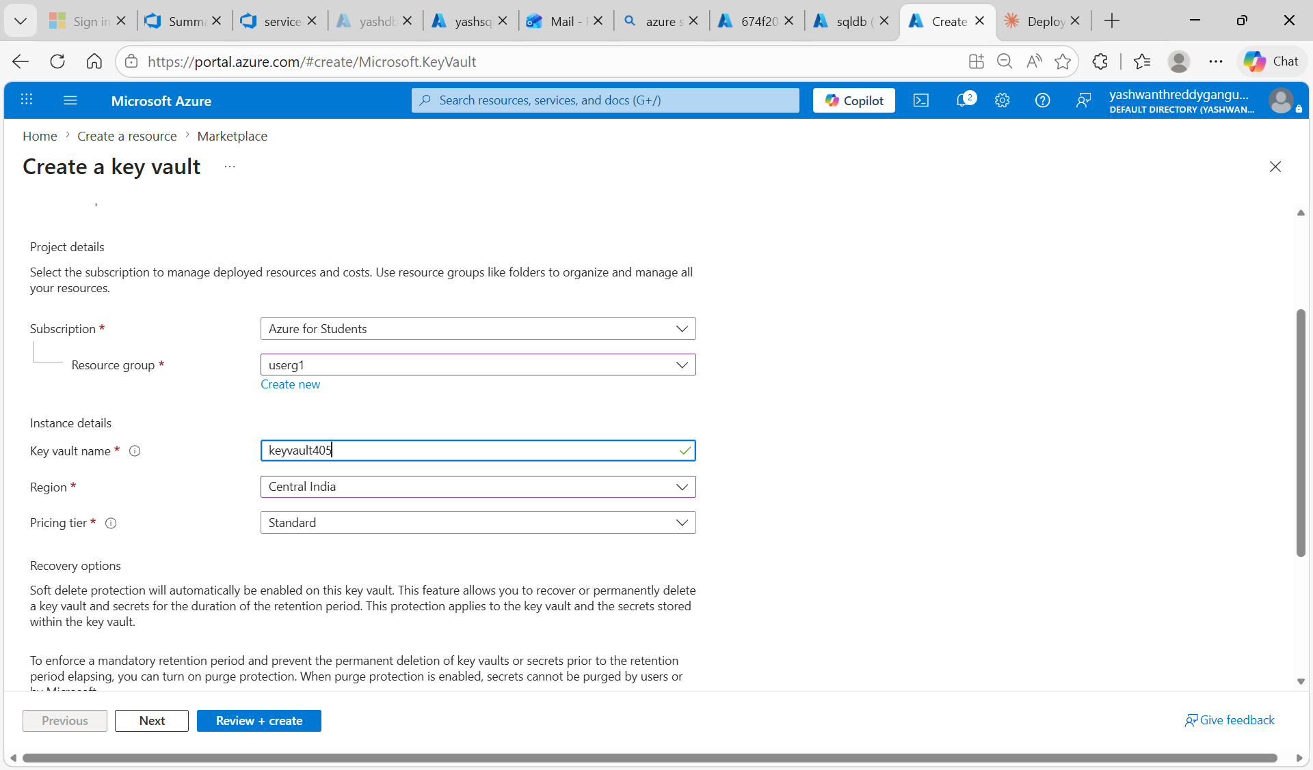
Figure 2.2 - Basics tab filled in: keyvault405 in userg1 resource group, Central India region, Standard pricing tier.

Step 3: Configure Access (Vault Access Policy Model)
On the Access configuration tab, choose the Permission model. There are two options:
- Azure role-based access control (RBAC) - permissions managed via Access control (IAM) blade
- Vault access policy - permissions managed via Access policies blade

Select 'Vault access policy'. This makes it straightforward to later grant the release pipeline's service principal Get / List permission on secrets through the Access policies UI. Under Resource access, tick 'Azure Resource Manager for template deployment' so ARM-based tasks (such as the release pipeline's Azure Key Vault task) can read secrets at deployment time. Click Next, leave Networking and Tags as default, then click Review + create -> Create.
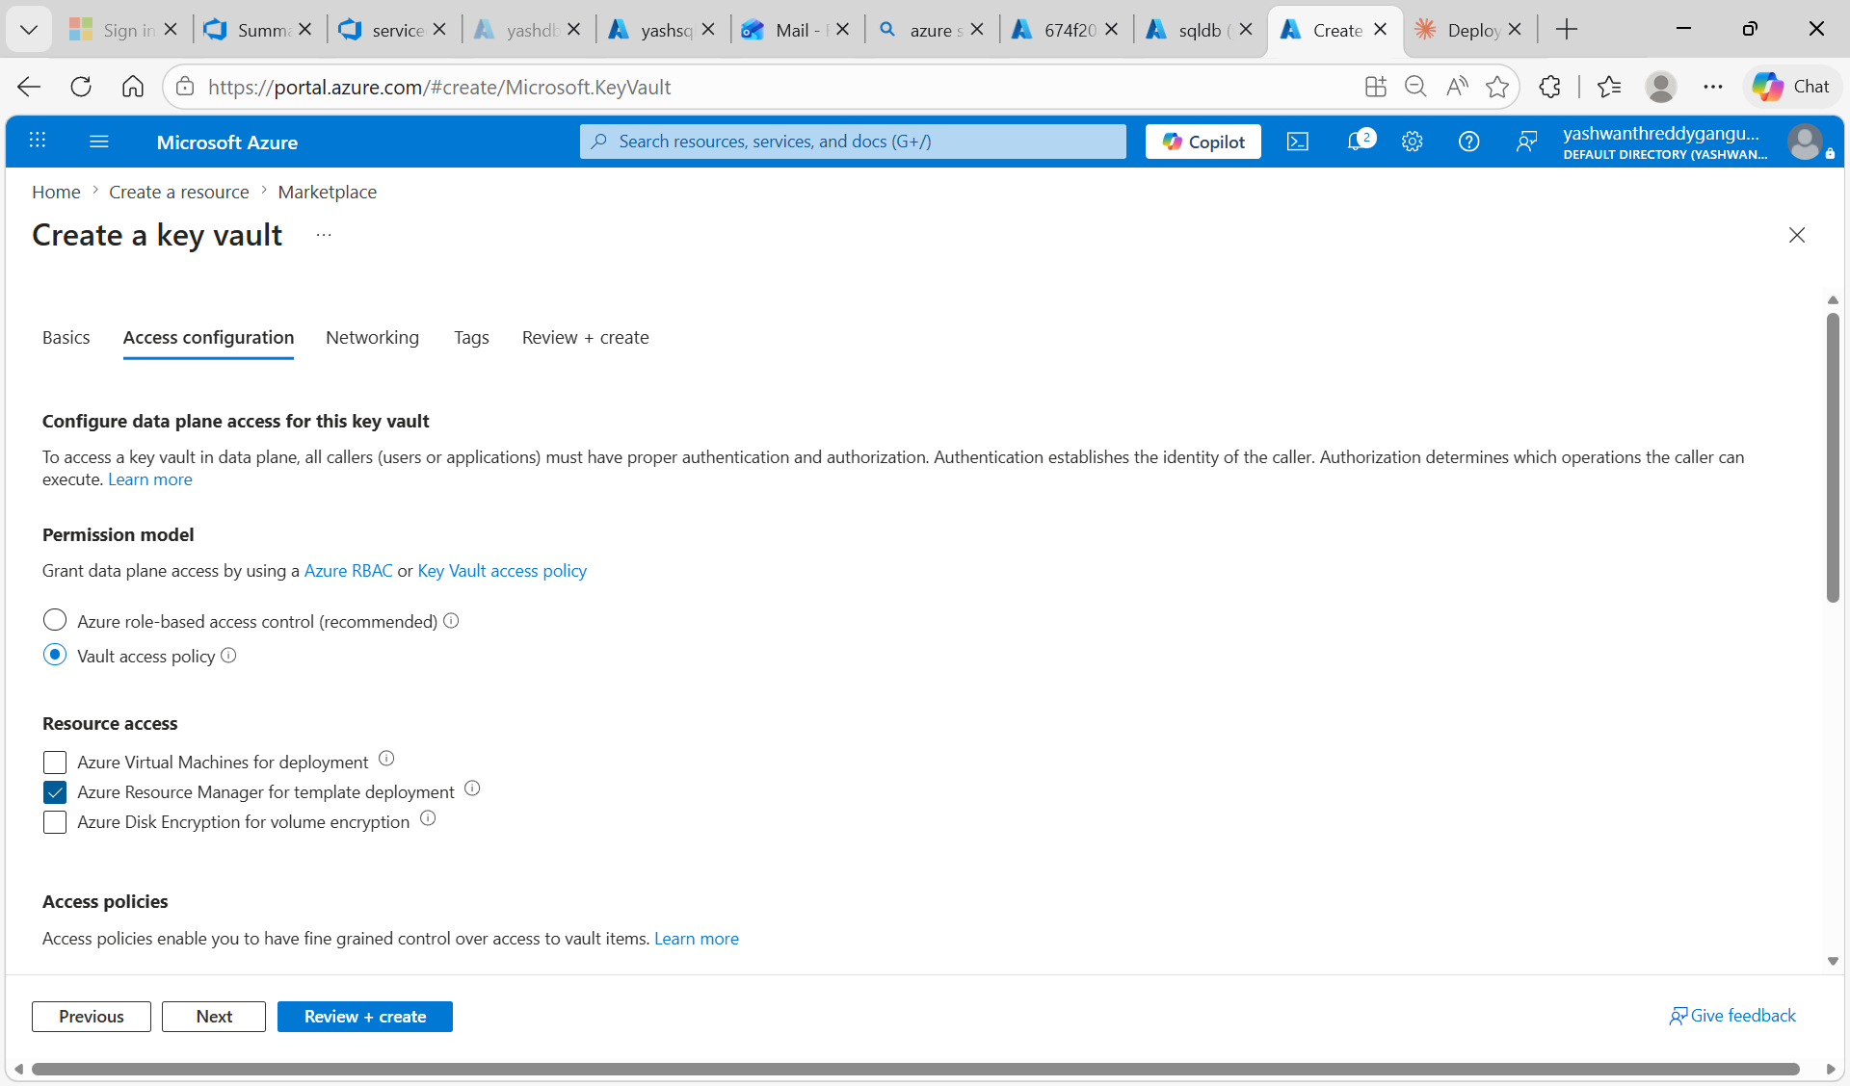
Figure 2.3 - Access configuration tab: Vault access policy permission model selected with Azure Resource Manager for template deployment enabled.

Step 4: Verify Key Vault Deployment Complete
After clicking Create, Azure provisions the Key Vault. The deployment overview page shows 'Your deployment is complete' along with a 'Deployment succeeded' notification toast in the top right of the screen confirming 'Deployment keyvault405 to resource group userg1 was successful'. Click 'Go to resource' to access the new Key Vault and start adding secrets.
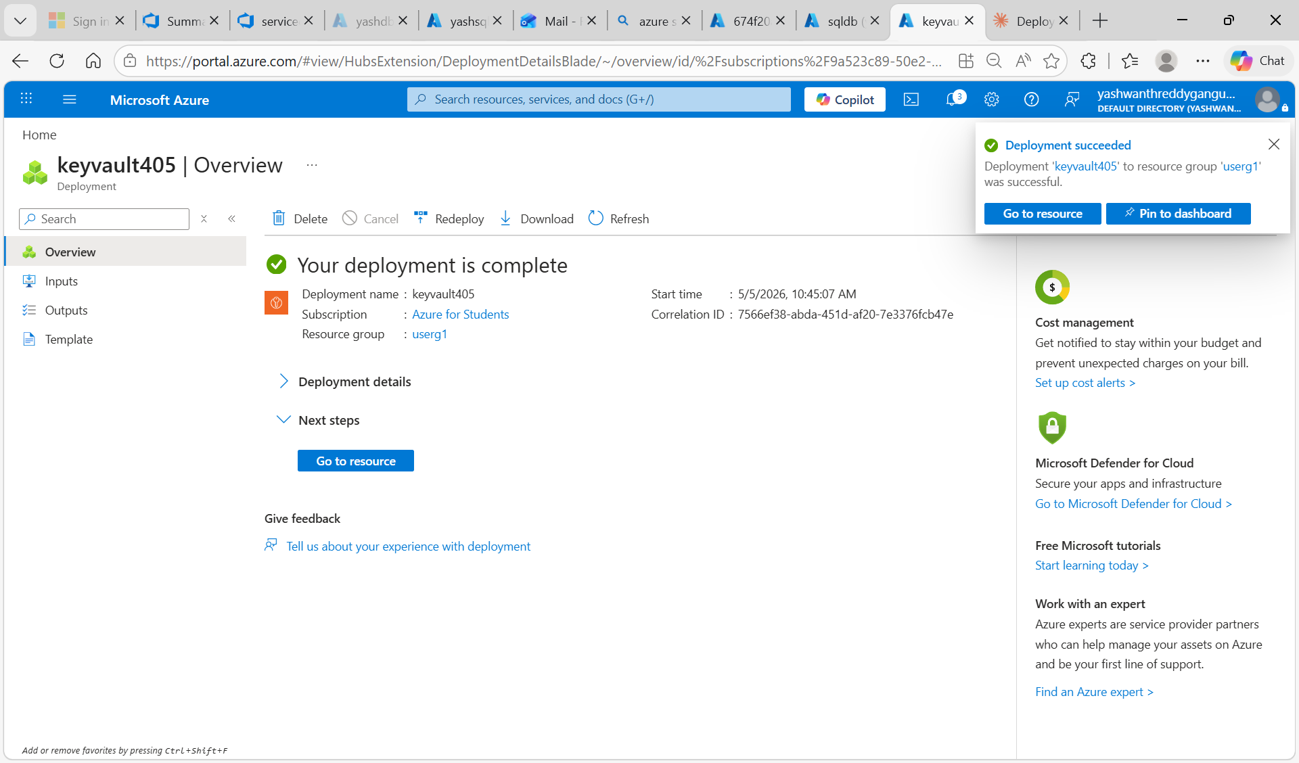
Figure 2.4 - keyvault405 deployment succeeded with the success notification visible.

Step 5: Create the Four Database Secrets
Open keyvault405 -> Objects -> Secrets and click + Generate/Import for each of the four secrets below. The secret names are exactly what the release pipeline references at deployment time, so they must match precisely:

Secret Name | Secret Value
SqlServerName | yashsqlserver2.database.windows.net
database | sqldb
serveradmin | serveradmin
serverpassword | Yash@123 (the SQL admin password set in Task 1)

After creating all four secrets, the Secrets list shows them with status Enabled. The most recently created secret (serverpassword) triggers a 'successfully created' toast at the top of the page that reads: 'The secret serverpassword has been successfully created.' With these four secrets in place, the release pipeline can connect to the database without any credentials in code or YAML.
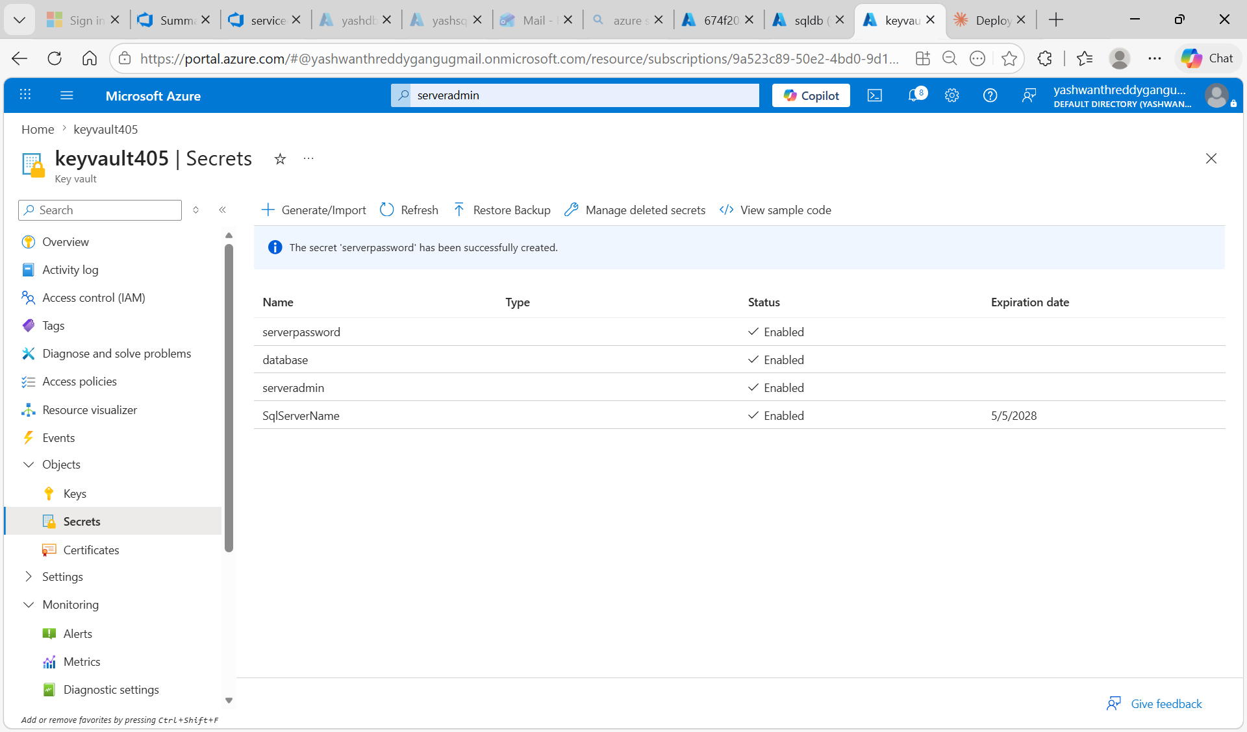
Figure 2.5 - keyvault405 Secrets list: serverpassword, database, serveradmin and SqlServerName all enabled.

Task 3: Pushing SQL Script Files to Azure Repos

Step 1: Prepare SQL Files in VS Code
In VS Code, open the SqlScripts folder containing the five SQL scripts plus a README. Each file is written to be idempotent so it can run repeatedly without breaking database state:
- 01-create-tables.sql - Creates Employees, Departments and Projects tables (idempotent with IF NOT EXISTS guards).
- 02-seed-data.sql - Inserts sample data into the three tables.
- 03-stored-procedures.sql - Creates four stored procedures for reporting (e.g. sp_GetEmployeesByDepartment).
- 04-views.sql - Creates three reporting views.
- 05-test-queries.sql - Verification queries used to confirm a successful deployment.
- README.md - Describes the schema, files, and how to run the deployment.

The README.md file is open in the editor showing the project documentation describing the database schema (Employees, Departments, Projects). The terminal at the bottom shows the initial git commands (git add ., git status, git branch -M master main) being executed in preparation for the push.
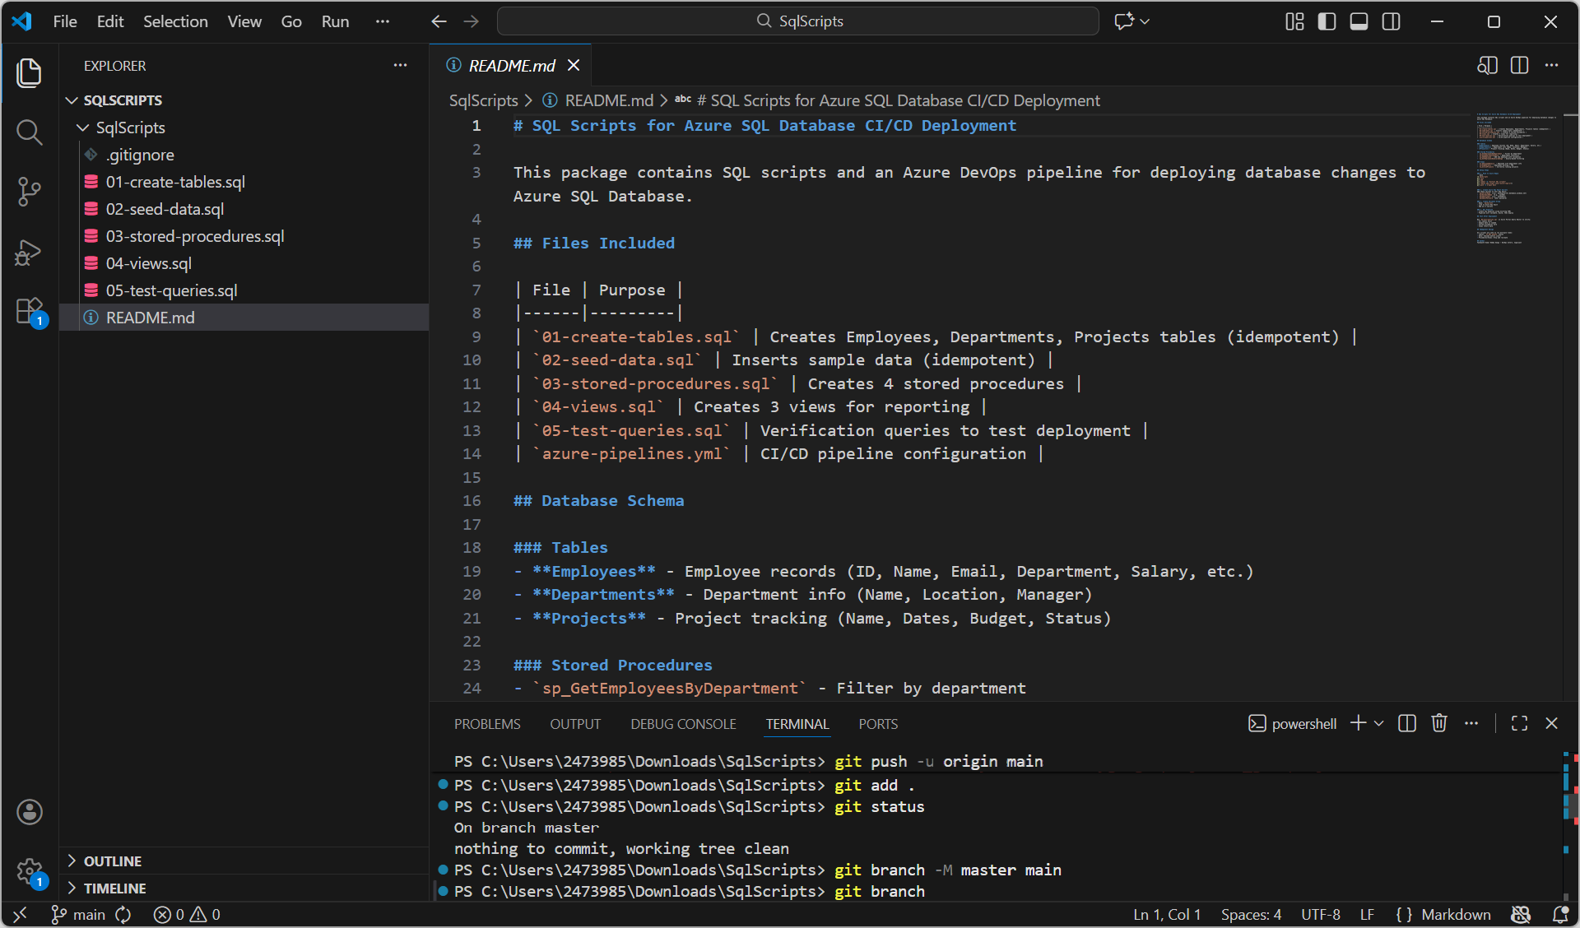
Figure 3.1 - VS Code SqlScripts workspace: README.md open, all five .sql files visible, terminal showing git add / status / branch.

Step 2: Initialize Git, Commit, and Push to Azure Repos
Open the integrated terminal in VS Code and run, in order:
git init
git remote add origin <Azure-Repos-HTTPS-URL>
git add .
git commit -m "Added SQL Scripts"
git branch -M master main
git push -u origin main

The terminal output confirms object enumeration (10 objects), compression (10/10 done), delta compression using up to 12 threads, and the final 'main -> main' push to Azure DevOps. This is the moment your local SQL scripts become available in Azure Repos.
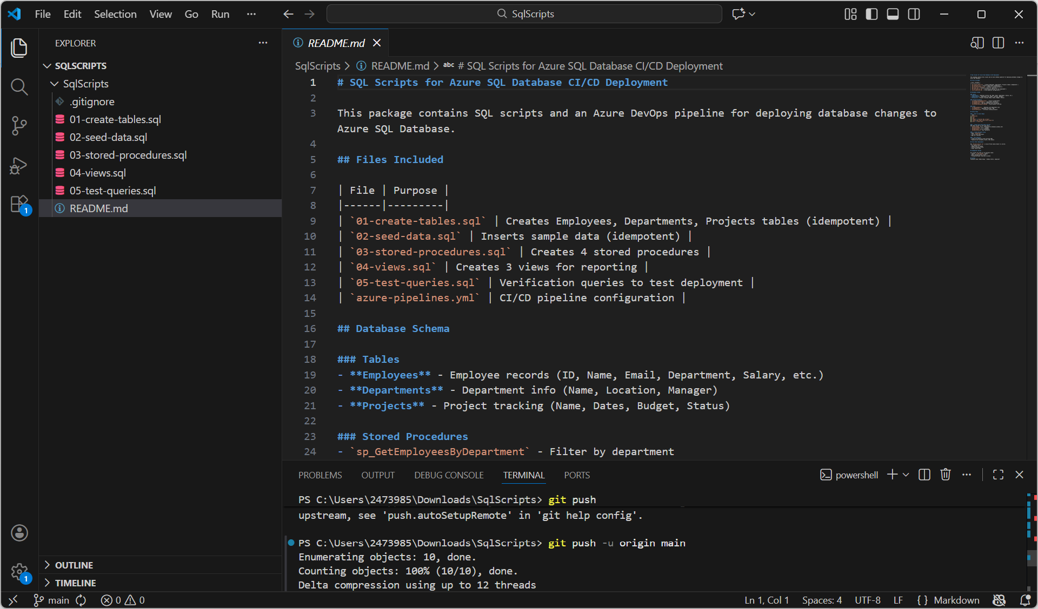
Figure 3.2 - VS Code terminal performing git push -u origin main with successful upload.

Step 3: Verify Files Are Visible in Azure Repos
Go to Azure DevOps -> project2 -> Repos -> Files and open the SqlScripts folder. All SQL files (.gitignore, 01-create-tables.sql, 02-seed-data.sql, 03-stored-procedures.sql, 04-views.sql, 05-test-queries.sql) and the README.md should appear with the latest commit hash (fd144443). This confirms the local repository has been published to Azure Repos and is ready for the CI pipeline to pick up.
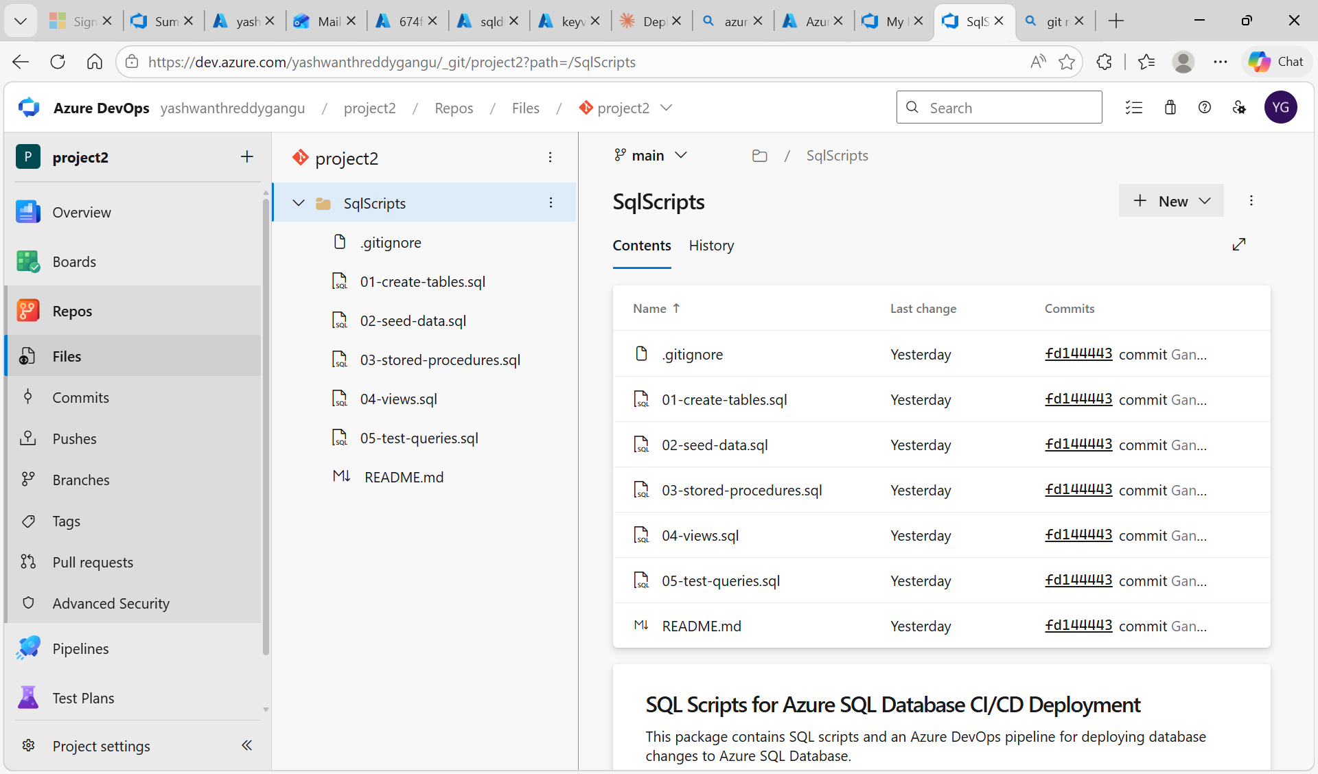
Figure 3.3 - Azure Repos showing SqlScripts folder with all six files committed under hash fd144443.

Task 4: Create Service Connection

Step 1: Begin Creating the Service Connection
Azure DevOps -> Project settings -> Service connections -> click 'Create service connection'. From the connection types list select 'Azure Resource Manager' and click Next. The Service Connection is what allows Azure DevOps pipelines to talk to Azure resources (SQL Database, Key Vault) on your behalf without storing credentials in pipeline code.
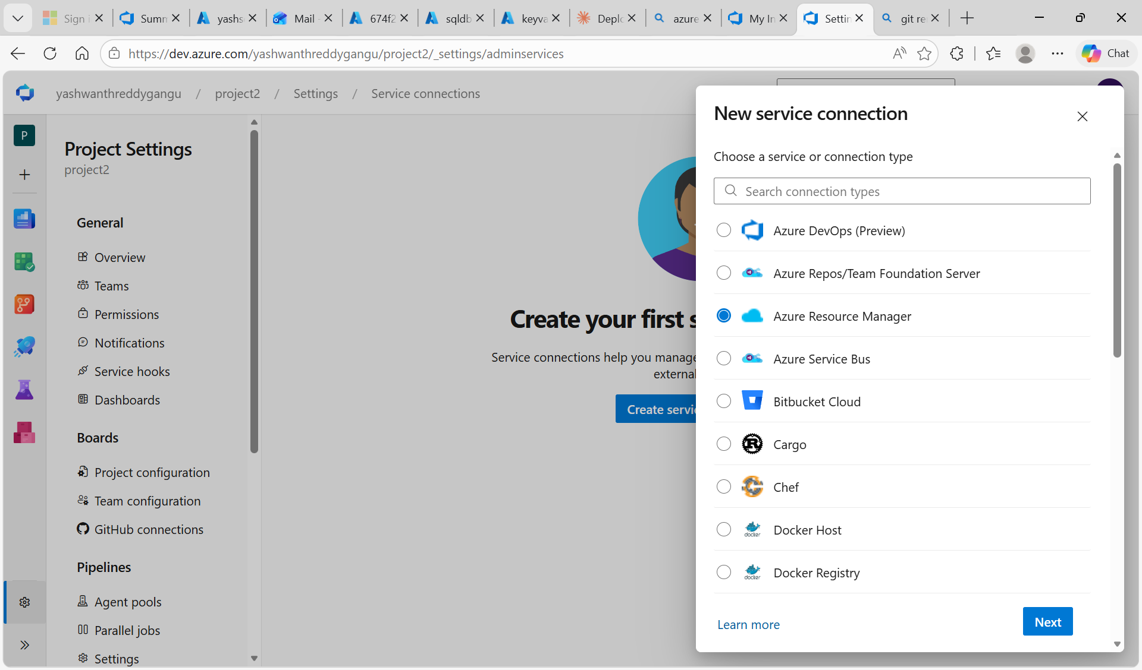
Figure 4.1 - New service connection panel with Azure Resource Manager selected.

Step 2: Configure Service Connection Details
Choose 'Workload identity federation (automatic)' as the credential method - this is the modern recommended approach which is more secure than the older Service Principal with secret. Set the Scope level to Subscription, pick Azure for Students (9a523c89-50e2-4bd0-9d1d-32d4216cb2fe), and scope it to the userg1 resource group so the connection can only touch resources used by this project (least privilege). Set the Service Connection Name to serviceconnectionproject2 and click Save.
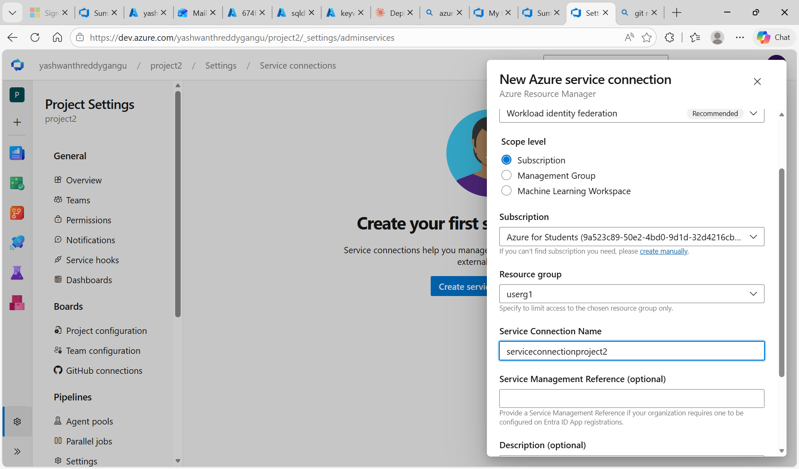
Figure 4.2 - Service connection details: workload identity federation, userg1 scope, name serviceconnectionproject2.

Task 5: Create CI Pipeline

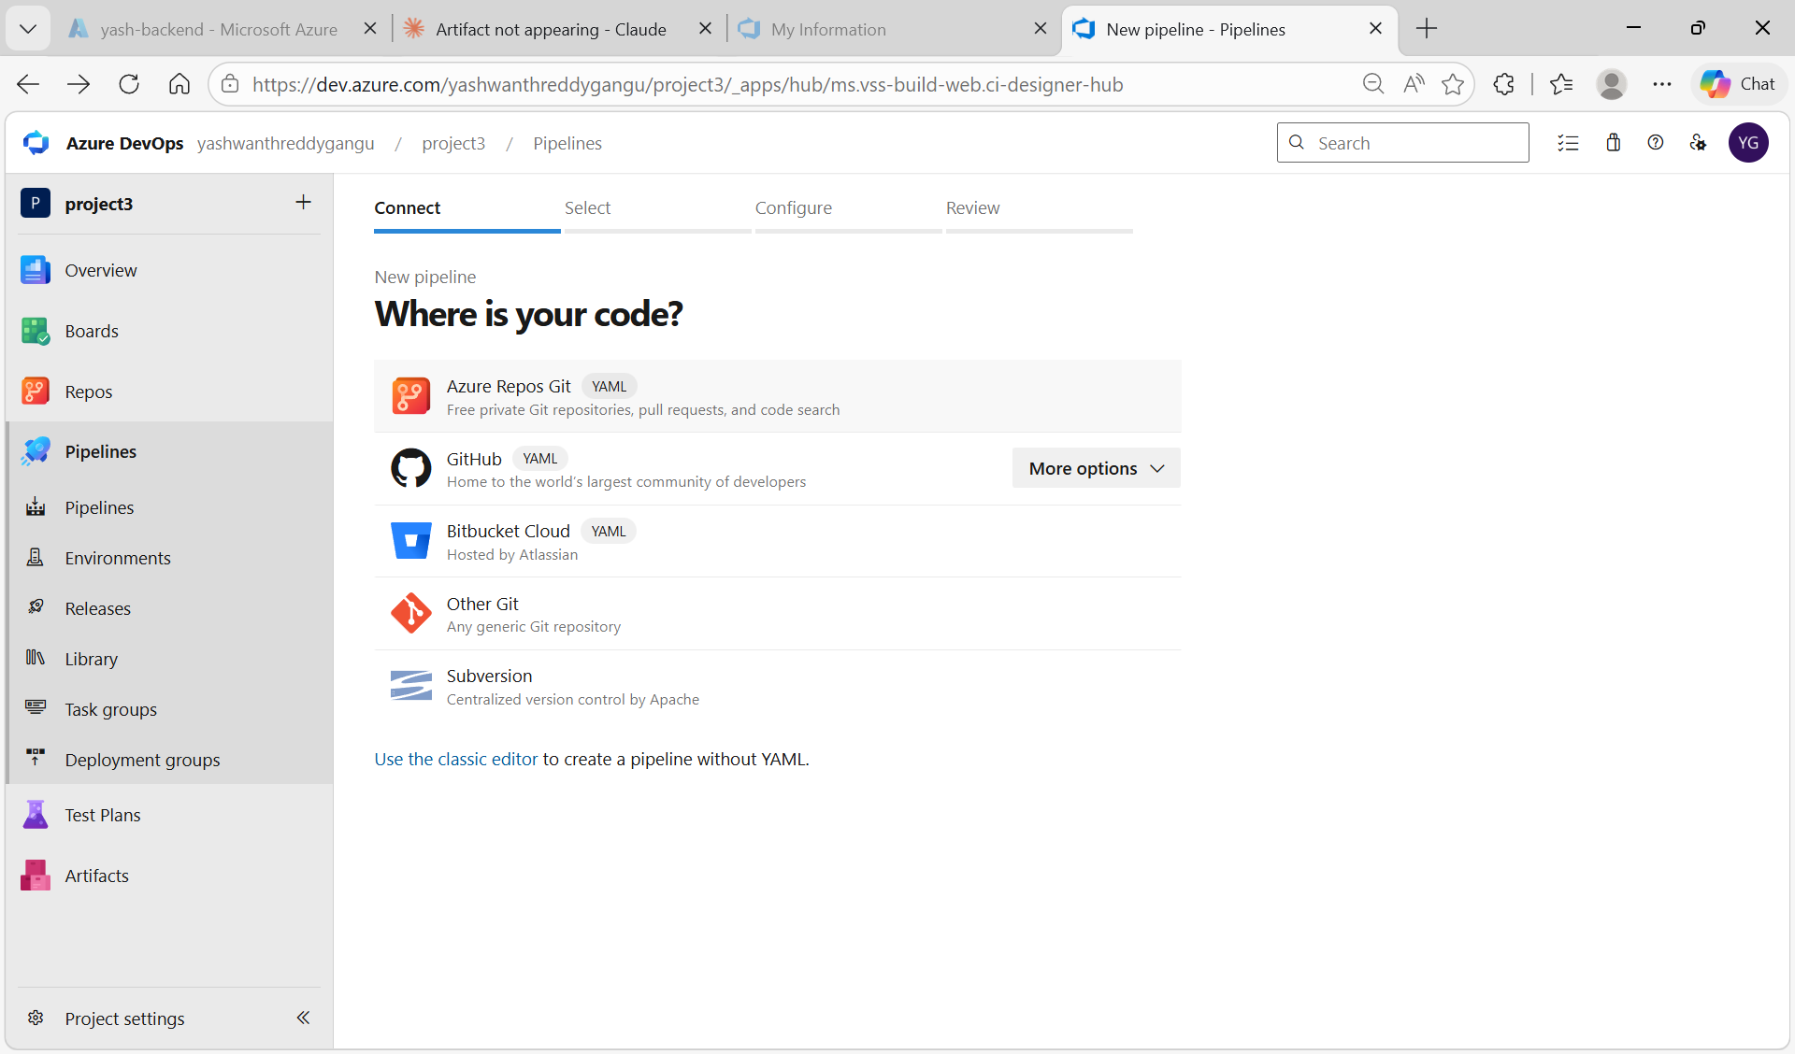

Step 1: Author the YAML Pipeline (azure-pipelines.yml)
Azure DevOps -> project2 -> Pipelines -> click 'Create Pipeline'. On the 'Where is your code?' screen select 'Azure Repos Git (YAML)'. Click project2 from the repository list, then choose 'Starter pipeline' so a new azure-pipelines.yml is created in the repo. Replace the starter content with the pipeline definition shown in the editor. The pipeline triggers on commits to main (and the sql-scripts branch), runs on the windows-latest hosted agent, and contains one Build stage with one ValidateSql job that has three tasks: PowerShell@2 (validates *.sql files exist), CopyFiles@2 (copies them to staging), and PublishBuildArtifacts@1 (publishes the staging directory as a container artifact named sql-scripts).
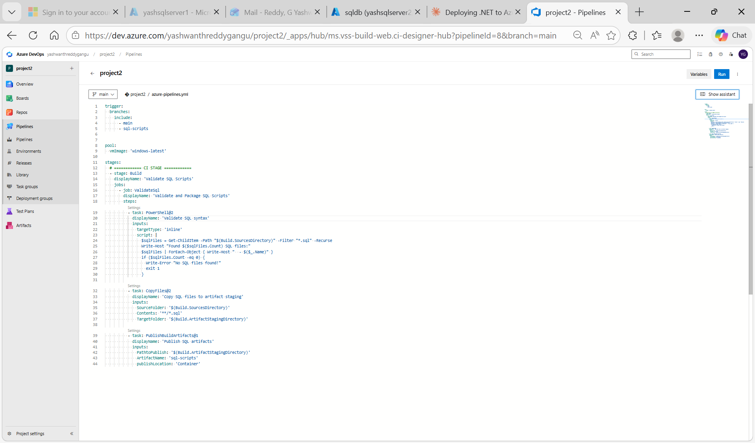
Figure 5.1 - azure-pipelines.yml in the Azure DevOps editor: trigger on main + sql-scripts, windows-latest pool, ValidateSql job with PowerShell, CopyFiles, and PublishBuildArtifacts tasks.

The full YAML content authored in the editor is:
trigger:
branches:
include:
- main
- sql-scripts
pool:
vmImage: 'windows-latest'
stages:
- stage: Build
displayName: 'Validate and Package SQL Scripts'
jobs:
- job: ValidateSql
displayName: 'Validate SQL Files'
steps:
- task: PowerShell@2
displayName: 'Validate SQL syntax'
inputs:
targetType: 'inline'
script: |
$sqlFiles = Get-ChildItem `
-Path "$(Build.SourcesDirectory)" `
-Filter "*.sql" -Recurse
Write-Host "Found $($sqlFiles.Count) SQL files"
if ($sqlFiles.Count -eq 0) {
Write-Error "No SQL files found!"
exit 1
}
- task: CopyFiles@2
displayName: 'Copy SQL files to artifact staging'
inputs:
SourceFolder: '$(Build.SourcesDirectory)'
Contents: '**/*.sql'
TargetFolder: '$(Build.ArtifactStagingDirectory)'
- task: PublishBuildArtifacts@1
displayName: 'Publish SQL artifacts'
inputs:
PathtoPublish: '$(Build.ArtifactStagingDirectory)'
ArtifactName: 'sql-scripts'
publishLocation: 'Container'
Add a commit message and click Save & run.

Step 2: Verify CI Pipeline Run Succeeds
After Save & run, the pipeline queues, picks an agent, and starts executing. The pipeline run page shows all steps completing with green checkmarks: Initialize job (1s), Checkout project2 (4s), Validate SQL syntax (2s), Copy SQL files to staging (<1s), Publish SQL artifacts (<1s), Post-job, Finalize Job, Report build status. The job summary on the right shows the pool (Azure Pipelines), image (windows-latest), and reports '1 artifact produced' confirming the sql-scripts artifact is ready for the release pipeline to consume.
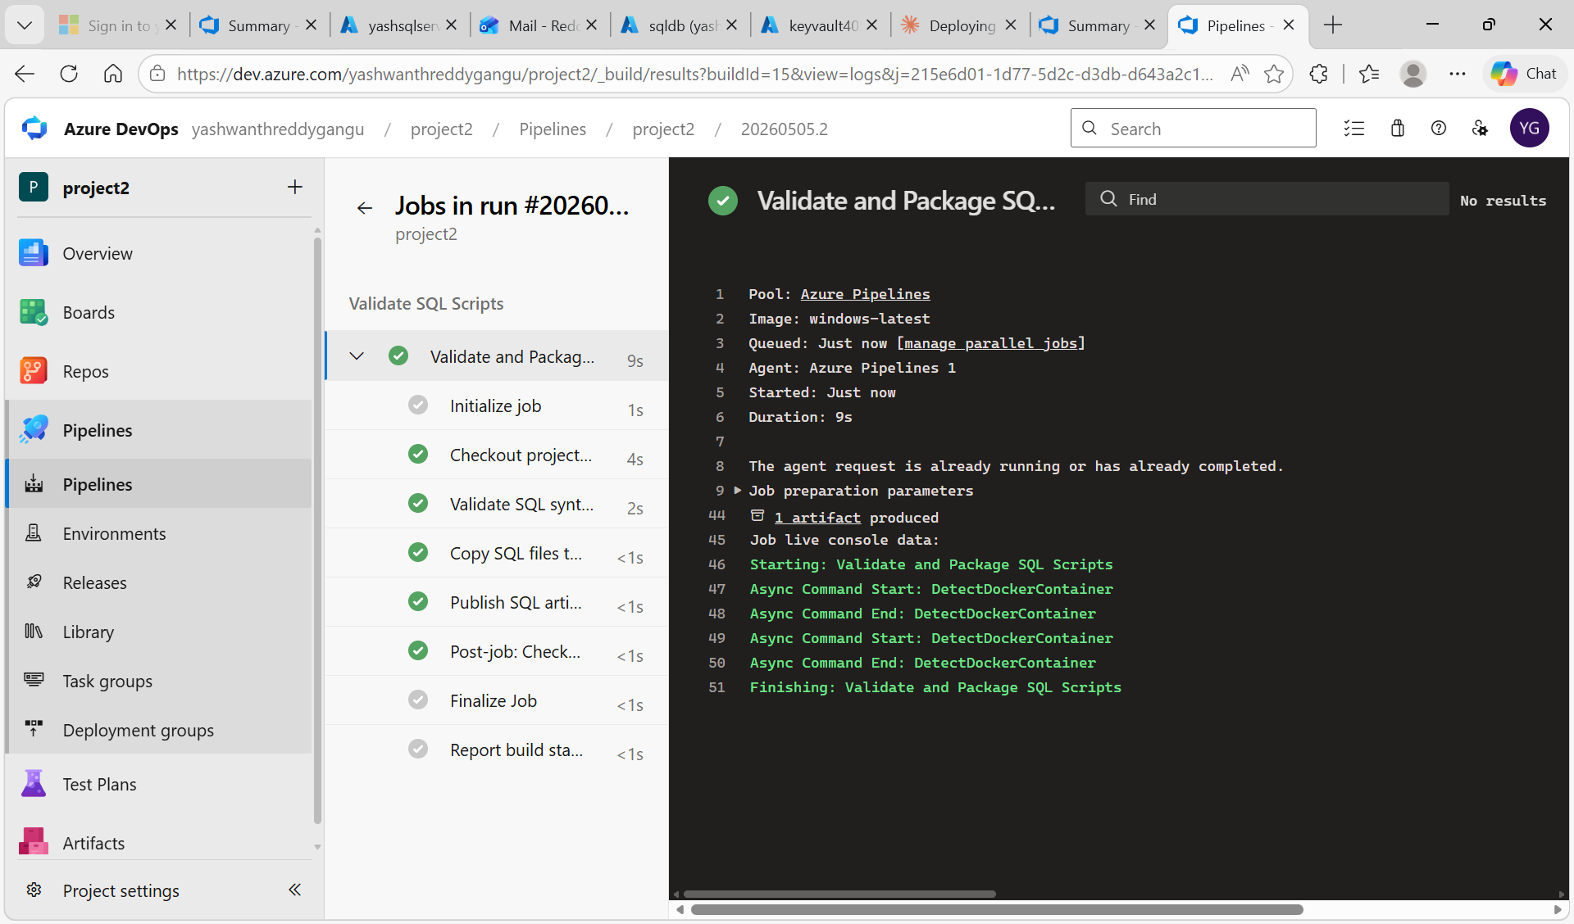
Figure 5.2 - CI run #20260505.2 succeeded; all job steps green; '1 artifact produced'.

Task 6: Create CD Release Pipeline with Key Vault Integration

Step 1: Create Empty Release Pipeline and Configure Agent Job
Pipelines -> Releases -> click 'New pipeline'. In the 'Select a template' panel click 'Empty job' at the top. Set the Stage name to 'Deploy SQL Scripts to Azure SQL Database' and close the panel. Click Save (keep default folder '/').

On the Pipeline tab, click '+ Add' under Artifacts to add the build artifact - Source type = Build, Project & Source pipeline = project2 (the YAML pipeline from Task 5), Default version = Latest. The release will pull the sql-scripts artifact published by the most recent successful CI run.

Switch to the Tasks tab and open the Agent job. Set Agent pool = Azure Pipelines and Agent Specification = DefaultHosted - this is the Microsoft-hosted Windows agent that the classic release pipeline uses. The Agent job is now configured but has no tasks yet (the right pane shows only the empty Agent job configuration).
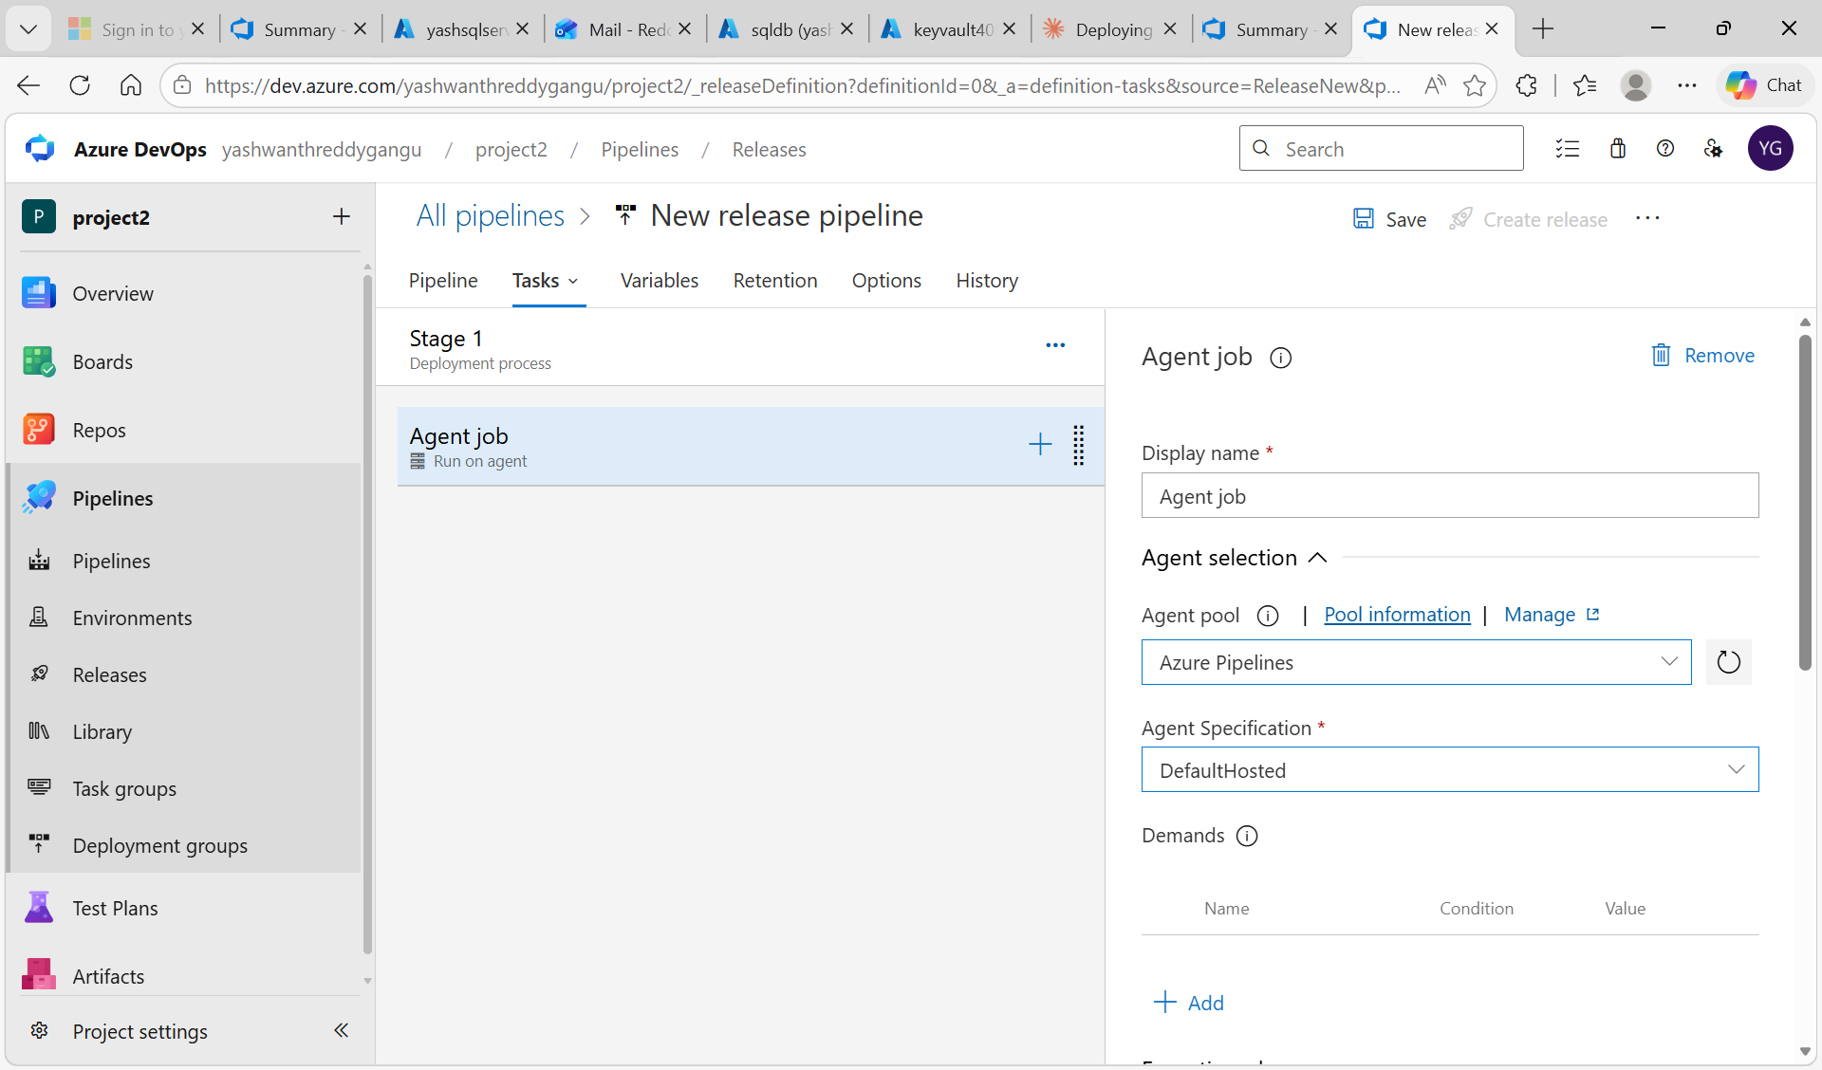
Figure 6.1 - Empty release pipeline with Stage 1 'Deployment process' and an empty Agent job (Run on agent) configured for Azure Pipelines / DefaultHosted.

Step 2: Add Azure Key Vault Task to Fetch Secrets at Runtime
Click the '+' on the Agent job and search for 'Azure Key Vault' in the task catalog. Add the Azure Key Vault task. This task must run BEFORE the SQL deployment task so its output secrets are available when the SQL task connects to the database. Configure the task fields:

Field | Value
Display name | Azure Key Vault: keyvault405
Azure subscription | serviceconnectionproject2
Key vault | keyvault405
Secrets filter | * (download all four secrets)
Make secrets available to whole job | (unchecked)

At runtime this task downloads SqlServerName, database, serveradmin, and serverpassword from keyvault405 and exposes them to the rest of the job as pipeline variables: $(SqlServerName), $(database), $(serveradmin), $(serverpassword). These variables are then bound to the connection fields of the SQL deployment task. This is the key mechanism that keeps all credentials out of code.
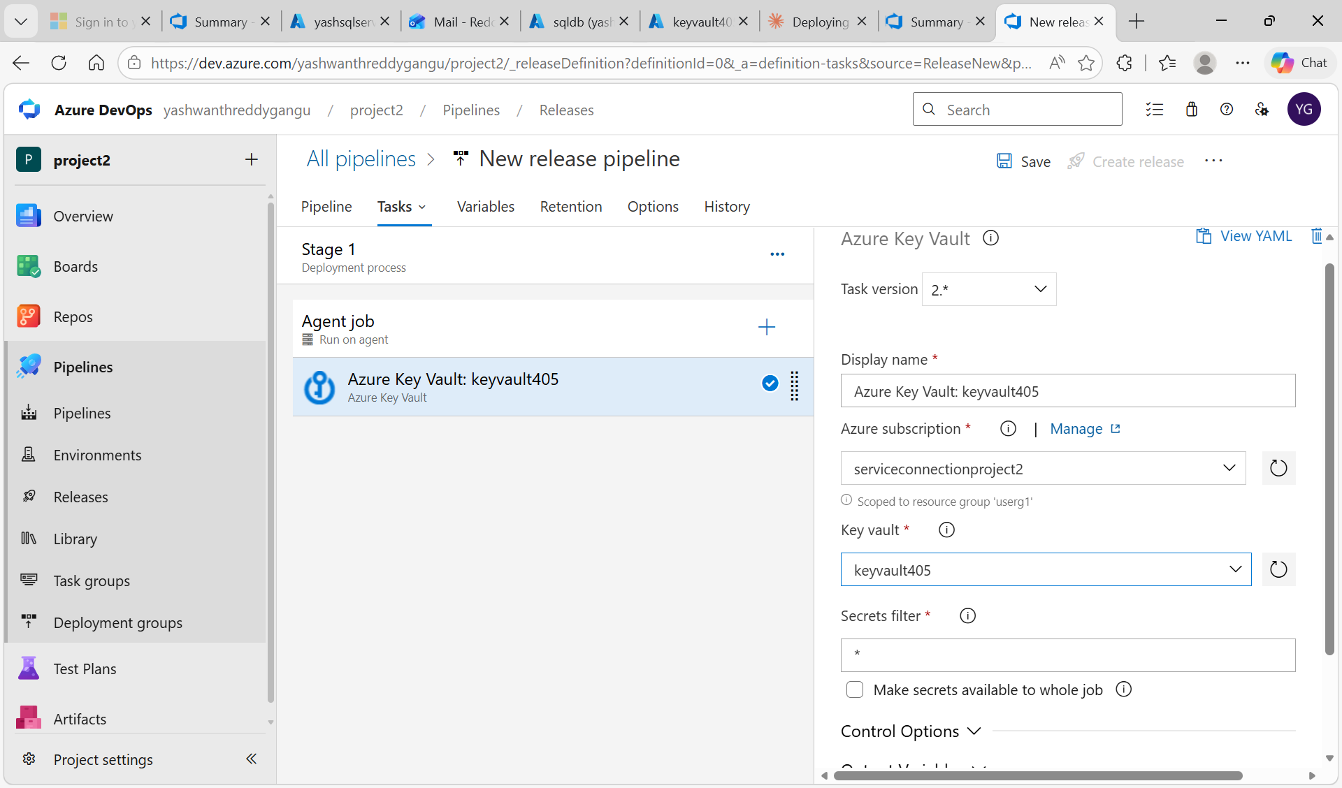
Figure 6.2 - Azure Key Vault task added to Agent job, configured to pull all secrets from keyvault405 via serviceconnectionproject2.

Step 3: Grant the Service Connection Access to Key Vault (Permissions Tab)
Why this is needed: The release pipeline runs under the service connection's identity (an automatically-created Microsoft Entra app registration). Until that identity is granted Get and List permission on Key Vault secrets, the Azure Key Vault task in the release pipeline will fail at runtime with an access-denied error.

Open keyvault405 -> Access policies -> + Create. The 'Create an access policy' wizard opens with four tabs: Permissions, Principal, Application (optional), Review + create. On the Permissions step, under 'Secret Management Operations', tick Get and List. Leave Key permissions and Certificate permissions empty (least privilege). The pipeline only needs read access to secrets - never write. Click Next.
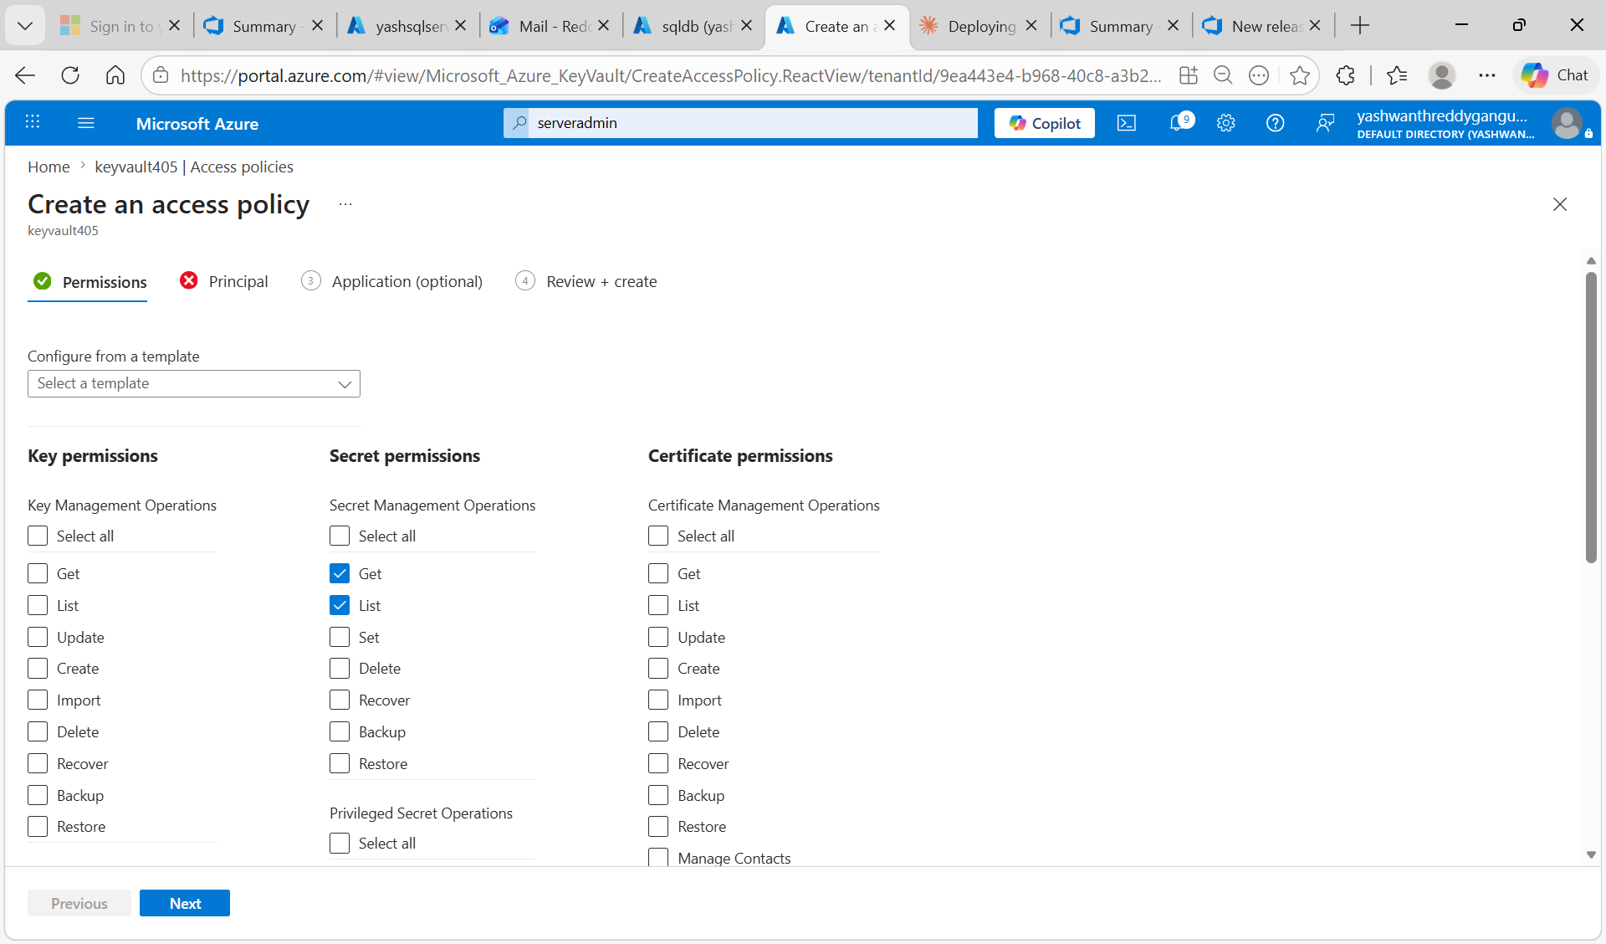
Figure 6.3 - Access policy Permissions tab: Get and List checked under Secret Management Operations.

Step 4: Select the Service Connection's App Registration as Principal
On the Principal tab, search by the Application (client) ID of the service connection's underlying app registration. To find the Application ID:
- Open Project settings -> Service connections -> serviceconnectionproject2
- Click 'Manage App registration' (opens Microsoft Entra ID app registration page in a new tab)
- Copy the Application (client) ID GUID, e.g. 0b346bf4-d767-4fbb-89d8-5929d7483f7b

Paste the GUID into the search box on the Principal tab. The matching app registration (yashwanthreddygangu-project2-4d6b0025-5dc1-4713-b5ba-a4571496e2d7) appears in the dropdown. Click on it - it appears under 'Selected item' at the bottom of the page. Click Next, Next, then Create. The access policy is now in place granting the pipeline's identity Get/List permission on all secrets.
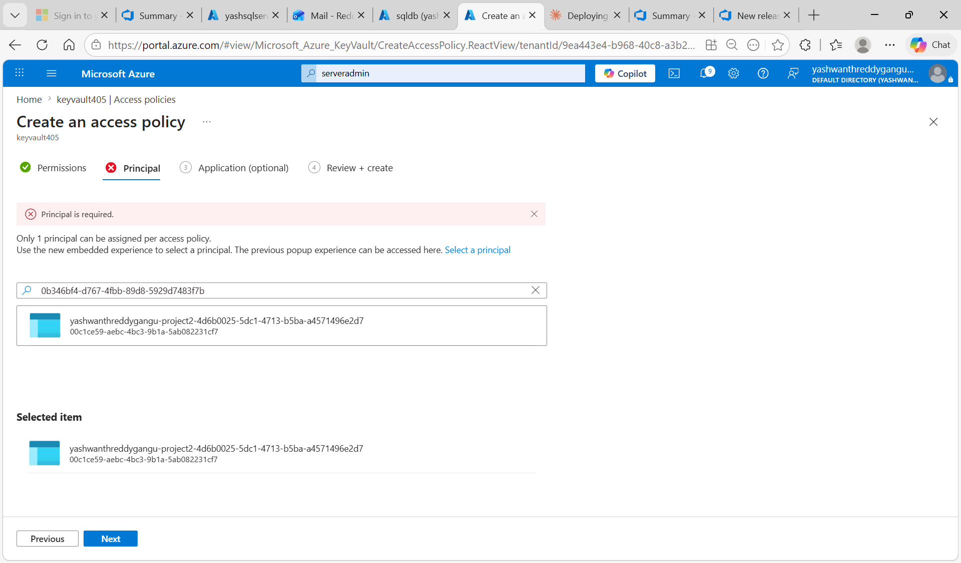
Figure 6.4 - Access policy Principal tab: the service connection's app registration selected via the Application ID GUID; visible under 'Selected item'.

Step 5: Add Azure SQL Database Deployment Task
Return to the release pipeline Tasks tab. Add a second task on the same Agent job: 'Azure SQL Database deployment'. This task connects to the Azure SQL Database and runs the SQL scripts. Configure the connection fields using the variables produced by the Key Vault task in Step 2:

Field | Value (uses Key Vault variable)
Azure Service Connection Type | Azure Resource Manager
Azure Subscription | serviceconnectionproject2
Authentication Type | SQL Server Authentication
Azure SQL Server | $(SqlServerName)
Database | $(database)
Login | $(serveradmin)
Password | $(serverpassword)
Deploy type | SQL Script File
SQL Script | Path to .sql file from build artifact

Important: Add ONE task instance per .sql file so they run in the correct order: 01-create-tables.sql, 02-seed-data.sql, 03-stored-procedures.sql, 04-views.sql. The order matters - tables must exist before data can be inserted, and tables/columns must exist before stored procedures and views can reference them. Save the release definition.

Task 7: Configure SQL Server Firewall for Pipeline Access
Why this is needed: Without a firewall rule, the Azure DevOps hosted pipeline agent cannot reach the Azure SQL Database. Azure SQL Server blocks all public connections by default for security. The 'Allow Azure services and resources' exception MUST be enabled so that Azure-hosted services (including the Microsoft-hosted DevOps agents) can connect to the database. Without this setting, the release pipeline will fail with a 'Cannot connect to server' error even when the credentials are completely correct.

Open the SQL server (yashsqlserver2) -> Security -> Networking. Set Public network access to 'Selected networks'. Under Firewall rules click 'Add your client IPv4 address (136.226.243.85)' so the local laptop can connect (useful for Query Editor). Then under Exceptions, tick the checkbox 'Allow Azure services and resources to access this server' so Azure DevOps hosted agents and the Query Editor (preview) can reach the database. Click Save.
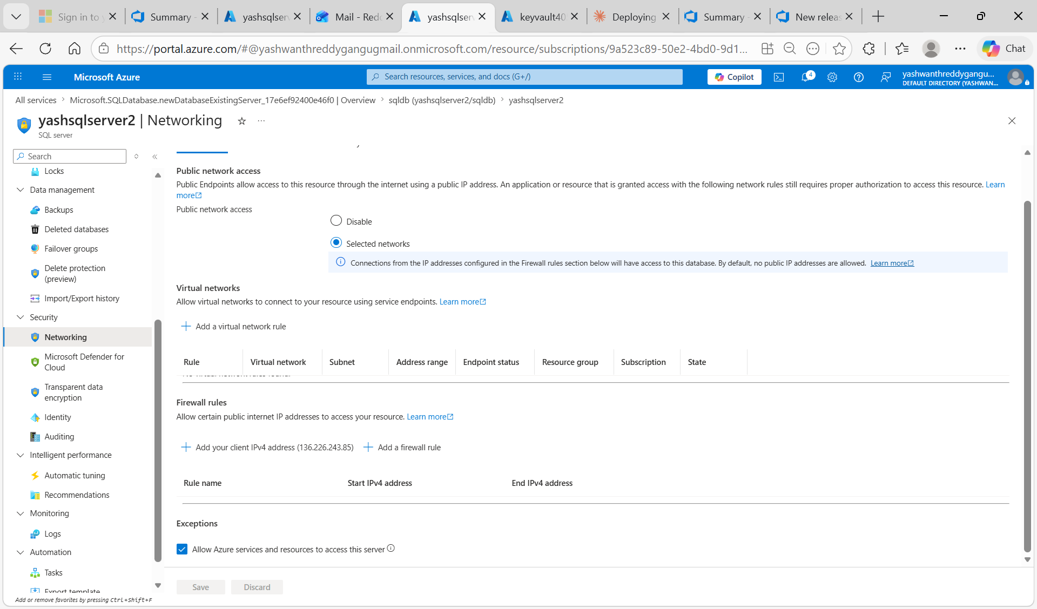
Figure 7.1 - yashsqlserver2 Networking: public network access set to Selected networks, 'Allow Azure services' exception ticked at the bottom.

Task 8: Create Release and Verify Deployment

Step 1: Create the Release
Save the release definition, then click 'Create release' -> Create. The release picks the latest build artifact (from CI run #20260505.2), runs the Azure Key Vault task to fetch the four secrets from keyvault405, and then runs the Azure SQL Database deployment task once per .sql file. When all stages turn green, every script has executed successfully against sqldb on yashsqlserver2.

Step 2: Verify Deployment in Query Editor
Azure Portal -> SQL database sqldb -> Query editor (preview). Sign in with serveradmin and the password using SQL authentication. Once logged in, expand the Explorer tree under sqldb -> dbo. The deployed objects are visible:
- Tables: Departments, Employees, Projects (from 01-create-tables.sql)
- Views: the three reporting views (from 04-views.sql)
- Stored Procedures: the four procedures including sp_GetEmployeesByDepartment (from 03-stored-procedures.sql)
- Functions and Queries folders also visible

This confirms end-to-end success: SQL scripts authored in VS Code -> committed to Azure Repos -> packaged by CI -> deployed by CD using Key Vault secrets -> live database schema. Run a sample verification query from 05-test-queries.sql to confirm both schema and seed data are in place.
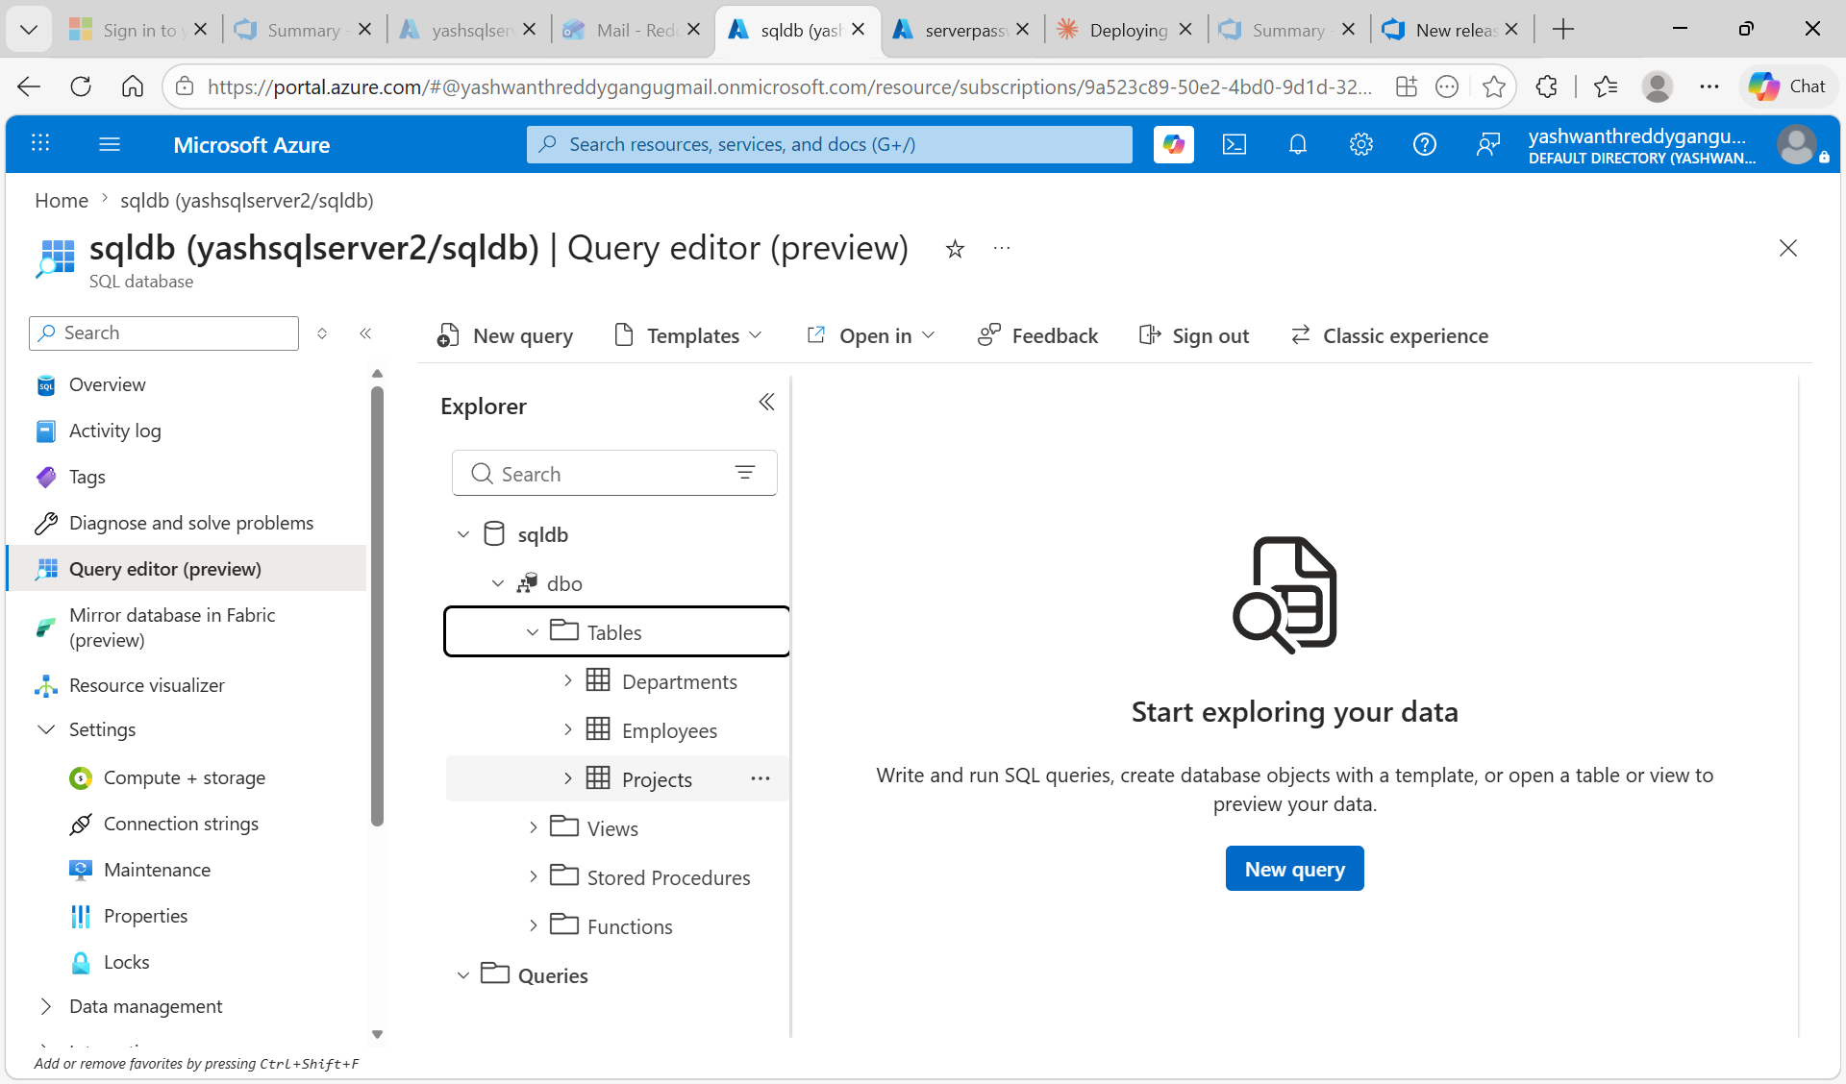
Figure 8.1 - Query Editor Explorer for sqldb showing Departments, Employees, and Projects tables, plus Views, Stored Procedures, Functions and Queries folders.

SELECT * FROM dbo.Employees;
SELECT * FROM dbo.Departments;
EXEC dbo.sp_GetEmployeesByDepartment @DepartmentName = N'Engineering';

Conclusion
This use case implemented an end-to-end Azure SQL Database deployment using Azure DevOps. The Azure SQL Server (yashsqlserver2) and database (sqldb) were provisioned and secured via firewall rules. SQL scripts authored in VS Code were committed to Azure Repos in project2 and built by a YAML CI pipeline that validates SQL syntax and publishes a sql-scripts artifact. Database credentials are kept out of source control by storing them as four secrets in keyvault405 (SqlServerName, database, serveradmin, serverpassword). A classic release pipeline links to that artifact, uses the Azure Key Vault task to download secrets at runtime, and then runs the Azure SQL Database deployment task to apply each script against sqldb. Verification through the Query Editor confirms that the Employees, Departments and Projects tables, along with the views and stored procedures, are present in the database after the release succeeds.

Key Outcomes
- Repeatable, idempotent SQL deployments - every script can be re-run without breaking state.
- Zero credentials in YAML or release definitions - all secrets resolve from keyvault405 at runtime.
- Least-privilege access - the service connection identity has only Get and List on Key Vault secrets and is scoped to the userg1 resource group.
- Clean separation between Build (validate + package) and Release (deploy) so failures are easy to localize.
- Modern authentication using Workload Identity Federation - no service principal secrets to leak or rotate.

Errors Encountered & Resolutions
During the implementation of this use case, several configuration issues were encountered - primarily around Azure Key Vault permissions. This section documents each error, its root cause, and the resolution applied.

Error 1: Created Wrong Key Vault Type - Azure Key Vault Managed HSM
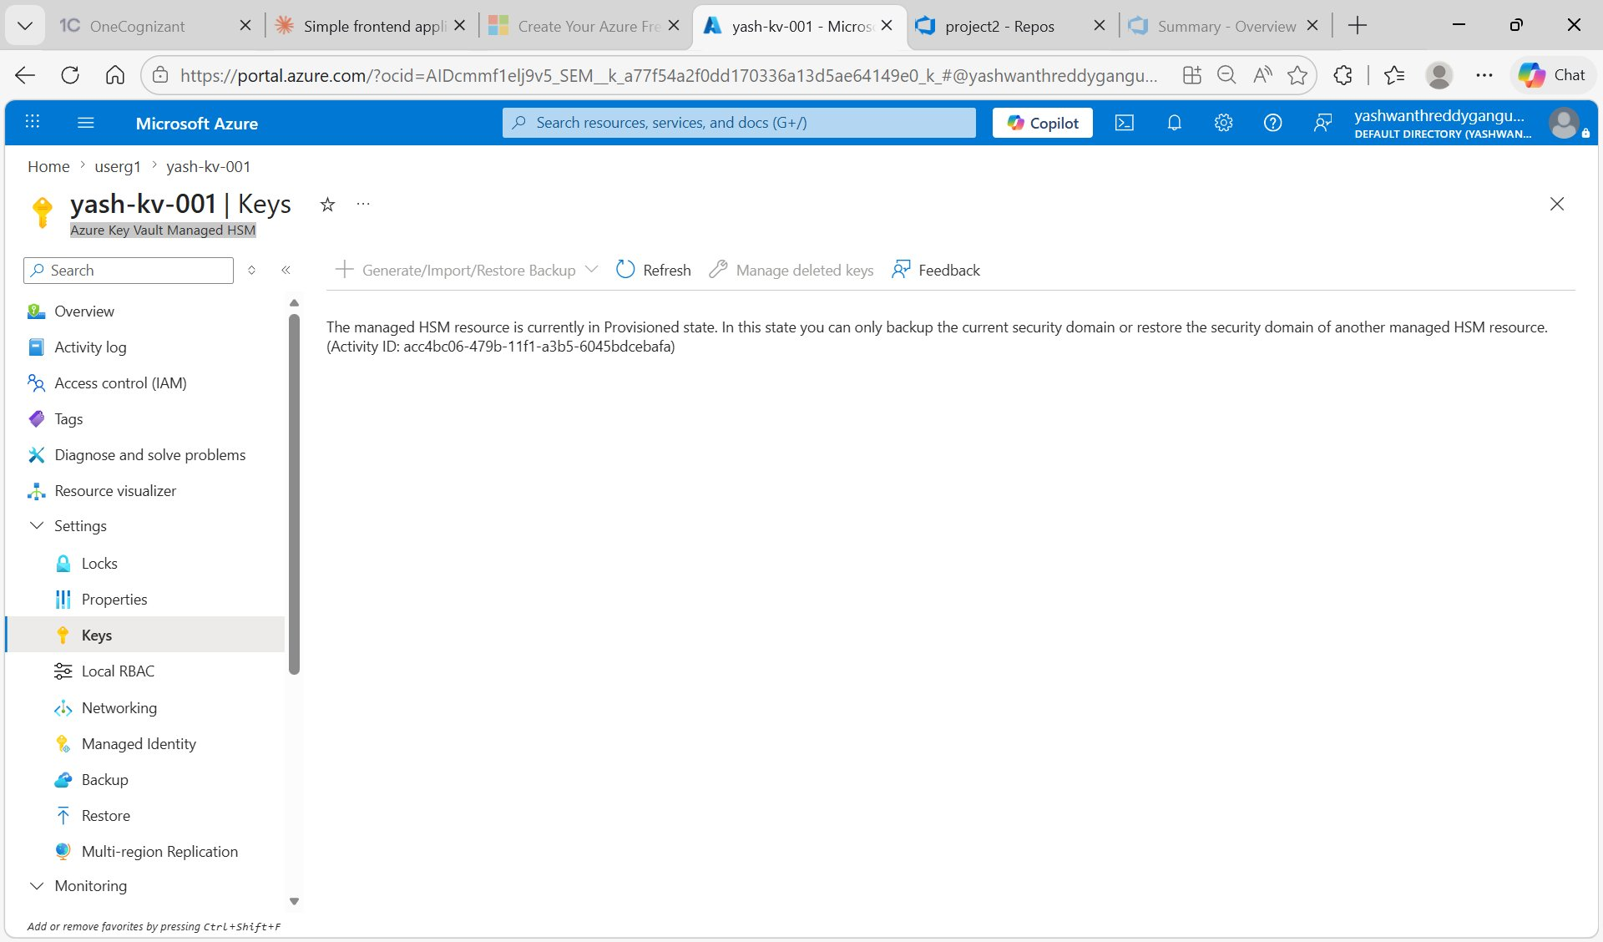
Initial wrong choice: Azure Key Vault Managed HSM instead of standard Azure Key Vault.
Error 1: Wrong Key Vault Type Selected
Root Cause:
While creating the Key Vault, the wrong resource type was selected - Azure Key Vault Managed HSM instead of standard Azure Key Vault. Managed HSM is a hardware-based premium service designed only for storing cryptographic Keys, not Secrets. Because of this, the Secrets section was missing entirely from the left navigation menu, making it impossible to add the SQL admin credentials.
Resolution:
Identified that the resource showed 'Azure Key Vault Managed HSM' instead of 'Key vault' below the resource name. Created a new resource by searching 'Key vaults' in the Azure Portal and selecting the standard Key Vault option (NOT Managed HSM). Used Pricing tier = Standard during creation to avoid the premium Managed HSM offering.

Error 2: The Operation 'List' is Not Enabled in this Key Vault's Access Policy
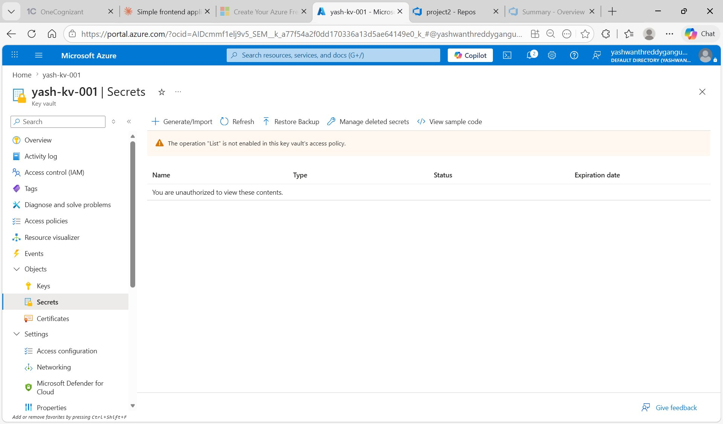
Key Vault Secrets page showing the 'List operation not enabled' warning.
Error 2: Creator Account Lacked Secret Permissions
Root Cause:
After opening the Secrets blade of the Key Vault, the page displayed: 'The operation List is not enabled in this key vault's access policy. You are unauthorized to view these contents.' The +Generate/Import button was greyed out, blocking the addition of any secrets. Even though the Key Vault was successfully created, the creator account was not automatically granted permission to list or manage secrets - Azure does not auto-grant Secret permissions to the creator.
Resolution:
Navigated to Access policies in the left menu of the Key Vault. Clicked +Create -> in the Permissions tab, selected all required Secret permissions (Get, List, Set, Delete, Recover, Backup, Restore, Purge). In the Principal tab, searched and selected the user account. Clicked Save in the Review + create tab to apply the access policy. Refreshed the Secrets page (Ctrl + F5) - the warning disappeared and +Generate/Import became active.

END OF DOCUMENTATION

