Use Case 1:

Deploying a Static HTML Web Page to Azure App Service using Azure DevOps CI/CD
Submitted by: Yashwanth Kumar | DevOps Intern | Cognizant

Objective

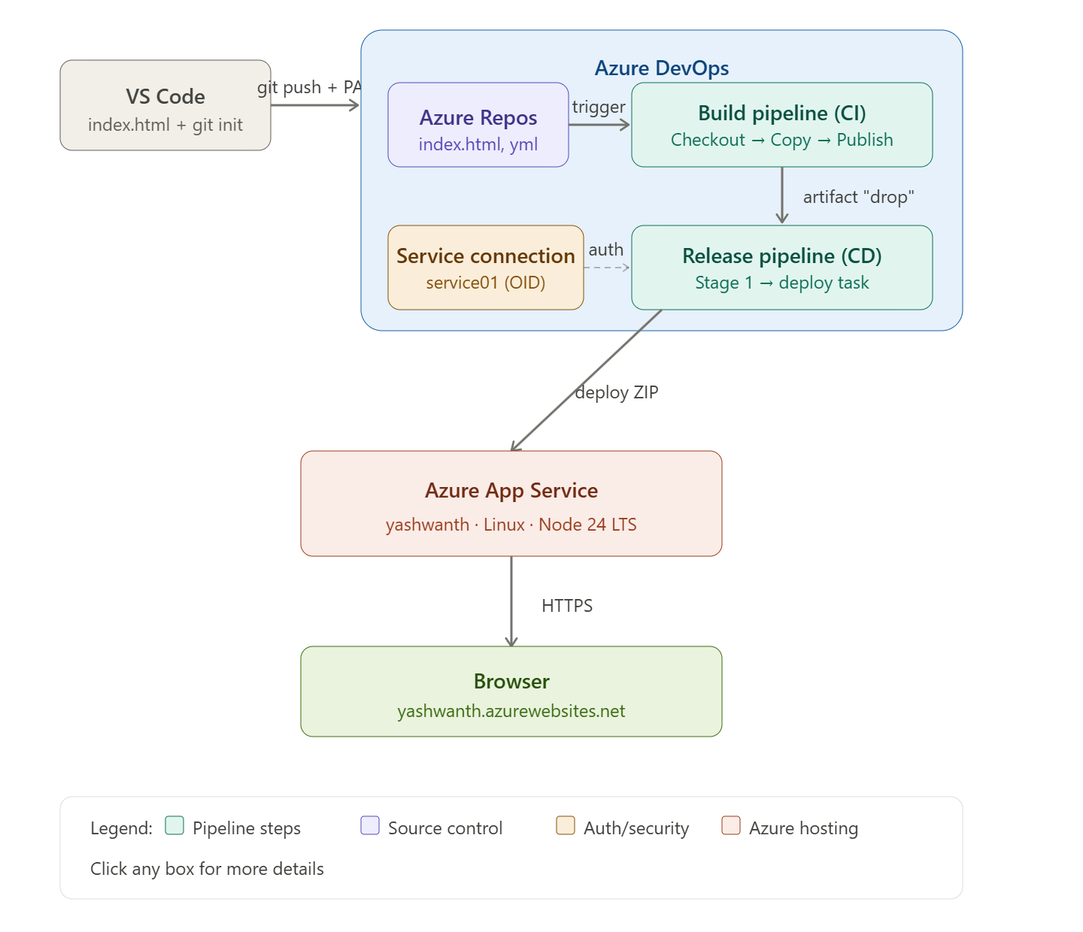
To build and deploy a simple HTML web page to an Azure Web App using Azure DevOps. The flow includes creating an Azure Web App, pushing the source code from VS Code to Azure Repos, configuring a Build Pipeline (CI), creating a Service Connection, and using a Release Pipeline (CD) to deploy the artifact to Azure App Service.

Step 1: Create an Azure Web App – Basics Tab
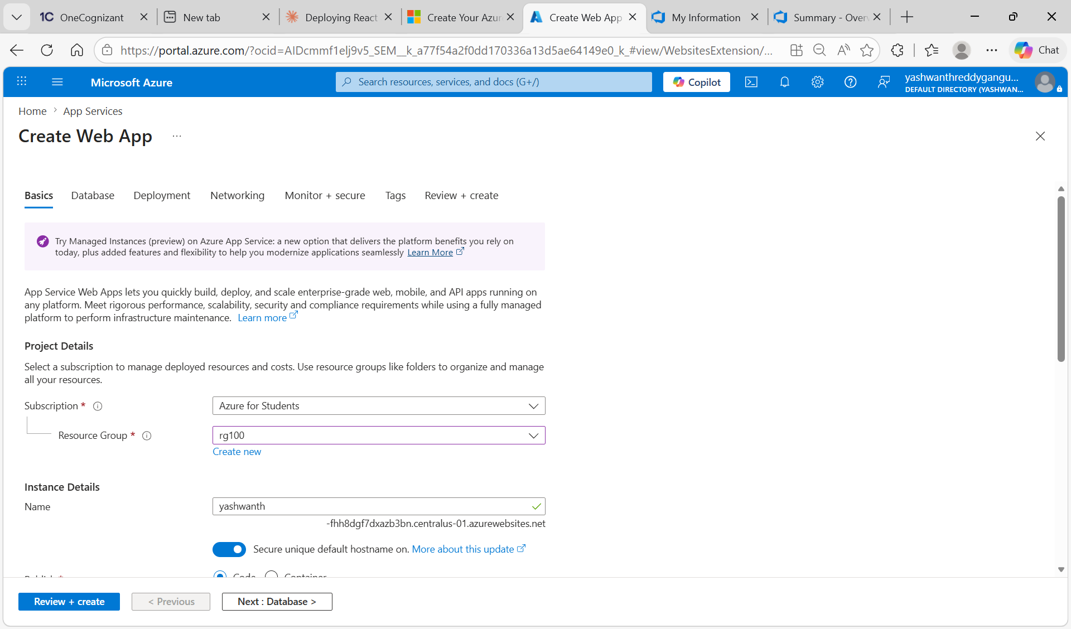
• Logged in to the Azure Portal and navigated to App Services → Create Web App.
• Selected the Subscription as “Azure for Students” and chose the Resource Group as rg100.
• Entered the Web App Name as “yashwanth”, which forms the public URL of the website.
• Enabled the Secure Unique Default Hostname option for security.
• Selected Publish = Code (since we are deploying static HTML files, not a container).

Step 2: Review and Create the Web App
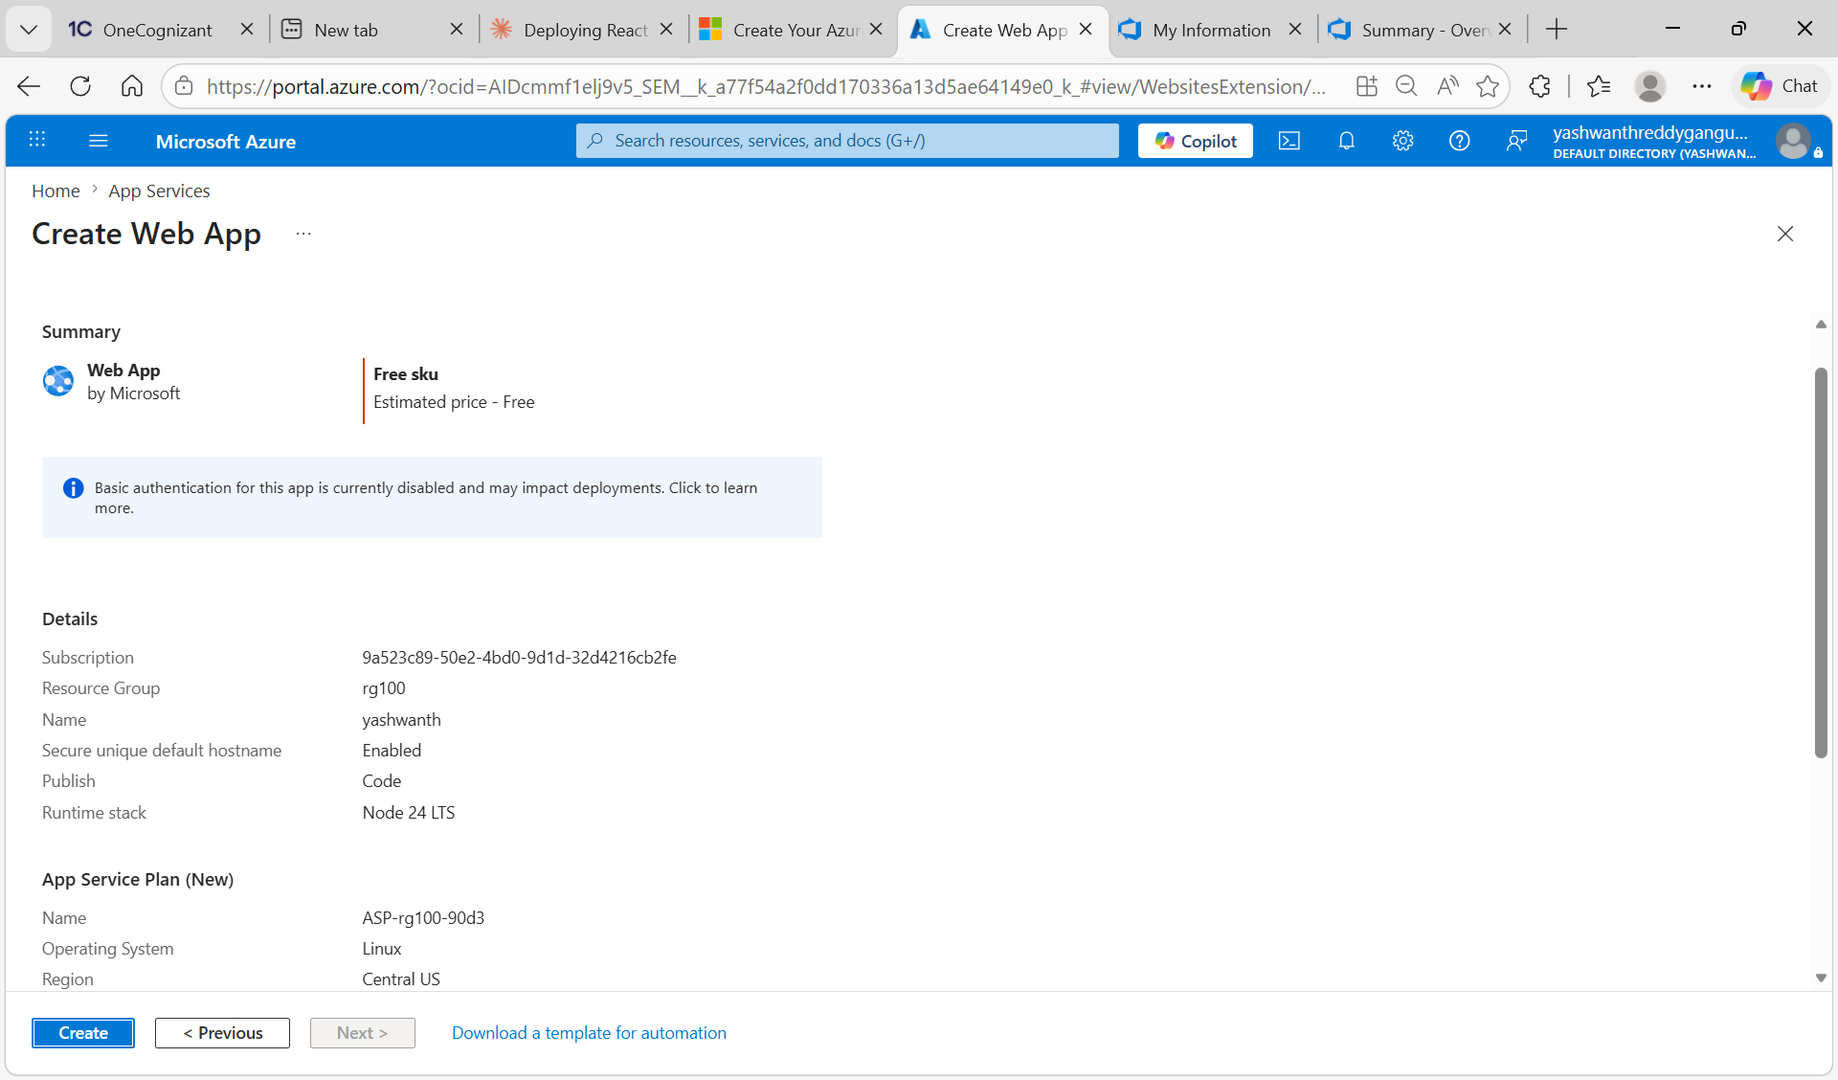
• Reviewed all configuration details on the Review + Create tab.
• Confirmed Runtime stack as Node 24 LTS, OS as Linux, and Region as Central US.
• Pricing plan was selected as Free SKU since this is a learning/lab exercise.
• Clicked Create to provision the Azure App Service Plan and Web App.

Step 3: Prepare HTML Code in VS Code and Initialize Git
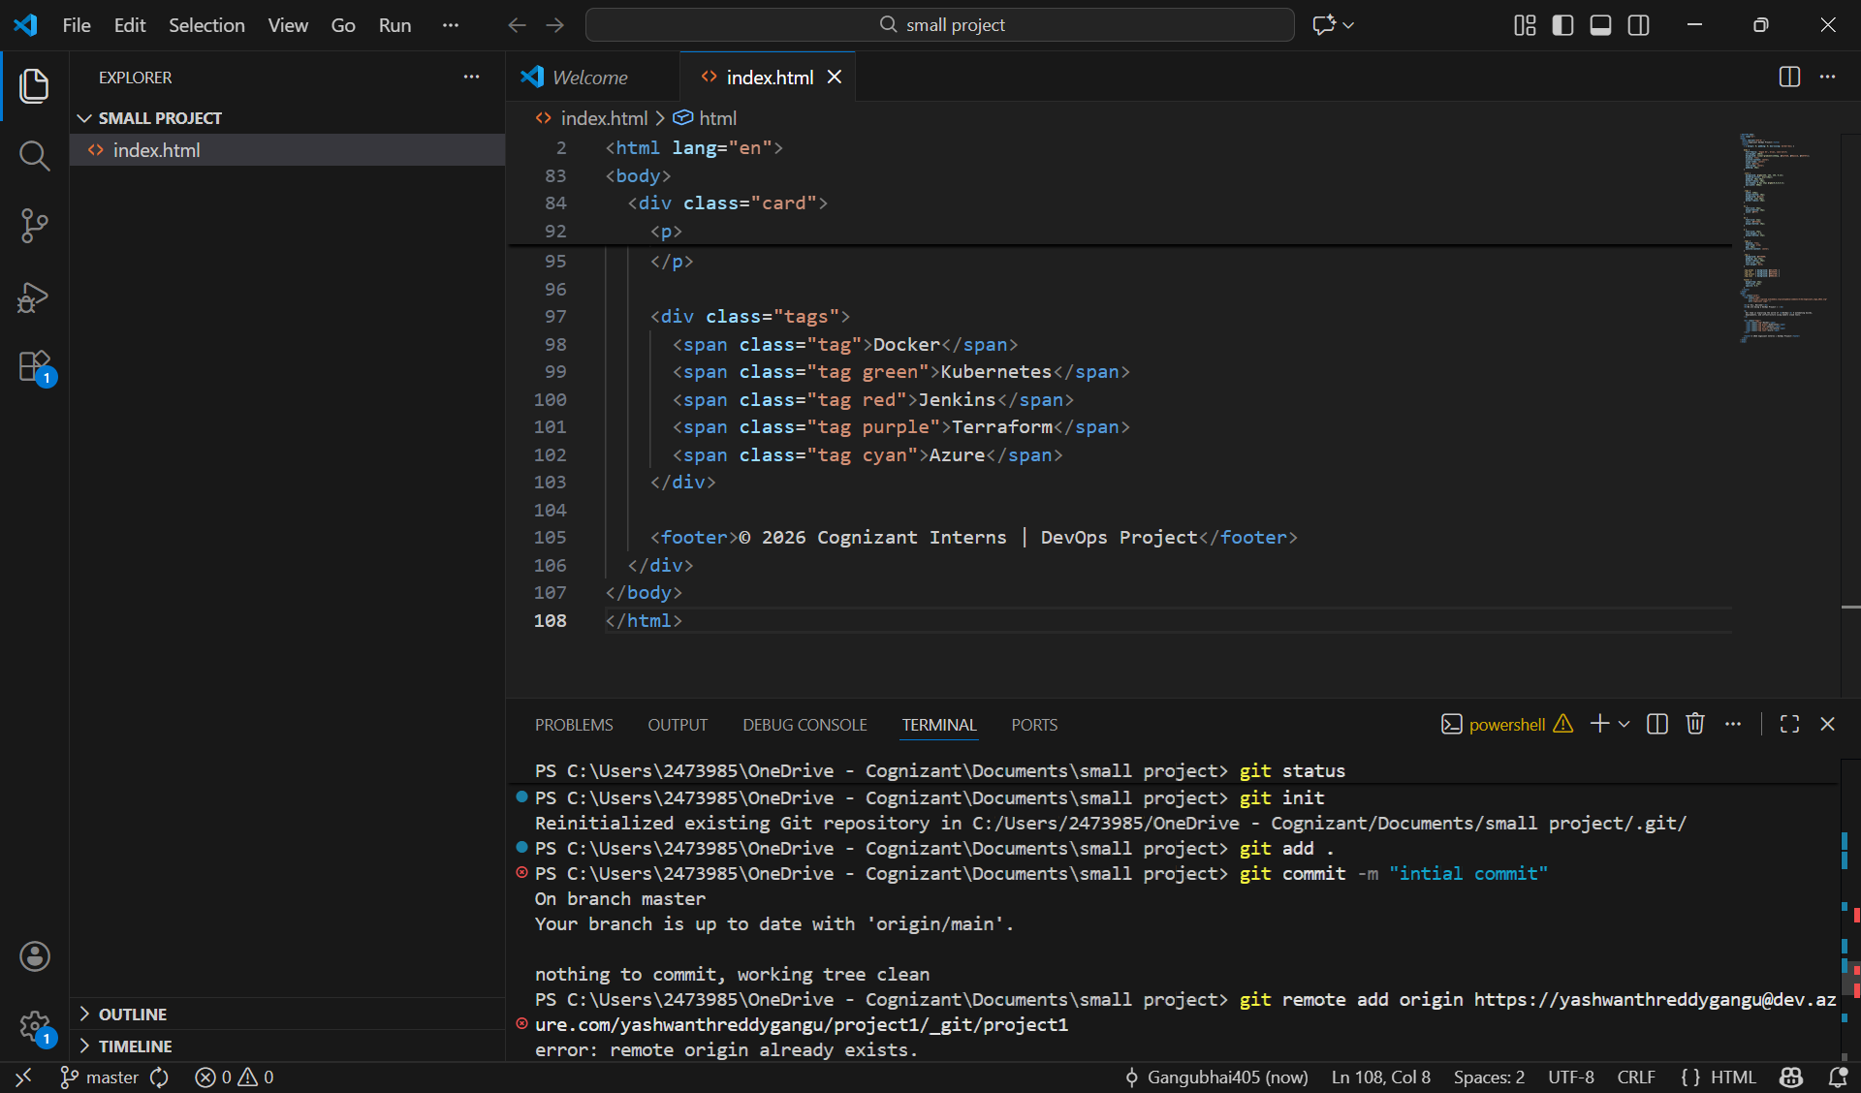
• Created a project folder in VS Code containing the index.html file with the Cognizant DevOps welcome UI.
• Opened the integrated terminal and ran git init to initialize a local Git repository.
• Staged all files using git add . and committed the changes with git commit -m "initial commit".
• Added the Azure DevOps remote URL using git remote add origin <repo-url>.

Step 4: Push Code from VS Code to Azure Repos
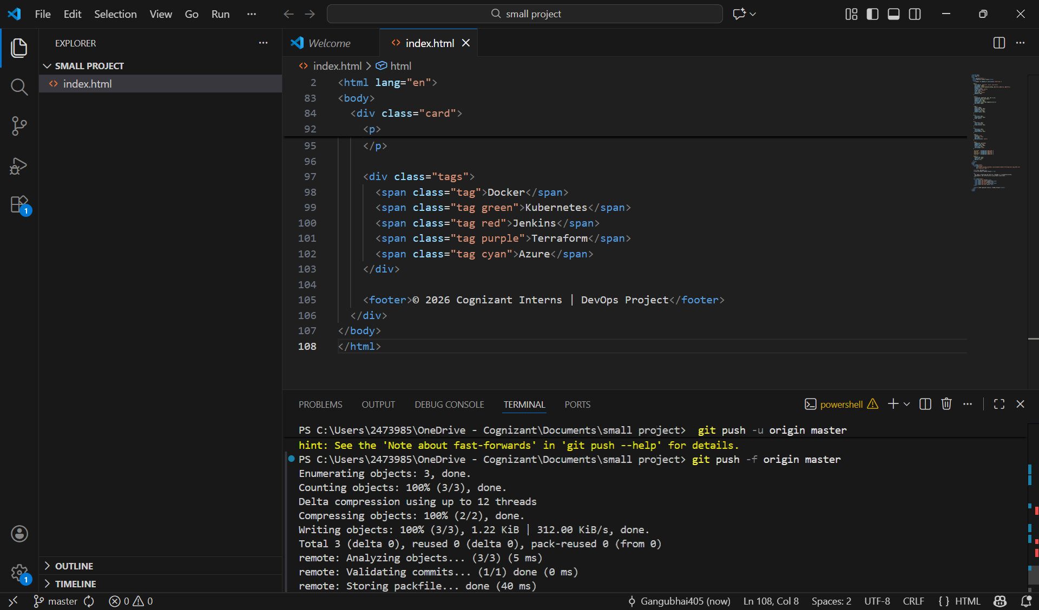
• Used git push -u origin master to push the local code to the Azure DevOps repository.
• Authenticated using a Personal Access Token (PAT) when prompted.
• Verified that all objects (HTML file and metadata) were successfully uploaded to Azure Repos.

Step 5: Verify Files in Azure Repos
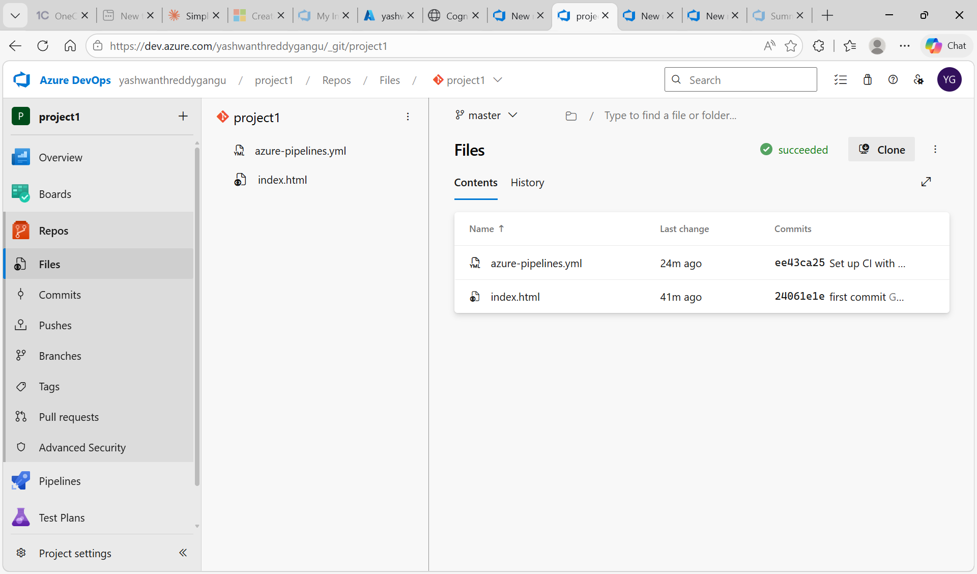
• Opened Azure DevOps → project1 → Repos → Files to confirm the upload.
• Verified that both index.html and azure-pipelines.yml files are present in the master branch.
• This confirms the source code is successfully version-controlled in Azure DevOps.
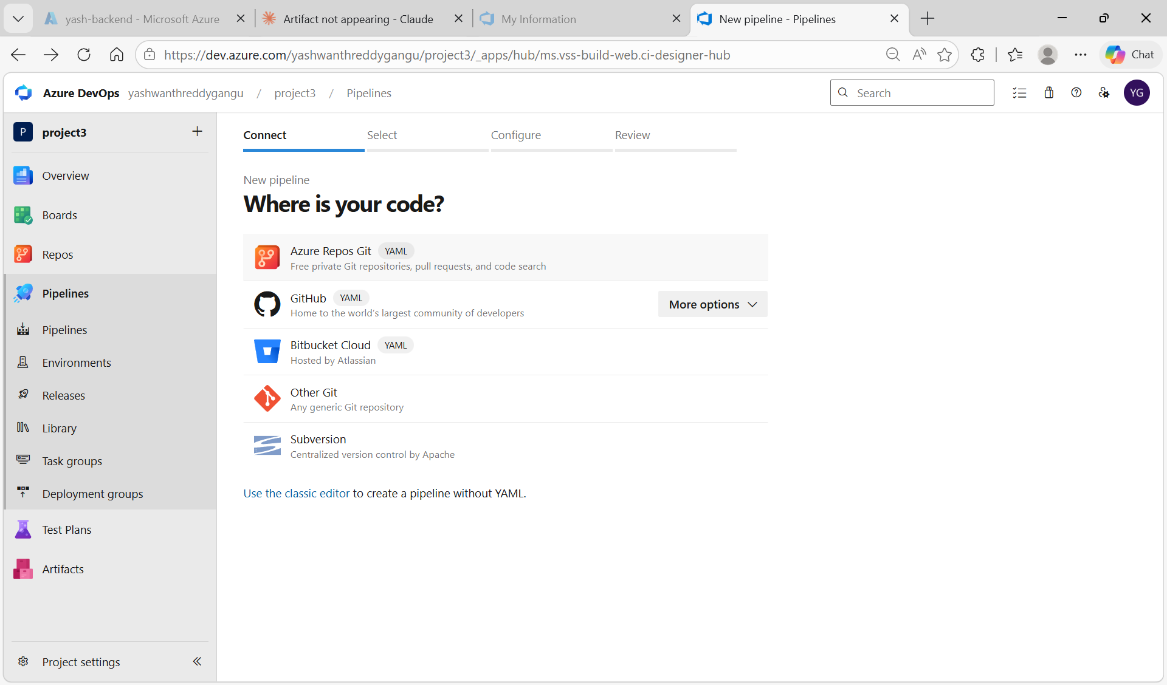
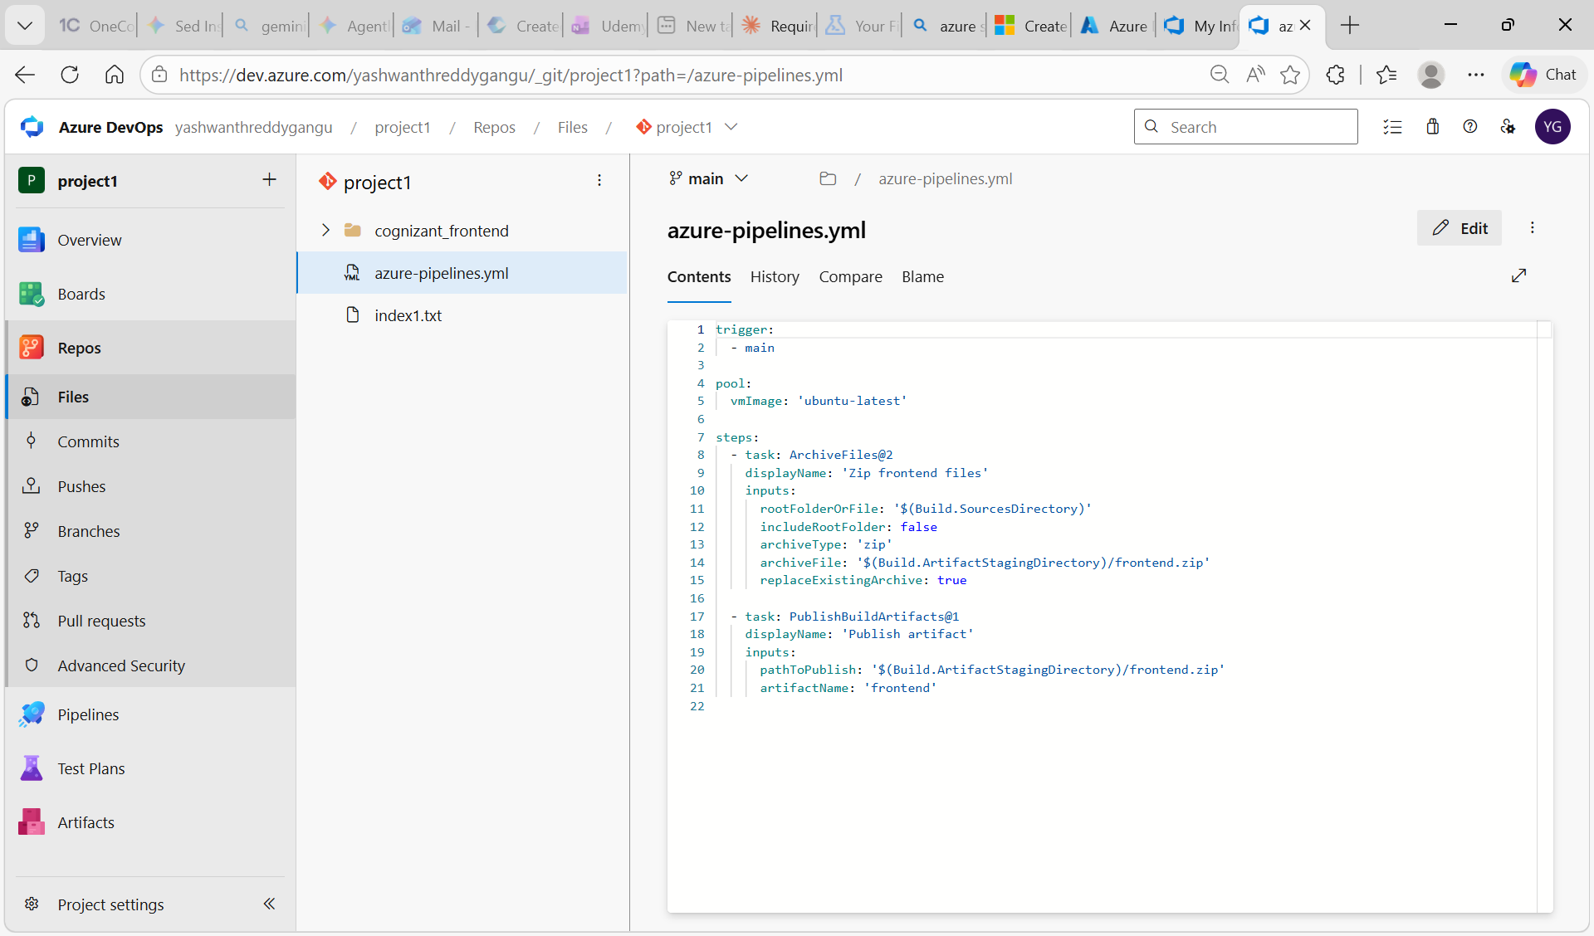

Step 6: Create the Azure Resource Manager Service Connection
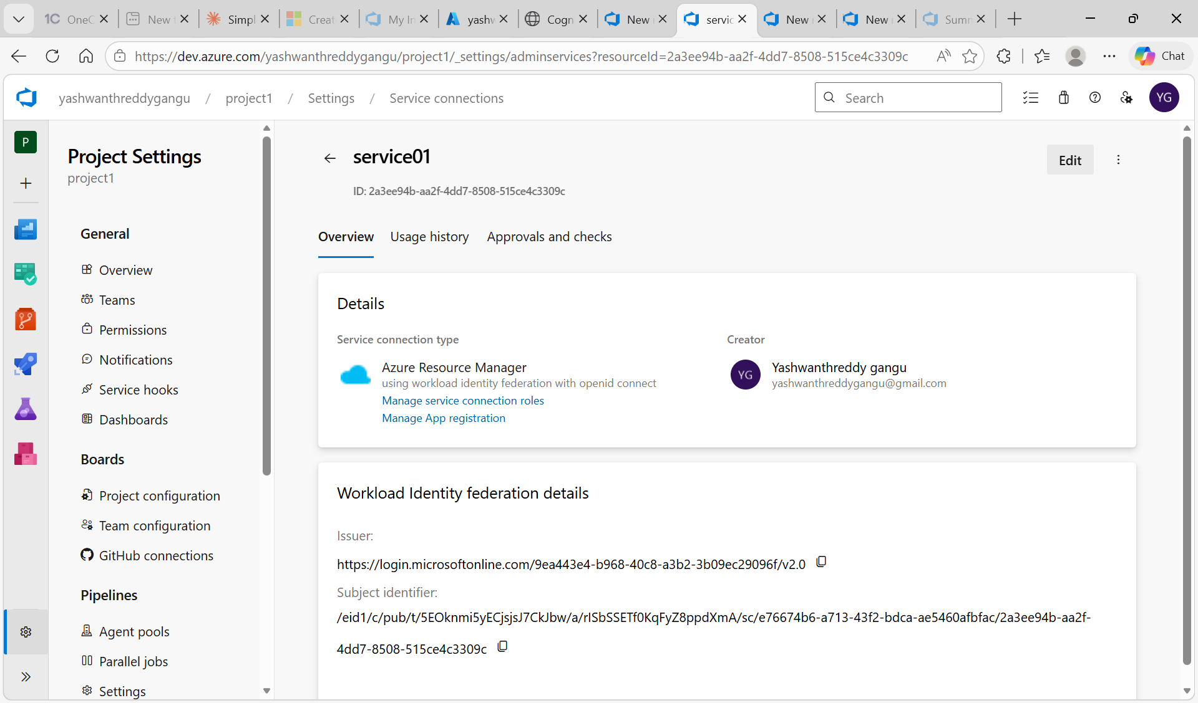
• Navigated to Project Settings → Service Connections → New Service Connection.
• Selected Azure Resource Manager with Workload Identity Federation (OpenID Connect) for secure authentication.
• Named the service connection as “service01” – this allows the pipeline to authenticate with Azure.
• Granted access to all pipelines so it can be reused across builds and releases.

Step 7: Run the Build Pipeline (CI)
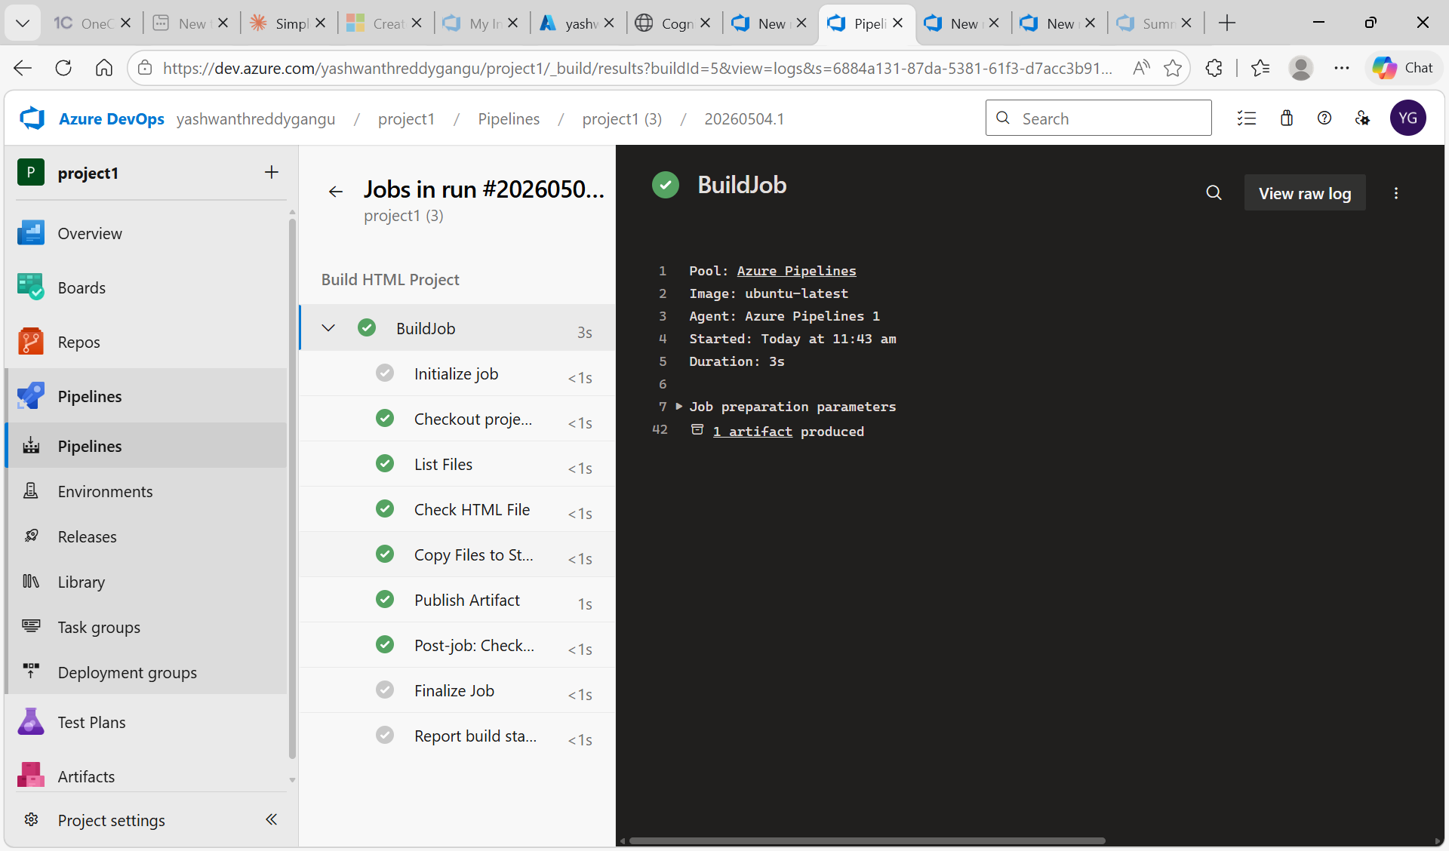
• Configured the YAML pipeline (azure-pipelines.yml) to build the HTML project.
• The build job ran on an Ubuntu-latest agent and executed the following steps: Initialize Job → Checkout Project → List Files → Check HTML File → Copy Files to Staging → Publish Artifact.
• All steps completed successfully, producing 1 artifact named “website” which contains the HTML files.

Step 8: Create the Release Pipeline – Stage Succeeded

• Navigated to Pipelines → Releases → New release pipeline.
• Linked the build artifact (_project1) so the latest successful build is automatically picked up.
• Triggered the release manually – Stage 1 executed successfully, deploying the build to the Azure Web App.

Step 9: Configure the Release Stage – Azure Subscription & App Name
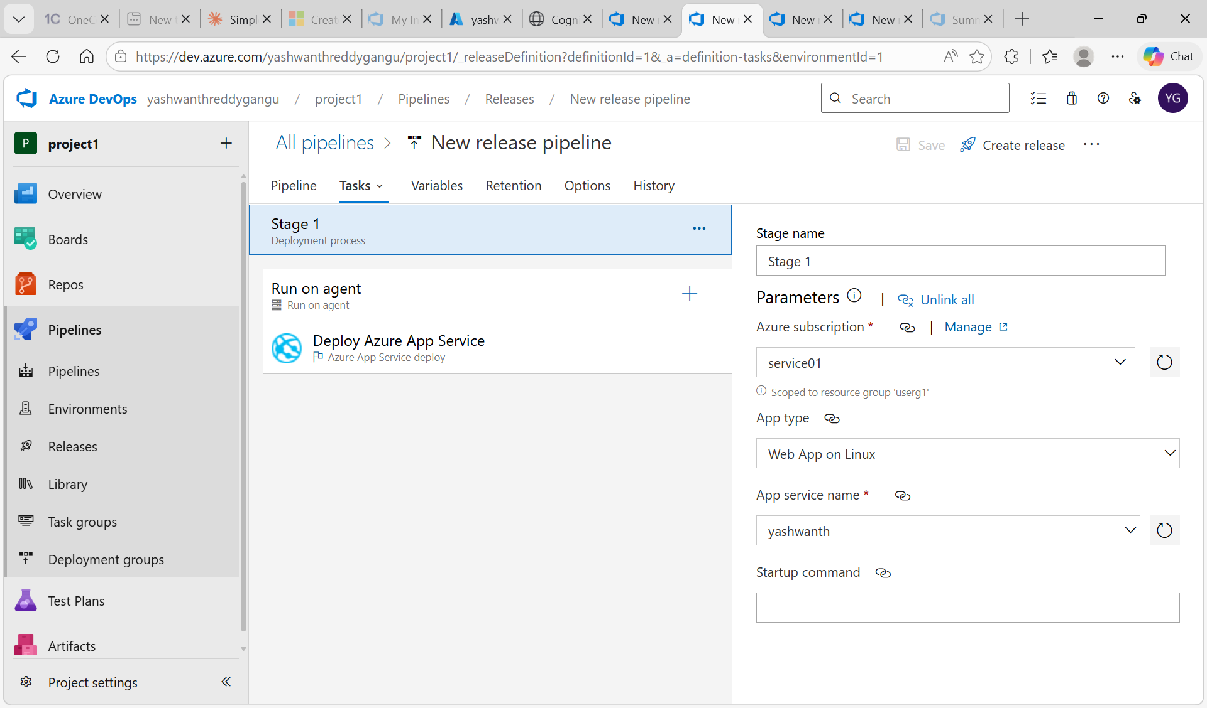
• Inside the release pipeline, opened Tasks → Stage 1 → Run on agent.
• Selected Azure subscription = service01 (the service connection created earlier).
• Set App type = Web App on Linux and App service name = yashwanth.
• This tells the release pipeline where to deploy the build artifact.

Step 10: Configure the Run on Agent Settings
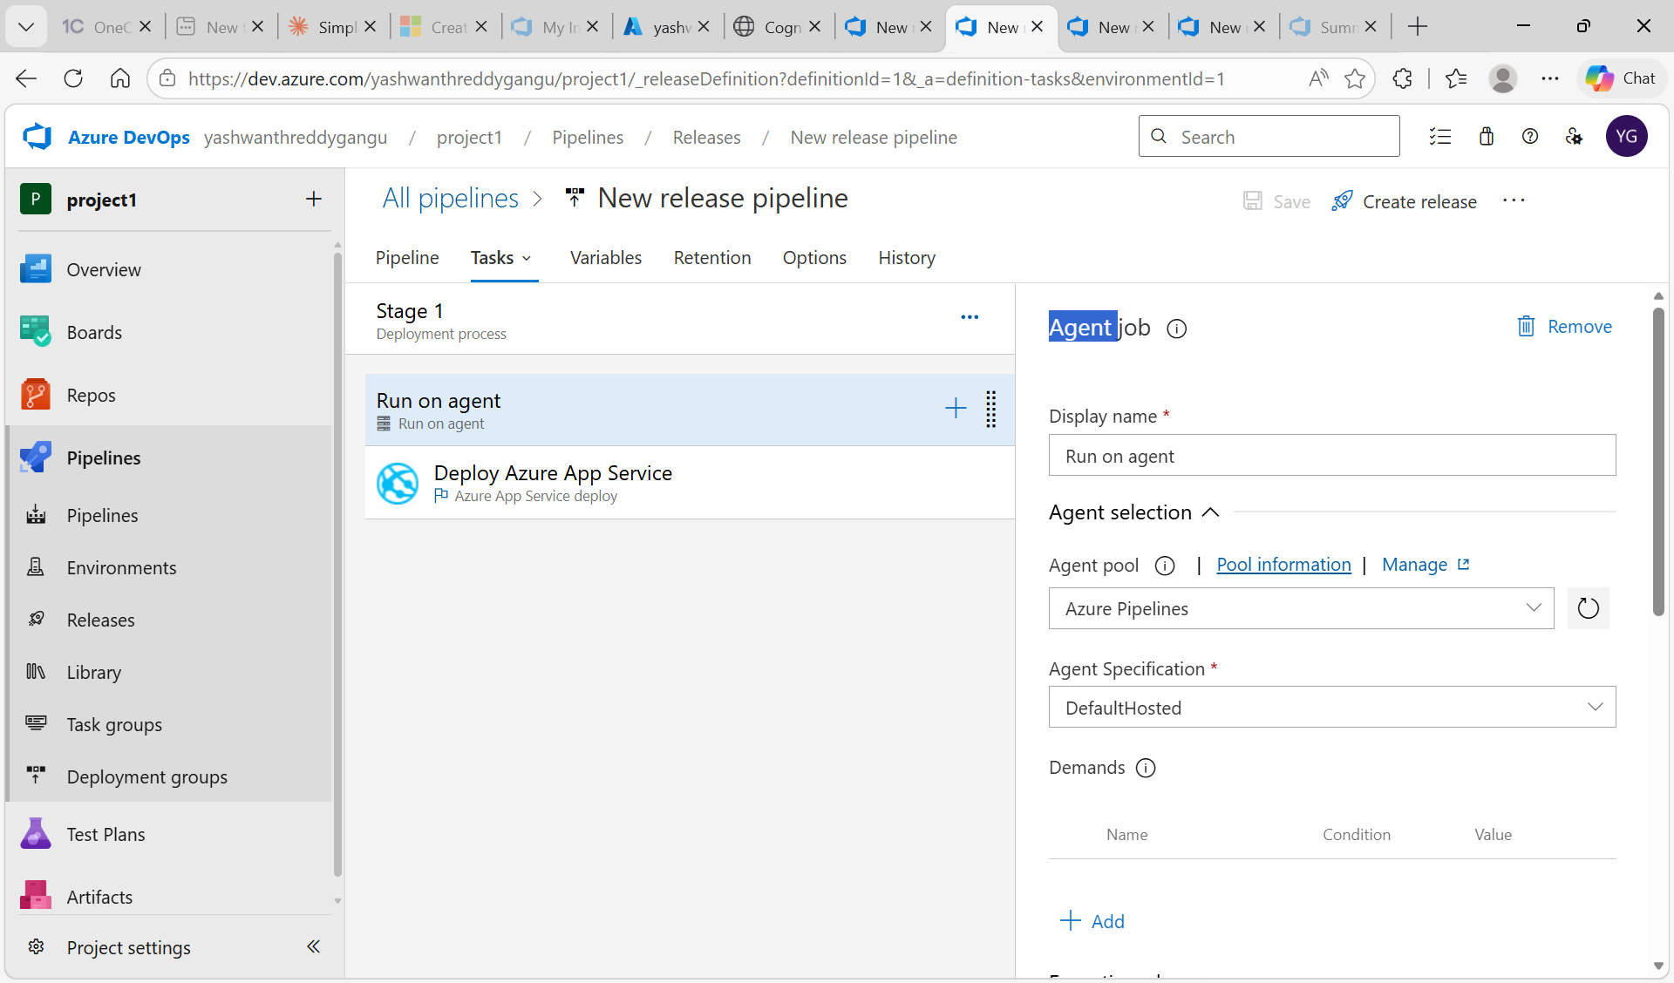
• Set the Agent pool to Azure Pipelines and Agent Specification to DefaultHosted (Microsoft-hosted agent).
• This Microsoft-hosted agent runs the deployment task without needing self-hosted infrastructure.
• The release agent picks up the artifact and deploys it to the configured Azure Web App.

Step 11: Configure the Deploy Azure App Service Task

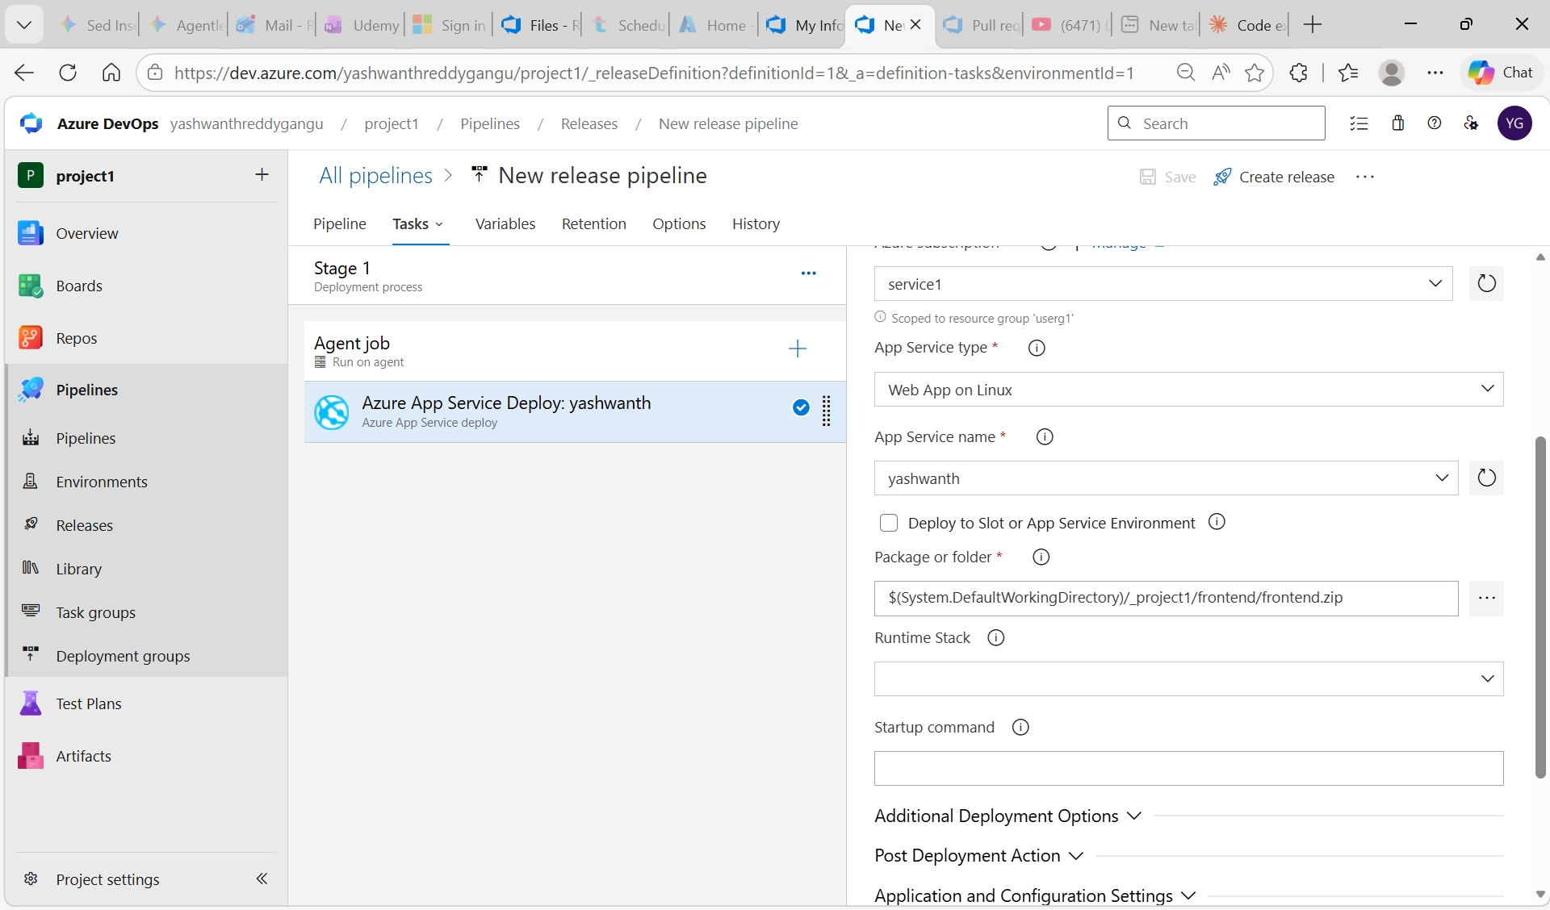

• Selected the Deploy Azure App Service task and set Connection type = Azure Resource Manager.
• Selected Azure subscription = service01 and App Service name = yashwanth.
• Set the Package or folder path that points to the build artifact (the published website folder).
• Saved the configuration so it can be reused for every release.

Step 12: Successful Release – Stage 1 Succeeded
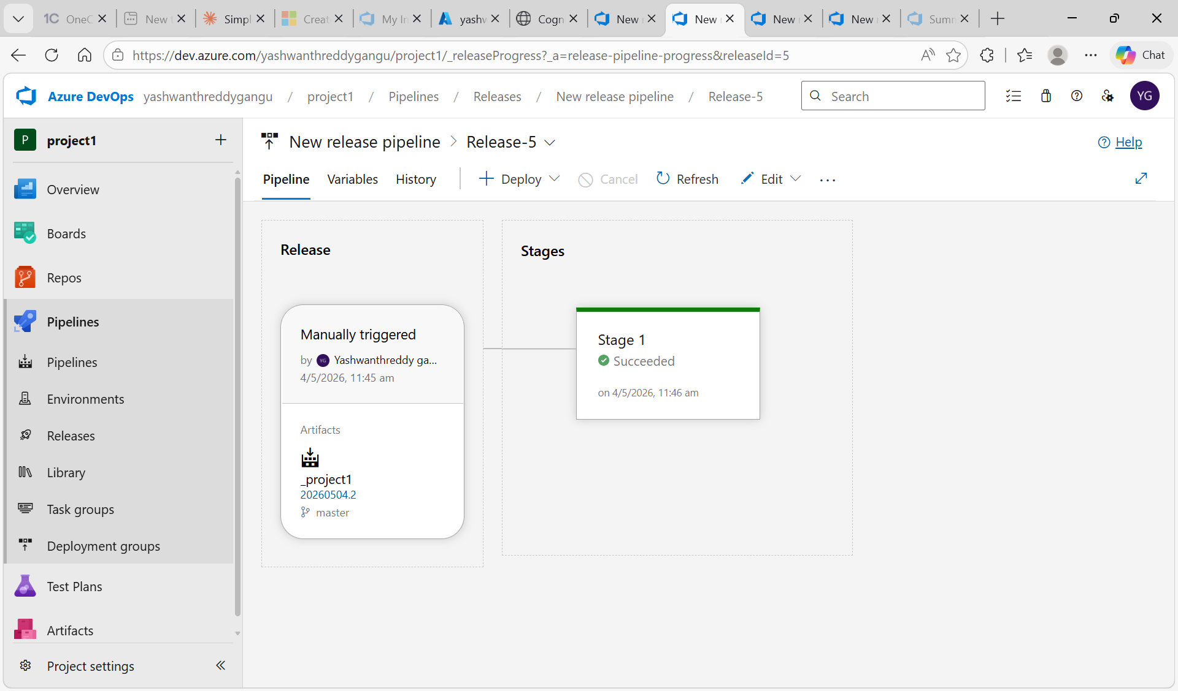
• Triggered the release pipeline, and Stage 1 completed with status = Succeeded.
• The HTML website (Cognizant DevOps welcome UI) was successfully deployed to the Azure Web App URL: https://yashwanth.azurewebsites.net.
• This completes the end-to-end CI/CD flow: VS Code → Azure Repos → Build Pipeline → Release Pipeline → Azure Web App.
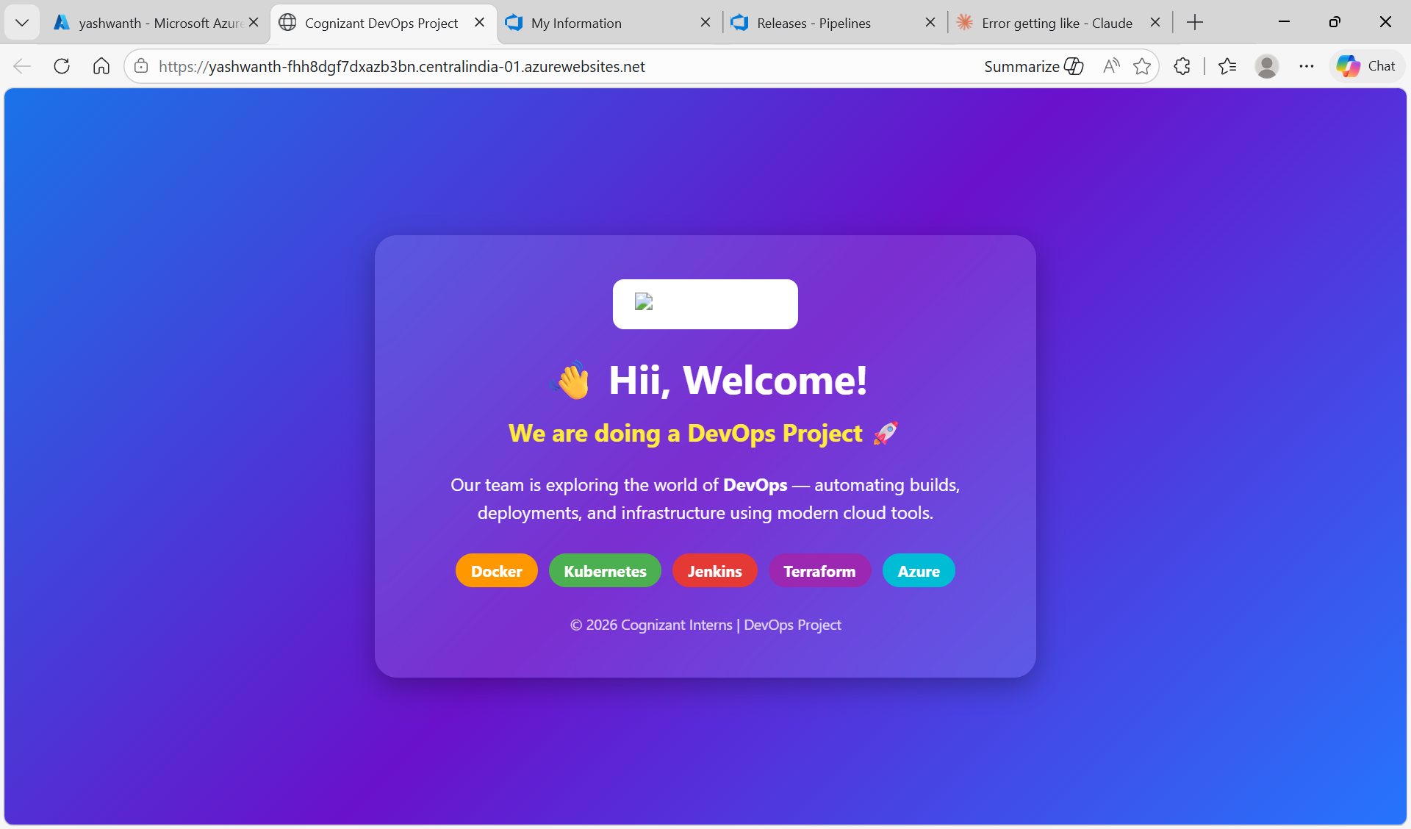

Conclusion
This use case successfully demonstrates a complete DevOps CI/CD lifecycle on Microsoft Azure. Source code maintained in VS Code is version-controlled via Azure Repos, automatically built into a deployable artifact through a Build Pipeline, and deployed to an Azure Web App using a Release Pipeline. The use of a Service Connection (service01) enables secure, automated authentication between Azure DevOps and Azure, replicating real-world enterprise DevOps practices.

Troubleshooting: Errors Encountered During Deployment
During the deployment process, the following errors were encountered and resolved. Each screenshot below captures a real issue faced while executing this use case.

Error 1: 403 – Web App Stopped
When the Azure App Service was first accessed via the browser, it returned a 403 – This web app is stopped error. This occurred because the App Service was in a stopped state. Resolution: The app was started from the Azure Portal (App Services → Start) or via Azure CLI: az webapp start.
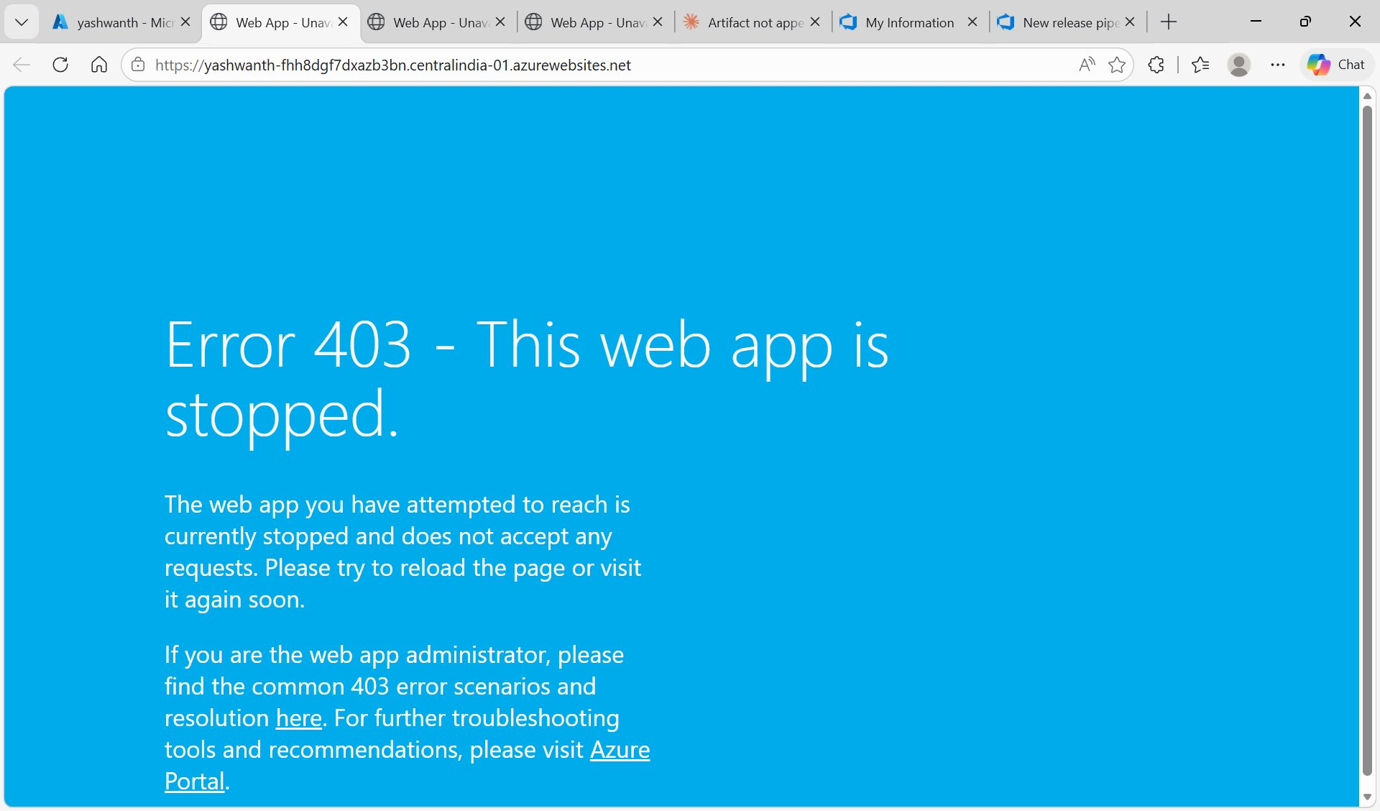
Figure: Error 403 – Azure App Service was in stopped state when accessed via browser

Error 2: 404 – Not Found After Pipeline Deployment
After the release pipeline reported Stage 1: Succeeded, the app still showed a 404 Not Found page. This was because the deployed ZIP contained the source files nested inside a subfolder (cognizant_frontend/) instead of placing index.html directly at the wwwroot root. Resolution: Updated the pm2 startup command to point to the correct subfolder path.
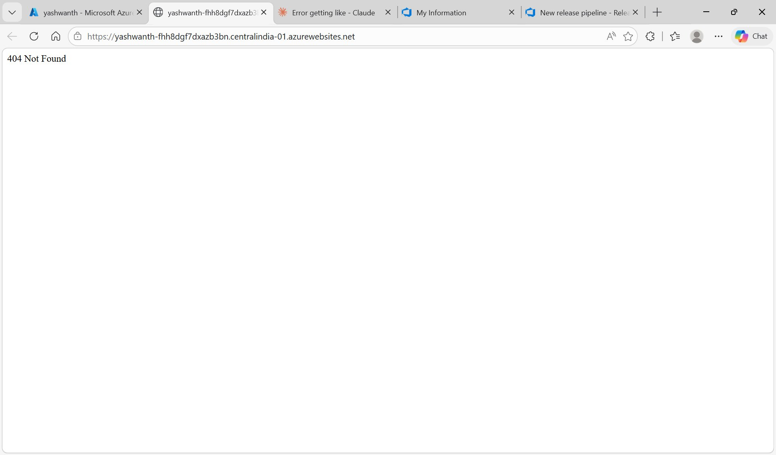
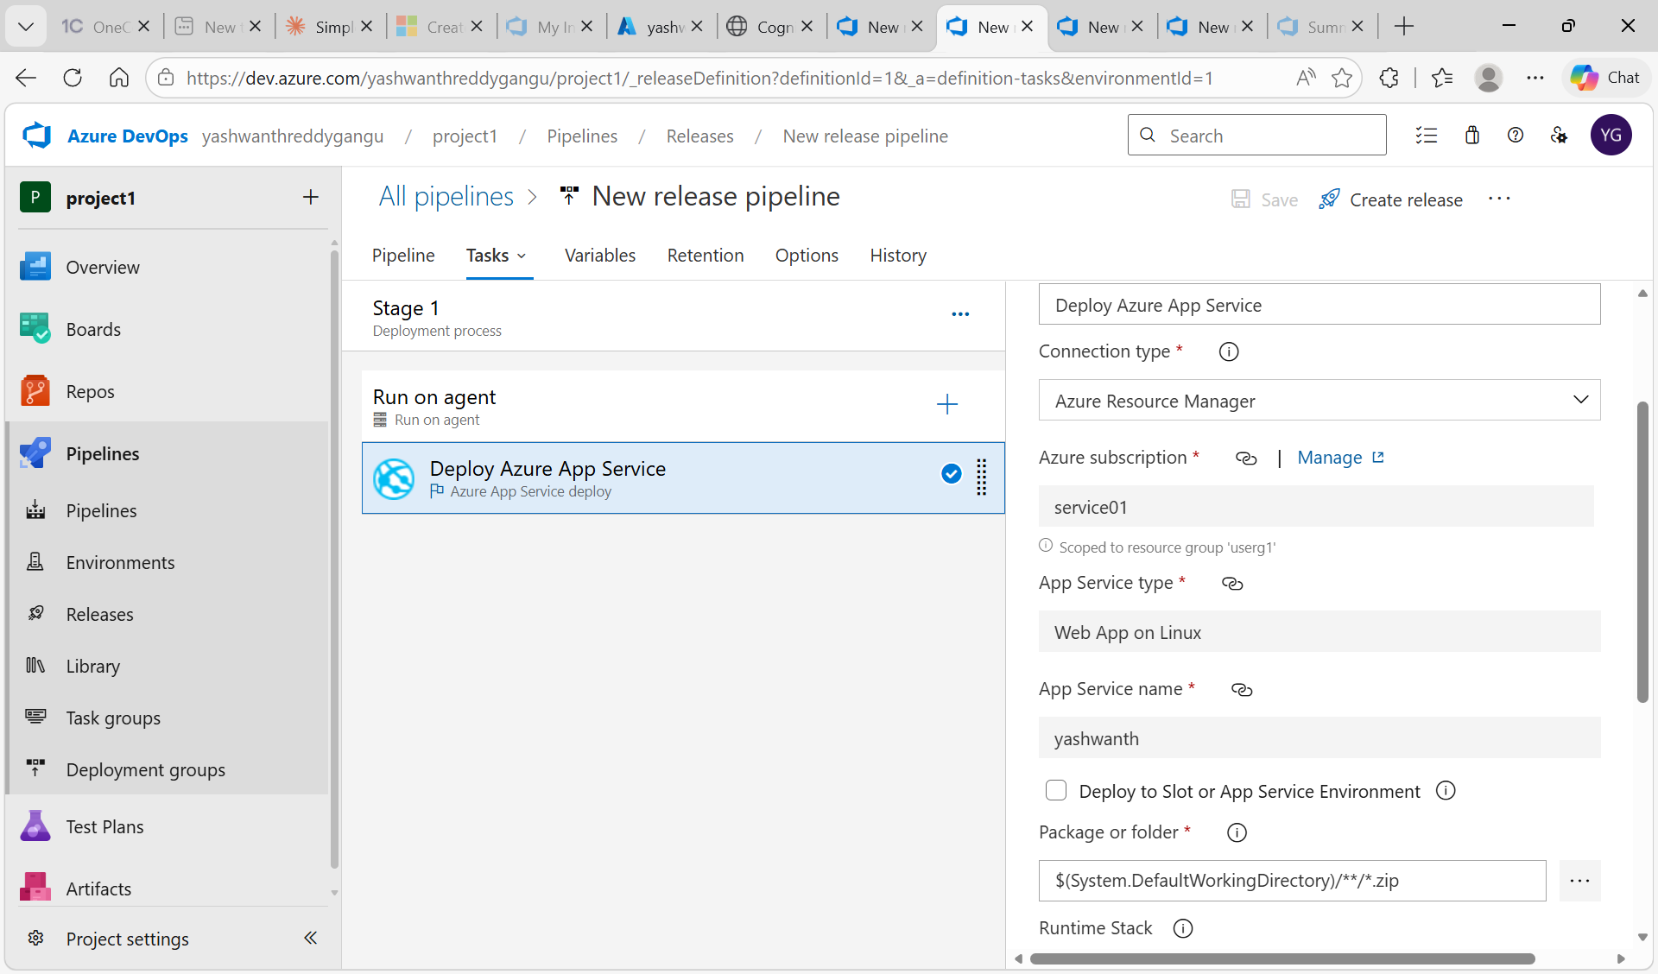
Figure: Error 404 – App running but HTML files not found at wwwroot root

Observation 3: Release Pipeline Succeeded but App Not Updated
The release pipeline showed Stage 1: Succeeded in Azure DevOps, but the website still showed 404. This confirmed that the Agent Job had no deploy task configured initially, and later the ZIP artifact path was incorrect. An empty agent job always shows Succeeded even if nothing is deployed – like sending an empty package marked as delivered.
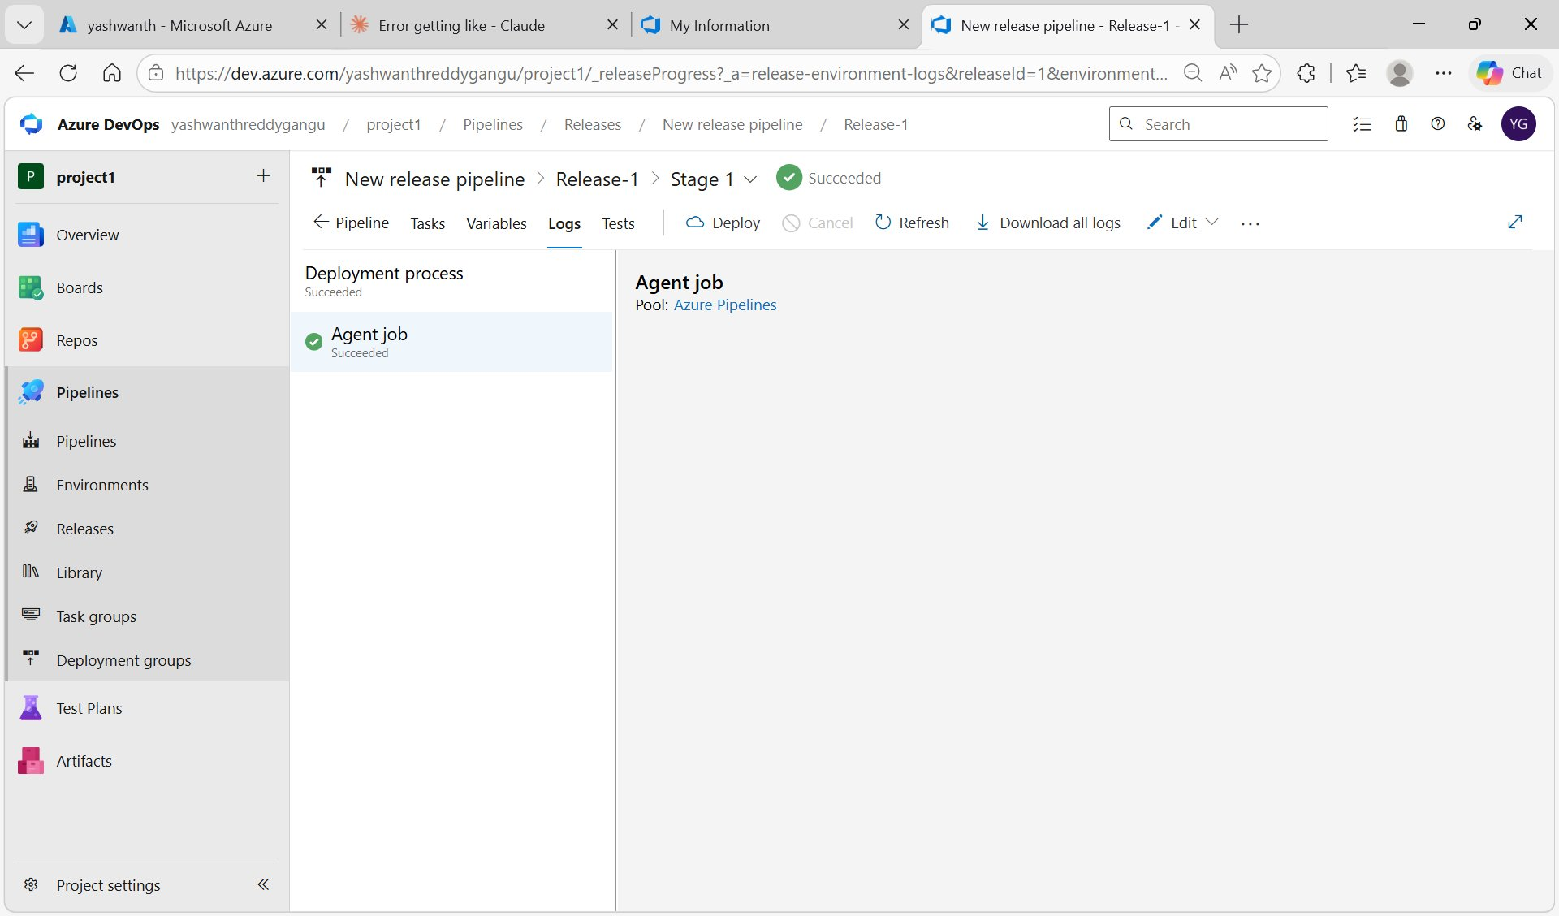
Figure: Release Pipeline showing Stage 1 Succeeded – but website still returned 404 due to missing deploy task

