USE CASE 4

DEPLOYMENT OF .NET APPLICATION
TO AZURE FUNCTION APP
USING AZURE DEVOPS CI/CD PIPELINES
Step-by-Step Implementation Guide

Submitted by:
Yashwanth Kumar Reddy Gangu
DevOps Intern, Cognizant

Date: May 2026

1. Use Case
Deployment of a .NET application to an Azure Function App using Azure DevOps CI/CD pipelines. The objective is to demonstrate a fully automated workflow where every code commit triggers a build, produces a deployable artifact, and pushes it to a live Azure Function App without manual intervention.

Tools Used
Category | Tool / Technology
Programming Language | .NET 8 (C#)
Cloud Platform | Microsoft Azure
Compute Service | Azure Function App (Consumption Plan)
DevOps Platform | Azure DevOps Services
Source Control | Azure Repos (Git)
CI Pipeline | Azure Pipelines (YAML)
CD Pipeline | Azure Release Pipelines (Classic UI)
Authentication | Azure Resource Manager Service Connection
Build Agent | Microsoft-hosted (ubuntu-latest / windows-latest)
Code Editor | Visual Studio Code
Version Control | Git

2. Step-by-Step Implementation with Screenshots
Each step below is described clearly before its corresponding screenshot. Follow them in order to reproduce the deployment.

STEP 1: Open Azure Portal and navigate to Create a Resource
Sign in to portal.azure.com, click 'Create a resource' from the home page, and locate Function App under Popular Azure services. This is where we begin provisioning the Function App resource.
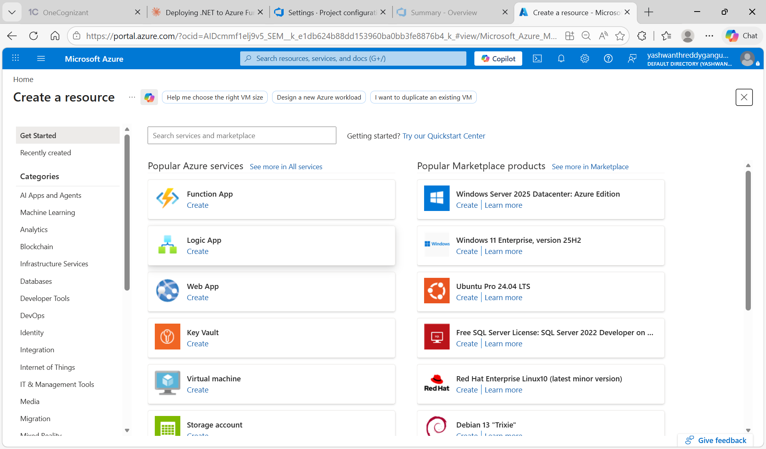
Screenshot 1: Azure Portal - Create a resource page showing Function App option

STEP 2: Select the Hosting Plan for Function App
Choose the hosting plan that determines how the function app scales and is billed. We initially saw the Flex Consumption option, but later switched to standard Consumption (Windows) for better compatibility with Azure DevOps deployment tasks.
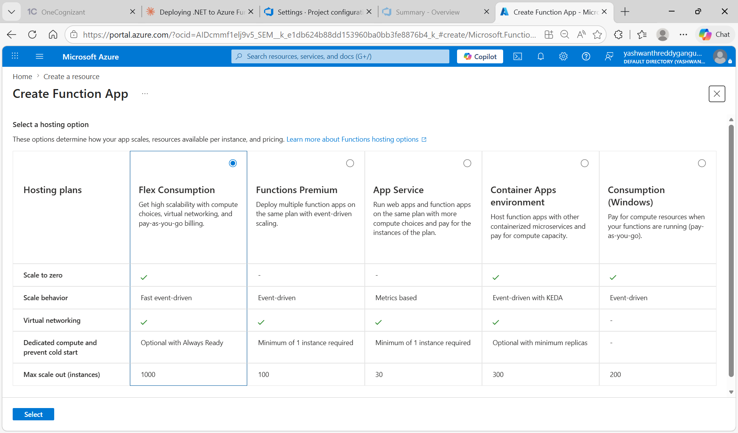
Screenshot 2: Hosting plan selection screen comparing Flex Consumption, Premium, App Service, Container Apps, and Consumption (Windows)

STEP 3: Fill in the Function App Basics tab
Configure the Function App with: Subscription = Azure for Students, Resource Group = userg1, Function App name = yashfunc, Region = Central India, Runtime stack = .NET. The unique URL suffix gets auto-generated by Azure for security.
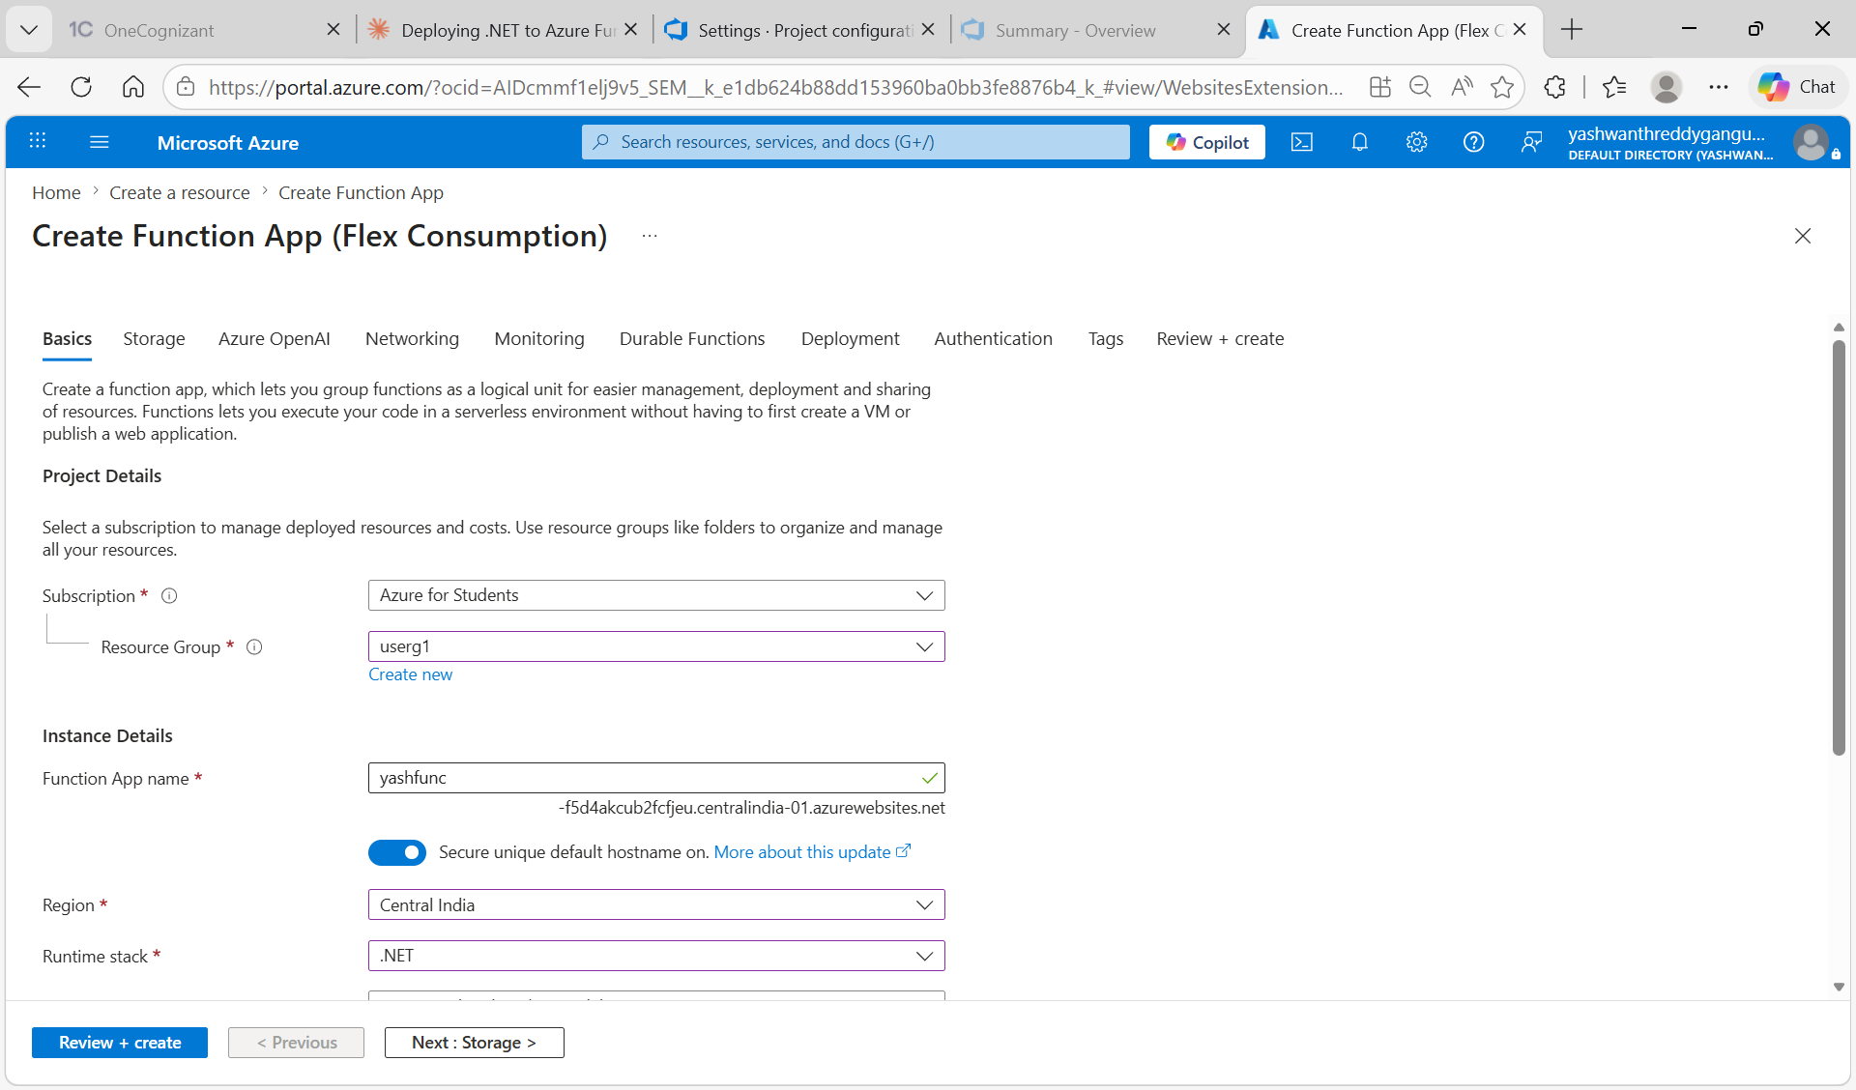
Screenshot 3: Function App basics page with project details and instance configuration filled in

STEP 4: Verify Successful Deployment of the Function App
After clicking Review + create and Create, Azure provisions the Function App. Wait for the deployment status to show 'Your deployment is complete'. Note the Resource group as userg1. Click 'Go to resource' to view the Function App.
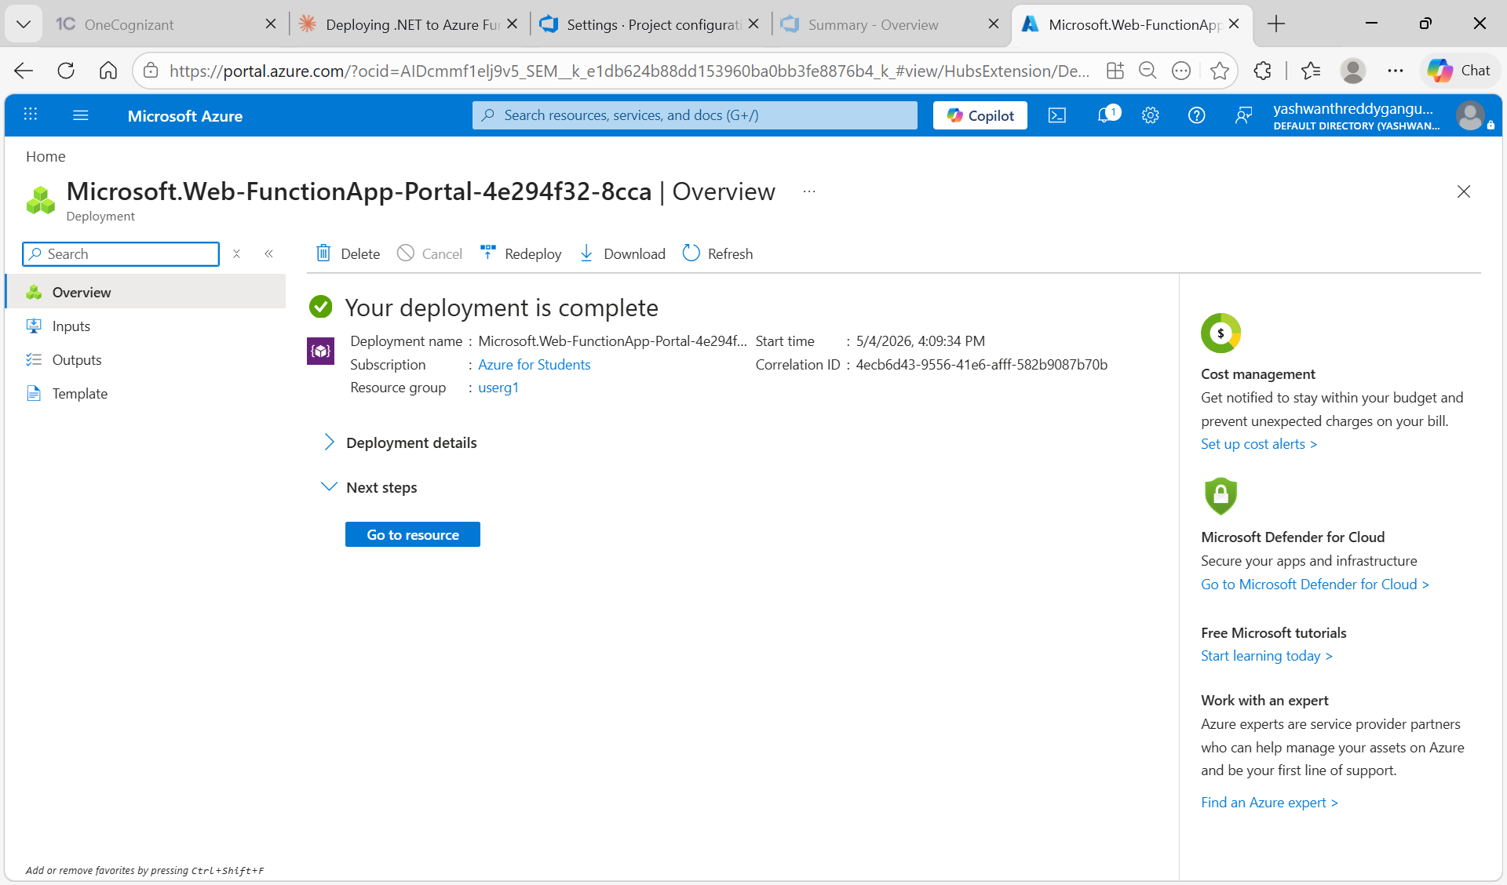
Screenshot 4: Deployment complete page confirming the Function App resource was successfully created

STEP 5: Open the .NET Application Code in Visual Studio Code
Open the SimpleWebApi project folder in VS Code. The project contains Program.cs (with HTTP endpoints), SimpleWebApi.csproj, appsettings.json, azure-pipelines.yml, and .gitignore. The terminal shows git init being run to initialize a Git repository.
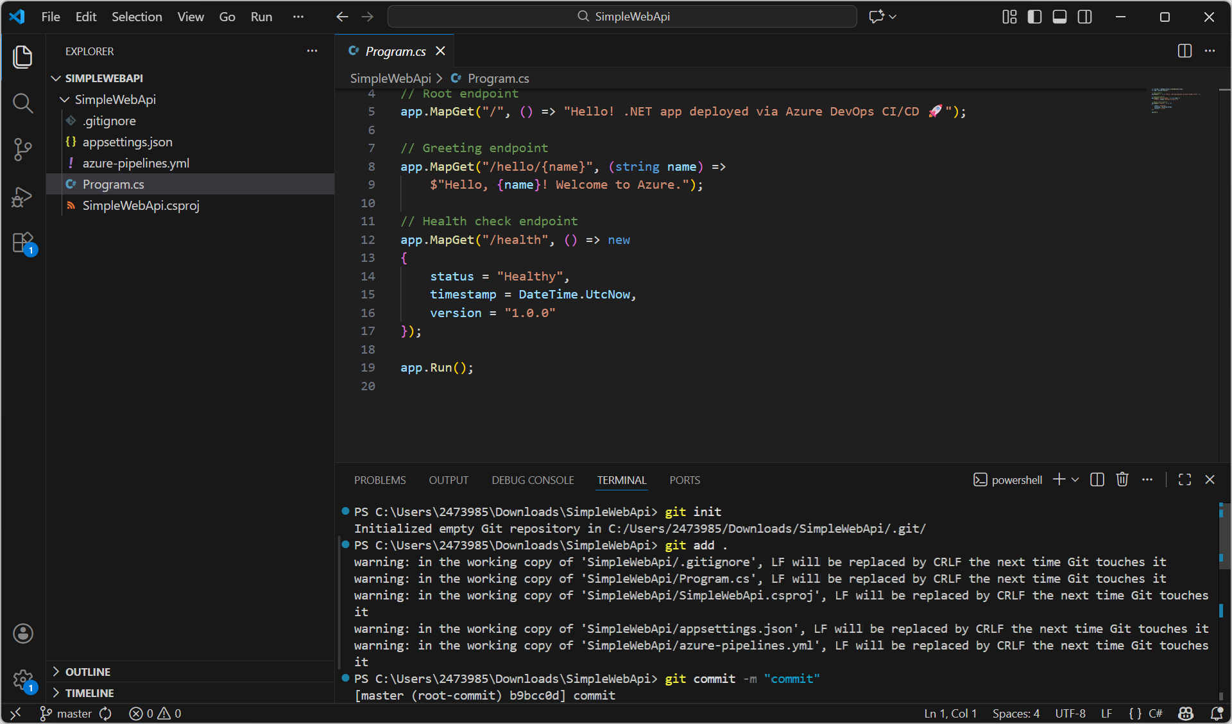
Screenshot 5: VS Code open with Program.cs showing .NET endpoints and terminal running 'git init' and 'git add .'

STEP 6: Push the Code to Azure Repos using Git Commands
After git init and git commit, add the Azure DevOps remote URL and push the code with 'git remote add origin' followed by 'git push -u origin --all'. The terminal output confirms successful object enumeration, compression, and upload to the remote repository.
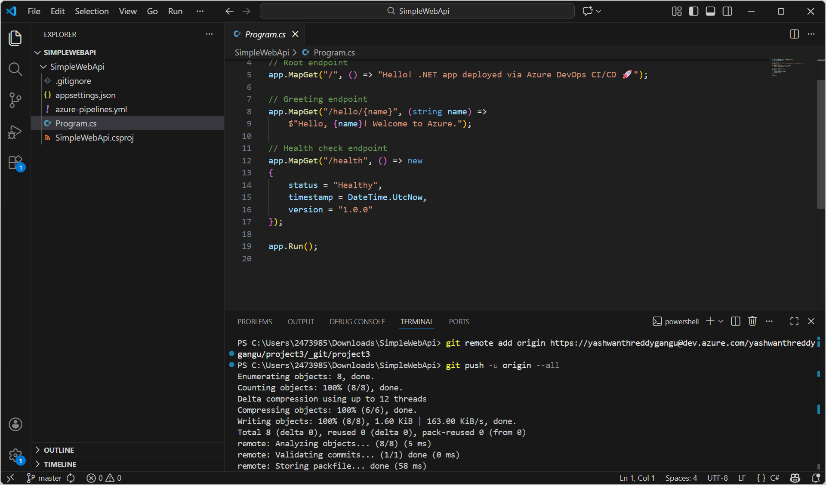
Screenshot 6: VS Code terminal showing successful git push to Azure DevOps remote (project3 repo)

STEP 7: Verify Files in Azure Repos
Navigate to Azure DevOps > project3 > Repos > Files. Confirm that all SimpleWebApi project files (.gitignore, appsettings.json, azure-pipelines.yml, Program.cs, SimpleWebApi.csproj) are visible under the SimpleWebApi folder. The commit message 'commit Gang...' indicates the first commit was successful.
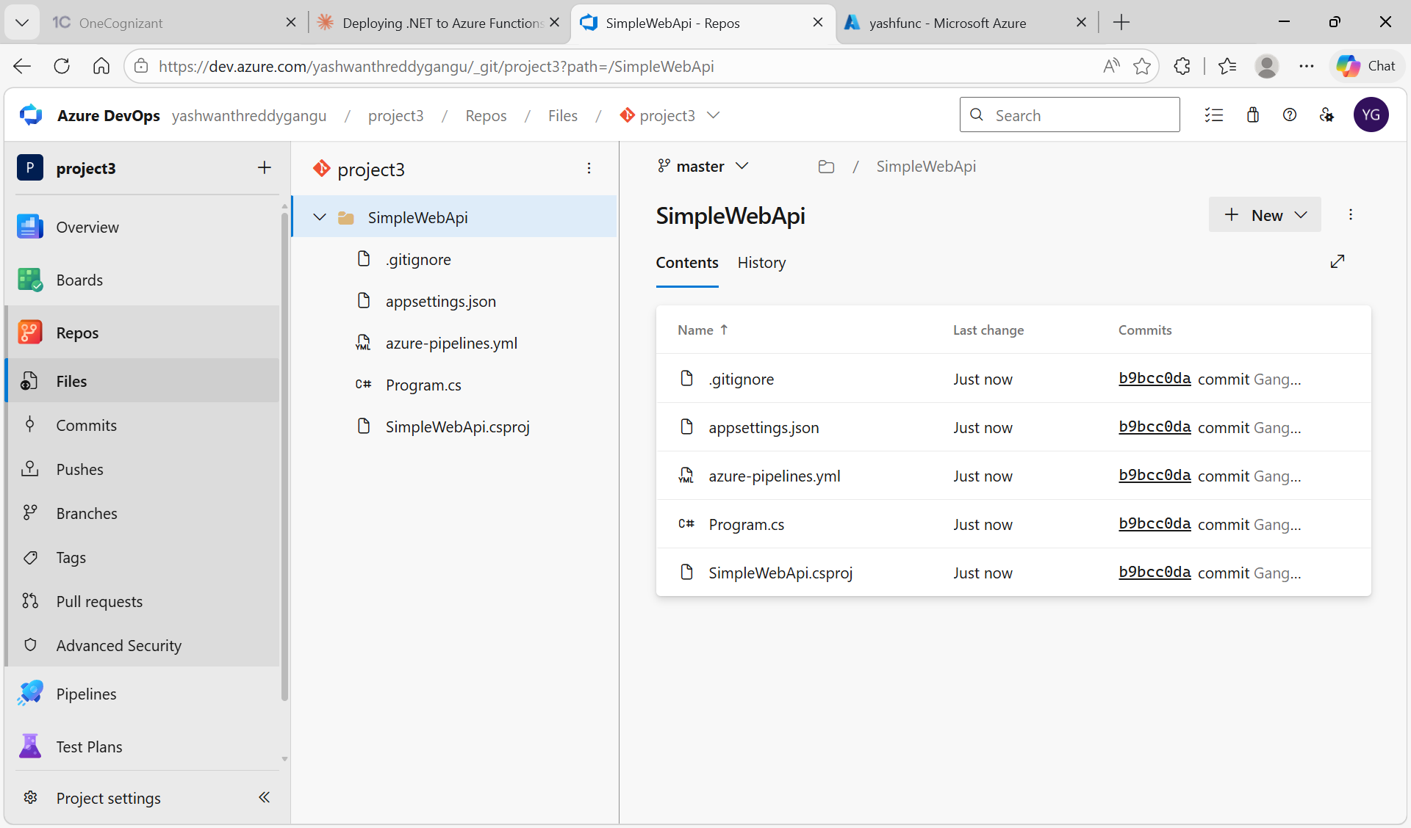
Screenshot 7: Azure Repos showing all project files successfully pushed to the master branch

STEP 8: Navigate to Azure DevOps Pipelines Section
From the left sidebar of Azure DevOps, click Pipelines > Pipelines. Since no pipeline exists yet, you will see the 'Create your first Pipeline' welcome screen. Click the blue 'Create Pipeline' button to start building the CI build pipeline.
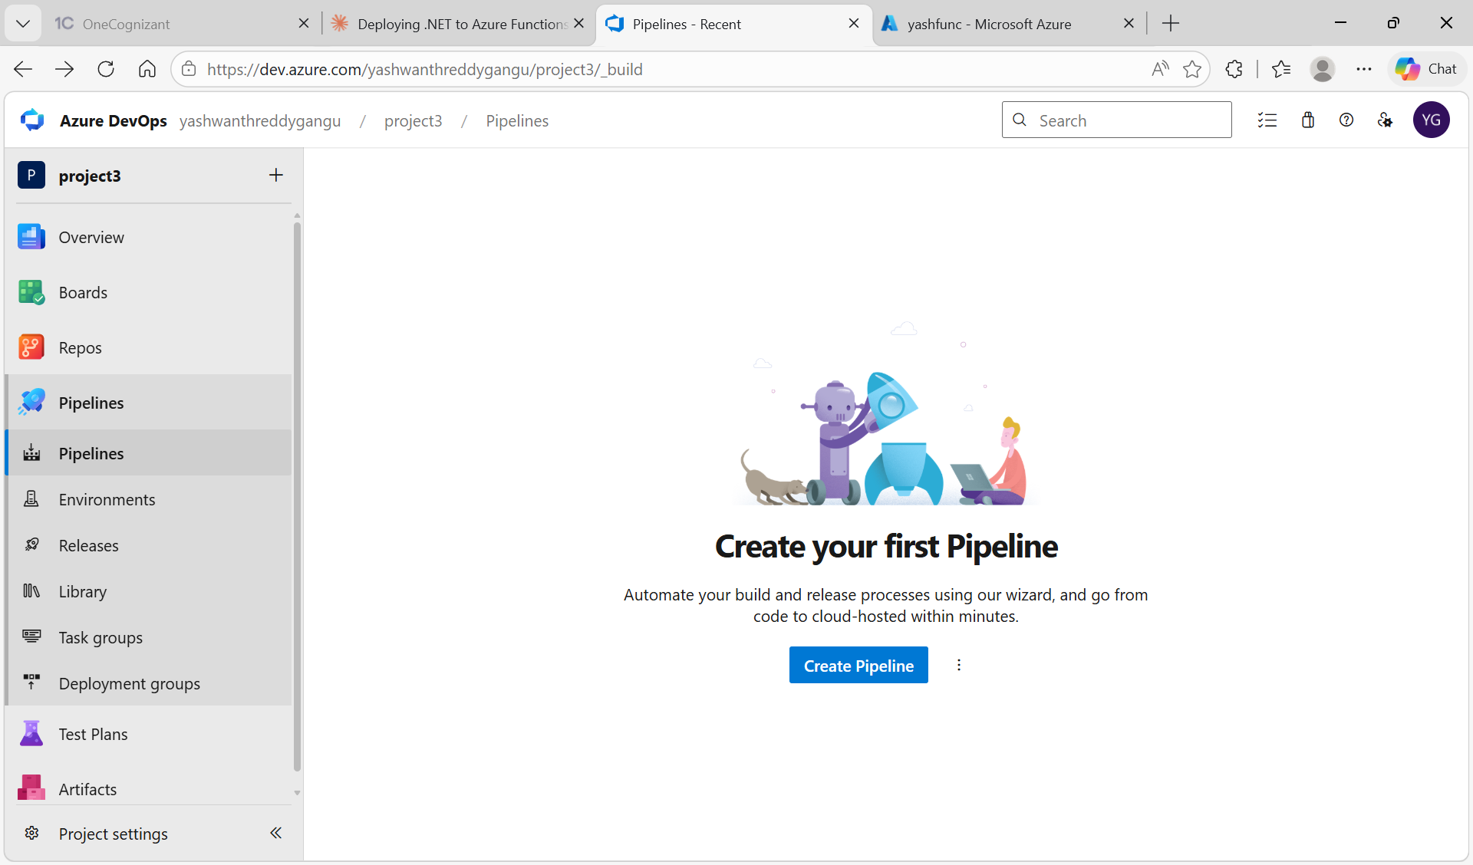
Screenshot 8: Azure DevOps Pipelines welcome page prompting to create the first pipeline

STEP 9: Connect the Pipeline to Azure Repos Git
On the 'Where is your code?' screen, the wizard shows three source options: Azure Repos Git, GitHub, and Bitbucket Cloud. Select 'Azure Repos Git' (with YAML tag) since the SimpleWebApi code lives in Azure Repos.
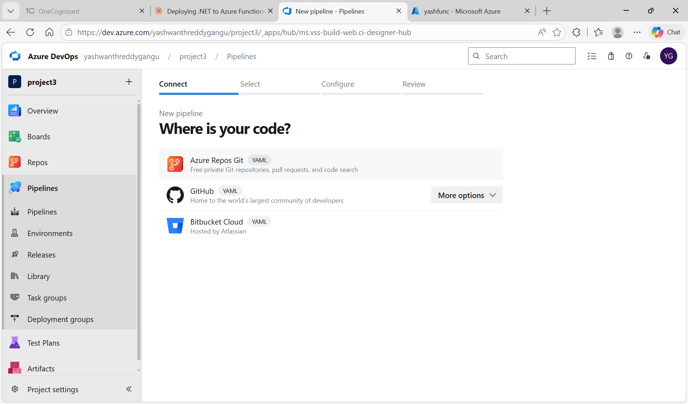
Screenshot 9: Pipeline source connection screen with Azure Repos Git highlighted

STEP 10: Select the Repository for the Pipeline
From the list of available repositories, choose 'project3' which contains the SimpleWebApi code. The keyword filter helps if there are multiple repos. Click on project3 to proceed to the configuration step.
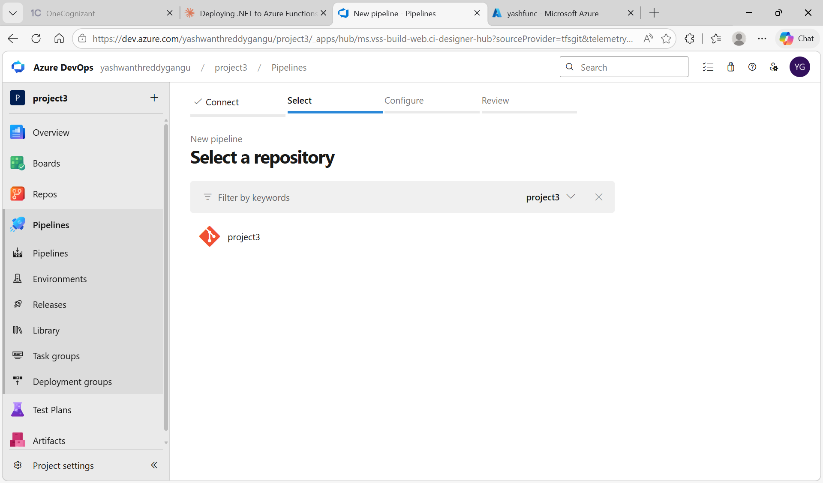
Screenshot 10: Repository selection screen showing project3 as the available repo

STEP 11: Configure the Pipeline Type
Choose how to configure the pipeline. Select 'Existing Azure Pipelines YAML file' since the azure-pipelines.yml file already exists in the repo. This option lets the wizard pick up the YAML directly without generating a starter template.
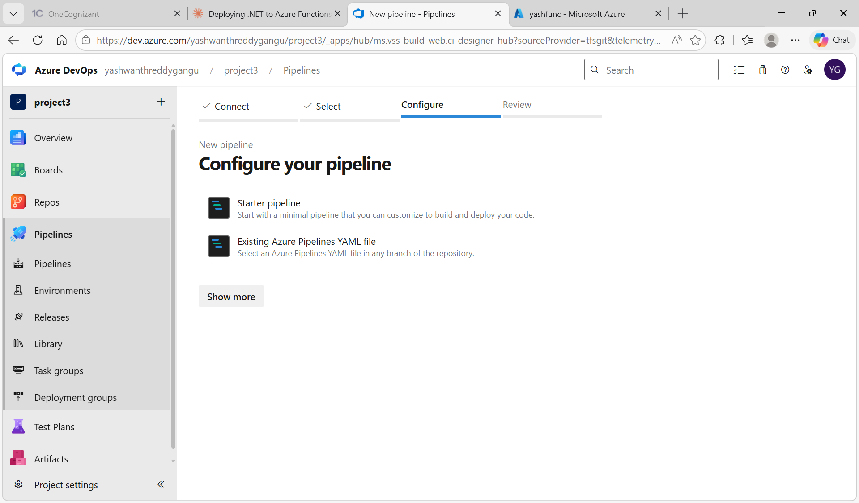
Screenshot 11: Pipeline configuration options with Existing Azure Pipelines YAML file option

STEP 12: Create New Service Connection in Project Settings
Navigate to Project Settings > Service connections > New service connection. From the connection types list, select 'Azure Resource Manager' which is the standard option for connecting Azure DevOps pipelines to an Azure subscription.
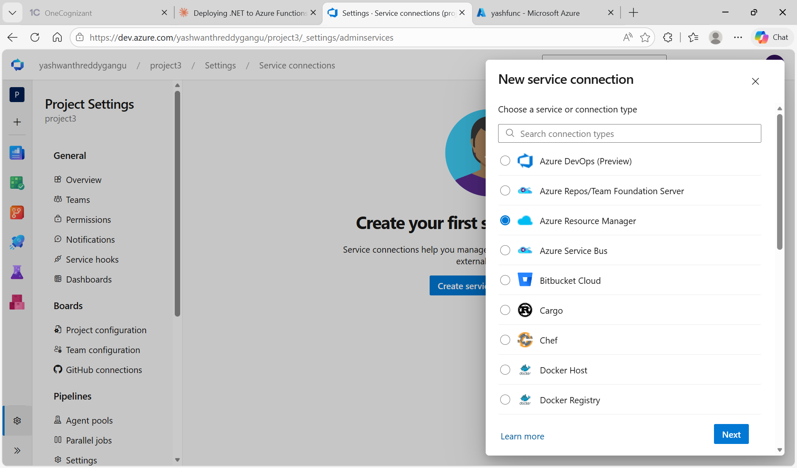
Screenshot 12: New service connection panel with Azure Resource Manager selected

STEP 13: Configure the Azure Service Connection Details
Fill in: Authentication = Subscription, Subscription = Azure for Students, Resource group = DefaultResourceGroup-CID (later changed to subscription scope), Service Connection Name = servicedotnet. This name must match exactly with what is referenced in the YAML and release pipeline.
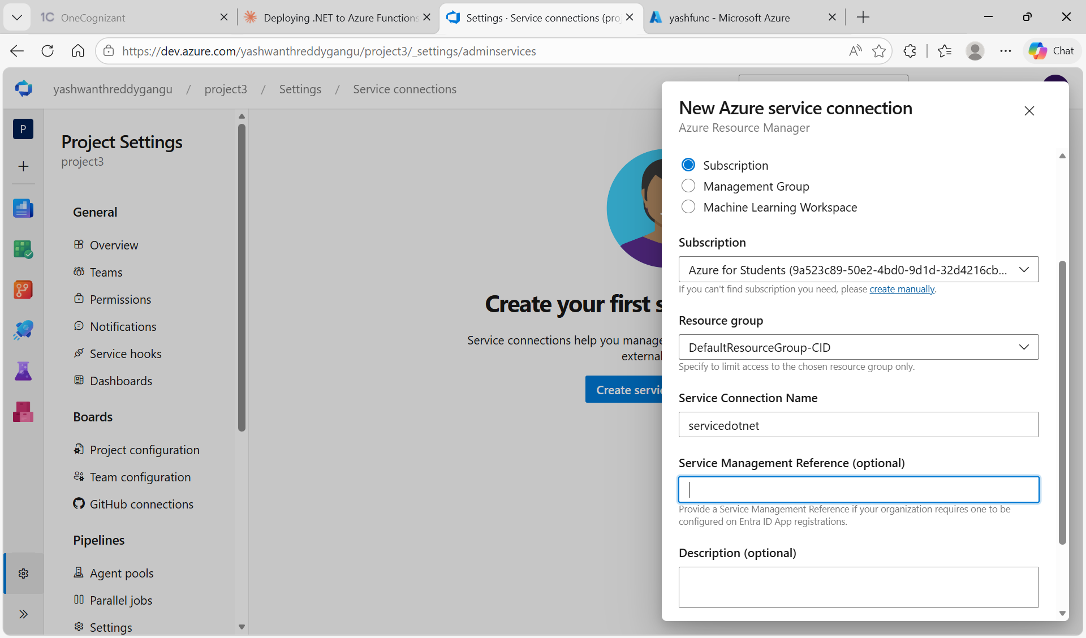
Screenshot 13: New Azure service connection form with subscription, resource group, and connection name servicedotnet

STEP 14: CI Build Pipeline Successfully Executed
After the YAML pipeline runs, all build steps complete with green checkmarks: Initialize job, Checkout project, Install .NET 8 SDK, Restore NuGet Packages, Build Project, Publish Project, Publish Artifact. The build completed in 22 seconds and produced 1 artifact named drop, ready for deployment.
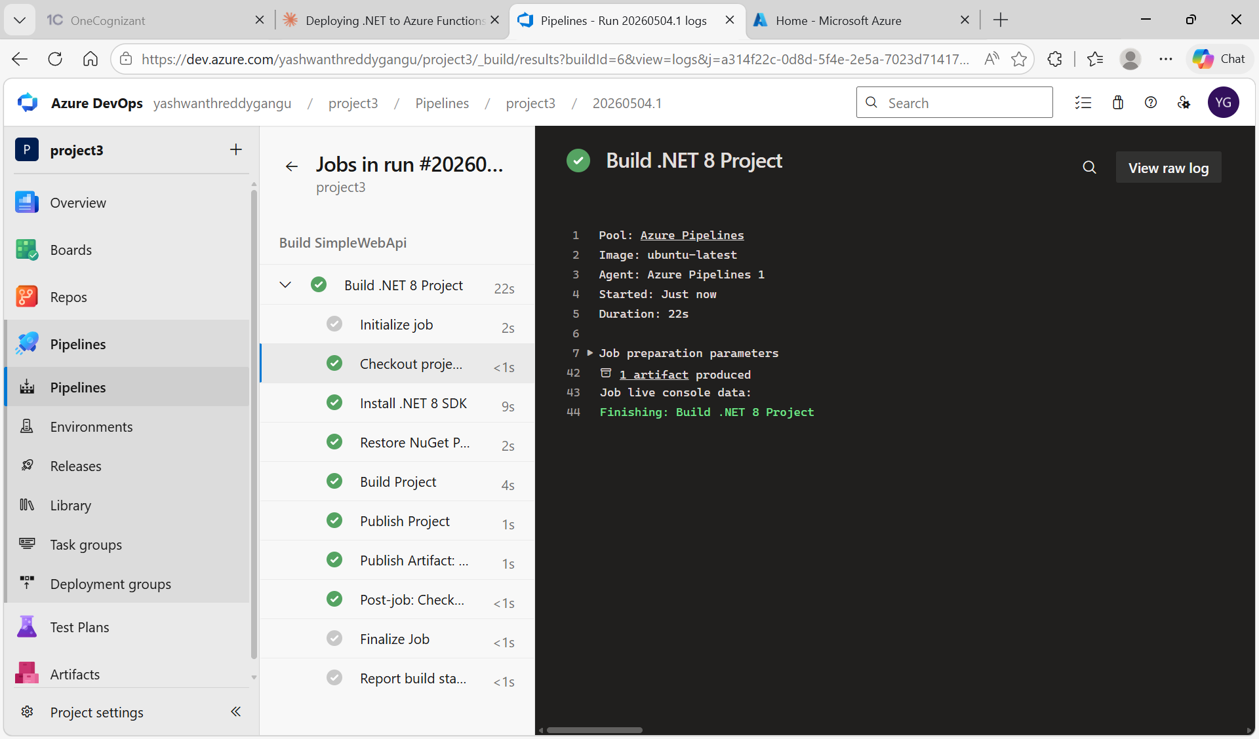
Screenshot 14: Build pipeline run #20260504.1 with all steps succeeded and artifact published

STEP 15: Service Connection Successfully Created Using Workload Identity
After saving, the Azure service connection is listed under Project Settings > Service connections. The service uses 'Azure Resource Manager using workload identity federation with openid connect' authentication, which is the modern and secure approach. The creator and Workload Identity federation details are shown.
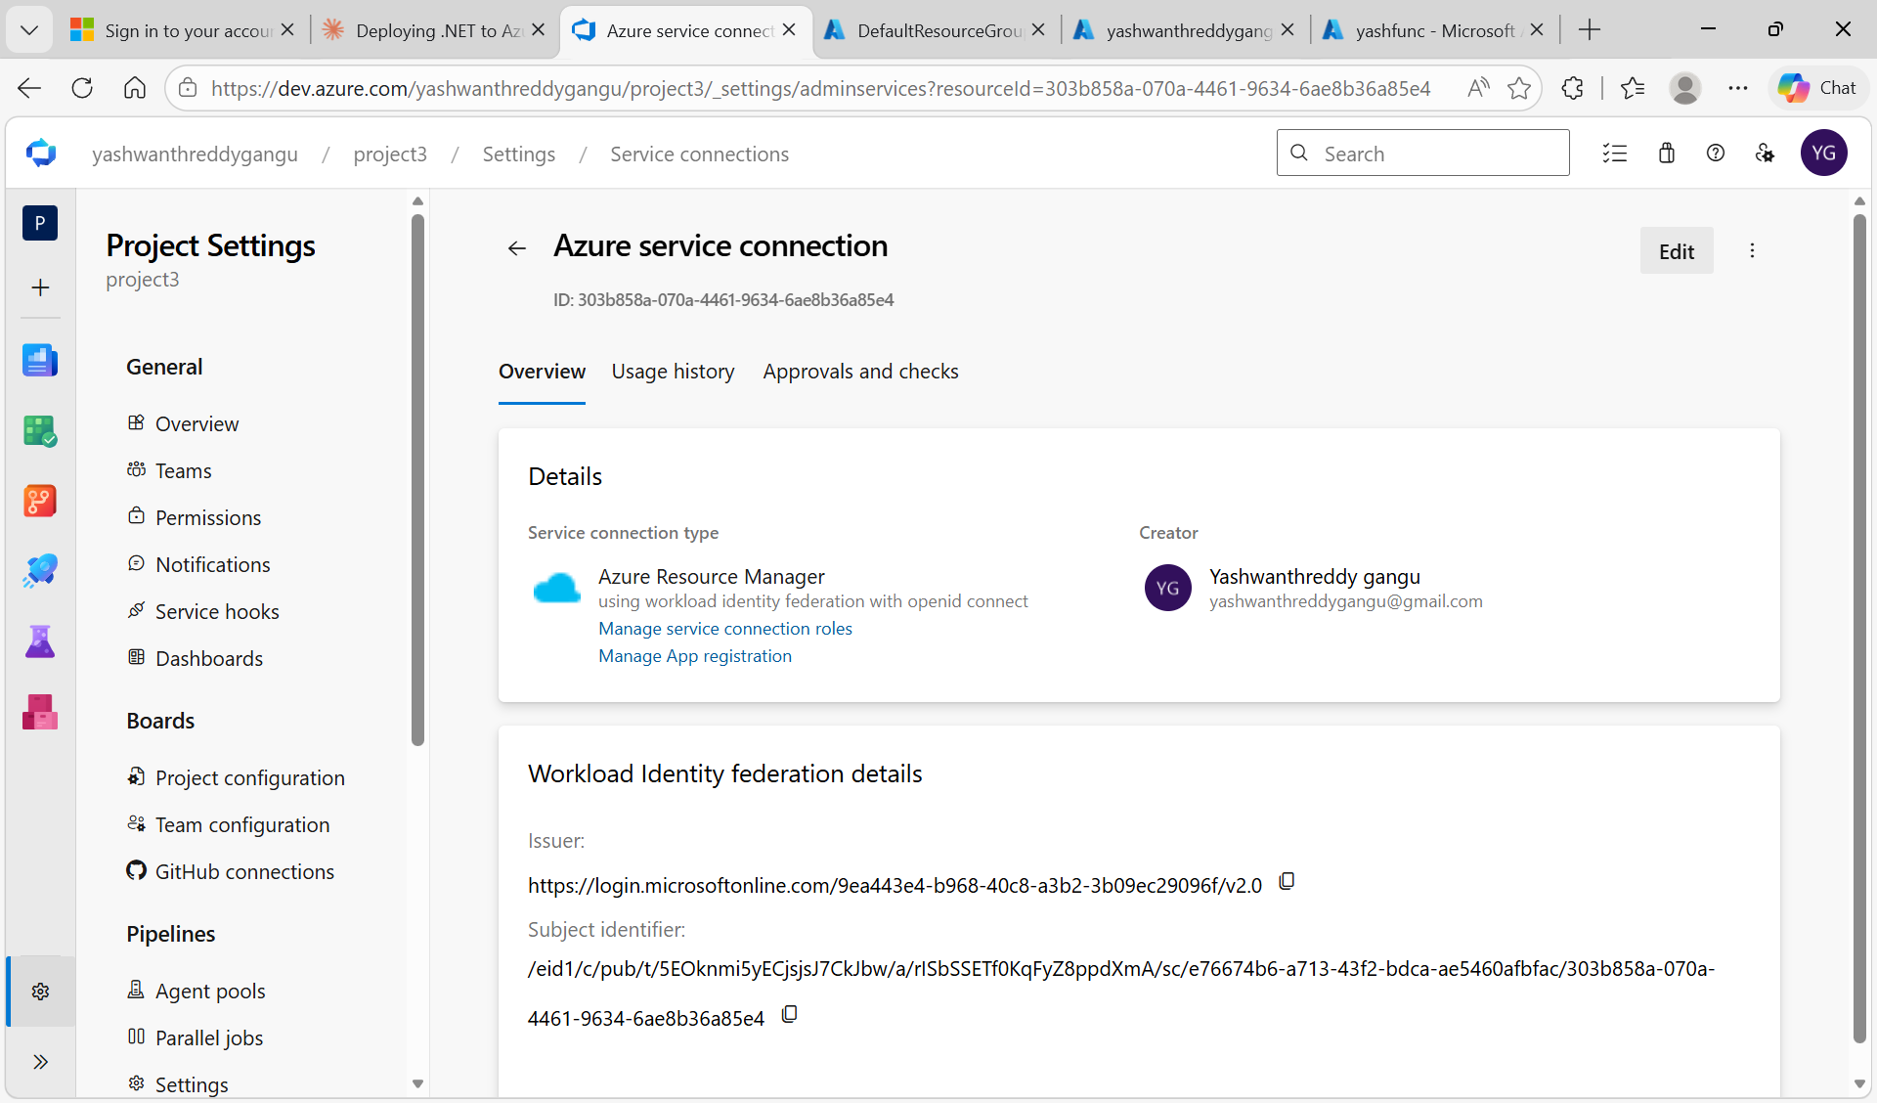
Screenshot 15: Service connection overview showing successful creation with workload identity federation

STEP 16: Create New Release Pipeline with Empty Job Template
Navigate to Pipelines > Releases > New pipeline. From the templates panel, click 'Empty job' at the top to start fresh without any pre-filled tasks. This gives full control over what tasks are added in the pipeline.
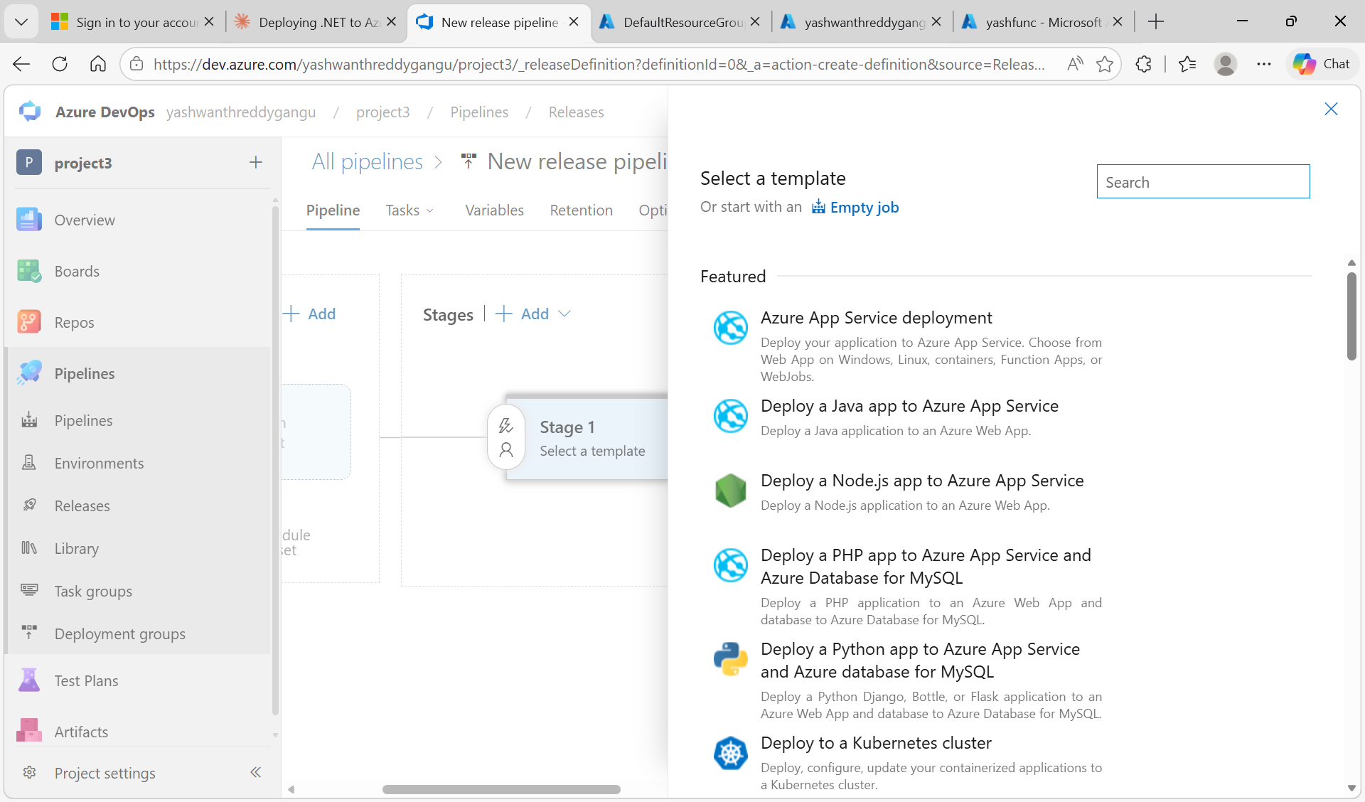
Screenshot 16: Release pipeline template selection screen with Empty job option highlighted

STEP 17: Configure Stage Properties for the Release Pipeline
After choosing Empty job, the Stage panel opens on the right. The default name is 'Stage 1' and Yashwanthreddy gangu is set as the Stage owner. You can rename the stage to 'Production' or any environment name. Close the panel after configuring.
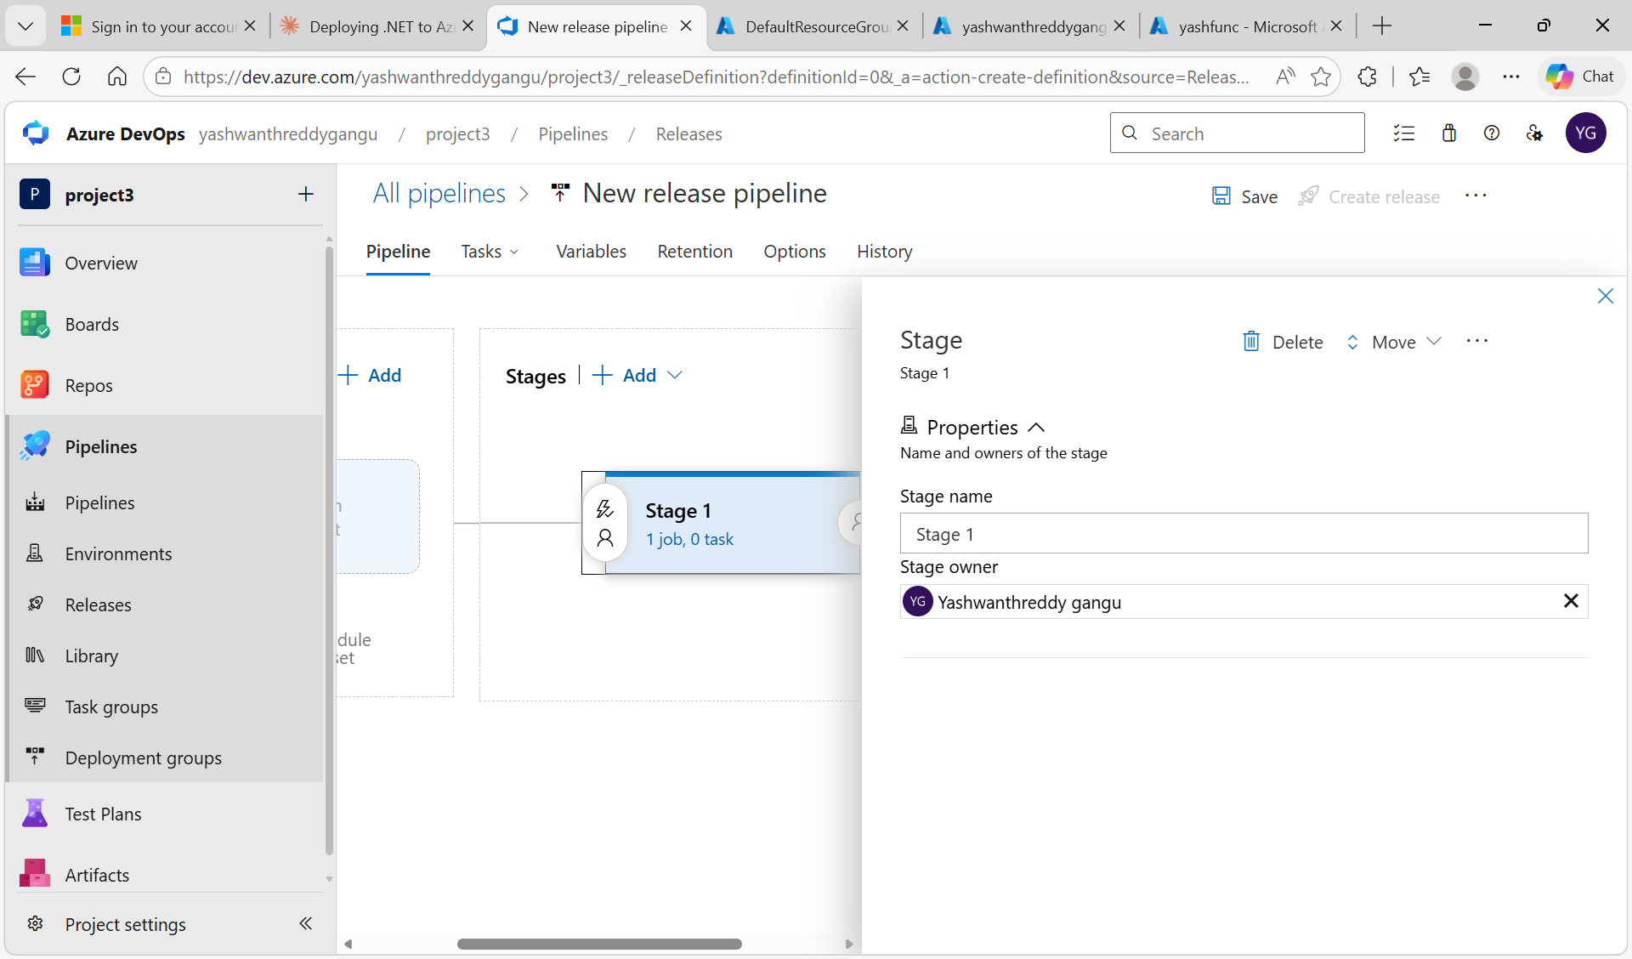
Screenshot 17: Release pipeline Stage 1 configuration panel showing stage name and owner

STEP 18: Search and Add the Azure Functions Deploy Task
Inside the Stage > Agent job, click the + icon to add a task. In the search box, type 'azure fun' to filter. From the results, select 'Azure Functions Deploy' which is the task that will deploy the .NET zip artifact to the Function App.
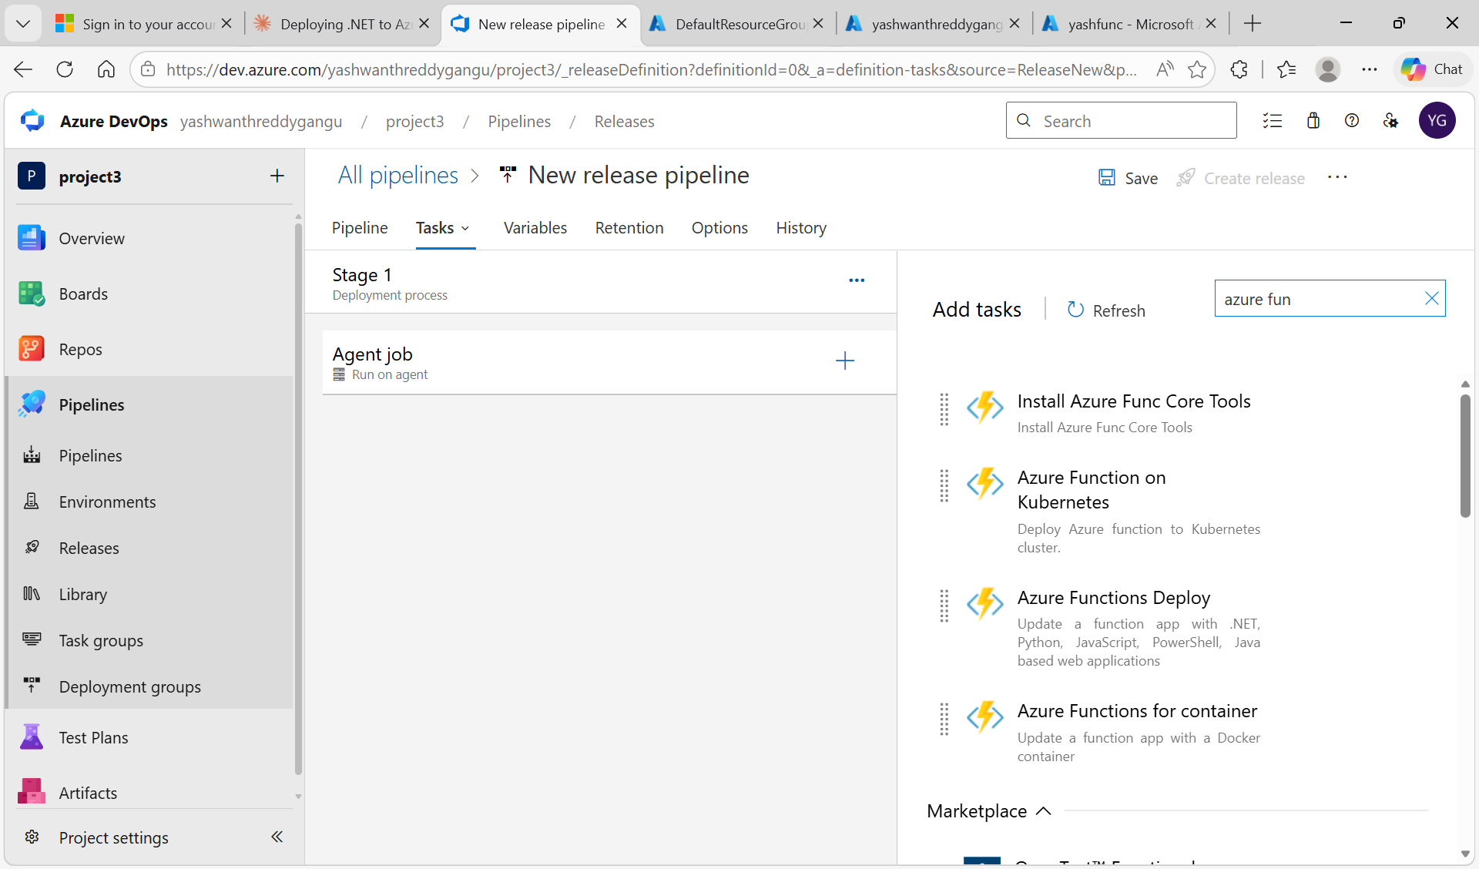
Screenshot 18: Add tasks panel showing Azure Functions Deploy task option to be added

STEP 19: Configure the Azure Functions Deploy Task Inputs
Set: Display name = Azure Function App Deploy: yashfunc, Azure Resource Manager connection = servicedotnet (scoped to userg1), App type = Function App on Linux (or Windows depending on Function App OS), and Azure Functions App name = yashfunc. The Is Function App on Flex Consumption Plan checkbox should be unchecked for Consumption plan.
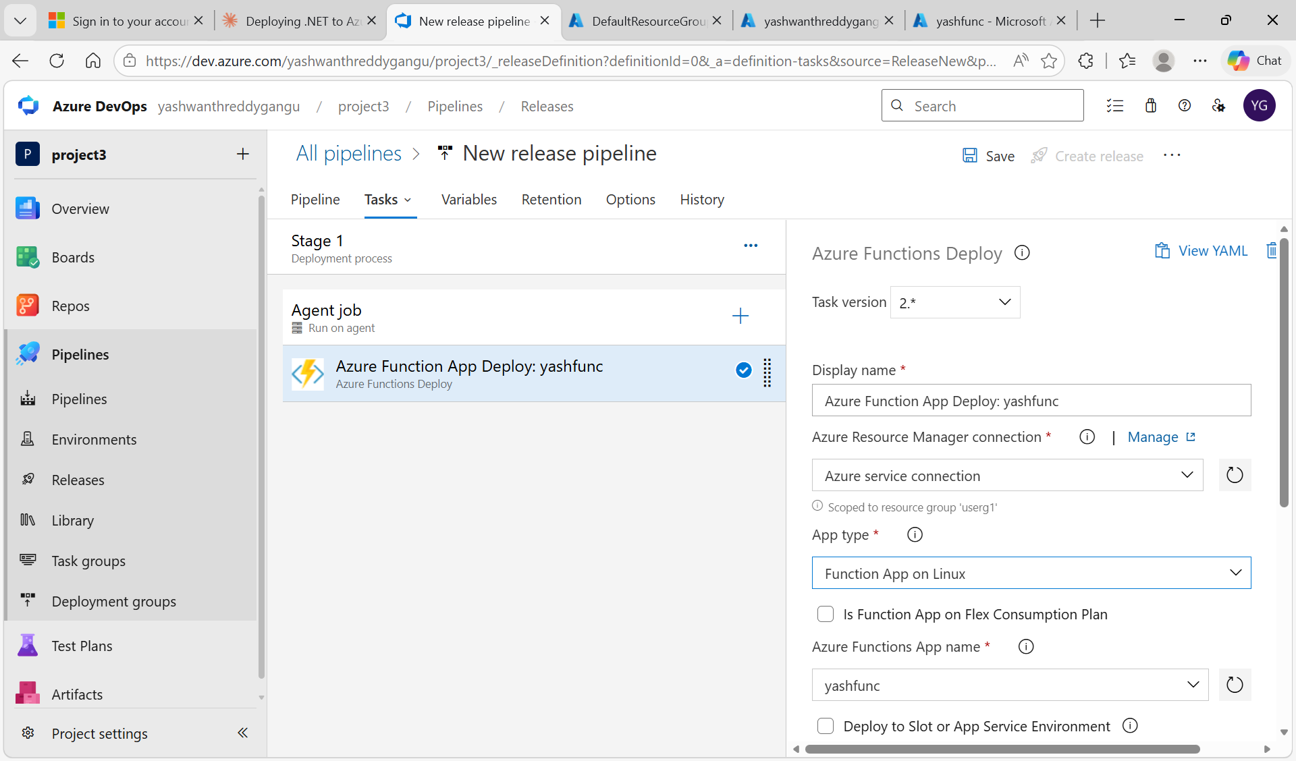
Screenshot 19: Azure Functions Deploy task fully configured with service connection and yashfunc app name

STEP 20: Create a New Release from the Pipeline
After saving the pipeline, click 'Create release' in the top right. The Create a new release panel opens. Verify the artifact source alias _project3 with version 20260504.2 (the latest build artifact). Add an optional release description and click Create to trigger the deployment.
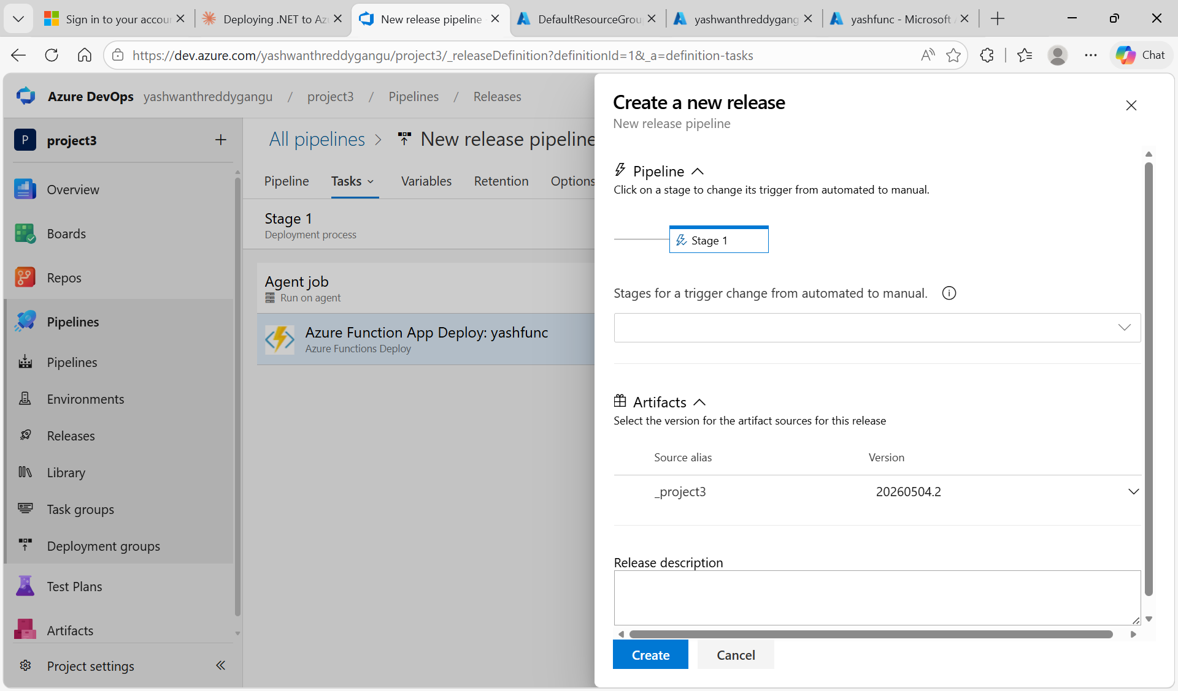
Screenshot 20: Create a new release panel showing artifact selection and trigger options

STEP 21: Release Pipeline Deployment Succeeded
After clicking Deploy, the release runs the Agent job with all tasks. The status changes to Succeeded with a green checkmark. The release pipeline page shows Release-1 > Stage 1 > Succeeded, confirming the .zip artifact was successfully uploaded and deployed to the Azure Function App yashfunc.
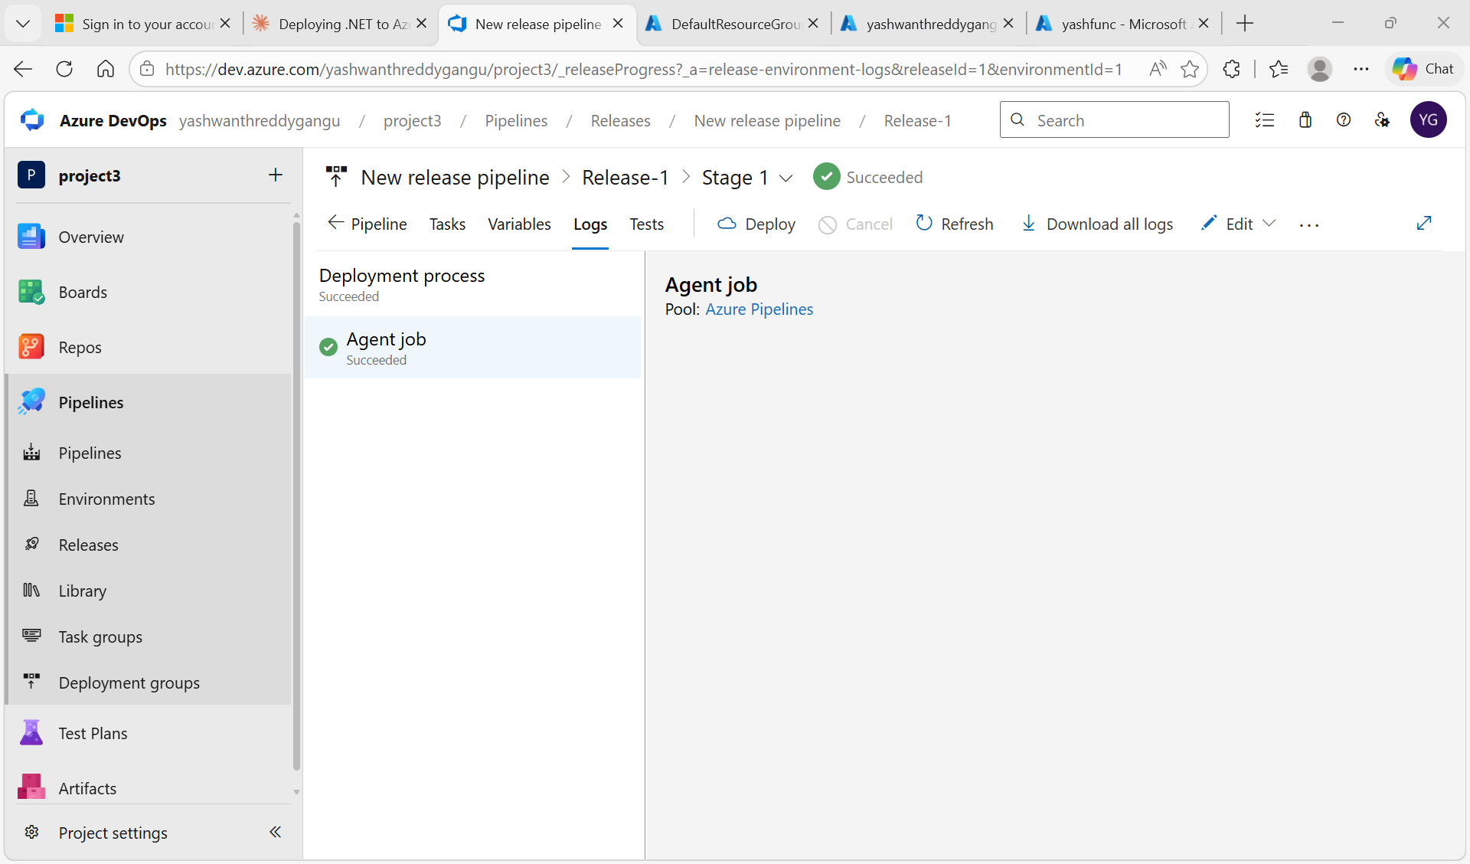
Screenshot 21: Release-1 deployment showing Succeeded status with Agent job logs

STEP 22: Function App Default Page Confirms Service is Running
Open the Function App URL (https://yashfunc-f5d4akcub2fcfjeu.centralindia-01.azurewebsites.net/) in a browser. The default 'Your Functions 4.0 app is up and running' welcome page appears, confirming the Function App is alive and the runtime is healthy.
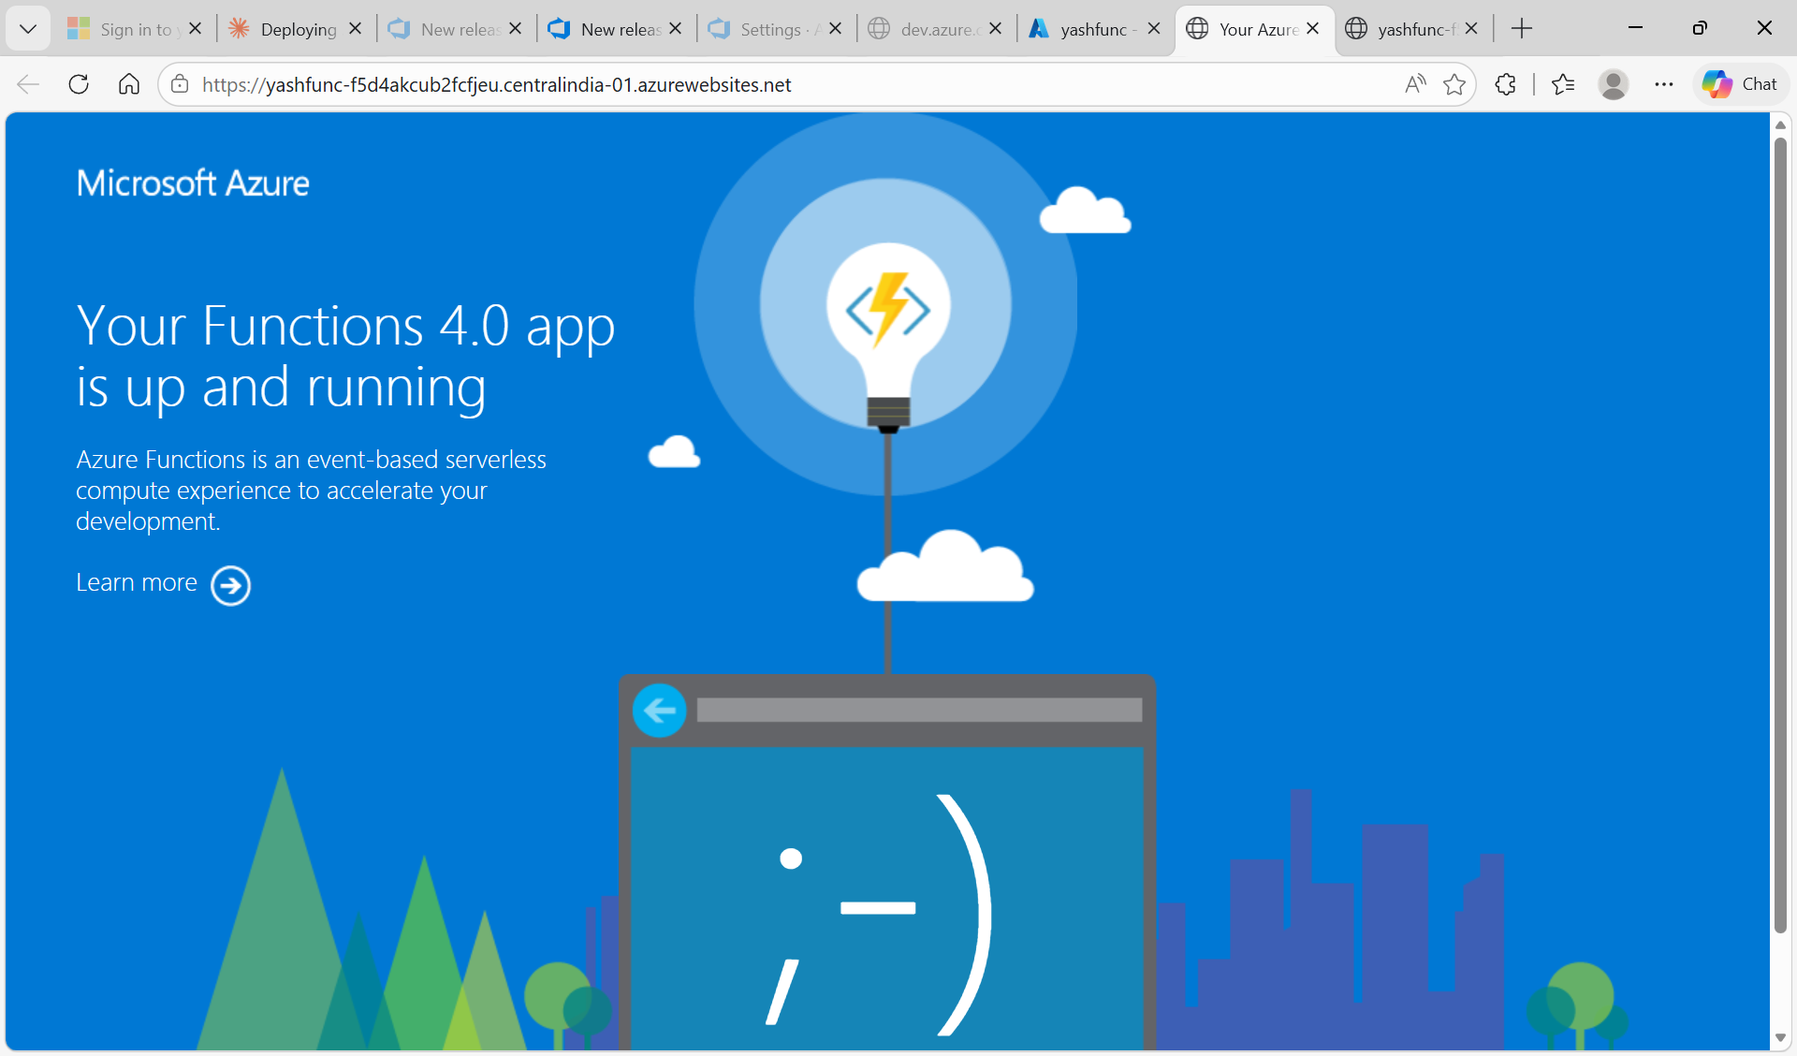
Screenshot 22: Function App default welcome page confirming the runtime is operational

STEP 23: Live HTTP Endpoint Returns JSON Response
Append /api/hello?name=Yash to the Function App URL and press Enter. The deployed Hello function executes and returns the JSON response with message 'Hello, Yash!', deployedVia 'Azure DevOps CI/CD', and a timestamp. This confirms the entire CI/CD pipeline works end-to-end.
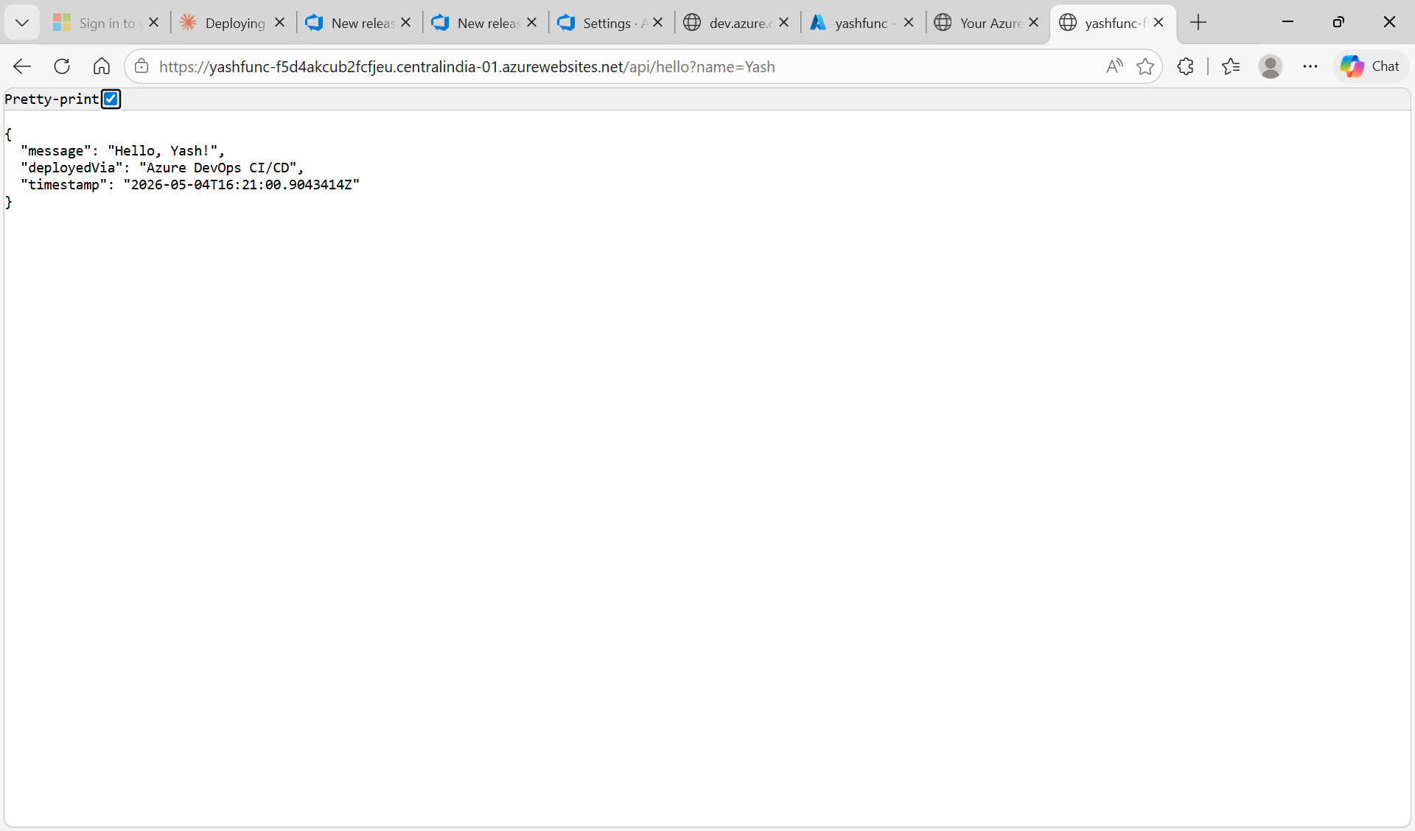
Screenshot 23: Browser showing JSON response from /api/hello?name=Yash endpoint - deployment is successful

3. Challenges Faced and Resolutions
The implementation encountered several challenges that are worth documenting for future reference and troubleshooting.

Challenge 1: Function App Must Be on Consumption Plan (Not Flex Consumption)
Problem: The Function App was initially created on the Flex Consumption plan. The standard AzureFunctionApp@2 deployment task did not work properly. Deployments completed with success status but no functions appeared in the Azure Portal.
Resolution: The Function App was deleted and recreated on the standard Consumption (Y1) plan. The Consumption plan is fully compatible with Azure DevOps deployment tasks.
Key Learning: Always use Consumption plan (Y1) for Azure DevOps CI/CD scenarios. The Flex Consumption plan requires special pipeline checkboxes that introduce complexity.

Challenge 2: Operating System Mismatch Between Pipeline and Function App
Problem: The Function App was running on Linux, but the CI pipeline used windows-latest agent. The deployment task App type was Function App on Linux. Even though deployments showed Succeeded, no functions registered.
Resolution: Aligned the OS across all components - Function App OS, build agent OS, and deployment task App type all set to Windows.
Key Learning: The build agent OS, deployment task App type, and Function App OS must all match. Mixing them causes silent deployment failures.

Challenge 3: Web API Code vs Function App Code
Problem: Initially, a standard ASP.NET Web API (SimpleWebApi) using app.MapGet endpoints was being deployed to the Function App. Function Apps need methods decorated with [Function] attribute - so the deployment found zero functions.
Resolution: Code rewritten as proper Function App project (YashFunc) using .NET 8 isolated worker model with [Function] attributes and HttpTrigger bindings.
Key Learning: Web API and Function App are different application types. Function Apps need [Function] attributes on each method.

Challenge 4: Service Connection Scoped to Wrong Resource Group
Problem: The initial Service Connection was scoped to DefaultResourceGroup-CID, but yashfunc lived in userg1. The Azure Functions App name dropdown showed 'No results found'.
Resolution: Created a new Service Connection at Subscription level (instead of Resource Group level) for full access across all resource groups.
Key Learning: Use Subscription-scoped Service Connections to avoid scope mismatch issues.

4. Key Takeaways

Why Consumption Plan is Mandatory
- AzureFunctionApp@2 deployment task is fully compatible with Consumption plan without special configuration
- Pay-per-execution pricing is ideal for development and demos
- Auto-scaling handled by Azure based on incoming requests
- Extensively documented in Microsoft tutorials
- Flex Consumption plan requires extra pipeline checkboxes that add complexity

Best Practices Applied
- Pipeline as Code: CI pipeline in YAML, version-controlled in the repo
- Stage Separation: Build (CI) and Deploy (CD) kept separate
- CD Trigger Enabled: Lightning bolt trigger automates deployment after build
- Subscription-Scoped Service Connection: Avoids RG mismatch
- Stable Package Versions: Reduces compatibility risk

Successful Outcomes
- End-to-end CI/CD pipeline configured and validated
- Build pipeline produces deployable artifacts
- Release pipeline auto-deploys to Function App
- Live HTTP endpoint returns expected JSON response
- Subsequent commits trigger automatic redeployment

END OF DOCUMENTATION

