NOTIFYHUB
SMART CAMPUS ANNOUNCEMENT PLATFORM

A PROJECT REPORT
Submitted in partial fulfilment of the requirements for the award of the degree of
BACHELOR OF TECHNOLOGY
in
COMPUTER SCIENCE AND ENGINEERING
Submitted by
[STUDENT NAME – REGISTRATION NUMBER]
[STUDENT NAME – REGISTRATION NUMBER]
[STUDENT NAME – REGISTRATION NUMBER]

Under the guidance of
V S S P L N Balaji Lanka
Assistant Professor

VIGNAN INSTITUTE OF TECHNOLOGY AND SCIENCE
2026

CONTENTS
S. No. | Content | Page No.
1 | Abstract | 1
2 | Introduction | 4
3 | Architecture | 6
4 | Implementation | 7
5 | Output Screens | 9
6 | Conclusion | 13

ABSTRACT

NotifyHub is a smart campus announcement platform designed to bring college-related notifications, events and urgent alerts together in one centralized web application. The platform is intended to reduce dependence on scattered communication channels such as informal messaging groups and physical notice boards, helping students and other campus users find relevant information from a common location.
The publicly accessible application presents dedicated sections for Home, Announcements, Events, Urgent Alerts and Contact. The announcements area provides a search field and category filters for Exams, Placements, Events, General, Finance and Holiday notices. The events area provides category filters such as Placements, Sports, Workshop, Ceremony, Fest and Social. A separate urgent-alert page highlights high-priority information, while the Contact Hub provides a form for users to submit queries.
The platform also highlights features such as instant announcements, event tracking, smart search and filtering, responsive access across devices and real-time updates. This report explains the purpose, high-level architecture, visible functional modules, implementation flow and user-interface outputs of NotifyHub.

2. INTRODUCTION

2.1 Overview
Educational institutions communicate many types of information every day, including examination schedules, placement drives, fee deadlines, workshops, sports activities, ceremonies, holidays and general circulars. When these updates are distributed through different channels, users may find it difficult to identify the latest or most relevant information. NotifyHub addresses this communication challenge by providing a single campus announcement interface.

2.2 Problem Statement
Campus information can become fragmented when notices are shared through multiple messaging groups, printed notice boards or separate departmental channels. Important updates may be overlooked, older notices may be difficult to locate, and urgent information may not receive sufficient visibility. A centralized and searchable announcement platform can make campus communication more organized and accessible.

2.3 Objectives
- Provide a common online location for college announcements and updates.
- Organize notices into recognizable categories for easier browsing.
- Provide search and category-filter controls to help users locate notices.
- Display campus events and group them by event type.
- Give high-priority information a dedicated Urgent Alerts section.
- Provide a contact form through which users can submit queries.
- Support access from desktop, tablet and mobile devices.

2.4 Scope of the Project
The scope of NotifyHub covers the presentation and organization of campus announcements, events and urgent alerts through a web-based interface. It includes navigation between the main sections, notice search and category filters, event-category filters, an urgent alert view, and a contact form with name, email, department and message fields. The platform can serve as a common information point for students and the wider college community.
The public website describes live updates and administrative posting of notices. The currently observable public pages do not expose the internal administration interface, database design, authentication mechanism or server-side implementation. Those technical details should be added from the actual project source code or deployment configuration rather than assumed.

3. ARCHITECTURE
At a functional level, NotifyHub can be represented as a web-based, multi-layer application. Users interact with the presentation layer through a browser. The application organizes the requested content into announcement, event, urgent-alert and contact modules. The data/service layer is responsible for supplying notice and event information and handling submitted contact information. The public website confirms the user-facing modules, but does not reveal the specific frameworks, database, API design or hosting internals.

3.1 High-Level Architecture
USER (Student / Faculty / Campus Visitor)
WEB BROWSER – Home, Announcements, Events, Urgent Alerts, Contact
APPLICATION LOGIC – Navigation, Search, Category Filters, Event Display, Contact Form
DATA / SERVICE LAYER – Announcement Data, Event Data, Alert Data, Contact Submissions
The above is a conceptual architecture based on the visible website functions. It is not a verified deployment diagram of the underlying source code.

3.2 Main Modules
Home Module: Introduces NotifyHub and summarizes its purpose and major features. The landing page displays counters for total notices, upcoming events, urgent alerts and departments.
Announcements Module: Displays the college-notice area with a search input and category filters: All, Exams, Placements, Events, General, Finance and Holiday.
Events Module: Provides a dedicated area for college events, drives and ceremonies, with filters for All, Placements, Sports, Workshop, Ceremony, Fest and Social.
Urgent Alerts Module: Provides a separate high-priority notice page intended for information requiring immediate attention.
Contact Module: Provides a contact form containing Full Name, Email Address, Department and Message fields, along with FAQs.

4. IMPLEMENTATION
The implementation described in this section is based on the functions and controls visible on the deployed NotifyHub website. Exact programming languages, frameworks, database technology and API endpoints are not identifiable from the public page content reviewed.

4.1 Home Page
The Home page acts as the entry point to the platform. It introduces the purpose of NotifyHub with the message “Never Miss a Campus Update Again” and provides navigation links to announcements and events. It also presents an overview section containing campus-information counters and a feature section describing announcements, urgent alerts, event tracking, search and filtering, cross-device access and live updates.

4.2 Announcements
The Announcements page brings college notices into one section. Users are provided with a search field and category controls. The available categories shown in the interface are Exams, Placements, Events, General, Finance and Holiday, in addition to the All option. These controls are intended to make browsing and locating a notice easier.

4.3 Events
The Events page groups campus events, drives and ceremonies in a dedicated view. The interface offers filters for Placements, Sports, Workshop, Ceremony, Fest and Social, along with an All option. The Home page also describes event countdowns as part of the event-tracking feature.

4.4 Urgent Alerts
The Urgent Alerts page is designed to bring high-priority notices to the user's attention. It is presented as a live-monitoring area for notices that require immediate attention, such as important deadlines or other time-sensitive campus information.

4.5 Contact Hub
The Contact Hub allows a visitor to submit a query by entering a full name, email address, department and message. The message field displays a 500-character counter. The page also contains frequently asked questions relating to urgent alerts, announcement posting and notice-board updates.

4.6 Navigation and Responsive Access
The common navigation menu links the Home, Announcements, Events, Urgent and Contact sections. The Home page states that the platform is intended to work on mobile, tablet and desktop devices.

5. OUTPUT SCREENS
The following screenshots should be captured from the deployed website and inserted in the indicated spaces before final submission. Use actual browser screenshots so that the report reflects the running application.

5.1 Home Page
Insert screenshot of https://notifyhub-campus.vercel.app/ showing the landing page, navigation, overview counters and feature section.

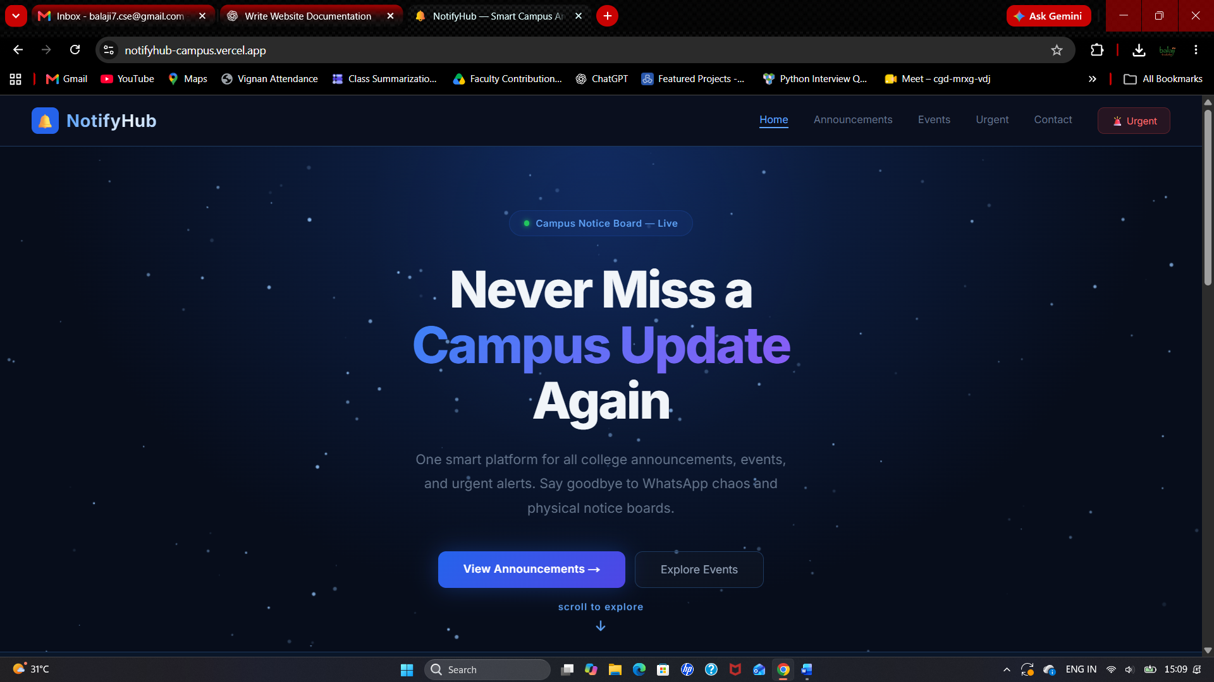5.2 Announcements Page
Insert screenshot of https://notifyhub-campus.vercel.app/announcements showing the search field and notice-category filters.

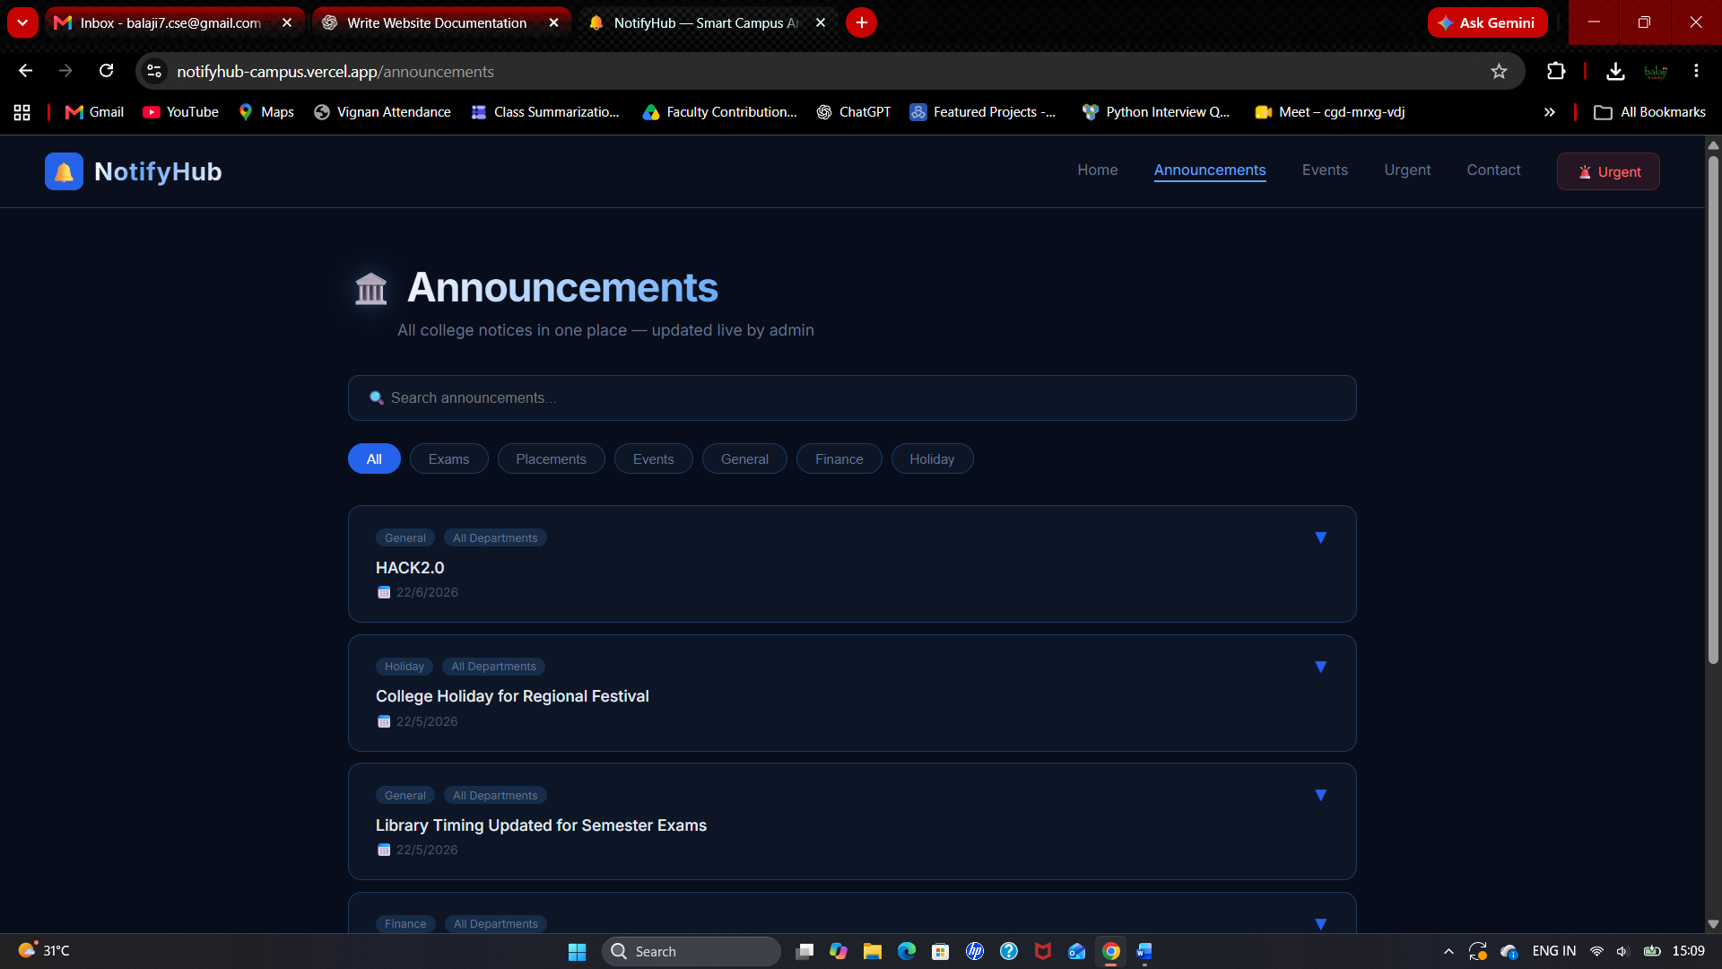5.3 Events Page
Insert screenshot of https://notifyhub-campus.vercel.app/events showing the event heading and event-category filters.

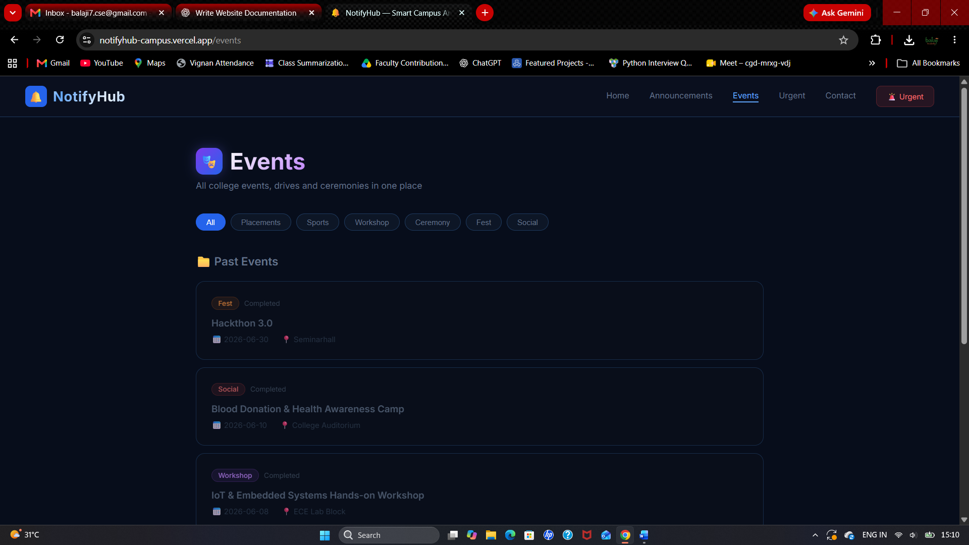5.4 Urgent Alerts Page
Insert screenshot of https://notifyhub-campus.vercel.app/urgent showing the Urgent Alerts heading and live-monitoring label.

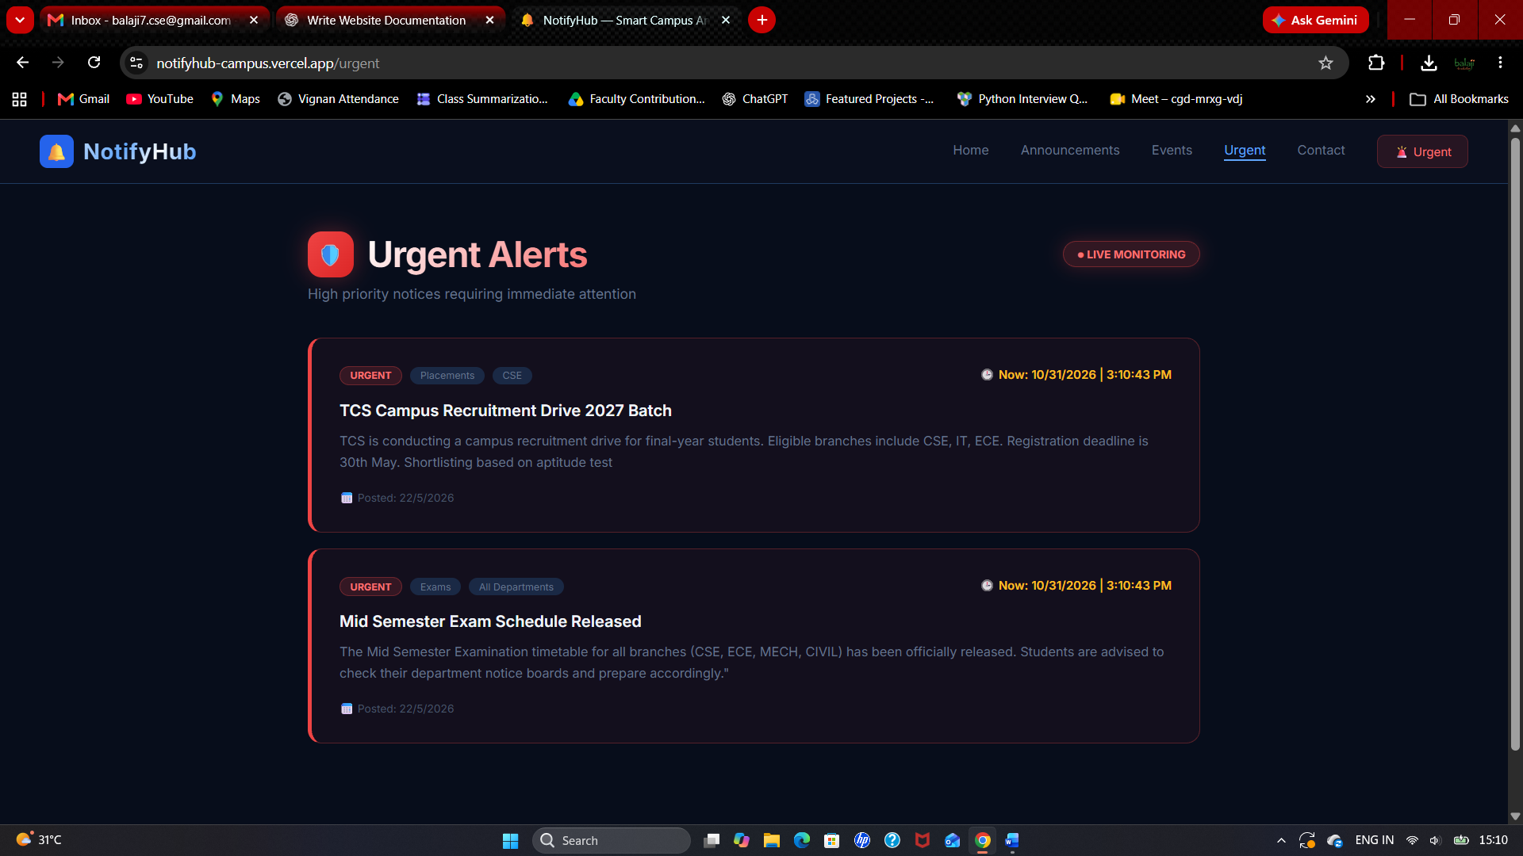5.5 Contact Hub Page
Insert screenshot of https://notifyhub-campus.vercel.app/contact showing the contact form and FAQ section.

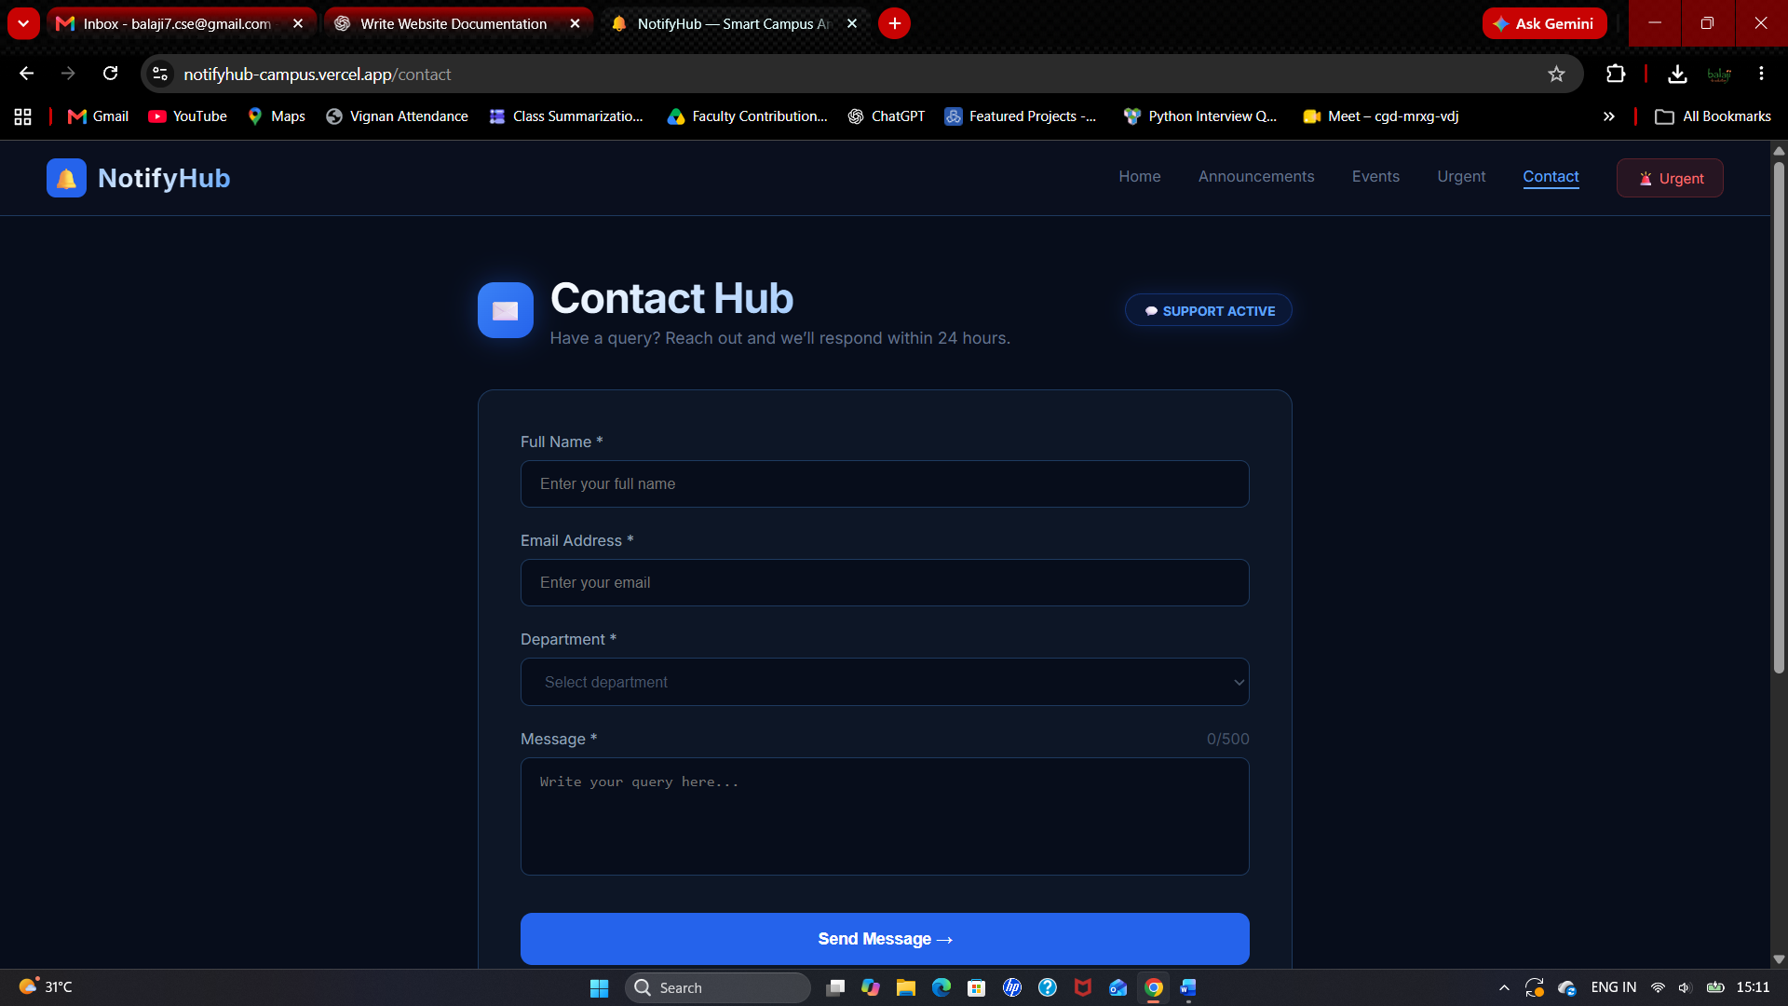Verification note: During review of the publicly accessible pages, the Announcements, Events and Urgent pages displayed loading indicators rather than populated records, and the Home page counters displayed zero values. Therefore, this report documents the visible interface and advertised functionality; it does not claim that live records or every backend operation were verified during the review.

6. CONCLUSION
NotifyHub provides a centralized web interface for campus announcements, events, urgent alerts and user queries. By organizing notices into categories and providing search and filter controls, the platform is intended to make important college information easier to access. Its dedicated urgent-alert area gives priority to time-sensitive communication, while the events section provides a common place to explore campus activities.
The project demonstrates how a web-based platform can support more structured campus communication and reduce dependence on scattered information channels. Further validation of the live data flow, administrative posting process, user access controls, contact-form submission and backend services should be carried out using the project source code and test environment before final technical claims are included in the report.

Website Reference
NotifyHub – Smart Campus Announcement Platform: https://notifyhub-campus.vercel.app/

