**Decision & Support Systems**

Homework-0

Given Tasks:

1. Create a Tableau account:

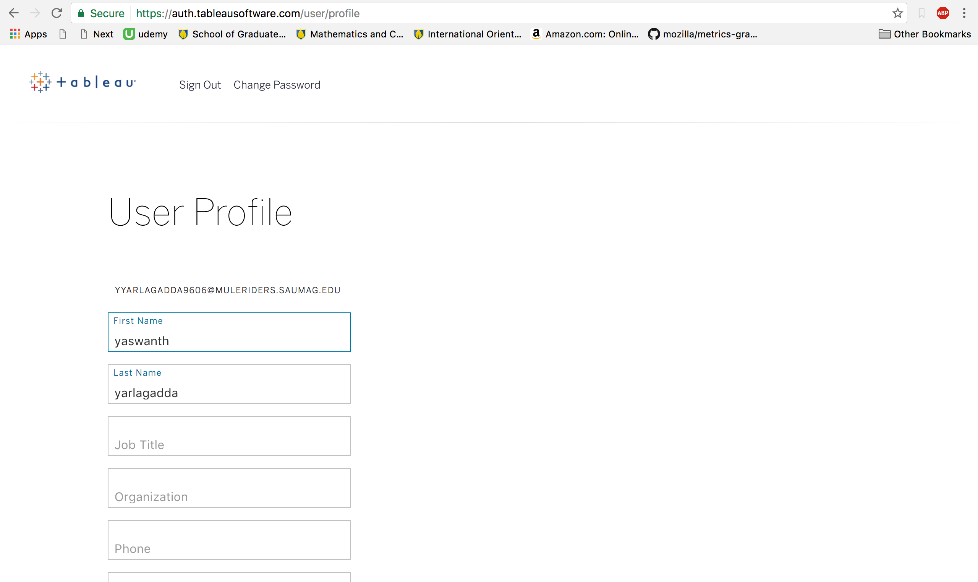

2. Create a GitHub account:

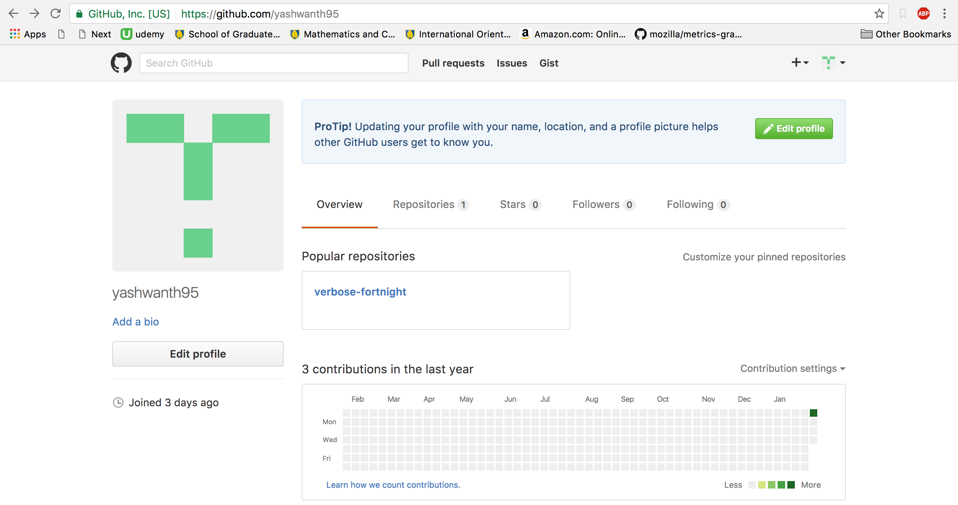

3. Summary for Which Food is the Coolest?

* Here we have an analysis on what people think is their coolest food ,This analysis is completed by using the hashtags which are posted by the individual user to a social networking mobile application named *“INSTAGRAM*”. This analysis also shows the number of hashtags used and number of posts made using the hashtags and the total number of hashtags
* This is a screenshot of the analysis made:

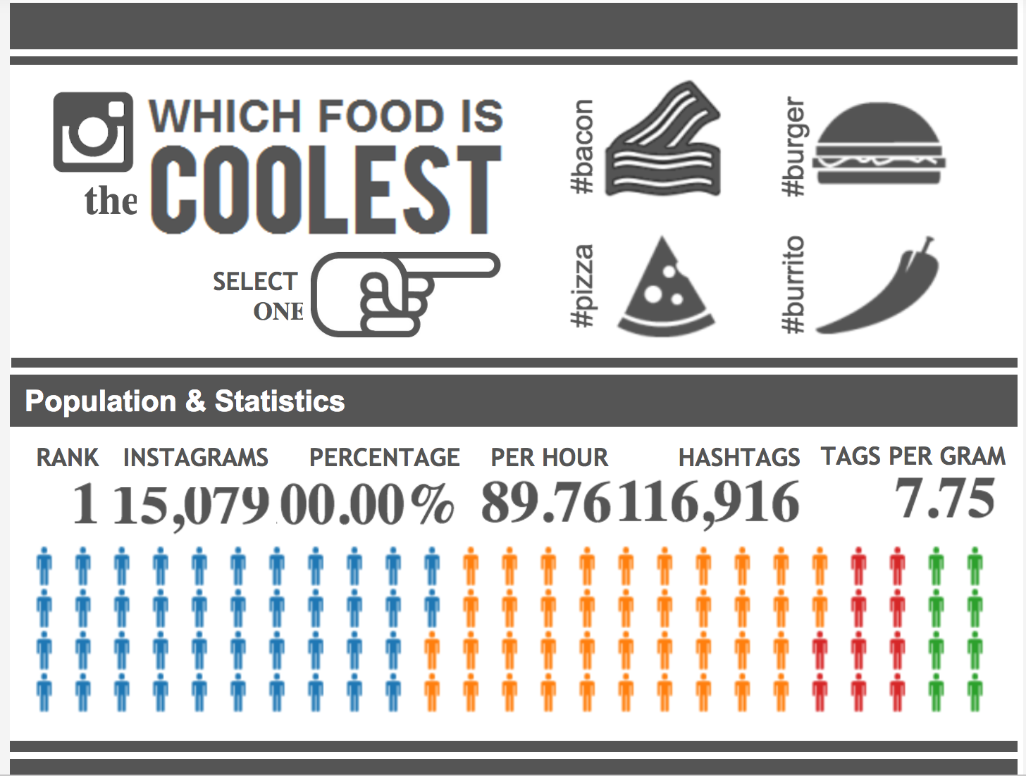

* Reference Link :<https://public.tableau.com/en-us/s/gallery/which-food-coolest>

4. Summary for a GitHub repository

* This repository is a library optimized for concise and principled data graphics and layouts for visualizing and laying out time-series data, This repository provides a simple way to produce common types of graphics in a principled and consistent way. It currently supports line charts, scatterplots, histograms, bar charts and data tables, as well as features like rug plots and basic linear regression.
* Screenshot of repository:

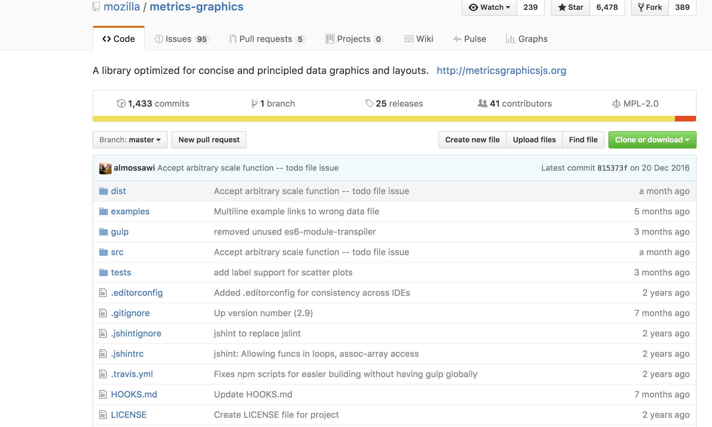

* Reference Link:<https://github.com/mozilla/metrics-graphics>