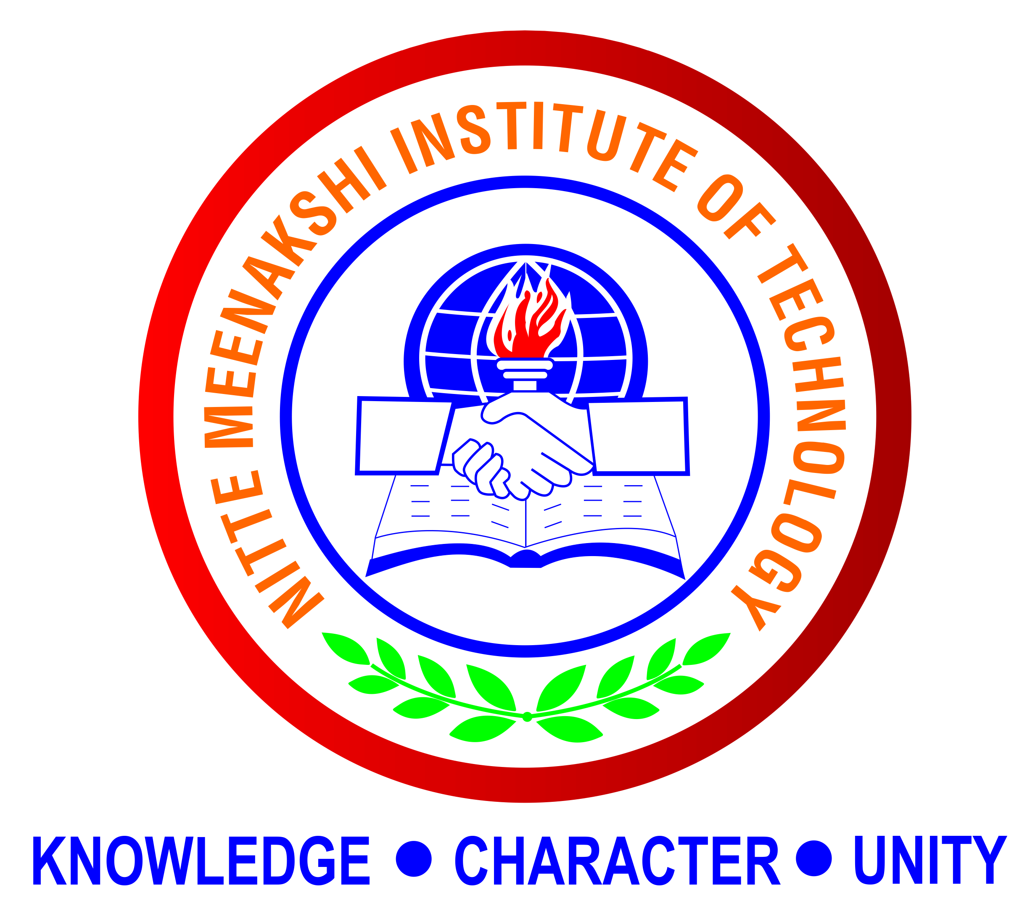

Nitte Meenakshi Institute of Technology
Bangalore-560064

Affiliated to Visvesvaraya Technological University, Belagavi

Project Report
on
“ADVANCES AND OUTLOOKS OF HEAT TRANSFER ENHANCEMENT BY LONGITUDANAL VORTEX GENERATOR”

Submitted in partial fulfillment for the award of
B.E
MECHANICAL ENGINEERING

Submitted by
SHASHI KIRAN 1NT15ME157
SAGAR R 1NT15ME142
PUSHOTHAMA G 1NT15ME118
YASHWANTH ARADHYA 1NT15ME201

Under the guidance of
MR RACHITH
ASST PROFESSOR
MECHANICAL DEPARTMENT
NMIT



Department of mechanical engineering

Nitte Meenakshi Institute of Technology
An Autonomous Institution under VTU, A Grade by NAAC, UGC
Approved by AICTE, Belgaum
Govind Pura, Guildhall, P B No. 6429, Yelahanka, Bangalore - 560064
Karnataka, India, Ph:080, 22167800, Fax:22167805, Website:www.nmit.ac.in

NOVEMBER2018

Nitte Meenakshi Institute of Technology
Bangalore-560064
Affiliated to Visvesvaraya Technological University, Belgaum.

Department of Mechanical Engineering
(UG Mechanical Engineering Program is Provisionally Accredited by NBA for 3 years from 2017-18)

CERTIFICATE

Certified that the project entitled “ADVANCES AND OUTLOOKS OF HEAT TRANSFER ENHANCEMENT BY LONGITUDANAL VORTEX GENERATOR” carried out by YASHWANTH ARADHYA H R (1NT15ME201) SHASHI KIRAN (1NT15M157) PURUSHOTHAMA(1NT15ME118) SAGAR R (1NT15ME142) a bonafide student of Nitte Meenakshi Institute of Technology, Bengaluru in partial fulfillment for the award of B.E Degree in Mechanical Engineering of the Visvesvaraya Technological University, Belgaum during the year 2018-19. It is certified that all corrections/suggestions indicated have been incorporated in the report deposited in the department library. The project work report has been approved as it satisfies the academic requirements in respect of project work prescribed for the said degree.

Mr. RACHITH S
Guide
Dr.Sudheer Reddy  Prof. & Head | Dr H. C Nagaraj  Principal

NOVEMBER2018

CONTENTS PAGE NO

1 INTRODUCTION 1

2 CHARACTERSTICS OF HEAT TRANSFER 2 ENHANCEMENT BY LVG

3 APPLICATIONS OF LVGS ON HEAT 3 TRANSFER ENHANCEMENT

3.1 HEAT TRANSFER ENHANCEMENT IN FLAT
PLATE CHANNELS BY LVGS 4

3.2 HEAT TRANSFER ENHANCEMENT BY
LVGS INFIN AND TUBE HEAT EXCHANGER 6

3.2.1 FIN AND TUBE HEAT EXCHANGER WITH
TWO ROWS OF STAGGERED TUBE TANKS 6

3.2.2 APPLICATION OF LGVS IN WAVY FIN AND
TUBE HEAT EXCHANGERS 14

3.2.3 APPLICATION OF LVGS AND OVAL TUBES
AND TUBE HEAT EXCHANGERS 21

4 CONCLUSION AND OUTLOOKS 52

5 REFERENCES 53

NOVEMBER2018

ACKNOWLEDGMENT

I would express our gratitude to our principal Dr. H C Nagaraj for doing the seminar.

I would express our gratitude to our HOD Dr.Sudheer Reddy for his valuable support without which the seminar would not have been successful.

I would express our gratitude to our Asst. prof Mr. RACHITH

for doing the seminar.

I would like to mention a special thanks to staff of ME department, NMIT for their support.

NOVEMBER2018

ABSTRACT

In the last several decades, heat transfer enhancements using extended surface (fins) has received considerable attentions. A new heat transfer enhancement technique – longitudinal vortex generator (LVG) – received more and more attentions since the 1990s. It is a special type of extended surface that can generate vortices with axes parallel to the main flow direction. The vortices are generated as a result of strong swirling secondary flow caused by flow separation and friction. The state-of-the-art on the researches of LVG for its applications in heat transfer enhancement in straight channels, plate and wavy fin-and-tube heat exchangers, fin-and-oval-tube heat exchanger, and fin-and-tube heat exchangers with multiple rows of tubes. The trends and future directions on heat transfer enhancement LVG are discussed.

NOVEMBER2018

