Employee Management System
Java Code
Screenshot 1 – Employee Management Menu and Setup
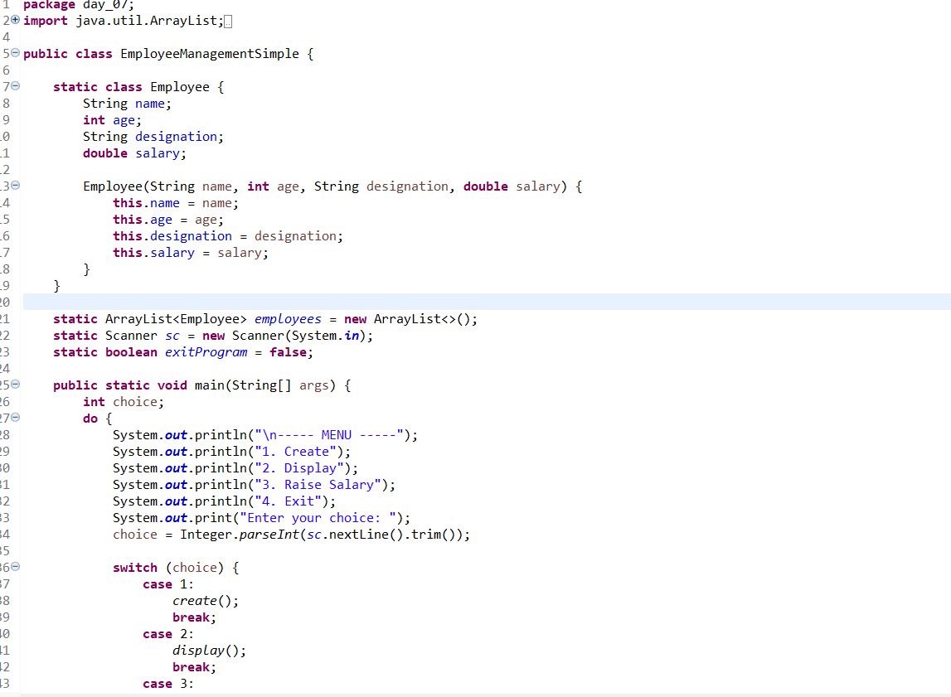
Explanation:
- ArrayList<Employee> employees creates a list to store multiple Employee objects.
- new ArrayList<>() creates an empty ArrayList where employees can be added dynamically.
- Scanner sc = new Scanner(System.in) is used to take input from the user through the keyboard.
- boolean exitProgram = false controls the exit condition and initially keeps the program running.

Screenshot 2 – Employee Creation and Input Validation
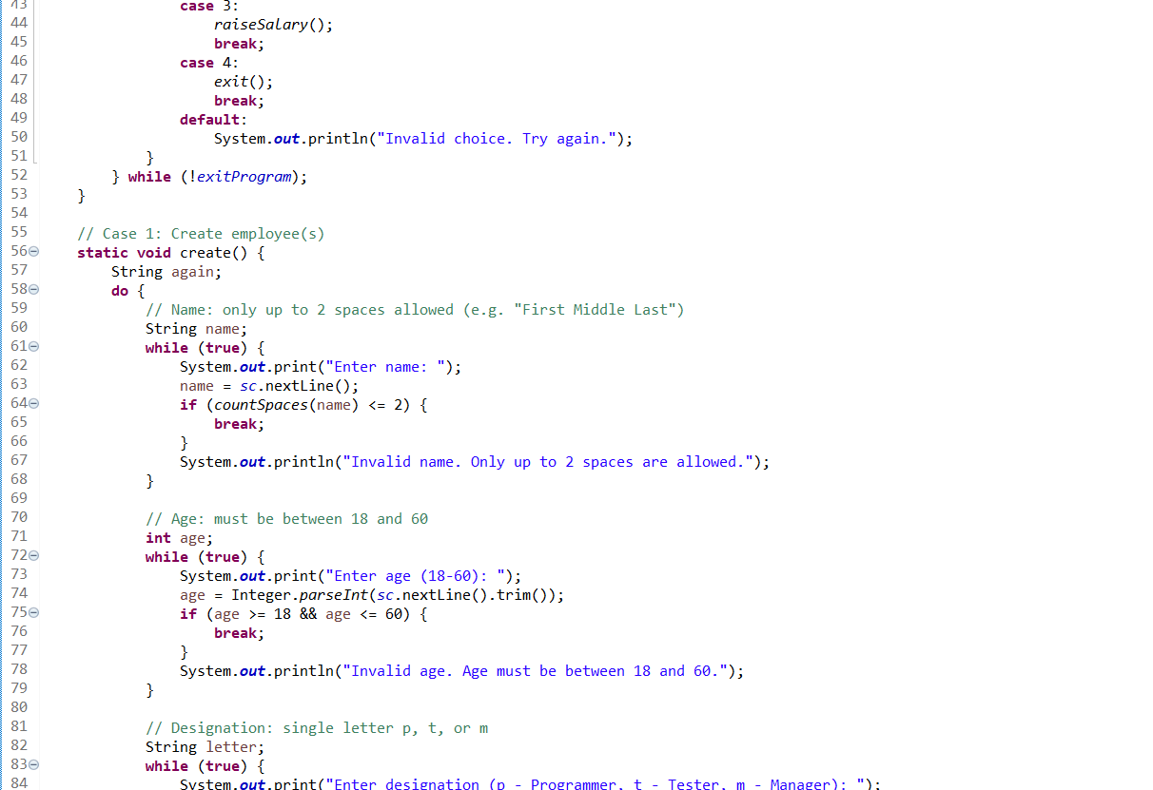
Explanation:
- Case 3 calls raiseSalary() to increase an employee's salary, while Case 4 calls exit() to terminate the program.
- The do-while loop keeps displaying the menu until exitProgram becomes true.
- The create() method takes employee details such as name and age and validates the entered values.
- It allows a name with a maximum of 2 spaces and accepts an age only between 18 and 60; invalid input is rejected and asked again.

Screenshot 3 – Designation, Salary Assignment and Space Counting
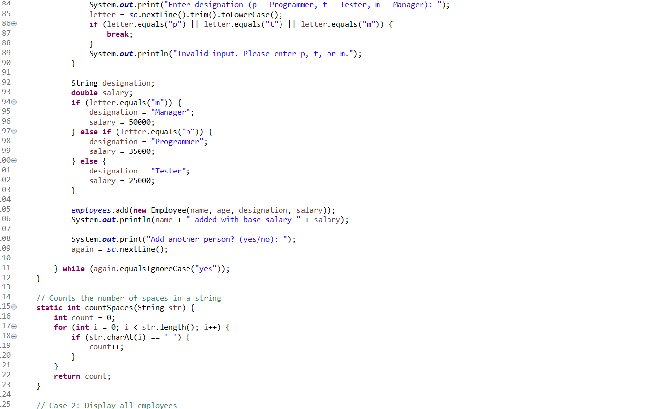
Explanation:
- The program checks the designation input (p, t, or m) and assigns the corresponding job title and base salary.
- A Manager gets ₹50,000, a Programmer gets ₹35,000, and a Tester gets ₹25,000 as the base salary.
- The employee object is created and added to the employees ArrayList, then the program asks whether to add another employee.
- The countSpaces() method counts spaces in the employee's name using a loop, helping ensure that the name contains no more than 2 spaces.

Screenshot 4 – Display Employees and Select Employee for Raise
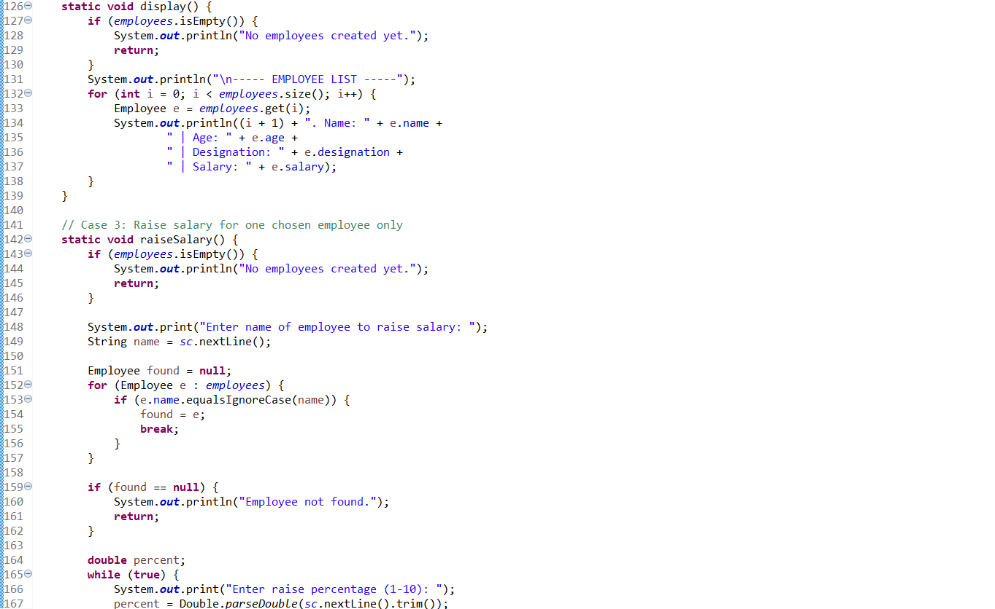
Explanation:
- The display() method checks whether the employee list is empty; if not, it displays all employee details such as name, age, designation, and salary.
- The for loop goes through each employee in the ArrayList and prints their information with a serial number.
- The raiseSalary() method asks the user for the name of the employee whose salary needs to be increased.
- It searches the list using equalsIgnoreCase() and, if the employee is found, allows the user to enter a raise percentage between 1 and 10.

Screenshot 5 – Salary Increase and Program Exit
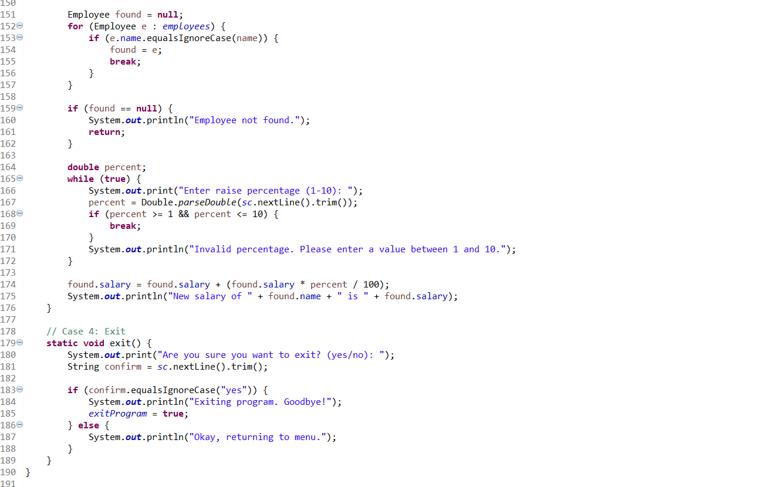
Explanation:
- The program searches for the employee by name using equalsIgnoreCase() and stores the matching employee in found; if not found, it displays an error message.
- It asks the user to enter a salary raise percentage between 1 and 10 and keeps asking until a valid value is entered.
- The employee's salary is increased using the formula salary + (salary * percent / 100).
- The exit() method asks for confirmation; if the user enters yes, exitProgram becomes true and the program terminates, otherwise it returns to the menu.

Screenshot 4 – Output
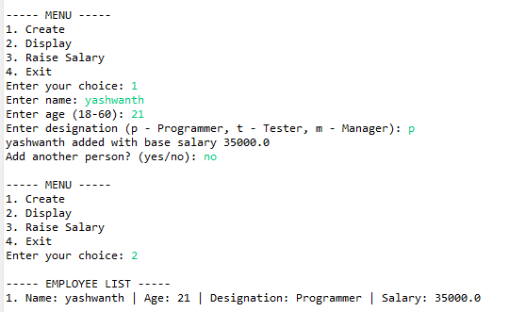
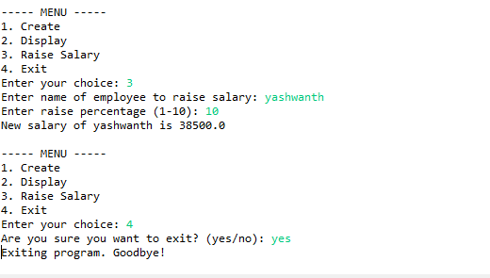
Explanation :
- In this output you may observe that we have first created with Name, Age, Designation, and Salary.
- In second we have displayed the employee list.
- And in the third we have raised the salary of the person, which we want. In that case, for example, Yashwanth, we have raised 10%.
- In the fourth option we have exited and we have confirmed that we want to exit.
- This is the output we got from this code.

