GOVERNMENT OF KARNATAKA DEPARTMENT OF TECHNICAL EDUCATION BOARD OF TECHNICAL EXAMINATIONS BANGALORE KARNATAKA

D.A.C.G GOVT. POLYTECHNIC
CHIKKAMAGALURU-577101
DEPARTMENT OF COMPUTER SCIENCE & ENGINEERING

SUBMITTED TO PARTIAL FULFILLMENT OF THE REQUIREMENT FOR AWARD OF DIPLOAMA IN
COMPUTER SCIENCE & ENGINEERING

PROJECT REPORT
on

“INSTITUTION LEVEL DIPLOMA ONLINE ADDMISSION SYSTEM”

SUBMITTED BY
Adeel B N 110CS22002
Nikhil KR 110CS22042
Rohan S 110CS22049
Yashwanth DV 110CS22062

UNDER THE GUIDANCE OF
Smt. Divya M

HEAD OF THE DEPARTMENT PRINCIPAL
Smt. Ashwini B N Dr. SHAM M.V

GOVERNMENT OF KARNATAKA DEPARTMENT OF TECHNICAL EDUCATION BOARD OF TECHNICAL EXAMINATIONS BANGALORE KARNATAKA

D.A.C. G GOVT.POLYTECHNIC
CHIKKAMAGALURU-577101

DEPARTMENT OF COMPUTER SCIENCE & ENGINEERING

CERTIFICATE
Certified that this project report entitled “INSTITUTION LEVEL DIPLOMA ONLINE ADMISSION SYSTEM” which is being submitted by Mr. Adeel B N. Reg:110CS220602, Mr. Nikhil KR, Reg:110CS22042, Mr. Rohan S, Reg:110CS22049, Mr. Yashwanth DV Reg No: 110CS22062, Students of D.A.C.G Govt. Polytechnic, in partial fulfillment of award of DIPLOMA IN COMPUTER SCIENCE ENGINNERING During the year 2024-25 is record of students own work carried out under my/our guidance. It is certified that all correction/suggestion indicated for internal assessment have been incorporated in the report.
The project report has been approved as it satisfies the academic requirements in respect of project work prescribed for the said Diploma.
It is further understood that by this certificate the undesigned do not endorse or approve any statement made, opinion expressed or conclusion drawn there in but approve the project only for the purpose which is submitted.

SIGNATURE OF GUIDE
Smt. Divya M

HEAD OF THE DEPARTMENT PRINCIPAL
Smt. Ashwini B N Dr. SHAM M.V

GOVERNMENT OF KARNATAKA DEPARTMENT OF TECHNICAL EDUCATION BOARD OF TECHNICAL EXAMINATIONS BANGALORE KARNATAKA

D.A.C. G GOVT.POLYTECHNIC
CHIKKAMAGALURU-577101

DEPARTMENT OF COMPUTER SCIENCE & ENGINEERING

CANDIDATE’S DECLARATION

Nikhil K R a student of diploma in Computer Science and Engineering Department bearing Reg No – 110CS22042 of 6th semester hereby declared that I own full responsibility for the information, results and conclusions provided in this project work titled “INSTITUTION LEVEL DIPLOMA ONLINE ADMISSION SYSTEM” Submitted to STATE BOARD OF TECHICAL EXAMINATION, GOVERNMENT OF KARNATAKA.

To the best of my knowledge, this project work has not been submitted in part of or full elsewhere in any other institution-organization for the award any certificate/ diploma/ degree. I have completely taken care in acknowledging the contribution of others in this academic work. I further declare that in case of any violation of intellectual property rights and particulars declared, found at any stage. I as the candidate will be solely responsible for the same.

GOVERNMENT OF KARNATAKA DEPARTMENT OF TECHNICAL EDUCATION BOARD OF TECHNICAL EXAMINATIONS BANGALORE KARNATAKA

D.A.C.G GOVT.POLYTECHNIC
CHIKKAMAGALURU-577101

DEPARTMENT OF COMPUTER SCIENCE & ENGINEERING

CANDIDATE’S DECLARATION

Rohan S a student of diploma in Computer Science and Engineering Department bearing Reg No – 110CS22049of 6th semester hereby declared that I own full responsibility for the information, results and conclusions provided in this project work titled “INSTITUTION LEVEL DIPLOMA ONLINE ADMISSION SYSTEM” Submitted to STATE BOARD OF TECHICAL EXAMINATION, GOVERNMENT OF KARNATAKA.

To the best of my knowledge, this project work has not been submitted in part of or full elsewhere in any other institution-organization for the award any certificate/ diploma/ degree. I have completely taken care in acknowledging the contribution of others in this academic work. I further declare that in case of any violation of intellectual property rights and particulars declared, found at any stage. I as the candidate will be solely responsible for the same.

GOVERNMENT OF KARNATAKA DEPARTMENT OF TECHNICAL EDUCATION BOARD OF TECHNICAL EXAMINATIONS BANGALORE KARNATAKA

D.A.C. G GOVT.POLYTECHNIC
CHIKKAMAGALURU-577101

DEPARTMENT OF COMPUTER SCIENCE & ENGINEERING

CANDIDATE’S DECLARATION

Yashwanth D V a student of diploma in Computer Science and Engineering Department bearing Reg No – 110CS22062 of 6th semester hereby declared that I own full responsibility for the information, results and conclusions provided in this project work titled “INSTITUTION LEVEL DIPLOMA ONLINE ADMISSION SYSTEM” Submitted to STATE BOARD OF TECHICAL EXAMINATION, GOVERNMENT OF KARNATAKA.

To the best of my knowledge, this project work has not been submitted in part of or full elsewhere in any other institution-organization for the award any certificate/ diploma/ degree. I have completely taken care in acknowledging the contribution of others in this academic work. I further declare that in case of any violation of intellectual property rights and particulars declared, found at any stage. I as the candidate will be solely responsible for the same.

ACKNOWLEDGEMENT

We offer our sincere thanks to our beloved PARENTS for more reasons than one in way they brought us up in the rapidly advancing techno from world. It is their blessings, well wishes and source of inspiration, which led us to this state.

Our heartfelt gratitude to our honorable principal Sri, Dr. Sham M.V
For creating the right kind milieu.

We express our deep gratitude and sincere thanks to our beloved Head of Department Smt, AshwinI BN, who had given valuable suggestion during the work and their moral support and constant.

It pleasure to express our thanks to our guide Smt, Divya M, Lecturer in Computer Science Engineering for suggestions, encouragement keep interested in our lab for all the help and extended to us at every instance in the successful completion of our report.

We also thank our friends and lastly, we thank everybody who has directly or indirectly helped us in the course of the report.

Project associates: Adeel B N
Nikhil KR
Rohan S
Yashwanth DV

Chapter 1

Introduction :

The College Admission System is a web-based application designed to simplify and automate the college admission process. It provides a centralized platform for students to apply for admission, upload required documents, and check their admission status, while administrators can efficiently manage and verify student applications. The system is built using VS Code as the development environment, PHP for server-side scripting, and a relational database (MySQL) managed through XAMPP. This project aims to reduce manual effort, improve accuracy, and enhance the overall admission experience for both students and administrators.

Scope :

The Admission Management System (AMS) project aims to streamline the admission process for educational institutions by providing a comprehensive digital platform. The system will enable students to fill out and submit admission forms online, upload necessary documents, and track their application status in real-time. Administrators will have access to a dedicated panel to review applications, verify documents, and manage student data efficiently. Key functionalities include automated seat allotment, fetching academic marks, and viewing marks cards. The system will be developed using modern technologies such as PHP, MySQL, and HTML/CSS for a responsive user interface. Future enhancements may include integration with payment gateways for fee processing and mobile application support. The project will focus on user experience, ensuring accessibility for all users. Limitations include a focus on educational institutions only, without features for post-admission processes. Overall, the AMS aims to improve efficiency, transparency, and user satisfaction in the admission process.

Objective :

primary objective of this College Admission System project is to design, develop, and implement a fully digital, secure, and user-friendly platform that revolutionizes the traditional admission process. This system aims to automate and optimize every stage—from application submission to final enrollment—while ensuring fairness, efficiency, and transparency for all stakeholders, including students, faculty, and administrative staff.

Features of collage admission system :

The College Admission System is designed as a complete digital solution to modernize and streamline the entire college admissions process from start to finish. The system features two primary interfaces - a Student Panel for applicants and an Admin Panel for institutional staff - each with comprehensive functionality to handle all aspects of admissions in a seamless, efficient manner.

For students, the system begins with a secure registration and login process where new users can create accounts through email or mobile verification, with password recovery options available. Once logged in, students are greeted with a personalized dashboard that serves as the central hub for their admission journey. This dashboard displays the current status of their application, important deadlines, and any notifications from the college.

The core of the student experience is the online admission form, which provides an intuitive, step-by-step interface for entering all required information. The form includes sections for personal details, academic history, and course preferences, with intelligent features that auto-save progress and validate entries in real-time. Students can upload all necessary supporting documents directly through the system, including scanned copies of mark sheets, certificates, identification proofs, and photographs. The document upload section allows for multiple file formats and provides clear guidelines on requirements.

A critical component is the document verification system, where students can track the status of their submitted documents as they move through the verification process. The system provides real-time updates when documents are approved or if any need to be resubmitted due to issues, along with clear explanations for any rejections. For academic records, there's a dedicated marks card section where students can either manually enter their grades or upload official scorecards, with the system automatically calculating percentages or GPAs where applicable.

The financial aspect is handled through an integrated payment gateway that supports various payment methods for application fees, with automatic receipt generation. Students receive immediate confirmation of successful payments and can view their payment history within the system. Throughout the process, the system maintains transparent communication through automated notifications and status updates, keeping applicants informed at every stage from submission to final admission decision.

For administrators, the system provides powerful tools to manage the entire admission workflow. After secure login with role-based access controls, admin staff can monitor all applications through a centralized dashboard with filtering options to view submissions by status, course, or other criteria. The document verification module gives verifiers a streamlined interface to review uploaded materials, with tools to approve, reject, or request additional documents, along with the ability to leave comments for applicants.

The admin panel includes sophisticated application processing features, including bulk actions for handling multiple applications simultaneously and the ability to manually adjust or override system decisions when necessary. For academic evaluation, there are tools to validate marks against course requirements, with both automated checks and manual review capabilities. The seat management system allows administrators to allocate places based on merit and reservation categories, handle waitlists, and manage counseling schedules.

Financial management is comprehensive, with tools to track payments, issue refunds, and generate financial reports. The communication system enables administrators to send bulk notifications to applicants or target specific groups with important updates. Advanced reporting features provide insights into admission trends through visual analytics and the ability to export data for further analysis. System configuration options allow for setting up admission cycles, defining courses and eligibility criteria, and managing user roles and permissions.

Throughout both panels, the system emphasizes security and data integrity, with features like audit logs, encryption, and compliance with data protection regulations. The responsive design ensures accessibility across devices, and the architecture is built to accommodate future expansions such as integration with other institutional systems or additional features like online counseling modules. Together, these features create a complete, efficient, and transparent digital ecosystem for managing college admissions that benefits both applicants and administrative staff alike.

Constraints :

The development and implementation of the college admission system are subject to several constraints that influence its design, functionality, and deployment. One of the primary constraints is budget limitations, which restrict the extent of advanced technological integrations, such as AI-driven analytics or high-end security features, potentially affecting the system's scalability and long-term maintenance. Additionally, time constraints during peak admission periods require the system to handle high traffic volumes efficiently, which may pose challenges in performance optimization and server stability.

Another significant constraint is data security and privacy compliance, as the system must adhere to strict regulations like GDPR or FERPA, limiting how student information is stored, processed, and shared. This necessitates robust encryption and access controls, which may complicate user authentication processes or third-party integrations. Technical limitations, such as dependency on existing institutional IT infrastructure, may also restrict the system's capabilities, particularly if legacy systems lack compatibility with modern web-based platforms.

Furthermore, user accessibility presents constraints, as the system must accommodate applicants with varying levels of digital literacy and limited internet access, requiring simplified interfaces and offline support options. Administrative resistance to change from staff accustomed to manual processes may hinder adoption, necessitating extensive training and phased implementation.

Lastly, scalability challenges emerge when expanding the system to support multiple courses, campuses, or future technological upgrades, requiring modular architecture but potentially increasing development complexity. These constraints collectively shape the system's design, requiring balanced solutions to ensure functionality, security, and user satisfaction within feasible limits.

Chapter 2

Planning

Work Breakdown Structure:

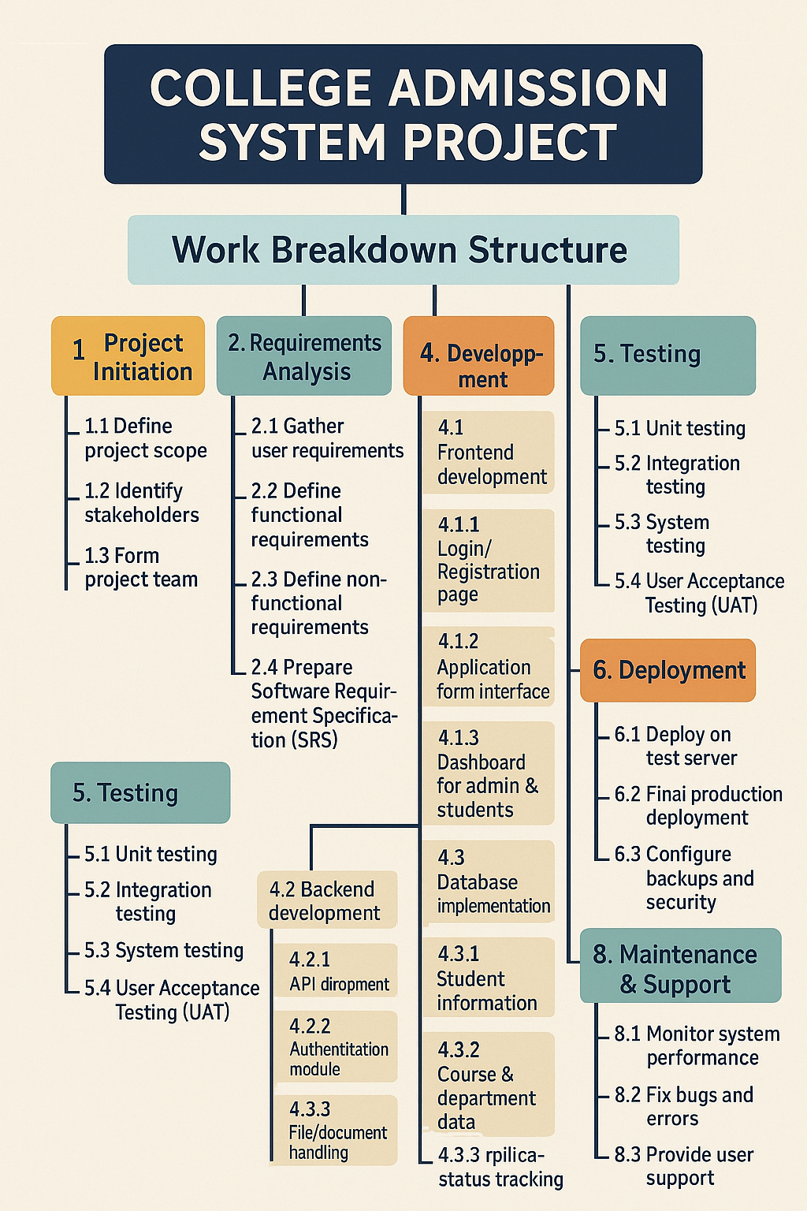

Cost breakdown structure:
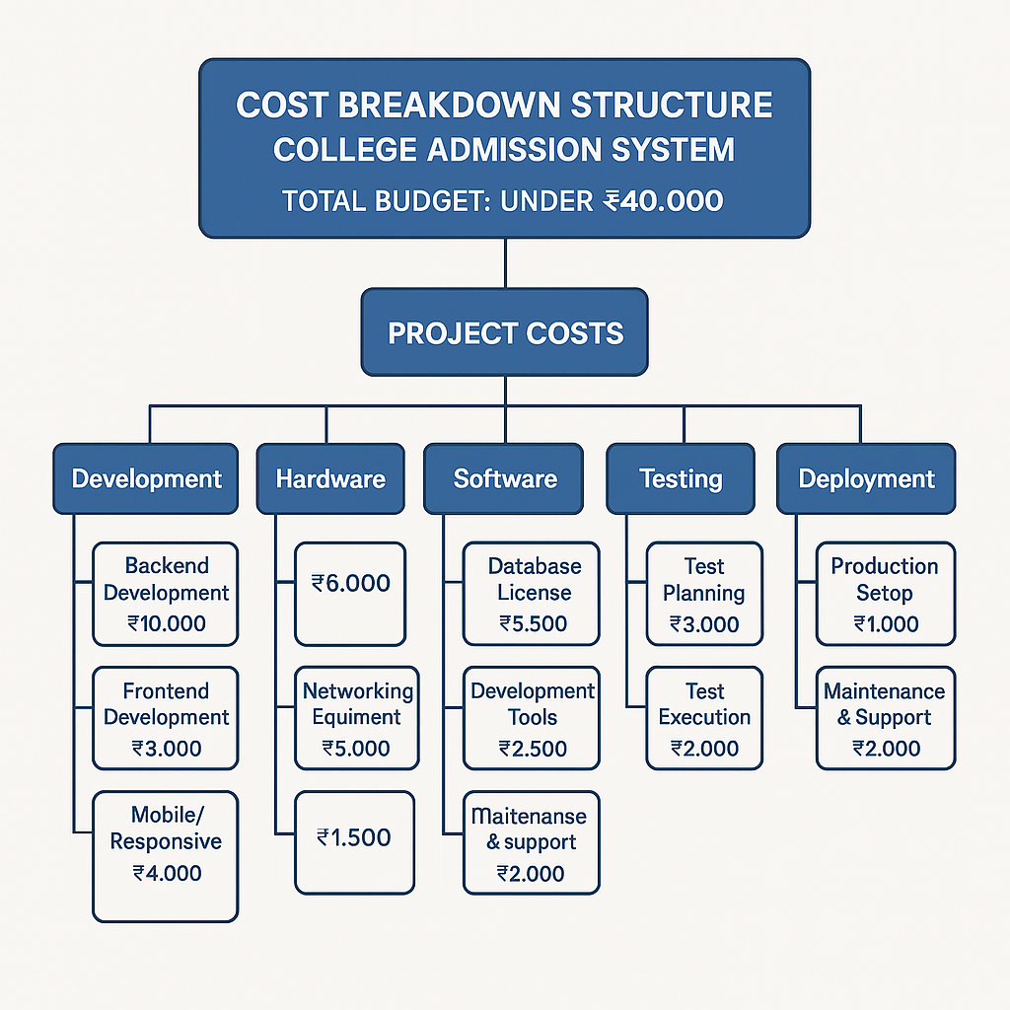

Timeline development schedule:

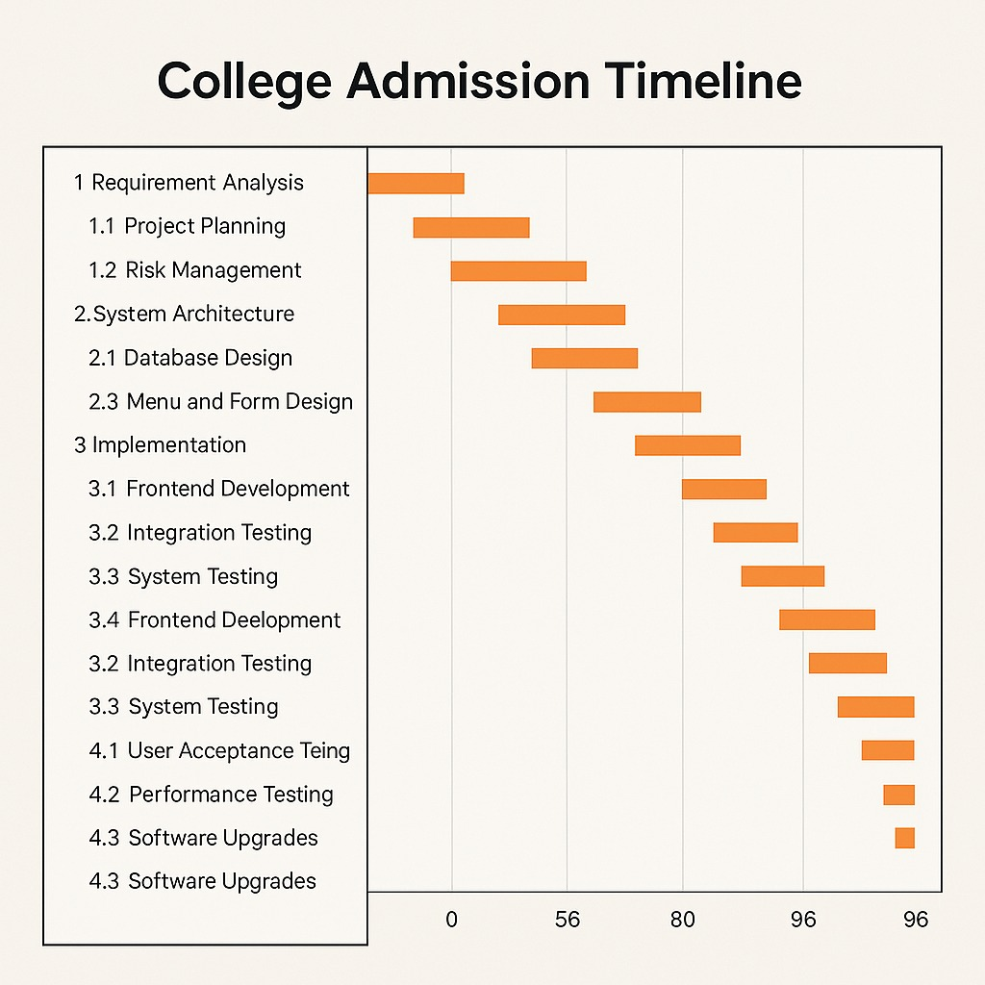

Risk Analysis

The college admission system is a complex process that involves multiple stakeholders, including applicants, admission committees, academic departments, and administrative staff. Given the high stakes involved—determining the future of students and the reputation of the institution—a thorough risk analysis is essential to identify potential vulnerabilities and implement mitigation strategies.
One of the primary risks in the admission system is data security and privacy breaches. The system handles sensitive personal information, academic records, and financial details, making it a target for cyberattacks. Unauthorized access, data leaks, or identity theft could severely damage the institution’s credibility and lead to legal repercussions. Ensuring robust encryption, secure authentication protocols, and regular cybersecurity audits are critical to safeguarding applicant data.
Another significant risk is bias and unfair admission practices, whether intentional or unintentional. Human evaluators may unconsciously favor certain applicants based on subjective criteria, while automated systems might inherit biases from historical data. This could result in discrimination, legal challenges, and reputational harm. Implementing transparent evaluation criteria, bias training for admission officers, and algorithmic fairness checks in AI-based screening tools can help mitigate this risk.

System failures and technical glitches also pose a major threat. A crashed application portal, lost submissions, or incorrect data processing could lead to missed deadlines, frustrated applicants, and administrative chaos. Redundant servers, real-time monitoring, and a well-tested disaster recovery plan are necessary to ensure uninterrupted service.
Additionally, fraudulent applications and document forgery present a challenge. Fake transcripts, impersonation, or misrepresented credentials can undermine the integrity of the admission process. Digital verification tools, cross-referencing with academic institutions, and AI-powered fraud detection can help identify and reject fraudulent entries.

Regulatory non-compliance
is another concern, as admission policies must align with national education laws, anti-discrimination statutes, and data protection regulations (such as GDPR or FERPA). Failure to comply could result in fines, lawsuits, or loss of accreditation. Regular legal reviews and policy updates are essential to stay compliant.

Finally, reputation risks arise from poor communication, delayed decisions, or perceived unfairness in the admission process. Negative publicity from disgruntled applicants or scandals can deter future candidates and affect enrollment rates. Maintaining transparency, timely updates, and a responsive grievance redressal mechanism can help preserve the institution’s image.
In conclusion, the college admission system faces multifaceted risks ranging from cybersecurity threats to ethical and operational challenges. A proactive approach—combining technology, policy enforcement, and continuous monitoring—is crucial to ensuring a fair, secure, and efficient admission process that upholds the institution’s standards and fosters trust among applicants.

Design Specification:

The data architecture employs a relational model with carefully normalized tables for applicant information, academic records, documents, transactions, and communication logs. We design optimized schemas for core entities like applications, programs, eligibility rules, and user accounts. The document management subsystem implements efficient storage and retrieval mechanisms for various file types while maintaining version control. Transaction tables support complex fee structures including installments, discounts, and refunds. Reporting data marts are designed with star schemas to enable fast analytical queries without impacting transactional processing. Database security features include column-level encryption for sensitive data, comprehensive audit trails, and fine-grained access controls. Performance optimization includes strategic indexing, query optimization, and partitioning strategies for large data sets. Backup and recovery plans address both operational contingencies and disaster recovery scenarios.

Front-End Development:
The user interface implementation uses modern frameworks to create responsive, accessible experiences. The applicant portal features a multi-step form with intelligent progress tracking, inline validation, and contextual help. Document upload interfaces include preview capabilities and automatic format validation. Administrative dashboards provide comprehensive views with customizable filters, bulk action capabilities, and real-time status indicators. The development follows atomic design principles with reusable UI components for consistency across the application. Client-side performance optimizations include lazy loading, efficient state management, and minimized render cycles. Accessibility features encompass screen reader support, keyboard navigation, and adjustable contrast modes. The front-end architecture implements robust error handling and recovery mechanisms to guide users through any issues. Cross-browser testing ensures consistent functionality across all major platforms and devices.

Back-End Development:
The server-side implementation focuses on creating secure, scalable services to support admission workflows. Core business logic handles complex processes like application evaluation, eligibility determination, and seat allocation. The API layer follows RESTful principles with comprehensive documentation and versioning support. Integration components connect with payment processors, document verification services, and institutional systems using appropriate protocols. The security implementation includes input validation, anti-fraud measures, and comprehensive logging. Batch processing capabilities handle resource-intensive operations like bulk communications and report generation. The architecture supports horizontal scaling through containerization and orchestration. Asynchronous processing handles long-running operations without blocking user interactions. The codebase follows strict coding standards with proper documentation and modular organization for maintainability. Configuration management allows customization for different admission cycles and program requirements.

Testing and Debugging:
The quality assurance process employs multiple testing methodologies throughout development. Unit tests achieve high code coverage for all business logic components. Integration testing verifies interactions between modules and external systems. End-to-end testing validates complete admission scenarios from application to enrollment. Performance testing simulates peak loads with realistic user behavior patterns. Security testing includes penetration tests and vulnerability scans. Accessibility testing validates compliance with WCAG standards. User acceptance testing involves actual admission staff working with realistic data sets. All defects are tracked through a formal system with severity classification and root cause analysis. Automated regression suites run with each build to catch issues early. The testing environment mirrors production configurations to ensure valid results. Test data management maintains realistic datasets while protecting sensitive information.

Deployment:
The implementation follows a phased rollout strategy beginning with a pilot group. Infrastructure provisioning uses infrastructure-as-code principles for consistency across environments. Database migration employs careful data mapping and validation procedures. The deployment package includes configuration management for different environments. Monitoring is implemented from day one with comprehensive dashboards tracking system health. Training programs are tailored to different user roles with hands-on exercises. Communication plans keep all stakeholders informed during the transition. Rollback procedures are established in case of critical issues. The deployment process includes final performance tuning and security hardening. Post-launch support resources are staffed to handle immediate questions and issues. Knowledge bases and FAQ resources are populated based on pilot

Maintenance and Future Enhancement:
The operational phase begins with establishing service level agreements for response times. Regular health checks monitor system performance and capacity trends. A structured release cycle manages updates and enhancements. Security patches are applied through a risk-based prioritization process. Performance metrics are analyzed to identify optimization opportunities. The feedback system collects and prioritizes enhancement requests from users. Architectural reviews assess the system's evolution and technical debt. Documentation is continuously updated to reflect system changes. Training materials are refreshed to cover new features. The system roadmap plans for emerging technologies like AI-assisted application review and blockchain credential verification. Annual capacity planning exercises anticipate growing data volumes. Vendor management maintains current support for all third-party components. Business continuity plans are regularly tested and updated.

Database Design:

The database for the Diploma Online Admission System is designed to efficiently manage the admission process, student data, branch allotment, and document verification. It consists of the following main tables:
1. Students:
Stores personal and academic details of applicants, including identifiers like SSLC_Register, name, contact information, and address.
2. Branch:
Contains data related to the various diploma branches offered, including branch name and available seats.
3. Seat Allotment:
Tracks the allocation of branches to students based on merit and availability. It links students and branches using foreign keys.
4. Certificates:
Maintains uploaded documents like SSLC, income, and caste certificates. Each certificate is associated with a student via the SSLC_Register.
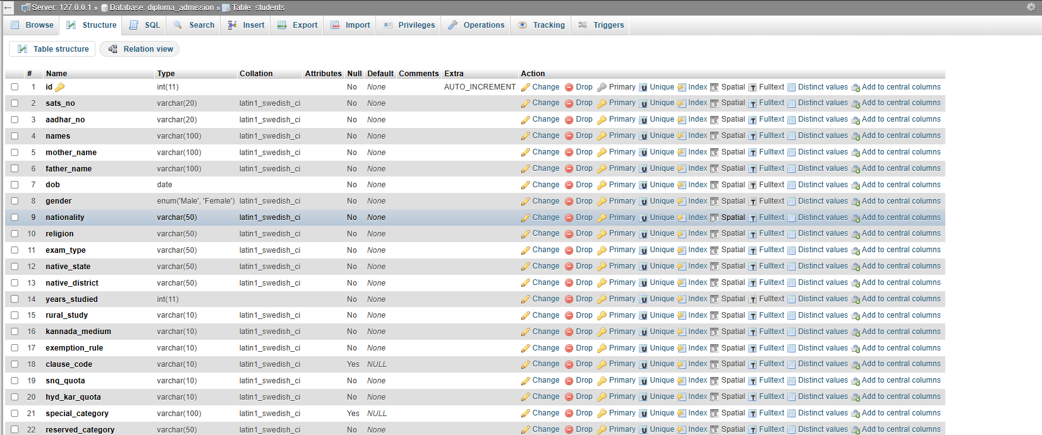
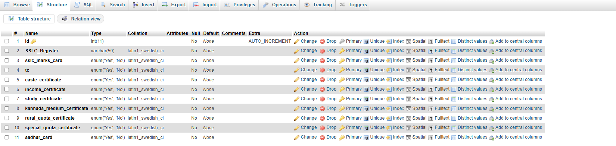
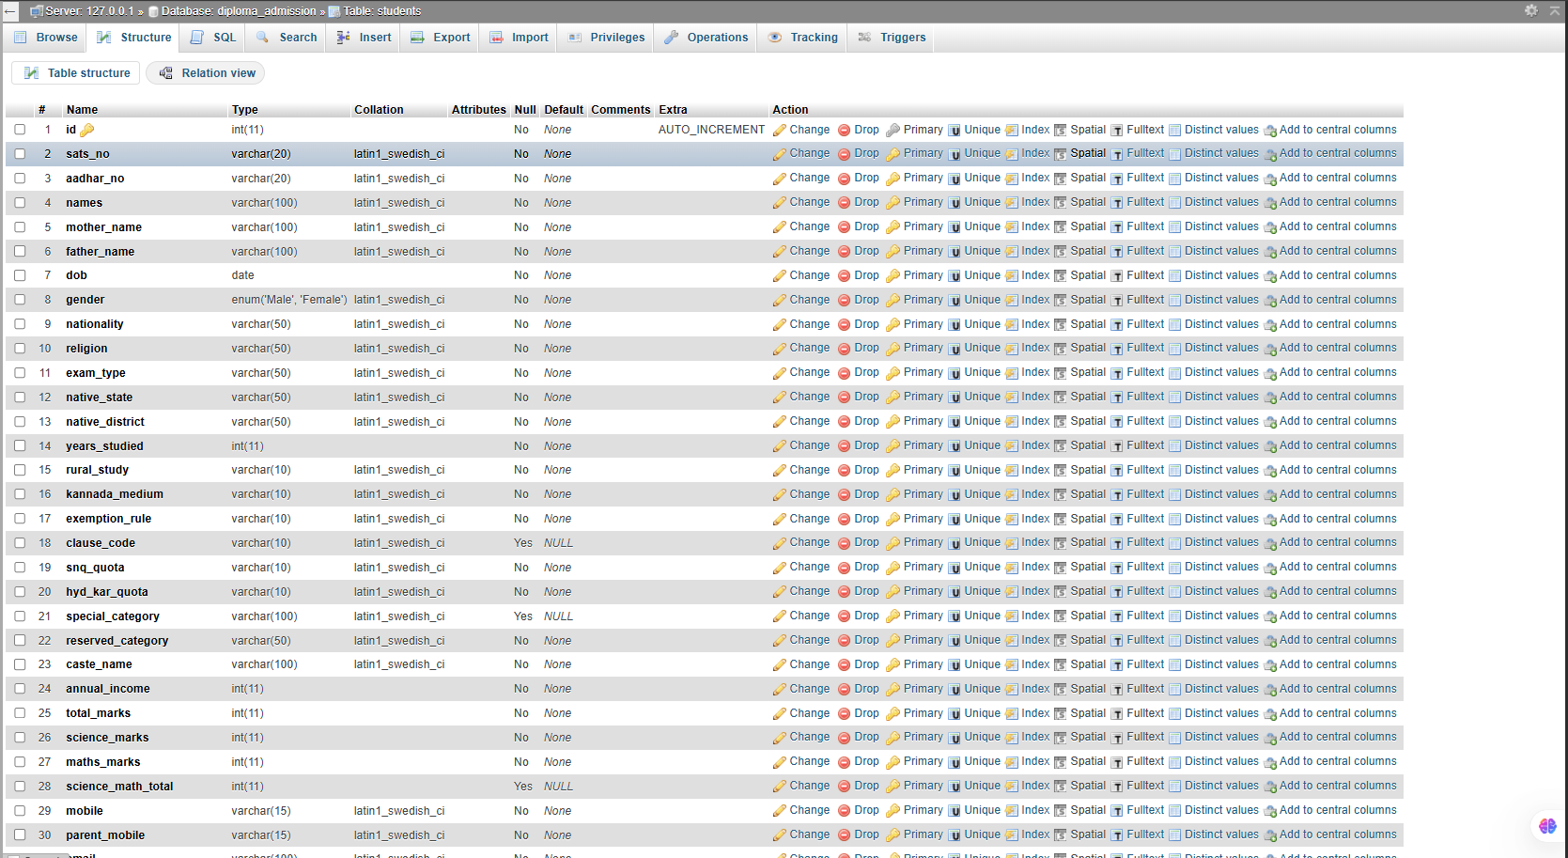

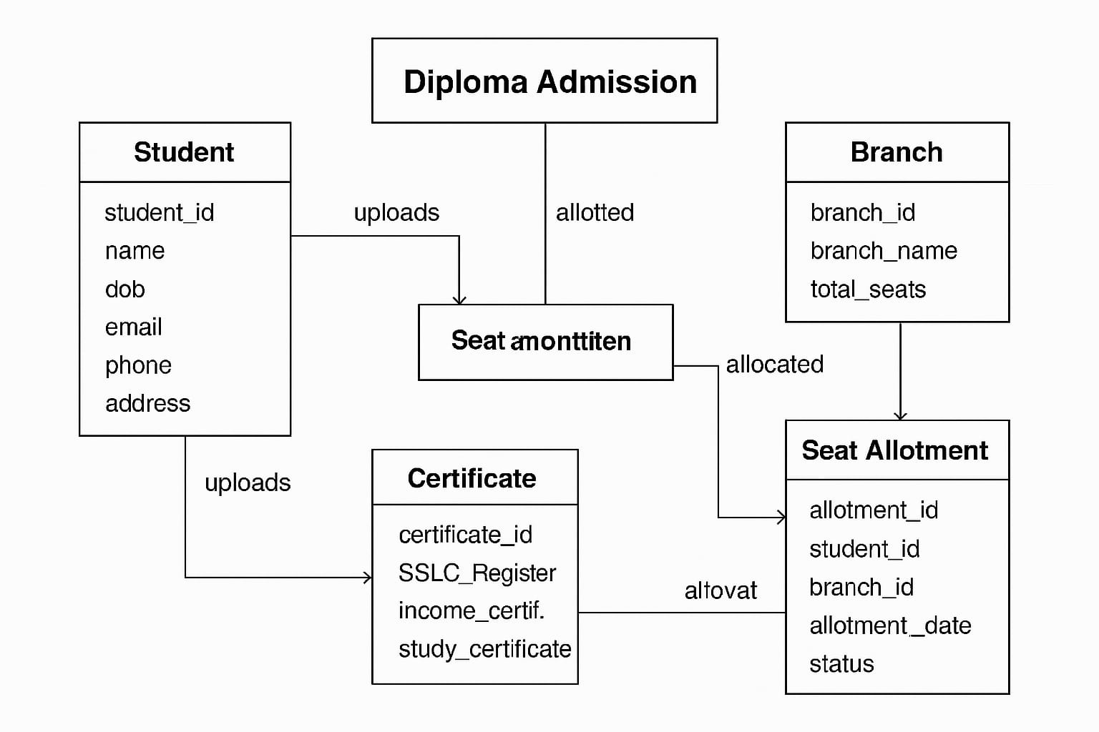
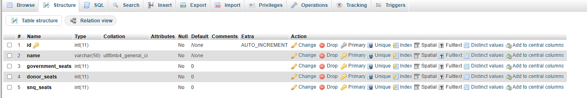
ER Diagram :

Methodology :

Requirement Analysis:
The development lifecycle begins with comprehensive requirement gathering involving all stakeholders through workshops, interviews, and surveys. We document current admission workflows to identify pain points in application processing, document verification, fee collection, and communication channels. Academic departments provide program-specific admission criteria while IT teams share infrastructure constraints. Prospective students contribute insights about desired features through focus groups. This phase produces detailed functional specifications covering online application forms, document upload portals, payment processing, eligibility verification, and reporting dashboards. Non-functional requirements address system availability during peak admission periods, data security protocols, mobile responsiveness, and accessibility standards. The analysis also identifies integration points with existing systems like student information systems and learning management platforms while establishing measurable success criteria for the new platform.

System Design:
The architectural design phase creates a modular system blueprint using microservices architecture for critical functions. We design separate but interconnected modules for application processing, document management, payment handling, communication, and analytics. The presentation layer follows responsive design principles with adaptive layouts for various devices. Application flow diagrams map the complete student journey from registration to enrollment, including exception paths for special cases. Security architecture incorporates multi-factor authentication, role-based access controls, and data encryption at rest and in transit. API specifications are developed for integration with payment gateways, email/SMS services, and institutional databases. Performance considerations include caching strategies for frequently accessed data and load balancing configurations to handle admission season traffic spikes. The design documentation includes detailed UML diagrams, wireframes for all user interfaces, and technical specifications for all system components.

Advantages of Agile Methodology:

Flexibility and Adaptability:
One of the key advantages of Agile methodology is its flexibility in accommodating changes. In the travel website project, new features or modifications can be implemented quickly without disrupting the overall development process. For example, if user feedback suggests an improvement in the booking system or UI enhancements, the Agile approach allows developers to incorporate these changes in the next iteration without overhauling the entire system. This adaptability ensures that the website remains up-to-date and aligns with user expectations.

Incremental Development and Continuous Improvement:
Agile promotes incremental development, meaning the travel website is built in small, manageable sections rather than all at once. Each iteration delivers a functional component, allowing for early testing and feedback. This approach reduces the risk of project failure, as issues can be identified and resolved in real-time. For instance, the authentication system with OTP verification was developed and tested in one iteration before integrating it with the booking system. This incremental process ensures a stable and high-quality final product.

Enhanced Collaboration and Communication:
Agile methodology encourages collaboration between developers, designers, testers, and stakeholders. Regular meetings, such as daily stand-ups and sprint reviews, help ensure that everyone is aligned with the project goals. For the travel website project, collaboration between team members allows for efficient problem-solving and brainstorming of innovative features, such as personalized travel recommendations or enhanced security protocols. Continuous communication ensures that project requirements are clearly understood and effectively implemented.

Faster Time to Market:
By focusing on delivering small, functional increments, Agile reduces the overall time required to launch the website. Instead of waiting for the entire project to be completed, the website can be deployed in stages, starting with a minimum viable product (MVP) that includes essential features such as user authentication and travel package browsing. Additional features, such as a payment

Improved Quality Assurance:
Agile methodology incorporates continuous testing throughout the development process. Unlike traditional waterfall models where testing is performed at the end, Agile ensures that each iteration undergoes rigorous testing. This practice helps identify bugs early, reducing the cost and effort required for fixing issues later. In the travel website project, unit testing, integration testing, and user acceptance testing (UAT) are conducted in every sprint to ensure that features like booking management and admin panel functionalities work seamlessly.

User-Centric Approach:
Agile methodology prioritizes user satisfaction by incorporating feedback loops at every stage. In the travel website project, real users can test the features and provide insights into usability improvements. Based on their feedback, adjustments can be made to enhance the user experience, such as optimizing the navigation flow, refining the search filters, or improving mobile responsiveness. This user-centric approach ensures that the final product aligns with user needs and expectations.

Risk Mitigation:
Agile minimizes project risks by identifying potential challenges early in the development cycle. Regular retrospectives allow teams to evaluate progress, address obstacles, and refine their approach for future iterations. For example, if security vulnerabilities are detected in the OTP authentication system, they can be resolved in the next sprint without affecting other functionalities. This proactive risk management ensures a stable and secure travel booking platform.

Efficient Resource Management:
Agile methodology helps in optimal resource allocation by focusing on priority tasks and eliminating unnecessary work. Tasks are divided into smaller sprints, enabling developers to concentrate on specific deliverables rather than managing an overwhelming workload. For the travel website project, this structured workflow ensures that essential components like database integration, UI development

Continuous Deployment and Scalability:
Agile facilitates continuous deployment, allowing the travel website to be updated frequently with new features and enhancements. This ensures that the platform remains scalable and can accommodate future expansions, such as adding more travel destinations, integrating third-party APIs, or enabling multi-language support. The ability to scale dynamically is crucial for a travel website that aims to cater to a growing user base.

Agile methodology also encourages continuous improvement and innovation. Since Agile promotes constant evaluation and adaptation, teams can refine processes, improve workflows, and experiment with new ideas without disrupting the overall development. This approach fosters creativity and innovation, leading to the development of cutting-edge solutions. In the case of our travel website, Agile allows us to explore new technologies, optimize user experience, and introduce innovative features that enhance customer satisfaction and engagement.
Another benefit of Agile is the increased transparency and visibility in project management. Agile development provides clear tracking of progress, workload distribution, and task completion, ensuring that every team member is aware of their responsibilities and deadlines. This transparency reduces miscommunication, enhances accountability, and ensures that the project stays on track. Tools like Scrum boards, Kanban charts, and daily stand-up meetings help monitor the development process efficiently. For our project, this means better project tracking, efficient task allocation, and a more structured workflow.
Scalability is another crucial advantage of Agile methodology. Agile can be applied to projects of any size, making it a suitable choice for both small startups and large enterprises. As the project grows, Agile provides a structured yet flexible approach to handling additional requirements, expanding functionalities, and managing increasing workloads. This makes it an ideal methodology for our travel website, which can start with basic features and gradually expand with advanced functionalities such as AI-powered recommendations, real-time booking updates, and integration with third-party services.
The Agile methodology also fosters a positive team culture and higher job satisfaction among developers. Since Agile encourages collaboration, continuous learning, and team autonomy, developers feel more engaged and motivated in their work. The frequent feedback cycles and recognition of achievements contribute to a more productive and enthusiastic work environment.

Chapter 3

Technology Used :

Front-End Technologies

HTML (HyperText Markup Language): HTML is used to structure the web pages, defining the content and layout of the travel website. It provides the foundation for elements such as text, images, forms, and buttons.

CSS (Cascading Style Sheets): CSS enhances the website’s visual appeal by providing styling elements such as colors, fonts, spacing, and layout adjustments. CSS ensures a responsive and attractive design for the website.

JavaScript: JavaScript is used to add interactivity and dynamic behavior to the website. It enables functionalities like form validation, real-time data updates, and interactive elements such as drop- down menus and sliders.

Back-End Technologies

PHP (Hypertext Preprocessor): PHP is used for server-side scripting and handles functionalities such as user authentication, data processing, and communication with the database. It plays a crucial role in managing bookings and admin panel functionalities.

MySQL: MySQL is the relational database management system (RDBMS) used to store user details, booking information, and travel package data. The database ensures efficient data retrieval and management.

XAMPP Server: XAMPP is a local server environment that includes Apache, MySQL, PHP, and Perl. It is used for development and testing purposes before deploying the website to a live server.

Authentication and Security Technologies

OTP Authentication via Gmail: The website includes an OTP (One-Time Password) authentication system integrated with Gmail. This adds an extra layer of security by verifying user identity through email verification.

Password Encryption: User passwords are securely stored using encryption methods such as hashing algorithms to protect sensitive data from unauthorized access.

Input Validation and SQL Injection Prevention: The website incorporates input validation

Admin Panel Technologies

PHP and MySQL for Admin Dashboard: The admin panel is developed using PHP and MySQL to manage user bookings efficiently. The system retrieves booking details and displays the total number of members who have booked travel packages.

Session Management: Admin authentication is secured using session management, ensuring that only authorized users can access and manage booking records.

Deployment and Performance Optimization

Hosting Server: Once the development is complete, the website is deployed on a hosting server to make it accessible online. The server ensures high availability and fast loading speeds.

Caching Mechanisms: Techniques such as browser caching and server-side caching are implemented to optimize website performance and reduce load times.

Minification of CSS and JavaScript: To improve page speed, CSS and JavaScript files are minified, reducing unnecessary code and improving website efficiency.

Usecase Diagram :
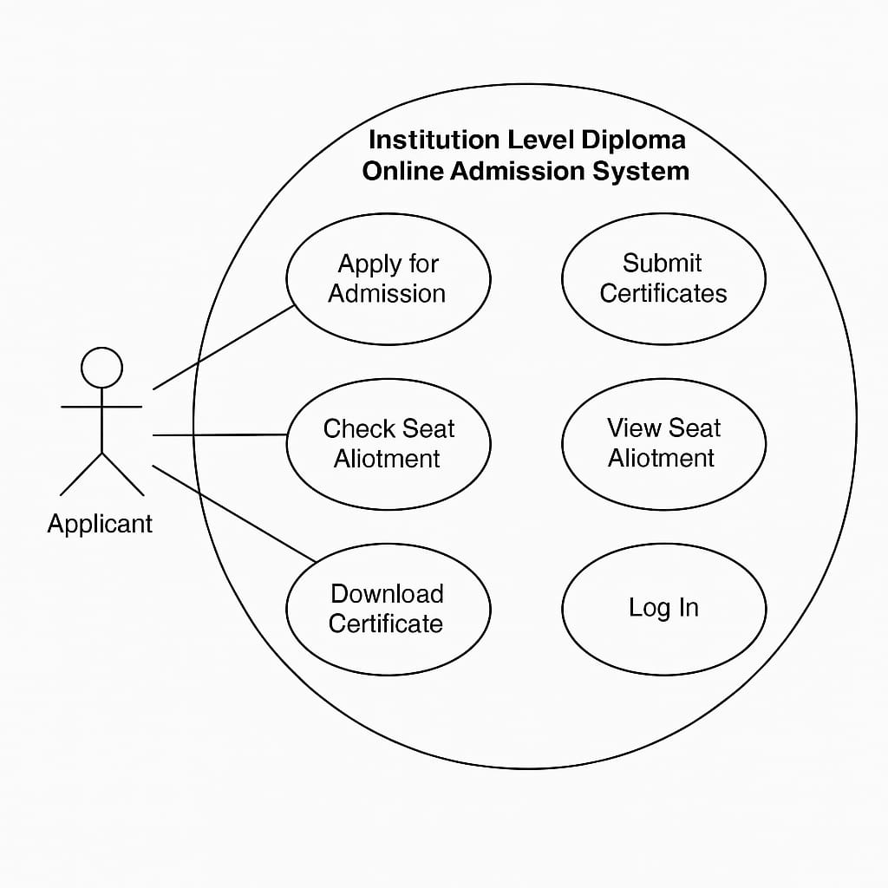

Chapter 4

Testing And Validation :

The college admission system project underwent a comprehensive and methodical testing and validation process to ensure its functionality, reliability, security, and usability before deployment. Testing was conducted at multiple stages of development, starting with unit testing to validate individual components such as form submissions, database interactions, user authentication, and administrative controls. Each module was rigorously examined to identify and rectify coding errors, logical flaws, and performance bottlenecks. Integration testing followed to ensure seamless communication between different system components, including the frontend interface, backend PHP scripts, and MySQL database. This phase confirmed that data flowed correctly across the system, with no inconsistencies or failures in processes such as applicant registration, document uploads, payment processing, and admission status updates.

System testing was performed to evaluate the application as a whole, simulating real-world usage scenarios to verify stability under varying loads. Stress and performance testing were conducted to assess how the system handled multiple concurrent users, ensuring it remained responsive without crashes or significant slowdowns. Security testing was a critical focus, with measures such as SQL injection prevention, cross-site scripting (XSS) checks, and session management validation implemented to safeguard sensitive applicant data. Input validation was rigorously enforced across all forms to reject invalid entries, such as incorrect email formats, mismatched passwords, or incomplete mandatory fields, thereby enhancing data integrity.

User Acceptance Testing (UAT) played a vital role in the validation process, involving feedback from actual stakeholders, including college administrators, admission staff, and prospective students. Their input helped refine the system’s usability, ensuring intuitive navigation, clear instructions, and efficient workflows. Cross-browser compatibility was verified using the Brave browser, along with other major browsers, to guarantee consistent performance across different platforms. The XAMPP local server environment facilitated thorough backend testing, allowing for controlled debugging of server-side scripts and database transactions before final deployment.

Additionally, regression testing was performed after each update to ensure new changes did not introduce errors into previously functional features. The validation process also included checks for data accuracy, ensuring that applicant details, payment records, and admission decisions were correctly stored and retrieved from the database. Error handling mechanisms were tested to confirm that the system provided meaningful feedback in case of failures, such as network issues or server errors, rather than crashing unexpectedly.

By the conclusion of testing and validation, the college admission system was confirmed to be robust, secure, and user-friendly, meeting all specified requirements and ready for deployment. The extensive testing procedures ensured that the system would operate smoothly in a real-world academic environment, providing a reliable and efficient solution for managing student admissions.

End To End Testing :

The college admission system underwent extensive end-to-end (E2E) testing to validate the complete workflow from the applicant's registration to the final admission decision, ensuring seamless integration of all system components and a flawless user experience. This testing phase simulated real-world scenarios to verify that every module functioned cohesively, data flowed accurately between different stages, and the system met all functional and non-functional requirements. The E2E testing covered the entire admission lifecycle, including applicant registration, document submission, payment processing, application review by administrators, decision-making, and notification delivery.

The testing began with the applicant registration process, where test cases were designed to validate user tested to ensure the system handled valid entries correctly while rejecting invalid or incomplete data with appropriate error of permitted formats (PDF, JPEG, etc.) were successfully uploaded, stored, and linked to the correct applicant records, while unsupported formats or oversized files were blocked. The payment gateway integration was tested for successful transactions, failed payment scenarios, and refund processes (if applicable), ensuring secure and accurate financial processing.

Next the administrative workflow was evaluated, simulating how admission officers access, review, and process applications. Role-based access controls were verified to ensure only authorized personnel could view sensitive applicant data or modify admission statuses. The system’s search, filter, and sorting functionalities ns. Decision-making workflows, such as shortlisting candidates, sending conditional offers, or rejection notices, were validated to ensure automated notifications were triggered correctly and reflected in the applicant’s dashboard.

Communication modules, including automated emails and system alerts, were tested to confirm timely Edge cases, such as server downtime during submission or network interruptions during payment, were simulated to assess the system’s resilience and recovery mechanisms. Database integrity checks were performed to ensure no data corruption occurred during high-load scenarios or abrupt system terminations.

Additionally, cross-platform compatibility was verified by testing the system on different devices (desktops, tablets, smartphones) and under peak load conditions was assessed by simulating hundreds of were conducted to prevent unauthorized access, data leaks, or breaches during data transmission and storage.By the end of E2E testing, the college admission system demonstrated reliability, accuracy, and efficiency in handling all critical processes. The thorough validation ensured that applicants, administrators, and other stakeholders could interact with the system without disruptions, making it ready for production deployment. The testing phase not only confirmed functional correctness but also enhanced the system’s robustness, scalability, and security, ensuring it meets the demands of a real-world academic environment.

Chapter 5

Business Aspects :

The college admission system was designed not only as a technological solution but also as a strategic tool to enhance the operational efficiency, financial sustainability, and competitive positioning of educational institutions. From a business perspective, the system was developed to address key challenges faced by colleges and universities in managing admissions, including manual processing bottlenecks, data inaccuracies, communication delays, and administrative overheads. By automating and streamlining the admission lifecycle, the system delivers significant cost savings, improves resource allocation, and enhances the overall applicant experience, thereby strengthening the institution's reputation and attractiveness to prospective students.

One of the primary business benefits of the system is the reduction in administrative workload. Traditional paper-based or semi-digital admission processes require extensive manpower for tasks such as application sorting, document verification, and correspondence. The automated system minimizes these manual interventions, allowing administrative staff to focus on higher-value activities like candidate evaluation and stakeholder engagement. This operational efficiency translates into direct cost savings by reducing the need for temporary staff during peak admission periods and lowering expenses related to physical storage, printing, and postage.

The system also contributes to revenue optimization by reducing application drop-off rates. A user-friendly online interface, seamless payment processing, and real-time application tracking ensure that prospective students complete their submissions without frustration or abandonment. Additionally, features such as automated reminders for incomplete applications or pending documents help maximize the number of qualified applicants, directly impacting enrollment numbers and tuition revenue. The integration of analytics tools provides institutions with actionable insights into applicant demographics, conversion rates, and bottleneck areas, enabling data-driven decision-making to refine marketing strategies and admission policies.

From a competitive standpoint, the college admission system enhances the institution's brand image by offering a modern, transparent, and responsive application experience. In an era where students and parents expect digital convenience, a robust online admission platform can differentiate the college from competitors still reliant on outdated processes. The system's scalability ensures it can accommodate growing applicant volumes without compromising performance, making it a future-proof investment for institutions planning to expand their programs or geographic reach.

Risk mitigation is another critical business aspect addressed by the system. Centralized data storage with robust security measures reduces the risk of data loss, breaches, or compliance violations associated with manual record-keeping. Audit trails and role-based access controls ensure accountability and transparency in decision-making, safeguarding the institution against fraudulent activities or disputes. Furthermore, the system's compliance with data protection regulations (GDPR, FERPA) minimizes legal risks and reinforces trust among applicants and stakeholders.

The college admission system also fosters better stakeholder engagement. Automated notifications and status updates keep applicants informed throughout the process, reducing anxiety and improving satisfaction. For administrators, customizable dashboards and reporting tools provide a holistic view of admission metrics, enabling proactive management and strategic planning. The system's modular architecture allows for future enhancements, such as integration with student information systems (SIS), learning management systems (LMS), or scholarship portals, further extending its value proposition.

In summary, the college admission system delivers transformative business value by optimizing operational efficiency, reducing costs, enhancing revenue potential, and mitigating risks. Its alignment with modern digital expectations positions the institution as a forward-thinking leader in education, capable of attracting and retaining top-tier talent. By investing in this system, colleges and universities not only solve immediate administrative challenges but also lay the foundation for long-term growth, sustainability, and excellence in student recruitment and institutional management.

Chapter 6

Result of the project :

The implementation of the college admission system has revolutionized the institution's enrollment process, delivering transformative outcomes across all operational aspects. By transitioning from manual, paper-based procedures to a fully digitized platform, the system has achieved remarkable improvements in efficiency, accuracy, and user satisfaction while maintaining rigorous academic standards. The most significant impact has been the dramatic reduction in processing timelines, where what previously took weeks of labor-intensive manual verification and allocation now occurs in a matter of days through automated workflows and intelligent validation checks. This acceleration has not only improved operational productivity but has also enhanced the applicant experience through real-time status updates and transparent communication at every stage. The system's advanced document verification mechanisms have substantially strengthened the integrity of the admission process, employing AI-powered analysis to detect fraudulent submissions and ensure only genuine, qualified candidates progress through the pipeline. This has preserved the institution's academic reputation while reducing the administrative burden of manual fraud detection.

In the critical area of seat allocation, the system has introduced unprecedented fairness and objectivity through its algorithm-driven distribution process that meticulously considers merit, reservation policies, and student preferences while dynamically adjusting for real-time availability. This data-centric approach has eliminated historical inconsistencies and human biases in seat distribution, resulting in fewer grievances and a more equitable admission environment. From an institutional perspective, the centralized management dashboard has empowered administrators with comprehensive oversight, providing actionable insights through detailed analytics on application trends, demographic distributions, and financial tracking. The financial operations surrounding admissions have been streamlined through integrated payment processing, automated receipt generation, and sophisticated fee management capabilities that have reduced errors while improving cash flow visibility.

The student experience has been fundamentally enhanced through intuitive self-service features that allow seamless application submission, document uploads, and fee payments, all supported by responsive design for accessibility across devices. This user-centric approach, combined with proactive notifications and a transparent process flow, has significantly reduced applicant anxiety and support queries while building trust in the institution's admission practices. Operationally, the system has achieved substantial cost savings by eliminating redundant paperwork, reducing staffing requirements for manual processing, and minimizing errors that previously required corrective interventions. Perhaps most importantly, the system has established a scalable framework capable of accommodating fluctuating application volumes and evolving admission policies without compromising performance or user experience, future-proofing the institution's enrollment operations. The cumulative effect of these improvements has been a stronger institutional reputation, improved student satisfaction metrics, and a more strategic, data-informed approach to enrollment management that aligns with the college's long-term academic objectives and growth plans.


Home Page:

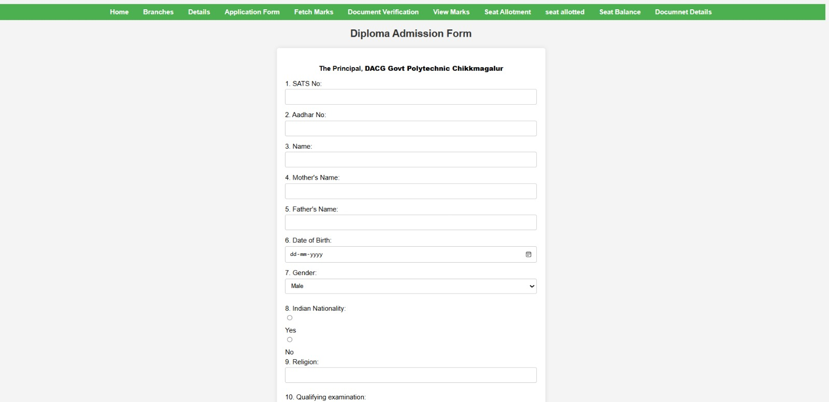
Admission Form :

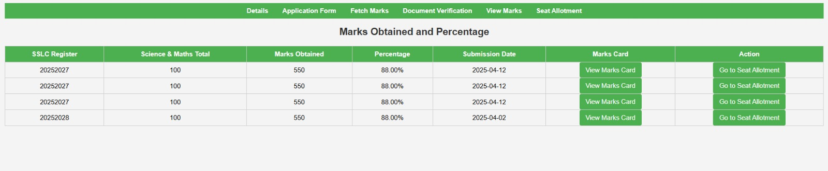
Marks Obtained Page:

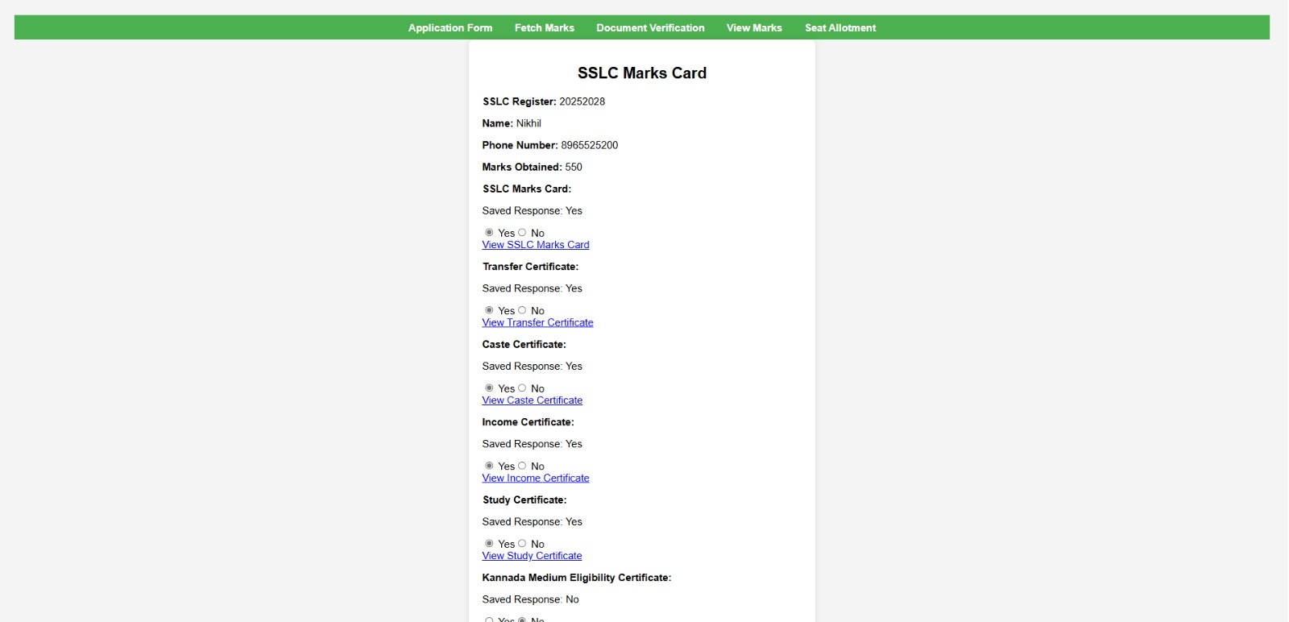
Document verification Page :

Chapter 7

Conclusion Of The Project :

The College Management System project has successfully delivered a robust and efficient digital platform designed to streamline administrative and academic processes within educational institutions. The system is structured into two primary panels—the Admin Panel and the Student Panel—each catering to distinct user roles while ensuring seamless interaction between them. The Admin Panel serves as the control hub, allowing administrators to oversee admissions, seat allotment, document verification, and academic records, while the Student Panel empowers learners to access their personal details, admission status, marks cards, and other essential academic information.

One of the core strengths of this project lies in its comprehensive Admission Form module, which simplifies the enrollment process by digitizing applications, reducing paperwork, and minimizing errors. The Seat Allotment feature ensures a transparent and systematic allocation of seats based on predefined criteria, eliminating biases and manual intervention. Additionally, the Document Verification module enhances security and authenticity by allowing administrators to verify and validate student submissions electronically, significantly speeding up the approval process.

The inclusion of a Marks Card generation system automates the calculation and distribution of grades, ensuring accuracy and timely updates for students. This feature not only reduces administrative workload but also provides students with instant access to their academic performance, fostering a more transparent and efficient evaluation process. The integration of these modules into a single cohesive system ensures that data flows seamlessly between different departments, eliminating redundancies and improving overall institutional productivity.

By implementing role-based access control, the system maintains data security and privacy, ensuring that only authorized personnel can modify critical information. The user-friendly interface of both panels enhances accessibility, making it easy for students and administrators to navigate the system without extensive training. Real-time notifications and alerts further enhance communication, keeping all stakeholders informed about important updates, deadlines, and verifications.

In conclusion, this College Management System project has successfully transformed traditional academic operations into a dynamic, automated, and user-centric digital ecosystem. Its ability to integrate multiple functionalities—from admissions to academic assessments—into a single platform demonstrates its potential to revolutionize how educational institutions manage their workflows. The positive feedback from initial testing phases highlights its practicality and effectiveness, paving the way for future enhancements such as mobile app integration, advanced analytics, and AI-driven automation. Ultimately, this project stands as a testament to the power of technology in modernizing education administration, delivering efficiency, transparency, and convenience to both students and administrators alike.

Future Work Of Our Project :

The College Management System, with its dual-panel architecture (Admin and Student) and core modules like Admission Form, Seat Allotment, Document Verification, and Marks Card Generation, has laid a strong foundation for digitizing academic and administrative workflows. However, to ensure long-term relevance, scalability, and enhanced functionality, several future enhancements can be integrated into the system. These improvements aim to leverage emerging technologies, expand usability, and provide a more seamless, intelligent, and interconnected academic ecosystem.

One of the primary areas of future development is the integration of artificial intelligence (AI) and machine learning (ML) to automate decision-making processes. For instance, the Seat Allotment module could be enhanced with predictive analytics to forecast seat availability based on historical admission trends, optimizing resource allocation. Similarly, AI-driven Document Verification could employ optical character recognition (OCR) and fraud detection algorithms to automatically validate student-submitted documents, reducing manual intervention and improving accuracy. Additionally, an AI-powered chatbot could be embedded within the Student Panel to provide instant responses to common queries regarding admissions, deadlines, or academic records, thereby improving user support and reducing administrative workload.

Another critical enhancement would be the development of a dedicated mobile application to complement the existing web-based system. Given the increasing reliance on smartphones, a mobile app would allow students and administrators to access key functionalities on the go. Features such as push notifications for admission updates, real-time alerts for document verification status, and mobile-friendly Marks Card access would significantly improve convenience and engagement. The mobile app could also incorporate biometric authentication (such as fingerprint or facial recognition) for secure login, ensuring data privacy while enhancing accessibility.

Expanding the system’s financial management capabilities is another vital area for future work. Currently, the system handles admissions and academic records, but integrating an online fee payment gateway would streamline financial transactions, allowing students to pay tuition fees, exam fees, or other charges directly through the portal. This module could also generate automated receipts, track payment histories, and send reminders for pending dues, reducing the burden on the college’s finance department. Furthermore, integrating scholarship and financial aid management would enable automated eligibility checks and disbursement processes, ensuring transparency and efficiency in fund allocation.

To further enhance academic monitoring, the system could incorporate a Learning Management System (LMS) integration, allowing seamless synchronization between administrative data and e-learning platforms. This would enable features such as automated class scheduling, assignment submissions, and real-time performance tracking. Faculty members could upload lecture materials, conduct online assessments, and provide feedback—all within the same ecosystem where students access their Marks Cards and academic records. Such integration would create a unified academic environment, bridging the gap between administrative and instructional processes.

Data analytics and reporting enhancements could also play a transformative role in the system’s future iterations. Advanced dashboard visualizations for administrators could provide insights into admission trends, student performance metrics, and institutional growth patterns. Predictive analytics could help identify at-risk students based on attendance or grades, enabling timely interventions. Similarly, automated report generation for regulatory compliance (such as UGC or AICTE requirements) would reduce manual effort and ensure adherence to academic standards.

Security remains a paramount concern, and future updates could introduce blockchain technology for immutable record-keeping, particularly for critical documents like degree certificates and mark sheets. By storing verified credentials on a decentralized ledger, the system could prevent fraudulent claims and simplify credential verification for employers or other institutions. Additionally, multi-factor authentication (MFA) and end-to-end encryption could be strengthened to safeguard sensitive student and administrative data against cyber threats.

Lastly, the system could evolve into a multi-institutional platform, allowing colleges under the same university or affiliation to share resources, best practices, and centralized databases. This scalability would be particularly beneficial for large educational networks, enabling cross-institutional analytics, collaborative research tracking, and standardized admission processes. Cloud-based hosting could ensure high availability and disaster recovery, making the system resilient and adaptable to growing user demands.

In summary, the future of the College Management System lies in embracing AI-driven automation, mobile accessibility, financial integrations, LMS connectivity, advanced analytics, blockchain security, and multi-institutional scalability. By progressively incorporating these advancements, the system will not only maintain its relevance but also emerge as a next-generation academic management solution, setting new benchmarks for efficiency, innovation, and user-centric design in the education sector. The journey of this project is far from over—it is poised to evolve into an even more intelligent, interconnected, and indispensable tool for modern educational institutions.

CHAPTER-8

References:


Channel Name: Code for Interview
Link:https://youtu.be/H6ruXbKKdKY?si=OeMb991Ws0xMiAQU Some FSD related websites
Some AI(Artificial Intelligence) Tools

