INDUSTRIAL PROJECT
1.Smart cities and Smart home using IOT Applications.

Introduction: In the digital age, the integration of technology into everyday life is transforming urban landscapes and residential spaces. Central to this transformation is the Internet of Things (IoT), a network of interconnected devices that communicate and share data to enhance functionality and efficiency. This paradigm shift is giving rise to the concepts of Smart Cities and Smart Homes, where IoT technology is leveraged to create environments that are more responsive, sustainable, and user-friendly.

Smart cities using IOT: The concept of a Smart City leverages the power of the Internet of Things (IoT) to enhance the efficiency, sustainability, and quality of urban life. By integrating IoT technology into city infrastructure and services, smart cities aim to create more responsive, connected, and adaptive environments that meet the needs of their residents while addressing complex urban challenges.
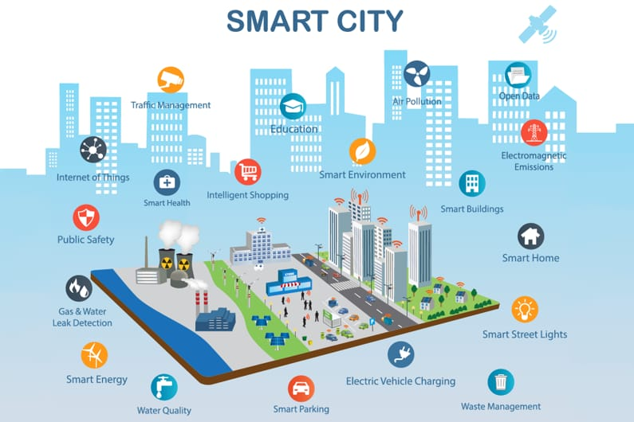

Applications OF Smart Cities Using IOT
- Traffic management: Traffic management is a critical component of smart city infrastructure, and IoT (Internet of Things) technology plays a pivotal role in enhancing its effectiveness. By integrating IoT sensors, data analytics, and communication systems, smart cities can significantly improve traffic flow, reduce congestion, and enhance overall transportation efficiency.

Working of Traffic management using IOT: Traffic management is essential to the functioning of modern urban environments, and the integration of IoT (Internet of Things) technology is transforming how cities approach this challenge. Here’s a detailed look at how IoT enhances traffic management systems:
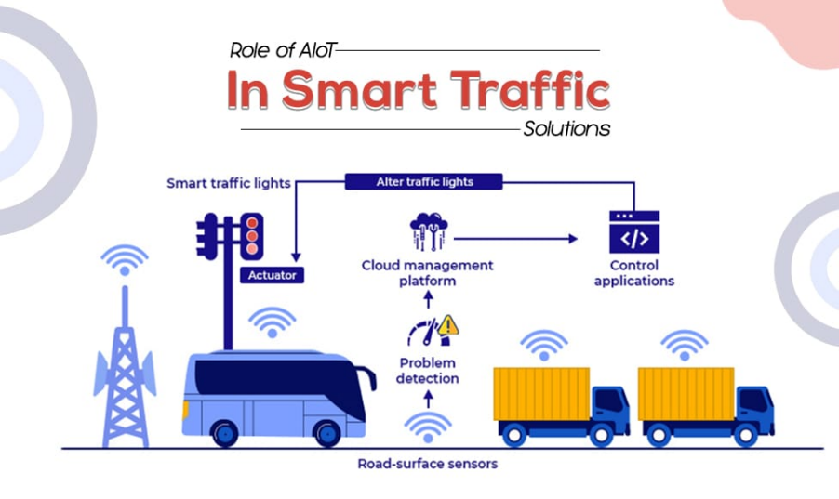
Requirements:
IoT Sensors and Devices
Communication Infrastructure
Traffic Signal Controllers
Data Aggregation Platforms
Deployment and Installation

- Smart Street Light: Smart street lights are a transformative component of modern urban infrastructure, leveraging Internet of Things (IoT) technology to enhance energy efficiency, improve public safety, and provide valuable data for city management.
Working of Smart Street Light using IOT: Smart street lights utilize Internet of Things (IoT) technology to optimize urban lighting, enhance safety, and improve energy efficiency. Here’s a detailed explanation of how these systems work:
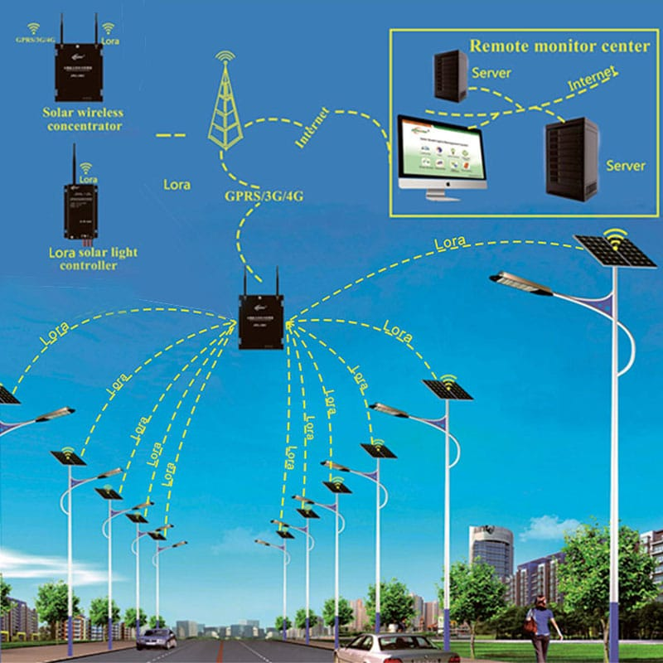
Requirements:
IoT Sensors and Connectivity
Data Collection and Processing
Adaptive Lighting Control
Traffic Flow and Public Safety
Energy Efficiency

- Smart health: The concept of Smart Health represents a transformative shift in how healthcare is delivered and managed, leveraging advancements in technology to improve patient outcomes, streamline medical processes, and enhance overall healthcare experiences. At its core, Smart Health integrates Internet of Things (IoT) technology, artificial intelligence (AI), data analytics, and other digital innovations to create a more connected, efficient, and personalized healthcare ecosystem.

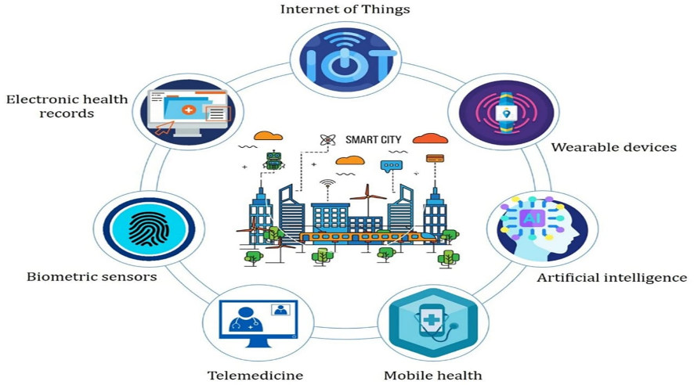
Working of Smart health using IOT: Smart Health leverages Internet of Things (IoT) technology to create a more connected and efficient healthcare system. IoT enables the integration of various digital devices and systems, allowing for real-time monitoring, personalized care, and streamlined healthcare operations. Here’s a detailed explanation of how Smart Health works using IoT
Requirements:
IoT Devices and Sensors
Data Collection and Integration
Data Analysis and Interpretation
Telemedicine and Virtual Care
Operational Efficiency

- Smart Education: Smart Education represents a paradigm shift in teaching and learning, driven by technological advancements and the integration of digital tools and resources. This modern approach leverages Internet of Things (IoT) devices, artificial intelligence (AI), data analytics, and other digital technologies to create a more engaging, personalized, and efficient educational experience.

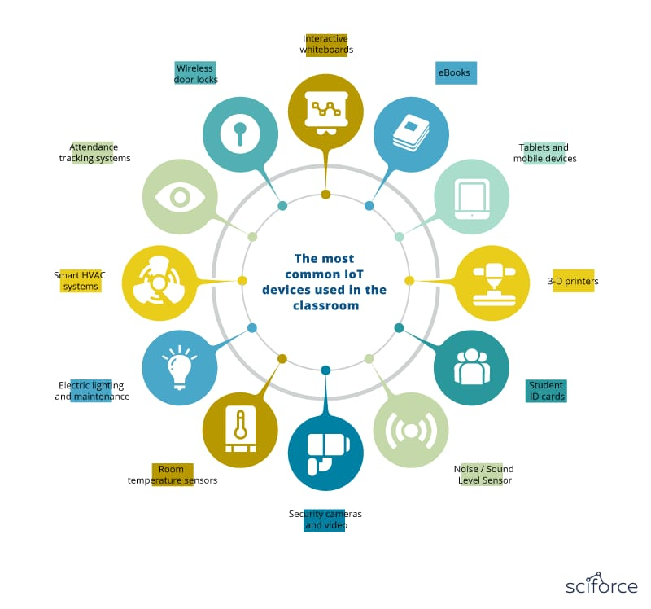
Working of Smart Education using IOT: Smart Education employs Internet of Things (IoT) technology to enhance the learning experience, streamline educational processes, and create a more connected and efficient educational environment. Here’s a detailed overview of how IoT works in the context of Smart Education:
Requirements:
Technological Infrastructure
Data Management and Security
Educational Tools and Resources

- Intelligent Shopping: Intelligent shopping refers to the use of IoT and other advanced technologies to optimize the retail process, making it more intuitive and responsive to consumer needs. In smart cities, this involves embedding smart devices, sensors, and data analytics into the shopping environment to create a dynamic and interconnected retail ecosystem.
Working of Intelligent Shopping using IOT: Intelligent Shopping using Internet of Things (IoT) technology transforms the retail experience by creating a more connected, personalized, and efficient shopping environment.
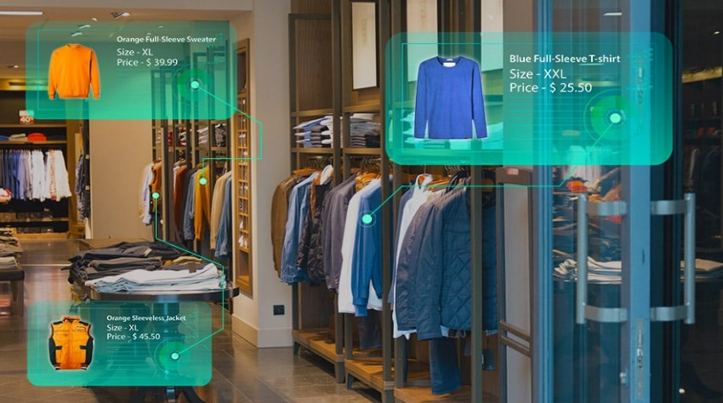
Requirements:
Smart Shelves and Displays
Data Collection and Integration
Personalized Shopping Experiences
Seamless Checkout and Payment
Customer Engagement and Support

- Benefits of using IOT in Smart cities:
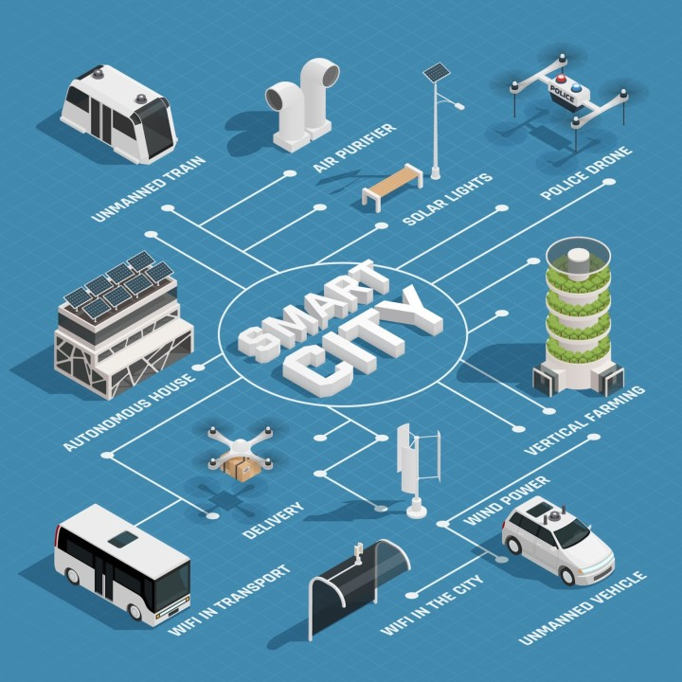

- Unmanned train
- Autonomous house
- Delivery
- Wi-Fi in transport
- Wi-Fi in the city
- Wind power
- Vertical framing
- Police drone
- Solar lights
- Air purification
- Public Safety
- Transportation
- Environmental Benefits

Smart Homes Using IOT : Smart homes using IoT (Internet of Things) technology refer to residences equipped with internet-connected devices and systems that enable automation, remote monitoring, and control of various functions to enhance convenience, comfort, security, and energy efficiency. A smart home using IoT (Internet of Things) integrates various internet-connected devices and systems within a household to automate and optimize functions traditionally handled manually.
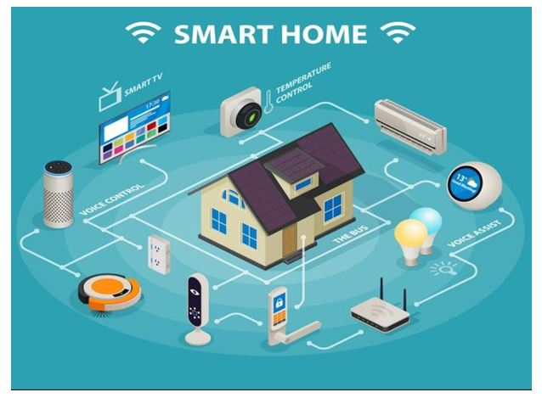
Application of Smart homes Using IOT :
- Home Automation: Home automation refers to the integration of various electronic devices and systems within a home to enable centralized control and automation of functions. With advancements in technology, particularly IoT (Internet of Things), home automation has become increasingly popular, offering convenience, energy efficiency, security enhancements, and lifestyle benefits.
Working Of Home Automation Using IOT: Home automation using IoT (Internet of Things) involves the integration of various smart devices and systems within a home, enabling centralized control, automation of tasks, and remote monitoring through internet connectivity.
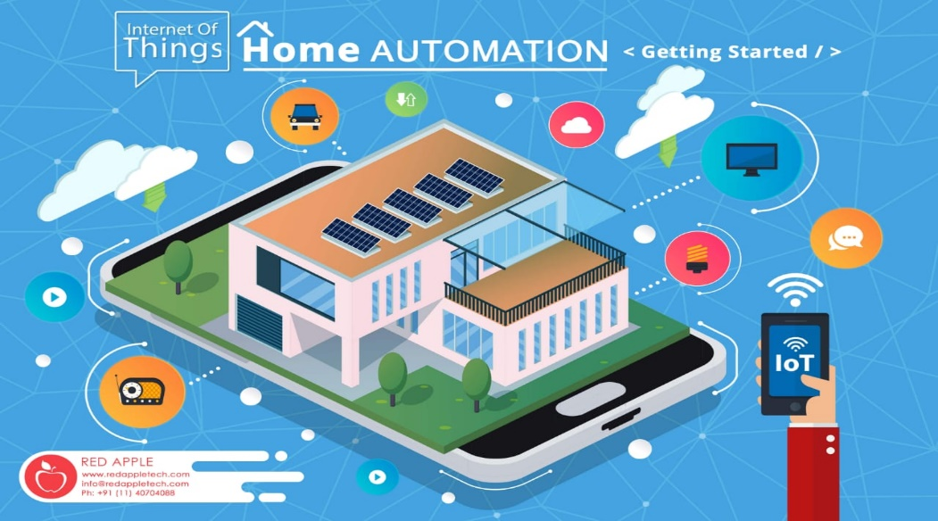
Requirements :
Network Infrastructure
Central hub or Gateway
Security Measures
User Interface
Energy Management

- Voice Assistant : Voice assistants play a crucial role in enhancing the functionality and convenience of smart homes using IoT (Internet of Things) technology. Voice assistants like Amazon Alexa, Google Assistant, and Apple Siri can control a wide range of smart devices such as lights, thermostats, smart plugs, and appliances

Working of Voice assistant using IOT : Voice assistants in smart homes utilizing IoT (Internet of Things) technology leverage a combination of voice recognition, cloud computing, and device connectivity to provide seamless control and automation.

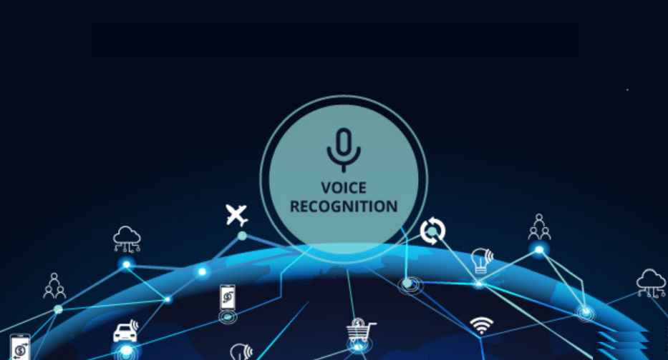
Requirements :
Microphone Array
Speaker
Processing unit
Internet connection
Communication protocols

- Security and Surveillance: Security and surveillance in smart homes using IoT integrate advanced technologies to enhance safety and monitoring capabilities. Smart locks provide remote access control and keyless entry, while surveillance cameras offer real-time video streaming and motion detection alerts. Intrusion sensors monitor doors, windows, and glass breakages, triggering alarms or notifications for unauthorized activity.
Working Of Security and surveillance Using IOT: The working of security and surveillance systems using IoT (Internet of Things) involves several interconnected components and technologies to ensure comprehensive monitoring, protection, and management of smart homes.
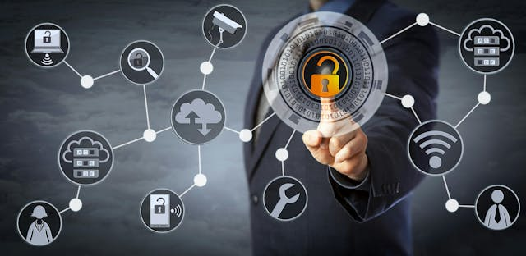
Requirements:
Smarts locks
Surveillance Cameras
Sensors
Cloud Services
Motion Sensors

- Smart TV: In smart homes using IoT, smart TVs provide enhanced connectivity and functionality by integrating with home automation systems. They allow for remote control of channels, volume, and media playback via mobile apps or voice assistants. Smart TVs can stream content from various services.
Working Of Smart TV Using IOT: Smart TVs in a smart home environment leverage IoT (Internet of Things) technology to provide an enhanced and connected viewing experience
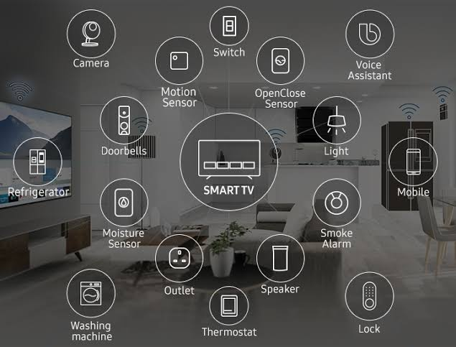
Requirements:
Wi-Fi or Ethernet
Wi-Fi/Bluetooth/Zigbee
IoT Platforms
APIs
Traditional Remote
Mobile App Control
Streaming Services
- Temperature control: Temperature control using IoT involves smart thermostats and sensors that continuously monitor and adjust indoor temperatures for optimal comfort and efficiency. These devices connect to the internet, allowing users to set and modify temperature settings remotely via mobile apps or voice commands. Smart thermostats learn user preferences and adapt heating and cooling schedules accordingly, reducing energy consumption. Integration with other smart home systems enables automated responses, such as adjusting the temperature when doors or windows are opened.
Working of Temperature Control Using IOT: Temperature control using IoT involves smart thermostats and sensors that continuously monitor and adjust indoor temperatures for optimal comfort and efficiency. These devices connect to the internet, allowing users to set and modify temperature settings remotely via mobile apps or voice commands. Smart thermostats learn user preferences and adapt heating and cooling schedules accordingly, reducing energy consumption. Integration with other smart home systems enables automated responses, such as adjusting the temperature when doors or windows are opened. Additionally, real-time alerts and reports provide insights into energy usage and system performance.
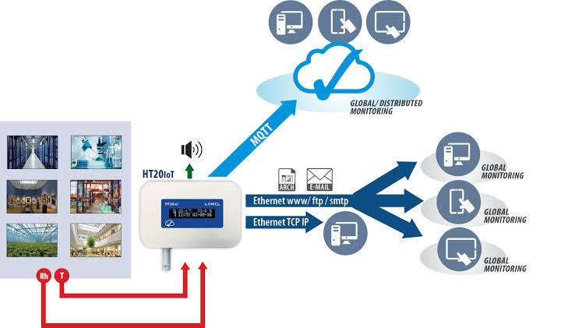
Requirement:
Connectivity
Sensors
Control Interface
Placement
Communication

Recent Improvements In Smart Cities:
Improvements in Smart Cities
- Advanced Traffic Management:
  - Real-Time Traffic Monitoring: IoT sensors and cameras collect data on traffic flow, congestion, and accidents. This data helps in real-time traffic management and optimization of traffic signals.
  - Smart Parking: IoT-enabled parking meters and sensors provide real-time information on available parking spaces, reducing time spent searching for parking and easing congestion.
- Enhanced Public Safety:
  - Smart Surveillance: High-definition cameras and IoT sensors enable better monitoring of public spaces, helping to improve safety and respond quickly to emergencies.
  - Gunshot Detection Systems: IoT-enabled acoustic sensors can detect gunshots and automatically alert authorities, aiding in faster response times.
- Improved Waste Management:
  - Smart Bins: IoT-equipped waste bins monitor fill levels and optimize waste collection routes, reducing operational costs and improving efficiency.
  - Recycling Monitoring: Sensors track recycling rates and contamination, enhancing waste sorting and recycling processes.
- Energy Efficiency:
  - Smart Grid Integration: IoT technology enables real-time monitoring and management of energy consumption across the grid, optimizing energy distribution and reducing waste.
  - Street Lighting: IoT-controlled street lights adjust brightness based on time of day and traffic conditions, leading to energy savings and extended bulb life.
- Environmental Monitoring:
  - Air Quality Sensors: IoT sensors track air pollution levels in real time, providing data to inform public health decisions and regulatory measures.
  - Weather Stations: Integrated weather sensors provide accurate, localized weather forecasts and environmental data, aiding in disaster preparedness and response.
- Public Transportation:
  - Smart Transit Systems: IoT technology enhances public transportation by providing real-time information on bus and train arrivals, tracking vehicle locations, and optimizing routes.
  - Vehicle-to-Everything (V2X) Communication: Enables vehicles to communicate with infrastructure and other vehicles to improve traffic flow and safety.
- Building Management:
  - Smart Building Systems: IoT sensors and controllers manage heating, ventilation, air conditioning (HVAC), lighting, and security systems, improving energy efficiency and occupant comfort.
  - Predictive Maintenance: Sensors monitor building systems and equipment to predict failures before they occur, reducing downtime and maintenance costs.

- Smart Water Management:
  - Leak Detection: IoT sensors detect leaks in water supply systems and notify maintenance teams, reducing water waste and preventing damage.
  - Smart Irrigation: IoT systems optimize irrigation schedules based on weather forecasts and soil moisture levels, conserving water and improving crop yields.
- Citizen Engagement:
  - Mobile Apps: Smart city apps provide citizens with real-time information on services, events, and emergencies, enhancing community engagement and service access.
  - Feedback Systems: IoT-based platforms allow residents to report issues, provide feedback, and participate in decision-making processes.
- Urban Planning:
  - Data Analytics: IoT-generated data helps city planners analyze trends and make informed decisions about urban development, infrastructure projects, and resource allocation.
  - Simulation Models: Advanced simulation models use IoT data to predict the impact of new developments and infrastructure changes.
Recent Improvements In Smart Homes:
Improvements in Smart Homes
- Home Automation:
  - Smart Lighting: IoT-enabled lighting systems allow for remote control, scheduling, and automation of lighting based on occupancy or time of day.
  - Automated Blinds: Smart blinds adjust automatically based on sunlight levels or user preferences, improving energy efficiency and privacy.
- Energy Management:
  - Smart Thermostats: IoT-controlled thermostats learn user preferences and optimize heating and cooling schedules, reducing energy consumption and costs.
  - Smart Plugs and Outlets: These devices allow users to monitor and control the power usage of plugged-in appliances remotely.
- Security and Surveillance:
  - Smart Locks: IoT-enabled locks provide keyless entry and remote access control, enhancing home security and convenience.
  - Video Doorbells: Smart doorbells with integrated cameras allow homeowners to see and communicate with visitors remotely.
- Health and Wellness:
  - Air Quality Monitors: IoT sensors detect indoor air pollutants and allergens, providing real-time data to improve indoor air quality.
  - Health Monitoring: Wearable devices and smart health gadgets track vital signs and fitness metrics, integrating with home systems to provide health insights.
- Voice Assistants:
  - Voice Control: Integration with voice assistants (e.g., Alexa, Google Assistant) allows for hands-free control of smart devices, including lights, thermostats, and entertainment systems.
  - Routine Management: Voice assistants can automate daily routines, such as adjusting the thermostat, turning off lights, or playing music.
- Home Entertainment:
  - Smart TVs: IoT-enabled TVs offer streaming capabilities, voice control, and integration with other smart home devices for a seamless entertainment experience.
  - Multi-Room Audio: IoT-connected audio systems allow users to stream music throughout the home, controlled via mobile apps or voice commands.
- Smart Appliances:
  - Connected Kitchen Appliances: Smart refrigerators, ovens, and coffee makers can be controlled remotely, and provide notifications about their status and maintenance needs.
  - Automated Cleaning: IoT-enabled vacuum cleaners and robotic mops autonomously clean floors and can be scheduled or controlled remotely.
- Water Management:
  - Leak Detectors: IoT sensors detect leaks or water damage and alert homeowners to prevent costly repairs and conserve water.
  - Smart Irrigation Systems: These systems optimize watering schedules based on weather forecasts and soil moisture, reducing water usage.
- Climate Control:
  - Smart Ventilation: IoT-controlled ventilation systems adjust airflow based on indoor air quality and temperature, enhancing comfort and energy efficiency.
  - Humidity Control: Smart humidifiers and dehumidifiers manage indoor humidity levels for improved air quality and comfort.
- Integration and Interoperability:
  - Unified Control Systems: Centralized control platforms integrate multiple smart home devices, allowing users to manage everything from a single app or interface.
  - Cross-Device Communication: Enhanced interoperability between different smart home devices and systems enables more cohesive and automated home management.

