**Json1.html**

<html>

 <body>

 <h2>Access a Javascript Object</h2>

 <p id = "demo"></p>

 <script>

 const myObj = {

 name:"John",

 age:30,

 city:"New York"

}

 document.getElementById("demo").innerHTML=myObj.age;

 </script>

 </body>

</html>

Output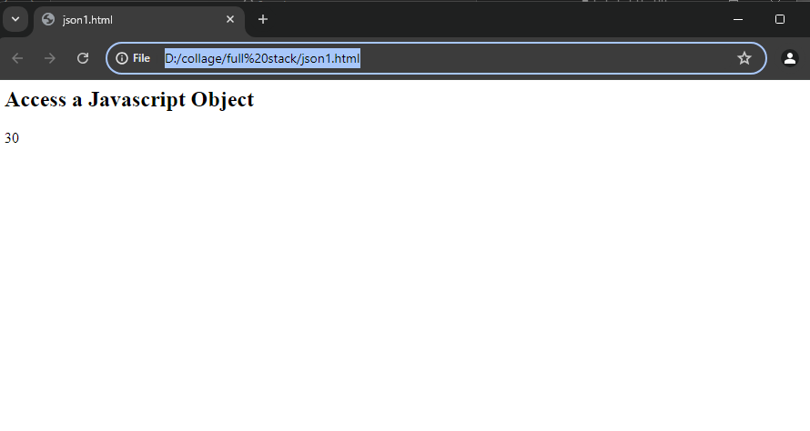

**Json2.html**

<html>

 <body>

 <h2>Creating an Object from a JSON String</h2>

 <p id="demo"></p>

 <script>

 const txt = '{"name":"John","age":30,"city":"New York"}';

 const myObj = JSON.parse(txt);

 document.getElementById("demo").innerHTML = myObj.name + " age: " + myObj.age;

 </script>

 </body>

</html>

Output

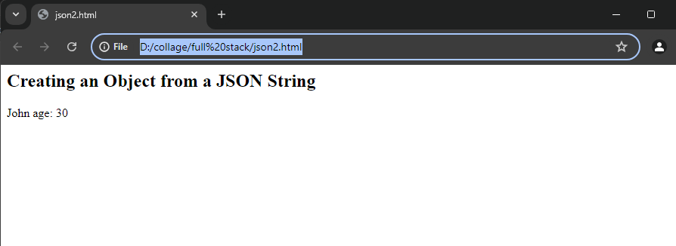

**Json3.html**

 <html>

 <body>

 <h2>Creating an String from a JSON Object</h2>

 <p id="demo"></p>

 <script>

 const student ={name:"John", age:30,city:"New York"};

 const txt = JSON.stringify(student);

 document.getElementById("demo").innerHTML = txt;

 </script>

 </body>

</html>

Output

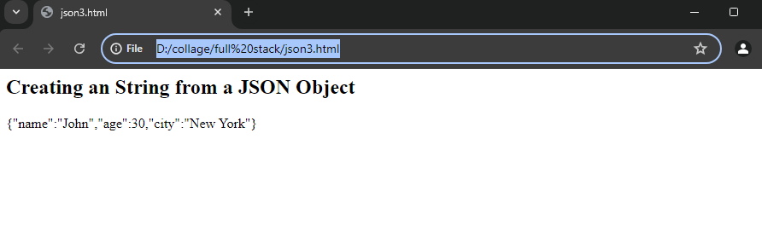

**Json4.html**

<html>

 <body>

 <h2>Creating JSON arrays</h2>

 <p id="demo"></p>

 <script>

 const myCar = ["Ford","BMW","KIA","Alto","Audi","TATA"];

 document.getElementById("demo").innerHTML = myCar[4];

 </script>

 </body>

</html>

Output

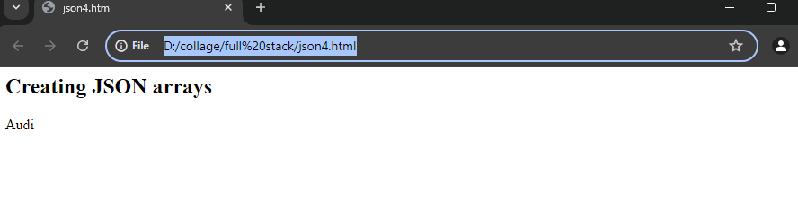

**Json5.html**

 <html>

 <body>

 <h2>Creating an Object with function</h2>

 <p id="demo"></p>

 <script>

 const Person = {

 fname: "Ajith",

 mname: "Kumar",

 lname: "Ujire",

 Dob: "12-12-2022",

 Age: "30",

 Fathername: "Suresh",

 State: "Karnataka",

 Fullname: function() {

 return this.fname + " " + this.mname + " " + this.lname;

 }

 };

 document.getElementById("demo").innerHTML = Person.Fullname();

 </script>

 </body>

</html>

Output

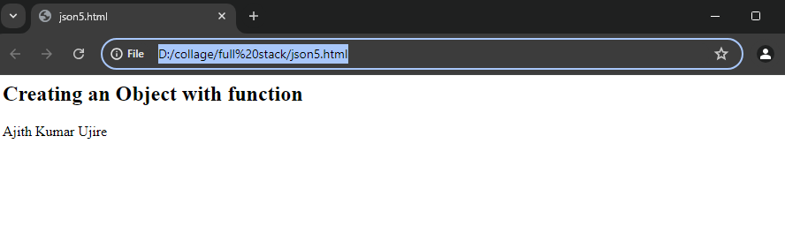

**Json6.html**

<html>

 <body>

 <h2>JSON Constructors</h2>

 <p id="demo"></p>

 <script>

 function person(first,last){

 this.fname=first;

 this.lname=last;

 }

 const myFather = new person("Kumar","Ujire");

 document.getElementById("demo").innerHTML=myFather.lname;

 </script>

 </body>

</html>

Output

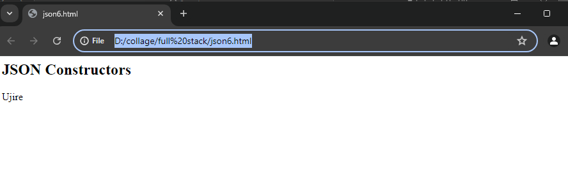

Yashwanth Gowda Mk

19/07/2024