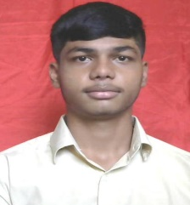

**YASHWANTH GOWDA MK**

+91 6360105919

Email Id: [mkyashwanthgowda@gmail.com](mailto:mkyashwanthgowda@gmail.com)

**OBJECTIVE**

To secure a position and be a part of progressive organization that give scope to enhance my knowledge and skills, which can be used for organization growth, personal growth and contribute to the organization success.

**EDUCATIONAL QUALIFICATIONS**

* Currently enrolled in a Diploma program in Computer Science and Engineering at Sri Dharmasthala Manjunatheshwara Polytechnic, Ujire, with anticipated graduation in 2025.
* Secondary School Leaving Certificate (SSLC), Morarji desai residential School, byakaravalli, 2022.

**TECHNICAL KNOWLDEGE & SKILLS**

* Basic Knowledge of C++ programming, Html5, CSS, Python, SQL, Hardware & Networking, Java, GitHub, React, JavaScript, Mongo DB.

**WORK EXPERIENCE**

Fresher

**PERSONAL DETAILS**

Father’s Name : KUMAR SWAMY MI

Mother’s Name : LOLAKSHI SK

Date of birth : 18-04-2006

Gender : Male

Languages Known : Kannada, Hindi, & English

**ADDITIONAL INFORMATION**

* **Hobbies** **:** travelling, watching movies,
* **Certifications** **:** html5 and css3,java features,multithreading in java.

**DECLARATION**

I here by declare that the above given information is true to the best of my knowledge and belief.

Place:

Date: (Yashwanth Gowda MK)