Priya Parameswarappa^{1*}  School of Technology  University of the Cumberlands  USA  Priya.parameswarappa@gmail.com | Taral Shah²  School of Information System  Pace Univerty  USA  Taralshah7@gmail.com | Govinda Rajulu,Lanke³  Data Science & Engineering  Birla Institute of Technology & Science  Govinda.lanke@gmail.com
A Machine Learning-Based Approach for Anomaly Detection for Secure Cloud Computing Environments

Abstract— The concept of "cloud computing" has been presented as a promising strategy for providing online service hosting and distribution. Despite the widespread adoption of cloud computing, security remains a top priority. Several secure methods have been devised to safeguard communication in such scenarios, with the majority of these solutions based on attack signatures. Unfortunately, these technologies cannot always detect every possible danger. A machine learning method was recently outlined. The judgment could be inaccurate if the training set is missing examples from a certain category. In this research, an innovative firewall strategy for safe cloud-based computing is presented using machine learning system. The proposed methods estimate the final assault category categorization by combining the judgments of the nodes from the past with the decision of the machine learning algorithm in the present, a technique termed most frequent decision. Both learning efficiency and system precision are improved by this method. Our results are based on UNSW-NB-15, a publicly available dataset. According to the evidence provided by our data, it improves anomaly detection by 97.68 percent. A Machine Learning-Based Approach for Anomaly Detection for Secure Cloud Computing Environments
Keywords— Cloud computing, cloud security Intrusion Detection System, Machine Learning-KNN, RF, DT, MLP, LR, Extra Tree and Gradient boosting, UNSW-NB-15.

I. INTRODUCTION
The term "cloud computing" refers to an advancement in technology that provides the facilities, platform, as well as software of information systems as Internet services. It is progressively being adopted by companies as private, public, or hybrid Clouds, and is believed to represent the realization of a long-standing goal known as "Computing for Use." Its primary goal is to provide consumers with the ability to utilize and pay for just the services that they need, whether those services are related to software or infrastructures[1].
2023
International Conference on Intelligent Data Communication Technologies and Internet of Things (IDCIoT) | 978-1-6654-7451-1/23/$31.00 ©2023 IEEE | DOI: 10.1109/IDCIoT
56793.2023.10053518
Cloud computing is widely recognized as a big and beneficial change in IT architecture, yet a great deal of further security work is still required to reduce the shortcomings of this technology. With so much sensitive data being kept in the cloud's data centers, it's crucial that we understand and work to mitigate the security risks inherent to using this technology. For the aforementioned reasons, cloud infrastructure may be vulnerable to attack because it uses traditional Internet protocols and is powered by virtualization. These attacks could come from more conventional sources such as the Address Resolution Protocol, IP spoofing, the Denial of Service (DoS), and similar techniques [2][3]. They could also have come from other places. For example, so-called "zeroday attacks," also known as "unknown assaults," pose a significant challenge to the cyber security industry.[4]. The conventional methods of detection and prevention are not effective enough to manage these kinds of assaults while also managing a significant amount of data flow.
Critical vulnerabilities in cloud computing include those in virtual machines, multi-tenancy, the Internet Protocol, unauthorized access to management interfaces, injection, and browser/API vulnerabilities [5, 6]. In addition to allowing network attacks and hackers to take control of access privileges, these flaws may also allow users to gain access to unlawful services and potentially expose sensitive data. All these weaknesses put the cloud in danger, either directly or indirectly, and one example of an indirect hazard is with organizations.
The potential assaults that may be launched against the Cloud need to be recognized as well as comprehended in order to defend it from the dangers that it faces and to avoid any harm. The following is a list of the attacks that are most often mentioned in relation to cloud computing[1]:
- Denial of Service (DoS) attack: is an effort to interfere with the provision of services for customers.
- Multiple computers are being used to launch a DoS attack using Distributed Denial of Service, or DDoS.
- Zombie attack: When an attacker floods the victim with requests from sites on the network unrelated to the attack. When this type of attack occurs, the Cloud does not function as it should, affecting the availability of Cloud services.
- Phishing attack: is an effort to deceive individuals into divulging their personal information in order to obtain control over them by taking them to a bogus link. To hide their own accounts and services from other Cloud customers, an adversary could be operating a Cloud service at Cloud and using it as a phishing attack website.
- Man-in-the-middle attack, where an enemy can access the communication path between two users and eavesdrop on their discussion. In the cloud, it is possible for an intruder to access information and exchanges across data centers.
Assaults that inject malware into the cloud, breaches of confidentiality, attacks on authentication, attacks on virtualization, and so on are only a few examples of the many dangers that exist in the cloud environment.
Machine learning (ML)-based methods may be useful in detecting both common and novel forms of assaults. The term "machine learning" is used to describe a class of algorithms that can detect trends and draw conclusions from large amounts of data. To improve prediction, researchers in the field of computer science known as artificial intelligence (AI) have combined statistical and other quantitative methods. [7]. It is important to note that ML encompasses not just semisupervised learning but also the other two main types of learning, supervised and unsupervised [8][9]. For supervised machine learning to be effective, it requires labelled data sets that can be utilized to build a classification model for training purposes. As the name implies, unsupervised learning allows a model to be trained without human intervention [7]. Various methods can be used to solve many different kinds of problems. An unsupervised algorithm is the K-means clustering method. Deep Learning (DL), a method that uses multi-layered models to learn data descriptions at different levels of abstraction, adds a new level to machine learning. Image processing, speech recognition, and text understanding are just some of the many areas that have benefited greatly from its use. [11].
The remaining parts of the sections are as follows: The research that is relevant is described in Section II of this paper. The methodology that was used in this study is broken out in Section III, which also outlines the overall process. The study is brought to a conclusion in Section V, which provides a few recommendations for further investigation. The results of the simulation are presented in Section IV, along with a discussion of the evaluation findings.

II. RELATED WORK
Here in this section provide the literature review of cloud data security using Machine learning techniques. Some relevant existing work discussed below:
As a result of their findings, the authors of this paper propose a cloud-based, machine learning-based DOS attack detection system [12]. To stop data packets from leaving a cloud server, this technique uses information gathered from the server's hypervisor and virtual machines. They do a comprehensive analysis of the nine most popular machine learning algorithms available today. Based on our experiments, we were able to effectively identify 99.7% of four distinct DOS assaults. No performance hit is taken with our method, and it is simple to scale up to larger distributed denial of service assaults.
The suggested model, denoted by[10], is built utilizing two machine learning algorithms to reap the benefits of collaborative filtering. This method improves the system's learning capabilities and precision. The findings are the product of training and testing the suggested SPC using a publicly accessible dataset. Based on our findings, the SPC model improves upon the detection accuracy of current machine learning techniques by 20% while maintaining a high assault detection rate.
Researchers conducted the experiment, using the CSIC 2010 HTTP dataset, which simulates user behavior on an e-commerce website. Our research shows that all machine learning algorithms can get better at finding and classifying online attacks if they use the recommended fine-tuned feature set extraction. We used metrics like precision, recall, accuracy, and F-measure to figure out how well the machine learning system could spot attacks. In terms of True Positive rate, Precision, and Recall, the J48 decision tree method is better than the other two.
In this work, we developed a system to detect DDoS attacks based on the C.4.5 algorithm in an effort to lessen their impact. When combined with signature detection methods, this strategy yields a decision tree that can be used to efficiently and attack signatures, like those used in distributed denial-of-service (DDoS) flooding attacks, automatically. We used a number of different machine learning techniques and compared how well they worked to make sure our system was reliable.
So, the use of AI, ML, and DL methods is necessary to meet the aforementioned requirements. This article uses machine learning and deep learning to explore malware, phishing, credential stuffing, as well as other cloud-based security threats. Future cloud security strategies have had their performance evaluated with regards to factors like accuracy, robust score, sensitivity, F1 score, as well as recall.
In this study, the authors suggest using the Enhanced Intrusion Detection and Classification (EIDC) system, which is a new kind of firewall, to make sure that cloud computing is safe. Using a novel combination approach termed most frequent decision, EIDC is able to recognize and classify incoming traffic packets at the nodes. To produce our findings, a publicly accessible dataset UNSW-NB-15 is employed. According to our findings, EICD is 24% more effective in spotting abnormalities than complicated tree.
The goal of this research is to find out if it is possible to use machine learning techniques to solve the problem of finding SQL injections in software. Evaluate classifier algorithms that have been trained on a variety of instances of critical and safe payloads. To determine whether an input payload contains malicious code, they evaluate it. The findings show that when it comes to dangerous payloads, these algorithms have a detection rate of 98% or higher. Additionally, machine learning algorithms for SQL injection detection are contrasted and compared.
In this paper, researchers investigate the use of a gradient boosting decision tree, in particular Light GBM, a novel and potent technique for foreseeing malware assaults on cloud-based infrastructure. Using a huge and sparse dataset given by Microsoft, we demonstrate that our method is superior to traditional machine learning techniques in predicting malware assaults using big datasets, with an accuracy of 73.89%.
In this research, researchers present an Improvised
Long Short-Term Memory (ILSTM) model that can autonomously train itself and retain behavioral data by seeing and learning from a user's actions. Whether a user's actions are typical or unusual is a simple matter for the model to determine. The suggested ILSTM not only detects an out-ofthe-ordinary node, but also determines, with the help of the computed trust factor, whether the offending node is a faulty one, a node belonging to a new user, or a hacked node. The suggested methodology not only efficiently identifies attacks, but also lessens the number of false positives in cloud infrastructures.

III. RESEARCH METHODOLOGY

3.1 Proposed Methodology
Cloud computing is used in a wide variety of academic subjects due to its high level of processing power as well as its capacity for network storage. The possibility of working from anywhere in the world, data privacy and security, and other perks like these are just a few of the reasons why today's remote workers find this technology to be so appealing. Servers that are used for cloud computing should now be able to defend themselves more effectively against assaults and provide an additional layer of security by preventing the formation of new threats. Our research into cloud security led to the creation of a cutting-edge intrusion detection model that makes use of deep learning and machine learning.
This research starts with the data collection process, so we have used UNSW-NB15 Dataset. The applied data preprocessing techniques for the check null value and missing values. After this applied feature selection with the help of Kbest Feature Selection (K-FS). Finally applied classification techniques that is LR, KNN, DT, RF, Extra Tree, and Gradient Boosting.
Data Collection: We utilized the UNSW-NB15 Dataset for this project. The network intrusion detection data set, UNSWNB15, is created by analyzing and analyzing diverse network connection data. The data set is organized into nine attack categories and one normal conduct category, with each data flow including 47 characteristics.
The UNSW dataset, released in 2015, has 10 separate traffic packet types and therefore is more suitable for use in contemporary anomaly detection systems than the prior datasets. “Analysis, backdoors, denial-of-service (DoS), denial-of-service (Exploits), fuzzers, reconnaissance, shell code, as well as worms all play a role. Table I shows the notation used in the research. UNSW-NB-15 is composed of two parts: a model training set (UNSW-NB-15 trainingset.csv) as well as a model testing set (UNSW-NB-15testingset.csv). The testing and training sets are made up of 175,341 and 82,332 records, respectively”.
TABLE I: CLASSES NOTATION
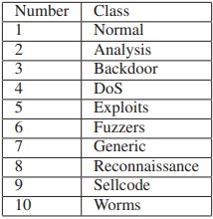
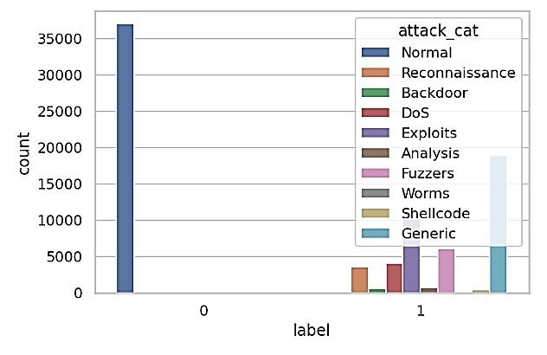
Figure 1: Label of input dataset
The label of an input dataset is shown in Figure 1. This dataset has 10 unique categories, as seen in the graph above. In machine learning, dataset labelling is the process of labelling raw data. The label defines the data in the line item. Labels have an important part in the execution of reports and apps.
Data Preprocessing: The task of preparing the dataset comes within the purview of the "Data Preprocessing" stage of the process that is also known as machine learning or deep learning. The handling of missing data and imbalances between classes are both taken into consideration by this method. The first thing you should focus on doing at this point in time is resolving the issue of missing values. The circumstance in which the anticipated values of the data are not obtained is referred to as "missing values," and the term "missing values" is used to describe the situation. As was said before, several of the columns in the dataset do not have any values associated with them.
Feature Selection: After the initial processing of the data, the next step is feature selection. Beginning with the FS stage of the process is the beginning of the process, and it is a key aspect of the process of creating categorization models. It is crucial to develop methods for selecting which characteristics are considered most important. If you use a feature selection technique, it is possible to construct robust learning models by only deleting data points that are unnecessary or redundant.
This may be done using. In this investigation, the K-best Feature Selection (K-FS) method was used for the feature selection process, and only the most significant ones were chosen.
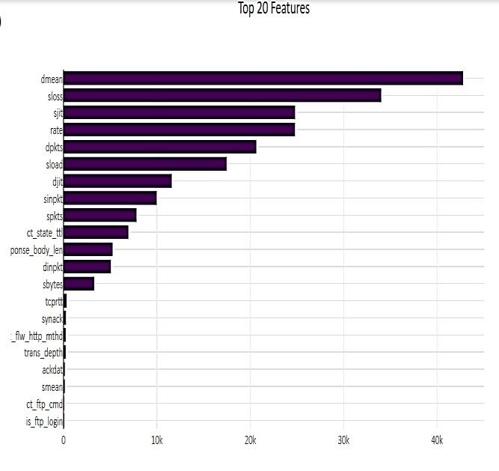
Figure 2: Select k-best features
The graph of some of the K-best features is shown up there in figure 3, which can be found above. We choose the top 20 characteristics, which are shown along the y-axis of the graph; the x-axis indicates the total number of values for the characteristics. The Select Best method selects features by looking at which ones have the k highest score.
Classification: In the field of machine learning, classification is an example of supervised learning, which is a kind of learning in which the goals of the learning process are explicitly supplied together with the input data. In order to make data more manageable, the technique of classification may be used to data that is either organized or unstructured. Both of these diverse sorts of data may be classified in their own unique ways. A presumption on the kind of the data that will be examined serves as the framework for the approach. In this study, we used six machine learning techniques that is Logistic Regression, K-Nearest Neighbor, Decision Trees, Extra Trees Classifier, random forest, gradient boosting, and Multilayer Perceptron layers.

3.2 Proposed Algorithm

Install Python and create environment
Import python libraries like numpy, pandas, matplotlib, seaborn, Sk-learn etc.

Step 1: Input UNSW-NB15 Dataset
Step 2: Apply data preprocessing that check missing value, drop irrelevant features etc.
Step3: Apply feature selection with the K-best features.
Step 4: Data split into training (80%) and testing dataset (20%)
Step 5: Implement machine learning techniques for the classification (LR, KNN, DT, ET, RF, GB, and MLP) Step 6: Evaluate performance matrix (Acc, Recall, Precision and F1 score) Step 7: Predicated Outcome

IV. RESULTS AND DISCUSSION
This part presents the results and also give a complete analysis of the model. Python is used throughout the whole of the experiment's process. This section provides a description of the dataset, as well as its metrics, parameters, and the results of any experiments carried out. Within the scope of this proposed piece of work, the programming language of Python as well as the platform of the Jupiter notebook have been examined and evaluated. The results of the experiment are presented using a number of different graphs, as well as metrics or tables. The results of the experiment are going to be investigated further and in more depth in the next phase. Utilized a comprehensive selection of separate performance matrices (described below). Because this investigation made use of a dataset, which will be discussed in more detail in the following paragraphs, it was feasible for these conclusions to be derived from the investigation

A. Performance Measures
In the process of putting machine learning into practice, one of the most significant jobs is assessing the effectiveness of various algorithms. All the extensive experiments were evaluated using several metrics where each metric has a different meaning of evaluation. The evaluate the results are described accuracy, precision, recall, and f1score.
1) Confusion Matrix
A confusion matrix is a matrix that provides a graphical representation of the performance of an algorithm. Following the training phase, the classifier will be validated using the real data. Using a confusion matrix, one may get an idea of the likelihood that will be achieved in the future. An examination of the accuracy, precision, and recall is carried out using the equations that are provided below. And shown via each of the many different kinds of assaults.
- “True Positive: The classifier predicts properly that an occurrence is positive.
- False Positive: The classifier incorrectly classifies the negative examples as positive.
- True Negative: Considered examples are negative & are accurately categorized as such”.
- False Negative: Though considered events were all positive, classifier incorrectly labelled them as neutral.
Precision: The fraction of potential threats that actually turn out to be threats is referred to as precision, which is also known as positive predictive value. The proportion of projected anomalous occurrences that turn out to be real anomalous occurrences.
Precision = 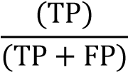 … (2)
Recall: The measurement of the percentage of positive records that can be recognized accurately is referred to as recall. the ratio of the number of attacks that were anticipated to the total number of attacks that were carried out.
Recall = 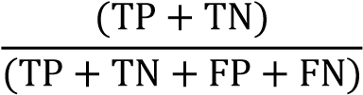 … (3)
F-score: The F1-score is the harmonic mean of the accuracy and recall measurements (what was formerly known as the "detection rate"). It provides an indication of how accurate the classifier is as well as the percentage of data points that it is taking into consideration.
2 × Precision × Recall
F1 − Score = … (3)
(Precision + Recall)
Accuracy: Accuracy can be thought of as the fraction of correctly identified outcomes (attack and normal traffic). Accuracy in multiclass classification is represented by the Jaccard index, which is the ratio of the intersection size to the union label set size.
Accuracy = 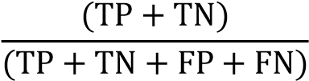 … (4)

A. Experimental Results
An investigation of each of the metrics that were included in the practical application of the suggested treatment was carried out while the experimental testing was being carried out. In this section of the text, we will accomplish the desired end result in a variety of different methods.
1) Classification results of Logistic Regression
Classifier
LR is a method of Supervised Machine Learning that is used in the resolution of classification issues. In order to solve these difficulties, we need to make use of independent variables, which will allow us to divide the dependent variable into a number of different groups. Logistic regression is one method that may be utilized to find out the results of a dependent variable that is categorical. As a result, it is imperative that one acquires a value that is either categorical or discrete as a consequence. It is not impossible for it to be either True or False, 0 or 1, True or False, etc.; nevertheless, rather than giving the precise outcome as 0 or 1, it offers probability values that range between 0 and 1.
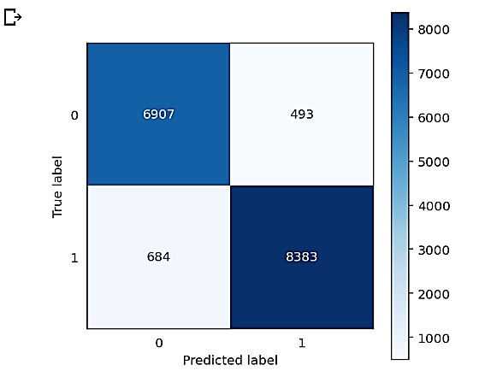
Figure 3: Confusion matrix of Logistic Regression Classifier
The fallowing LR matrix figure 4 shows the TN of 6907, TP of 8383 while FN is 493 and FP is 684, respectively. In the figure x-axis are show the predicted label and in the y-axis are show true label of data.
TABLE II PERFORMANCE OF LR MODEL
Parameters | Logistic Regression Classier
Accuracy | 92.85
Precision | 92.85
Recall | 92.89
F1-Score | 92.86

Figure
4
Bar graph of LR performance
:

92.8
5
92.8
5
92.89
92.86
92.83
92.84
92.85
92.86
92.87
92.88
92.89
92.9
Accuracy
Precision
Recall
F1-Score
in %
Parameter
Logistic Regression Classier
The above figure 5 and table 2 shows the LR model performance. The LR accuracy and precision 92.95%, recall is 92.89% and f1-score is 92.96% respectively. In bar graph xaxis shows the performance parameters and y-axis shows the parameter percentage.
2) Classification results of KNN Classifier
The K-Nearest Neighbour algorithm is a simple pattern recognition algorithm that divides things into sets based on their proximity in the element space. The number in question will be assigned to the appropriate category based on how the new vector perceives it. New types of vectors can be created by employing a subset of the qualifying data. Giving newly created vectors to the most populous class.
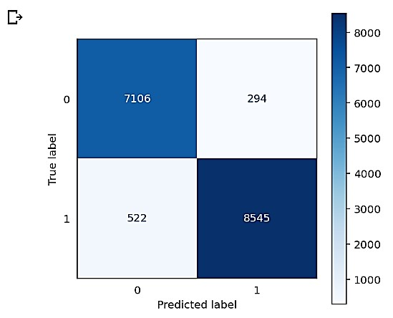
Figure 5: Confusion matrix of KNN Classifier
The fallowing KNN matrix figure 6 shows the TN of 7106, TP of 8545 while FN is 294 and FP is 522, respectively.
TABLE III: PERFORMANCE OF KNN MODEL
Parameters | KNN classifier
Accuracy | 95.04
Precision | 95.04
Recall | 95.09
F1-Score | 95.05

95.0
4
95.0
4
95.09
95.05
95
95.02
95.04
95.06
95.08
95.1
Accuracy
Precision
Recall
F1-Score
in%
Parameters
KNN classifier
Figure 6: Bar graph of KNN performance
The above figure 7 and table 3 shows the KNN model performance. The KNN accuracy and precision 95.04%, recall is 95.09% and f1-score is 95.05% respectively. In bar graph xaxis shows the performance parameters and y-axis shows the parameter percentage.
3) Classification results of Decision Tree
To solve regression and classification issues, supervised learning methods, such as Decision Trees, are often used. Successful implementation of this method relies on the decision tree's application of the binary tree to the problem of predicting the value of a target variable. The outside nodes represent attributes, whereas the interior nodes represent classes, as seen in this decision tree. " If-then-else clauses are common in decision rules. As the number of rules and branches in a tree grows, so does the model's ability to accurately predict outcomes.
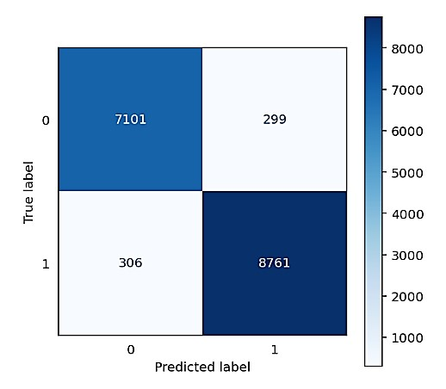
Figure 7: Confusion matrix of Decision Tree Classifier
The fallowing DT matrix figure 8 shows the TN of 7101, TP of 8761 while FN is 299 and FP is 306, respectively.
TABLE IV: PERFORMANCE OF DT MODEL
Parameters | DT classifier
Accuracy | 96.33
Precision | 96.33
Recall | 96.33
F1-Score | 96.33

Figure
8

:
Bar graph
of
DT

Classifier

96.33
96.33
96.33
96.33
0
20
40
60
80
100
120
Accuracy
Precision
Recall
F1-Score
in %
Parameters
DT classifier
The above figure 9 and table 4 shows the DT model performance. The DT accuracy, precision, recall and f1-score is 96.33% respectively. In bar graph x-axis shows the performance parameters and y-axis shows the parameter percentage.
4) Classification results of Extra Tree
The ensemble learning method, the Extremely Randomized Trees Classifier (or Extra Trees Classifier) generates its classification performance by combining the results of many independent decision trees into a single total result. This class gives a working example of a meta-estimator, a technique that fits several random-sample decision trees (sometimes called extra-trees) to distinct parts of a dataset in order to improve predictive accuracy and limit over-fitting.

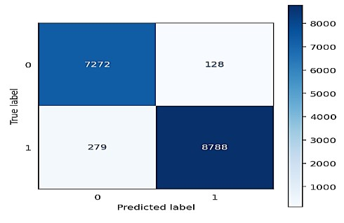
Figure 9: Confusion matrix of Extra Tree Classifier
The fallowing ET matrix figure 10 shows the TN of 7272, TP of 8788 while FN is 128 and FP is 279, respectively.
TABLE V PERFORMANCE OF ETC MODEL
Parameters | Extra Tree classifier
Accuracy | 97.53
Precision | 97.53
Recall | 97.53
F1-Score | 97.53

Figure 10: Bar graph of ETC Classifier

97.53
97.53
97.53
97.53
0
20
40
60
80
100
120
Accuracy
Precision
Recall
F1-Score
in%
Parameters
Extra Tree classifier
97.68
97.68
97.68
97.68
0
20
40
60
80
100
120
Accuracy
Precision
Recall
F1-Score
in %
Parameter
RF classifier
The above figure 11 and table 5 shows the ETC model performance. The ETC accuracy, precision, recall and f1-score is 97.53% respectively. In bar graph x-axis shows the performance parameters and y-axis shows the parameter percentage.
5) Classification results of Random Forest Since RF is a classifier that can be applied to tree-defined collections, the input x variable of each tree acts as the unit for that classification. Because of this, RF is also referred to as a tree-based classifier. Every possible number of randomly produced vectors may be dispersed in this system. Random forest usually works well. In addition to numeric and binary data, the system can also handle nominal data.
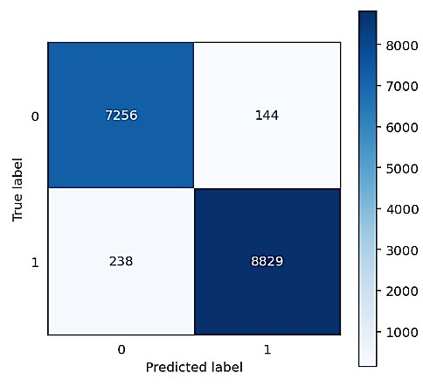
Figure 11: Confusion matrix of Random Forest Classifier
The fallowing RF matrix figure 10 shows the TN of 7256, TP of 8829 while FN is 144 and FP is 238, respectively.
TABLE VI: PERFORMANCE OF RF MODEL
Parameters | RF classifier
Accuracy | 97.68
Precision | 97.68
Recall | 97.68
F1-Score | 97.68
Figure 12: Bar graph of RF Classifier
Figure 13 and Table 6 are show how well the RF model works. The RF accuracy, recall, precision, and f1-score are all 97.68%. The x-axis of a bar graph shows the performance parameters, while the y-axis shows the percentage of each parameter.

6) Classification results of Gradient boost Classifier
Using gradient boosting classifiers, we can combine many less accurate models into one accurate prediction model. Decision trees are often used in gradient boosting. Gradient boosting is a greedy method, hence it often overfits the data used for training. In order to improve algorithm's overall performance by reducing overfitting, it might make use of regularization algorithms that reprimand certain parts of process.
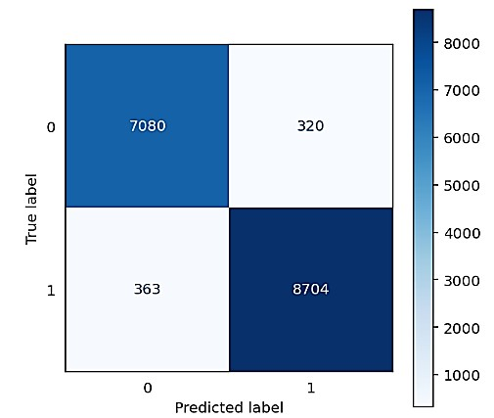
Figure 13: Confusion matrix of Gradient boost Classifier
The fallowing GB matrix figure 14 shows the TN of 7080, TP of 8704 while FN is 320 and FP is 363, respectively.
TABLE VII PERFORMANCE OF GB MODEL
Parameters | GB classifier
Accuracy | 95.85
Precision | 95.85
Recall | 95.86
F1-Score | 95.85

GB classifier
95.865
95.86
95.8 |  | 5 95.8 |  | 5 |  | 95.85
95.86
95.855
in%
95.85
95.845
Accuracy Precision Recall F1-Score
Parameter
Figure 14: Bar graph of GB Classifier
“The above figure 15 and table 7 shows the GB model performance. The GB accuracy, precision, recall and f1-score is 95.85 and 95.86% respectively. In bar graph x-axis shows the performance parameters and y-axis shows the parameter percentage”.
7) Classification results of MLP
“In the realm of artificial neural networks (ANN), a multilayer perceptron (MLP) is one example. Even the most basic multilayer perceptron (MLP) has at least these three layers of nodes: input, hidden, and output”. Everyone knows that the MLP can solve this problem. But in an open set problem, the classifier might be presented with information that does not fit any of the known categories. Since the issue has an open set, we can do this. In this case, the classifier must determine whether or not the input data belong to a given set of classes, in addition to classifying them within those classes. Despite its common application to open set problems, the MLP has been shown to be unreliable when it comes to the identification of non-class data.
.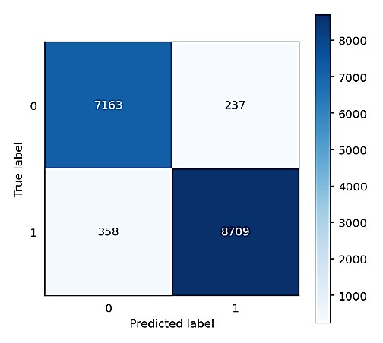
Figure 15: Confusion matrix of MLP Classifier
The fallowing MLP matrix figure 16 shows the TN of 8709, TP of 8709 while FN is 237 and FP is 358, respectively.

TABLE VIII PERFORMANCE OF MLP MODEL
Parameters | MLP classifier
Accuracy | 96.39
Precision | 96.39
Recall | 96.39
F1-Score | 96.39

96.39
96.39
96.39
96.39
0
20
40
60
80
100
120
Accuracy
Precision
Recall
F1-Score
in%
parameter
MLP classifier
Figure 16: Bar graph of MLP Classifier
The above figure 17 and table 8 shows the MLP model performance. The MLP accuracy, precision, recall and f1score is 96.39% respectively. In bar graph x-axis shows the performance parameters and y-axis shows the parameter percentage.

V. CONCLUSION AND FUTURE WORK
The prevention of intrusion is regarded as the core of cloud security. Despite the significant amount of work that has been put into cloud intrusion detection over the last decade, the establishment of a cloud-based intrusion detection system that utilizes an adequate intrusion detection approach is still sought. In the course of this study, an innovative firewall that has been given the name machine learning and deep learning system has been constructed in order to provide a cloud environment that is secure. The suggested method employs a new combination strategy that draws on past decisions and current ones to enhance hazardous user detection and classification. The results of the simulation showed that this method is superior to the traditional learning method in terms of its ability to identify attacks. Furthermore, it has the potential to improve classification accuracy from 95 percent to as high as 97 percent. In further research, we will investigate more complex approaches for profiling normal packets, with the goal of improving classification performance via the use of techniques such as data mining and data classification by deep learning.

VI. REFERENCES
- A. B. Nassif, M. A. Talib, Q. Nasir, H. Albadani, and F. M. Dakalbab, “Machine Learning for Cloud Security: A Systematic Review,” IEEE Access. 2021. doi: 10.1109/ACCESS.2021.3054129.
- B. Xu, S. Chen, H. Zhang, and T. Wu, “Incremental k-NN SVM method in intrusion detection,” 2018. doi:
10.1109/ICSESS.2017.8343013.
- R. Moreno-Vozmediano, R. S. Montero, E. Huedo, and I. M.
Llorente, “Efficient resource provisioning for elastic Cloud services based on machine learning techniques,” J. Cloud Comput., 2019, doi: 10.1186/s13677-019-0128-9.
- A. Aleroud and G. Karabatis, “A contextual anomaly detection approach to discover zero-day attacks,” 2012. doi:
10.1109/CyberSecurity.2012.12.
- C. Modi, D. Patel, B. Borisaniya, A. Patel, and M. Rajarajan, “A survey on security issues and solutions at different layers of Cloud computing,” J. Supercomput., 2013, doi: 10.1007/s11227-012-0831-
5.
- M. T. Khorshed, A. B. M. S. Ali, and S. A. Wasimi, “A survey on gaps, threat remediation challenges and some thoughts for proactive attack detection in cloud computing,” 2012. doi:
10.1016/j.future.2012.01.006.
- N. Chand, P. Mishra, C. R. Krishna, E. S. Pilli, and M. C. Govil, “A comparative analysis of SVM and its stacking with other classification algorithm for intrusion detection,” 2016. doi: 10.1109/ICACCA.2016.7578859.
- J. Arshad, P. Townend, and J. Xu, “A novel intrusion severity analysis approach for Clouds,” Futur. Gener. Comput. Syst., 2013, doi: 10.1016/j.future.2011.08.009.
- D. Kwon, H. Kim, J. Kim, S. C. Suh, I. Kim, and K. J. Kim, “A survey of deep learning-based network anomaly detection,” Cluster Comput., 2019, doi: 10.1007/s10586-017-1117-8.
- M. Ahsan and K. E. Nygard, “Convolutional neural networks with LSTM for intrusion detection,” 2020. doi: 10.29007/j35r.
- L. H. Fang and D. Yonggui, “Human Machine Integrated Interactions and Internet of Things,” Journal of Machine and Computing, pp. 172–178, Oct. 2021.
.[12] Z. He, T. Zhang, and R. B. Lee, “Machine Learning Based DDoS Attack Detection from Source Side in Cloud,” 2017. doi:
10.1109/CSCloud.2017.58.

