Project Summary

|  |  |
| --- | --- |
| Batch details |  |
| Team members |  |
| Domain of Project |  |
| Proposed project title |  |
| Group Number |  |
| Team Leader |  |
| Mentor Name |  |

**Dataset name**

**Introduction to the problem/domain/background details:** In this you can inform about the background of the domain, the introduction you would like to give before working on the data. Any prior business information or facts that you collected.

**Problem Statement:** What is the problem that you will be solving

**Business problem/ Impact in business of your problem/Need for this study/Abstract (Executive summary):** Explain the need of solving this problem.Explain how important to solve this problem in the industry in general or specific to the current business in question. Elaborate what kind of impact does this problem have on current business in question. Make sure the abstract should contain details on expected business outcome after solving the current problem statement.

**Variable identification**: Independent variables and Target

**Variable information/Data description:** Provide the data dictionary and make sure each and every variable is briefly explained with all relevant details, moreover see if we can categorize the variables into different groups (if required).

**Future Work/Methodology (Details of algorithms):** Ideas of the upcoming work that you would be doing/ Steps to be done in further analysis/Methodology to go ahead with. Using CRISP-DM life cycle, elaborate each step (e.g., BUSINESS UNDERSTANDING, DATA UNDERSTANDING, DATA PREPARATION, MODEL BUILDING, MODEL EVALUATION, ETC...) from the life-cycle and provide details relevant to our current project and how you would like to execute each step individually in brief.

**Timeline Chart (Weekly plan):** Tentative weekly plan that you will be following. E.g. as shown below.

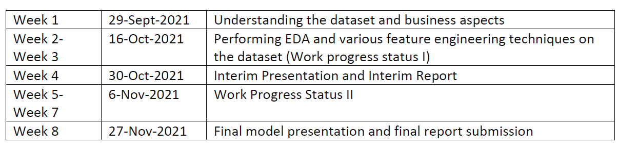

Note: Please don’t plagiarize the content. Kindly make use of your original thoughts and descriptions as applicable.

**Extra information(optional):** Any extra information that you want to give about your data like any data curation you have done or merging some data, or any analysis that is already over.

**References (Data set source/Journals/articles)**

**Declaration: This is to declare that the dataset that we are using for our capstone project does not have any relevant legality associated to it** **and can be used to showcase the work we do on it as a presentation in Great Learning.**

**Marking Scheme (Only for reference, please remove it during preparation):**

|  |  |  |
| --- | --- | --- |
|  | **Rubrics** | |
| [S.no.](http://s.no/) | Component | Marks |
| 1 | Problem statement /Intro | 2 |
| 2 | Abstract (Executive summary)/Data information | 2 |
| 3 | Methodology (Details of algorithms) | 2 |
| 4 | Timeline chart (Weekly plan) | 2 |
| 5 | References (Data set source/Journals/articles | 2 |