**SPECIFICATION DOCUMENT:**

**Introduction:**

The project is titled as Lockedme.com. The main motto of the project is to digitalize their products. Hence, they choose Lockedme.com as the first project to begin with. The prototype of this application is presented to the relevant stakeholders for budget approval.

**PLANNING DOCUMENT:**

Plan more than two sprints to complete the application.

Document the step-by-step process starting from sprint planning for the product release.

**PRODUCT BACKLOG:**

* **USER STORIES**
  1. Display the welcome screen
  2. Option to Retrieve the file names in an ascending order
  3. Option to add a user specified file to the application
  4. Option to delete a user specified file from the application
  5. Option to search a user specified file from the application
  6. Navigation option to close the current execution context and return to the main context
  7. Option to close the application

**SPRINT 1**

**SPRINT BACKLOG**

To add the following functionality to the application:

1. Display the welcome screen
2. Option to Retrieve the file names in an ascending order
3. Option to add a user specified file to the application
4. Option to delete a user specified file from the application

**SPRINT PLANNING MEETING**

* USER STORIES INTO TECHNICAL TASKS
  1. Display the welcome screen
     + Application name and the developer details
     + The details of the user interface such as options displaying the user interaction information
     + Features to accept the user input to select one of the options listed
  2. Option to Retrieve the file names in an ascending order
     + The first option should return the current file names in ascending order. The root directory can be either empty or contain few files or folders in it.

**SPRINT 2**

Option to add a user specified file to the application

* + - The second option should return the details of the user interface such as options displaying the following:

Add a file to the existing directory list.

You can ignore the case sensitivity of the file names.

**SPRINT 3**

Option to delete a user specified file from the application

* + - The second option should return the details of the user interface such as options displaying the following:

Delete a user specified file from the existing directory list.

You can add the case sensitivity on the file name in order to ensure that the right file is deleted from the directory list.

Return a message if FNF (File not found).

* DEFINITION OF DONE

All the features in the sprint backlog would be considered done when all the relevant test cases have been passed.

* CAPACITY FOR THE SPRINT

Sprint capacity = 8hrs per day X 5 days X 1 = 40 hours

**SPRINT 4**

**SPRINT BACKLOG**

To add the following functionality to the application:

1. Option to search a user specified file from the application
2. Navigation option to close the current execution context and return to the main context
3. Option to close the application

**SPRINT PLANNING MEETING**

* USER STORIES INTO TECHNICAL TASKS
  1. Option to search a user specified file from the application
     + The second option should return the details of the user interface such as options displaying the following:

Search a user specified file from the main directory.

You can add the case sensitivity on the file name to retrieve the correct file.

Display the result upon successful operation.

Display the result upon unsuccessful operation.

* 1. Navigation option to close the current execution context and return to the main context.
     + The second option should return the details of the user interface such as options displaying the following:

Option to navigate back to the main context

* 1. Option to close the application
     + There should be a third option to close the application.
* DEFINITION OF DONE

All the features in the sprint backlog would be considered done when all the relevant test cases have been passed.

* CAPACITY FOR THE SPRINT

Sprint capacity = 8hrs per day X 5 days X 1 = 40 hours

**Algorithm:**

Step1: Ask for User choice

Step 2: If user choice is 1, then retrieve files from the current directory

Step 3: If user choice is 2, then give the user options to add, delete, search or return to the main menu.

Step 4: If user choice is 3, exit the application.

Step 5: When the user choice is 2 in Step 2, and then choice is 1, add a user specified file

Step 6: When the user choice is 2 in Step 2, and then choice is 2, delete a user specified file

Step 7: When the user choice is 2 in Step 2, and then choice is 3, search a user specified file

Step 8: When the user choice is 2 in Step 2, and then choice is 4, go back to the main menu.

**Flowchart:**

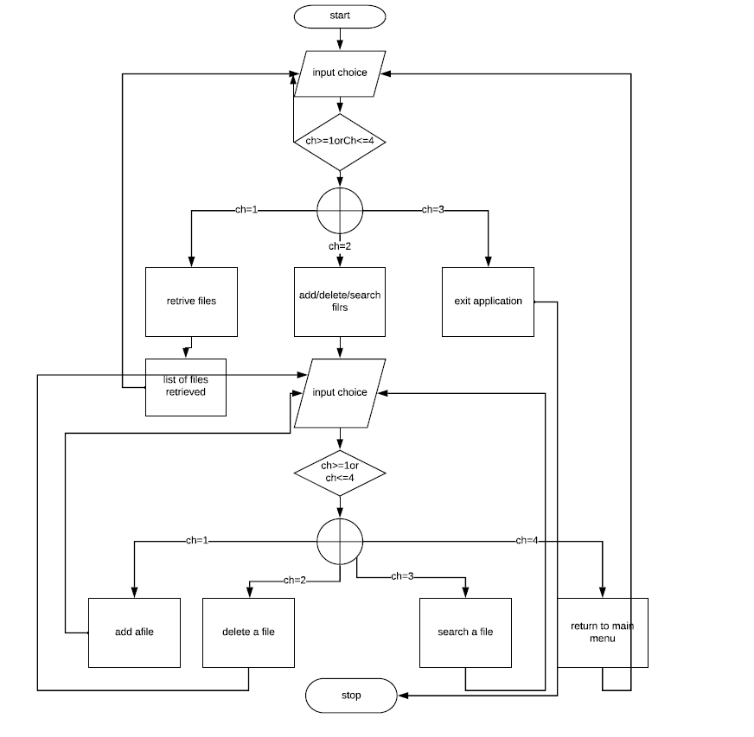

**CORE CONCEPTS USED IN THIS PROJECT:**

Arrays.sort method is used to provide ascending order to the list of files when retrieved.

File class is used for all the file operations in the application.

Separate presentation layer and persistence layer is used in the application.

**Presentation layer classes:**

MainClass.java

This the main class which is the entry point of the application.

**Persistence Layer:**

BusinessLevelOperations.java

This is the data access object interface which has all the methods for file operations like add, delete, and search.

FileInterface.java

This is the implementation of file operations interface.

**Github Repositry Link:**

https://github.com/yashwanthshanigaram/LockedMeProject.git

**Conclusion:**

Further this prototype can be enhanced by adding a “chooser dialog box” for the user to choose the directory. When adding a new file, we are currently adding blank files. We can enhance this functionality by providing user specified user contents to the file.