Simplilearn phase 2 Project

Learner Academy

By yashwanth

*Problem Statement:*

Learner’s Academy is a school that has an online management system. The system keeps track of its classes, subjects, students, and teachers. It has a back-office application, The administrator can:

* Set up a master list of all the subjects for all the classes
* Set up a master list of all the teachers
* Set up a master list of all the classes
* Assign classes for subjects from the master list
* Assign teachers to a class for a subject (A teacher can be assigned to different classes for different subjects)
* Get a master list of students (Each student must be assigned to a single class)

There will be an option to view a Class Report which will show all the information about the class, such as the list of students, subjects, and teachers

The goal of the company is to deliver a high-end quality product as early as possible.

**Tools used:**

|  |  |
| --- | --- |
| **Programming language** | **Java, Hibernate** |
| **IDE** | **Eclipse** |
| **Database** | **MYSQ** |
| **API** | **POSTMAN** |
| **Methodology** | **Agile-Scrum-Jira** |

Sprints and user stories

**Sprint 1:**

**User Story-1**: as an administrator, I want to have have an option create list of students,teachers,classes,subjects so that I can create a master list of all students.

**User Story-2:** as an administrator, I want to have an option to view the list of all created students,subjects,teachers,classes by id.

**Sprint 2:**

**User Story-3**: as an administrator, I want to assign classes,students,subjects,teachers among them

**Sprint 3:**

**User Story-4**: as an administartor, I want to have an option to update the list of students,teachers,subjects,classes.

**Sprint 4:**

**User Story-5:** as an administrator,I want to have an option to delete the list of students,teachers,subjects,classes.

**FLOWCHART:**

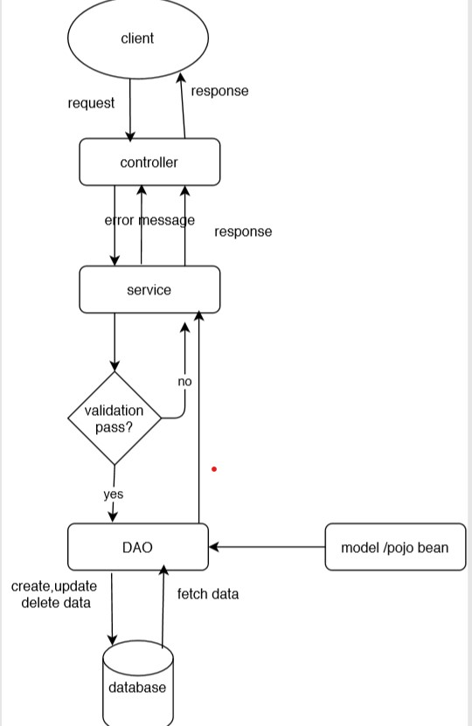

ENTITY RELATION TABLES

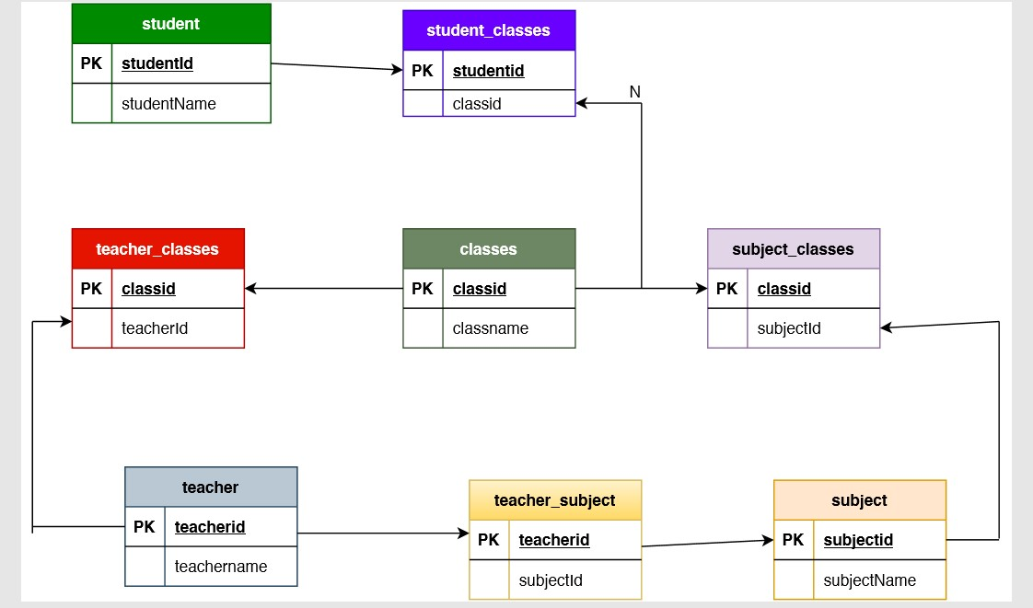

**Project Requirement and Verification in POSTMAN Tool:**

|  |  |  |  |
| --- | --- | --- | --- |
| **Project Requirement** | | **Verifying in POSTMAN tool** | |
| **S.No.** | **Requirement** | **HTTP Method** | **Request URL** |
| 1 | Set up a master list of all the subjects | GET | <http://localhost:8080/Learner_Academy/Subject> |
| 2 | Set up a master list of all the teachers | GET | <http://localhost:8080/Learner_Academy/Teacher> |
| 3 | Set up a master list of all the classes | GET | <http://localhost:8080/Learner_Academy/Classes> |
| 4 | Assign subject for class | GET | <http://localhost:8080/Learner_Academy/Classes> |
| 5 | Assign teacher to subject | GET | <http://localhost:8080/Learner_Academy/Classes> |
| 6 | Get a master list of students | GET | http://localhost:8080/Learner_Academy/Student |
| 7 | An option to view a Class Report which will show all the information about the class, such as the list of students, subjects, and teachers | GET | http://localhost:8080/Learner_Academy/Classes |

***GitHub Repository:***

***All the project related files are uploaded to the below GitHub repository.***

***https://github.com/yashwanthshanigaram/learner.git***

***Note: The data in the database might be different from the screenshots, as few data were modified for testing purpose after taking screenshot. This project specification document is uploaded to below GitHub Repository in both .doc and .pdf extensions.***