Simplilearn phase 3 Project

Learner Academy

By yashwanth

***Problem Statement:***

Sporty Shoes is a company that manufactures and sells sports shoes. They have a walk-in store, and now, they wish to launch their ecommerce portal sportyshoes.com.

You’re asked to develop a prototype of the application. It will be then presented to the relevant stakeholders for budget approval. Your manager has set up a meeting where you’re asked to do the following:

● Presenting the specification document which has the product’s capabilities, appearance, and user interactions  
● Setting up Git and GitHub account to store and track your enhancements of the prototype   
● Explaining the Java concepts used in the project   
● Discussing the generic features of the product:  
● There will be an admin to manage the website. An administrator login will be required to access the admin page.

**The admin should be able to change his password if he wants, he should be able to:**

● Manage the products in the store including categorizing them  
● Browse the list of users who have signed up and be able to search users  
● See purchase reports filtered by date and category

Sprints and user stories

**Sprint 1:**

**User Story-1**: as an administrator, I want to have an option create list of Users and the Products and so that I can create a master list of all users and the products.

**User Story-2:** as an administrator, I want to have an option to view the list of all the Users and the Products by id or all of the list at once.

**Sprint 2:**

**User Story-3**: as an administrator, I want to have an option to delete users and products bi id.

**Sprint 3:**

**User Story-4**: as an administrator, I want to have an option to map the purchased products to the users and report the analysis by date and category.

**Sprint 4:**

**User Story-5:** as an administrator, I want to have an option to change or update my password.

***Tools used in the Project:***

|  |  |
| --- | --- |
| ***Programming Language and related*** | ***Java, SpringBoot, bootstrap*** |
| ***IDE*** | ***Eclipse*** |
| ***Database*** | ***H2 – persistent DB*** |
| ***Version Control System*** | ***Git & GitHub*** |
| ***Software Development Methodology*** | ***Agile - Scrum – Jira*** |

Different tables have been created in the h2 database

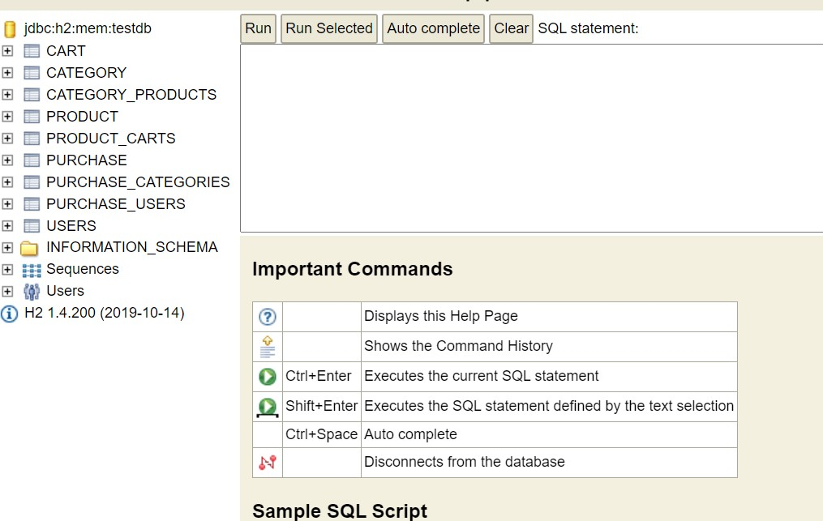

Swagger Ui is used in the application to test the application and it gives a complete view of the application and its end points, a part of Swagger, is an open source tool that generates a web page that documents the APIs generated by the Swagger specification. This UI presentation of the APIs is user friendly and easy to understand, with all logic complexity kept behind the screen. This enables developers to execute and monitor the API requests they sent and the results they received, making it a great tool for developers, testers and end consumers to understand the end points they are testing. Swagger UI represents apis within browser so brings more intuitively than other tools such as: [Postman](https://www.blazemeter.com/blog/getting-started-postman?utm_source=blog&utm_medium=BM_blog&utm_campaign=getting-started-with-swagger-ui), SoapUI, and [others](https://www.blazemeter.com/api-functional-testing?utm_source=blog&utm_medium=BM_blog&utm_campaign=getting-started-with-swagger-ui).

***GitHub Repository:***

***All the project related files are uploaded to the below GitHub repository.***

***https://github.com/yashwanthshanigaram/sportsshoe.git***

***Note: The data in the database might be different from the screenshots, as few data were modified for testing purpose after taking screenshot. This project specification document is uploaded to below GitHub Repository in doc.***