Cyber Threat Analysis and Mitigation System

Course Code:

Course Title:

Professor:

Done By

Name: Yashwant Chowdary. N

Reg NO: 22BCE0845

Abstract
The Cybersecurity Threat Analysis and Mitigation (CTAM) System is an end-to-end intelligent threat assessment platform that integrates real-time vulnerability ingestion, machine learning-based risk prediction, and generative AI-driven mitigation planning. The system continuously collects Known Exploited Vulnerabilities (KEVs) from the CISA feed, preprocesses vulnerability metadata, and trains a Random Forest classifier to categorize threat risk levels into Low, Medium, or High. High-risk threats are further processed through generative AI to produce contextual, human-readable mitigation strategies. The platform exposes REST API endpoints using Flask and supports an interactive web dashboard for visualization, custom vulnerability analysis, user role-based access control, audit logging, and automated alerting via Email and Slack/Slackbot webhooks. The system enhances cybersecurity operations by enabling predictive vulnerability triaging and AI-augmented remediation guidance while maintaining accountability through audit logs and alert traceability.

Literature Review
Cybersecurity threat analysis systems traditionally rely on signature-based intrusion detection (Snort, Suricata) or rule-based vulnerability scoring frameworks (CVSS, NVD). Recent advancements incorporate machine learning to predict exploitability, severity, and attack trends. Notable works include:
- ML-based vulnerability risk classification: Random Forest, XGBoost, and SVM have demonstrated strong performance for vulnerability severity prediction using structured CVE metadata.
- Threat intelligence feeds: CISA KEV, NVD, MITRE, and vendor advisories provide continuously updated vulnerability intelligence.
- AI-assisted mitigation: Large Language Models (LLMs) such as OpenAI GPT, Google Gemini, and LLaMA are used to convert technical threat reports into actionable remediation plans.
- Security dashboards: SIEM platforms (Splunk, Wazuh, ELK Stack) visualize security events and threat indicators for operational use.
- Alerting systems: SOC pipelines integrate Slack and Email for notifying analysts of critical threats.
- Audit logging and user roles: Security frameworks enforce accountability via RBAC, audit trails, and compliance logs for traceability.
However, most existing solutions lack a unified pipeline combining live KEV collection, ML risk prediction, generative mitigation, alert tracking, and audit accountability in a lightweight deployable Flask dashboard architecture.

Literature Gap
Despite significant progress, the following gaps remain:
Gap Category | Missing in Current Systems
Real-time exploited vulnerability ingestion | Many tools do not pull KEVs automatically from CISA or correlate exploitability with ML
ML-based risk prediction | Often based only on static CVSS scores, not predictive classification
AI-generated mitigation | Lacks contextual, human-readable, threat-specific remediation guidance
Alert traceability | No integrated alert pipeline with Email/Slack and audit linkage
User roles & audit logs | Lightweight dashboards rarely implement RBAC with tamper-proof audit trails
Compliance & accountability | No audit logging for actions like data collection, model training, vulnerability analysis, or alert dispatch
Collaboration alerts | Slack alerts are not enriched with ML confidence, remediation summaries, or role-based targeting
The CTAM System bridges these gaps by delivering a predictive and explainable vulnerability risk engine with AI mitigation and accountable alerting.

Problem Statement
Organizations face a growing volume of vulnerabilities, making manual triage slow, inconsistent, and error-prone. Static severity metrics such as CVSS do not reliably reflect real exploitability, leading to mis-prioritized remediation. Additionally, mitigation guidance is scattered across vendor advisories and security blogs, lacking uniformity and contextual clarity. Security dashboards often omit role-based access control and audit logging, reducing accountability. Critical alerts are frequently sent through external tools, losing traceability within internal workflows. Therefore, there is a need for an automated system that:
- Collects live exploited vulnerabilities,
- Predicts risk using machine learning,
- Generates clear AI-driven mitigation plans,
- Delivers real-time alerts via Email and Slack, and
- Maintains audit logs tied to user roles and system actions.

Proposed Architecture Design

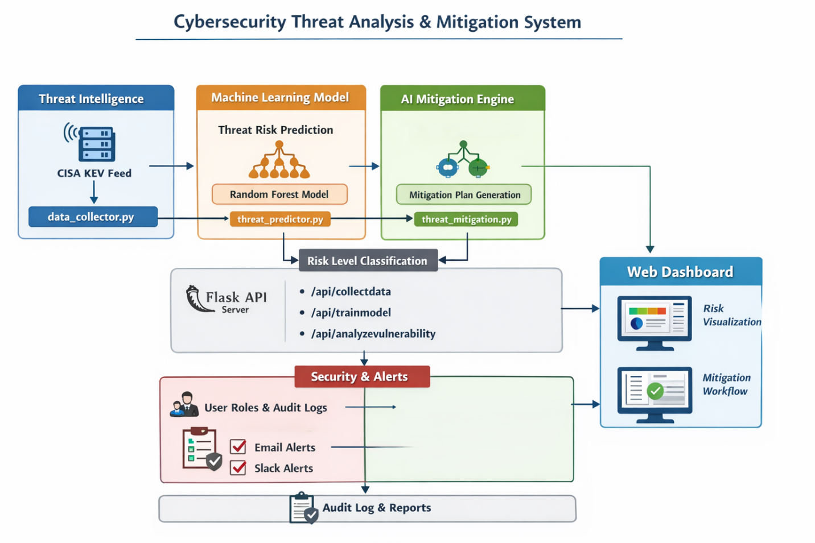

System Architecture
The CTAM System consists of six core layers:
- Threat Intelligence Layer
  - Pulls live KEVs from the CISA feed via data_collector.py
  - Stores structured vulnerability data in CSV/JSON
- ML Threat Prediction Layer
  - Preprocesses data using threat_predictor.py
  - Trains a Random Forest model to classify risk levels
  - Outputs threatmodel.pkl and model metrics
- Generative Mitigation Layer
  - Uses threat_mitigation.py and threat_mitigation.py
  - Calls Google Gemini to generate mitigation strategies
  - Falls back to rule-based mitigation if AI fails
- API & Orchestration Layer
  - server.py exposes endpoints:
    - /api/collectdata
    - /api/trainmodel
    - /api/analyzevulnerability
  - Implements CORS for dashboard integration
- Security Governance Layer
  - Implements:
    - User roles: Admin, SOC Analyst, Auditor
    - Audit logs for all sensitive actions
    - Tamper-traceable activity logs
    - Audit filtering per role
- Alerting & Collaboration Layer
  - Triggers alerts for High-Risk vulnerabilities
  - Alert logs stored for traceability
  - Alerts enriched with:
    - Risk level
    - ML confidence
    - AI mitigation summary
    - Timestamp
    - Triggering user/system action

Proposed Workflow of the System

Phase 1: Data Collection
1. Poll CISA KEV API → JSON vulnerabilities
2. Query NIST NVD API → CVE details (CVSS, descriptions)
3. Scrape Exploit-DB → Proof-of-concept availability
4. Normalize features → Pandas DataFrame
5. Store → PostgreSQL with TimescaleDB extension

Phase 2: ML model Training
1. Load historical data
2. Feature engineering:
- CVSSv3 Base/Impact scores
- Days since disclosure
- Exploit availability (binary)
- CISA KEV status
3. Handle imbalance → SMOTE (imbalanced-learn)
4. Train Random Forest → 500 estimators, stratified CV
5. Save → threatmodel.pkl + metadata.json

Phase 3: Real-Time Analysis
POST /api/analyzevulnerability { "cveID": "CVE-2025-1234" }

1. Fetch CVE details (multi-source)
2. Extract features → Load threatmodel.pkl
3. Predict risk → Low/Medium/High (probability)
4. Generate prompt → Google Gemini API
5. Return structured response:
{
"risk": "High",
"probability": 0.87,
"mitigation": "Apply vendor patch...",
"urgency": "Immediate"
}

Phase 4: Alert Dashboard Creation

High-risk triggers (P>0.8):
├── Email → security-team@org.com
├── Slack → #vulnerability-alerts
├── Audit log → PostgreSQL audit.users_actions
└── Dashboard → Real-time Chart.js updates

Additional Proposed Enhancements
Component | Purpose
Email alerts | Notify security teams of high-risk threats
Slack alerts (webhook/Slackbot) | Real-time SOC collaboration notifications
User roles (RBAC) | Restrict sensitive endpoints and dashboard actions
Audit logs | Track data collection, training, analysis, and alerts
Alert trace logs | Ensure alerts are tied to a triggering event
Mitigation fallback system | Maintain reliability if AI fails
Dashboard CORS integration | Enable smooth frontend-backend communication

Conclusion
The CTAM System proposes a lightweight, scalable, accountable, and intelligent vulnerability triaging pipeline that combines real-time exploited threat intelligence, machine learning risk prediction, AI-generated mitigation strategies, role-based access control, audit traceability, and SOC collaboration alerts. This system provides explainability, automation, and governance missing from existing minimal cybersecurity dashboards.

