**Part1 : Output**

Clustering results using dot product kernel:  
 4  
 4  
 4  
 1  
 3  
 2  
 1  
 1  
 1  
 1  
 1  
 1  
 1  
 1  
 1  
 1  
 1  
 1  
 1  
 1  
 1  
 4  
 1  
 1  
 1  
 1  
  
Clustering results using polynomial kernel (degree 2):  
 4  
 1  
 4  
 1  
 3  
 2  
 1  
 4  
 1  
 1  
 1  
 1  
 1  
 1  
 1  
 1  
 1  
 1  
 1  
 1  
 1  
 4  
 1  
 1  
 1  
 1  
  
** Analysis of Diagonal Sub-Matrices (assuming class labels in file names) **  
 - Class 1:  
 Mean similarity: 788266  
 Standard deviation of similarity: 0  
 Jaccard similarity matrix (upper triangle):  
 0  
  
 - Class 2:  
 Mean similarity: 13413901.4082  
 Standard deviation of similarity: 89544382.1049

Jaccard similarity matrix (upper triangle):  
 0  
 1  
 1  
 1  
 1  
 1  
 1  
 0  
 1  
 1  
 1  
 1  
 1  
 0  
 1  
 1  
 1  
 1  
 0  
 1  
 1  
 1  
 0  
 1  
 1  
 0  
 1  
 0  
  
 - Class 3:  
 Mean similarity: 626.16  
 Standard deviation of similarity: 2104.5498

Jaccard similarity matrix (upper triangle):  
 0  
 1  
 1  
 1  
 1  
 1  
 1  
 1  
 1  
 1  
 0  
 1  
 1  
 1  
 1  
 1  
 1  
 1  
 1  
 0  
 1  
 1  
 1  
 1  
 1  
 1  
 1  
 0  
 1  
 1  
 1  
 1  
 1  
 1  
 0  
 1  
 1  
 1  
 1  
 1  
 0  
 1  
 1  
 1  
 1  
 0  
 1  
 1  
 1  
 0  
 1  
 1  
 0  
 1  
 0  
  
 - Class 4:  
 Mean similarity: NaN  
 Standard deviation of similarity: NaN

Jaccard similarity matrix (upper triangle):  
 - Class 5:  
 Mean similarity: NaN  
 Standard deviation of similarity: NaN

Jaccard similarity matrix (upper triangle):

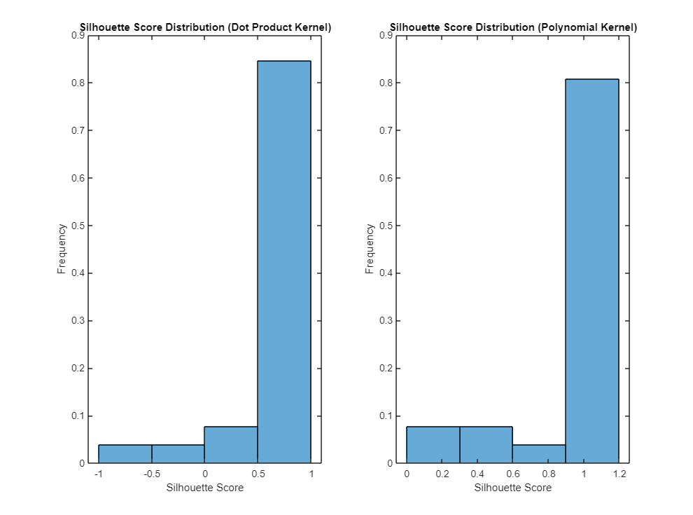

**Part2 : Output**

Clustering results using dot product kernel:  
 4  
 1  
 4  
 1  
 3  
 2  
 1  
 1  
 1  
 1  
 1  
 1  
 1  
 1  
 1  
 1  
 1  
 1  
 1  
 1  
 1  
 1  
 1  
 1  
 1  
 1  
  
Clustering results using polynomial kernel (degree 2):  
 4  
 1  
 4  
 1  
 3  
 2  
 1  
 1  
 1  
 1  
 1  
 1  
 1  
 1  
 1  
 1  
 1  
 1  
 1  
 1  
 1  
 1  
 1  
 1  
 1  
 1  
  
Average Silhouette Score using dot product kernel clustering:  
 0.9468  
  
Average Silhouette Score using polynomial kernel clustering:  
 0.9796  
  
** Analysis of Diagonal Sub-Matrices (assuming class labels in file names) **  
 - Class 1:  
 Mean similarity: 1628396237  
 Standard deviation of similarity: 0

Jaccard similarity matrix (upper triangle):  
 0  
  
 - Class 2:  
 Mean similarity: 3554904633.9184  
 Standard deviation of similarity: 13264137683.8259

Jaccard similarity matrix (upper triangle):  
 0  
 1  
 1  
 1  
 1  
 1  
 1  
 0  
 1  
 1  
 1  
 1  
 1  
 0  
 1  
 1  
 1  
 1  
 0  
 1  
 1  
 1  
 0  
 1  
 1  
 0  
 1  
 0  
  
 - Class 3:  
 Mean similarity: 16998816.5  
 Standard deviation of similarity: 19601707.4591

Jaccard similarity matrix (upper triangle):  
 0  
 1  
 1  
 1  
 1  
 1  
 1  
 1  
 1  
 1  
 0  
 1  
 1  
 1  
 1  
 1  
 1  
 1  
 1  
 0  
 1  
 1  
 1  
 1  
 1  
 1  
 1  
 0  
 1  
 1  
 1  
 1  
 1  
 1  
 0  
 1  
 1  
 1  
 1  
 1  
 0  
 1  
 1  
 1  
 1  
 0  
 1  
 1  
 1  
 0  
 1  
 1  
 0  
 1  
 0  
  
 - Class 4:  
 Mean similarity: NaN  
 Standard deviation of similarity: NaN

Jaccard similarity matrix (upper triangle):  
 - Class 5:  
 Mean similarity: NaN  
 Standard deviation of similarity: NaN

Jaccard similarity matrix (upper triangle):

