

Assignment No. : 02

PROBLEM STATEMENT:
Write a menu driven program in C to implement the basic arithmetic operations such as Addition, Subtraction, Multiplication, and Division.

OBJECTIVES:
• To understand the concept of menu driven programming in C.
• To apply conditional statements and switch–case control structures.
• To perform basic arithmetic operations using user-defined input.
• To enhance logical thinking and problem-solving skills.

THEORY:
if–else ladder statements syntax and sample program
switch–case or if–else ladder statement syntax and sample progrM
Basic arithmetic operations include Addition, Subtraction, Multiplication, and Division. Division by zero should be avoided.

Algorithm:
- START
- Display the menu: Addition, Subtraction, Multiplication, Division
- Read the user’s choice
- Read two numbers a and b
- If display it == 1, then calculate result a + b and display it
- Else if choice == 2, then calculate result a-b and display it
- Else if choice == 3, then calculate result a*b and display it
- Else if choice == 4: If b != 0, calculate result == a/b and display it
- Else display invalid choice
- STOP

CODE1:
#include <stdio.h>

int main() {
int choice;
float a, b, result;

printf("Menu:\n");
printf("1. Addition\n");
printf("2. Subtraction\n");
printf("3. Multiplication\n");
printf("4. Division\n");

printf("Enter your choice: ");
scanf("%d", &choice);

printf("Enter two numbers: ");
scanf("%f %f", &a, &b);

switch(choice) {
case 1:
result = a + b;
printf("Addition = %.2f", result);
break;

case 2:
result = a - b;
printf("Subtraction = %.2f", result);
break;

case 3:
result = a * b;
printf("Multiplication = %.2f", result);
break;

case 4:
if (b != 0) {
result = a / b;
printf("Division = %.2f", result);
} else {
printf("Error! Division by zero is not allowed.");
}
break;

default:
printf("Invalid choice!");
}

return 0;
}

CODE2:
#include <stdio.h>

int main() {
int ch;
int a, b;

printf("1.Addition\n2.Subtraction\n3.Multiplication\n4.Division\n");
printf("Enter choice: ");
scanf("%d", &ch);

printf("Enter two numbers: ");
scanf("%d %d", &a, &b);

if (ch == 1)
printf("Result = %d", a + b);
else if (ch == 2)
printf("Result = %d", a - b);
else if (ch == 3)
printf("Result = %d", a * b);
else if (ch == 4)
printf("Result = %d", a / b);
else
printf("Invalid choice");

return 0;
}

FLOWCHART:
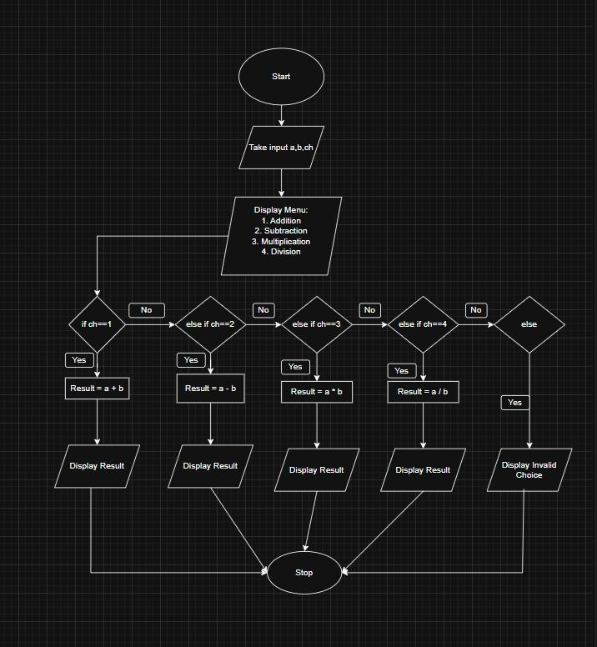

INPUT:
Choice of operation and two numbers
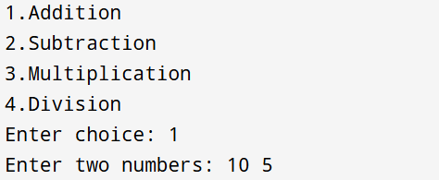

OUTPUT:
Displays the result of the selected arithmetic operation
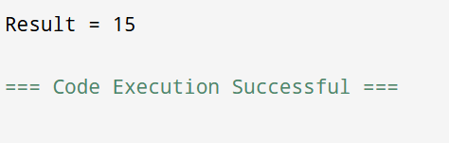

CONCLUSION:
Thus, the menu driven program in C successfully performs basic arithmetic operations using switch–case statements.

