Web APPLICATION SECURITY AUDIT REPORT

Testing url

(http://localhost/DVWA)
(SQL INJECTION ROOM TRYHACKME)

Project :- Web Application Security Testing with DVWA

Objective: To identify and exploit common web application vulnerabilities, including SQL injection, Cross-site scripting(XSS) and Authentication Flaws, in order to understand their implications and the importance of security measures.

DETAILS OF VULNERABILITY
s. No. | Vulnerability | Severity | Description | Recomendation
1. | BRUTE FORCE | HIGH | Brute force attack is a cyber attack that involves systematically trying all possible combinations of password or usernames until the correct one is found. It’s a simple effective and popular ways for the hackers to gain unauthorized access to system and networks | -Implement a reliable brute-force protection system  -Enforce a secure password policy  -Apply HTTP strict transport  security (HSTS)  -Consider disabling username enumeration  -Modify cookie headers  Scrutinize your coding on  verifications  -Use parameterized statements  Implement proper multi-factor authentication
2. | SQL | HIGH | SQL injection is a Web security vulnerability that allows an attacker to Interfere with the queries that an application makes to its Database. | -Use Prepared Statements  Stored Procedures  -Input Validation and Sanitization  -Error Handling Web Application Firewalls (WAF)
3. | Command INJECTION | HIGH | Command Injection is a critical vulnerability that occurs when an application improperly handles user input and passes it directly to a system shell or command interpreter. This allows attackers to inject and execute arbitrary system commands on the server, potentially leading to full system compromise. | -Validate and sanitize user inputs strictly  - Avoid using shell calls with unsanitized input  - Use safe APIs (e.g., exec, subprocess.run with list args)  - Implement least privilege for application users  - Monitor and log shell command usage  - Use Web Application Firewalls (WAF)

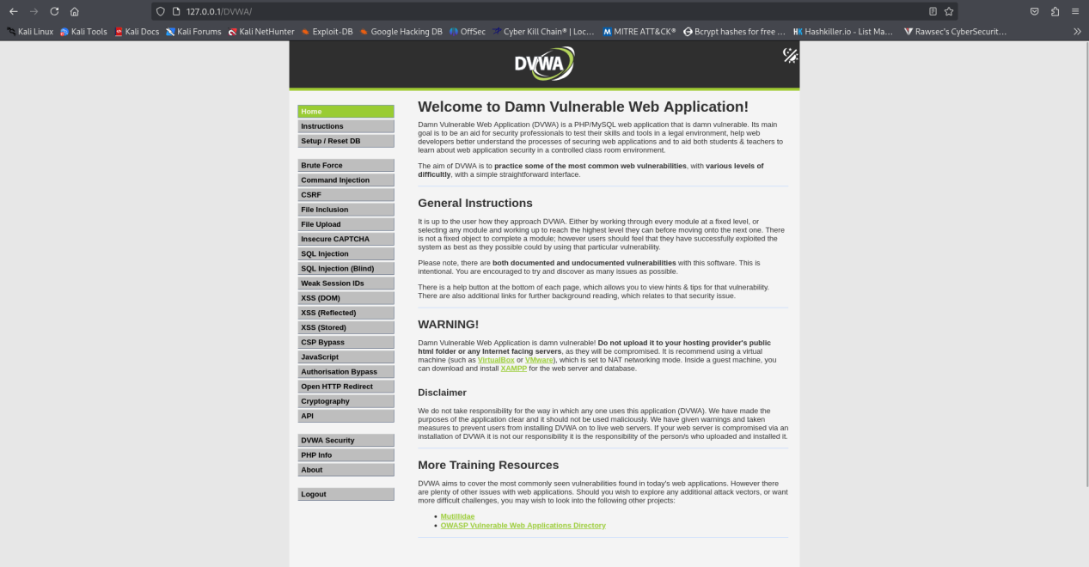

This is the Dvwa Web Application interface i have looged into it and you can see we can start with so many modules here so let’s go and try to test the vulnerabilities in the web application

VULNEARABILITY:- BRUTEFORCE

Severity: High
Description: If attackers can illegally pass through the authentication process and gain
access to a user account, they can steal critical data like names, credit card details, social
security numbers (SSNs), medical records, and tax IDs. They can also take actions on a user’s behalf, such as initiating financial transactions, deleting data, or transferring ownership of resources.

POC:-

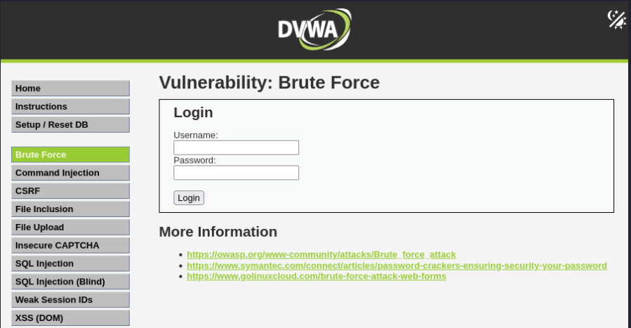

Let’s Bruteforce using the burpsuite
I have just intercepted the request of the DVWA and send it to the intruders
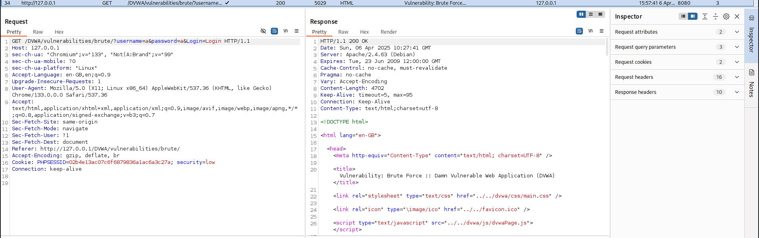
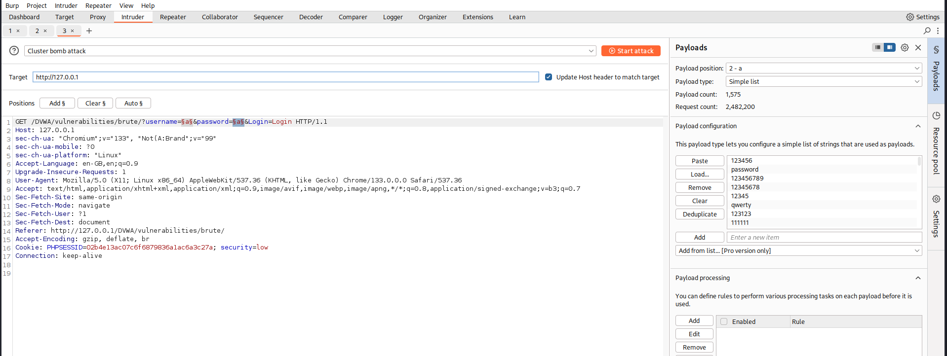

Let’s add the ppayload in the usernae and password section of the request of the http request adn try the Cluster bomb attack for it
I have added the username and password list in the attack

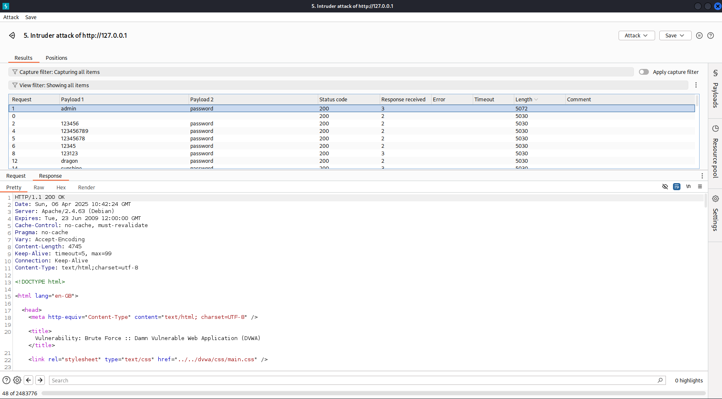
We just got the usename and password lets try it in the login page

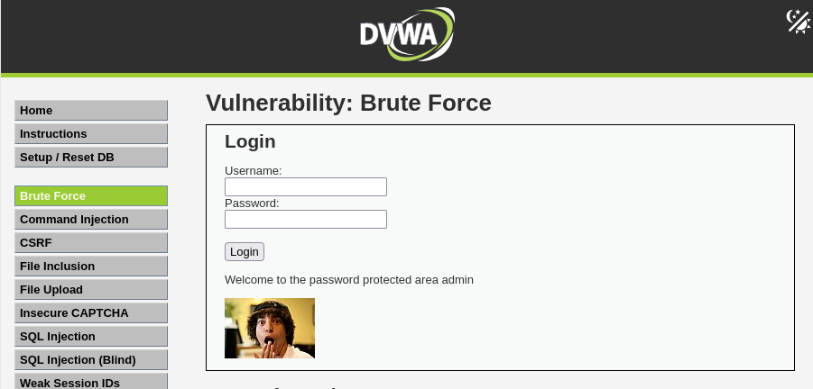

VULNERABILITY: SQL_INJECTION

Severity: High
Description: Attackers can use SQL Injection vulnerabilities to bypass application security
measures. They can go around authentication and authorization of a web page or web
application and retrieve the content of the entire SQL database. They can also use SQL
Injection to add, modify, and delete records in the database.

POC:-

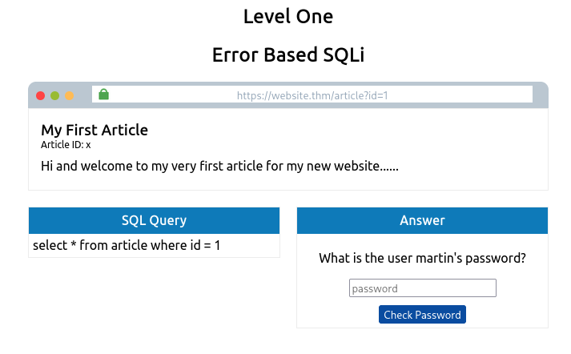
Here we will be getting the flag if we are able to solve the sql injection attack here so let’s get started
Let’s check for the sql injection in the url
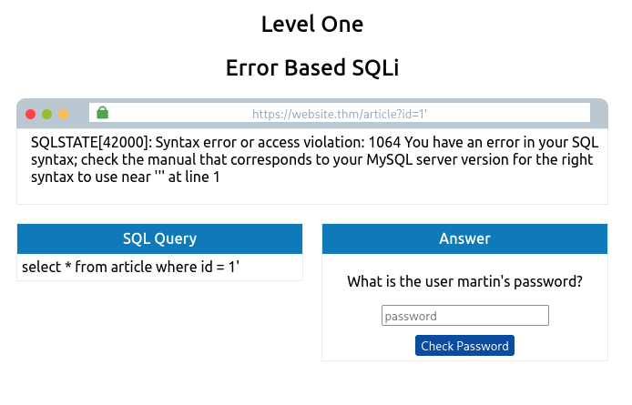
Here we see that the url is vulnerable to sql injection so we have to retrive the password of the user martin’s from the database let’s craft a payload for that

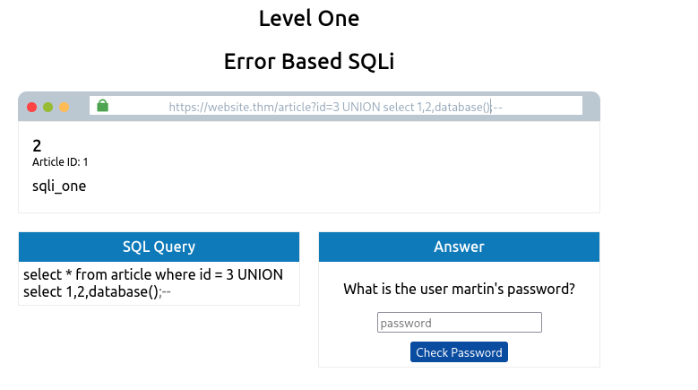
3 UNION select 1,2,database();-- from this payload i get to know the dabase name is sqli_one

Lets try to get the table names inside the database now

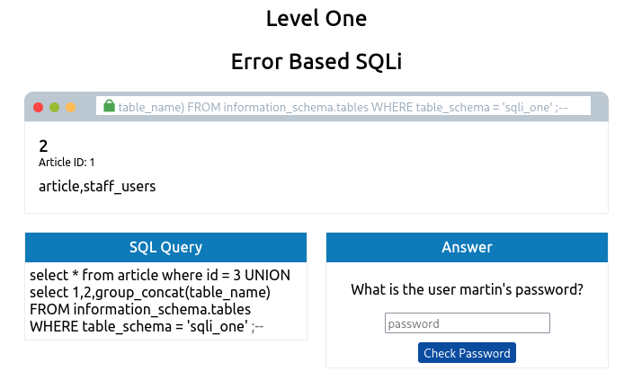
3 UNION select 1,2,group_concat(table_name) FROM information_schema.tables WHERE table_schema = 'sqli_one' ;--
From this crafted injection we get to know the table names of the database now lets find the colunm names too
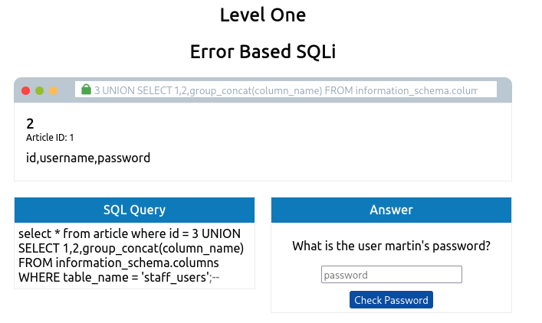
3 UNION SELECT 1,2,group_concat(column_name) FROM information_schema.columns WHERE table_name = 'staff_users';--
Now we got the column names too so lets get the details from the information we have
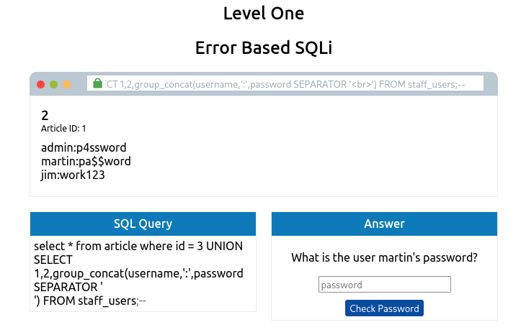
3 UNION SELECT 1,2,group_concat(username,':',password SEPARATOR '<br>') FROM staff_users;--
We got the username and password from the database

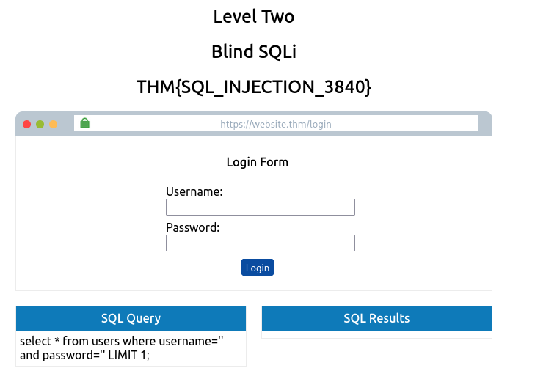

We got the flag let’s try the level second as well

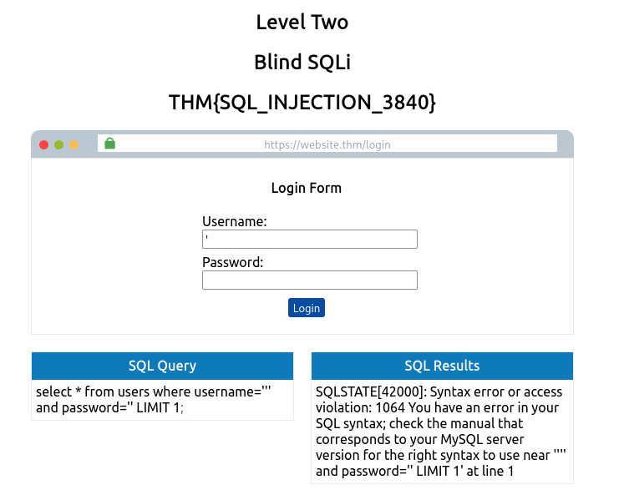
Here we saw that we got the sql error in the admin filed when we provided the ‘ apostrophe sign so let’s try yo craft a payload

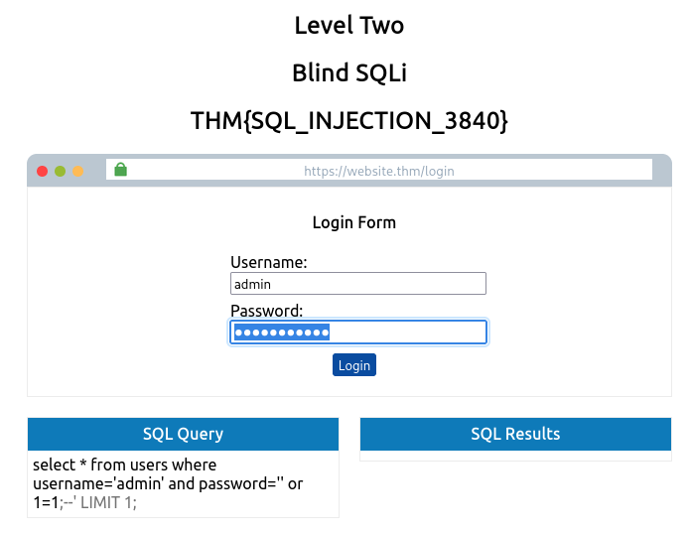
i provide this paylod into the password section : ‘ or 1=1;--
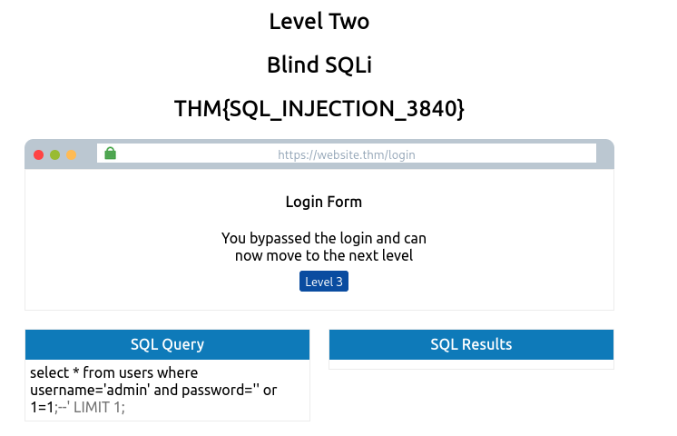

VULNERABILITY:- COMMAND INJECTION

Severity: High
Description: Command Injection is a critical vulnerability that occurs when an application improperly handles user input and passes it directly to a system shell or command interpreter. This allows attackers to inject and execute arbitrary system commands on the server, potentially leading to full system compromise.
If exploited, command injection can result in:

- Unauthorized access to system files or sensitive data
- Execution of arbitrary commands with server privileges
- Full takeover of the server in severe cases
- Network pivoting or lateral movement within the infrastructure

POC:-

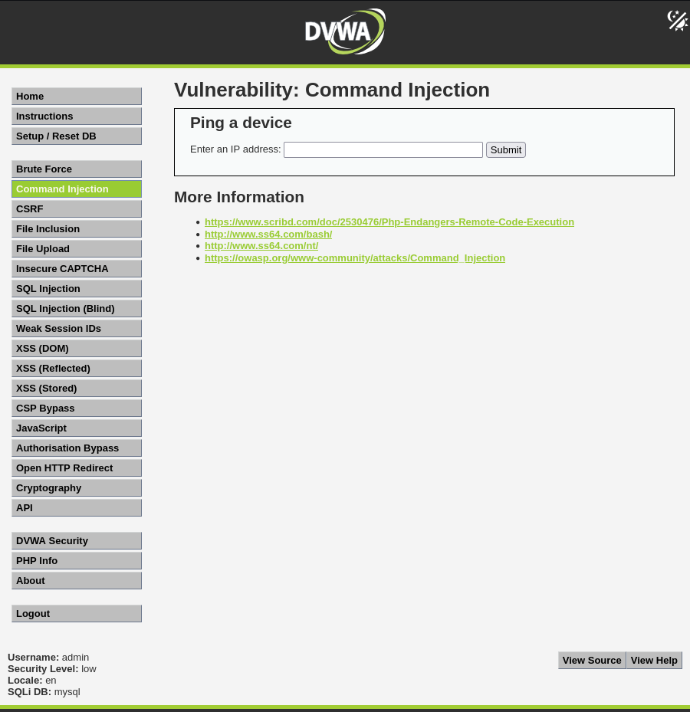

Let’s jus try to ping our ip and see wht it is doing
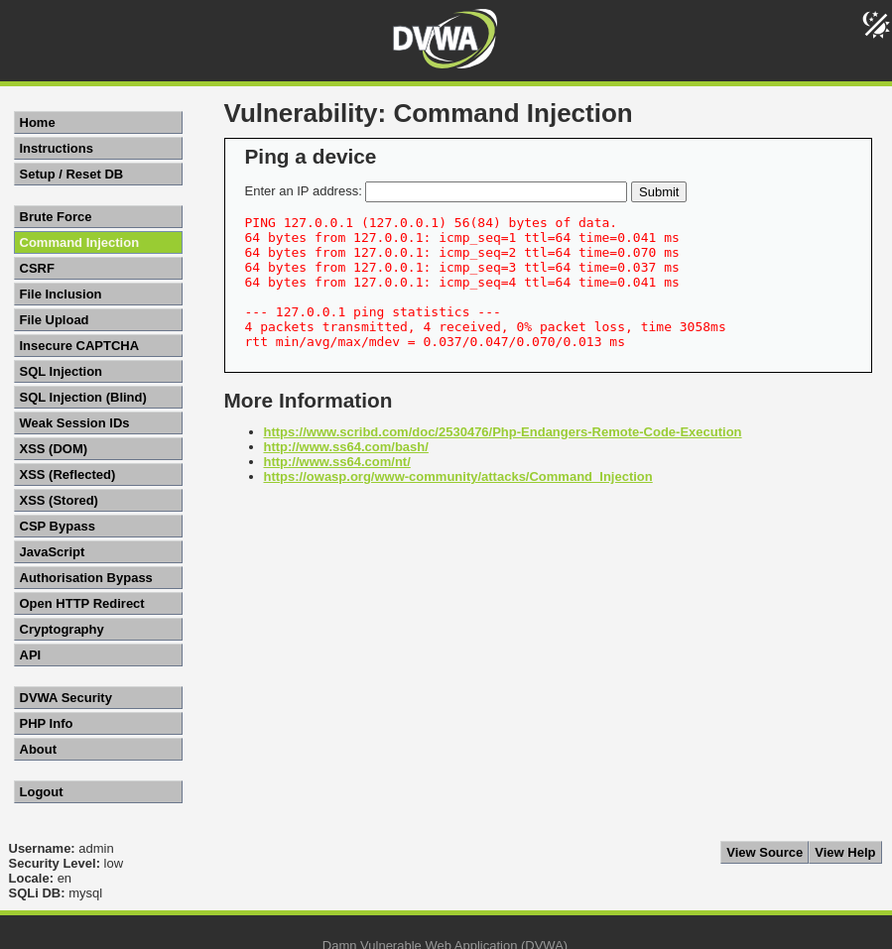

Now let’s see the sorce code
<?php
if( isset( $_POST[ 'Submit' ] ) ) {
// Get input
$target = $_REQUEST[ 'ip' ];

// Determine OS and execute the ping command.
if( stristr( php_uname( 's' ), 'Windows NT' ) ) {
// Windows
$cmd = shell_exec( 'ping ' . $target );
}
else {
// *nix
$cmd = shell_exec( 'ping -c 4 ' . $target );
}

// Feedback for the end user
echo "<pre>{$cmd}</pre>";
}
?>

This is the source code so let’s craft a payload and run our command
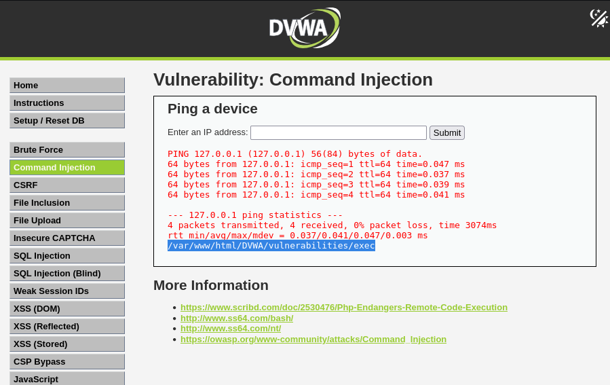

Here we get that we are in which direcctory it is a critical vulnerability and by crafting reverse shell payload we can get into the system as well

Let’s now change the security of the command injection to Medium
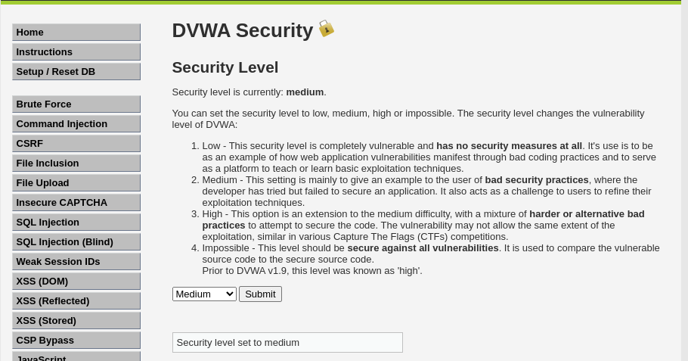

<?php
if( isset( $_POST[ 'Submit' ] ) ) {
// Get input
$target = $_REQUEST[ 'ip' ];

// Set blacklist
$substitutions = array(
'&&' => '',
';' => '',
);

// Remove any of the characters in the array (blacklist).
$target = str_replace( array_keys( $substitutions ), $substitutions, $target );

// Determine OS and execute the ping command.
if( stristr( php_uname( 's' ), 'Windows NT' ) ) {
// Windows
$cmd = shell_exec( 'ping ' . $target );
}
else {
// *nix
$cmd = shell_exec( 'ping -c 4 ' . $target );
}

// Feedback for the end user
echo "<pre>{$cmd}</pre>";
}
?>

We see that from the source code that the script is sanitizing the input if we provide any ; and && it will convert them to “ then let’s intercept the request in burpsuite and paste the crafted payload in the ip section

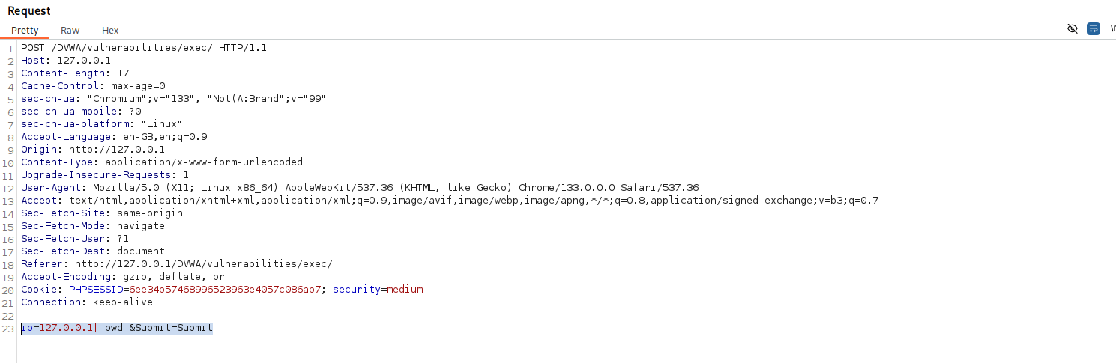
I just interceoted the request and make some changes in the ip iput this crafted payload: 127.0.0.1| pwd

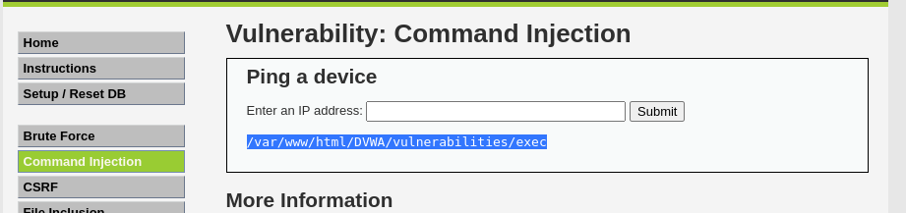
We got the executed command results here. We can also make some revese shell code and send it to the target

