 |  | 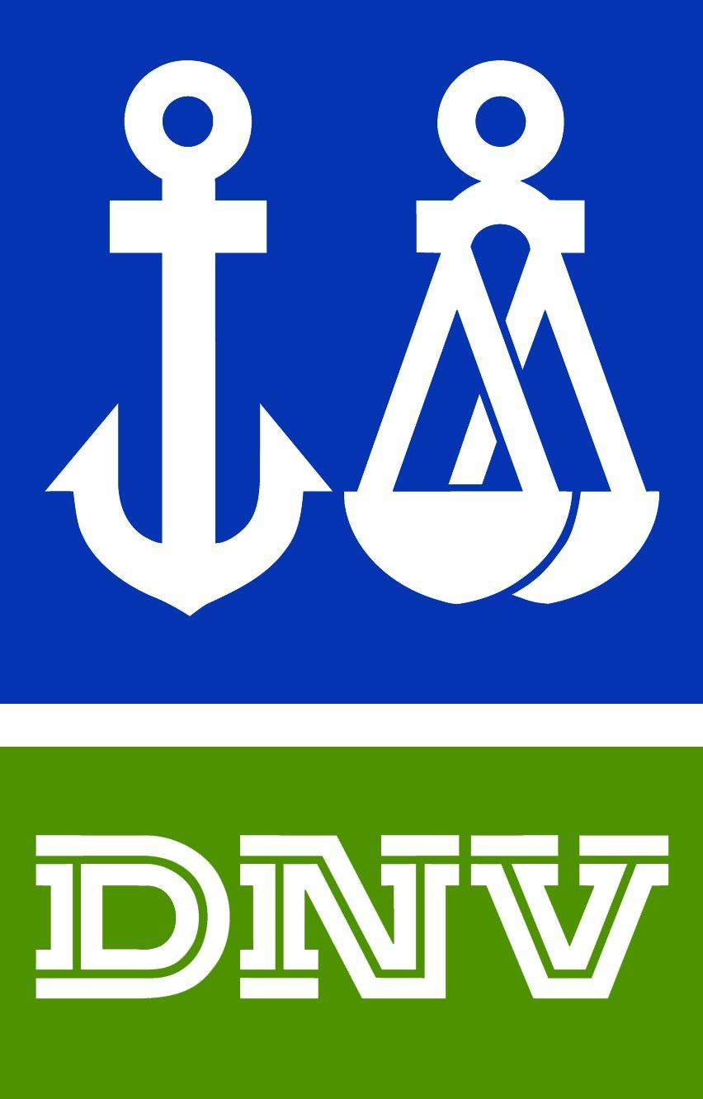

Det Norske Veritas
Management System Certificate
Certificate No.109357-2012-AQ-IND-RVA
This is to certify that the Management System of:
BURAD CHEMICALS PRIVATE LIMITED
At
620 – Mahuvad, Near Channel Chokdi,
Padra – 391 440, District: Baroda, Gujarat, INDIA

has been found to conform to:
ISO 9001:2008
This Certificate is valid for the following product or service ranges:
Manufacturing and supply of Antitac agents for rubber & tyre industries & surfactant for textile industries.
Initial Certification date:  14 February 2006 | 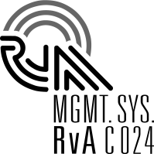 |  |  | Place and date:  Chennai,
This Certificate is valid until:  14 February 2015 |  |  |  | for the Accredited Unit:  DNV Certification B.V.,  The Netherlands
The audit has been performed under the supervision of
Gopal Raghunath Panchal |  |  |  | Bhupalam Ajit
Lead Auditor |  |  |  | Management Representative

