**Docker Installation and Execute selenium script**

**Introduction:**

Docker is a software platform designed to make it easier to create, deploy, and run applications by using containers. It allows developers to package up an application with all the parts it needs in an images and container, and then ship it out as one package.

**Images vs Containers:**

An instance of an image is called a container. You have an image, which is a set of layers as you describe. If you start this image, you have a running container of this image. You can have many running containers of the same image.

If you want to see all images which is installed in my docker,

>> **docker images**

You want to see running state containers mean can use **docker ps** command whereas you can see all containers with **docker ps –a** command

***Download Docker****:*

>> Install Docker Desktop for Windows,

[Docker-for-windows/install/](https://docs.docker.com/docker-for-windows/install/)

After Install,

- Need to check docker version in Windows Power shell:

**PS C:\Users> docker –version**

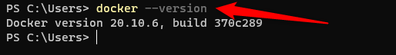

-----------------------------------------------------

**Download Image file:**

[Hub.docker.com/Selenium/Standalone-chrome-debug](https://hub.docker.com/r/selenium/standalone-chrome-debug)

like,

selenium/standalone-chrome-debug

selenium/standalone-chrome

selenium/standalone-firefox-debug

selenium/standalone-firefox

-----------------------------------------------------

Download image file in docker using below mentioned pull command

Example:

docker pull selenium/standalone-chrome-debug

Once it’s done, need to check on terminal using ***docker images*** command.

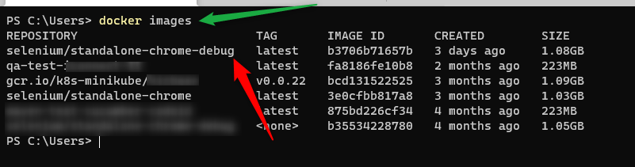

Need to start Docker Container file,

Example for Chrome browser

docker run -d -p 4444:4444 -p 5900:5900 selenium/standalone-chrome-debug

**:**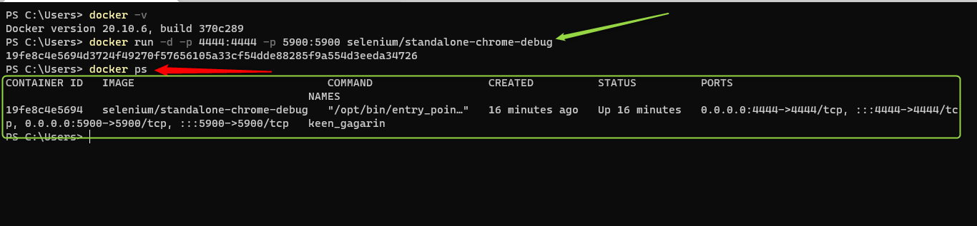

* To check Grid console >> [GridCondole](http://localhost:4444/)

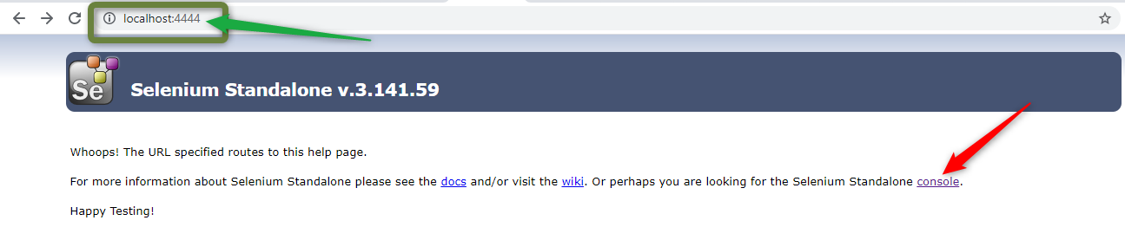

**VNC Viewer:**

You can download the [Real-VNC Viewer](https://www.realvnc.com/en/connect/download/viewer/) and Install as per your operating system.

Using *VNC Viewer*, we will be able to see the test execution.

<<LOCAL-IP-ADDRESS>>:<<CONTAINER-PORT-NUMBER>>

**Note**: Refer previous command on Container run command

***Example***:

**>> *localhost:5900***

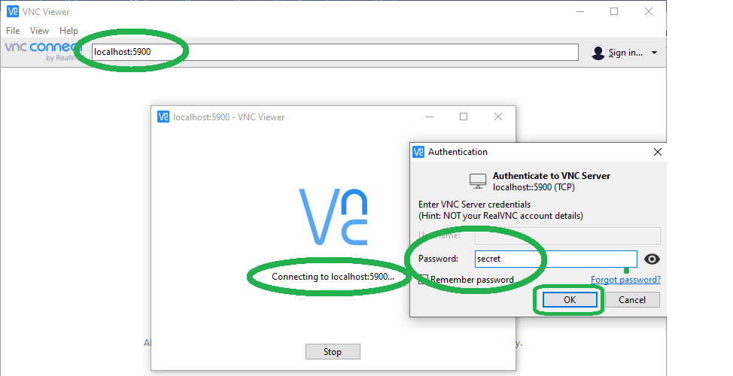

**Sample Selenium script using Remote WebDriver:**

**import** org.openqa.selenium.WebDriver;  
**import** org.openqa.selenium.remote.DesiredCapabilities;  
**import** org.openqa.selenium.remote.RemoteWebDriver;  
**import** org.testng.annotations.Test;  
**import** java.net.URL;  
  
**public class** DockerTest {  
 @Test  
 **public void** runTestOnDocker() **throws** Exception {  
  
 DesiredCapabilities cap = DesiredCapabilities.*chrome*();  
 URL strGridURL = **new** URL(**"http://localhost:4444/wd/hub"**);  
 WebDriver driver = **new** RemoteWebDriver(strGridURL, cap);  
  
 driver.get(**"https://www.google.com/"**); *// Get URL* System.***out***.println(**"QA Test: "**+driver.getTitle()); *// Print Title* driver.quit();  
 }  
}

* Now, You can run your selenium scripts,

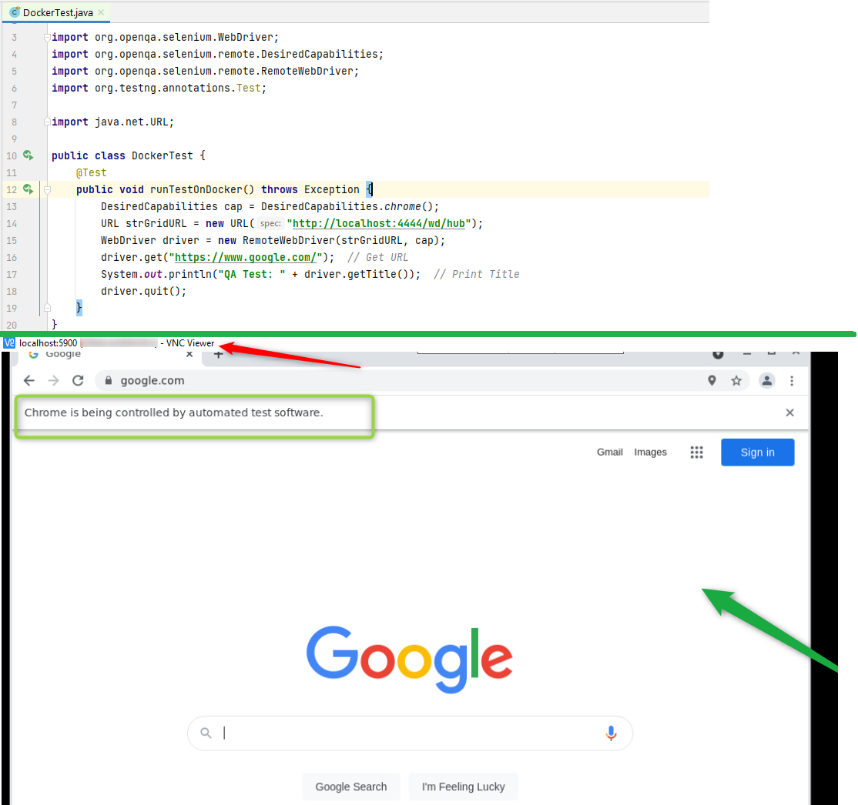

Note:

Basic Docker Commands,

1. docker –v :: To view Docker version
2. docker images :: To view all image files
3. docker ps :: To view running state docker container
4. docker ps –a :: TO view all containers(Like running state and Stopped state)
5. docker start <<container ID>> :: To start the existing docker container which is already installed.
6. docker stop <<Container ID>> :: To stop my running state container,
7. docker rm <<container ID>> :: To remove from docker existing container.
8. docker rmi <<Image ID>> :: TO remove from existing image.

**Thank You!!!**