In Python, 2 + 2 is called an expression. Expressions consist of values (such as 2 ) and operators (such as + ), and they can always evaluate (that is, reduce) down to a single value. That means you can use expressions anywhere in Python code.
In the previous example, 2 + 2 is evaluated down to a single value, 4 .A single value with no operators is also considered an expression.

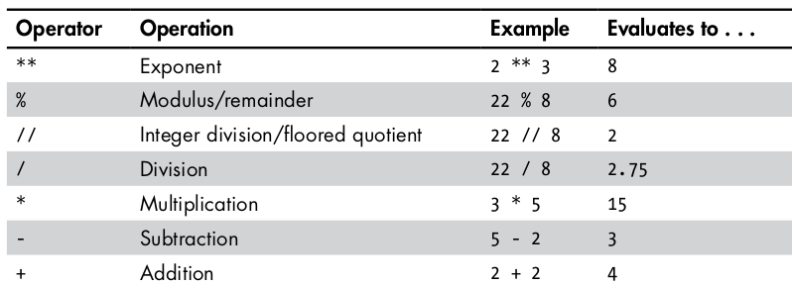
The order of operations (also called precedence) of Python math operators is similar to that of mathematics.
The ** operator is evaluated first.
The * ,/ , // , and % operators are evaluated next, from left to right.
And the + and - operators are evaluated last (also from left to right).
You can use parentheses to override the usual precedence if you need to.

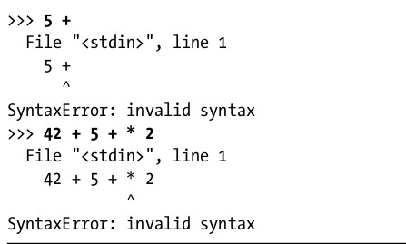

The Integer, Floating-Point, and String Data Types

Remember that expressions are just values combined with operators, and they always evaluate down to a single value.
A data type is a category for values, and every value belongs to exactly one data type.

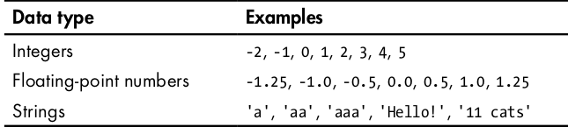
Always surround your string in single quote ( ' ) characters so that Python knows where the string
begins and ends.

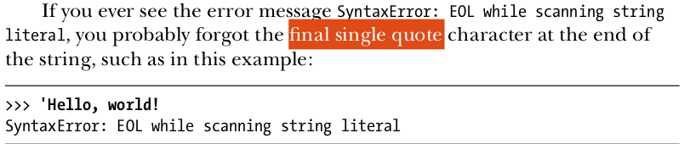

String Concatenation and Replication

The meaning of an operator may change based on the data types of the values next to it.
For example, + is the addition operator when it operates on two integers or floating-point values. However, when + is used on two string values, it joins the strings as the string concatenation operator.

'Alice' + 'Bob'
'AliceBob'

However, if you try to use the + operator on a string and an integer value, Python will not know how to handle this, and it will display an error message.

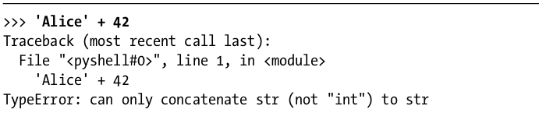
The * operator multiplies two integer or floating-point values.
But when the * operator is used on one string value and one integer value, it becomes the string replication operator.

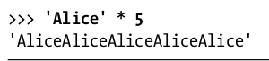
The * operator can be used with only two numeric values (for multiplication), or one string value and one integer value (for string replication).

Otherwise, Python will just display an error message, like the following:
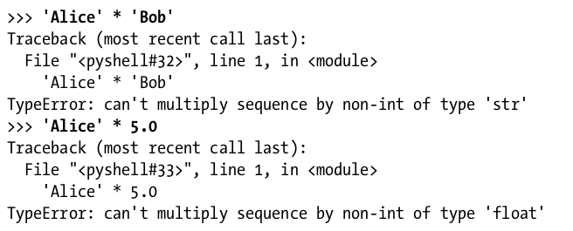
Storing Values in Variables

A variable is initialized (or created) the first time a value is stored in it . After that, you can use it in expressions with other variables and values .

When a variable is assigned a new value, the old value is forgotten. This is called overwriting the variable.
The input() Function

The input() function waits for the user to type some text on the keyboard and press enter .
