

Alkaram Bakers Website Documentation
A single-page bakery website for Karachi with a working shopping cart, menu filters, gallery and checkout. This guide covers every section with screenshots, the menu data in charts, how ordering works, and what to update before going live.
Number | What it counts
33 | Menu items
5 | Menu categories
12 | Page sections
3 | Files you normally edit (index.html, style.css, script.js)

Contents
1. Overview
2. Project files
3. Page by page
4. Menu in numbers
5. Cart and ordering
6. Mobile view
7. Settings
8. What was fixed
9. Before you publish

1. Overview
The site is plain HTML, CSS and JavaScript with no build step. Bootstrap 5 and Bootstrap Icons load from a CDN, and fonts (Playfair Display and Poppins) load from Google Fonts. Open index.html in a browser to run it, or upload the folder to any web host.
Customers can browse the menu, add items to a cart that is remembered between visits, and check out with Cash on Delivery or Bank Transfer. Delivery is Rs. 150 and is free when the subtotal is Rs. 2,000 or more.
Note about screenshots: they were taken without internet access. Product, hero and chef photos come from the web, so here they appear as the Alkaram logo. On the live site visitors will see the real photos.

2. Project files
File | What it does
index.html | The whole single-page website: navbar, hero, categories, menu, reviews, services, offers, gallery, about, contact, footer, cart and checkout popups.
style.css | All styling. Brand colours are CSS variables at the top (--brown-900, --gold, --cream). The block named "FIXES v2" at the bottom holds the cart, checkout and category button styles.
script.js | Cart, delivery rule, checkout, WhatsApp order, sliders, menu and gallery filters, image fallback, contact form. The SETTINGS block at the top is the only part you normally edit.
sitemap.html | Visitor-facing list of links to every section.
sitemap.xml / robots.txt | For Google. Both use the domain www.alkarambakers.com.
images/alkaram-logo.png | Logo used in the navbar, favicon, and as the fallback when a product photo fails to load.

3. Page by page

Navbar and hero slider
The navbar stays at the top while scrolling and highlights the section you are in. The hero slider has three slides that change every 5 seconds, with arrows and dots. "Order Now" goes to the categories and "View Menu" goes to the menu.
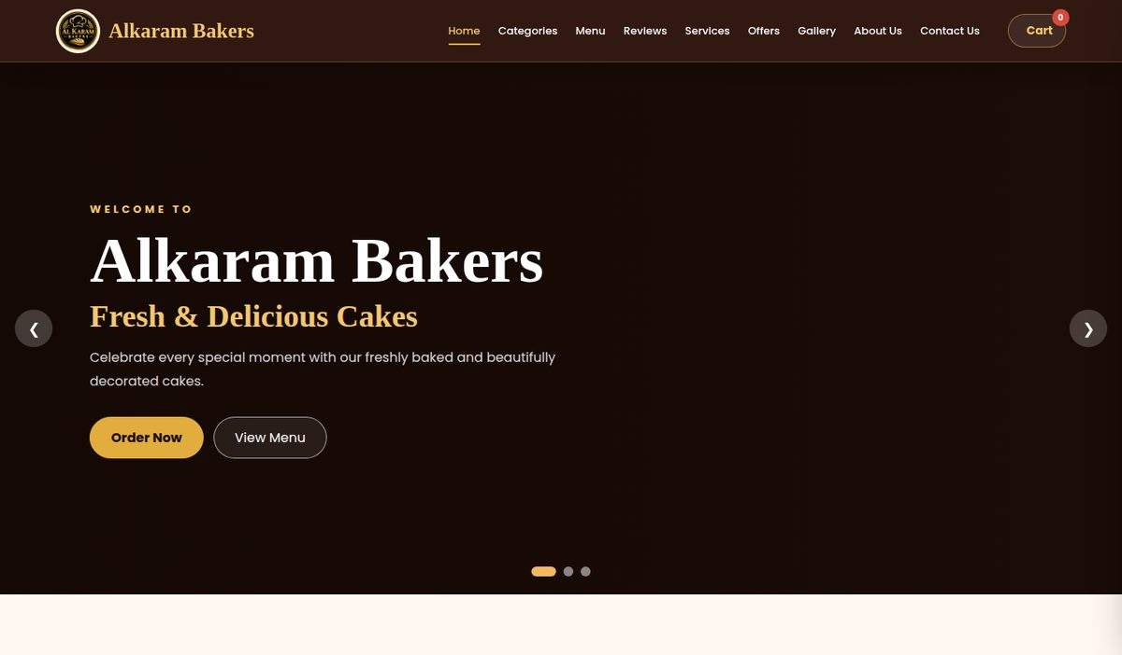
Figure 1. Home page: navbar, cart button and hero slider

Categories
Four cards for Cakes, Pastries, Cookies and Pies. "View Category" jumps to the menu with that category selected. "Add to Cart" adds the category at its starting price, which is taken from the cheapest item in the menu.
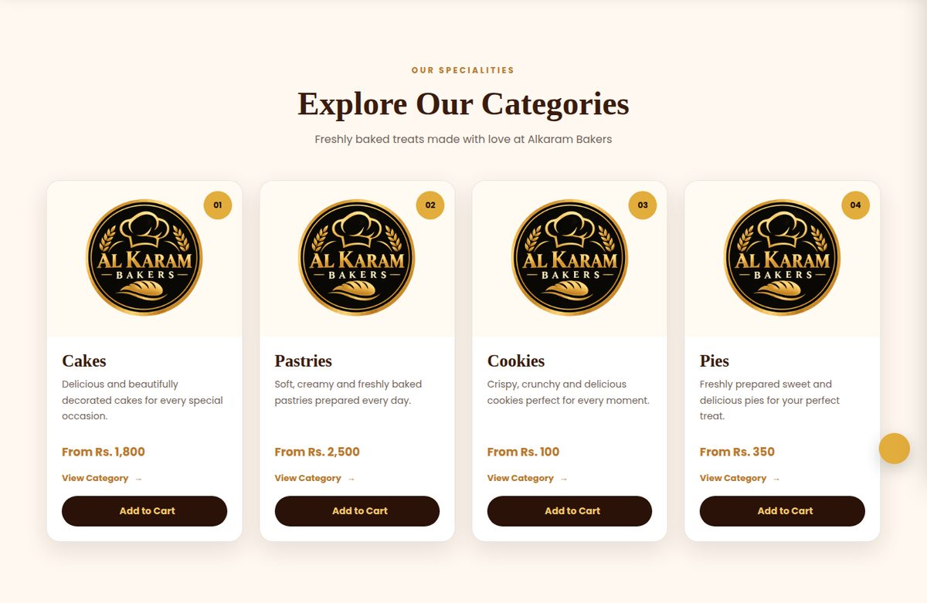
Figure 2. Category cards with starting prices and Add to Cart buttons

Full menu
Every product has a photo, name, price and an Add to Cart button. The filter buttons show one category at a time. Pies has no items yet, so it shows a message asking visitors to contact you.
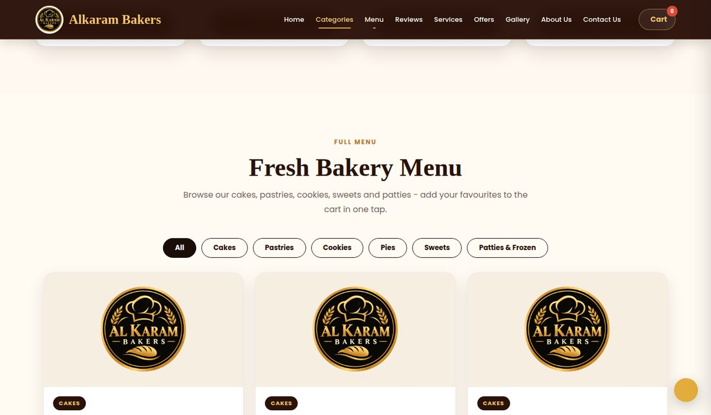
Figure 3. Menu with filter buttons
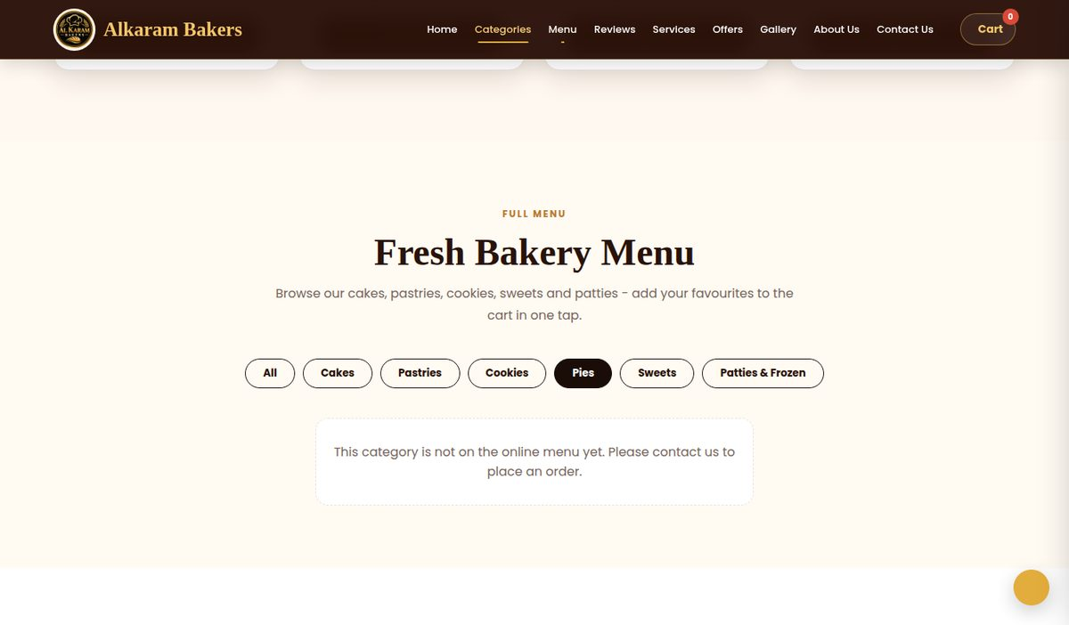
Figure 4. Choosing Pies shows a friendly message instead of a blank area

Reviews, services and offers
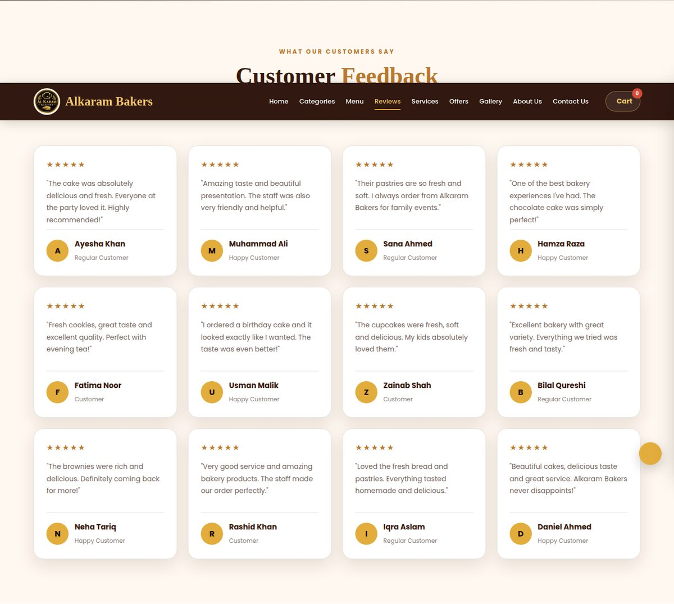
Figure 5. Customer feedback cards (sample content)
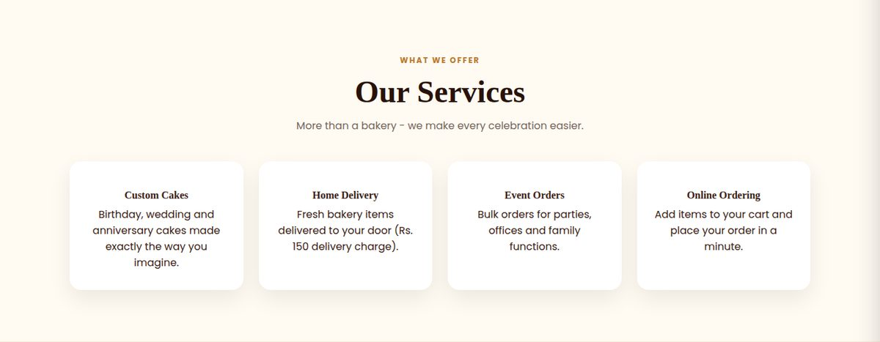
Figure 6. Services: custom cakes, home delivery, event orders, online ordering
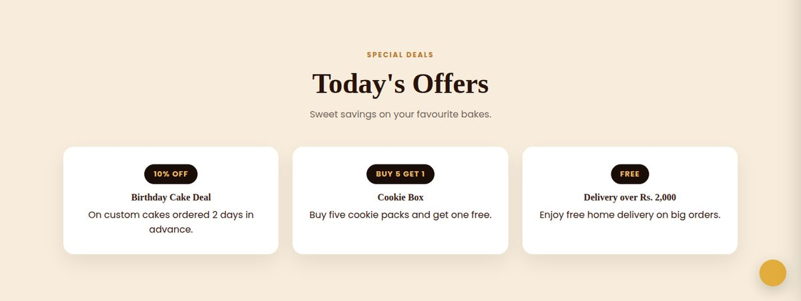
Figure 7. Offers. Free delivery over Rs. 2,000 is applied automatically in the cart

Gallery
The gallery has its own filters. Clicking a picture opens it larger in a popup that appears above the navbar. The screenshot shows only the top of the gallery.
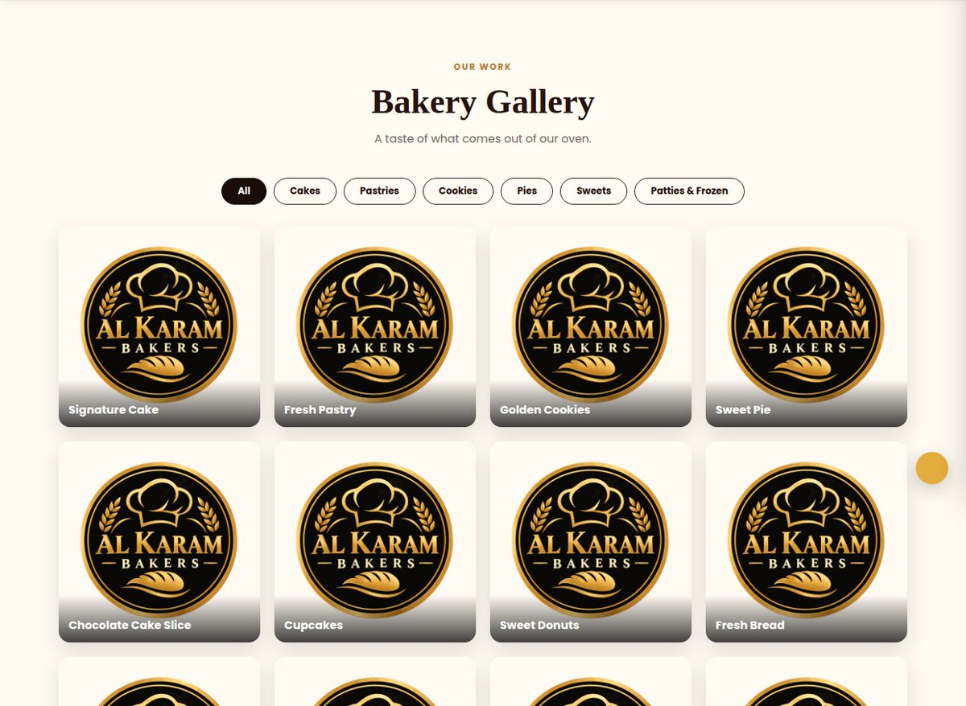
Figure 8. Gallery with category filters (top part)

Team, about and contact
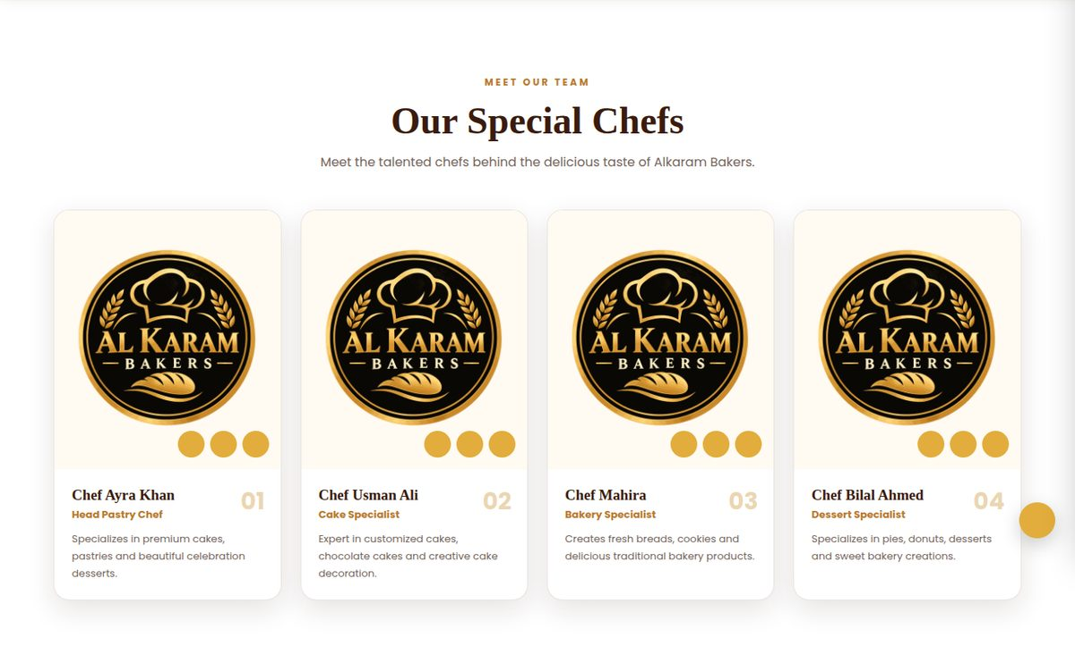
Figure 9. Special chefs section (sample names and stock photos)
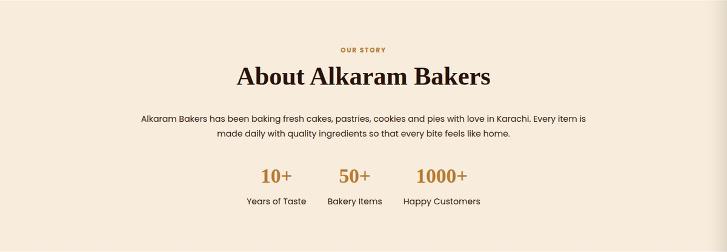
Figure 10. About section with business statistics
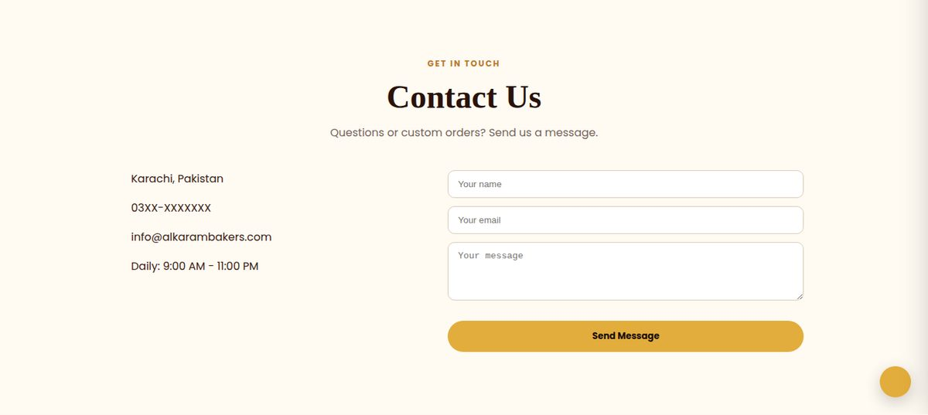
Figure 11. Contact details and message form. Sending opens the visitor's email app

Footer
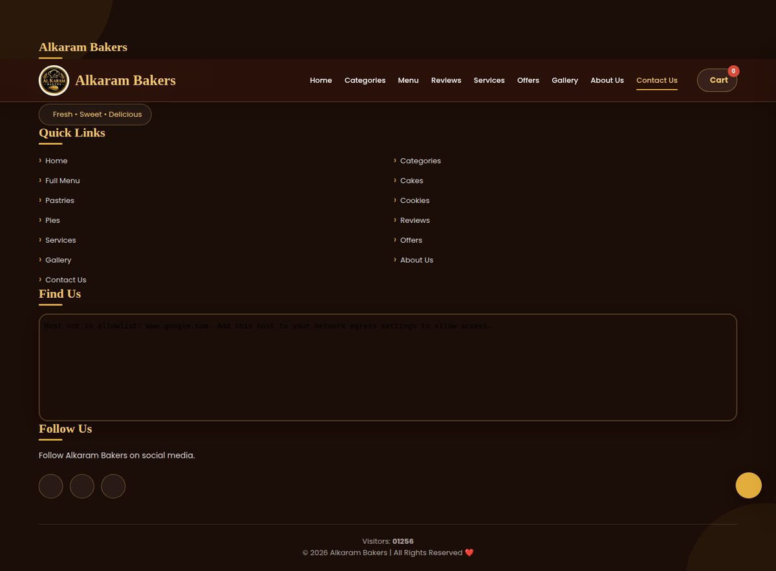
Figure 12. Footer with quick links, Google map, social icons and visitor counter

Sitemap page
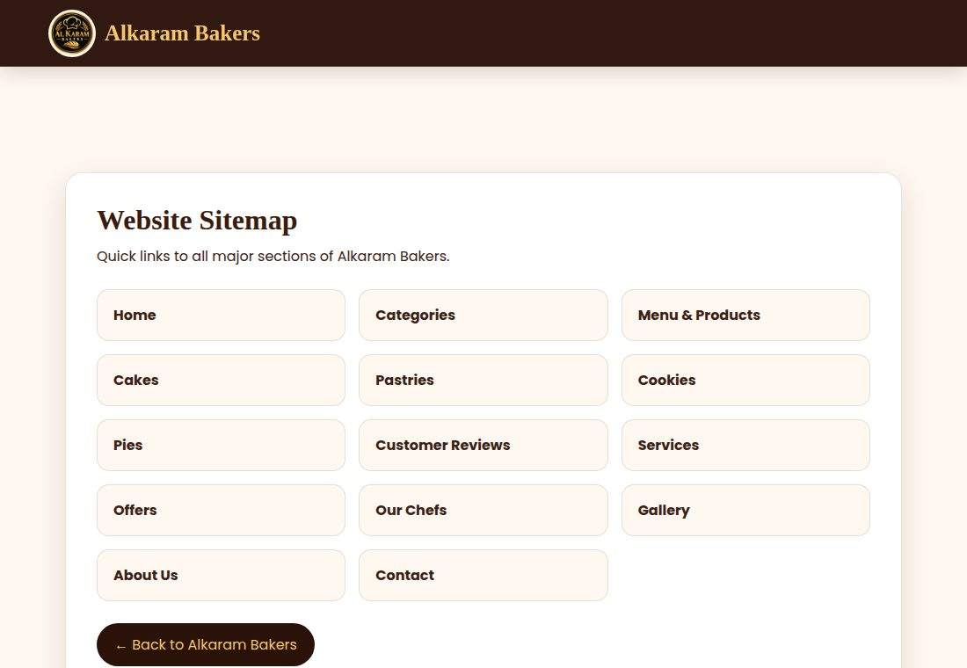
Figure 13. sitemap.html, linked from the floating Sitemap button

4. Menu in numbers
These charts are drawn from the 33 items currently in the menu.

Items per category
Cakes have the most items (9). Pastries, cookies, sweets and patties have six each.
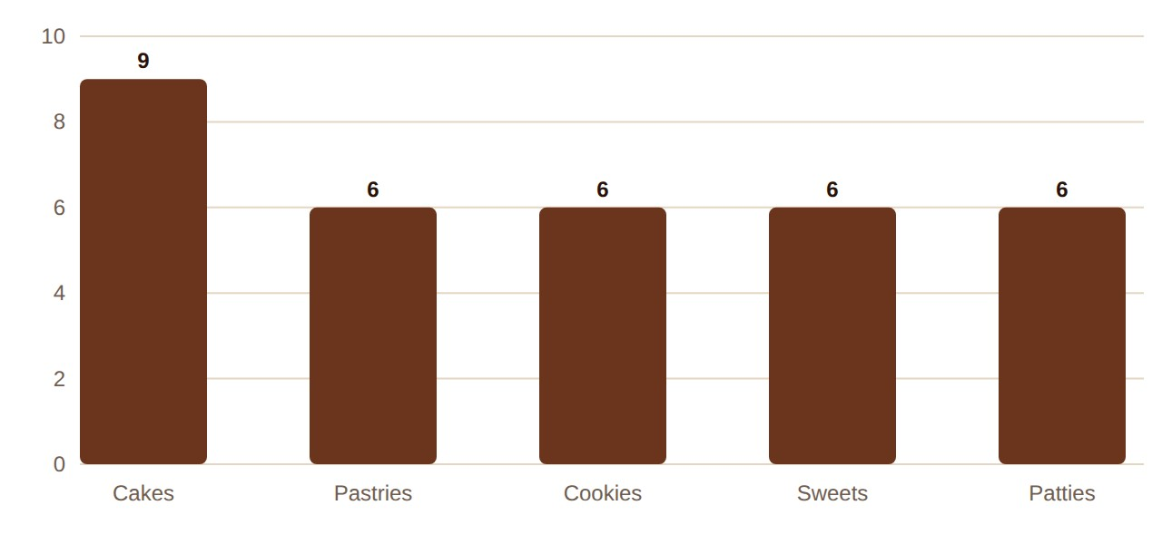
Chart 1. Number of menu items per category

Share of the menu
Cakes are 27% of the menu, and each of the other four categories is 18%.
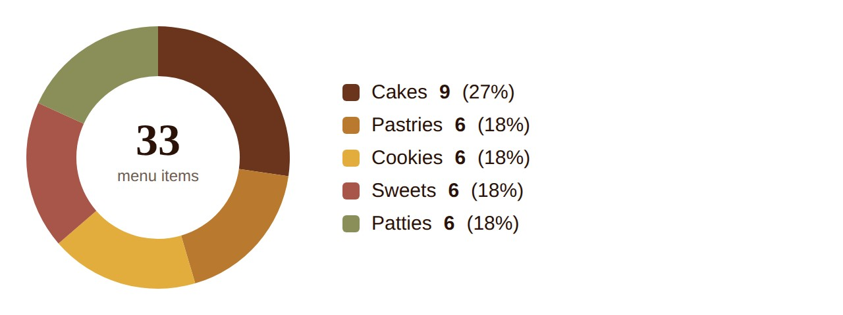
Chart 2. Share of menu items by category

Price range per category (Rs.)
The bar shows the lowest to highest price. The dark dot is the average. A flat line means every item in that category costs the same.
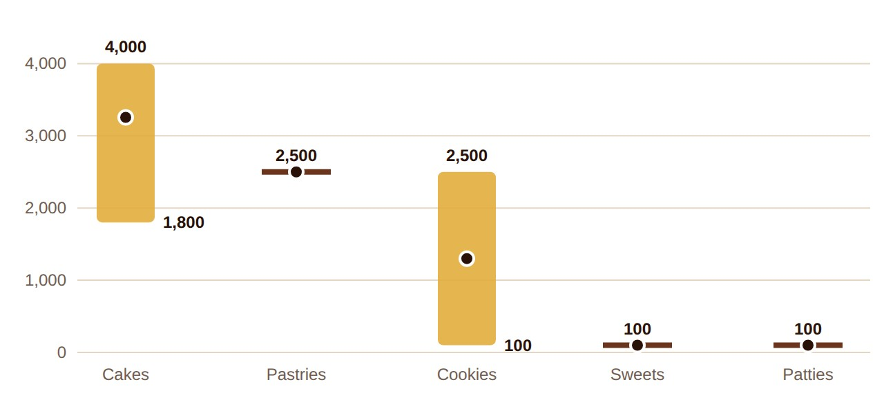
Chart 3. Price range per category
Pastries are all Rs. 2,500, and sweets and patties are all Rs. 100. If these are not your real prices, edit the data-price value on each menu item in index.html.

5. Cart and ordering
The cart opens as a drawer from the right. Items can be increased, decreased or removed, and the cart is saved in the browser so it survives a page refresh.

How an order flows
- The visitor taps Add to Cart and the cart drawer opens.
- The cart adds Rs. 150 delivery, unless the subtotal is Rs. 2,000 or more, in which case delivery is free.
- The visitor taps Proceed to Checkout and enters name, phone, address and payment method.
- The visitor taps Place Order.
- If a WhatsApp number is set in script.js, the order opens in WhatsApp and the visitor presses Send. If not, the order is only saved in the visitor's own browser.
- An Order Placed message shows the order number and the cart is emptied.

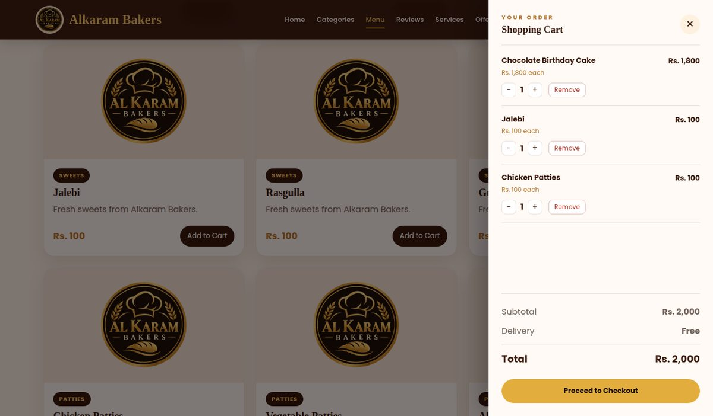
Figure 14. Cart with three items. A subtotal of Rs. 2,000 or more makes delivery free
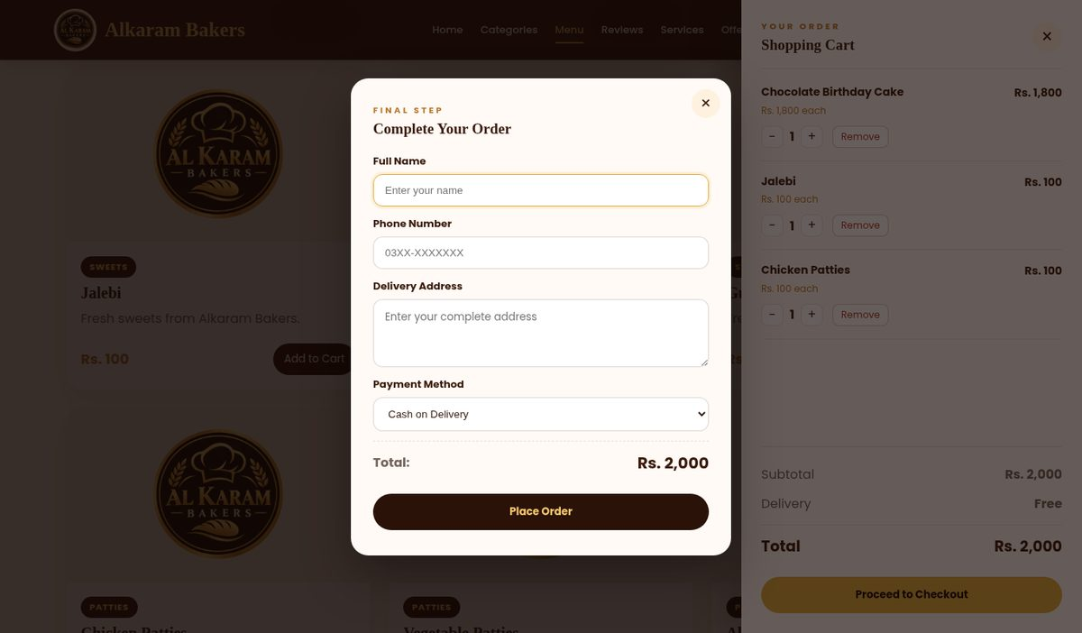
Figure 15. Checkout popup asks for name, phone, address and payment method
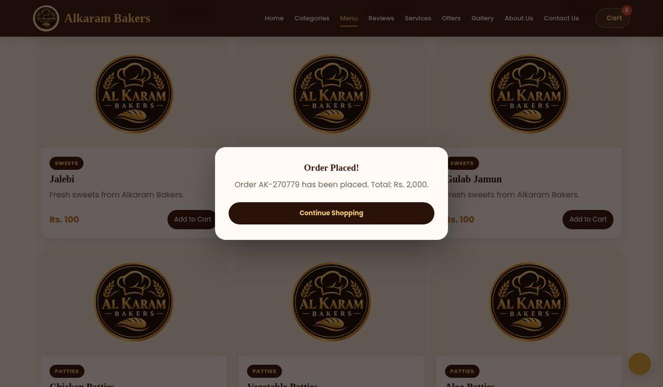
Figure 16. Order confirmation with the order number
Important: without a WhatsApp number in script.js, you will not receive orders. They are stored only in the customer's own browser. Set the number before going live.

6. Mobile view
Below 992 px wide the navbar collapses into a hamburger menu, cards stack into one column, and the cart drawer fills the screen height.
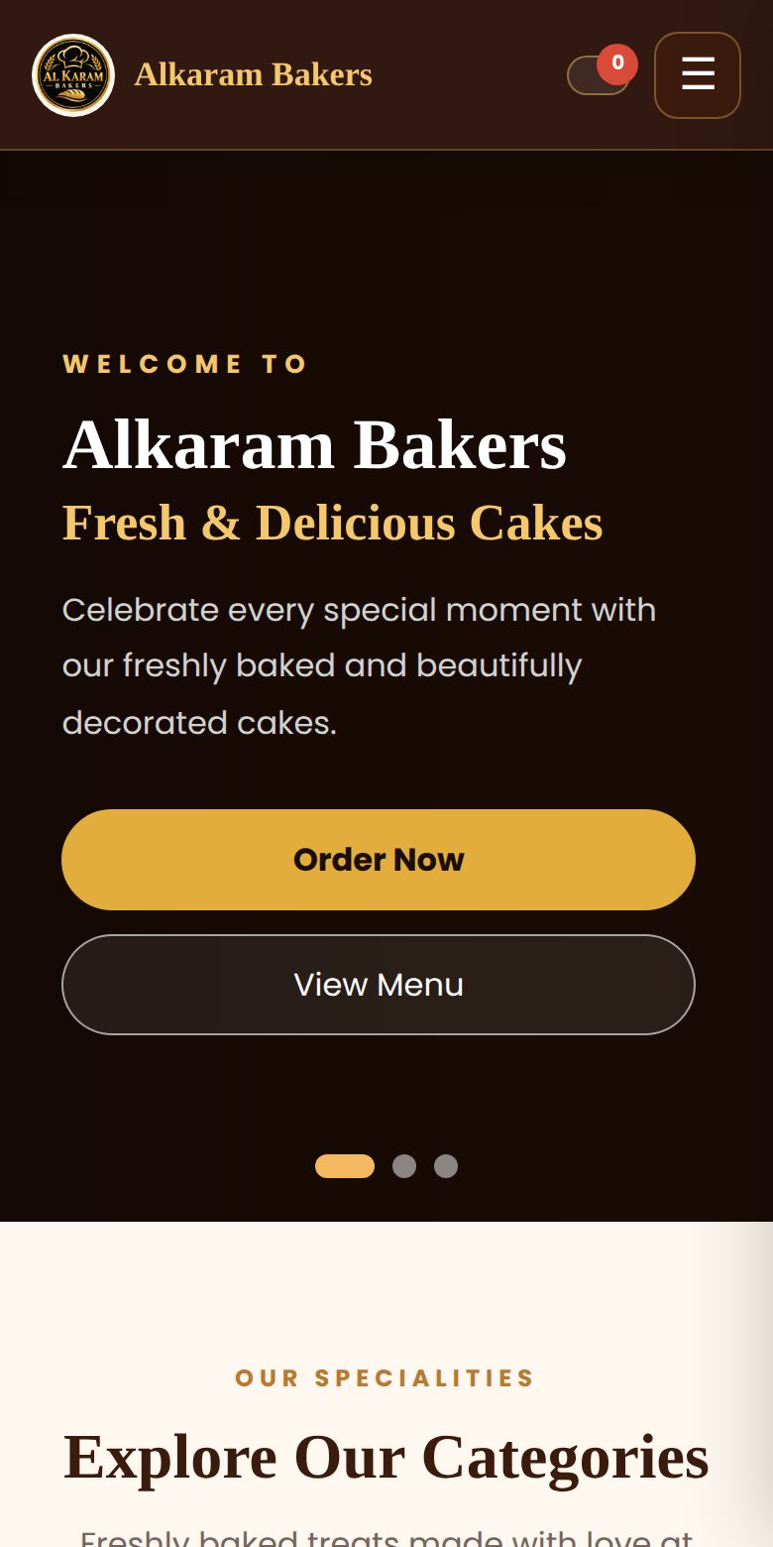  Home | 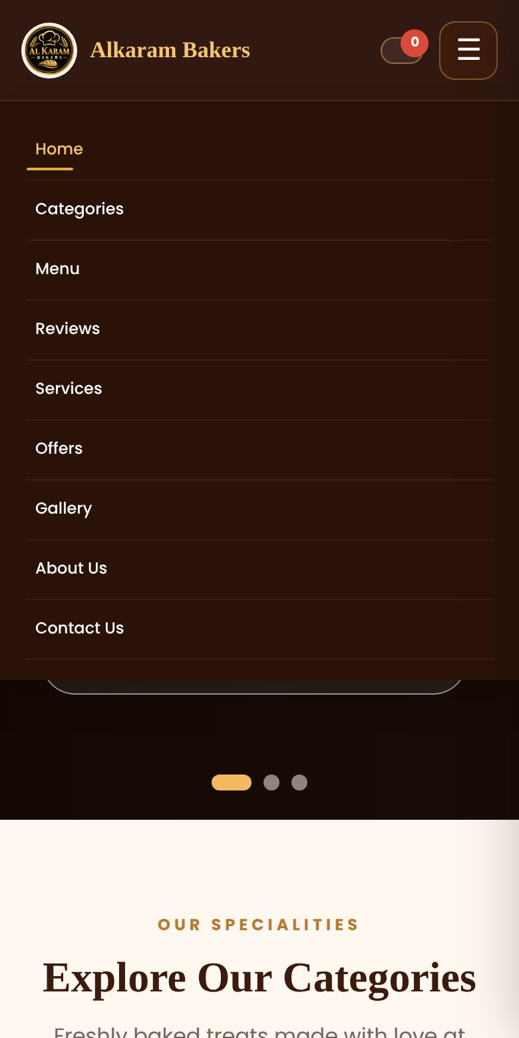  Menu open | 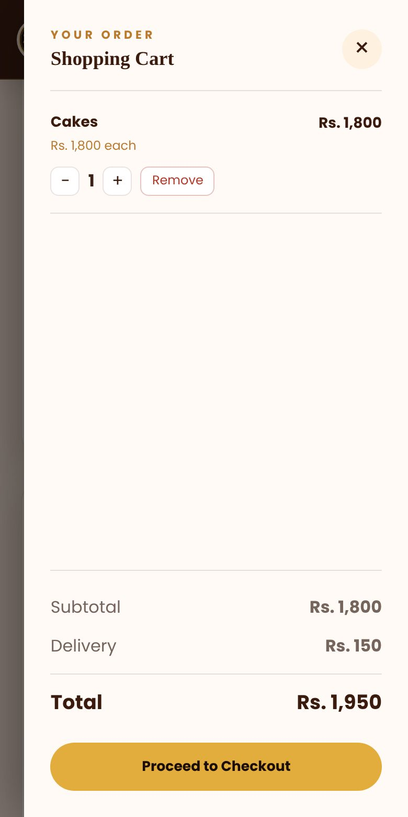  Cart

7. Settings
Open script.js. The block at the very top controls ordering.
const SETTINGS = {
whatsappNumber: "", // e.g. "923001234567"
contactEmail: "info@alkarambakers.com",
deliveryFee: 150,
freeDeliveryOver: 2000
};

Setting | Meaning
whatsappNumber | Country code plus number, no plus sign or spaces. Orders open in WhatsApp for the customer to send to you.
contactEmail | Where contact form messages are addressed.
deliveryFee | Delivery charge in rupees.
freeDeliveryOver | Subtotal at which delivery becomes free. Also update the offer text in index.html if you change it.

Adding a menu item
Copy any menu-card block in the menu section of index.html. Change data-category (cakes, pastries, cookies, sweets, patties or pies), the photo, the name, the price text, and the data-price and data-product on the button. Give every product a unique name.

8. What was fixed
Problem | Result
Hero slider dots | One dot button had broken HTML, so the first dot never highlighted. Fixed.
Cart merged different cakes | Two cakes shared a name, so the Rs. 3,500 cake was added at the Rs. 4,000 price. The second was renamed and the cart now matches on name and price.
Free delivery | The "free delivery over Rs. 2,000" offer was never applied. It now is, in the cart and at checkout.
Checkout and success popups | They had no CSS, so they sat open at the bottom of the page. They are now real popups.
Cart drawer | Quantity buttons, remove button, empty state and totals are now styled and match the JavaScript.
Category "Add to Cart" button | It was an unstyled browser button. It is now a full-width brown button with a gold hover.
Pies filter | Pies had no menu items, so the menu went blank. It now shows a clear message.
Menu filter buttons | The menu now has its own filter buttons instead of borrowing the gallery ones.
"From Rs." prices | They now follow the real menu prices instead of fixed numbers that no longer matched.
Navigation | Links now follow the page order, and "View Menu" goes to the menu instead of the gallery.
Sitemap page | Five links pointed to sections that did not exist, and the icon font was missing.
SEO and speed | robots.txt no longer blocks images, Open Graph image uses a full URL, and the logo went from 1.1 MB to 35 KB.

9. Before you publish
Item | What to do
Phone number | 03XX-XXXXXXX is still a placeholder in the contact section and in the Google structured data (JSON-LD).
WhatsApp number | Set SETTINGS.whatsappNumber in script.js, for example "923001234567". Until then, placed orders are only stored in the visitor's own browser and do not reach you.
Contact email | The contact form opens the visitor's email app addressed to SETTINGS.contactEmail (now info@alkarambakers.com).
Product photos | Most menu photos are linked from other websites, and some are temporary Google thumbnails. Save your own photos into the images folder.
"50+ Bakery Items" | The About section says 50+, but the menu lists 33. Update one of them.
Prices | Check Rs. 2,500 for Mini pastries 4pcs, Mix Nimko and Masala Papri, and Rs. 100 for Cookies Box.
Visitor counter, reviews, chefs | These are sample content. The counter grows on every refresh of the same browser.
Social links | Instagram, Facebook, X and the chef icons link to the generic home pages.

When everything above is done, upload the whole folder (including images) to your host and submit sitemap.xml in Google Search Console.

