BNI ENTERPRISES
BIKE DEALER MANAGEMENT SYSTEM

OFFICIAL SYSTEM AUDIT & USER MANUAL

Date: 4/20/2026
Version: 2026.3.0
Classification: Internal / Corporate

TABLE OF CONTENTS

Dashboard Module

Purpose
This module facilitates the manage of dashboard within the system. It allows for the tracking, reporting, and classification of critical business records.

Form Fields & Controls

Data Architecture (Tables)
MODEL | CATEGORY | INVENTORY | SOLD | RETURNED | AVAILABLE
E8S M2 Electric Scooter | Electric Scooter | 2 | 1 | 0 | 1
E8S Pro Electric Scooter | Electric Scooter | 1 | 0 | 0 | 1
LY SI Electric Bike | Electric Bike | 2 | 0 | 0 | 2

DATE | CHASSIS | MODEL | PRICE | MARGIN
18/03/2026 | TH12L72300000416 | Thrill Pro LFP Electric Bike | Rs. 246,000 | Rs. 34,076
18/03/2026 | T910G72260008679 | T9 Sports Electric Bike | Rs. 179,000 | Rs. 17,560
12/03/2026 | M615L72300006176 | M6 Lithium NP Electric Bike | Rs. 285,000 | Rs. 29,760

DATE | CHASSIS | MODEL | PRICE | STATUS
05/02/2026 | LY05G48270002304 | LY SI Electric Bike | Rs. 125,225 | IN_STOCK
05/02/2026 | LY05G48270002202 | LY SI Electric Bike | Rs. 125,225 | IN_STOCK
05/02/2026 | DD35G48130001177 | W. Bike H2 Electric Bike | Rs. 94,595 | IN_STOCK

Visual Evidence
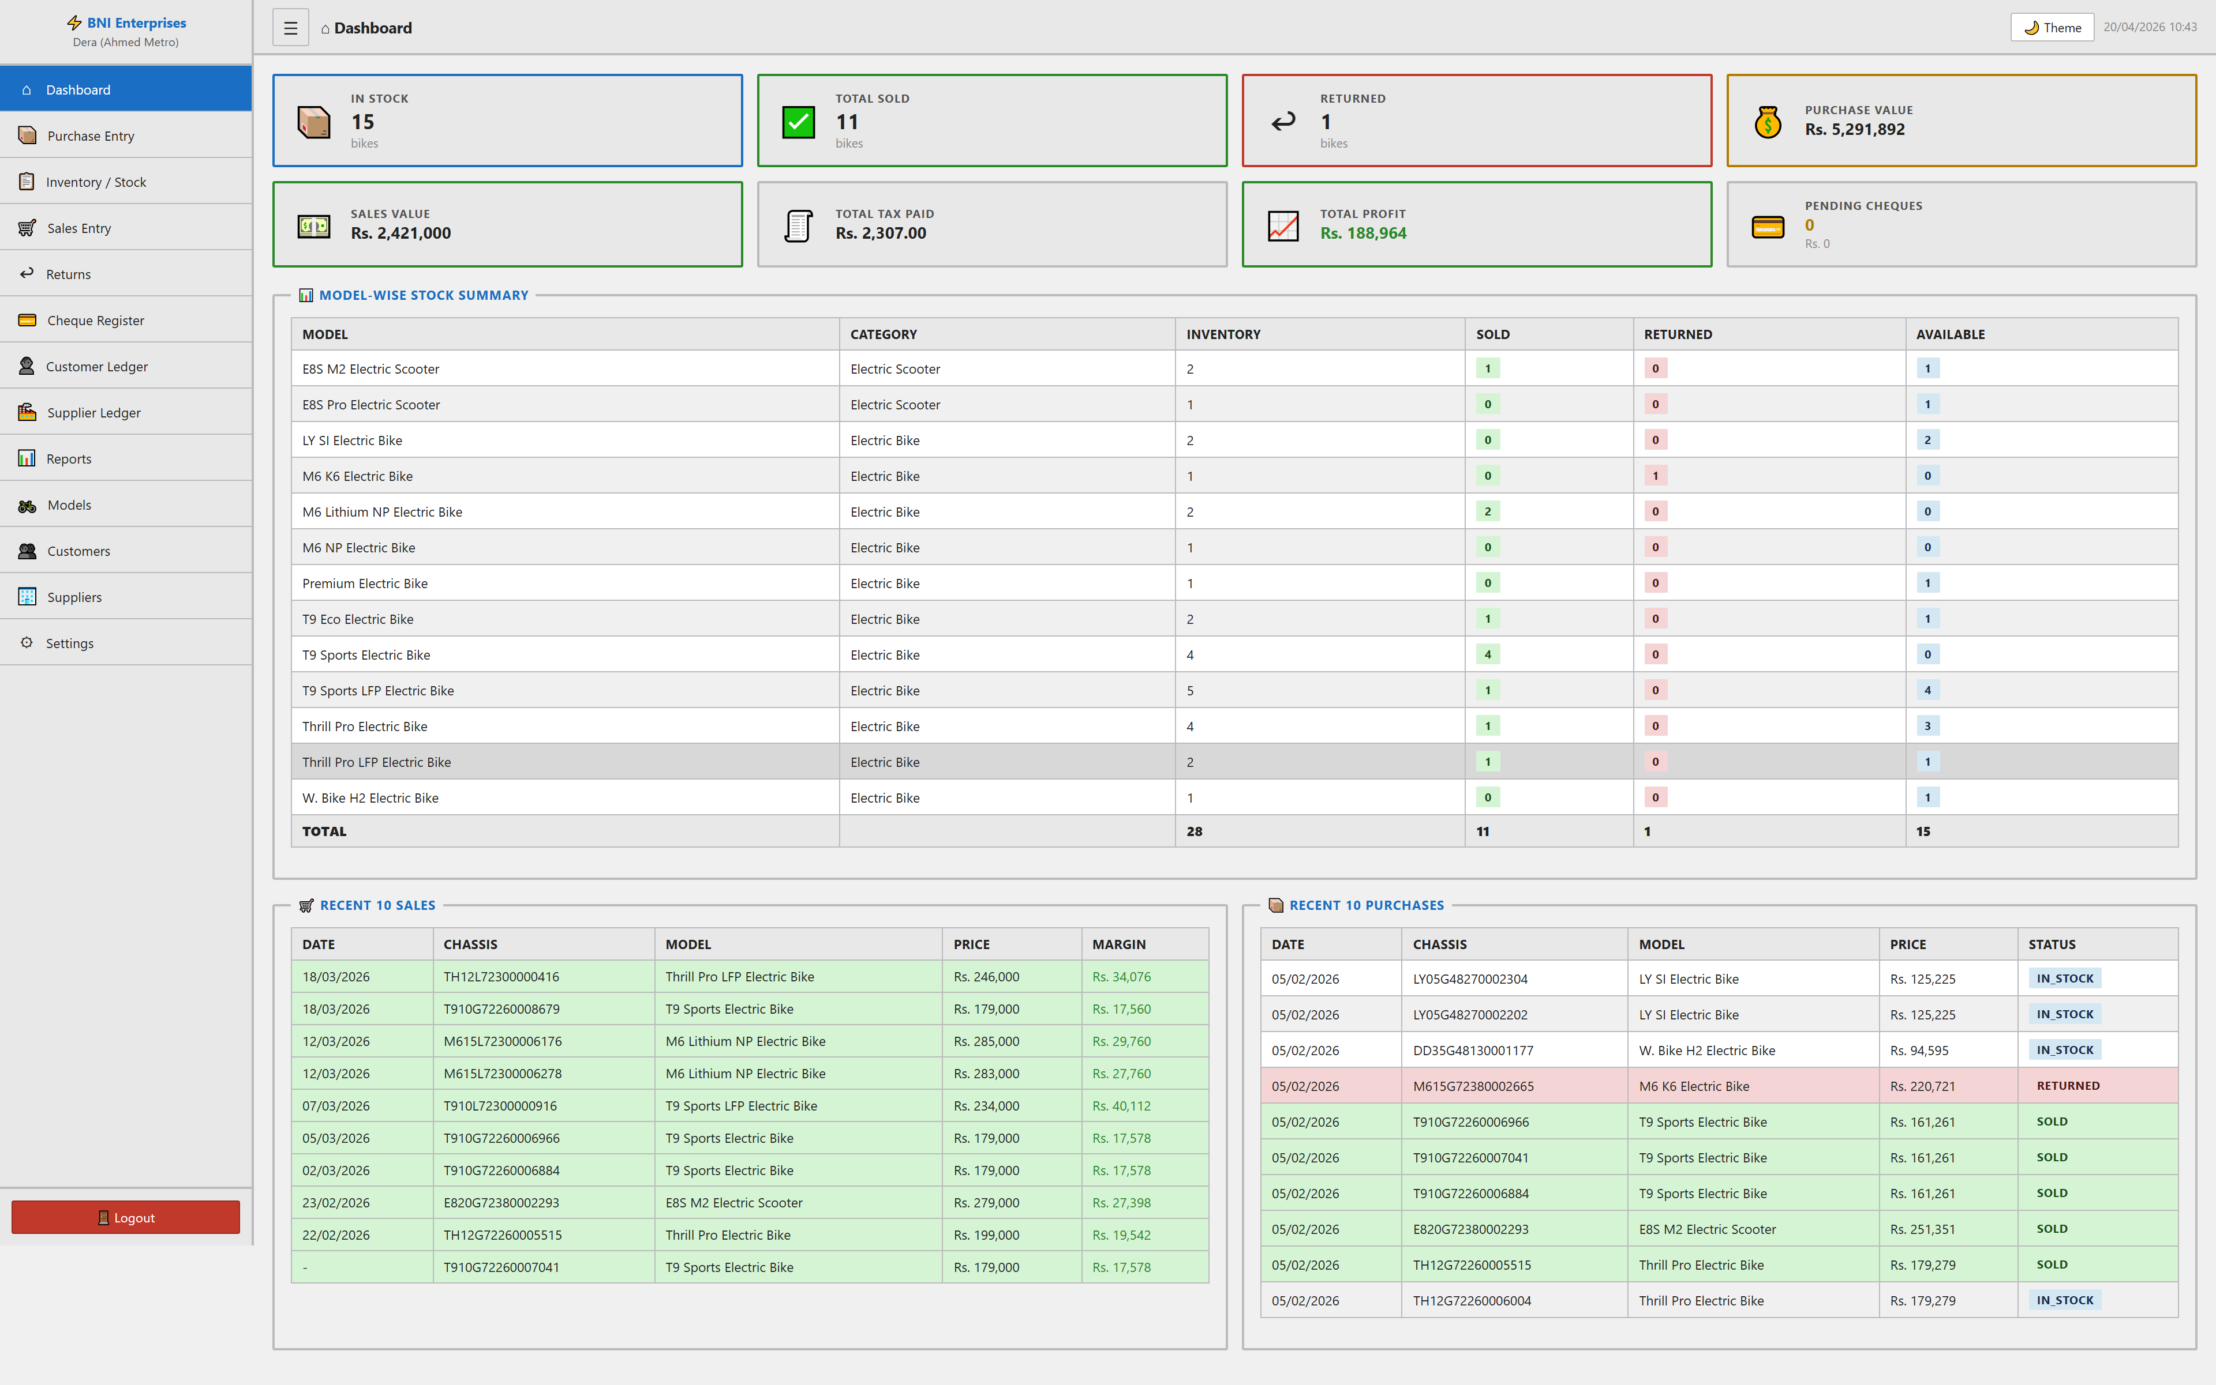

Cheque Register Module

Purpose
This module facilitates the manage of cheque register within the system. It allows for the tracking, reporting, and classification of critical business records.

Form Fields & Controls
STATUS (select): Standardized categorization dropdown.
TYPE (select): Standardized categorization dropdown.
BANK (text): Captures standardized information for records.
FROM (date): Chronological tracking for historical reporting.
TO (date): Chronological tracking for historical reporting.

Data Architecture (Tables)
SR# | CHEQUE # | BANK | DATE | AMOUNT | TYPE | STATUS | PARTY | REFERENCE | ACTIONS
1 | D72981756 | Meezan | 18/03/2026 | Rs. 1,241,441.00 | PAYMENT | CLEARED | Default Supplier | purchase_order #4 | 🗑
2 | 03420809 | UBL | 12/03/2026 | Rs. 1,002,710.00 | PAYMENT | CLEARED | Default Supplier | purchase_order #3 | 🗑
3 | 03420811 | UBL | 27/02/2026 | Rs. 509,910.00 | PAYMENT | CLEARED | Default Supplier | purchase_order #2 | 🗑

Visual Evidence
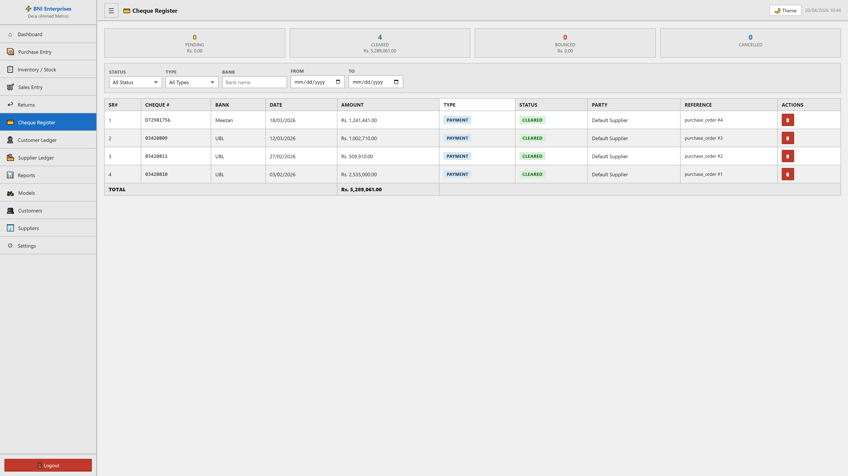

Customer Ledger Module

Purpose
This module facilitates the manage of customer ledger within the system. It allows for the tracking, reporting, and classification of critical business records.

Form Fields & Controls
SELECT CUSTOMER (select): Standardized categorization dropdown.

Visual Evidence
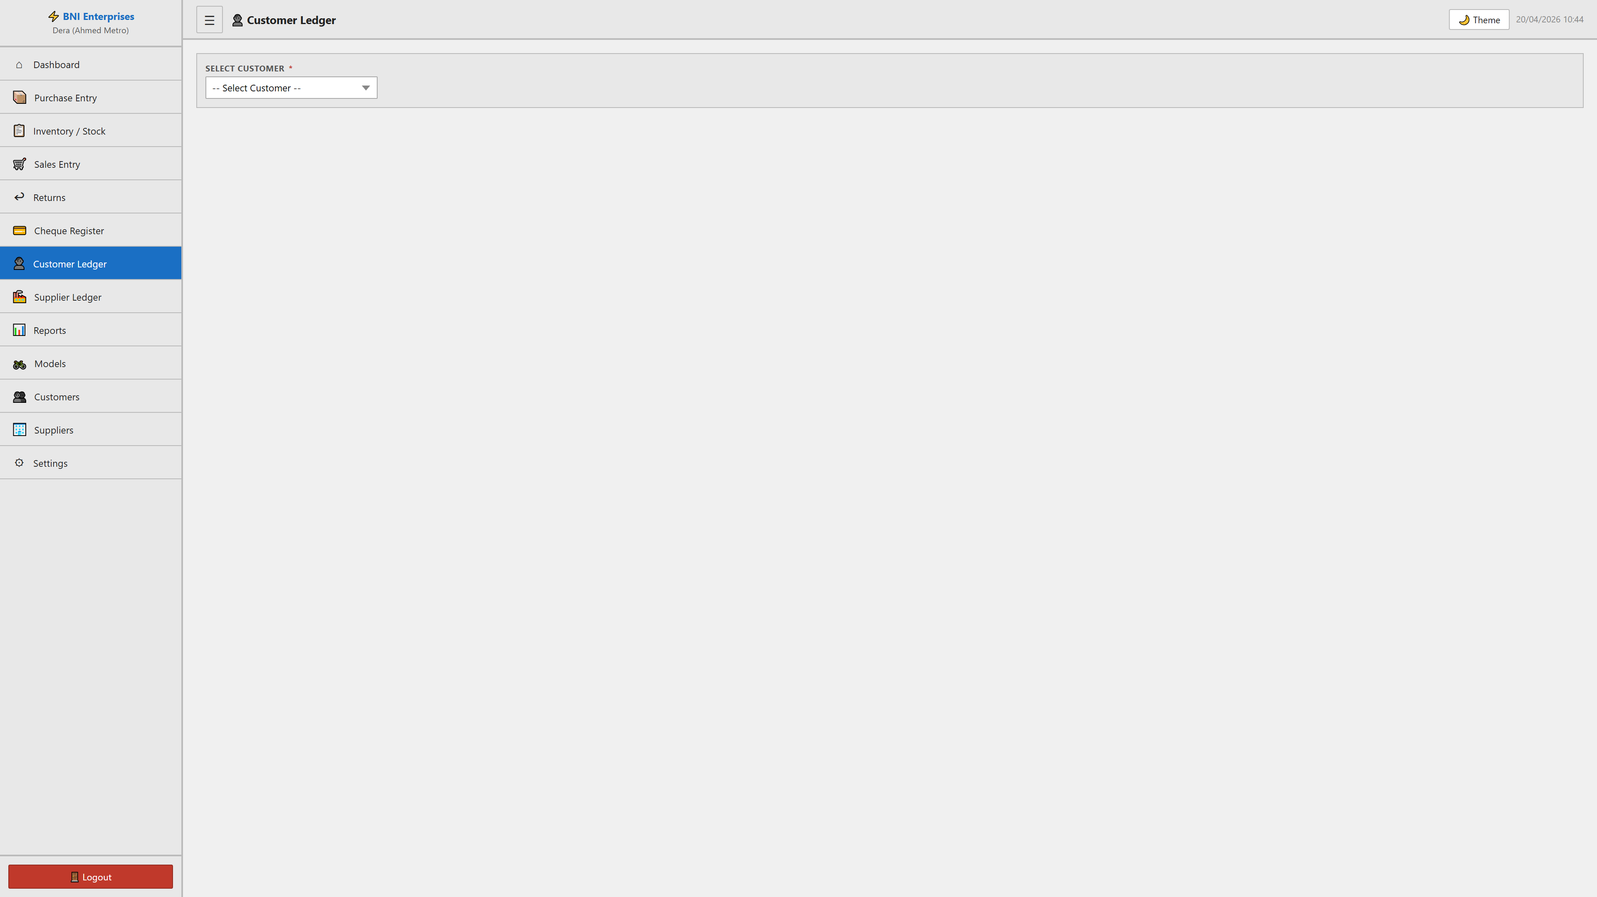

Customers Module

Purpose
This module facilitates the manage of customers within the system. It allows for the tracking, reporting, and classification of critical business records.

Form Fields & Controls
Name (text): Primary record identifier for classification.
Phone (text): Captures standardized information for records.
CNIC (text): Captures standardized information for records.
Address (textarea): Captures standardized information for records.

Data Architecture (Tables)
SR# | NAME | PHONE | CNIC | ADDRESS | BIKES PURCHASED | TOTAL AMOUNT | ACTIONS
1 | Ahmed Ali | 0321-1234567 | 35201-1234567-1 | Dera Ghazi Khan, Punjab | 0 | Rs. 0.00 | 📒

✏
🗑 |
✏
🗑 |
✏
🗑 |

Visual Evidence
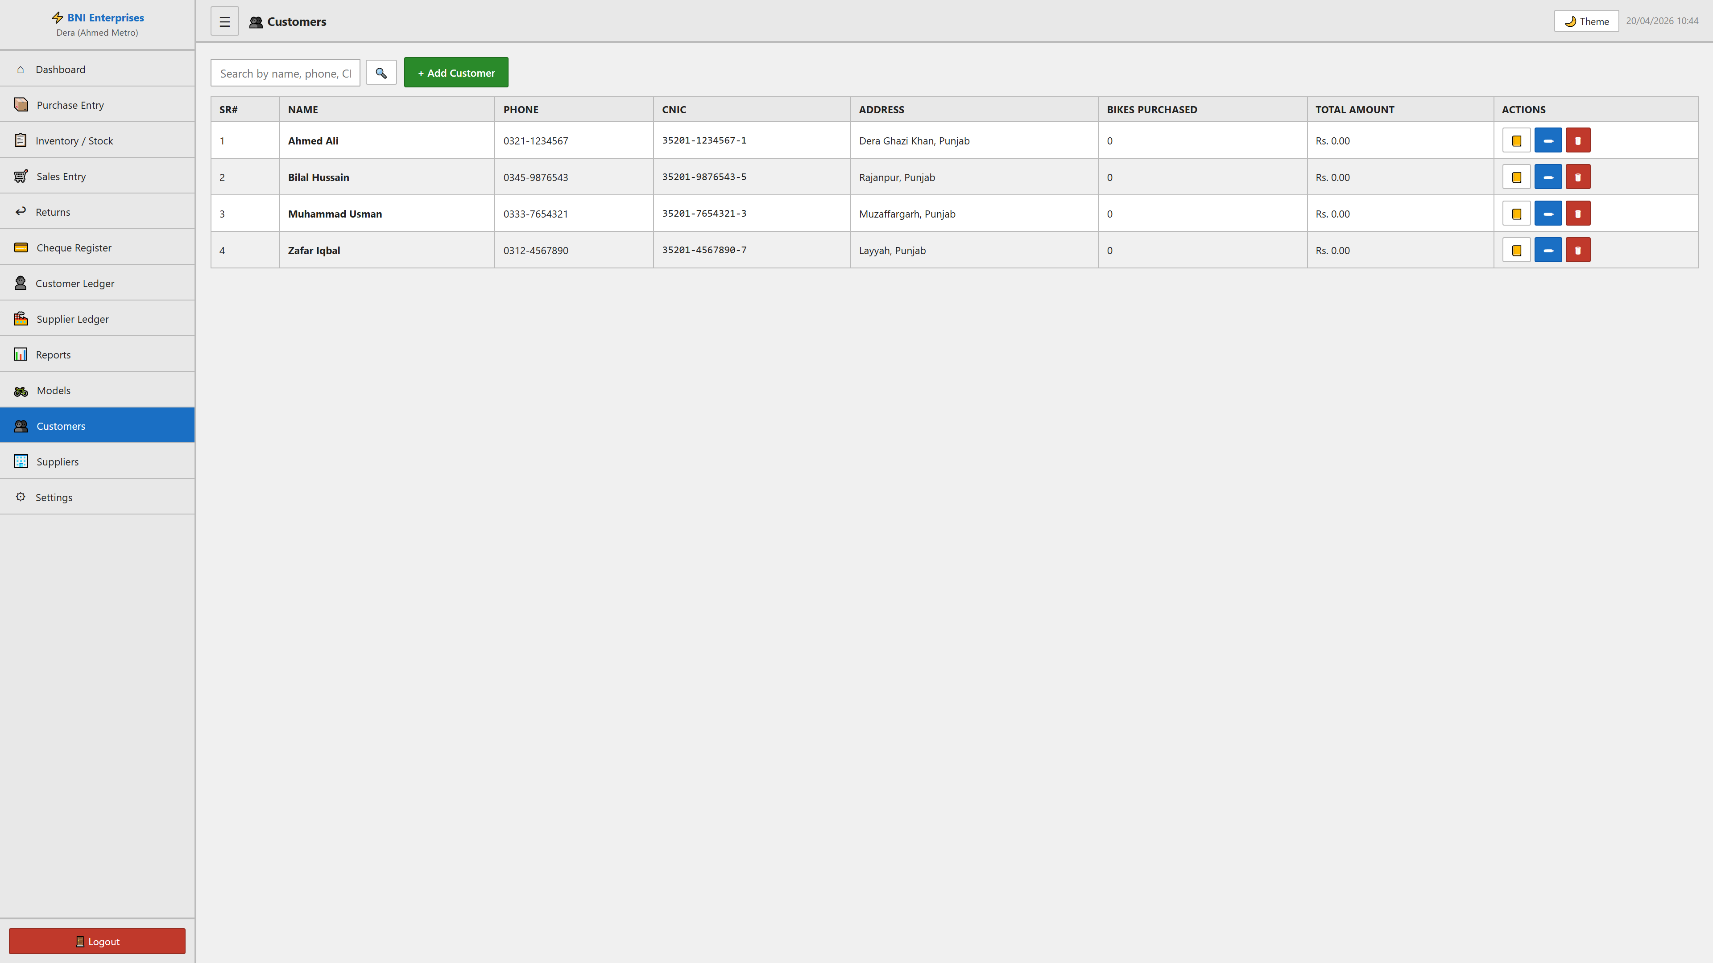

Inventory / Stock Module

Purpose
This module facilitates the manage of inventory / stock within the system. It allows for the tracking, reporting, and classification of critical business records.

Form Fields & Controls
SEARCH (text): Captures standardized information for records.
STATUS (select): Standardized categorization dropdown.
MODEL (select): Standardized categorization dropdown.
COLOR (text): Captures standardized information for records.
FROM (date): Chronological tracking for historical reporting.
TO (date): Chronological tracking for historical reporting.

Data Architecture (Tables)
SR# | CHASSIS | MOTOR# | MODEL | COLOR | PURCHASE PRICE | STATUS | SELLING PRICE | SELLING DATE | MARGIN | ACTIONS
1 | LY05G48270002304 | *XRLY48052125D0002228* | LY SI Electric Bike | Black | Rs. 125,225.00 | IN_STOCK | - | - | - | 👁

🛒
✏
🗑 |
🛒
✏
🗑 |
🛒
✏
🗑 |

Visual Evidence
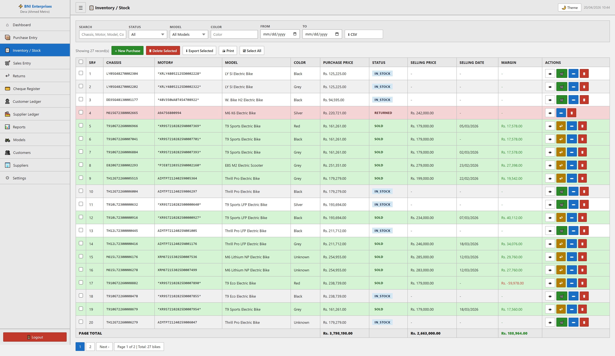

Models Module

Purpose
This module facilitates the manage of models within the system. It allows for the tracking, reporting, and classification of critical business records.

Form Fields & Controls
Model Code (text): Captures standardized information for records.
Model Name (text): Primary record identifier for classification.
Category (text): Captures standardized information for records.
Short Code (text): Captures standardized information for records.

Data Architecture (Tables)
SR# | MODEL CODE | MODEL NAME | CATEGORY | SHORT CODE | TOTAL INVENTORY | IN STOCK | SOLD | ACTIONS
1 | E8S M2 | E8S M2 Electric Scooter | Electric Scooter | E8S | 2 | 1 | 1 | ✏ Edit

🗑 |
🗑 |
🗑 |

Visual Evidence
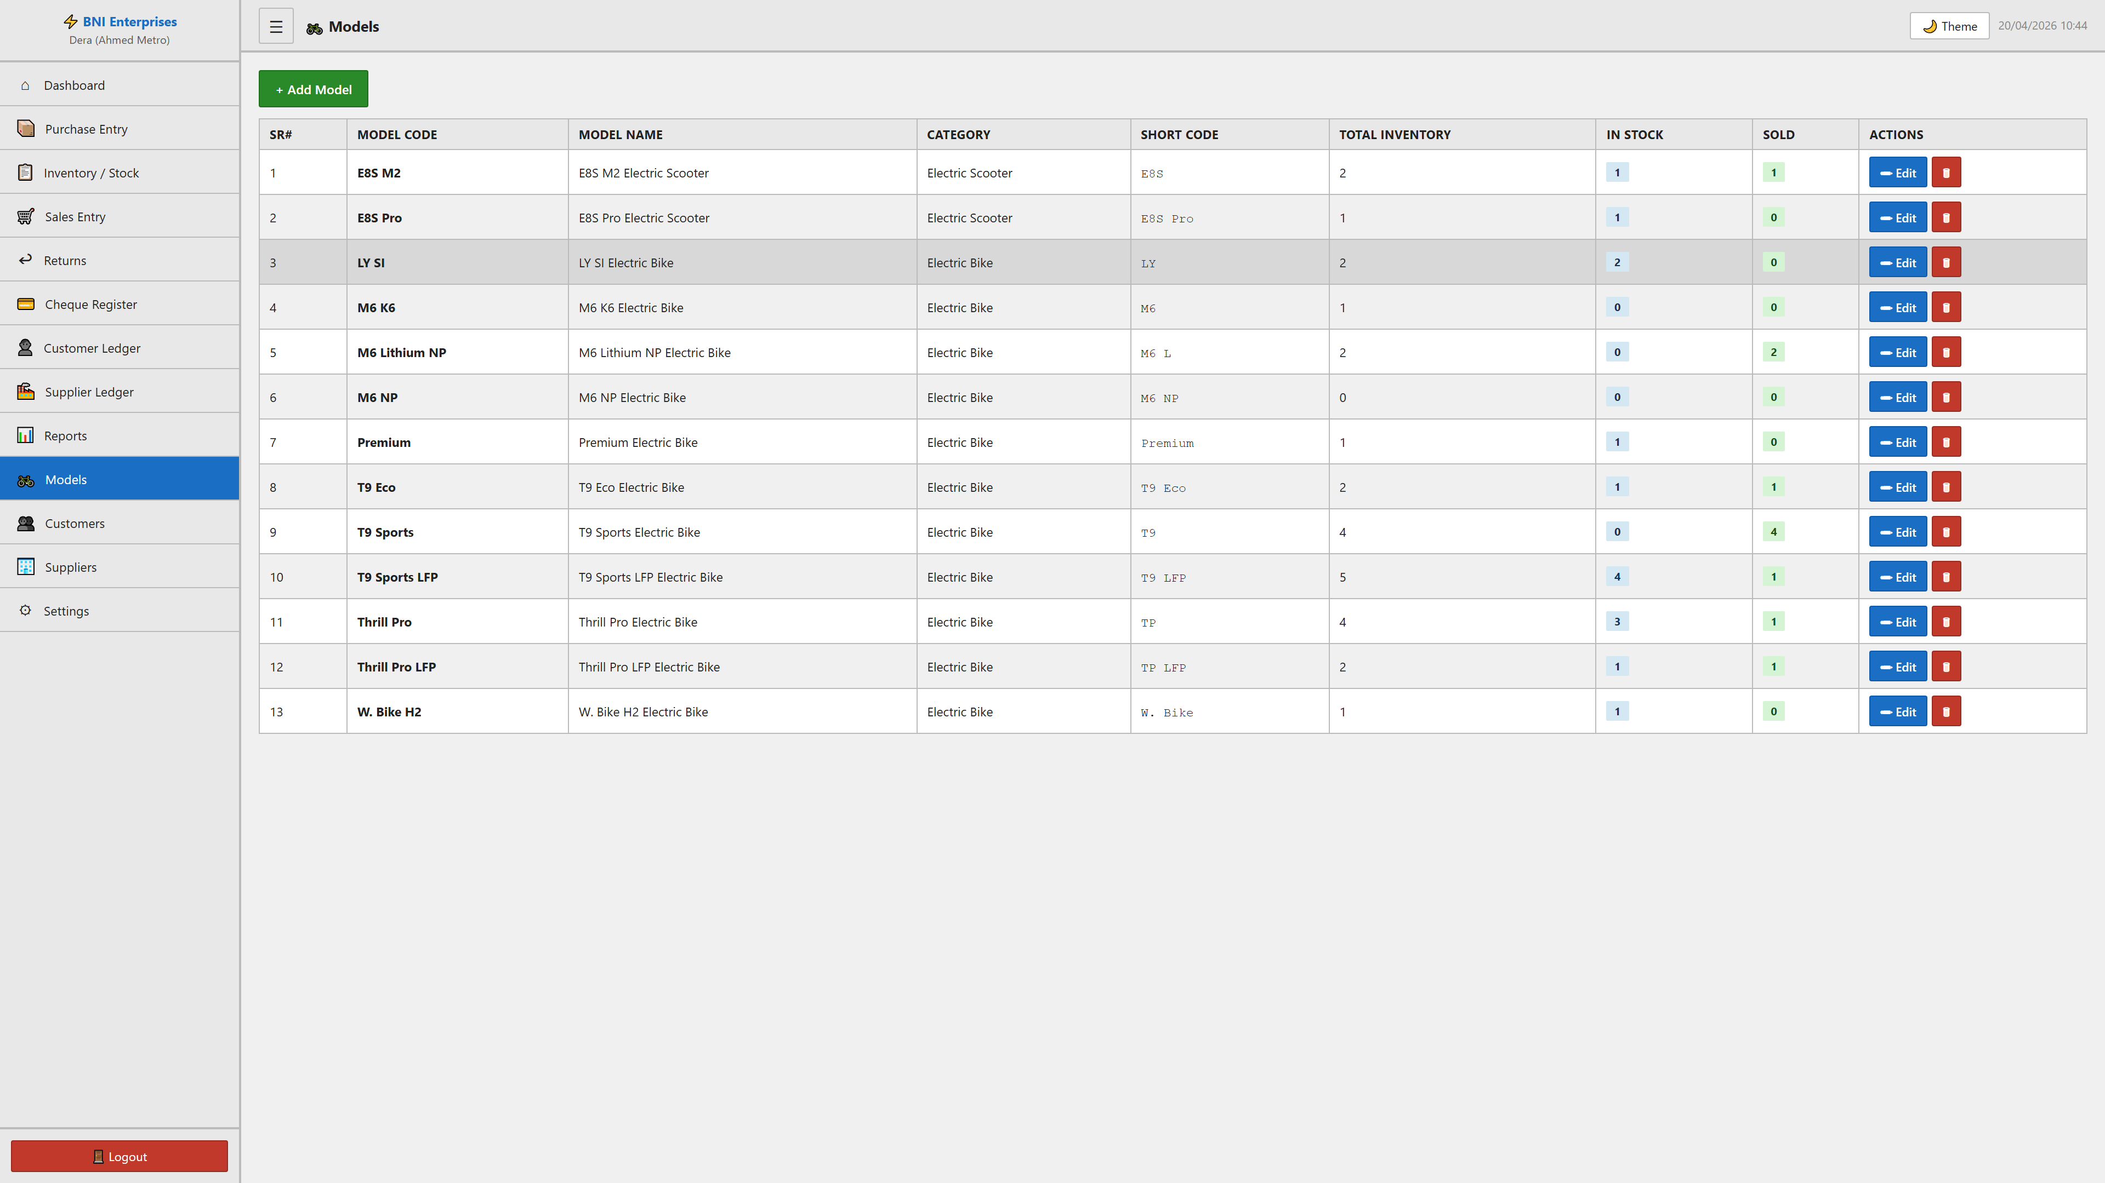

Purchase Entry Module

Purpose
This module facilitates the manage of purchase entry within the system. It allows for the tracking, reporting, and classification of critical business records.

Form Fields & Controls
ORDER DATE (date): Chronological tracking for historical reporting.
INVENTORY DATE (date): Chronological tracking for historical reporting.
SUPPLIER (select): Standardized categorization dropdown.
CHEQUE NUMBER (text): Captures standardized information for records.
BANK NAME (text): Primary record identifier for classification.
CHEQUE DATE (date): Chronological tracking for historical reporting.
CHEQUE AMOUNT (number): Captures standardized information for records.
NOTES (textarea): Captures standardized information for records.
CHASSIS NUMBER (text): Captures standardized information for records.
MOTOR NUMBER (text): Captures standardized information for records.
MODEL (select): Standardized categorization dropdown.
COLOR (text): Captures standardized information for records.
PURCHASE PRICE (RS.) (number): Captures standardized information for records.
SAFEGUARD NOTES (text): Captures standardized information for records.
ACCESSORIES (text): Captures standardized information for records.
NOTES (text): Captures standardized information for records.
Name (text): Primary record identifier for classification.
Contact (text): Captures standardized information for records.
Address (textarea): Captures standardized information for records.
Model Code (text): Captures standardized information for records.
Model Name (text): Primary record identifier for classification.
Category (text): Captures standardized information for records.
Short Code (text): Captures standardized information for records.

Visual Evidence
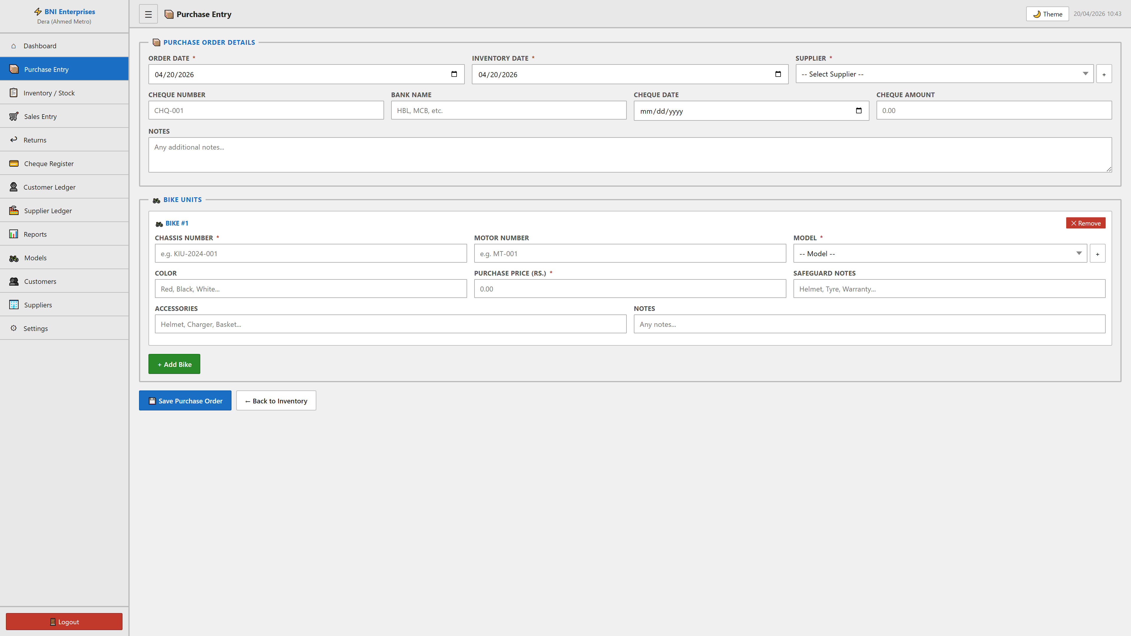

Interface Variation: + Modal
Captures supplementary data during complex transactions.
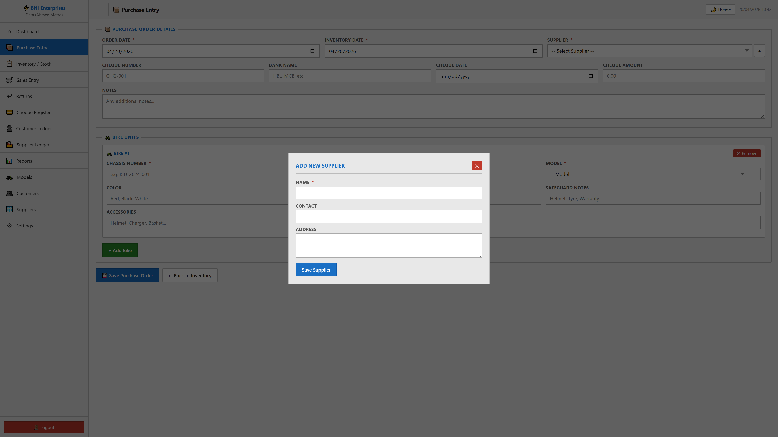

Reports Module

Purpose
This module facilitates the manage of reports within the system. It allows for the tracking, reporting, and classification of critical business records.

Form Fields & Controls
FROM DATE (date): Chronological tracking for historical reporting.
TO DATE (date): Chronological tracking for historical reporting.
YEAR (number): Captures standardized information for records.
MONTH (select): Standardized categorization dropdown.

Data Architecture (Tables)
SR# | CHASSIS | MOTOR# | MODEL | CATEGORY | COLOR | PURCHASE PRICE | INVENTORY DATE | DAYS IN STOCK
1 | E810G72380000595 | *10ZW7273316YECKTS0000107* | E8S M2 Electric Scooter | Electric Scooter | Grey | Rs. 251,351.00 | 27/03/2026 | 24 days
2 | E820G72380000466 | 12ZW7271327YE*CERR116670C* | E8S Pro Electric Scooter | Electric Scooter | Blue | Rs. 247,748.00 | 27/03/2026 | 24 days
3 | LY05G48270002304 | *XRLY48052125D0002228* | LY SI Electric Bike | Electric Bike | Black | Rs. 125,225.00 | 05/02/2026 | 74 days

Visual Evidence
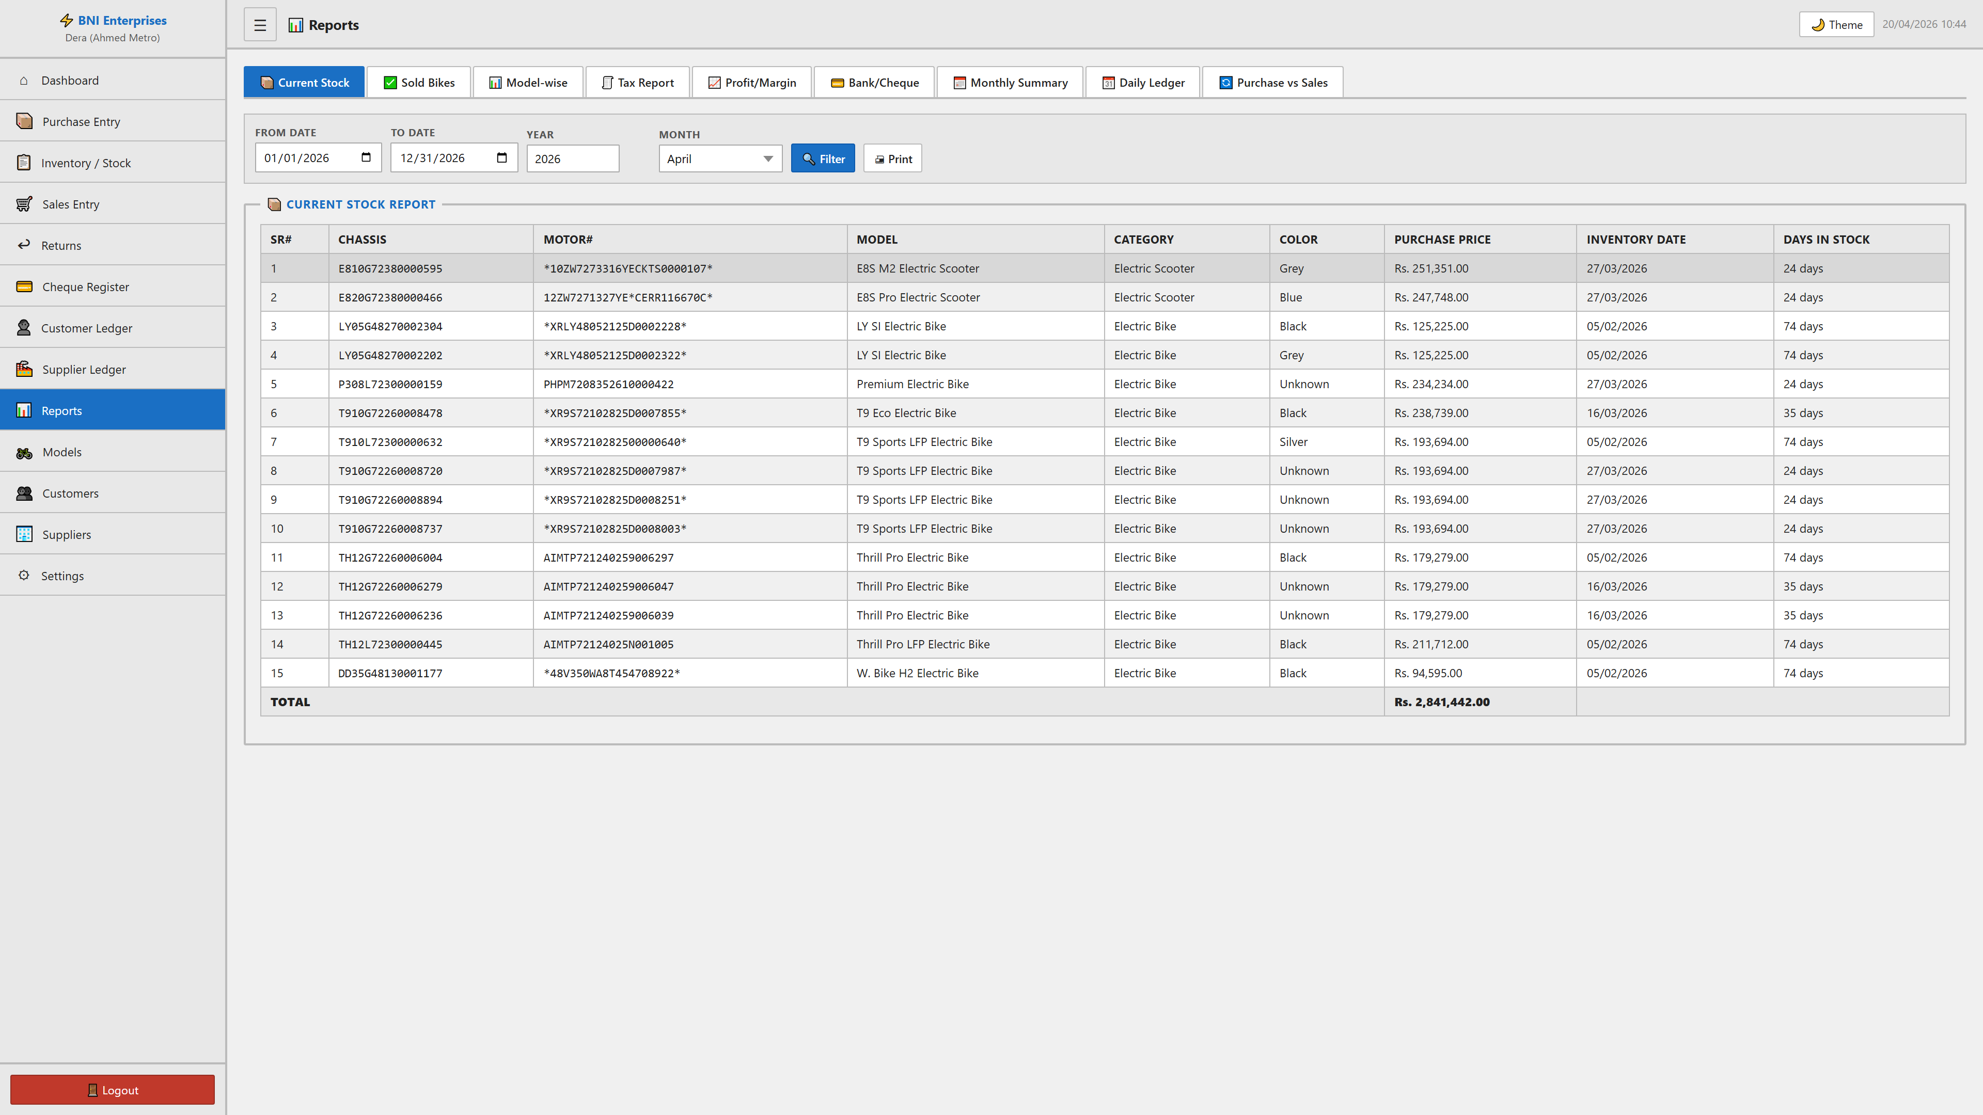

Returns Module

Purpose
This module facilitates the manage of returns within the system. It allows for the tracking, reporting, and classification of critical business records.

Form Fields & Controls
SELECT SOLD BIKE (select): Standardized categorization dropdown.
RETURN DATE (date): Chronological tracking for historical reporting.
RETURN AMOUNT (RS.) (number): Captures standardized information for records.
REFUND METHOD (select): Standardized categorization dropdown.
Cheque Number (text): Captures standardized information for records.
Bank Name (text): Primary record identifier for classification.
Cheque Date (date): Chronological tracking for historical reporting.
RETURN NOTES (textarea): Captures standardized information for records.

Visual Evidence
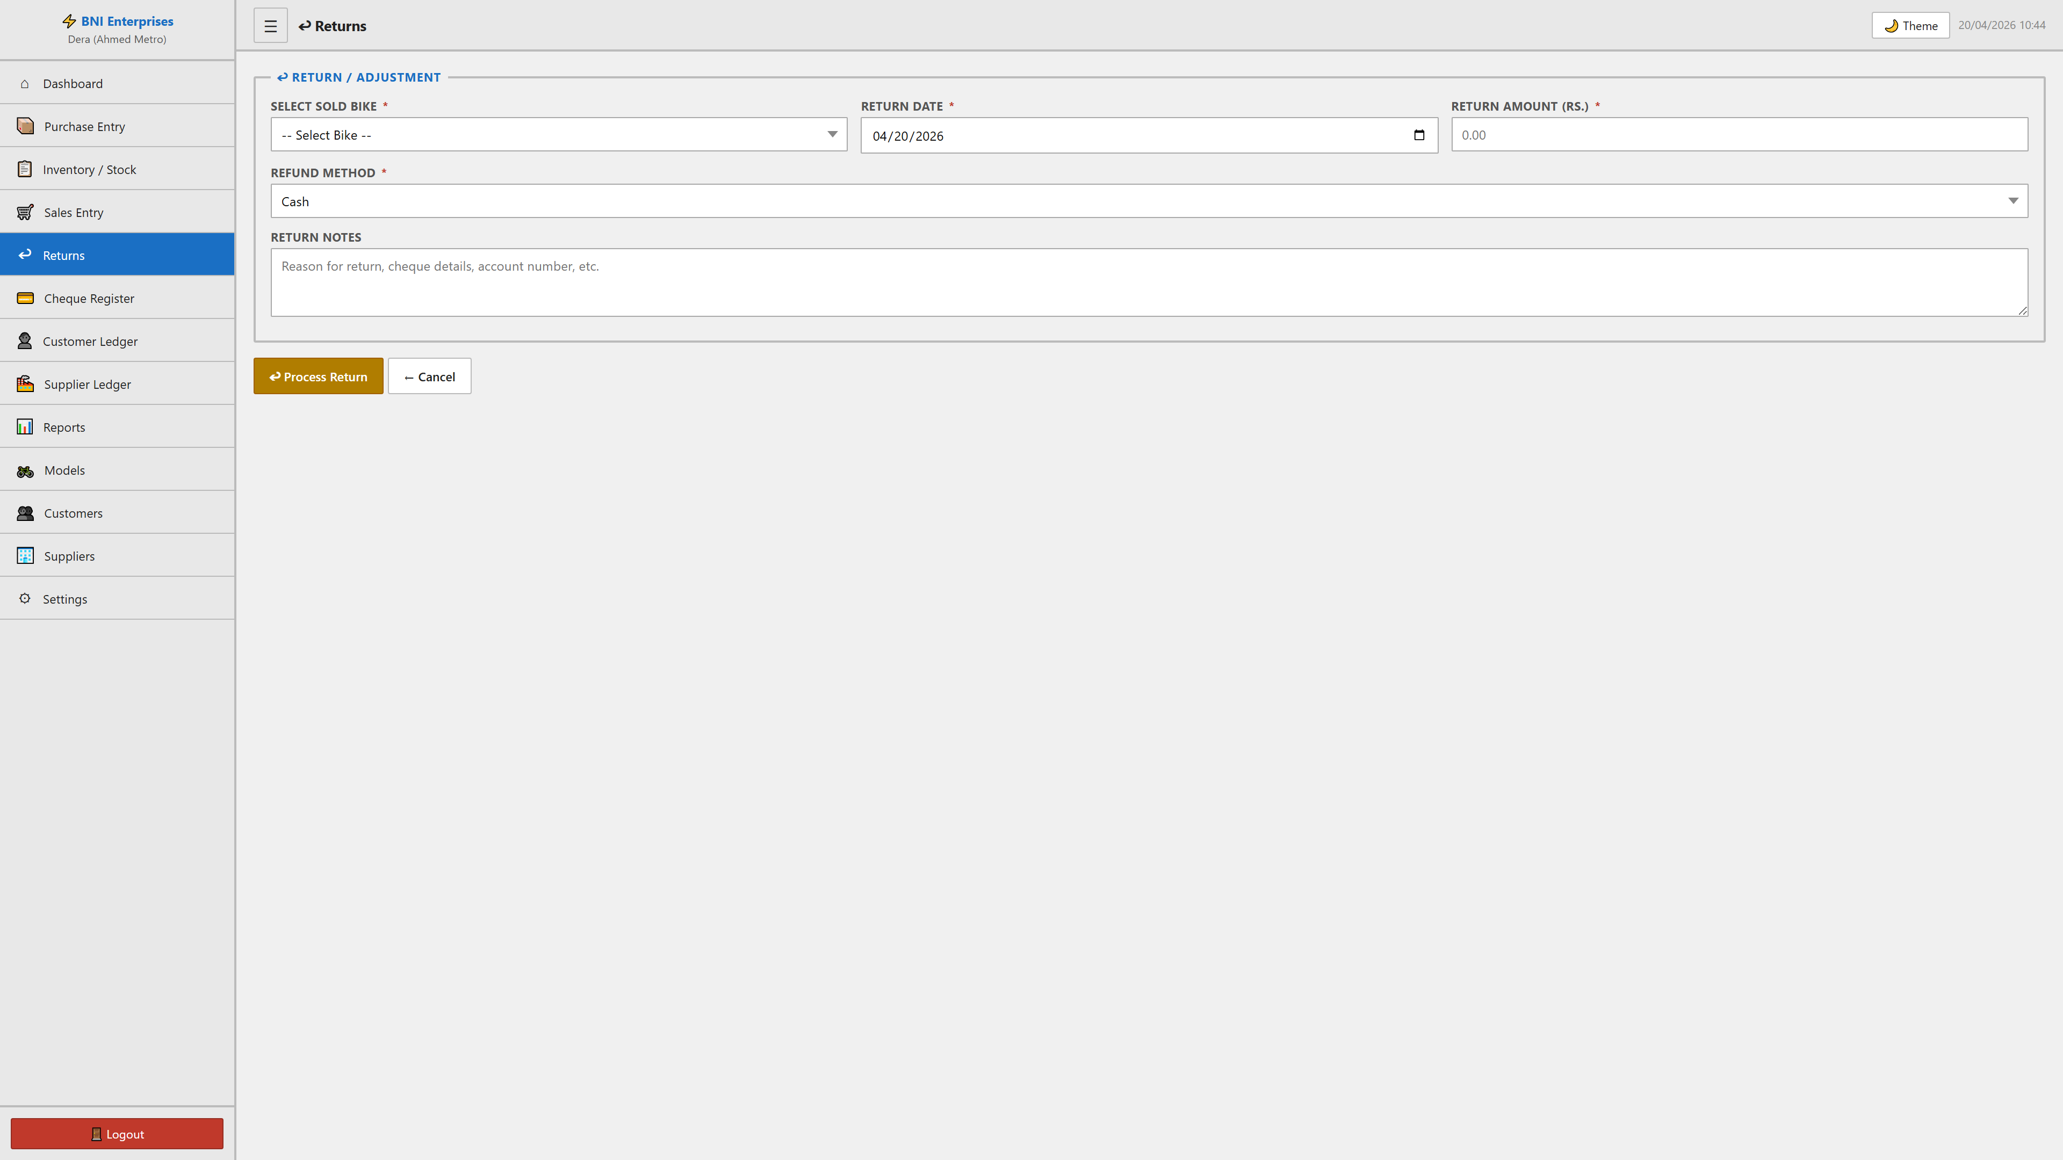

Sales Entry Module

Purpose
This module facilitates the manage of sales entry within the system. It allows for the tracking, reporting, and classification of critical business records.

Form Fields & Controls
SELECT BIKE (select): Standardized categorization dropdown.
SELLING DATE (date): Chronological tracking for historical reporting.
SELLING PRICE (RS.) (number): Captures standardized information for records.
PURCHASE PRICE (number): Captures standardized information for records.
TAX AMOUNT (0.1% OF PURCHASE PRICE) (text): Captures standardized information for records.
MARGIN / PROFIT (text): Captures standardized information for records.
CUSTOMER (select): Standardized categorization dropdown.
PAYMENT METHOD (select): Standardized categorization dropdown.
Cheque Number (text): Captures standardized information for records.
Bank Name (text): Primary record identifier for classification.
Cheque Date (date): Chronological tracking for historical reporting.
Cheque Amount (number): Captures standardized information for records.
ACCESSORIES GIVEN (text): Captures standardized information for records.
NOTES (text): Captures standardized information for records.
Name (text): Primary record identifier for classification.
Phone (text): Captures standardized information for records.
CNIC (text): Captures standardized information for records.
Address (textarea): Captures standardized information for records.

Visual Evidence
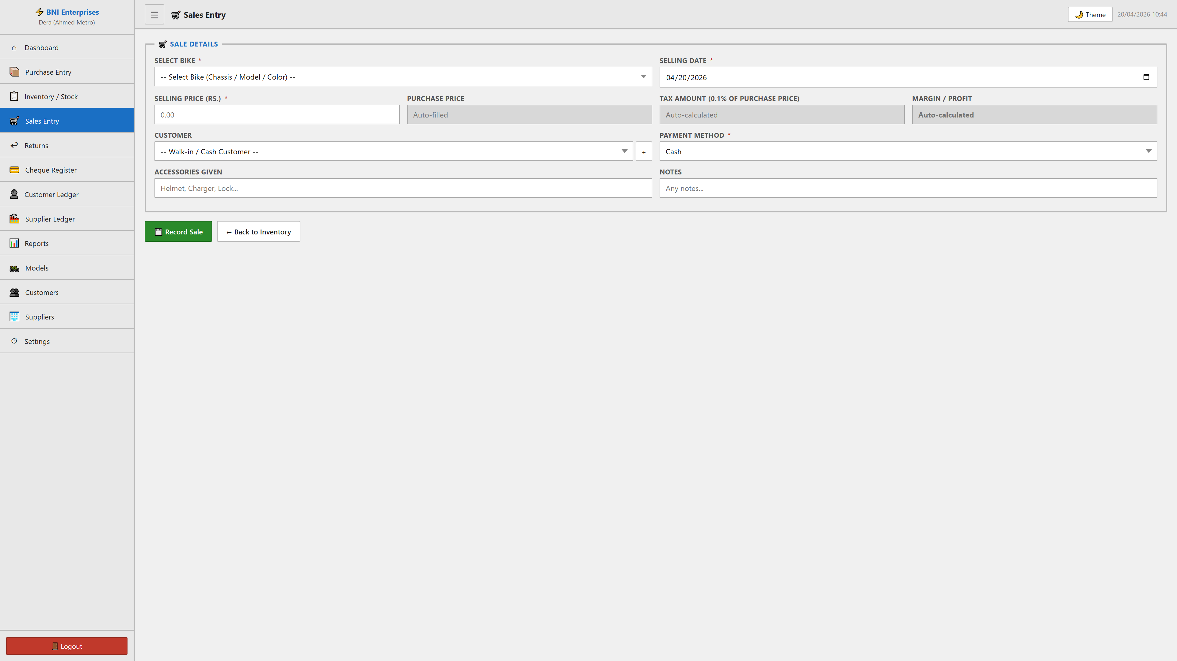

Interface Variation: + Modal
Captures supplementary data during complex transactions.
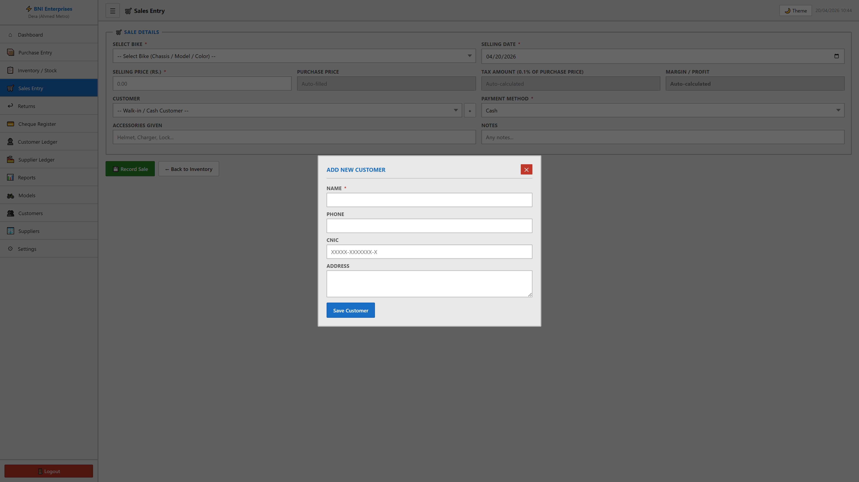

Settings Module

Purpose
This module facilitates the manage of settings within the system. It allows for the tracking, reporting, and classification of critical business records.

Form Fields & Controls
COMPANY NAME (text): Primary record identifier for classification.
BRANCH NAME (text): Primary record identifier for classification.
CURRENCY SYMBOL (text): Captures standardized information for records.
TAX RATE (%) (number): Captures standardized information for records.
TAX CALCULATED ON (select): Standardized categorization dropdown.
SHOW PURCHASE PRICE ON INVOICE (select): Standardized categorization dropdown.
NEW PASSWORD (MIN 8 CHARACTERS, LEAVE BLANK TO KEEP CURRENT) (password): Captures standardized information for records.

Visual Evidence
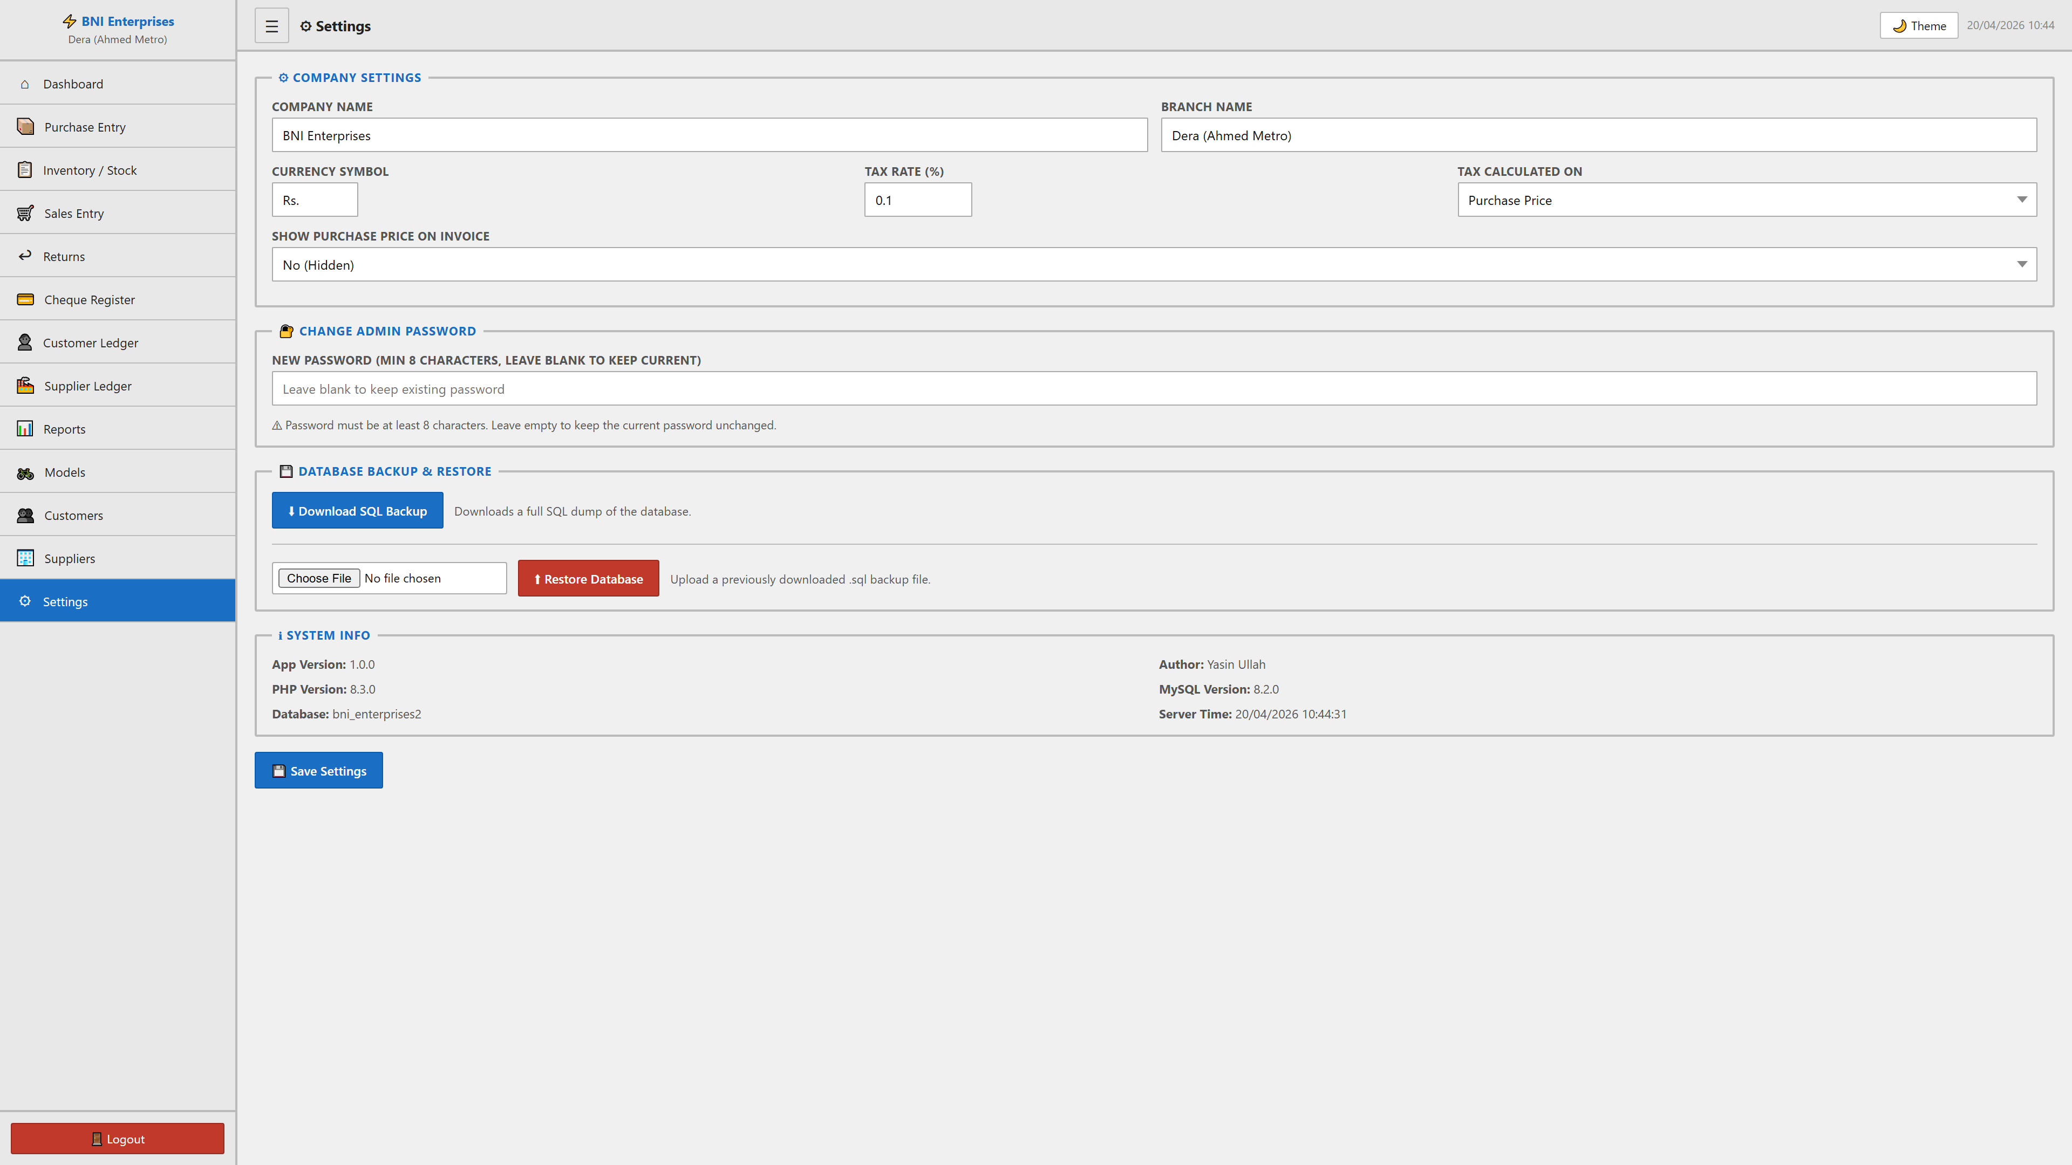

Supplier Ledger Module

Purpose
This module facilitates the manage of supplier ledger within the system. It allows for the tracking, reporting, and classification of critical business records.

Form Fields & Controls
SELECT SUPPLIER (select): Standardized categorization dropdown.

Visual Evidence
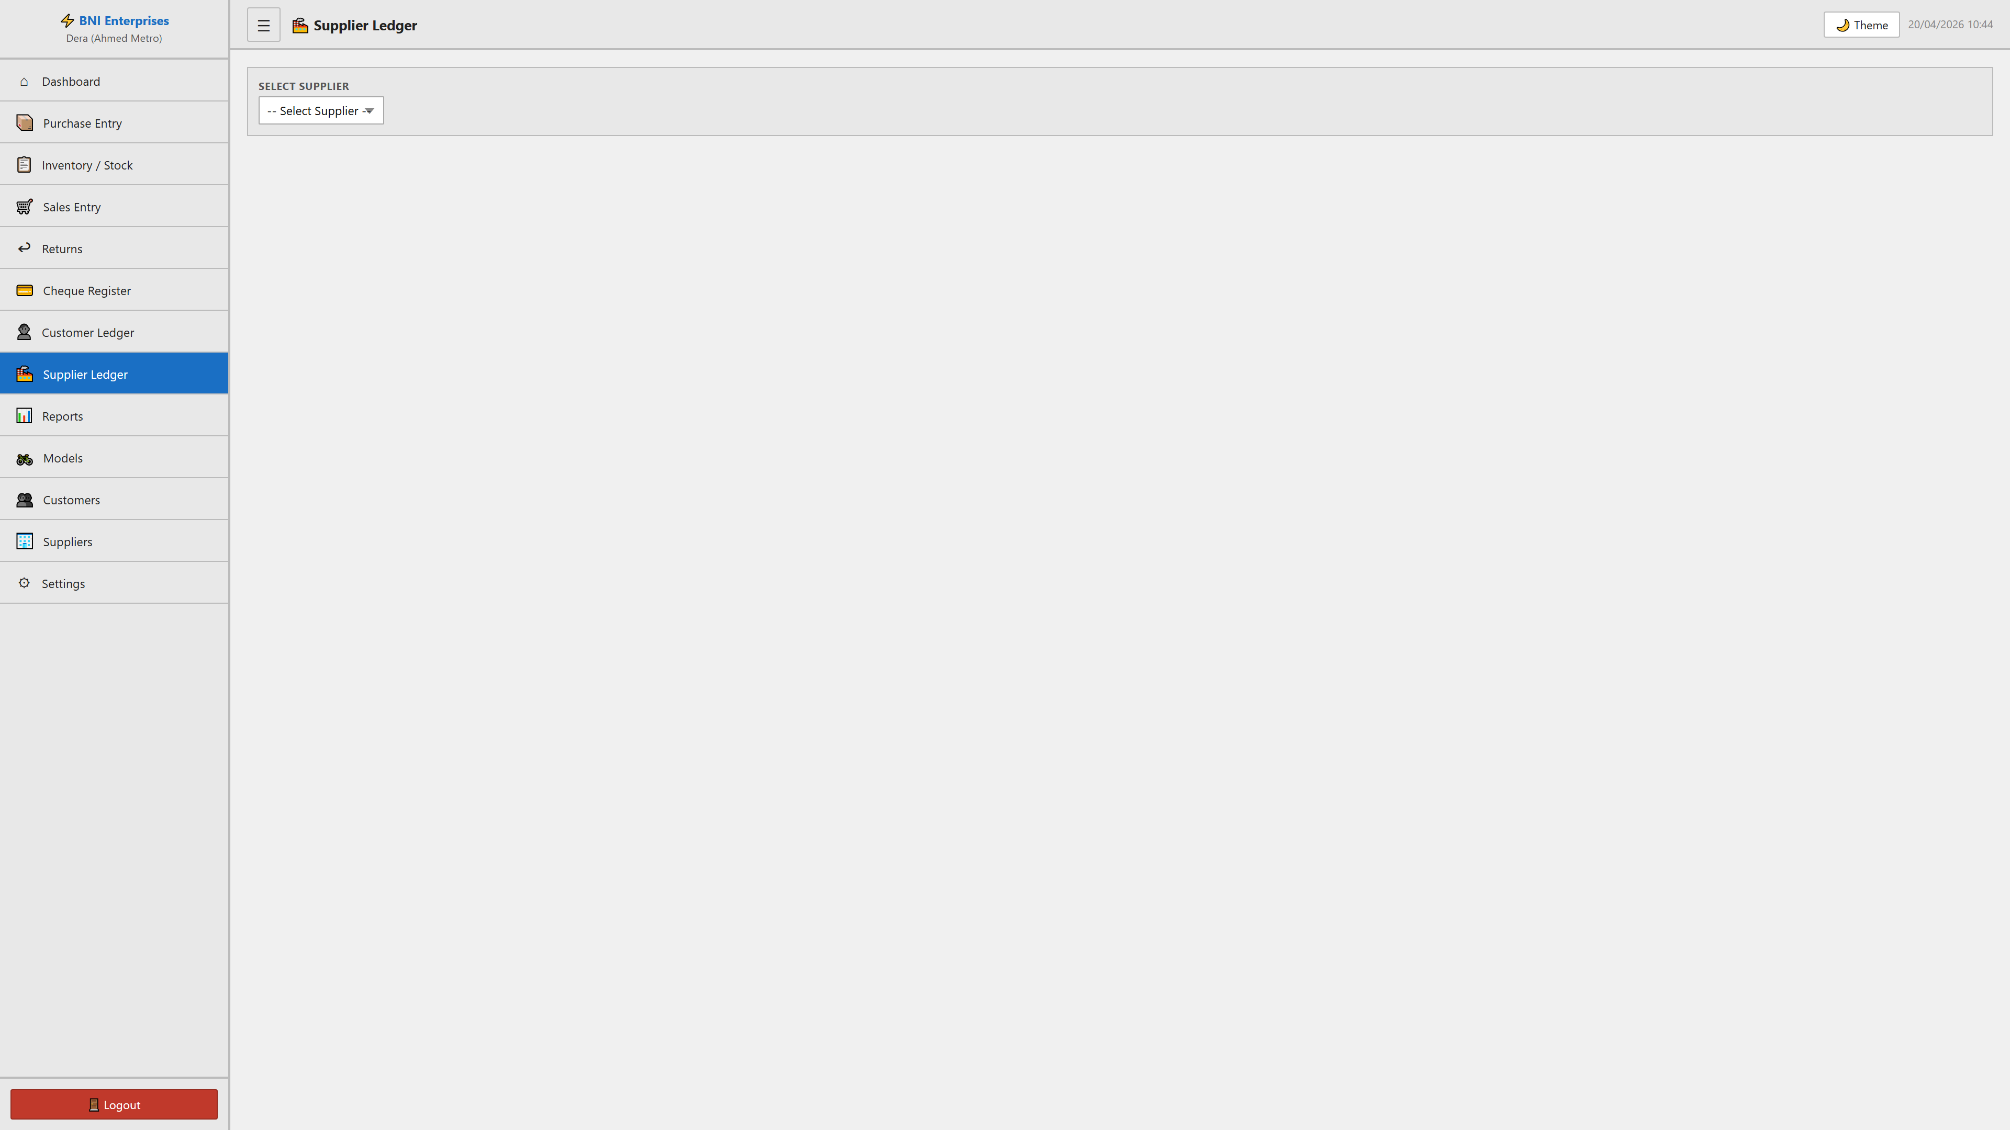

Suppliers Module

Purpose
This module facilitates the manage of suppliers within the system. It allows for the tracking, reporting, and classification of critical business records.

Form Fields & Controls
Name (text): Primary record identifier for classification.
Contact (text): Captures standardized information for records.
Address (textarea): Captures standardized information for records.

Data Architecture (Tables)
SR# | NAME | CONTACT | ADDRESS | ORDERS | TOTAL PAID | ACTIONS
1 | Default Supplier | 0300-0000000 | Pakistan | 4 | Rs. 5,289,061.00 | 📒

✏
🗑 |

Visual Evidence
