**CSE1142 Computer Programming II(Spring 2021)**

**Term Project**

(Due: 28.05.2021 –23:59)

150119565 Osman Buğra Göktaş

170517033 Yasin Alper Bingül

PROBLEM DEFINITION

In our term project, we were asked to make a game by using the JavaFX framework. Our goal in this game is to destroy all boxes on a chessboard-like 10 by 10 surface with minimum clicks. When you click on a box in the game, it will also affect the neighboring boxes (right, left, up, and down boxes). So if you want to make a high score, you have to choose carefully.

The game consists of several levels and many boxes(wall, empty, mirror, and wood) with different properties(indestructible, destructible, durability). The user must destroy all destructible boxes in the current level to move to the next level.

IMPLAMANTATION DETAILS

First of all we started our term project by choosing which pane we will use and decided to use borderpane then divided the screen into three pieces as top bottom and center. At the top, score and level information are shown. In the bottom part, player movements and the next level button are shown. For the center, our aim was to create the game screen.

To fill the game screen, the boxes class was created. Then subclasses of the boxes class were created for 4 different types of box . Each box class has its own durability and image data fields. In addition, the isClicked method was used to react to the player's move.

* UML Diagram of Boxes

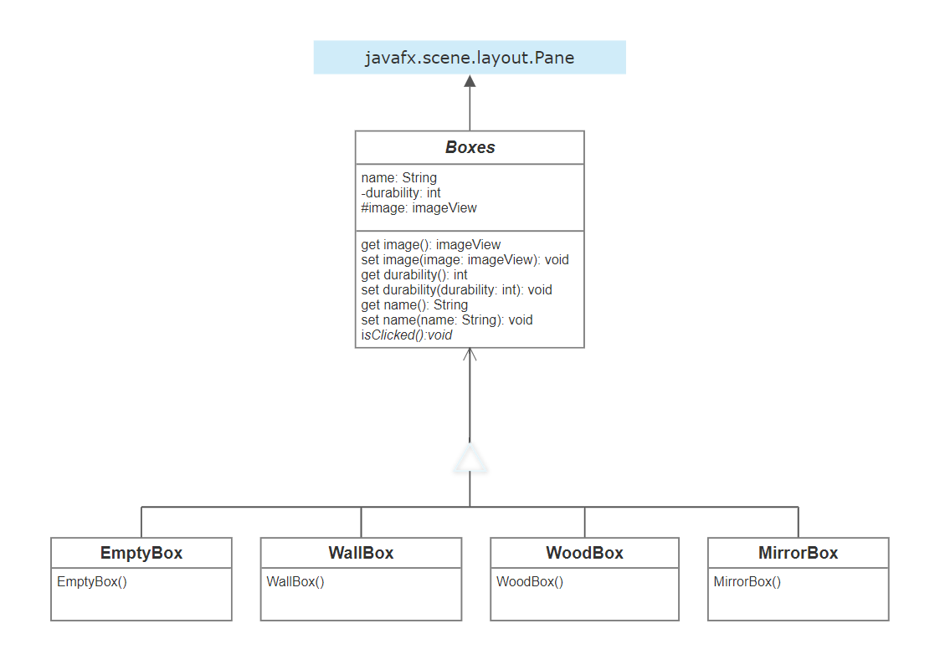

Afterwards gameplay methods of the game were created in the TheGame class. The drawMap method was used to create current level by taking the information from the relevant level file. Also, with the help of Text I/O, the level files were read and the information about the relevant level was obtained.

During the gameplay phase when a box is clicked, the box that is clicked and the neighboring boxes have been updated with the update Neighbors method and earned score calculated. To show current score updateTopLabel method was used and the score and the textfield of the score is displayed in the upper label.

Every time the player breaks a box, the game is checked with the checkBoxes method and when all breakable boxes are destroyed, the next level button appears at the bottom of the screen. Finally, when the next level button is clicked, the new level lay out will be displayed on the screen with the help of updatemap method.

* UML Diagram of TheGame

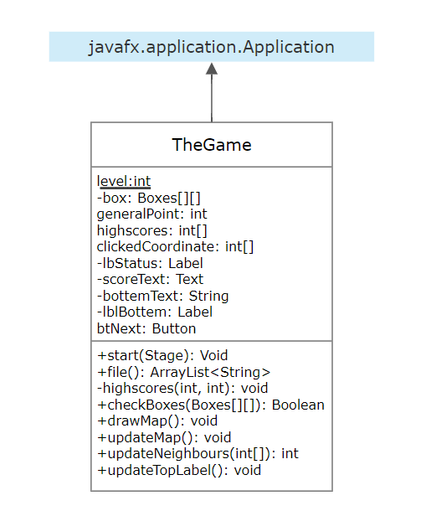

* **Dificulties we have encountered**

We had a lot of NullPointerException Exception and Game Board overflow because of that we using the pane for nearly every method. We got over these difficulties with removing the boxes at beginning of each program and adding the boxes at the end of each program.

We spent a lot of time to getting understand that we should update the borderpane and label events after each modification in top label and borderpane.

We got confused with recording high score. Because of that we changed the game end. If the player reach the last level of our game, he/she can go back and play the game again with recorded high scores. But when the game is closed, the player can't reach the recorded high scores again.

We usually got over the difficulties with System.out.println() statement. If we had confused with some code statements, we added the System.out.println statement to understand the issue.

* **Additional Functionalities**

Because we got confused with recording the high scores, we changed the game end. According to the new game end, If the player reaches the last level of our game, he/she can go back and play the game again with recorded high scores. But when the game is closed, the player can't reach the recorded high scores again.

TEST CASES

|  |  |
| --- | --- |
|  | When the game starts, we see the level 1 game design at the screen. There are current level, score and high score information at the top of the screen. At the bottem of scree, player moves and points earned will be displayed. |
|  | There is a mirror box with a durability of 1 at the [1,8] coordinate. When the user clicks on this box, the neighboring boxes (at [2,8] and [1,7]) are affected and their durability decreases by 1. Thus the boxes at [1,8], [2,8] and [1,7] will change from mirror to empty box because of their durability decreases.  The current score is also displayed at the top of the screen and the moves made are shown at the bottom of the screen |
|  | When the player breaks all the boxes and there are no more breakable boxes in the game, the next level button appears at the bottom of the screen. |
|  | After the player complated first level and clicks the next level button, the lay out of the next level will be shown on the screen |