**CSE2225 Data Structures**

# PROJECT #2 (Due January 7, 2021, Friday at 17:00)

In this project, you will construct a BST with the keys that are in the given input file. The BST has the following properties:

* its nodes are distributed over 3⎣log4 n⎦ depth levels;
* it provides the best possible total access time (as that asked in midterm exam)

You will develop an algorithm that reads the keys from input.txt file and inserts the keys to the BST with the properties as defined above. After constructing the BST, your program will print the depth level of the BST, and the number of nodes in each depth level. Next any key may be searched for in the BST. If the key is in the BST, the program's output will be the depth level and the distance to the leftmost node, otherwise the output will be the following message: “The key is not in the tree.”

* The BST should have at least 16 nonnegative and non-replicated keys, you have to control the input file, if input file contains less and/or negative keys then the program produces an error message.
* The name of the input file must be “**input.txt**” and it should be at the same directory with your source code. (I won’t check the path and the name of your input file. When I run your program if the path or source file is not found, I will not evaluate your code.)
* The input file contains strictly positive (i.e., excluding 0) integers separated with space in a line. An example follows:
  + 10 5 3 25 70 97 115 2 65 69 32 152 1 21 49 8 12 78
* Your program should work under Windows or Linux. (I will use Dev-C++ 4.9.9.2 with TDM-GCC 4.9.2 Compiler or Codeblocks 20.03 with GNU GCC Compiler). If you use another IDE, please control your program works under these environments.
* By the due date you are to electronically submit (cse2225marmara@gmail.com)
  + the source code of your program as **NameSurname**.c or **NameSurname.cpp**
  + and a documentation in a proper word processor that contains a detailed discussion of your algorithm as **NameSurname.doc** or **NameSurname.docx** or **NameSurname.rtf**
* Do not use another header file or do not separate your functions into different source files. There will be only one source file.
* Please write your name and surname in your source file as a comment.
* Do not compress your files, there will be only 2 files as attachment in your e-mail.
* The subject of your e-mail will be “**Name Surname CSE2225 Project 2**”
* Note that projects submitted after the project’s due date will not be accepted and evaluated. Please keep this in mind and promptly start working on your projects!
* ***Individual effort*** ***is mandatory. Any potential violation of this rule will lead everyone involved to failing from this project and class and necessary disciplinary actions will be taken.***

Example Run:

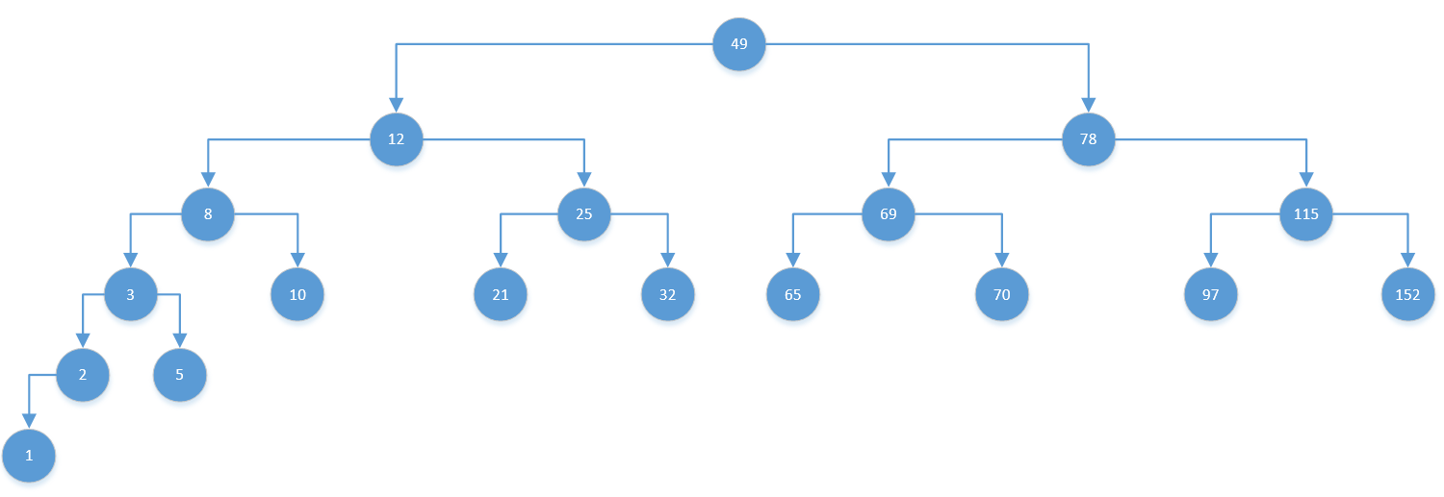

Output:

Depth level of BST is 6

Depth level 0 🡪1

Depth level 1 🡪2

Depth level 2 🡪4

Depth level 3 🡪8

Depth level 4 🡪2

Depth level 5 🡪1

Key value to be searched (Enter 0 to exit) : **32**

**At Depth level 3, 4th element**

Key value to be searched (Enter 0 to exit) : **152**

**At Depth level 3, 8th element**

Key value to be searched (Enter 0 to exit) : **78**

**At Depth level 1, 2nd element**

Key value to be searched (Enter 0 to exit) : **4**

**4 is not found in BST**

Key value to be searched (Enter 0 to exit) : **0**

**Exit**