EcoTrack

Test Report

Version 0.1 — 27 September 2026

Revision History
Date | Version | Description | Author
27/Sep/26 | 0.1 | Evidence-backed draft; role workflows pending | Sahanya

Table of Contents
1. Evaluation Mission and Test Motivation
2. Target Test Items
3. Test Approach
4. Actual Results and Evidence
5. Deliverables
6. Risks, Dependencies, Assumptions, and Constraints
7. References

Test Report

Evaluation Mission and Test Motivation

EcoTrack is a multi-tenant platform for citizen incident reporting and organization-led cleanup. This evaluation examines whether the hosted web experience supports the principal workflows and protects private records. The report records actual observations and outstanding risks for the 27 September 2026 submission.
The team divides execution by surface: Sahanya owns web functional/UI testing and report assembly; Member 2 owns API, database, security, performance and deployment diagnosis; Member 3 owns Android device, resource and notification evidence. Usability participant testing is outside these assignments.

Target Test Items

The test items are the hosted EcoTrack web app, hosted API, Supabase Auth/Storage, the disposable application test database, official Kesbewa geography, and representative Windows browser configurations. Hosted web: https://eco-track-ctd.pages.dev. Hosted API: https://p01--eco-track--xnjn7t9fk69n.code.run/api/v1.
Local source revision: 4181db9c2dd455569aa872ce0c73541c8cd632ce. The deployed revision has not been verified; local source is used for expected behavior and local checks, not as proof of the hosted build.

Test Approach
W01–W17 cover authentication, profile completion, incident creation and persistence, map discovery, organization application/review, event lifecycle, notifications, keyboard/narrow-width use, browser comparison, offline recovery and sign-out. P0 flows are prioritized. Every case starts NOT_RUN and moves to PASS, FAIL or BLOCKED only after an attempted execution is recorded.
Oracles are current source validation, the team guide's expected outcomes, controlled fixture IDs, visible UI states, sanitized request/response status and content, and persisted records when checked by Member 2. Empty lists and HTTP 200 responses alone do not prove filtering or recipient correctness.

Testing Techniques and Types

Data and Database Integrity Testing
Technique Objective: | Verify persistence and tenant integrity of application data.
Technique: | Member 2 runs isolated API/SQL checks against a verified test DB; Member 1 references results and UI persistence only.
Oracles: | Returned values, known fixture IDs, database rows and tenant boundaries agree.
Required Tools: | Member 2 tools and versions: pending handover.
Success Criteria: | Key integrity and cross-tenant assertions observed; setup excluded from counts.
Special Considerations: | Do not run destructive integration suites against the shared hosted test DB.

Function Testing
Technique Objective: | Exercise citizen and organization business flows.
Technique: | Run W01–W13 and W17 through hosted web with separate role contexts and synthetic records.
Oracles: | Visible final state, API result and persisted details match each case expectation.
Required Tools: | Playwright Core 1.55.1, Edge 154, Chrome 153; local Vitest 4.1.11.
Success Criteria: | Each full case has timestamped evidence and a justified PASS/FAIL/BLOCKED verdict.
Special Considerations: | UI setup actions and SQL/API fixture setup are labeled separately.

User Interface Testing
Technique Objective: | Check navigation, validation, focus and narrow viewport behavior.
Technique: | Use semantic controls, keyboard Tab/Shift+Tab/Enter/Escape, 1440x1000 and 390x844 views, and screenshots of loaded states.
Oracles: | Fields, errors, focus, modal controls and layout are understandable and operable.
Required Tools: | Playwright screenshots; Edge/Chrome developer inspection where available.
Success Criteria: | No clipped core controls or page horizontal overflow; issues documented with exact scope.
Special Considerations: | Basic UI checks are not a SUS participant study or blanket accessibility claim.

Performance Profiling
Technique Objective: | Measure individual response times for selected operations.
Technique: | Member 2 captures timed API requests after an agreed quiet window.
Oracles: | Observed timestamps and response status/content are recorded per request.
Required Tools: | Member 2 measurement tools: pending handover.
Success Criteria: | Actual timings and environmental conditions are reported without inventing an SLA.
Special Considerations: | Smoke request durations alone are not load-test evidence.

Load Testing
Technique Objective: | Evaluate response under concurrent load.
Technique: | Member 2 runs the agreed controlled load plan against the test target.
Oracles: | Error rate, latency distribution and server metrics correspond to the same window.
Required Tools: | Member 2 tools/results: pending handover.
Success Criteria: | Only executed load results and known limits appear in the report.
Special Considerations: | No load run overlaps normal team interaction or shared service changes.

Security and Access Control Testing
Technique Objective: | Verify authenticated role and record boundaries.
Technique: | Member 1 checks browser sign-out and cross-account visibility; Member 2 checks API authorization and tenant IDs.
Oracles: | Unauthorized access rejected and private records absent outside owning context.
Required Tools: | Playwright and hosted API observations; Member 2 security tools pending.
Success Criteria: | Positive and negative role assertions have separate evidence.
Special Considerations: | Route hiding alone does not establish backend authorization.

Failover and Recovery Testing

Technique Objective: | Observe controlled failure and recovery.
Technique: | W16 toggles browser offline mode for a read and controlled save, then retries after reconnection.
Oracles: | Clear error/recovery without duplicate writes or loss of confirmed data.
Required Tools: | Edge/Chrome DevTools or Playwright network emulation, if executed.
Success Criteria: | Failure and recovery are captured as separate states.
Special Considerations: | Do not claim failover of backend infrastructure from a browser offline test.

Configuration Testing
Technique Objective: | Compare representative browser and device configurations.
Technique: | W15 compares Edge and Chrome; Member 3 checks Android device/build behavior.
Oracles: | Core tasks render and behave consistently in observed configurations.
Required Tools: | Edge 154, Chrome 153; Android details pending Member 3.
Success Criteria: | Report exact versions and observed combinations only.
Special Considerations: | Edge and Chrome share Chromium; they are not independent rendering engines.

Actual Results and Evidence

Member 1 hosted web
At this draft checkpoint: 17 planned web cases; 0 PASS, 0 FAIL, 4 BLOCKED, 13 NOT_RUN. Partial observations do not count as complete case passes.
Fresh hosted observations: Edge loaded the signed-out login and blocked a malformed email. Tab and Shift+Tab followed the email-submit order; keyboard Enter on malformed input triggered native validation without an auth API request. Keyboard focus was visible and the 390 px login page had no horizontal document overflow. Chrome rendered the signed-out login. Unauthenticated GET /api/v1/auth/me returned HTTP 401. Magic-link callback and role workflows remain pending in this draft.
Detailed case steps, each attempt, UTC timestamps, actual statuses and sanitized paths are in the Member 1 run's cases.csv, results.csv and evidence-index.csv. These are the authoritative execution records.

Local automated checks
Vitest passed 48 tests in 16 files. TypeScript/Vite build passed (187 modules). ESLint passed on a larger-heap retry. The initial npm lint attempt exhausted Node memory and the initial Vitest startup hit spawn EPERM; both are retained as tool failures. Local checks do not establish hosted acceptance.

Prior hosted smoke baseline
The separate 27 September smoke package records an initial hosted incident POST HTTP 500 at 12:35:06.530 UTC and a later successful retest without an application fix. D01 remains open with an unconfirmed cause. The lifecycle completion HTTP 409 came from a synthetic fixture's timestamp precision; it passed after fixture correction. A browser locator expected Unread text while All was selected; visual review found the correct empty inbox. These observations are cited under their original run and not counted as new Member 1 cases.

Pending cross-member handovers
Member 2 API/database/security/performance and Member 3 Android/device/notification result packages are not yet present in the repository. Their cases remain pending in this report. Real phone receipt, email delivery, registration/approval, populated spatial filtering and full browser event lifecycle must not be inferred from the prior smoke package.
Figure 1. Malformed email blocked on hosted login. Evidence: member-1-web/20260927-194235/screenshots/W01_attempt-01_invalid-email.png (27 September 2026, 14:26:50 UTC).
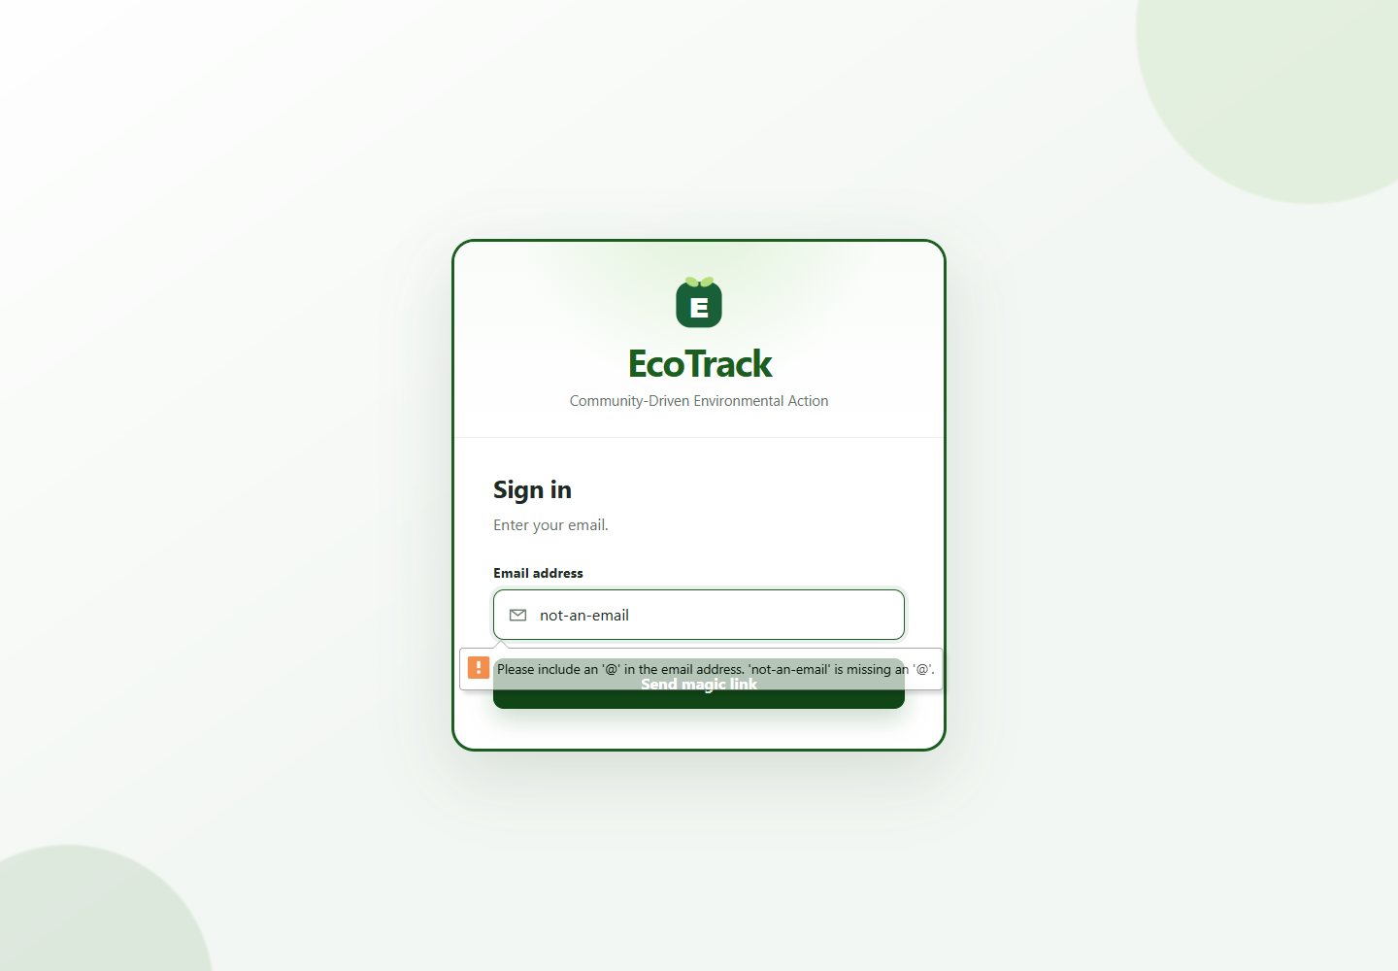
Figure 2. Hosted login at 390x844. Evidence: member-1-web/20260927-194235/screenshots/W14_attempt-01_narrow.png (27 September 2026, 14:26:50 UTC).
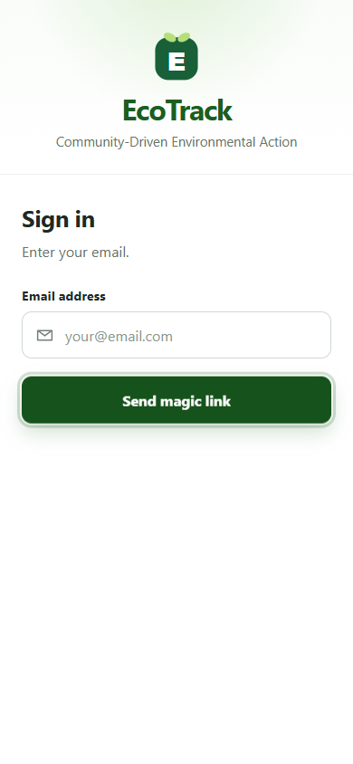

Deliverables
The Member 1 evidence folder contains environment metadata, planned cases, per-attempt results, fixture manifest, defects, screenshot index, sanitized logs/requests and reproducible tool snapshots. The existing smoke run is retained at its original path. A combined final report requires the other members' verified handovers.

Test Evaluation Summaries
This report summarizes unique W-case verdicts, links attempts and retests separately, and names unresolved defects. It excludes setup, cleanup and repeated attempts from product-test counts.

Reporting on Test Coverage
The authoritative per-attempt record is results.csv. Source review, local Vitest/lint/build, hosted browser actions, prior smoke, and human observations are presented as distinct evidence sources. No pass rate is reported until the planned suite is genuinely executed.

Risks, Dependencies, Assumptions, and Constraints
Risk | Mitigation Strategy | Contingency (Risk is realized)
Test database identity | Verify hosted API points at eco-track-test before writes. | Pause write cases; continue read-only UI and local checks.
Role access | Use volunteer, org-admin and superadmin reviewer test accounts. | Mark dependent cases BLOCKED and retain partial evidence.
Incident HTTP 500 | Keep D01 open; request server logs and distinct retest. | Report intermittent failure and limit acceptance claim.

References
1. EcoTrack Member 1 web testing guide, repository, accessed 27 September 2026.
2. EcoTrack 2026-09-27 hosted smoke README, RESULTS.csv, defects and harness notes, accessed 27 September 2026.
3. EcoTrack local source at 4181db9c2dd455569aa872ce0c73541c8cd632ce, accessed 27 September 2026.
4. Course-supplied 6 Template for Test plan.docx, accessed 27 September 2026.
5. Playwright Page API: https://playwright.dev/docs/api/class-page, accessed 27 September 2026.
6. Vitest guide: https://vitest.dev/guide/, accessed 27 September 2026.
7. Vite guide: https://vite.dev/guide/, accessed 27 September 2026.
8. ESLint docs: https://eslint.org/docs/latest/, accessed 27 September 2026.

