EcoTrack Final Report Chirana Part II
Prepared by E.A.D.C.I.B. Edirisinghe | Index 230169F
This section explains the architecture and data decisions behind EcoTrack, then documents the implementation method, source materials and retry-safe incident submission algorithm. The design is described against the implemented repository and dated verification evidence [1].

3.2 System Design

3.2.1 Architecture and responsibilities
EcoTrack is a modular monolith. The web client built with React and Vite and the React Native and Expo mobile client call one versioned Express API at /api/v1. Feature modules group the incident, organization application, organization review, cleanup event, membership, notification, dashboard and map operations. Within a module, a route selects the HTTP method and middleware; a controller validates input and shapes the response; a service or use case applies business rules; and a repository performs database work. This structure keeps related code together while allowing database transactions across related operations without distributed-service coordination [1].
Authentication and organization access are checked before a protected controller executes. A Supabase access token identifies the user, the local profile establishes account status, and tenant middleware resolves an active membership in an active organization. CASL then builds permissions from the profile, organization and, where relevant, event coordinator context. A resource-aware authorization check applies those rules to the requested organization or event. The organization identifier in the URL is therefore a request for context, not proof of access. Repositories retain organization filters when selecting private records [1].
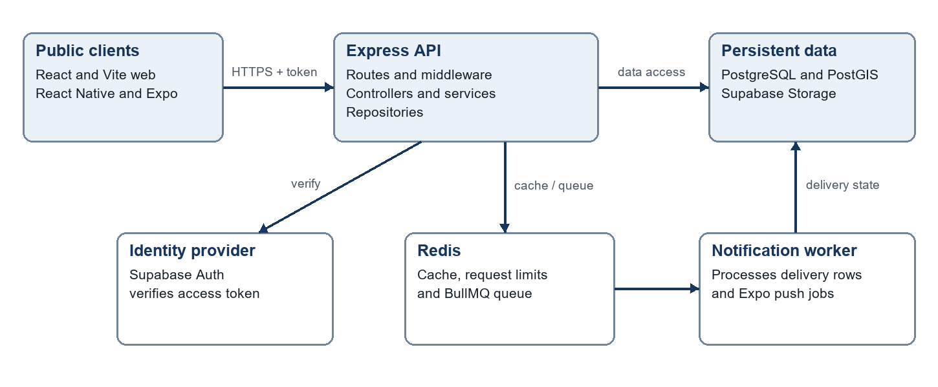
Fig. 2. EcoTrack deployment and module architecture.
Fig. 2 shows the public clients, authenticated API and persistence boundary. PostgreSQL stores durable business records, while PostGIS supports location and boundary queries. Supabase Storage stores incident images; Redis supports caching, request limits and BullMQ notification jobs. A separate worker processes notification deliveries recorded in PostgreSQL. The September 2026 hosted test configuration placed the web application on Cloudflare Pages and the API and worker on Northflank; this describes that recorded deployment, not a later capacity claim [1], [3].

3.2.2 Incident submission and organization review
Incident reporting separates file transfer from database creation. The client first asks for an evidence upload intent and uploads the image to its signed Supabase Storage path. It then posts the incident details and that path to the API. The controller validates fields and Sri Lankan coordinates. The service verifies the active category and confirms that each image path belongs to the authenticated user and submission and that the object exists. A Prisma transaction creates the incident, photo metadata and initial status history together. The client receives a new-record or replay response [1].
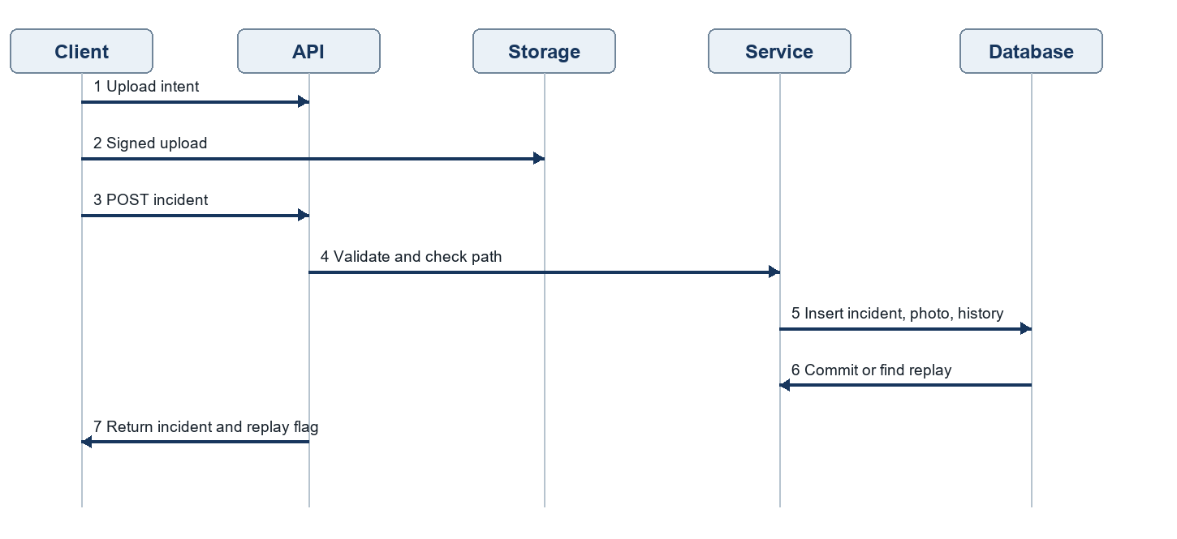
Fig. 3. Incident evidence upload and retry-safe submission sequence.
Fig. 3 separates the storage upload from the database transaction. It also shows why a submission identifier is retained: when a client retries after a lost response, the service returns the existing incident. A unique database key on reporterUserId and submissionId prevents two concurrent submissions from becoming two incident records. The hosted test verified signed upload, exact-byte photo retrieval, one incident and one photo row, idempotent replay, and rejection of missing or foreign evidence paths [1], [3].
Organization review follows the same layered request path but adds a different scope. The PATCH /api/v1/organizations/:organizationId/incidents/:id/review route verifies the token, active tenant and CASL resource permission. Within a transaction, the service locks the organization-incident review operation, confirms the incident is available to that organization, upserts that organization's review, writes an audit entry and, for a final decision, creates an in-app notification. The unique incident-organization review pair preserves independent decisions: two covering organizations may assess the same public incident without sharing private review notes [1].

3.3 Database Design
The database separates shared reports from organization-owned action. An incident belongs to its reporter and category and can be discovered by several approved organizations whose service areas cover its point. Each organization has its own membership, service areas, incident review and cleanup events. A cleanup event belongs to one organization and may refer to an incident; the incident relationship is nullable because an organization can also create a direct event. Coordinators, participants, evidence, histories, rewards and notifications record later activity. This model avoids copying one citizen report into every organization while keeping operational decisions scoped to the organization [1].
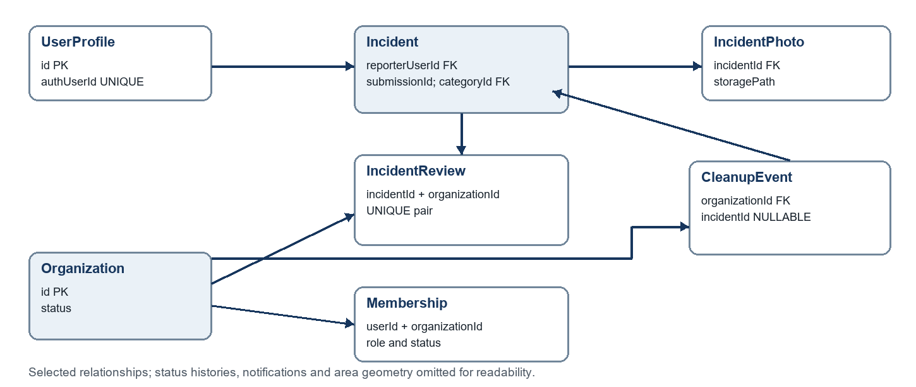
Fig. 4. Core EcoTrack entity relationships and selected integrity keys.
Fig. 4 presents the principal relationships. Foreign keys protect links among users, organizations, incidents and events. The incident review table has a unique incident-organization pair; the incident table has a unique reporter-submission pair. Event publication additionally checks that a linked incident is not already claimed by another active event. Audit and status-history rows retain the decisions and transitions that a current-status field alone could not explain [1].
PostGIS stores the incident point and official administrative boundaries for map discovery and service-area coverage. Radius queries use ST_DWithin, viewport queries use ST_Intersects, and coverage checks use ST_Covers so a point on a boundary remains included. Spatial point construction uses longitude before latitude. GiST spatial indexes and organization, status and cursor indexes support bounded result sets. The checked-in EXPLAIN capture dated 25 September 2026 recorded 17 incidents, 10 cleanup events, 24 organization service areas and 13,836 administrative areas. Its public incident viewport and radius plans selected incidents_geo_point_gist_idx. These plans show index selection for that fixture size; they do not establish production latency or the 100-user requirement [1], [2].
Transactions keep related changes atomic. An organization application creates the organization, requested service-area rows and audit information as one operation. Incident creation writes the report, photos and initial history together. Event publication checks readiness and claims a linked incident within a coordinated database operation. Redis is used for transient queue and cache state; PostgreSQL retains the recoverable notification and delivery records [1].

4 System Implementation

4.1 Implementation Procedure
Development proceeded by feature modules and database migrations. The backend uses TypeScript, Express, Zod, Prisma, PostgreSQL and PostGIS; the clients use React with Vite and React Native with Expo. Supabase provides token verification and signed image storage. Redis and BullMQ support caching, rate limits and background notification work. Git commits record separate additions to organization applications, incident reporting and review, map projection and spatial plan verification. GitHub Actions runs backend checks with Node.js 24, PostGIS and Redis, alongside web and mobile checks [1].
The implementation strategy was to put permission checks at the route boundary while retaining business and persistence checks in services and repositories. This matters for a multi-organization system: a route can reject a user without an active membership, and a repository still limits private rows to the verified organization. Database constraints then protect against races that application checks alone cannot resolve. The isolated backend run on 27 September applied 20 migrations, generated Prisma code, passed typecheck and build, and finished with 163 passing tests. A prior run failed because its container omitted a checked-in query-plan file; the harness was corrected without changing application logic [1], [3].
The recorded September deployment used Cloudflare Pages for the web client, Northflank for the API and notification worker, Northflank Redis, and Supabase services. The 27 September inspection showed one configured API instance and one worker instance at revision 4181db9. It did not demonstrate autoscaling or failover. Hosted tests also exposed Prisma P2028 transaction timeouts during one incident creation and two volunteer withdrawal attempts; those defects remained open in the dated evidence [3].

4.2 Materials and Data Sources
The principal reference data is the official Grama Niladhari Division boundary layer obtained through the Sri Lanka National Spatial Data Infrastructure ArcGIS service. The importer requests GeoJSON geometry and stores validated administrative areas in PostGIS. The hosted test project contained 73 active Kesbewa GN divisions during the 27 September verification; this is a local coverage subset rather than a claim of complete Sri Lankan coverage. Incident categories and platform settings are seeded application reference data. OpenStreetMap tiles provide map context and are credited to OpenStreetMap contributors in the clients [1], [3].
Testing data was deliberately different from official geography. Labeled synthetic incidents and events at known distances were used to verify radius and coverage rules, and a tiny synthetic PNG was used to test signed photo upload and retrieval. These points and images are test fixtures, not official observations or field photographs. Keeping their provenance separate prevents a successful API test from being mistaken for evidence that all geographic areas or real-device camera and push flows were tested [3].

4.3 Main Algorithm Retry Safe Incident Submission
Incident submission is the key algorithm because a mobile client may retry after a timeout or loss of connectivity. The first lookup avoids repeating normal work for a known submission. The unique database key remains necessary because two requests can pass an application lookup at nearly the same time. The pseudocode below summarizes the implemented decisions without copying source code [1].
INPUT authenticated user, submissionId, incident fields, evidence paths
IF incident exists for (user, submissionId): RETURN existing incident
CHECK rate limit, active category and validated location
FOR each evidence path:
CHECK user/submission prefix and stored object existence
BEGIN database transaction
CHECK submission again
INSERT incident, photo metadata and initial status history
COMMIT
IF unique-key race occurs: READ and RETURN existing incident
RETURN created incident
Fig. 5. Retry-safe incident submission pseudocode.
The image upload is completed before this transaction and is not rolled back with PostgreSQL. The service therefore checks that each referenced object exists and has the expected owner and submission prefix before writing metadata. In the hosted test, a repeated submission returned the original incident, while missing and wrong-owner paths were rejected without extra incident rows. These observations validate the tested flow but do not remove the open transaction-timeout concern recorded elsewhere in the report [3].

References for Part II
[1] Group 05, EcoTrack source repository, backend/prisma/schema.prisma, backend/src/app.ts, incident and organization modules, .github/workflows/ci.yml, and README.md, inspected 3 Oct. 2026.
[2] Group 05, MAP-03 Query Plans, docs/team-plans/MAP-03_Query_Plans.json, captured 25 Sep. 2026.
[3] E.A.D.C.I.B. Edirisinghe, Member 2 API Database and Performance Evidence, docs/testing/evidence/member-2-api/20260927-201125, 27 Sep. 2026.

