EcoTrack Final Report Chirana Part II
Prepared by E.A.D.C.I.B. Edirisinghe
Index number 230169F
This report explains how EcoTrack turns a citizen report into information that organizations can review and use to coordinate cleanup work. The three parts describe the system design, the database design and the implementation. The Software Architecture Document (SAD) diagrams show the main relationships, while the repository and recorded tests explain how the design was implemented [1], [2], [3].

Part 1 System Design

Applications and backend responsibilities
EcoTrack uses one modular backend for its web and mobile applications. The web application uses React and Vite, while the mobile application uses React Native and Expo. Both send requests to the Express API under /api/v1. The backend groups related operations into modules for incidents, organizations, cleanup events, memberships, notifications, rewards and dashboards [1].
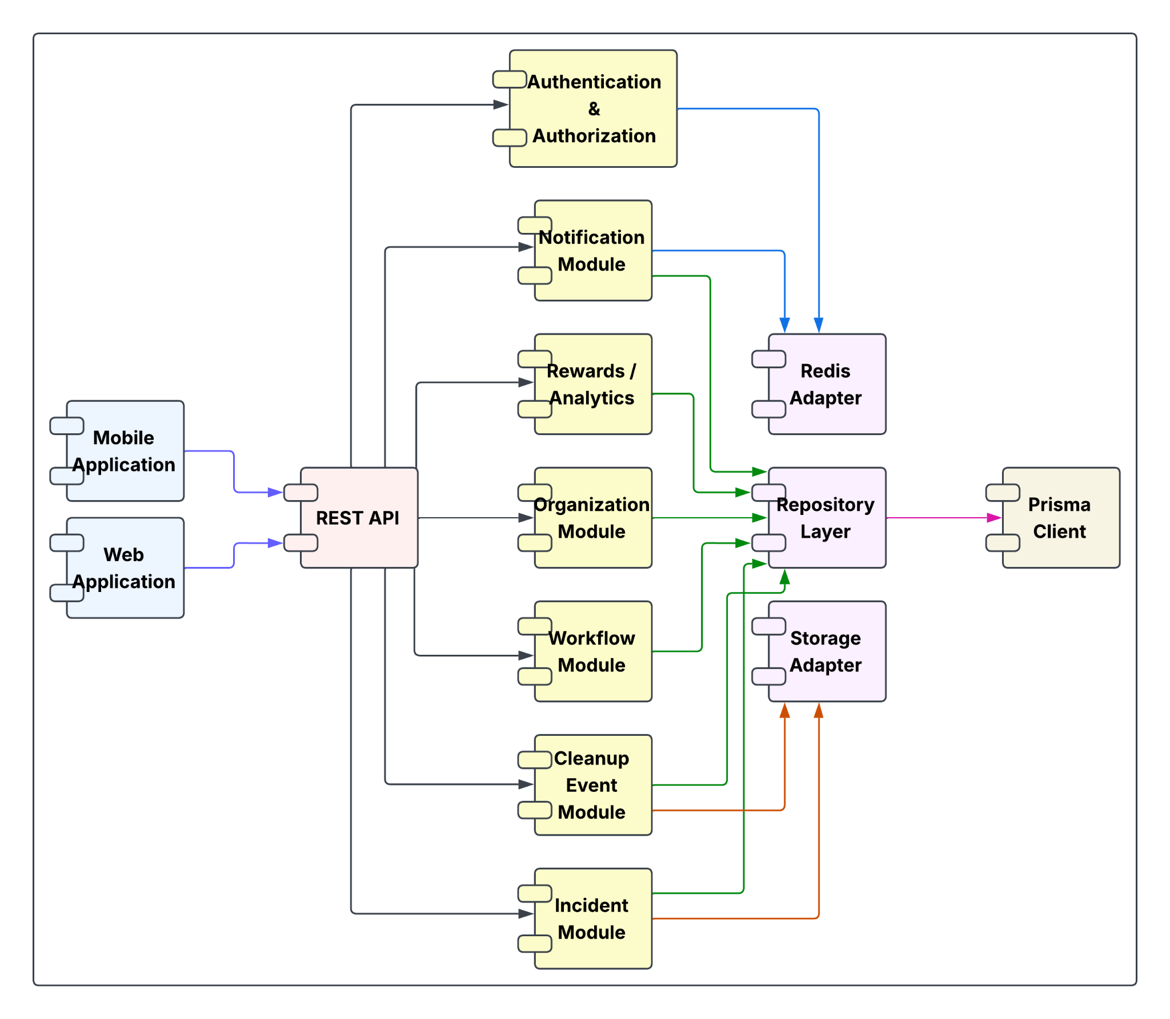
Figure 1 EcoTrack component structure from SAD Figure 26 [3]
Figure 1 shows how the feature modules use shared repositories and separate storage and Redis adapters. PostgreSQL stores permanent records, PostGIS handles spatial queries, and Supabase Storage holds uploaded evidence. Redis supports temporary cache data, request limits and queued notification work. A separate worker processes notification deliveries whose recoverable records remain in PostgreSQL [1].

Passwordless sign in
A user begins by entering an email address. The application asks Supabase Auth to send a magic link. When the user opens that link, the application exchanges the callback for a session. A valid link produces access and refresh tokens. An invalid or expired link ends the sign-in attempt and the user must request a new link [3].
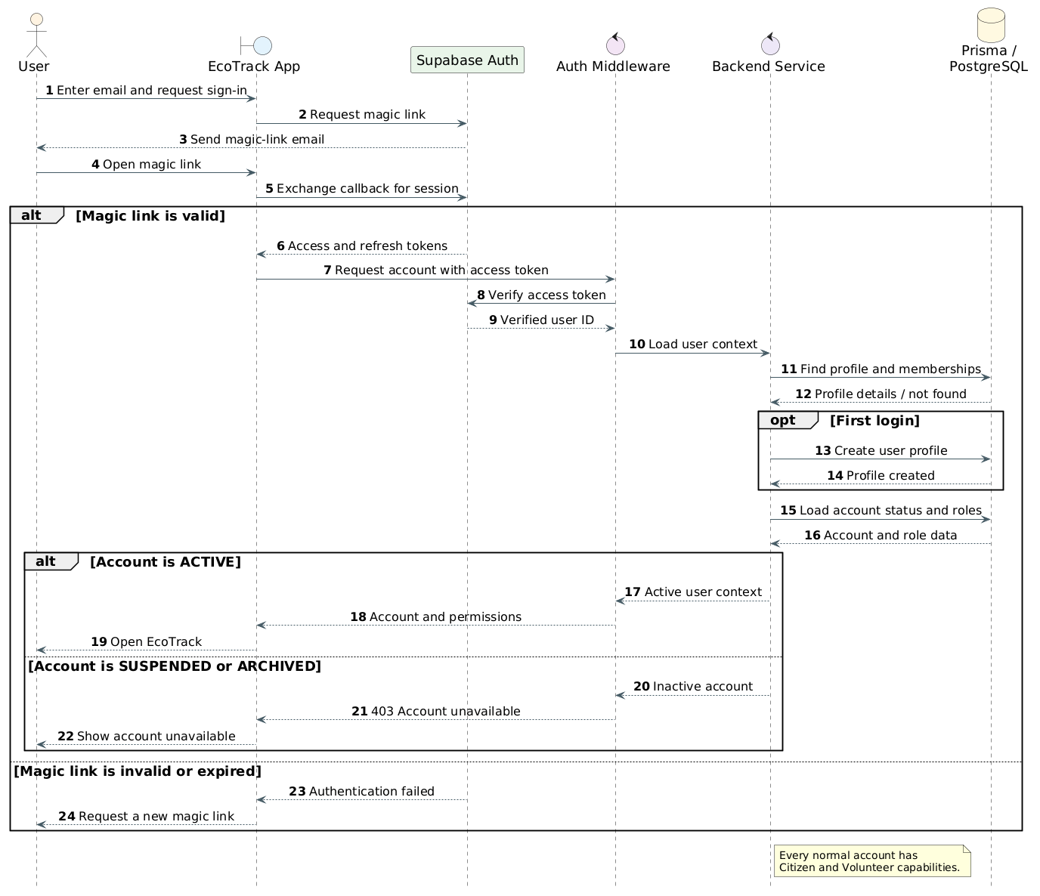
Figure 2 Passwordless authentication sequence from SAD Figure 16 [3]
The application then sends the access token to the account endpoint. The backend verifies the token and uses the verified identity to load or create an EcoTrack profile. An active account can continue to the application. A suspended or archived account receives HTTP 403. A first-time user completes the required profile details before using the relevant features [1].
The SAD groups account and permission loading into one logical step. In the implementation, GET /api/v1/auth/me returns the profile, platform role and account status. Organization membership and CASL permissions are resolved when an organization-scoped route is requested. The server checks active membership and applies organization filters to private records, so a role or organization identifier supplied by the client cannot grant access [1], [3].

Part 2 Database Design

Shared incidents and organization records
The database keeps a citizen incident as one shared record. The incident belongs to its reporter and category. Approved organizations discover it when their service areas cover its location. Each organization stores its own review and private operational information, which allows several organizations to assess the same incident independently [1].
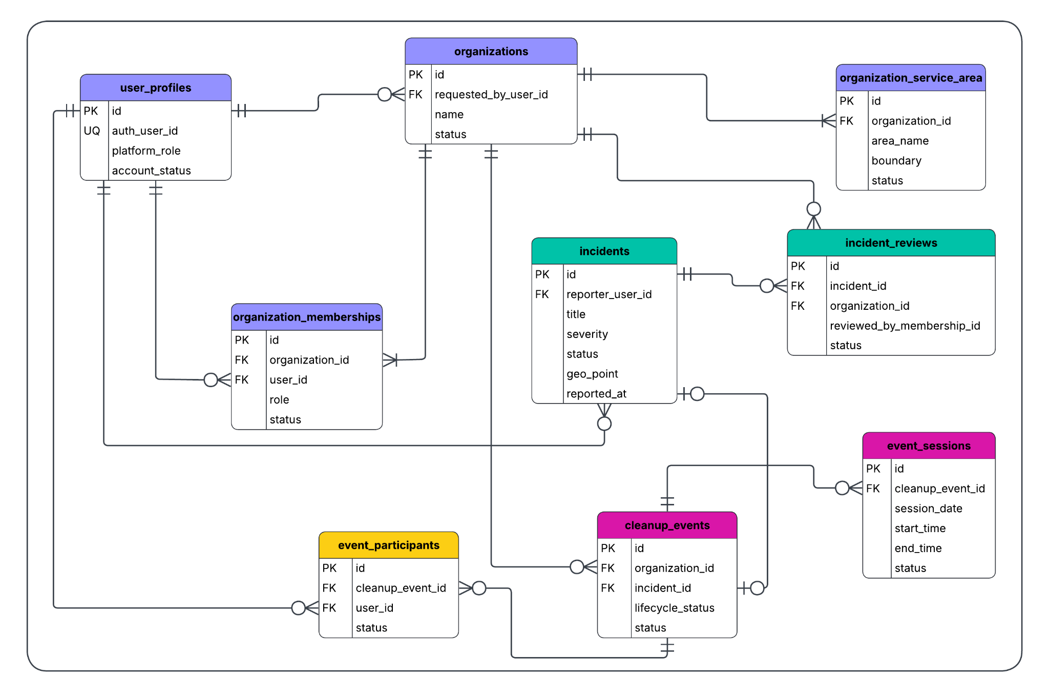
Figure 3 Core entity relationships from SAD Figure 29 [3]
Figure 3 connects user profiles, memberships, organizations, incidents and cleanup events. Membership records determine a user's role within an organization. Each cleanup event belongs to one organization and may link to an incident. This link is optional because an organization can also arrange a direct cleanup event. Sessions and participants record when the work takes place and who joins it [1], [3].
Foreign keys maintain the relationships between these records. A unique incident and organization pair prevents duplicate review records for the same organization. A unique reporter and submission pair prevents a retried report from creating a second incident. Event publication also protects the rule that an incident can have only one active cleanup event claiming it [1].

Location and service area queries
PostGIS stores incident points and administrative boundaries. A radius query uses ST_DWithin to find records within a requested distance. A viewport query uses ST_Intersects to find records inside the visible map area. A service-area check uses ST_Covers so a point on the boundary is included. Point construction uses longitude before latitude [1].
Spatial indexes support these queries, while organization, status and cursor filters keep results bounded. The query-plan capture from 3 October 2026 used a disposable local database containing 2,000 synthetic incidents, 2,000 published events, 51 service areas and 13,844 synthetic GN polygons. All six incident and event plans selected their spatial GiST indexes. The small service-area table used a bounded sequential scan. These results demonstrate query planning for that controlled dataset and do not establish production latency or support for 100 simultaneous users [4].

Reference data and test data
The application obtains official Grama Niladhari Division boundaries through the Sri Lanka National Spatial Data Infrastructure ArcGIS service. The importer requests GeoJSON geometry and stores validated administrative areas in PostGIS. During the hosted verification on 27 September 2026, the test project contained 73 active Kesbewa GN divisions. That test coverage did not include all Sri Lankan divisions [1], [2].
Seeded incident categories and platform settings provide application reference data. OpenStreetMap tiles provide map context and the clients credit OpenStreetMap contributors. Synthetic points at known distances were used to test radius and coverage rules. A small synthetic PNG tested image upload and retrieval. These fixtures are separate from official boundary data and do not represent field observations or successful phone-camera testing [1], [2].

Transactions and recovery
Transactions keep related database changes together. An organization application writes the organization, requested service areas and audit information as one operation. Incident creation writes the incident, photo metadata and initial status history together. Publication checks event readiness and claims a linked incident within a coordinated database operation. If a database operation fails, its related writes do not remain partly completed [1].
External image uploads and push delivery sit outside those database transactions. An image must already exist before incident metadata is saved. Notification and delivery records remain in PostgreSQL so the worker can recover pending work after a Redis or worker interruption. Audit records and status histories retain the decisions behind the current state [1].

Part 3 System Implementation

From design to a working request
Development followed the feature modules and versioned database migrations. The backend uses TypeScript, Express, Zod and Prisma with PostgreSQL and PostGIS. Supabase provides authentication and evidence storage. Redis and BullMQ support background notification delivery. Git records the changes, and GitHub Actions runs backend, web and mobile checks [1].
A request first reaches its route and security middleware. The controller validates the input and prepares the response. The service applies the business rules, then calls a repository for database work. This order keeps validation, permissions and persistence understandable without placing all responsibilities in one controller [1].
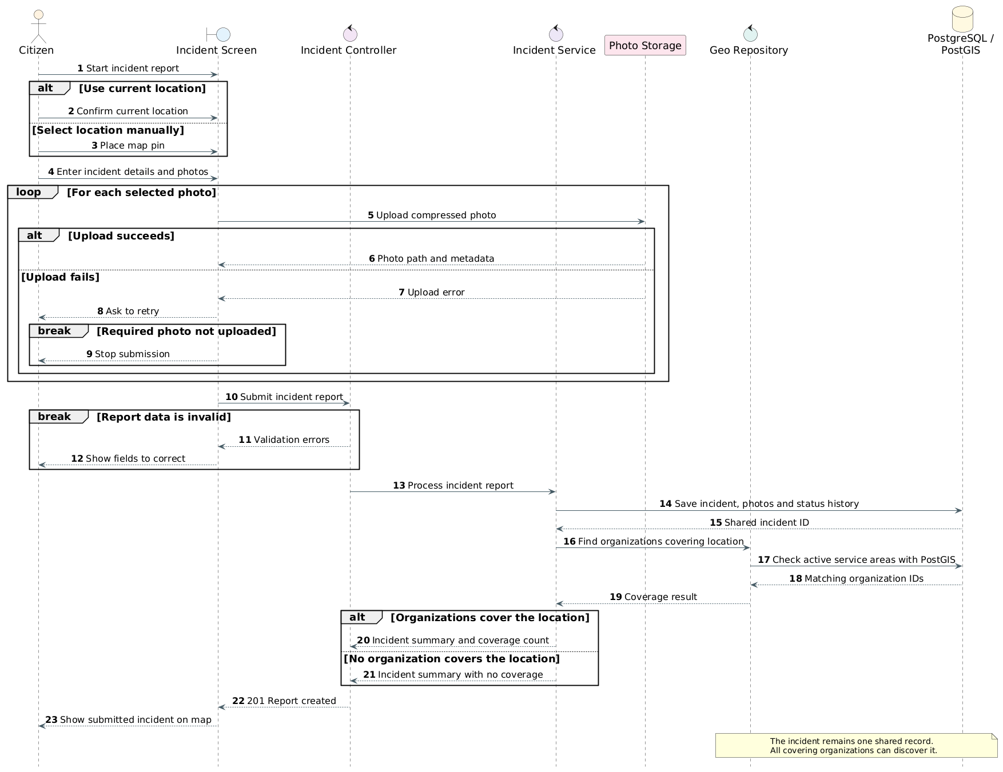
Figure 4 Incident submission and spatial discovery from SAD Figure 17 [3]
Figure 4 follows the report from location selection and photo upload to storage and spatial discovery. The report remains shared even when several organizations cover its location. The implementation adds validation and retry protection around this flow so a repeated request can return the original incident [1], [3].

Incident submission in sequence
The client first obtains a signed upload path and uploads the evidence image to Supabase Storage. It then sends the incident fields, evidence paths and a stable submission identifier to the API. The controller validates the request before the service continues with the following steps [1].
First, the service looks for an incident with the same authenticated reporter and submission identifier. If one already exists, it returns that incident.
Next, it applies the configured submission rate limit and checks that the selected category is active. The request must also contain a valid incident location.
The service then checks each evidence path. The path must belong to the authenticated user and submission, and the uploaded object must exist in storage.
After these checks, a database transaction checks the submission identifier again. If no record exists, it creates the incident, photo metadata and initial status history together.
If two requests race to create the same report, the unique database key prevents the duplicate. The service reads and returns the incident created by the successful request.
Finally, the API returns the new or existing incident. The client can therefore retry after a lost response without creating another report.
The storage upload is completed before the database transaction. A rollback therefore does not remove the uploaded object. Checking its ownership and existence before saving metadata prevents the service from attaching a missing image or another user's evidence to the report [1].

Independent organization review
After discovery, an organization can review the incident through an authenticated organization route. The backend checks membership and resource permission before updating the review. Within a transaction, the service verifies that the incident is available to that organization, writes its review and audit entry, and creates the appropriate notification for a final decision. The unique review pair preserves separate decisions and private notes for each organization [1].

Verification and deployment results
The isolated backend run on 27 September 2026 applied 20 migrations, generated Prisma code, passed typecheck and build, and completed 163 tests successfully. An earlier attempt failed because the test container omitted the checked-in map query-plan file. The test setup was corrected and the suite was repeated without changing application logic [2].
The hosted incident test verified signed upload, exact-byte image retrieval, one incident and one photo row, and replay of the same submission. Missing and wrong-owner evidence paths were rejected without creating extra incident rows. These observations support the tested submission behavior [2].
The recorded deployment used Cloudflare Pages for the web application and Northflank for the API, notification worker and Redis. Supabase provided the database, authentication and storage services. The inspection recorded one API instance and one worker instance at revision 4181db9. It did not demonstrate autoscaling or failover [2].
Hosted testing also recorded transaction timeout errors during an incident creation and two volunteer withdrawal attempts. Those defects remained open in the dated evidence. A later successful request does not establish that the cause was fixed. Worker health and an in-app notification were verified, but provider delivery and physical phone receipt were not established. These limits must remain visible when evaluating the implementation [2].

References
[1] Group 05. EcoTrack source repository. Prisma schema, Express application, incident and organization modules, authentication and authorization code, CI configuration and project README. Inspected 3 October 2026.
[2] E.A.D.C.I.B. Edirisinghe. Member 2 API Database and Performance Evidence. Run 20260927-201125, 27 September 2026. Repository location docs/testing/evidence/member-2-api/20260927-201125.
[3] Group 05. EcoTrack Software Architecture Document. Figures 16, 17, 26 and 29. Supplied SAD.pdf, 2026. The diagrams in this report are reproduced from that document.
[4] Group 05. MAP-03 Query Plans and Spatial Performance and Security Regression Notes. Query plans captured 3 October 2026. Repository location docs/team-plans.

