* **Link to website:** <http://singh1jo.myweb.cs.uwindsor.ca/lab3/vote_index.cgi>
* **Description:**
* CGI Script to work as a Polling website.
* User Can cast their vote
* User can see the current voting status via Number of vote counts in each category and their percentage as per total number of votes.
* Required files:
* **vote_index.cgi** - CGI Script
* **vote_count.txt** -Hold the voting count
* **sb-admin.css** - css file
* **bootstrap.min.css** -bootstrap lib
* **jquery.js** -jquery lib
* **lab3lib.js** -cgi lib
* **Demo:**
* **Welcome Page :** The welcome page consists of the option for user to cast its vote and also displays the number of votes in the category and its percentage

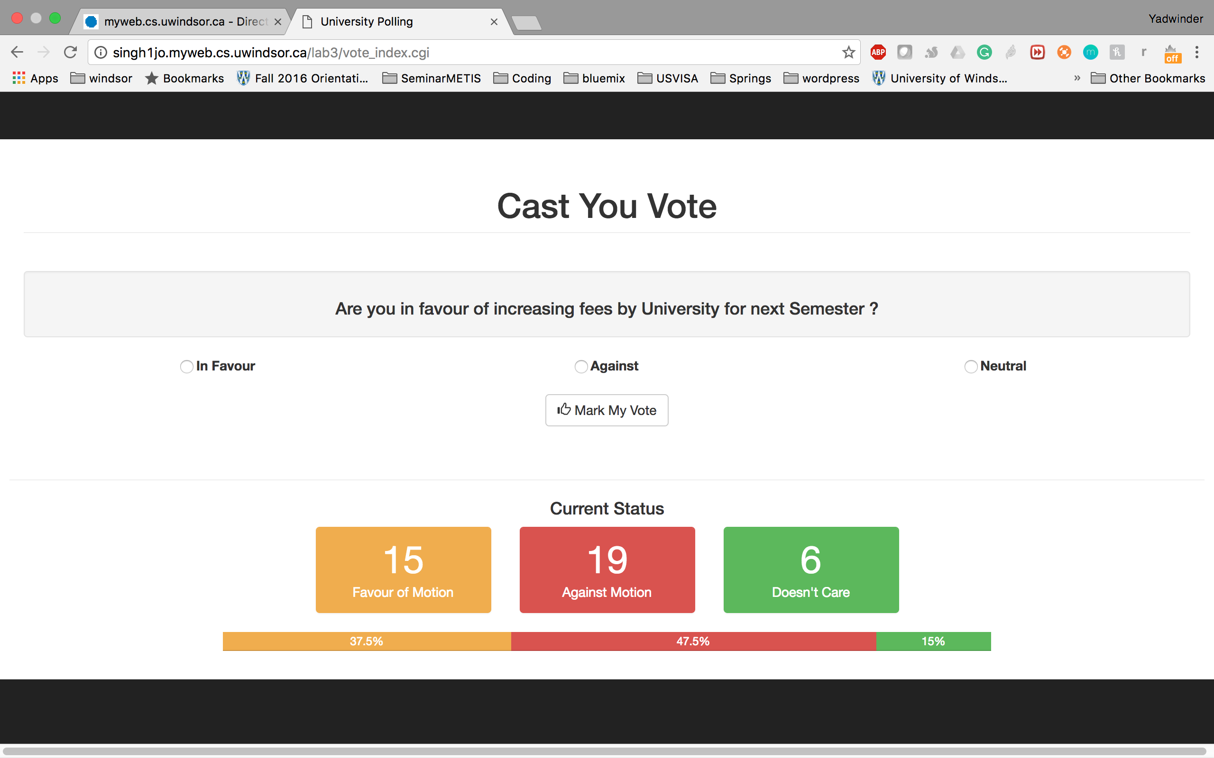

* **Vote Submission Page:** Once the user cast its vote. The current page will be updated with the Thank you page. This is all done using single CGI script.

